Drug Testing and Bacterial Growth Questions
Q1.
In the 18th century, William Withering trialled the use of an extract of foxglove plants to treat a heart condition.
Give four reasons why a contemporary drug testing protocol is an improvement on the trial used by William Withering.
(4)
.............................................................................................................................................
.............................................................................................................................................
.............................................................................................................................................
.............................................................................................................................................
.............................................................................................................................................
.............................................................................................................................................
.............................................................................................................................................
.............................................................................................................................................
(Total for question = 4 marks)
Q2.
In a drug trial, people with a heart condition were given one of three drug treatments. The table shows the recorded improvement in their condition for each of the three treatments.
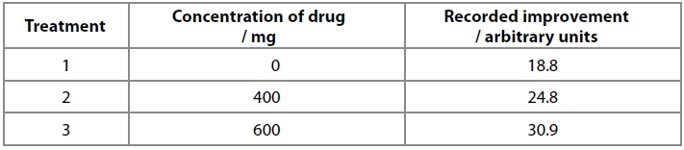
It was concluded that the drug treatment improved the condition of the patients.
Analyse the data to comment on this conclusion.
(3)
.............................................................................................................................................
.............................................................................................................................................
.............................................................................................................................................
.............................................................................................................................................

(Total for question = 3 marks)

Q3.
Answer the questions with a cross in the boxes you think are correct . If you change your mind about an answer, put a line through the box and then mark your new answer with a cross .
William Withering tested his digitalis 'soup' by an early form of drug testing.
Withering reported that his first patient found that the digitalis
"made him very sick, the sickness recurring at intervals for several days."
Modern drug testing protocols include four stages.
(i) In modern drug testing protocols, the first stage that patients with an illness are involved is
(1)
A preclinical trials
B phase 1
C phase 2
D phase 3
(ii) In modern drug testing protocols, side effects such as nausea will first be identified in healthy volunteers during
(1)
A preclinical trials
B phase 1
C phase 2
D phase 3

(Total for question = 2 marks)
Q4.
William Withering tested his digitalis 'soup' by an early form of drug testing.
Withering reported that his first patient found that the digitalis
"made him very sick, the sickness recurring at intervals for several days."
Modern drug testing protocols include four stages.
Modern drug testing protocols must ensure that new drugs are effective at treating patients.
Explain the role that a placebo and a double blind trial have in producing valid conclusions.
(4)
Placebo
.............................................................................................................................................
.............................................................................................................................................
.............................................................................................................................................
.............................................................................................................................................
.............................................................................................................................................
.............................................................................................................................................
Double blind trial
.............................................................................................................................................
.............................................................................................................................................
.............................................................................................................................................
.............................................................................................................................................
.............................................................................................................................................
.............................................................................................................................................

(Total for question = 4 marks)

Q5.
Many plants produce chemicals that have antimicrobial properties.
The suitability of using wood from three types of tree to make kitchen chopping boards was investigated.
In this investigation, 50 cm³ of a bacterial culture was added to 100 g of wood chippings from each of three types of tree.
The growth of bacteria was measured at the start (Day 0), and then after 1, 2, 4 and 8 days.
The results are shown in the graph.
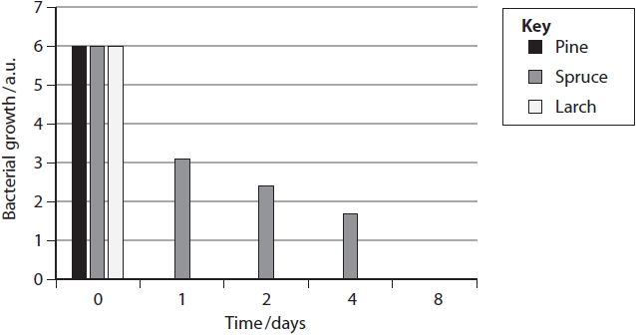
Temperature and the moisture content of wood from pine trees can affect bacterial growth.

Graph 1 shows the effect of temperature on bacterial growth.
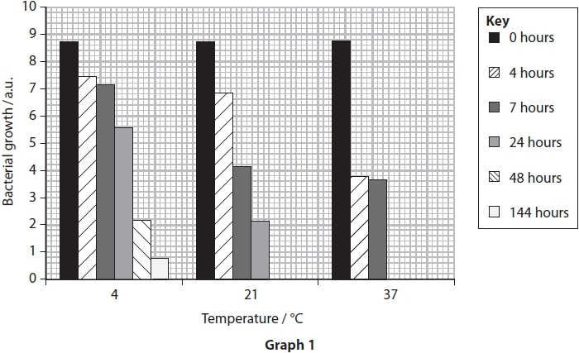
Graph 2 shows the effect of temperature on the moisture content of wood.
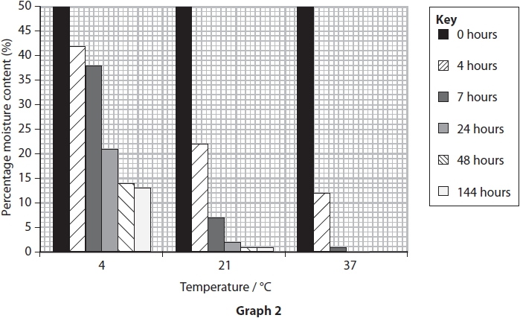

Analyse the data to deduce the effects of these two factors on bacterial growth on wood from pine trees.
(4)
.............................................................................................................................................
.............................................................................................................................................
.............................................................................................................................................
.............................................................................................................................................
.............................................................................................................................................
.............................................................................................................................................
.............................................................................................................................................
.............................................................................................................................................
.............................................................................................................................................
.............................................................................................................................................
.............................................................................................................................................
.............................................................................................................................................
.............................................................................................................................................
.............................................................................................................................................
.............................................................................................................................................
.............................................................................................................................................
(Total for question = 4 marks)
Q6.
Bald's Leechbook was written in the 9th Century. This book contains details of medical treatments used over 1000 years ago.
The recipe for a 'salve', used to treat infections, is shown in the photograph.
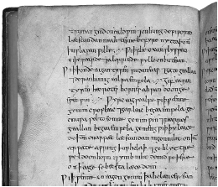
Scientists followed the recipe to make this salve and tested it in the laboratory.
They found that the salve was very effective against Staphylococcus aureus. This bacterium commonly causes infections in humans.
Describe two aseptic techniques that should be used when working safely with bacteria.
(2)
.............................................................................................................................................
.............................................................................................................................................
.............................................................................................................................................
.............................................................................................................................................
.............................................................................................................................................
.............................................................................................................................................
(Total for question = 2 marks)
Q7.
Extracts from four different plants were added on separate small paper discs to agar plates containing E. coli bacteria.
After 48 hours, the zone of inhibition around each extract was measured.
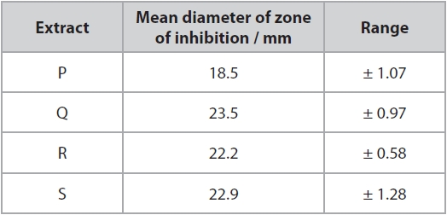
(i) Calculate the area of the largest zone of inhibition for extract S.
(3)
........................................................... mm²

(ii) Comment on the antimicrobial properties of these four plant extracts.
(3)
.............................................................................................................................................
.............................................................................................................................................
.............................................................................................................................................
.............................................................................................................................................
.............................................................................................................................................
.............................................................................................................................................
.............................................................................................................................................
.............................................................................................................................................
.............................................................................................................................................
.............................................................................................................................................
.............................................................................................................................................
.............................................................................................................................................

(Total for question = 6 marks)
Mark Scheme
Q1.
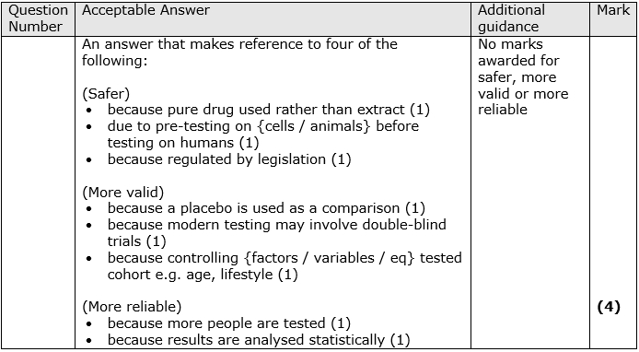

Q2.
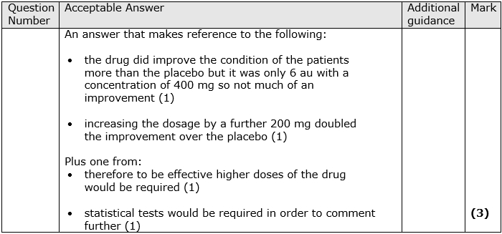

Q3.
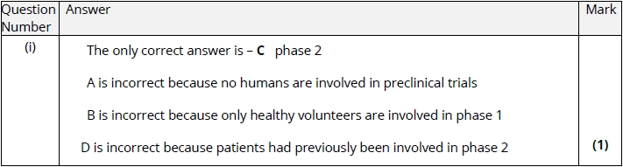
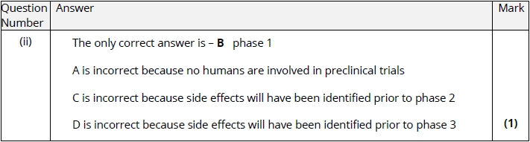

Q4.
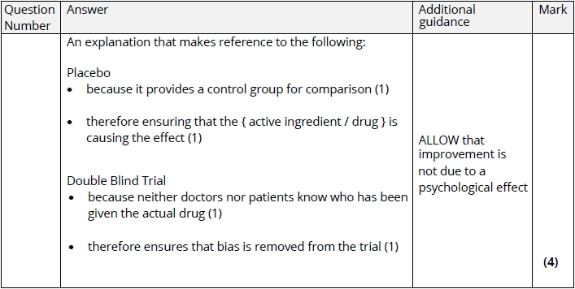

Q5.
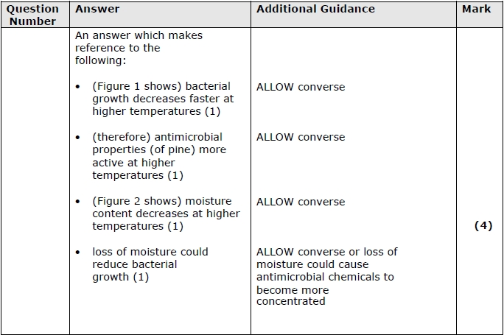

Q6.
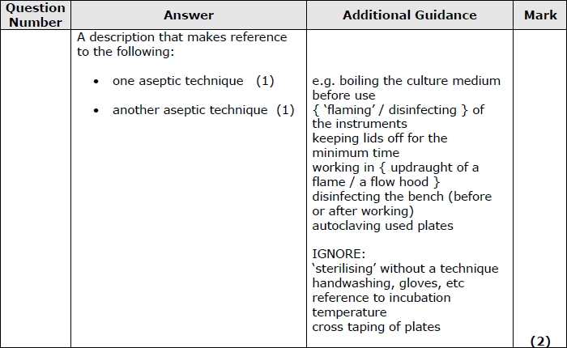
Q7.

