Miss Khorozyan
DRAYTON MANOR HIGH SCHOOL
ECONOMICS
Year 12 to year 13 summer transition work

VANILLA: ICE CREAM SCREAMING
Extract A:

Vanilla prices, January 2004-May 2018  (US dollars per kilogram) | Largest global exporters of vanilla, 2014 (measured in tonnes)
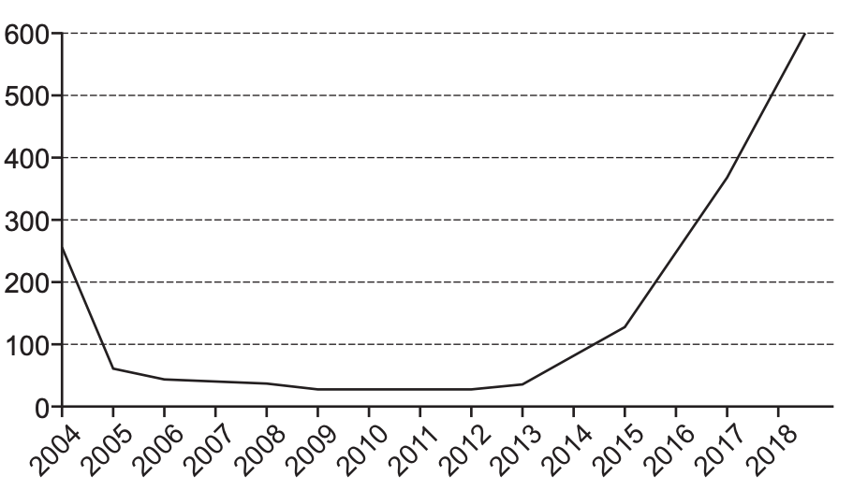 | 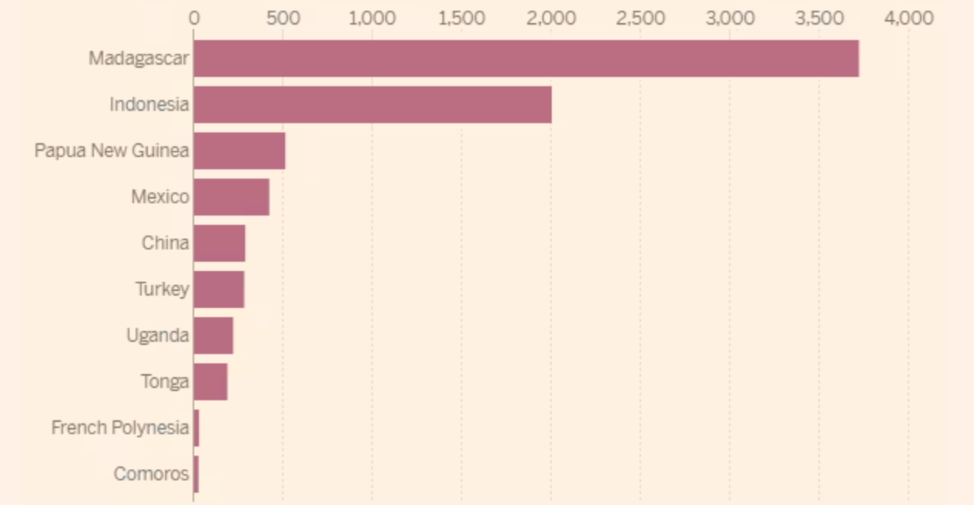
Source: news reports, 2020 | Source: news reports, 2015  .
Extract B: Vanilla’s choppy ride

The price of natural vanilla hit a record high of US$600 per kilogram in May 2018, making it even more expensive than silver. As a result, many ice cream producers are considering whether they should raise their prices or perhaps stop selling the vanilla flavour of ice cream. The price of natural vanilla has been rising sharply since March 2017 when a cyclone hit Madagascar, which accounts for 75% of global production. Natural vanilla represents 20% of Madagascan exports, worth around US$600 million at current prices.  Natural vanilla comes from the vanilla orchid, which produces vanilla beans. Madagascar has the perfect climate and soil for growing vanilla, but poor harvest have reduced the country’s vanilla production by more than 20%, leading to a worldwide supply shortage. It takes three years for the plant to start producing. So if there is a sharp rise in price, people plant more, but then it makes three years for the new supplies to reach the market.  Vanillin is a synthetic substitute to natural vanilla that can be used in the production of ice cream. It is made from more reliable sources of plentiful raw materials, such as wood pulp and petroleum and it has been failing in price. For many years, some of the world’s largest producers of ice cream replaced natural vanilla with vanillin. A consequence of this falling demand for natural vanilla was that Madagascar’s farmers earned very low returns and many ceased growing natural vanilla. Surprisingly, despite there being fewer growers, the price of natural vanilla stayed low between 2005 and 2012. | 1  5  10  15
Source: Hong Kong Economic Journal, May 2018

Extract C: Vanillin’s health risks

From 2012, concerns about possible health risks arising from the use of vanillin caused some producers to use more natural vanilla in their ice cream production process. For example, in 2015, one of the world’s largest ice cream producers announced plans to end their use of vanillin and use only natural ingredients by 2020. It has been said that excessive consumption of vanillin can cause cancer in some cases. In recent years, however, the sharply rising price of natural vanilla has persuaded some ice cream makers to consider turning back to vanillin. As a result, some of the leading producers of ice cream have more than a year’s stock of vanillin.  If vanillin poses such a risk, should the government intervene? Some argue that they should, by regulating the market and insuring that health risks are kept to a minimum. As such, the government could consider banning the use of vanillin in the production process. Another possible idea could be to set a minimum price for vanillin. This could be off-putting for producers though, as this creates an artificially high price that increases their cost of production. Another possible idea could be to subsidise the cost of using natural vanilla whilst the price of vanilla has reached unprecedent levels.  One thing is clear– there is a problem associated with the increased use of vanillin and it needs to be sorted sooner rather than later. | 1  5  10  15
Source: news reports, 2017

Using the data from Extract A, work out the percentage increase in vanilla from January 2004 to May 2018
[2 marks]
Explain how the data in Extract A shows that global ice cream manufacturers are likely to have an increased cost of production in the past few years.
[4 marks]
Extract B (lines 7–9) states that “Madagascar has the perfect climate and soil for growing vanilla, but poor harvests have reduced the country’s vanilla production by more than 20%, leading to a worldwide supply shortage”.
With the help of a diagram, explain the effects of a “poor harvests” for vanilla upon the price of ice cream.
[9 marks]
Extract C (lines 14–15) states that “there is a problem associated with the increased use of vanillin and it needs to be sorted sooner rather than later.”
Use the extracts and your knowledge of economics to evaluate the possible actions a government could take in order to reduce the issues arising from the increased use of vanillin.
[25 marks]

AIRLINES: A CRASH LANDING IN THE MAKING
Extract A:

Number of passengers carried by air in the European Union (EU) from 2008-2020, measured in millions of passengers | Percentage market share of airline groups within Europe, 2018
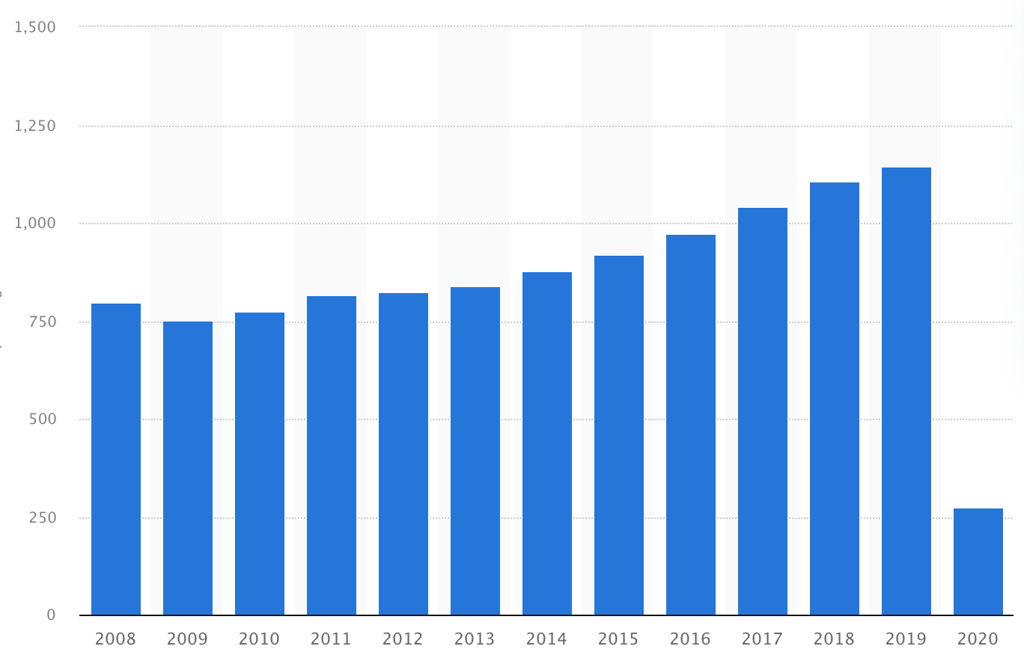 | 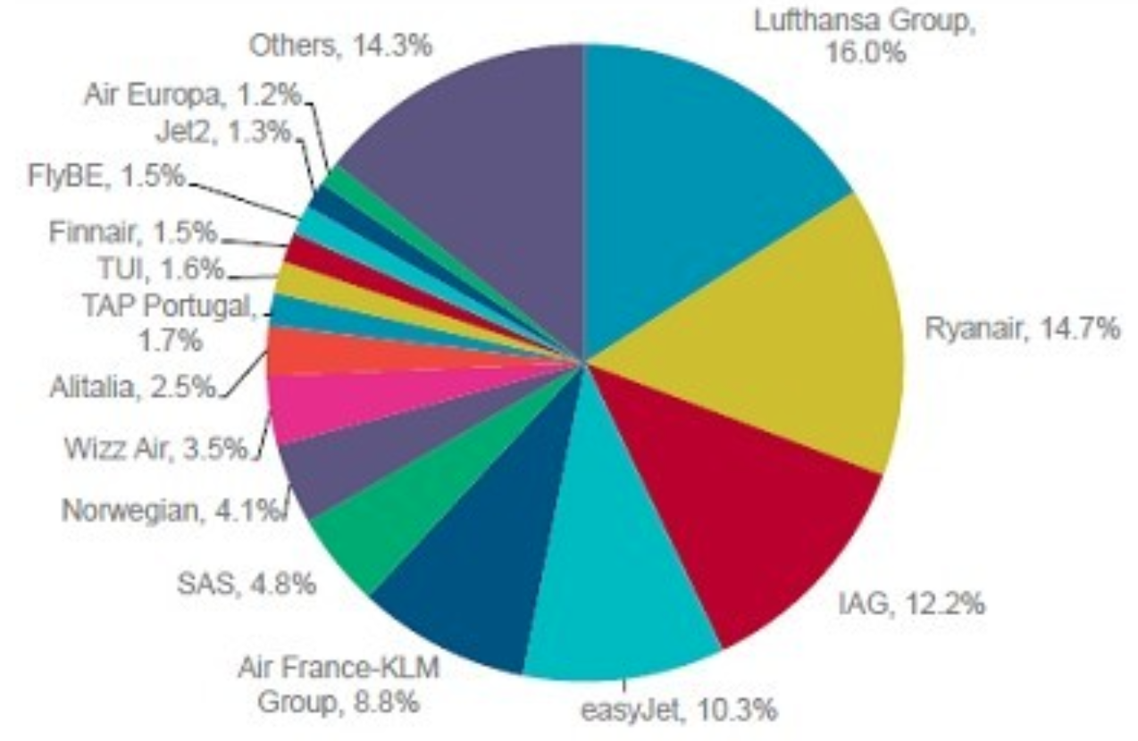
Source: Statista, 2021 | Source: Davy Research, 2018  .
Extract B: Airlines damning deterioration

The COVID-19 pandemic is entering its endemic stages in some parts of the world, and airlines burnt through $168bn in losses in 2020. The temptation is to pin the blame solely on the pandemic-induced plunge in passenger traffic, that would ignore the airline industry’s underlying and long-term health problems.  Although the COVID-19 pandemic hit airlines harder than any other aviation subsector, it was not doing particularly well before then. From 2012 to 2019, despite a favourable environment of strong economic growth and low fuel prices, airlines were bleeding through $17bn in losses a year globally. This begs the question – how is this possible? The reasons are well documented. The high capital intensity, combined with fluid supply and low barriers to entry have meant that their market power is beginning to wane. Furthermore, airports have stronger negotiating power and can demand higher fees from airlines to use their landing slots. On the customer side, passengers hold significant power and have driven the price down, alongside the boom in flight price comparison sites – such as Skyscanner, or cheap flight finders – such as Jack’s Flight Club.  Airlines are also especially vulnerable to external shocks beyond their control, because they have high fixed costs and mostly variable revenues. The Gulf War, 9/11 terror attack, the 2010 Eyjafjallajökull Icelandic volcano eruption and the 2008 global finance crisis all affects airlines dramatically – although, not to the extent that the COVID-19 pandemic has done.  Airlines need to bolster their resilience. They could increase their cash reserves, voluntarily or by regulation, which would reduce the need for bailouts every time a crisis hits. They could work to make their operations more agile and nimble – perhaps by increasing the level of competition within the industry. Or, they could set a minimum price for flights, thereby increasing their revenues and allowing for a more consistent profit. Regardless, one thing is clear – the airline industry is in trouble, and it needs action to remedy their long-term issues. | 1  5  10  15  20
Source: news reports, 2022

Extract C: Cargo carriers’ clamour for credit in declining industry

The sole bright spot in the aviation world is the air cargo industry. Air cargo is the process of flying a plane with the sole intention of carrying parcels or other items across the world. In 2020, there were only five airlines that reaped profits in 2020 – AirBridgeCargo, Atlas Air, CargoJet, Cargolux and Kalitta – and they are all cargo carriers.  During the pandemic, demand for air cargo was initially driven by protective personal equipment (PPE) and medications, and later by challenges in the ocean-shipping supply chain and strong growth in e-commerce sales. The supply of air cargo fell as the number of grounded passenger planes rose, leading to a growing demand for air cargo, yet supply of cargo planes being restricted. This, in turn, led to higher profits for cargo carriers – adjusting their prices upwards for cargo.  This then begs the question – should more traditional airlines focus more on cargo as opposed to passengers? One could argue that they should, but perhaps a better answer is to think whether the industry needs to be as competitive as it is in its current form. Can we not have just one airline in business? Would this be such a problem? Do we need so many different operators doing so many different routes? Perhaps this would be a better solution and allow for the usual arguments that are for monopolies, rather than viewing them with evilness and distain. | 1  5  10  15
Source: news reports, 2021-2022
Using the data from Extract A and given the fact there were approximately 1,100,000 passengers carried within the EU in 2018, calculate the number of passengers that Ryanair carried. Give your answer correct to the nearest million passengers.
[2 marks]
Explain how the data in Extract A shows that there could be an oligopoly within the airline industry operating within the EU.
[4 marks]
Extract B (lines 21–22) states that “they could set a minimum price for flights, thereby increasing their revenues and allowing for a more consistent profit.”
With the help of a diagram, explain the impacts of a minimum price upon the inelastic demand for flights, and thus the impact upon revenue.
[9 marks]
Extract C (lines 22–23) states that “perhaps a better answer is to think whether the industry needs to be as competitive as it is in its current form.”
Use the extracts and your knowledge of economics to assess the view of whether the market structure of the airline industry is necessarily desirable in its current form.
[25 marks]

