Ecosystem, Niche, Sampling and Succession Exam Questions
Q1.
The banded snail Cepaea nemoralis occupies many habitats.
The thrush is a major predator of the banded snail.
The thrush and the banded snail, shown in the photograph, occupy different niches.
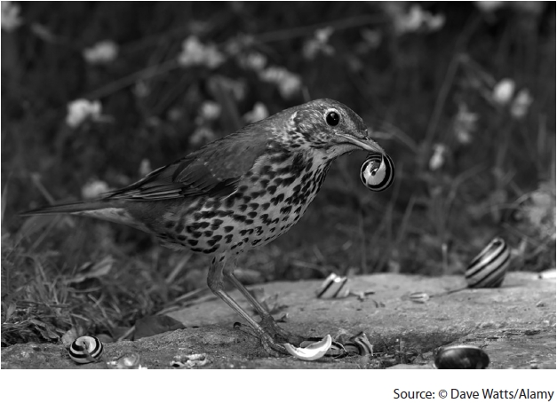
Describe the difference between the terms niche and habitat.
(2)
.............................................................................................................................................
.............................................................................................................................................
.............................................................................................................................................
.............................................................................................................................................
.............................................................................................................................................
.............................................................................................................................................

(Total for question = 2 marks)

Q2.
Wildlife conservation can involve keeping animals in zoos as well as protecting habitats.
Habitats can be destroyed by road building.
A link road is planned to connect two major roads.
The diagram shows the two possible sites for the link road and two woodland habitats.
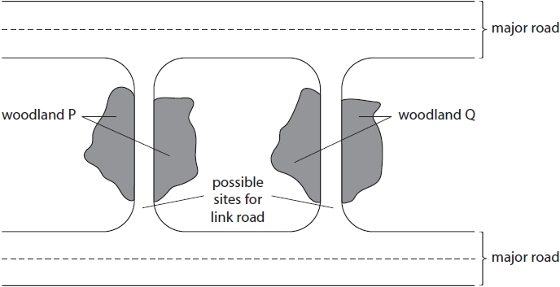
(1)
.............................................................................................................................................
.............................................................................................................................................
.............................................................................................................................................
(ii) To decide which of the two link roads should be built, studies of the biodiversity of woodlands P and Q need to be carried out.
Discuss what information needs to be collected from the two woodlands to make a decision about the site of the link road.
(4)
.............................................................................................................................................
.............................................................................................................................................
.............................................................................................................................................
.............................................................................................................................................
.............................................................................................................................................
.............................................................................................................................................
.............................................................................................................................................
.............................................................................................................................................
.............................................................................................................................................
.............................................................................................................................................
.............................................................................................................................................
.............................................................................................................................................

(Total for question = 5 marks)

Q3.
The distribution and abundance of species on a rocky shore were investigated using a systematic sampling technique.
(a) The diagram shows the placing of the transect and quadrats on a rocky shore.
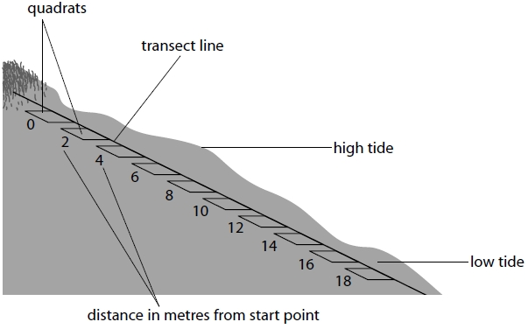
Not to scale
(i) Give a reason why systematic sampling, rather than random sampling, was used in this investigation.
(1)
.............................................................................................................................................
.............................................................................................................................................
*(ii) The diagram shows the distribution of some of the abiotic and biotic components of a sea shore. There are three species of seaweed (Fucus) and one species of limpet (Patella vulgata). Limpets feed on seaweed.
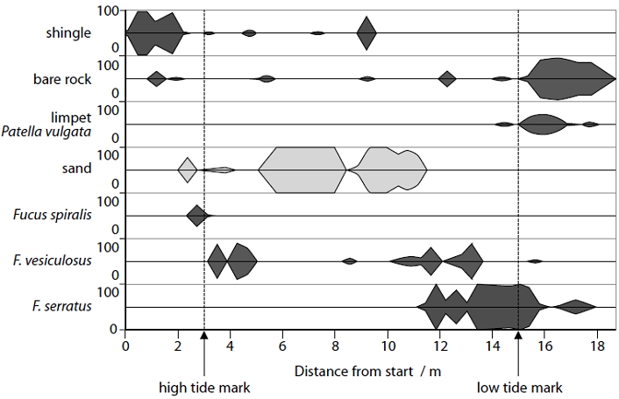
Analyse the data to explain how the distribution patterns of Fucus spiralis, Fucus vesiculosus and Fucus serratus are affected by abiotic and biotic factors.
(6)
.............................................................................................................................................
.............................................................................................................................................
.............................................................................................................................................
.............................................................................................................................................
.............................................................................................................................................
.............................................................................................................................................
.............................................................................................................................................
.............................................................................................................................................
.............................................................................................................................................
.............................................................................................................................................
.............................................................................................................................................
.............................................................................................................................................

(Total for question = 7 marks)

Q4.
Surtsey is a newly-formed volcanic island. The volcanic eruption finished in 1967. The island is protected so that it can be used to study succession on volcanic islands.
The photograph below shows the plants on part of the island about 10 years after the island was formed.
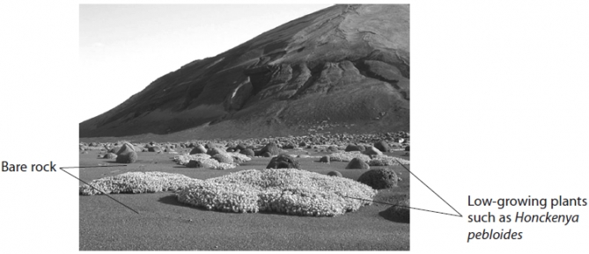
(a) State what is meant by the term succession.
(1)
.............................................................................................................................................
.............................................................................................................................................
.............................................................................................................................................
(b) Suggest how this part of the island may have appeared five years before and five years after this photograph was taken. Give reasons for your answer.
(4)
Five years before
.............................................................................................................................................
.............................................................................................................................................
.............................................................................................................................................
.............................................................................................................................................
Five years after
.............................................................................................................................................
.............................................................................................................................................
.............................................................................................................................................
.............................................................................................................................................
(c) (i) Describe how to carry out a study to compare the distribution of Honckenya pebloides on two different parts of the island.
(4)
.............................................................................................................................................
.............................................................................................................................................
.............................................................................................................................................
.............................................................................................................................................
.............................................................................................................................................
.............................................................................................................................................
.............................................................................................................................................
.............................................................................................................................................
.............................................................................................................................................
.............................................................................................................................................
(ii) Water availability affects the distribution of Honckenya pebloides.
Describe how water availability could be investigated in these two parts of the island.
(2)
.............................................................................................................................................
.............................................................................................................................................
.............................................................................................................................................
.............................................................................................................................................
(d) In 1985, the lesser black-backed gull colonised this island.
A large increase in the number of species of plants was recorded after these birds colonised the island.
Suggest an explanation for this increase in the number of species of plants.
(2)
.............................................................................................................................................
.............................................................................................................................................
.............................................................................................................................................
.............................................................................................................................................
.............................................................................................................................................
.............................................................................................................................................
.............................................................................................................................................
.............................................................................................................................................

(Total for question = 13 marks)

Mark Scheme
Q1.
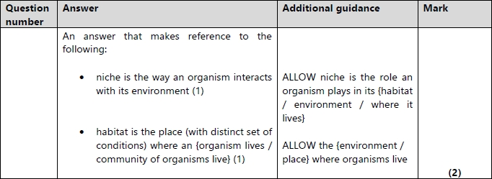

Q2.
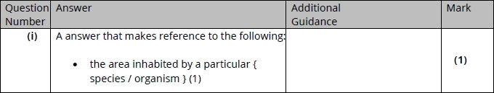
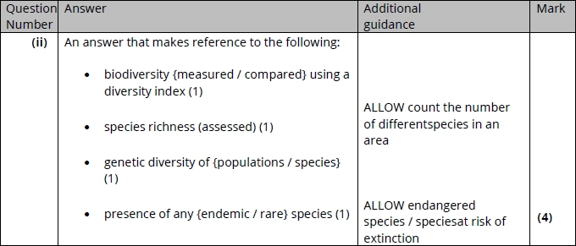

Q3.
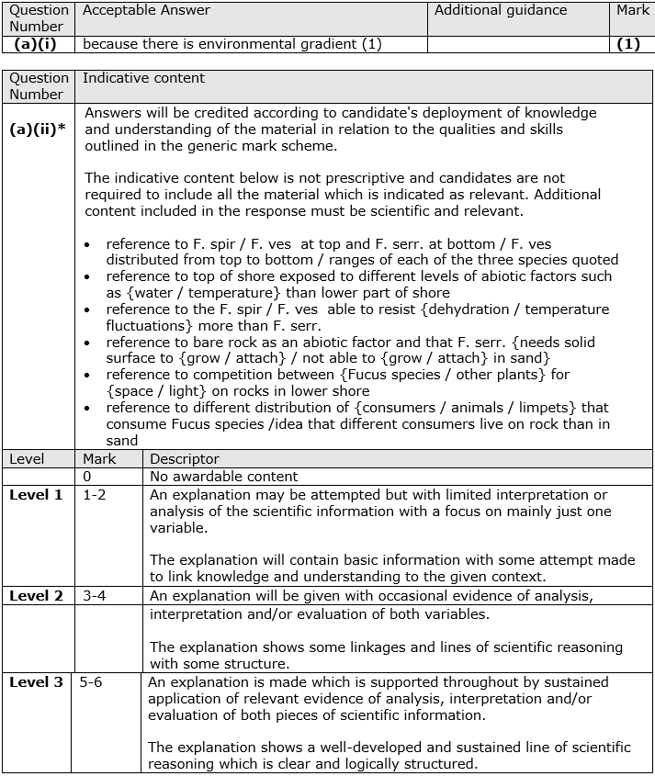

Q4.
