T5.10 -5.16 Energy Transfer and Climate Change Questions
Q1.
The Sylt-Rømø Wadden Sea, shown in the diagram below, has a high gross primary productivity (GPP) which is monitored constantly.
The Sylt-Rømø Wadden Sea is protected from the North Sea by an island.
There are no large rivers flowing into the Sylt-Rømø Wadden Sea.
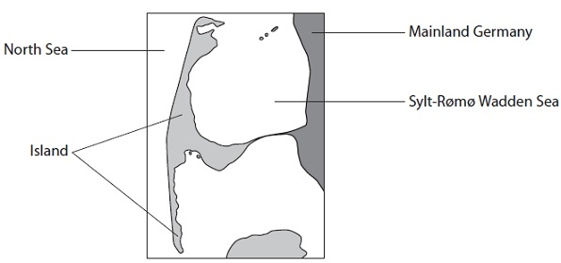
(a) Explain the meaning of the term gross primary productivity (GPP).
(2)
.............................................................................................................................................
.............................................................................................................................................
.............................................................................................................................................
.............................................................................................................................................
(b) Seagrass, microphytobenthos and phytoplankton are the producers found in the Sylt-Rømø Wadden Sea.
The chart below shows the distribution of GPP between these producers.
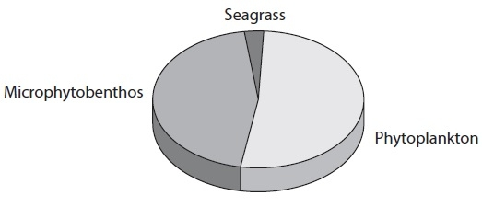
(i) Using the chart, describe the distribution of GPP in this sea.
(2)
.............................................................................................................................................
.............................................................................................................................................
.............................................................................................................................................
.............................................................................................................................................
(ii) The total GPP for this sea is 840 × 10⁶ kJ m⁻² y⁻¹.
Explain how GPP for the phytoplankton could be calculated.
(2)
.............................................................................................................................................
.............................................................................................................................................
.............................................................................................................................................
.............................................................................................................................................
(iii) Suggest why GPP for this sea is very high.
(2)
.............................................................................................................................................
.............................................................................................................................................
.............................................................................................................................................
.............................................................................................................................................
(c) Explain why net primary productivity (NPP) is lower than GPP.
(2)
.............................................................................................................................................
.............................................................................................................................................
.............................................................................................................................................
.............................................................................................................................................
(Total for Question = 10 marks)

Q2.
Answer the question with a cross in the box you think is correct . If you change your mind about an answer, put a line through the box and then mark your new answer with a cross .
Silver Springs is a state park in Florida. The photograph shows one of the many waterways in this state park.
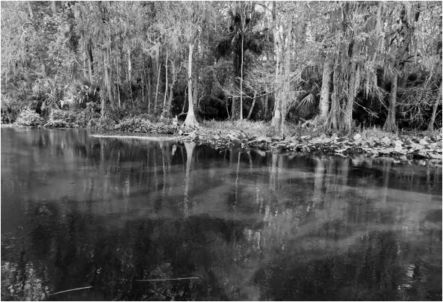
Energy flow through this ecosystem has been studied. The results are shown in the flow chart.
All values are given in kJ m⁻² yr⁻¹.
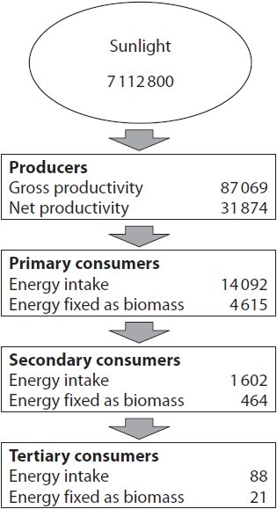
(i) Calculate how much energy is lost through respiration by the primary consumers.
(1)
Answer ........................................................... kJ m⁻² yr⁻¹
(ii) The table gives details of energy transfers at the different trophic levels.
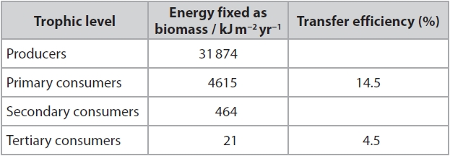
Calculate the efficiency of energy transfer between primary consumers and secondary consumers.
(1)
........................................................... %
(iii) The efficiency of photosynthesis can be measured as the percentage of
energy from sunlight that is converted to gross primary productivity (GPP).
Which of the following shows the percentage efficiency of photosynthesis in this ecosystem?
(1)
A 1.2%
B 12%
C 36.6%
D 55.8%

(Total for question = 3 marks)

Q3.
Scientists are concerned that climate change may be affecting the Arctic environment and the polar bears that live there.
In a study, scientists recorded the length of time ice was present each year in the sea around the west coast of Spitsbergen, an island in the Arctic.
The graph shows the number of days each year when sea ice was present.
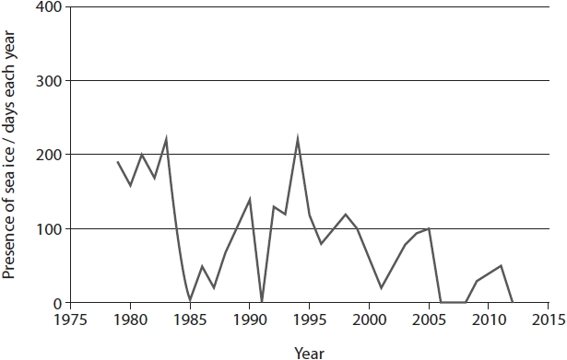
(i) Explain how the data could support a conclusion that climate change is occurring in the Arctic.
(2)
.............................................................................................................................................
.............................................................................................................................................
.............................................................................................................................................
.............................................................................................................................................
.............................................................................................................................................
.............................................................................................................................................
.............................................................................................................................................
.............................................................................................................................................
(ii) Explain why the data may not be useful for predicting future climate change.
(4)
.............................................................................................................................................
.............................................................................................................................................
.............................................................................................................................................
.............................................................................................................................................
.............................................................................................................................................
.............................................................................................................................................
.............................................................................................................................................
.............................................................................................................................................
.............................................................................................................................................
.............................................................................................................................................
.............................................................................................................................................
.............................................................................................................................................

(Total for question = 6 marks)

Q4.
Leaf rust is a disease caused by a species of fungus. Leaf rust affects cereal crops
such as wheat.
Leaf rust yeast spreads through cereal crops when the humidity is high.
Discuss the possible impact of climate change on the effects of leaf rust on the
yield of wheat crops.
(4)
.............................................................................................................................................
.............................................................................................................................................
.............................................................................................................................................
.............................................................................................................................................
.............................................................................................................................................
.............................................................................................................................................
.............................................................................................................................................
.............................................................................................................................................
.............................................................................................................................................
.............................................................................................................................................
.............................................................................................................................................
.............................................................................................................................................
.............................................................................................................................................
.............................................................................................................................................
.............................................................................................................................................

(Total for question = 4 marks)

Q5.
The golden snub-nosed monkey (Rhinopithecus roxellana) is endemic to high mountainous regions of China.
This endangered species of monkey feeds on seeds.
Golden snub-nosed monkeys live in areas with very cold winters.
The seeds in their diet contain lipids and carbohydrates.
Climate change is reducing seed production by plants in their habitat.
Discuss the impact of climate change on the monkey population.
(4)
.............................................................................................................................................
.............................................................................................................................................
.............................................................................................................................................
.............................................................................................................................................
.............................................................................................................................................
.............................................................................................................................................
.............................................................................................................................................
.............................................................................................................................................
.............................................................................................................................................
.............................................................................................................................................
.............................................................................................................................................
.............................................................................................................................................
.............................................................................................................................................
.............................................................................................................................................
.............................................................................................................................................
.............................................................................................................................................

(Total for question = 4 marks)

Mark Scheme
Q1.
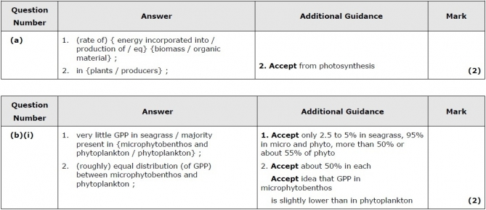
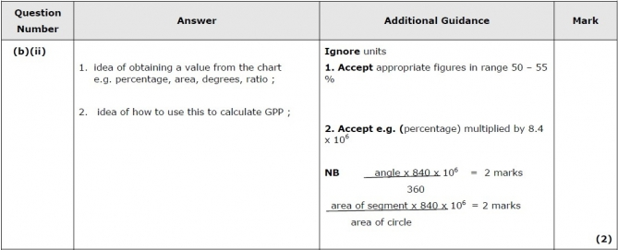
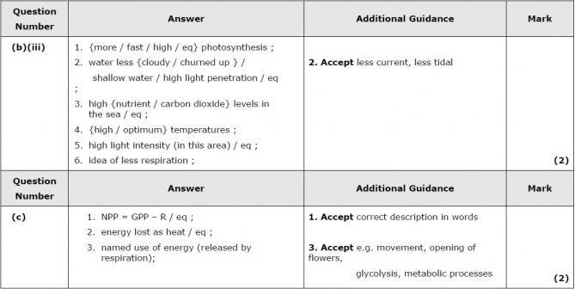

Q2.
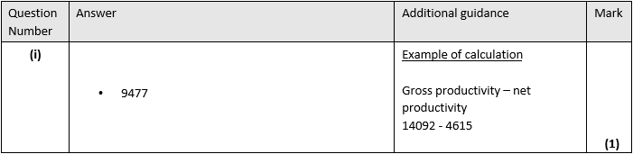
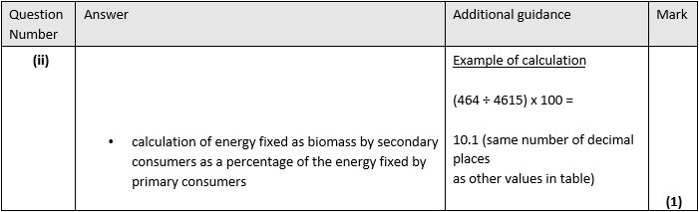
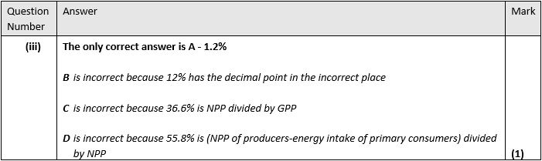

Q3.
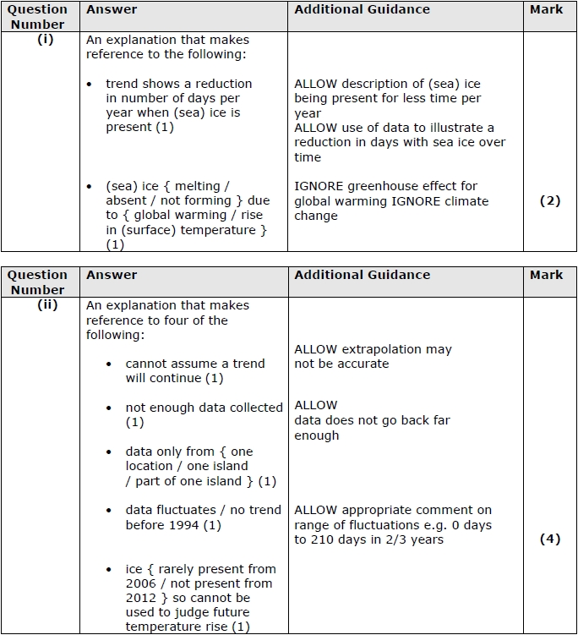

Q4.
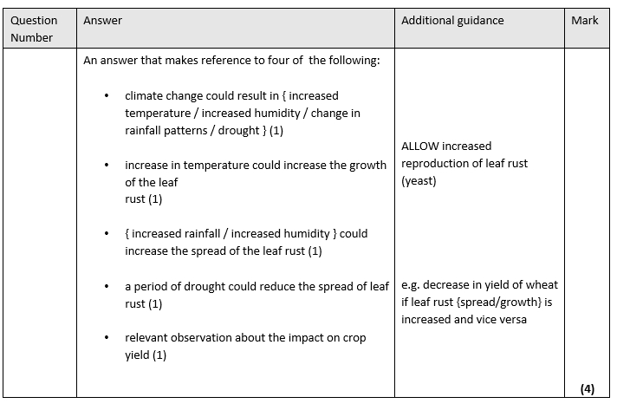

Q5.
