Exam Questions On Key Themes Of Article 2024
Q1.
A new species of mosquito has evolved in the tunnels of the London Underground. These mosquitoes are believed to be the descendants of bird-biting mosquitoes which colonised the tunnels 100 hundred years ago. The mosquitoes now feed on rats, mice and human beings instead of birds.
(a) Place a cross in the box next to the best definition of a species.
(1)
A individuals can interbreed to produce fertile offspring
B individuals can interbreed to produce hybrid offspring
C individuals can interbreed to produce sterile offspring
D individuals can interbreed to produce offspring
(b) Explain how this species of mosquito may have evolved.
(5)
.............................................................................................................................................
.............................................................................................................................................
.............................................................................................................................................
.............................................................................................................................................
.............................................................................................................................................
.............................................................................................................................................
.............................................................................................................................................
.............................................................................................................................................
.............................................................................................................................................
.............................................................................................................................................

(Total for question = 6 marks)

Q2.
The polar bear, Ursus maritimus, preys on seals and fish. Polar bears are adapted to live in cold Arctic regions.
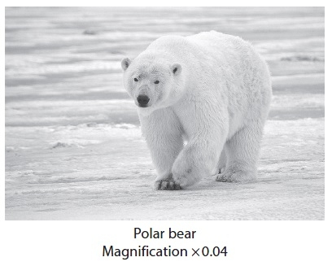
A recent study has shown that all polar bears are descended from populations that diverged from the Irish brown bear, Ursus arctos, approximately 120 000 years ago.
In this study, DNA from modern polar bears, the remains of historic polar bears and the remains of Irish brown bears was analysed.
(a) The first part of the study involved the amplification of DNA to give large enough samples for analysis.
(i) Describe how small samples of DNA can be amplified.
(4)
.............................................................................................................................................
.............................................................................................................................................
.............................................................................................................................................
.............................................................................................................................................
.............................................................................................................................................
.............................................................................................................................................
.............................................................................................................................................
.............................................................................................................................................
.............................................................................................................................................
.............................................................................................................................................
(ii) Name one technique that could be used to analyse the amplified DNA samples.
(1)
.............................................................................................................................................
(b) Suggest how the scientists who conducted the study had their results accepted by other scientists.
(2)
.............................................................................................................................................
.............................................................................................................................................
.............................................................................................................................................
.............................................................................................................................................
(c) Suggest how each of the following may have contributed towards the divergence of polar bears and Irish brown bears into two separate species.
(i) Separation of the Arctic and Irish regions by sea
(2)
.............................................................................................................................................
.............................................................................................................................................
.............................................................................................................................................
.............................................................................................................................................
.............................................................................................................................................
.............................................................................................................................................
(ii) Genetic mutation
(2)
.............................................................................................................................................
.............................................................................................................................................
.............................................................................................................................................
.............................................................................................................................................
(Total for question = 11 marks)

Q3.
The banded snail Cepaea nemoralis occupies many habitats.
The thrush is a major predator of the banded snail.
The thrush and the banded snail, shown in the photograph, occupy different niches.
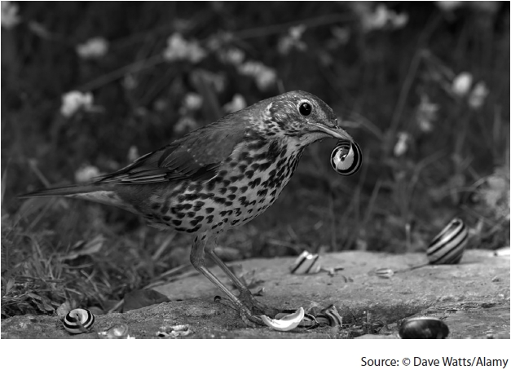
Describe the difference between the terms niche and habitat.
(2)
.............................................................................................................................................
.............................................................................................................................................
.............................................................................................................................................
.............................................................................................................................................
.............................................................................................................................................
.............................................................................................................................................

(Total for question = 2 marks)

Q4.
There are two main types of woodland in the UK. One consists of broadleaved
deciduous trees, the other contains coniferous trees that have needle-like leaves.
In a study of two woodlands, 11 species of plant were found in a deciduous
woodland and 4 different species in a coniferous woodland.
The table shows the other data recorded in this study.
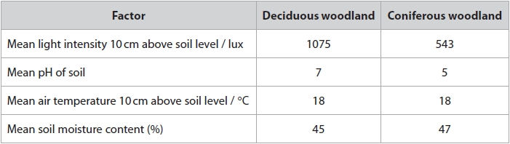
Assess the reasons for the differences in the number of species between these two types of woodland.
(4)
.............................................................................................................................................
.............................................................................................................................................
.............................................................................................................................................
.............................................................................................................................................
.............................................................................................................................................
.............................................................................................................................................
.............................................................................................................................................
.............................................................................................................................................
.............................................................................................................................................
.............................................................................................................................................
.............................................................................................................................................
.............................................................................................................................................
.............................................................................................................................................
.............................................................................................................................................
.............................................................................................................................................

(Total for question = 4 marks)

Q5.
Trypsin is an enzyme found in many groups of living organisms.
Trypsin specifically acts on a polypeptide to form amino acids.
The primary structures of trypsin molecules from different species have been used to produce a phylogenetic tree for trypsin.
Each branch of the following phylogenetic diagram represents trypsin from a different species.
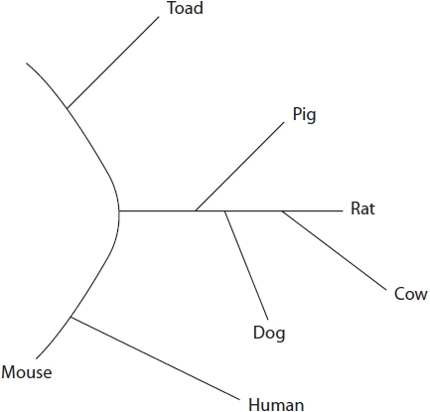
Explain how the primary structure of trypsin molecules can be used to produce a phylogenetic tree.
(3)
.............................................................................................................................................
.............................................................................................................................................
.............................................................................................................................................
.............................................................................................................................................
.............................................................................................................................................
.............................................................................................................................................
.............................................................................................................................................
.............................................................................................................................................
.............................................................................................................................................

(Total for question = 3 marks)

Q6.
All known organisms can be placed into one of the three domains of life.
The table shows some information about the three different domains.
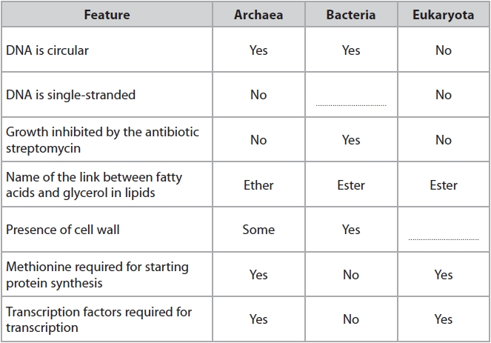
Explain how the information in the table can be used to show that the Archaea are more closely related to the Eukaryota than to the Bacteria.
(3)
.............................................................................................................................................
.............................................................................................................................................
.............................................................................................................................................
.............................................................................................................................................
.............................................................................................................................................
.............................................................................................................................................
.............................................................................................................................................
.............................................................................................................................................
.............................................................................................................................................
.............................................................................................................................................
.............................................................................................................................................

(Total for question = 3 marks)

Q7.
Athletic competitions often take place during the summer months when ambient temperatures are high.
High ambient temperatures affect marathon runners.
Heat stress occurs when the core body temperature rises above 40 °C.
Describe how thermoregulatory mechanisms are controlled to help marathon runners avoid heat stress.
(4)
.............................................................................................................................................
.............................................................................................................................................
.............................................................................................................................................
.............................................................................................................................................
.............................................................................................................................................
.............................................................................................................................................
.............................................................................................................................................
.............................................................................................................................................
.............................................................................................................................................
.............................................................................................................................................
.............................................................................................................................................
.............................................................................................................................................

(Total for question = 4 marks)

Q8.
Athletes compete in a range of environmental conditions.
An investigation studied the effects of environmental conditions on athletes.
A group of nine athletes ran for 50 minutes in two sets of environmental conditions:
• warm temperature and high humidity
• cool temperature and low humidity.
All other variables were kept constant including the level of exercise.
The core temperature of each athlete was recorded during the exercise and for 70 minutes following the exercise.
The results are shown in the graph.
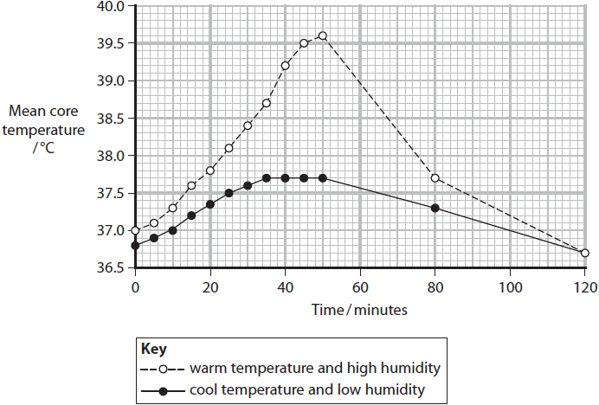
(i) Explain why there was a change in core temperature during the first 20 minutes of exercise.
(2)
.............................................................................................................................................
.............................................................................................................................................
.............................................................................................................................................
.............................................................................................................................................
.............................................................................................................................................
.............................................................................................................................................
(ii) Using the results of this investigation, a student concluded that during exercise:
• the human thermoregulatory system only works in cool environmental temperatures when the humidity is low.
Comment on this conclusion.
(4)
.............................................................................................................................................
.............................................................................................................................................
.............................................................................................................................................
.............................................................................................................................................
.............................................................................................................................................
.............................................................................................................................................
.............................................................................................................................................
.............................................................................................................................................
.............................................................................................................................................
.............................................................................................................................................
.............................................................................................................................................
.............................................................................................................................................
(iii) Compare and contrast the changes in core body temperature, in the two environments, after the exercise was completed.
(3)
.............................................................................................................................................
.............................................................................................................................................
.............................................................................................................................................
.............................................................................................................................................
.............................................................................................................................................
.............................................................................................................................................
.............................................................................................................................................
.............................................................................................................................................
.............................................................................................................................................

(Total for question = 9 marks)

Q9.
Calcium ions are required for muscle contraction.
Describe the role of calcium ions in the contraction of muscle fibres.
(3)
.............................................................................................................................................
.............................................................................................................................................
.............................................................................................................................................
.............................................................................................................................................
.............................................................................................................................................
.............................................................................................................................................
.............................................................................................................................................
.............................................................................................................................................
.............................................................................................................................................

(Total for question = 3 marks)

Q10.
All mammals have an internal skeleton that includes bone and cartilage. Bones contain calcium ions.
Explain one way in which cartilage at the ends of the bones in the knee joint reduces wear and tear.
(2)
.............................................................................................................................................
.............................................................................................................................................
.............................................................................................................................................
.............................................................................................................................................
.............................................................................................................................................
.............................................................................................................................................

(Total for question = 2 marks)

Q11.
Ebola virus disease (EVD) is a rare and deadly disease most commonly found in Africa. Following a severe outbreak in 2014, in which 11 000 people died, work has been underway to develop a vaccine.
The diagram shows the structure of an Ebola virus.
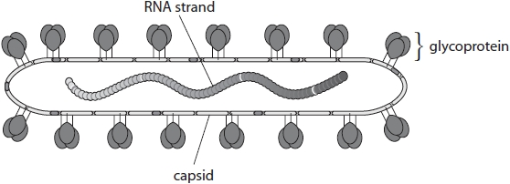
Compare and contrast the structure of Ebola virus with that of the human immunodeficiency virus (HIV).
(3)
.............................................................................................................................................
.............................................................................................................................................
.............................................................................................................................................
.............................................................................................................................................
.............................................................................................................................................
.............................................................................................................................................
.............................................................................................................................................
.............................................................................................................................................
.............................................................................................................................................

(Total for question = 3 marks)

Q12.
Ebola virus disease (EVD) is a rare and deadly disease most commonly found in Africa. Following a severe outbreak in 2014, in which 11 000 people died, work has been underway to develop a vaccine.
A vaccine has been developed by genetically modifying a virus that infects cattle. In the genetically modified virus, one of the genes was replaced with a gene for a protein found in the Ebola virus.
In a trial of 52 volunteers, 48 developed antibodies against the Ebola virus within 14 days of injection.
(i) The type of immunity given by this vaccine is
(1)
A artificial active immunity
B artificial passive immunity
C natural active immunity
D natural passive immunity
(ii) Explain the role of T cells in the immunity to the Ebola virus that develops following the use of this vaccine.
(3)
.............................................................................................................................................
.............................................................................................................................................
.............................................................................................................................................
.............................................................................................................................................
.............................................................................................................................................
.............................................................................................................................................
.............................................................................................................................................
.............................................................................................................................................
.............................................................................................................................................
.............................................................................................................................................
.............................................................................................................................................
.............................................................................................................................................

(Total for question = 4 marks)

Q13.
Actin and collagen are both proteins.
The diagram shows two filaments of actin from a muscle fibre. Each filament is a
polymer of repeating globular protein units.
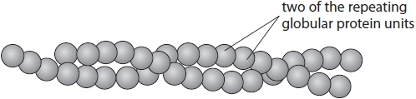
Compare and contrast the structures of an actin filament and collagen.
(3)
.............................................................................................................................................
.............................................................................................................................................
.............................................................................................................................................
.............................................................................................................................................
.............................................................................................................................................
.............................................................................................................................................
.............................................................................................................................................
.............................................................................................................................................
.............................................................................................................................................

(Total for question = 3 marks)

Q14.
The diagram shows actin and other components (P and Q) of a thin filament in a myofibril.
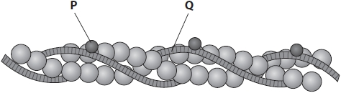
(i) Describe the interaction between P and Q that allows muscle contraction.
(2)
.............................................................................................................................................
.............................................................................................................................................
.............................................................................................................................................
.............................................................................................................................................
.............................................................................................................................................
.............................................................................................................................................
(ii) The thick filament in a myofibril contains myosin. The myosin head contains the enzyme ATPase.
Explain the importance of the primary structure for the functioning of this enzyme.
(3)
.............................................................................................................................................
.............................................................................................................................................
.............................................................................................................................................
.............................................................................................................................................
.............................................................................................................................................
.............................................................................................................................................
.............................................................................................................................................
.............................................................................................................................................
.............................................................................................................................................

(Total for question = 5 marks)

Q15.
Photosynthesis is the process by which plants fix carbon.
The diagram shows some of the light dependent reactions of photosynthesis.
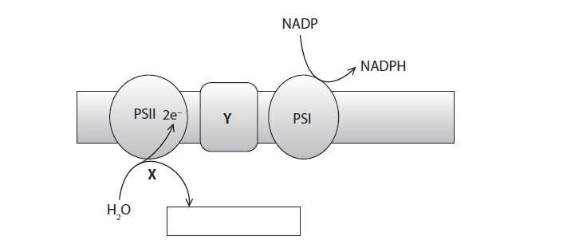
(i) Complete the box with the products of the reaction at PSII.
(1)
(ii) Which of the following is the type of reaction taking place at X?
(1)
A condensation
B hydrolysis
C photolysis
D reduction
(iii) Which of the following molecules are found in the PSI and PSII?
(1)
A ATP
B ATP synthase
C chlorophyll
D RUBISCO
(iv) In which part of the chloroplast does the reduction of NADP take place?
(1)
A chloroplast outer membrane
B chloroplast stroma
C granum
D thylakoid lumen
(v) Describe the role of the group of membrane proteins represented by Y in the
diagram.
(2)
.............................................................................................................................................
.............................................................................................................................................
.............................................................................................................................................
.............................................................................................................................................
.............................................................................................................................................
.............................................................................................................................................

Q16.
Photosynthesis in green plants involves light-dependent reactions and the Calvin cycle.
The Calvin cycle uses the products of the light-dependent reactions.
(i) State the location of the Calvin cycle.
(1)
.............................................................................................................................................
(ii) Describe the roles of the products of the light-dependent reactions in the Calvin cycle.
(3)
.............................................................................................................................................
.............................................................................................................................................
.............................................................................................................................................
.............................................................................................................................................
.............................................................................................................................................
.............................................................................................................................................
.............................................................................................................................................
.............................................................................................................................................
.............................................................................................................................................

(Total for question = 4 marks)

Q17.
Athletes monitor the effect of different levels of exercise on their blood lactate concentration. This helps them to train effectively.
In a study, three athletes, P, Q and R, used an exercise bicycle for 45 minutes.
The power needed to maintain a constant speed was increased every 15 minutes.
Their blood lactate concentration was measured at 5-minute intervals.
The results are shown in the graph.
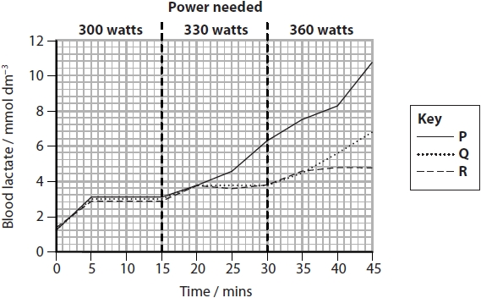
Explain the increase in blood lactate concentration observed between 0 and 5 minutes.
(2)
.............................................................................................................................................
.............................................................................................................................................
.............................................................................................................................................
.............................................................................................................................................
.............................................................................................................................................

(Total for question = 2 marks)

Q18.
Cellular respiration is a metabolic process essential for life.
The diagram represents part of aerobic respiration in a muscle cell.
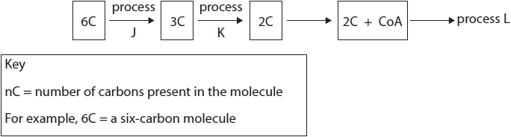
(i) Name two products, other than the three-carbon molecule (3C), that are formed by process J.
(1)
.............................................................................................................................................
.............................................................................................................................................
(ii) Describe what would happen to the three-carbon molecule (3C) if process K stopped.
(2)
.............................................................................................................................................
.............................................................................................................................................
.............................................................................................................................................
.............................................................................................................................................
.............................................................................................................................................
.............................................................................................................................................
.............................................................................................................................................
.............................................................................................................................................
.............................................................................................................................................
(iii) Which one of the following represents process L?
(1)
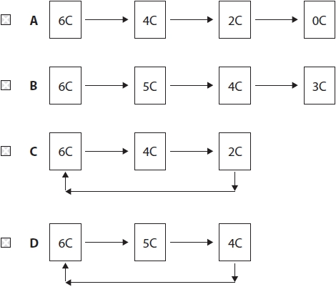

(Total for question = 4 marks)

Mark Scheme
Q1.
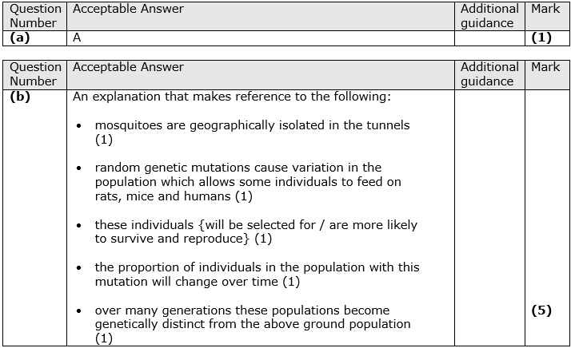

Q2.
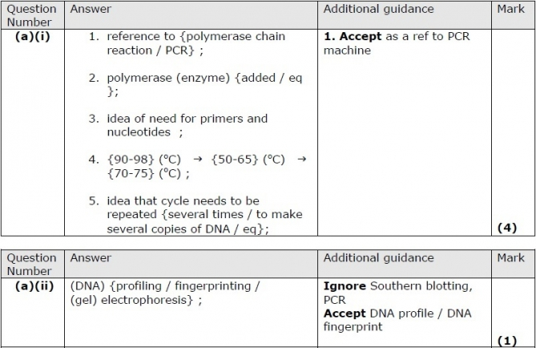
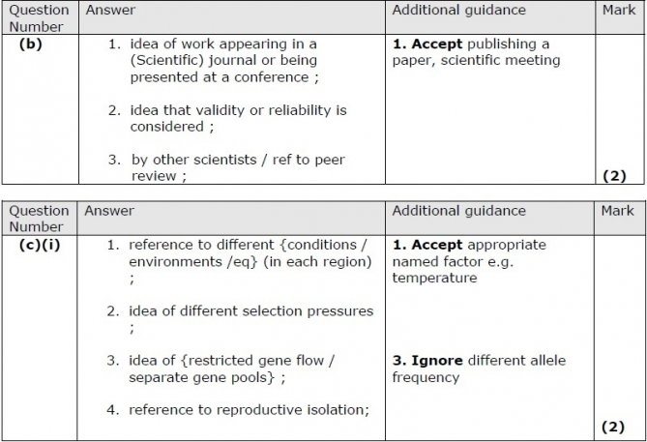
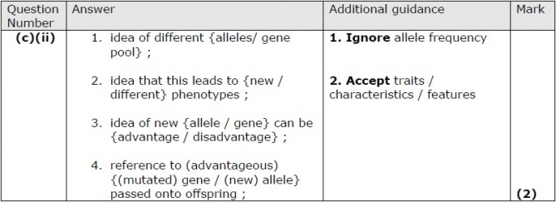

Q3.
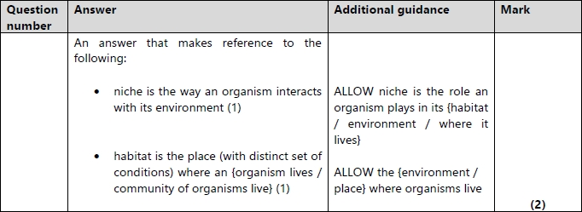

Q4.
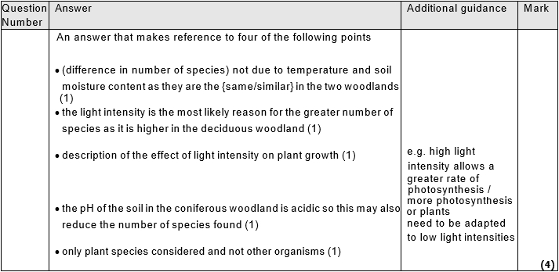

Q5.
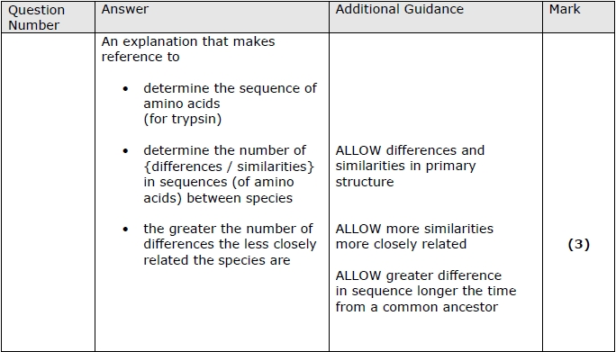

Q6.
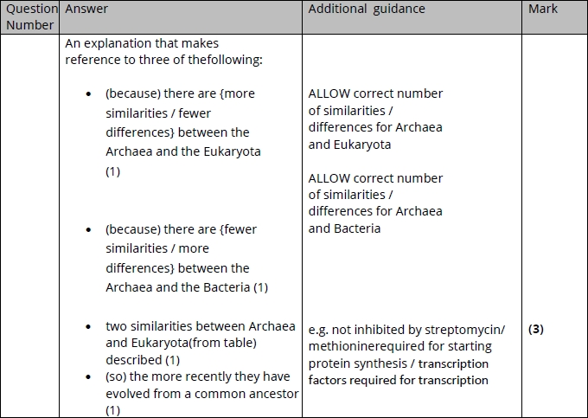

Q7.
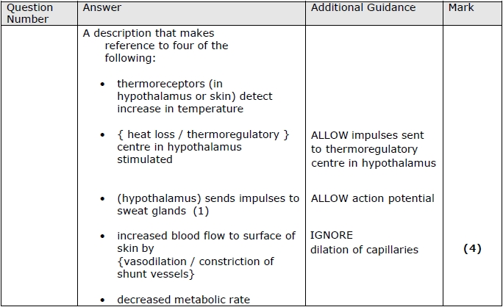

Q8.
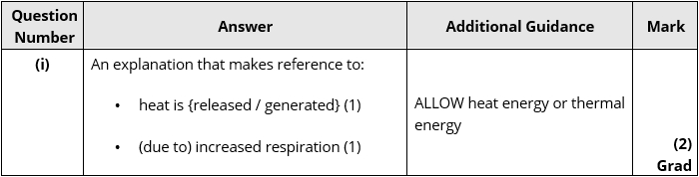
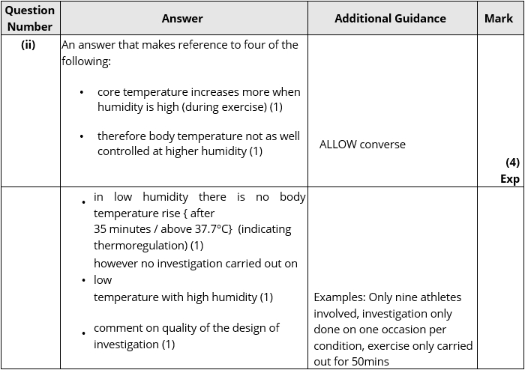
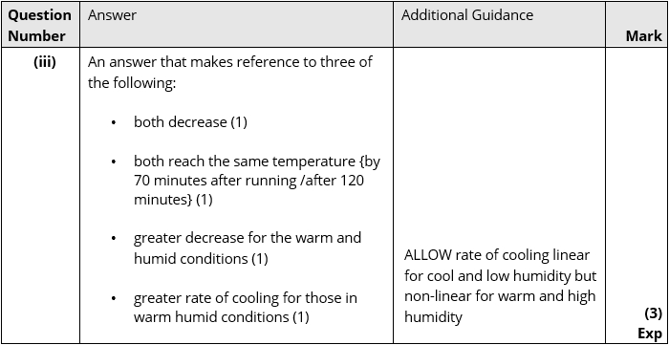

Q9.
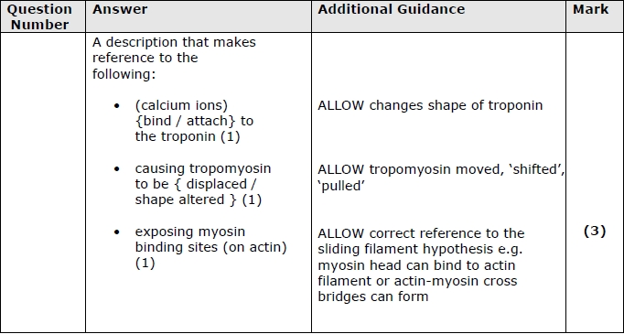

Q10.
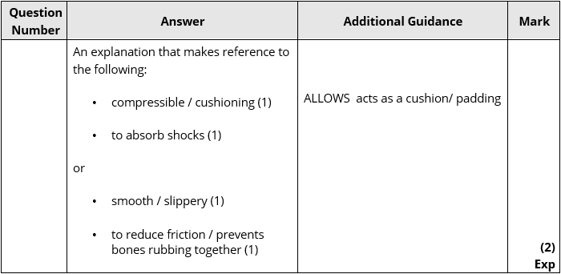

Q11.
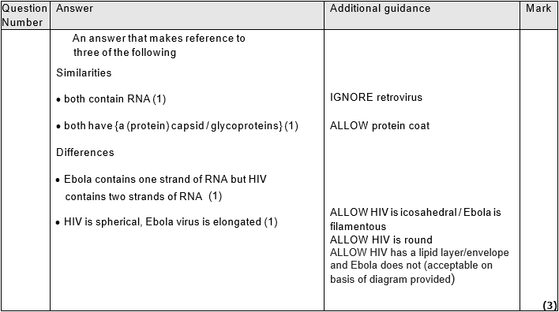

Q12.
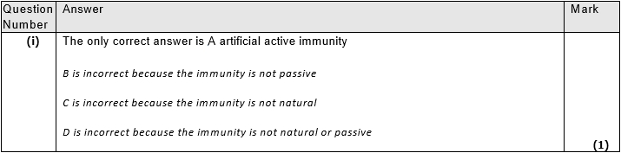
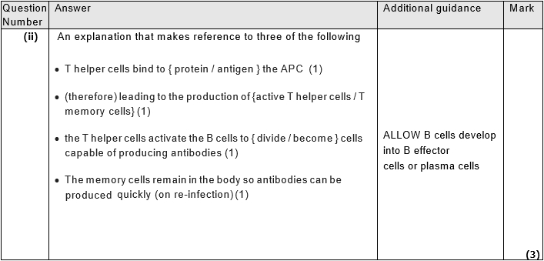

Q13.
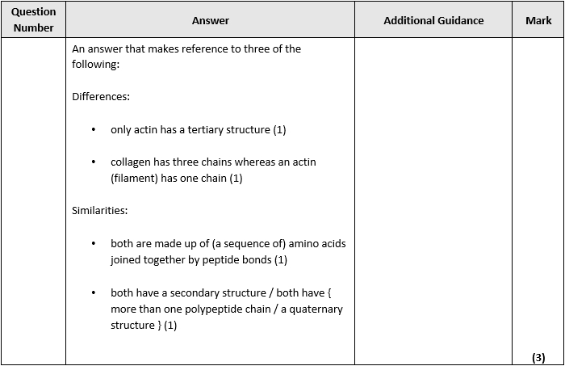

Q14.
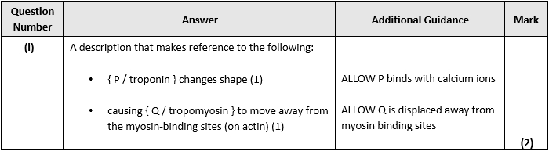
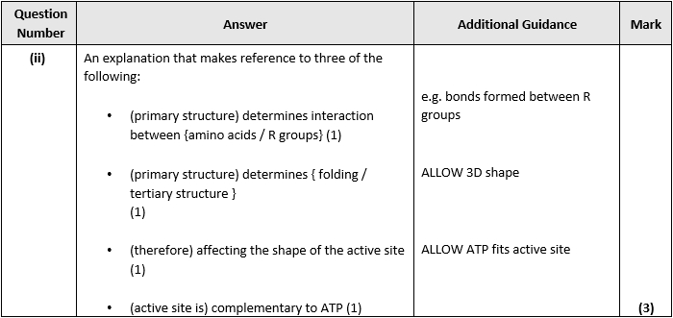

Q15.
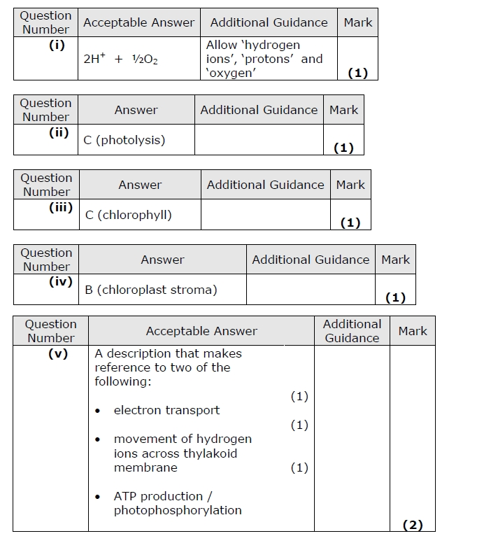

Q16.
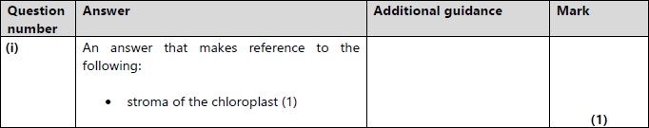
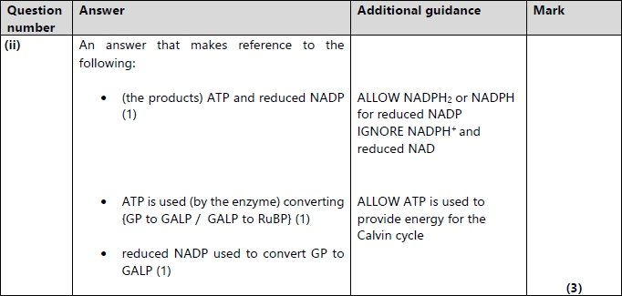

Q17.
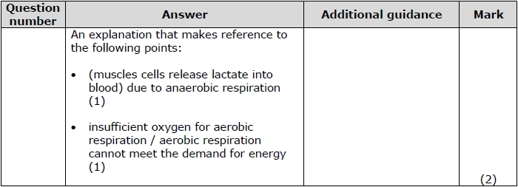

Q18.
