
Knowledge Booklet
Forensic Psychology

Student name: ………………………………………………………………………...

Teacher: …………………………………………………………………………………..

Specification:
- Offender profiling: the top-down approach, including organised and disorganised types of offender; the bottom-up approach, including investigative Psychology; geographical profiling.
- Biological explanations of offending behaviour: an historical approach (atavistic form); genetics and neural explanations.
- Psychological explanations of offending behaviour: Eysenck’s theory of the criminal personality.
- Cognitive explanations of offending behaviour: level of moral reasoning and cognitive distortions, including hostile attribution bias and minimalization
- Differential association theory.
- Psychodynamic explanations of offending behaviour.
- Dealing with offending behaviour: the aims of custodial sentencing and the psychological effects of custodial sentencing. Recidivism. Behaviour modification in custody, anger management and restorative justice programmes.

Forensic Psychology | Poor |  |  | Okay |  |  | Good
Forensic Psychology | 1 | 2 | 3 | 4 | 5 | 6 | 7
Offender profiling
Biological explanations of offending behaviour
Psychological explanations of offending behaviour
Cognitive explanations of offending behaviour
Differential association theory
Psychodynamic explanations of offending behaviour
Dealing with offending behaviour

Offender profiling:

Offender profiling is an investigative tool employed by the police when solving crimes, the main aim of which is to narrow the field of enquiry and the list of likely suspects.

The top-down approach:
The top-down approach to profiling originated in the United States as a result of work carried out by the FBI in the 1970s. More specifically, the FBI's Behavioural Science Unit drew upon data gathered from in-depth interviews with 36 sexually motivated serial killers including Ted Bundy. Murderers or rapists are classified in one of two categories (organised or disorganised) on the basis of the evidence, and this classification informs the subsequent police investigation.

- Organised offenders show evidence of having planned the crime in advance; the victim is deliberately targeted and will often reflect the fact that the killer or rapist has a 'type'. They maintain a high degree of control during the crime and may operate with almost detached surgical precision. There is little evidence or clues left behind at the scene. They tend to be of above-average intelligence, in a skilled, professional occupation and are socially and sexually competent. They are usually married and may even have children.

- In contrast, disorganised offenders show little evidence of planning, suggesting the offence may have been a spontaneous, spur of the moment act. The crime scene tends to reflect the impulsive nature of the attack - the body is usually still at the scene and there appears to have been very little control on the part of the offender. They tend to have a lower than average IQ, be in unskilled work or unemployed, and often have a history of sexual dysfunction and failed relationships. They tend to live alone and often relatively close to where the offence took place.

There are therefore 4 main stages in the construction of a top-down offender profile:
- ﻿﻿Data assimilation - the profiler reviews the evidence (crime scene photographs, pathology reports, etc.)
- ﻿﻿Crime scene classification - as either organised or disorganised.
- ﻿﻿Crime reconstruction - hypotheses in terms of sequence of events, behaviour of the victim. Etc.
- ﻿﻿Profile generation - hypotheses related to the likely offender, e.g. of demographic background, physical characteristics, behaviour, etc.

Evaluation of the top-down approach:
- A limitation of the top-down approach to offender profiling is that it is best suited to crime scenes that reveal important details about the suspect such as murder. More common offences such as burglary do not lend themselves to profiling because the resulting crime scene reveals very little about the offender. This means that, at best, it is a limited approach to identifying a criminal.

- Another limitation of the top-down approach is that it is based on outdated models of personality. This is because it is based on the assumption that offenders have patterns of behaviour and motivations that remain consistent across situations and contexts. However, several critics have suggested that this approach is informed by old-fashioned models of personality that see behaviour as being driven by stable dispositional traits rather than external factors that may be constantly changing. This means the top-down approach, which is based on 'static' models of personality, is likely to have poor validity when it comes to identifying likely criminals.

- A final limitation of the top-down approach is that it was developed using interviews with 36 killers in the US. Critics have pointed out that this is too small and unrepresentative a sample upon which to base a typology system that may have a significant influence on the nature of the police investigation. It has also been argued that it is not sensible to rely on self-report data with convicted killers when constructing a classification system due to the possibility of deceit.

The bottom-up approach
The aim of the bottom-up approach is to generate a picture of the offender - their likely characteristics, routine behaviour and social backaround - through systematic analysis of evidence at the crime scene. Unlike the US top-down approach, the British bottom-up model does not begin with fixed typologies. Instead, the profile is 'data-driven' and emerges as the investigator engages in deeper and more rigorous scrutiny of the details at the offence.

Investigative psychology

The bottom up approach uses investigative psychology which aims to establish patterns of behaviour that are likely to occur across crime scenes. This is in order to develop a statistical 'database' which then acts as a baseline for comparison. Specific details of an offence, or related offences, can then be matched against this database to reveal important details about the offender, their personal history, family background, etc. This may also determine whether a series of offences are linked in that they are likely to have been committed by the same person.

Geographical profiling
Geographical profiling is a type of bottom-up profiling which uses information to do with the location of crime scenes thought to be committed by the same offender to make inferences about the likely home of an offender - known as crime mapping. The assumption is that serial offenders will restrict their 'work' to geographical areas they are familiar with, and so understanding the spatial pattern of their behaviour provides investigators with a 'centre of gravity' which is likely to include the offender's base (often in the middle of the spatial pattern). It may also help investigators make educated guesses about where the offender is likely to strike next.

Evaluation of the bottom-up approach:
- A strength of the bottom-up approach/geographical profiling is that there is evidence to demonstrate its effectiveness. For example, profilers collated information from 120 murder cases involving serial killers in the USA. They found spatial consistency in the behaviour of the killers in that the location of each body disposal site was in an alternate direction from the previous sites, creating a 'centre of gravity'; the offender's base was invariably located in the centre of the pattern. The effect was more noticeable for attenders who travelled short distances.

- Another strength of bottom-up/geographical profiling is that it is more objective and scientific than the top-down approach. This is because it is more grounded in evidence and psychological theory, and less driven by speculation and hunches.

- Another advantage the bottom-up approach has over its US rival is that it can be applied to a wide range of offences. Techniques such as geographical profiling can be used in the investigation of crimes such as burglary and theft as well as more serious offences such as murder. In contrast, the top-down approach is best suited to explaining a limited number of crimes that reveal a lot of information about the offender based upon their ‘way of working’.

Biological explanations of offending behaviour - Lombroso’s Atavistic form
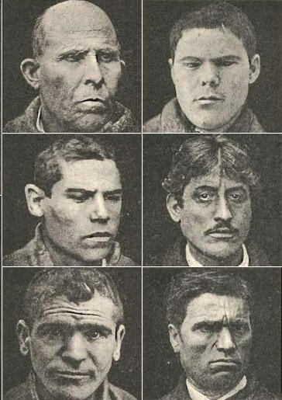
In the 1800s, Lombroso suggested that criminals were 'genetic throwbacks' - a primitive sub-species who were biologically different from non-criminals. Offenders were seen by Lombroso as lacking evolutionary development, their savage and untamed nature meant that they would find it impossible to adjust to the demands of civilised society so would inevitably turn to crime.

Lombroso argued that these genetic throwbacks could be identified based on biologically determined ‘atavistic’ characteristics, mainly features of the face and head, that make criminals physically different from the rest of us. In terms of cranial characteristics, the atavistic form included a narrow, sloping brow, a strong prominent jaw, high cheekbones and facial asymmetry. Other physical markers included dark skin and curly hair. Lombroso went on to categorise particular types of criminal in terms of their physical and facial characteristics. Murderers were described as having bloodshot eyes, curly hair and long ears; sexual deviants - glinting eyes, swollen, fleshy lips and projecting ears, whilst the lips of fraudsters were thin.

Evaluation of the historical approach (atavistic form):
- Lombroso has been hailed as the 'father of modern criminology'. He is credited as shifting the emphasis in crime research away from unscientific theories (within which offenders were judged as being wicked and weak-minded) towards a more scientific and credible realm (that of evolutionary influences and genetics). Also, in trying to describe how particular types of people are likely to commit particular types of crime, Lombroso's theory, in many ways, heralded the beginning of criminal profiling. In this way he made a major contribution to the science of criminology.

- However, several critics have drawn attention to the distinct racial undertones within Lombroso's work. Many of the features that Lombroso identified as criminal and atavistic, such as curly hair and dark skin, are most likely to be found among people of African descent.

- A limitation of Lombroso’s atavistic form is that it has received opposing evidence. For example, a researcher set out to establish whether there were any physical or mental abnormalities among the criminal classes. After conducting a comparison between 3000 criminals and 3000 non-criminals he concluded that there was no evidence that offenders are a distinct group with unusual facial and cranial characteristics (though he did suggest that many people who commit crime have lower than average intelligence). Whilst the point about intelligence does offer some limited support to Lombroso's argument that criminals are a 'sub-species', it does question the key element of his theory that criminals are different in terms of their appearance.

- Finally, even if there are criminals who have some of the atavistic elements in their facial appearance that Lombroso suggested, this does not necessarily mean this is the cause of their offending. Facial and cranial differences may be influenced by other factors, such as poverty or poor diet, rather than being an indication of delayed evolutionary development.
Biological explanations of offending behaviour - Genetic explanation

Genetic explanations for crime suggest that offenders inherit a gene, or combination of genes, that predispose them to commit crime.

Twin studies - The first criminal twin study was conducted by a researcher who investigated 13 identical (MZ) and 17 non-identical (DZ) twins where one of the twins in each pair had served time in prison. They found that 10 of the MZ twins but only 2 of the DZ twins had a co-twin who was also in prison. They therefore concluded that genetic factors must play a predominant part in offending behaviour.

Adoption studies - have also found that adopted children who had a biological parent with a criminal record had a 50% risk of having a criminal record by the age of 18, whereas adopted children whose mother didn't have a criminal record only had a 5% risk.

Candidate genes - A genetic analysis of almost 900 offenders revealed abnormalities on two genes that may be associated with violent crime. One example is the MAOA gene (which controls dopamine and serotonin in the brain and has been linked to aggressive behaviour) and CDH13 (that has been linked to substance abuse and attention deficit hyperactivity disorder). Within the Finnish sample, individuals with this high risk combination were 13 times more likely to have a history of violent behaviour.

Evaluation of genetic explanations of offending behaviour:
- A limitation of the genetic explanation is that twin study evidence has methodological flaws. This is because twin studies typically involve small sample sizes. In addition, the fact that most twins are reared in the same environment is a major confounding variable as concordance rates may be due to shared learning experiences rather than genetics.

- A limitation of the genetic explanation is that it fails to consider the influence of environmental factors. For example, a major study of over 13,000 adoptees was conducted. They found that when neither the biological nor adoptive parents had criminal convictions, the percentage of adoptees that did was 13.5% This figure rose to 20% when either of the biological parents had convictions, and 24.5% when both adoptive and biological parents had convictions. This data suggests that although genetic inheritance plays an important role in offending, environmental influence cannot be disregarded.

- Furthermore, a limitation of the genetic explanation is that evidence from adoption studies also suffers from methodological flaws. This is because the presumed separation of genetic and environmental influences in adoption studies is complicated by the fact that many children experience late adoption, which means that much of their infancy and childhood may have been spent with their biological parents anyway. Similarly, lots of adoptees maintain regular contact with their biological parents following their adoption. Both of these points make it difficult to assess, from adoption studies, the environmental impact the biological parents might have had.

- A final limitation is that in the field of criminality, the notion of a 'criminal gene' presents something of a dilemma. Our legal system is based on the premise that criminals have personal and moral responsibility for their crimes, and only in extreme cases, such as a diagnosis of mental illness can claim they were not acting under their own free will. This raises ethical questions about what society does with people who are suspected of carrying criminal genes, and what implications this may have for sentencing.

Biological explanations of offending behaviour - Neural explanation

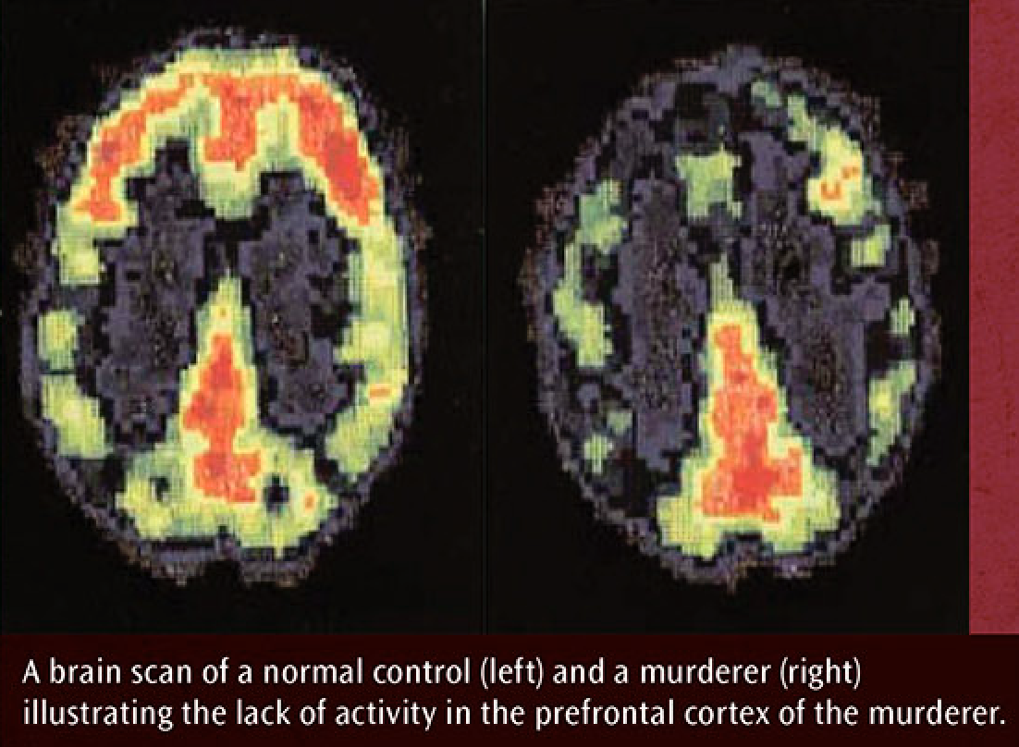
Evidence suggests there may be neural differences in the brains of criminals and non-criminals. Much of the evidence in this area has investigated individuals diagnosed with antisocial personality disorder (APD). APD is associated with reduced emotional responses, a lack of empathy for the feelings of others, and is a condition that characterises many convicted criminals.

Several brain-imaging studies demonstrate that individuals with antisocial personalities have reduced activity in the prefrontal cortex, the part of the brain that regulates emotional behaviour. Alongside this, research has found an 11% reduction in the volume of grey matter in the prefrontal cortex of people with APD compared to controls.

Recent research also suggests that criminals with APD can experience empathy but they do so more sporadically than the rest of us. For example, one study found that only when criminals were asked to empathise (with a person depicted on film experiencing pain) did their empathy reaction (controlled by mirror neurons in the brain) activate. This suggests that APD individuals are not totally without empathy, but may have a neural 'switch' that can be turned on and off, unlike the 'normal' brain which has the empathy switch permanently on.

Evaluation of neural explanations of offending behaviour:
- The case of Phineas Gage also provides support for the role of the prefrontal cortex in offending behaviour. Phineas Gage suffered damage to this brain region when a metal pole shot through his prefrontal brain area when working on the railway. Although he recovered physically, he went from being a sober, quiet family man to an aggressive drunk. Prefrontal brain areas are therefore suggested to control impulsive behaviours often seen in offending behaviour.

- In recent years, non-invasive neural interventions such as transcranial magnetic stimulation have been used to manipulate activity within the brain to provide more direct causal evidence of the functions of specific brain regions with regard to behaviour. Using such methods, upregulation (causing increased activity) of the prefrontal cortex has been found to decrease criminal intentions and increase perceptions of moral wrongfulness of aggressive acts, providing support for the causal influence of the prefrontal cortex on criminal behaviour.

- A final limitation is that in the field of criminality, the notion of a neural correlate for offending presents something of a dilemma. Our legal system is based on the premise that criminals have personal and moral responsibility for their crimes, and only in extreme cases, such as a diagnosis of mental illness can claim they were not acting under their own free will. This raises ethical questions about what society does with people who are suspected of having a neurological abnormality, and what implications this may have for sentencing.

Psychological explanations of offending behaviour: Eysenck’s theory of the criminal personality:

According to Eysenck, our personality traits are biological in origin and come about through the type of nervous system we inherit. Thus, all personality types - including the criminal personality type - have an innate, biological basis.

Eysenck proposed that criminals possess a criminal personality whereby they score highly on extraversion, neuroticism and psychoticism.
- Extraverts have an underactive nervous system which means they constantly seek excitement, stimulation and are likely to engage in risk-taking criminal behaviours. They also tend not to condition easily and do not learn from their mistakes.
- Neurotic individuals tend to be nervous, jumpy and over-anxious, and their general instability means their behaviour is often difficult to predict and are more likely to commit impulsive violent outbursts.
- Psychoticism is characterised as cold, unemotional and prone to aggression.

To measure the criminal personality, Eysenck developed a Personality Inventory (EPI), a form of psychological test which locates respondents along the extraversion, neuroticism and psychoticism scale.

Evaluation of Eysenck’s theory of the criminal personality:
- A strength of Eysenck’s theory of the criminal personality is that it has received supporting evidence. For example, Eysenck compared thousands of male prisoners' scores on the EPI with thousands of male controls. On measures of psychoticism, extraversion and neuroticism, prisoners recorded higher scores than controls. However, another researcher reviewed several studies and reported that offenders tended to score high on psychoticism measures, but not for extraversion and neuroticism.

- The idea that all offending behaviour can be explained by a single personality type has been heavily criticised. This is because Eysenck’s criminal personality type is outdated in comparison to modern personality theories. For example, the Five Factor Model of personality suggests that alongside extraversion and neuroticism there are additional dimensions of openness, agreeableness and conscientiousness. From this perspective, multiple combinations are available and therefore a high extraversion and neuroticism score does not mean offending is inevitable.

- Eysenck's theory is built on the premise that it is possible to measure personality through the use of a psychological test. Critics have suggested that personality type may not be reducible to a score in this way: indeed, many argue there is no such thing as personality - in the sense of a stable entity. On a daily basis, we play many different parts and our personality may change depending who we are with and the situation we are involved in. There may be no fixed and unchangeable 'true self' directing our behaviour, criminal or otherwise.

Cognitive explanations of offending behaviour

Level of moral reasoning explanation:

Kohlberg proposed that people's decisions and judgements on issues of right and wrong can be summarised in a stage theory of moral development - the higher the stage, the more sophisticated the reasoning. Kohlberg based his theory on people's responses to a series of moral dilemmas, such as the Heinz dilemma.

Many studies have suggested that criminals tend to show a lower level of moral reasoning than non-criminals. Kohlberg, using his moral dilemma technique, found that a group of violent youths were significantly lower in their moral development than non-violent youths.

Criminal offenders are more likely to be classified at the pre-conventional level of Kohlberg's model (stages 1 and 2), whereas non-criminals have generally progressed to the conventional level and beyond. The pre-conventional level is characterised by a need to avoid punishment and gain rewards, and is associated with less mature, childlike reasoning. Thus, adults and adolescents who reason at this level may commit crime if they can get away with it or gain rewards in the form of money, increased respect, etc. Individuals who reason at higher levels tend to sympathise more with the rights of others and exhibit more conventional behaviours such as honesty, generosity and non-violence.

Cognitive distortions explanation:
Cognitive distortions are errors or biases in people's information processing system characterised by faulty thinking. Two examples of cognitive distortions are:
- Hostile attribution bias - Evidence suggests that a propensity for violence is often associated with a tendency to misinterpret the actions of other people - in other words, to assume others are being confrontational when they are not. Offenders may misread non-aggressive cues (such as being 'looked at') and this may trigger a disproportionate, often violent, response.
- Minimalisation - is an attempt to deny or downplay the seriousness of an offence. For instance, burglars may describe themselves as ‘trying to support their family’ as a way of minimising the seriousness of their offences.

Evaluation:
- A strength of the cognitive explanations is that they have received supporting evidence. For example, researchers presented 55 violent offenders with images of emotionally ambiguous facial expressions. When compared with a non-aggressive matched control group, the violent offenders were significantly more likely to perceive the images as angry and hostile. This supports the role of hostile attribution bias in offending behaviour.

- In addition, there is further supporting evidence from research into sexual offences. E.g. studies suggest that individuals who commit sexual offences are particularly prone to minimalisation. One study found among 26 incarcerated rapists, 54% denied they had committed an offence at all and a further 40% minimised the harm they had caused to the victim. Similarly, another study reported that 35% of a sample of child molesters argued that the crime they had committed was non-sexual (they were 'just being affectionate') and 36% stated that the victim had consented. This supports the role of minimalisation in offending behaviour.

- Furthermore, understanding the nature of cognitive distortions has proven beneficial in the treatment of criminal behaviour. The dominant approach in the rehabilitation of sex offenders is cognitive behaviour therapy which encourages offenders to 'face up' to what they have done and establish a less distorted view of their actions. Studies suggest that reduced incidence of denial and minimalisation in therapy is highly correlated with a reduced risk of reoffending.

- A limitation of Kholberg’s explanation is that the level of moral reasoning may depend on the type of offence. For example, researchers found that individuals who committed crimes for financial gain, such as robbery, were more likely to show pre-conventional moral reasoning than those convicted of impulsive crimes such as assault where reasoning of any kind tended not to be evident.

Differential association theory

The differential association theory proposes that individuals learn the values, attitudes, techniques and motives for criminal behaviour through association and interaction with different people (hence, differential association).

Offending behaviour may be acquired in the same way as any other behaviour through the processes of learning. This learning occurs most often through interactions with significant others that the child associates with, such as the family and peer group. Criminality arises from two factors: learned attitudes towards crime, and the learning of specific criminal acts:

Pro-criminal attitudes
When a person is socialised into a group they will be exposed to values and attitudes towards the law. Some of these values will be pro-crime, some of these will be anti-crime. It is argued that if the number of pro-criminal attitudes the person comes to acquire outweighs the number of anti-criminal attitudes, they will go on to offend.

Learning specific criminal acts:
In addition to being exposed to pro-criminal attitudes, the would-be offender may also learn particular techniques for committing crime. These might include how to break into someone's house through a locked window or how to disable a car stereo before
stealing it. As well as offering an account of how crime may 'breed' amongst specific social groups and in communities, this theory can also account for why so many convicts released from prison go on to reoffend. It is reasonable to assume that whilst inside prison inmates will learn specific techniques of offending from other, more experienced criminals that they may be eager to put into practice upon their release. This learning may occur through observational learning and imitation or direct tuition from criminal peers.

Evaluation:
- This theory was successful in moving the emphasis away from early biological accounts of crime, such as Lombroso's atavistic theory, as well as away from those that explained offending as being the product of individual weakness or immorality. Differential association theory draws attention to the fact that dysfunctional social circumstances and environments may be more to blame for criminality than dysfunctional people. This approach is more desirable because it offers a more realistic solution to the problem of crime instead of eugenics (the biological solution) or punishment (the morality solution).

- The differential association theory suffers from being rather difficult to test. It is hard to see how, for instance, the number of pro-criminal attitudes a person has, or has been exposed to, could be measured. Similarly, the theory is built on the assumption that offending behaviour will occur when pro-criminal values outnumber anti-criminal ones. However, without being able to measure these, it is difficult to know at what point the urge to offend is realised and the criminal career triggered. The theory does not provide a satisfactory solution to these issues, undermining its scientific credibility.

- Sutherland suggested that the response of the family is crucial in determining whether the individual is likely to engage in offending. If the family is seen to support criminal activity, making it seem legitimate and reasonable, then this becomes a major influence on the child's value system. This is supported by the fact that offending behaviour often seems to run in families.. It was also the case in an adoption study that found that boys who had criminal adoptive parents and non-criminal biological parents were more likely to go on to offend than boys whose biological and adoptive parents were non-criminal, illustrating the importance of family influence.

- However, not everyone who is exposed to criminal influences goes on to commit crime. Indeed, there is a danger within differential association theory of stereotyping individuals who come from impoverished, crime-ridden backgrounds as 'unavoidably criminal'. The theory tends to suggest that exposure to pro-criminal values is sufficient to produce offending in those who are exposed and ignores the fact that some may choose not to offend despite such influences.

Psychodynamic explanations of offending behaviour

The inadequate superego
The superego is formed at the end of the phallic stage of development when children resolve the Oedipus or Electra complex. The superego works on the morality principle and exerts its influence by punishing the ego through guilt for wrongdoing, whilst rewarding it with pride for moral behaviour. It is therefore argued that if the superego is somehow deficient or inadequate then criminal behaviour is inevitable because the id is given 'free rein' and not properly controlled.

Three types of inadequate superego have been proposed:
- ﻿﻿The weak superego - If the same-sex parent is absent during the phallic stage, the child cannot internalise a fully-formed superego as there is no opportunity for identification. This would make immoral or criminal behaviour more likely.
- ﻿﻿The deviant superego - If the superego that the child internalises has immoral or deviant values this would lead to offending behaviour. For instance, a boy that is raised by a criminal father is not likely to associate guilt with wrongdoing.
- ﻿﻿The over-harsh superego - A healthy superego is like a kind but firm internal parent: it has rules, but it is also forgiving of transgressions. In contrast, an excessively punitive or overly harsh superego means the individual is crippled by guilt and anxiety. This may (unconsciously) drive the individual to perform criminal acts in order to satisfy the superego's overwhelming need for punishment.

Evaluation:
- An implicit assumption within Freudian theory is the idea that girls develop a weaker superego than boys. Having not experienced castration anxiety, girls are under less pressure to identify with their mothers (than boys are with their fathers), so their superego - and consequently their sense of morality - is less fully realised. The implication of this is that females should be more prone to criminal behaviour than males. This is simply not supported by evidence e.g. the statistics of the male-female ratio of inmates in prison. In addition, in a study where children were required to resist temptation, the researcher found hardly any evidence of gender differences, and when there was, little girls tended to be more moral than little boys.

- There is very little evidence that children raised without a same-sex parent are less law-abiding as adults (or fail to develop a conscience). This contradicts the weak superego argument. Similarly, if chilaren who are raised by deviant parents go on to commit crime themselves, this could be due to the influence of genetics or socialisation, rather than the formation of a deviant superego. Finally, the idea that criminal behaviour reflects an unconscious desire for punishment seems implausible, as most offenders go to great lengths to conceal their crimes which suggests they want to avoid punishment at all costs.

- Psychodynamic explanations in general suffer from a lack of falsifiability. The many unconscious concepts within Freudian theory mean that applications to crime are not open to empirical testing. In the absence of supporting evidence, arguments such as the inadequate superedo can only be judged on their face value rather than their scientific worth. For this reason, psychodynamic explanations are regarded as pseudoscientific ('fake' science) and may contribute little to our understanding of crime or how to prevent it

Dealing with offending behaviour: Custodial sentencing

Custodial sentencing is when an offender is found guilty in court and spends time in prison or another closed institution such as a young offenders’ institution or psychiatric hospital.

The aims of custodial sentencing:

 | Deterrence | Incapacitation | Retribution | Rehabilitation
Outline: | This is the idea that prison serves to prevent criminals from offending or reoffending. This is because prison acts as a deterrent through:  - Vicarious reinforcement - individuals will be less likely to imitate criminal behaviour because it is observed to be punished (seeing others go to prison).  - Negative reinforcement - individuals will be less likely to reproduce criminal behaviour because they were previously punished for it (sent to prison). | Sending offenders to prison removes them from society. In this way, at least for the duration of their sentence, the offender is no longer able to offend and is no longer perceived as a threat to the public. The length of incapacitation typically depends upon the severity of the offence. | Retribution focuses on the feelings of the victim(s), their friends and family, and society generally. It is the idea that the offender should pay for their actions in some way. By sending them to prison, they lose their freedom and this is seen as a necessary consequence of their actions. | It is argued that a prison sentence allows for rehabilitation of the offender so they are less likely to reoffend. For example, counselling and offender programmes are offered within prison which offer the chance for the offender to deal with their problems and/or learn skills. In doing so, offenders will be in a better position to lead a crime-free life once released.
Evaluation: | Recidivism rates (rates of reoffending) indicate prison does not deter offending behaviour. For example, approximately 70% of young male offenders re-offend within two years. | In most cases, incapacitation is only temporary, meaning that prison may only have short-term benefits for reducing offending behaviour.  People can continue to commit crimes in prison so incapacitation is not complete. | It is sometimes argued that retribution is the main reason why prison exists. This is because statistics indicate that it does not serve to deter offending or prevent reoffending. | High recidivism rates suggests that the aims of rehabilitation are not fulfilled by custodial sentencing. In contrast, prison has even been named the ‘college of crime’ as it offers a source of information (from other inmates) on how to commit crimes. This means that it possibly has the opposite effect to rehabilitation. Alternatives to prison may therefore be better e.g. restorative justice programmes.

The psychological effects of custodial sentencing:
- Institutionalisation – having adapted to the norms and routines of prison life, inmates may lose their sense of autonomy. This means they may experience distress due to failing to function on the outside.
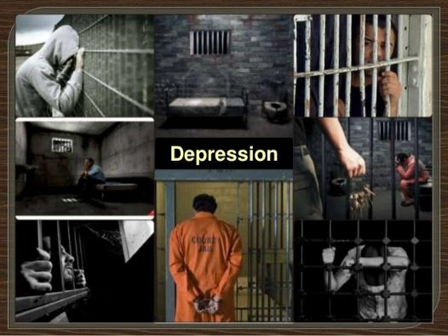
- Brutalisation – prison may act as school for crime, reinforcing a criminal lifestyle and criminal norms. This leads to high recidivism rates with approximately 70% of young offenders re-offending within 2 years.
- Mental health – There is a high prevalence of psychological problems in prison populations including depression, anxiety, self-harm and suicide. This could be due to overcrowding, low staff-to-offender ratio, lack of access to medical service and physical exercise, and an increased risk of physical assault.
- Labelling – custodial sentencing can result in reduced employability due to the label of those released from prison as being ex-prisoners. This can result in feelings of hopelessness.

Evaluation:
- Zimbardo’s Stanford prison study illustrated the effects of incarceration can have on individuals. For example, some of the prisoners became depressed and anxious, causing mental breakdowns. This is potentially because of the withdrawal of their freedom and the treatment from the ‘guards’. However, caution should be used in generalising these findings to real prisons as the validity of this study is low. For example, participants were volunteers and, because of their interest in participating in the study, may have been more likely to have displayed demand characteristics. As a result, they could have just been playing a role they thought Zimbardo wanted them to play. In addition, the set up was not a real prison and the participants were not real prisoners or people who have commited crimes. The ecological and population validity of the findings can therefore be questioned.

- There are difficulties with establishing cause and effect. For example, it is difficult to show that psychological problems are due to imprisonment. This is because prisoners with psychological problems may have had these problems before they were incarcerated.

- The evident negative psychological effects of custodial sentencing suggests that alternatives to custodial sentencing may be better for low-risk offenders. For example, community service would allow offenders to keep their job and avoid some of the problems that occur in prison including de-individuation and a culture of dependency. Indeed, research has found that offenders sentenced to community rehabilitation were less likely to re-offend. However, it could be argued that the success of community rehabilitation programmes is that they are only given to less serious offenders and thus the same impact may not be evident in more serious offenders.

- Custodial sentencing can have benefits. It offers opportunities to develop skills, counselling, rehabilitation etc. This can have a positive impact on inmates’ mental health and open up opportunities for employment etc when they are released. Also, treatment programmes, such as anger management may help offenders modify their behaviour and so avoid reoffending.

Dealing with offending behaviour: Behaviour modification in custody

Behaviour modification in custody is an application of the behaviourist approach to managing offenders in prisons. More specifically, it is based on the principles of operant conditioning. The general aim is to replace undesirable behaviours with desirable ones through the systematic use of reinforcement for desired behaviours. This is made possible in prison through the use of a token economy system, which is managed by prison staff.

Token economy:

Based on operant conditioning, token economy involves reinforcing desirable behaviour with a token that can then be exchanges for a reward that is desirable to the offender. Desirable behaviour may take many forms but is likely to include following prison rules, keeping one’s cell orderly etc. Prisoners are given a token each time they perform a desirable behaviour. These tokens are secondary reinforcers because they derive their value from their association with a primary reinforcer, the reward. Rewards in prison may also take many forms but is likely to include a phone call to a loved one, time in the gym or exercise yard or extra cigarettes, TV time or food.

Evaluation:
- Token economies in custody is easy to implement and cost effective as it can be implemented across the prison and there is no need for expertise in comparison to other ways of dealing with offending behaviour such as anger management programmes. This adds to the appropriateness of behaviour modification as a way of dealing with offending behaviour in custody.

- The effectiveness of token economy systems depends on a consistent approach from prison staff. The benefits of this method of dealing with offending behaviour would be lost if prison staff applied it inconsistently due to factors such as lack of appropriate training or high staff turnover. This therefore would question the effectiveness of behaviour modification programmes in custody.

- Behaviour modification has little rehabilitative value in that any positive changes in behaviour that may occur whilst the prisoner is in prison may quickly be lost when they are released. This may be because offenders play along with the token economy system in order to access the rewards, but this produces little change in their overall character. Other treatments, such as anger management are much more active in their approach as they require the offender to reflect on the cause of their offending and are given greater responsibility for their own rehabilitation. Because of this, they may have more rehabilitative value than token economies. Additionally, law-abiding behaviour is not always reinforced on the outside, or the rewards the offender receives from breaking the law may be more powerful. The effects of behaviour modification are therefore less likely to extend beyond the custodial sentencing in comparison to the skills learned during anger management. This therefore questions the effectiveness of behaviour modification programmes.

Dealing with offending behaviour: Anger management

Anger management is a form of cognitive behaviour therapy that is based on the assumption that cognitive factors trigger the emotional arousal which precedes aggressive acts. This means that, in some people, anger is often quick to surface in situations that are perceived to be anxiety-inducing or threatening.
As a result, the aim of anger management for dealing with offending behaviour is to teach offenders how to recognise their anger and manage it.
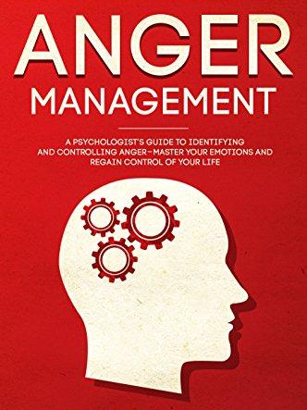
This involves 3 stages:
- Cognitive preparation – offenders recognise their own feelings of anger and what triggers their anger. This can involve offenders reflecting on their past experiences and considering the typical pattern of their anger.
- Skills acquisition - offenders learn strategies to control their own anger e.g. deep breathing, repeating calming mantra, counting to 10 etc.
- Application practice – offenders are provided with an opportunity to practice their newly acquired skills in safe situations e.g. role play of an anger provoking situation. The idea is that offenders are prepared for future situations that might have resulted in outbursts of anger in the past.

Evaluation:
- Researchers have compared the progress of two groups of offenders, one of which took part in anger management and the other a non-treatment control group. After the treatment group had completed 12 sessions, outcomes were assessed using interviews, a behaviour checklist completed by prison staff and a self-report questionnaire. The group who took part in anger management showed more improvements in behaviour than the non-treatment control group. This supports the effectiveness of anger management as a way of dealing with offending behaviour.

- Unlike behaviour modification, anger management tries to tackle one of the causes of offending. This is because, rather than focusing on superficial surface behaviour, it attempts to address the thought processes that underlie offending behaviour.

- Anger management provides offenders with strategies to use to manage their anger outside of their custodial sentencing. This is in contrast to behaviour modification which rarely lasts outside of prison. However, practicing the skills in role-play situations is argued to be very different from real life when the level and intensity of emotion are typically greater. The offender may therefore experience difficulty in applying the skills to real-life situations that provoke feelings of anger. For this reason, the effectiveness of anger management programmes can be questioned.

- The appropriateness of anger management programmes is questionable. For example, not all offending behaviour is caused by anger and so such ways of dealing with offending behaviour may only be applicable to a subgroup of offenders. In addition, the active nature on the behalf of the offender in anger management programmes mean they are only suitable for individuals who will maintain a level of effort and commitment. As many offenders will not maintain this, the appropriateness of anger management is questionable.

Dealing with offending behaviour: Restorative justice programmes:

Restorative justice programmes switch the emphasis from the needs of the state to enforce the law and punish to the needs of the victim to come to terms with the crime and move on. As such, victims are encouraged to take an active role in the process, whilst offenders are required to take responsibility and face up to what they have done.

Restorative justice is therefore a process of managed collaboration and reconciliation between the offender and victim. A supervised meeting between the two parties is organised and attended by a trained mediator. In this meeting, the victim is given the opportunity to confront the offender and explain how the incident affected them. Similarly, the offender is able to see the consequences of their actions, including the emotional distress it caused.

Not all restorative programmes involve face-to-face encounters between offender and victim. Instead, the offender may make some financial compensation which may reflect the psychological or physical damage caused. Other variations may involve the offender repairing damaged property themselves. Restorative justice programmes are therefore flexible and can function as an alternative to prison (especially if the offender is young), as an add-on to community service.

Evaluations:
- Unlike custodial sentencing, which tends to adopt a ‘one size fits all’ approach, there is a degree of flexibility in the way in which restorative justice programmes can be administered. This is a strength in that the schemes can be adapted and tailored to the needs of the individual and their situation. However, this flexibility does present difficulties in terms of drawing conclusions about the effectiveness of restorative justice programmes.

- There is a danger that offenders may ‘sign up’ for the scheme to avoid prison, or for the promise of a reduced sentence, rather than a genuine willingness to want to make amends to the victim. This means that restorative justice programmes may not lead to positive outcomes when offenders feel no remorse.
- Despite the fact that restorative justice programmes may reduce rates of recidivism, and might be much cheaper than running and staffing overcrowded prisons, alternatives to custodial sentencing tend not to receive much public support. This is because they are often regarded as soft options while society demands for retribution.

- The meeting between offender and victim may be an emotionally charged affair requiring the input of an experienced professional to act as a mediator. Specialists who are trained in these matters are likely to be expensive and few and far between. In addition, restorative justice programmes often suffer from high dropout rates as the offender or victim may ‘lose their nerve’ prior to the scheduled meeting and withdraw from the scheme. This means that, in practice, it may not always be the most cost-effective solution.

- Restorative justice programmes that enable the offender to avoid prison or have their sentence reduced help to avoid the negative effects of custodial sentencing e.g. brutalisation, effects on mental health etc

