T3 Gametes and Fertilisation Exam Questions
Q1.
In animals, sperm cells and egg cells are involved in sexual reproduction.
The photomicrographs show human sperm cells and a human egg cell. They are not shown to scale.
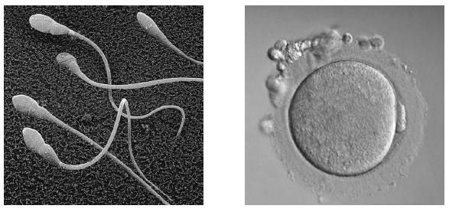
Using an eyepiece graticule (micrometer), the head of a human sperm cell was measured as 5 μm in length and the egg cell 0.1 mm in width.
Explain why the egg cell is much larger than the head of the sperm cell.
(2)
.............................................................................................................................................
.............................................................................................................................................
.............................................................................................................................................
.............................................................................................................................................
.............................................................................................................................................

Q2.
The diagram shows a mature sperm cell.
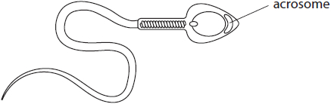
Describe the role of the acrosome in fertilisation.
(2)
.............................................................................................................................................
.............................................................................................................................................
.............................................................................................................................................
.............................................................................................................................................
.............................................................................................................................................
.............................................................................................................................................

(Total for question = 2 marks)

Q3.
A zygote is formed when gametes fuse at fertilisation.
Describe how the process of fertilisation results in the formation of a zygote from the gametes in humans.
(3)
.............................................................................................................................................
.............................................................................................................................................
.............................................................................................................................................
.............................................................................................................................................
.............................................................................................................................................
.............................................................................................................................................
.............................................................................................................................................
.............................................................................................................................................
.............................................................................................................................................

(Total for question = 3 marks)

Q4.
Answer the question with a cross in the box you think is correct . If you change your mind about an answer, put a line through the box and then mark your new answer with a cross .
(i) The table shows the chromosome number and chromatid number of some of the cells formed during oogenesis in humans.
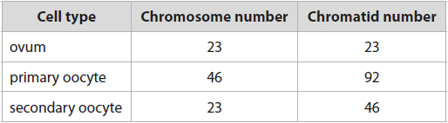
Which of the cells are haploid?
(1)
A ovum and primary oocyte
B ovum and secondary oocyte
C primary oocyte and secondary oocyte
D ovum alone
(ii) Explain how meiosis produces new combinations of alleles in gametes.
(4)
.............................................................................................................................................
.............................................................................................................................................
.............................................................................................................................................
.............................................................................................................................................
.............................................................................................................................................
.............................................................................................................................................
.............................................................................................................................................
.............................................................................................................................................
.............................................................................................................................................
.............................................................................................................................................
.............................................................................................................................................
.............................................................................................................................................

(Total for question = 5 marks)

Q5.
Changes must occur to mammalian sperm cells as they pass through the female reproductive tract, if successful fertilisation is to take place.
Capacitation results in changes to the sperm cell membrane and increased motility.
The acrosome reaction (AR) must follow capacitation but not too soon nor too late.
Explain why the timing of the AR is important for successful fertilisation.
(3)
.............................................................................................................................................
.............................................................................................................................................
.............................................................................................................................................
.............................................................................................................................................
.............................................................................................................................................
.............................................................................................................................................
.............................................................................................................................................
.............................................................................................................................................
.............................................................................................................................................

(Total for question = 3 marks)

Q6.
Explain why a defective acrosome reaction may result in male infertility.
(4)
.............................................................................................................................................
.............................................................................................................................................
.............................................................................................................................................
.............................................................................................................................................
.............................................................................................................................................
.............................................................................................................................................
.............................................................................................................................................
.............................................................................................................................................
.............................................................................................................................................
.............................................................................................................................................

Q7.
Egg cells vary in size between different species of animal.
Egg cells from different animals were measured and some further information about each species was recorded. The data are shown in the table.
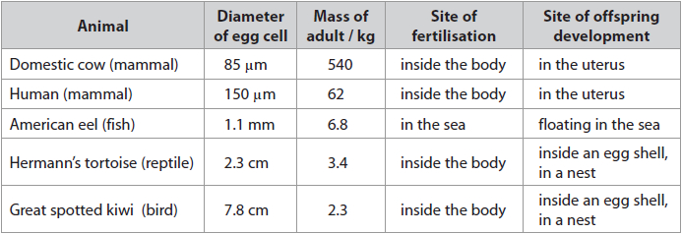
(a) The human egg cell and the eel egg cell are approximately spherical. The formula for the volume of a sphere is
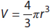
where V is the volume and r is the radius of the sphere.
The volume of the human egg cell is 1.8 × 10⁶ μm³.
Calculate how many times larger the volume of the eel egg cell is than the volume of the human egg cell.
(3)
Answer ........................................................... times larger
(b) The eel egg cell is larger than the human egg cell, yet an adult eel is smaller than an adult human.
Analyse the data in the table to explain why it is advantageous for the eel to have a larger egg cell.
(2)
.............................................................................................................................................
.............................................................................................................................................
.............................................................................................................................................
.............................................................................................................................................
.............................................................................................................................................
.............................................................................................................................................
.............................................................................................................................................
.............................................................................................................................................
(c) (i) Deduce the relationship between egg cell diameter and the mass of the adult animal shown by the data.
(1)
.............................................................................................................................................
.............................................................................................................................................
.............................................................................................................................................
.............................................................................................................................................
(ii) Criticise this data set as evidence for a relationship between egg cell diameter and the mass of the adult.
(4)
.............................................................................................................................................
.............................................................................................................................................
.............................................................................................................................................
.............................................................................................................................................
.............................................................................................................................................
.............................................................................................................................................
.............................................................................................................................................
.............................................................................................................................................
.............................................................................................................................................
.............................................................................................................................................
.............................................................................................................................................
.............................................................................................................................................
.............................................................................................................................................
.............................................................................................................................................
.............................................................................................................................................
.............................................................................................................................................
.............................................................................................................................................
.............................................................................................................................................

(Total for question = 10 marks)

Q8.
The relationship between the length of a sperm cell and the speed at which it can swim was investigated.
The data collected are shown in the graph.
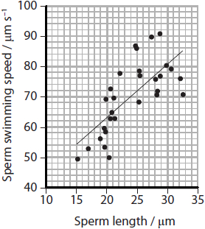
(i) Calculate the swimming speed of a sperm cell that is 40 μm long, as predicted by the line shown on the graph.
(2)
Answer ...........................................................
(ii) Explain the limitations of using the line on the graph to predict the swimming speed of sperm cells.
(2)
.............................................................................................................................................
.............................................................................................................................................
.............................................................................................................................................
.............................................................................................................................................
.............................................................................................................................................
.............................................................................................................................................
.............................................................................................................................................

(Total for question = 4 marks)

Q9.
Methyl methanesulfonate (MMS) can be used as a cancer treatment. One side effect
associated with MMS is teratozoospermia.
Three groups of rats were exposed to the following additives to their diet as
shown in the table.
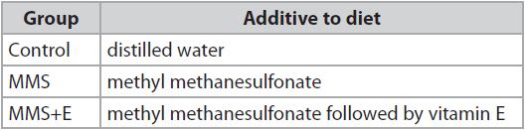
The graphs show the results of the study of the sperm cells produced by these
three groups of rats.
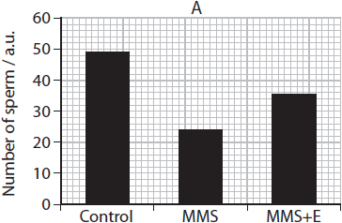
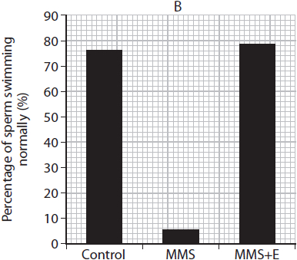
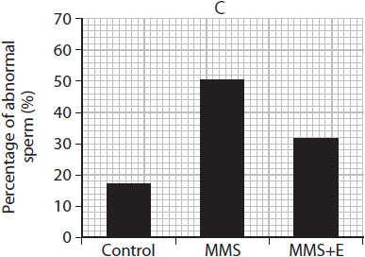
Deduce the effects of MMS on the production of sperm cells in rats.
(3)
.............................................................................................................................................
.............................................................................................................................................
.............................................................................................................................................
.............................................................................................................................................
.............................................................................................................................................
.............................................................................................................................................
.............................................................................................................................................
.............................................................................................................................................
.............................................................................................................................................
.............................................................................................................................................
.............................................................................................................................................
.............................................................................................................................................

(Total for question = 3 marks)

Q10.
Some lipoproteins may reduce fertility in mammals.
An investigation was carried out using mice of the same breed.
Female mice were divided into three groups, P, Q and R. Each group was given a different treatment.
The table shows the treatment given to the three groups of female mice.
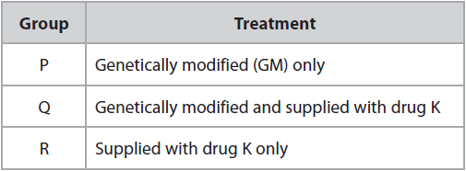
The GM mice have an increased concentration of high-density lipoproteins (HDLs) in their blood plasma.
Drug K was used to lower the blood plasma HDL levels.
The mice in each group were allowed to breed with non-genetically modified male mice and the number of offspring born was recorded.
The graph shows the results.
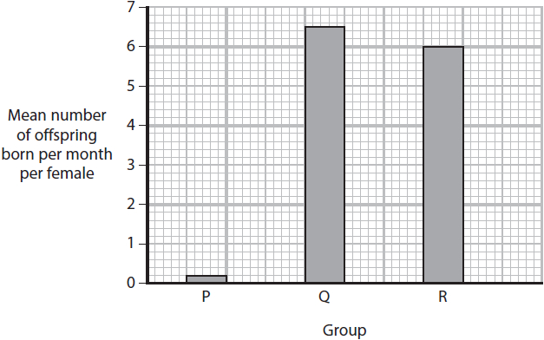
(i) The mice were all of one breed to improve data
(1)
A accuracy
B precision
C quantity
D validity
(ii) State a null hypothesis for this investigation.
(1)
.............................................................................................................................................
.............................................................................................................................................
.............................................................................................................................................
(iii) Comment on the effect of blood plasma HDL levels on the fertility of these female mice.
(4)
.............................................................................................................................................
.............................................................................................................................................
.............................................................................................................................................
.............................................................................................................................................
.............................................................................................................................................
.............................................................................................................................................
.............................................................................................................................................
.............................................................................................................................................
.............................................................................................................................................
.............................................................................................................................................
.............................................................................................................................................
.............................................................................................................................................

(Total for question = 6 marks)

Q11.
* There are many products that may increase the ability of sperm to swim. One of these products contains zinc sulphate.
Devise an investigation to obtain valid data to show whether taking zinc sulphate tablets affects the ability of sperm to swim.
(6)
.............................................................................................................................................
.............................................................................................................................................
.............................................................................................................................................
.............................................................................................................................................
.............................................................................................................................................
.............................................................................................................................................
.............................................................................................................................................
.............................................................................................................................................
.............................................................................................................................................
.............................................................................................................................................
.............................................................................................................................................
.............................................................................................................................................

(Total for question = 6 marks)

Q1.
No Examiner's Report available for this question

Q2.
The majority of candidates scored a mark for stating that the acrosome breaks down the zona pellucida. A few stated that the egg membrane was broken down or the egg cell wall, which we did not think was acceptable at this level. The second mark was less frequently awarded as a large proportion of candidates wrote that the sperm could then fertilise the egg cell which is pretty much just a repeat of the question.

Q3.
Candidates tend to know the events that take place during fertilisation quite well. We would have preferred candidates to refer to the secondary oocyte but accepted ovum and egg cell, but we really could not accept egg.
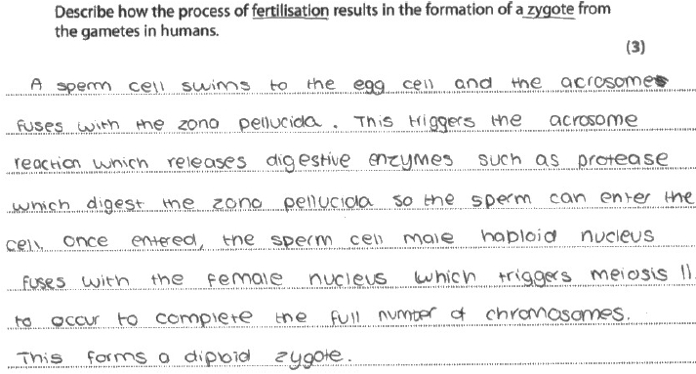
Results Plus: Examiner Comments
This is a clear response, illustrating our first three mark points very clearly.

Results Plus: Examiner Tip
Read through your response when you think you have finished it to make sure that you have not made any careless mistakes or used sloppy language.

Q4.
(i) This straightforward question tested students' knowledge of the terms haploid and diploid. Most were able to recognise that the ovum and secondary oocyte were haploid.
(ii) This question required students to give a basic description of how different combinations of gametes are produced in meiosis. Many excellent answers were seen that fully explained how independent assortment and crossing over occur and many students used vocabulary confidently. Weaker students gave vague answers that often referred to different chromosomes rather than specifically stating homologous chromosomes. A few students referred to gene mutations – the question was focused on the production of different allele combinations. Students are encouraged to use full scientific vocabulary precisely and to add as much depth as possible to their answers.

Q5.
The key to this question was the timing of the acrosome reaction. Unfortunately, many candidates demonstrated their knowledge of the enzymes and what they did but did not relate this to timing, and so gained no credit. Few gained the last point regarding what would happen if the acrosome reaction was taking place too late.
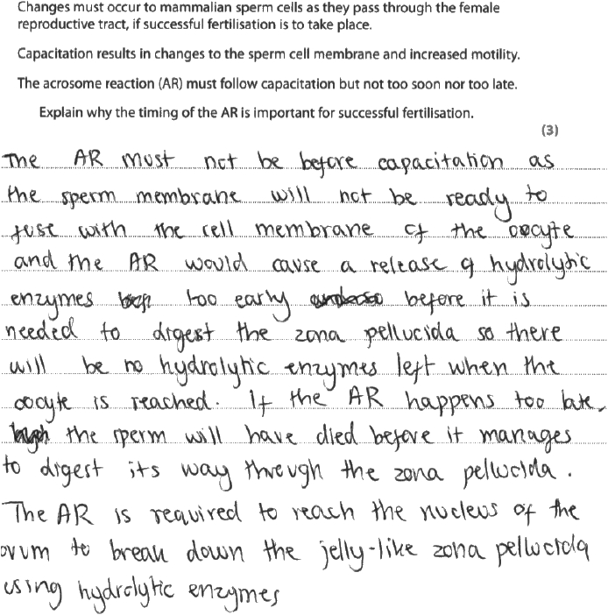
Results Plus: Examiner Comments
This is an example of a response where the candidate addressed all 3 mark points clearly in their answer.

Results Plus: Examiner Tip
Read the question carefully. Don't be tempted to see a key word and then write what you know about it without putting it into the context of the question.

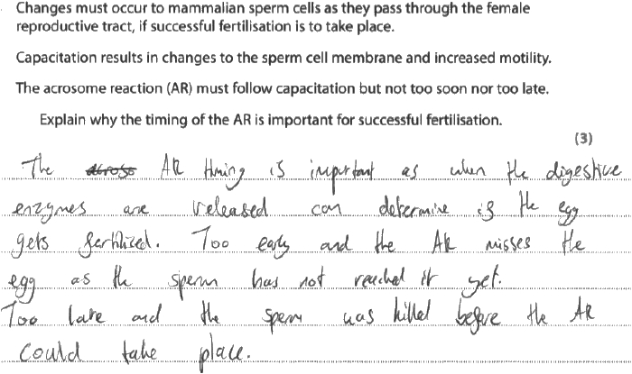
Results Plus: Examiner Comments
The candidate has gained the third mark point, but not linked their point on the enzymes to the acrosome reaction taking place too early.

Q6.
No Examiner's Report available for this question

Q7.
(a)
This question was based around a set of data which shows a negative correlation between the mass of the adult of various species and the diameter of its egg cell. Of course this negative correlation does not hold true more widely across the animal kingdom, it just happens to be the case for the five species selected; the reproductive strategies of these organisms have a much greater influence on the sizes of their eggs cells, so information about the sites of fertilisation and offspring development was also given.
Many candidates carried out this multi-step calculation successfully – well done. However, others found a number of potential pitfalls. The most common were: to get in a muddle with units, since the eel egg diameter was given in mm while the volume of the human egg was given in μm³; to attempt to subtract the two volumes to find a difference, rather than dividing to find the multiplication factor; or simply being unable to use the formula for volume correctly, often squaring rather than cubing the radius.
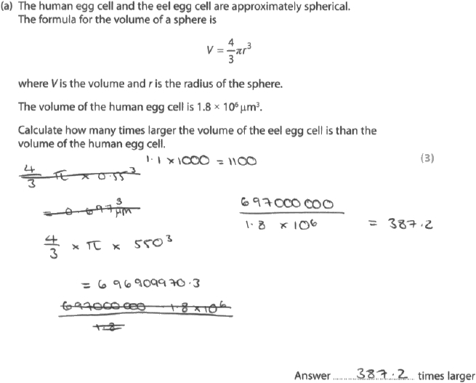
Results Plus: Examiner Comments
This answer scored all 3 marks and clearly shows the three steps in the calculation. At the top we see the conversion of the eel data into μm (1.1 x 1000 = 1100). On the left-hand side the formula for volume is used correctly. On the right we then see a correct division to find how many times larger the eel egg is. Ideally the final answer should be rounded to two significant figures, since this was the degree of precision to which the data were given; however, on this occasion unrounded answers were accepted because the examiners did not want to penalise candidates who had carried out all the steps of the calculation correctly.

Results Plus: Examiner Tip
Think about the appropriate degree of precision for your answer. However, only round off when you have reached the end of the calculation, to ensure your answer is as accurate as possible.

(b)
Candidates most frequently addressed the third bullet point on the mark scheme here, commenting on the increased likelihood of fertilisation. The examiners did not accept that a larger egg is 'easier' to fertilise, because this is not the case, but the larger egg provides a larger target for the sperm. Far fewer candidates integrated their own knowledge of the structure and function of the egg cell with the information provided, so the marks relating to lipid droplets and the energy content of the egg were not awarded so often.
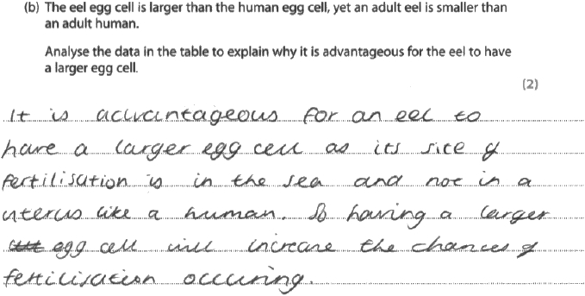
Results Plus: Examiner Comments
This answer scored 1 mark for the final bullet point in the mark scheme, the idea of a greater chance of fertilisation.

(c)(i)
Almost all candidates correctly identified the negative correlation and gained the mark.
(c)(ii)
Some candidates appeared to misinterpret what the command term 'criticise' was asking them to do: some responses quoted the numerical data in great detail to provide evidence to support the existence of a negative correlation, but did not offer any criticism. However, the majority had their doubts that the correlation would hold true in general and most candidates were able to identify at least one problem with the data set. There was a tendency to focus on one particular flaw identified and discuss it at length, rather than going on to consider a range of different issues with the data set, so the full 4 marks were infrequently awarded.
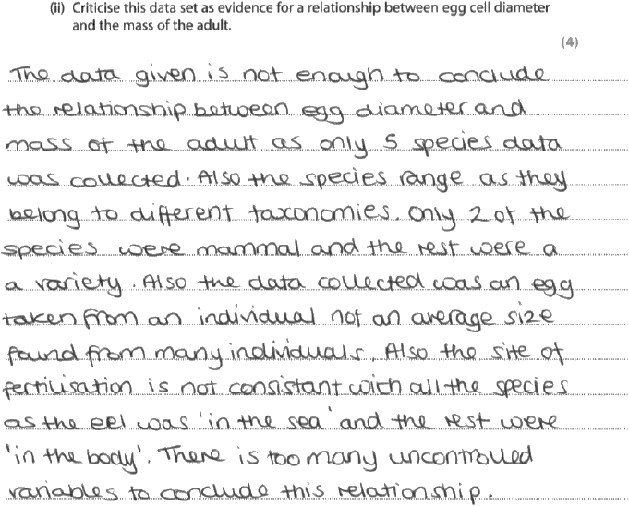
Results Plus: Examiner Comments
This was a good answer that considered a range of weaknesses of the data set and scored 4 marks. The first four bullet points in the mark scheme are addressed, in the same order in which they appear in the mark scheme.

Q8.
(i)
This question assessed candidates' ability to work with linear relationships of the form y = mx + c (mathematical skill A.3.3). Many candidates answered successfully by finding the gradient of the line on the graph, which allowed them to extrapolate beyond the extent of the x-axis. However, some candidates extended the x-axis and the line on the graph and attempted to read the swimming speed directly from their extended graph. Although this was a creative approach, it usually did not yield a sufficiently accurate answer. A disappointing number of candidates failed to achieve the second mark for use of correct units, even though these really could be taken directly from the graph. Some candidates omitted units entirely, while another surprisingly common mistake was for the 's' to become superscript which is biologically nonsensical.
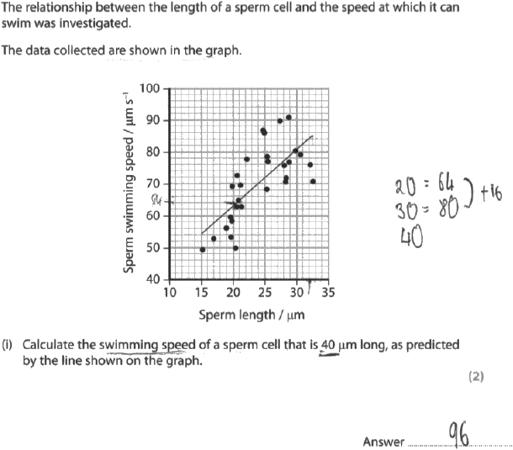
Results Plus: Examiner Comments
The working (beside the graph) in this answer reflects a valid method of extrapolation. Unfortunately the candidate has not read the graph accurately enough so has not obtained the correct answer, and units are omitted, so neither of the two marks could be awarded.

Results Plus: Examiner Tip
You are expected to read graphs as accurately as possible, even if the reading is in-between the grid lines. For example, at a length of 20μm the line is half-way between the grid lines for 62 and 64μm s⁻¹, so you should read off 63μm s⁻¹.

(ii)
Of course, linear extrapolation is not always appropriate in biological contexts. This question asked candidates to consider the limitations of the swimming speed they had predicted in part (i). Answers tended to focus on either the first or the second bullet point in the mark scheme, rarely considering both. Bullet point 1 was much more frequently seen by the examiners, probably because the variability of the data visible in the graph helped to point candidates in the right direction.
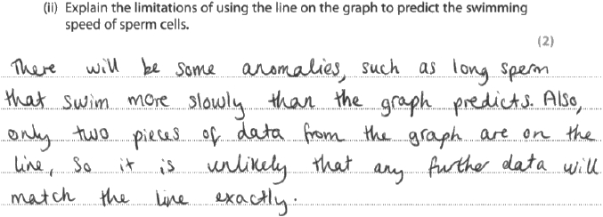
Results Plus: Examiner Comments
This answer correctly explains the first bullet point in the mark scheme, so was awarded 1 mark.

Results Plus: Examiner Tip
Look for signposts as to how many points to include in your answer. In this case the question refers to limitations (plural), and two marks were available, so the examiners were looking for two distinct points.

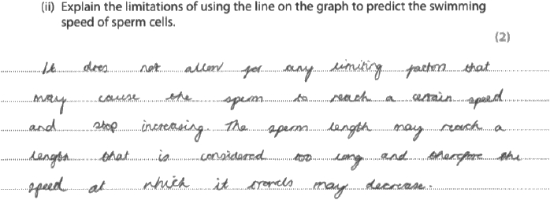
Results Plus: Examiner Comments
This answer correctly explains the second bullet point in the mark scheme, so was awarded 1 mark.

Q9.
There was a tendency for candidates to describe each graph in turn. This typically generated a mark for lowering sperm count. By describing the abnormal sperm graph candidates often neglected to mention the increase caused by MMS.
There were few attempts to "deduce" the effect.

Q10.
(ii) This question required candidates to offer a null hypothesis in relation to an investigation considering fertility in mice. Approximately half the cohort appreciated that the hypothesis should suggest there was no link between the various treatments the female mice had and their fertility.
This answer correctly links the two variables being considered to gain the mark.
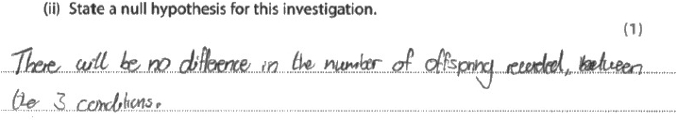
Results Plus: Examiner Comments
The reference to conditions was considered an acceptable alternative to treatments or groups.

Results Plus: Examiner Tip
Make sure you know how to link the dependent and independent variables in a null hypothesis.

(iii) In this item candidates had to review graphical data relating to mouse fertility, and the full mark range was seen. Many were able to appreciate how the various treatments affected the HDL levels within the mice, and therefore, to deliver a credit worthy response.
This response focused on the first two marking points, which was common to a number of candidates.
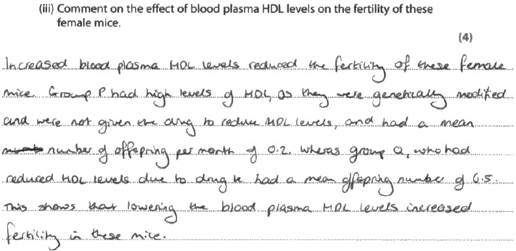
Results Plus: Examiner Comments
The first sentence correctly links raised HDL levels in mice with a reduction in fertility, so the second marking point could be given. The second sentence moves towards the first marking point but for this mark to be given the candidate has to state that the group P mice produced the lowest number of offspring per mouse per month.

Results Plus: Examiner Tip
Consider whether quoting values from provided data will be sufficient to gain the mark.

Q11.
No Examiner's Report available for this question

Mark Scheme
Q1.
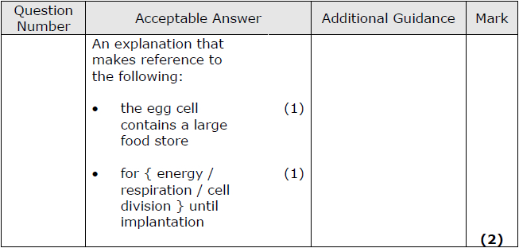

Q2.
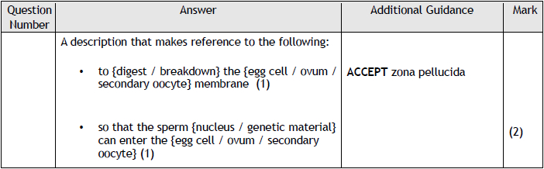

Q3.
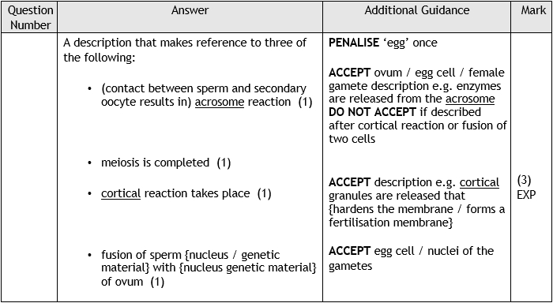

Q4.
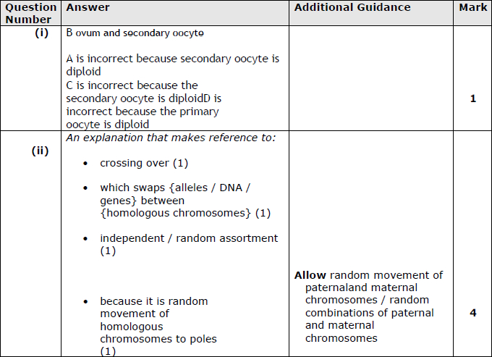

Q5.
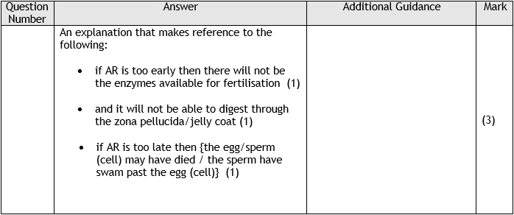

Q6.
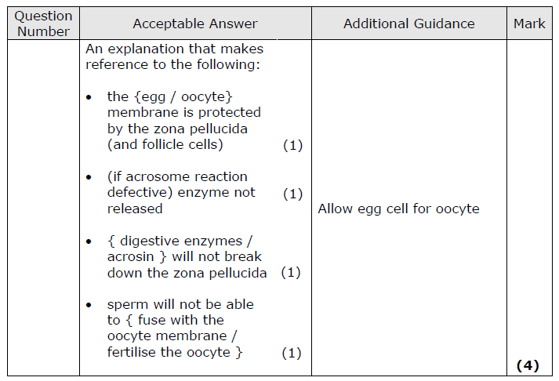

Q7.
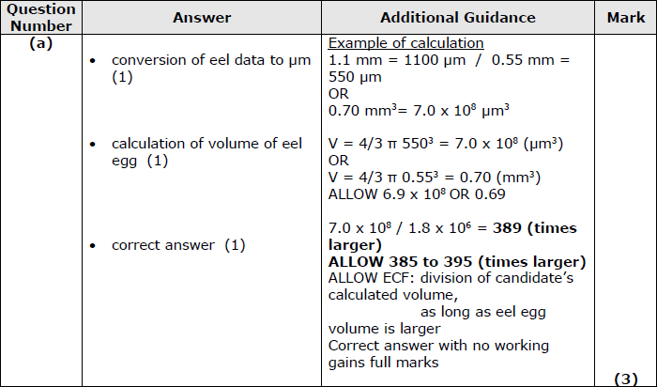
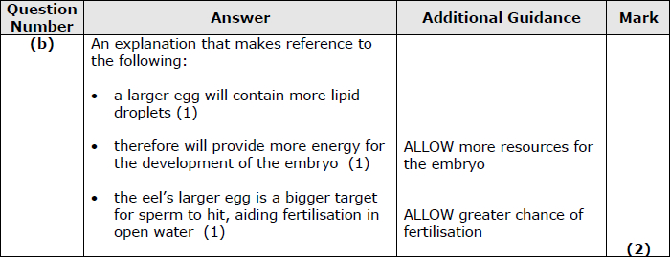
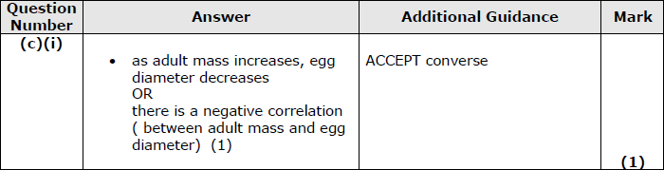
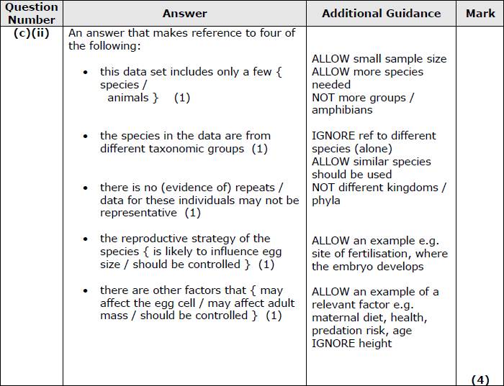

Q8.
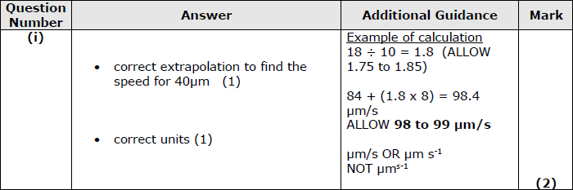
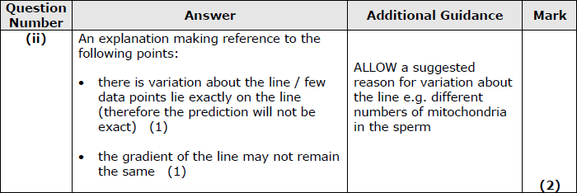

Q9.
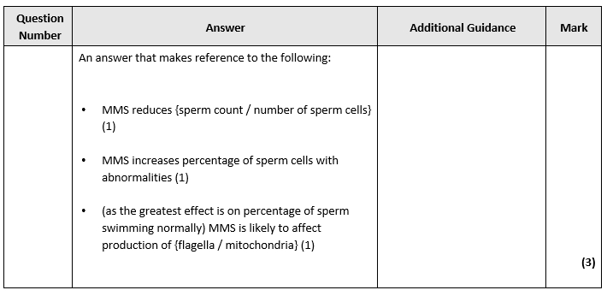

Q10.
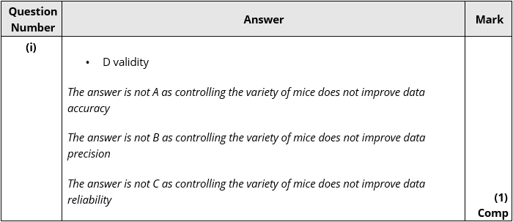
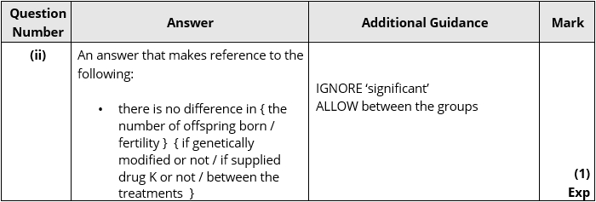
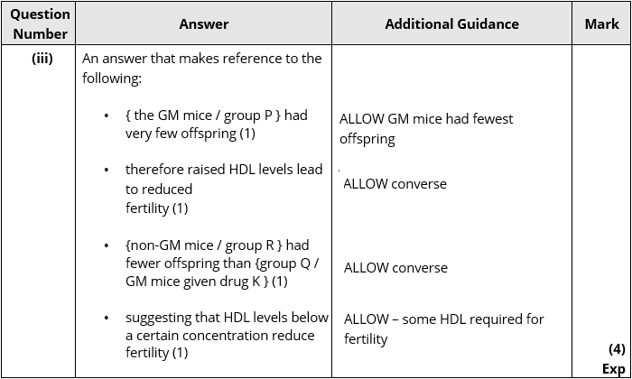

Q11.
