**Drayton Manor High School GCSE to A Level Transition Resources**

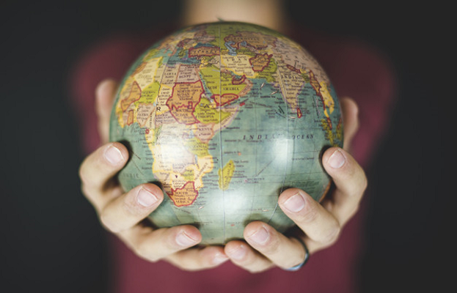

**Introduction**

It is great that you are considering studying Geography at A Level.

This pack contains a programme of activities and resources to prepare you to start an A Level in Geography in September. It is aimed to be used after you complete your GCSE throughout the remainder of the summer term and over the summer holidays to ensure you are ready to start your course in September.

The pack is divided into some of the key topics you will study in A Level Geography: Rivers , Coasts, Water Cycle/ Water Insecurity, Globalisation and Regeneration. There are a range of different activities to do in each topic area.

Discovering the world, we live in is great fun. I hope that you will agree!

**Chapter 1: Tectonic Processes and Hazards**

**Pre knowledge topic – How to answer questions on natural hazards (and other) processes.**

Tectonic hazards – earthquakes, volcanic eruptions and secondary hazards such as tsunamis – represent a significant risk in some parts of the world. This is especially the case where active tectonic plate boundaries interact with areas of high population density and low levels of development. Resilience in these places can be low, and the interaction of physical systems with vulnerable populations can result in major disasters. An in-depth understanding of the causes of tectonic hazards is key to both increasing the degree to which they can be managed, and putting in place successful responses that can mitigate social and economic impacts and allow humans to adapt to hazard occurrence

For this example, you are going to look at the formation of a waterfall. This technique can be used for almost all of the processes you are going to look in your Geography A level.

A common exam question would be –

*“C*ompare the characteristics of earthquakes, volcanoes and tsunamis*. (6 marks)”.*

The key part is that they are asking for a diagram and written explanation so the two must be linked. The best way to approach this is firstly draw 4 boxes in the space provided to draw your diagrams and then label them 1,2,3,4 (for some process you might need more or less boxes but no less than 2 and no more than 6). Then in each box you will draw 4 key diagrams from the process. This has been done in the example below.

Then in the section below write the first paragraph that links to the first image you have drawn. Start this paragraph with a so it clearly links to the diagram. This is again shown in the example below. You now have a stuttered answer which is simple to follow and answers the question giving you the best chance for full marks.

Sometimes questions might be slightly different for example –

*“Describe and explain and the characteristics….”*

There are no rules stating you cannot draw a diagram!

**Tectonic Processes and Hazards task**

**Tectonic Processes and Hazards**

With some extensive research this is quite an easy task.

You are to create an A3 poster with a**detailed** annotated diagram **explaining why are some locations more at risk from tectonic hazards**.

There should be a clear process to this and should be in extensive detail making it easy to follow and explain. Use the Glossary for key terminology. The poster should be clear and in extensive detail. Within this you need to incorporate key words that are defined (a good idea is to have flaps with the key term on one side and then the definition under it). Make it bright bold and clear so it is an easy and “fun” revision tool.

For some information you can start here [www.geographyiseverything.com/a---level.html](http://www.geographyiseverything.com/a---level.html). You can also try searching Google.

**Glossary for Natural processes and hazards**

|  |  |
| --- | --- |
| **Key Term** | **Definition** |
| Ash | The very fine particles of rock ejected during a volcanic eruption. These particles form part of the tephra, which is a term for all sizes of  ejected volcanic material. |
| Asthenosphere | The part of the mantle, below the lithosphere, where the rock is semi- molten. |
| Benioff zone | The area where friction is created between colliding tectonic plates, resulting in intermediate and deep earthquakes. |
| Collision plate boundary | Where two plates move towards each other causing a very slow collision which is likely to cause folding and faulting of crustal rocks  and the uplift of continental crust to form fold mountains. |
| Community adaptation | People within communities, either whole or parts of settlements, work together to change their way of life so that the impact of a tectonic hazard event is not as hazardous. |
| Community preparedness | People within communities, either whole or parts of settlements, work together to change their way of life so that the impact of a tectonic  hazard event is not as hazardous. |
| Conservative plate movement | Where two plates meet and move alongside each other in a similar direction or opposite direction, usually at different speeds. Friction between the two plates is great and stresses and strains build up to create shall earthquake foci.  Also **transform plate boundary.** |
| Constructive plate boundary | Where two plates move in opposite directions, leaving a zone of faulting and a gap into which magma from the asthenosphere rises. Also **divergent plate boundary.** |
| Convection currents | Hot, liquid magma currents moving in the asthenosphere. |
| Convergent plate boundary | Where two plates move towards each other and at the boundary the denser oceanic plate (basaltic) is subducted beneath the less dense continental plate (granitic), creating surface features such as a trench, and deep features such as the Benioff zone.  Also **destructive plate boundary**. |
| Crustal fracturing | When energy released during an earthquake causes the Earth’s crust to crack. |
| Epicentre | The point on the Earth’s surface directly above the focus of an earthquake. |
| Focal depth | The depth at which an earthquake starts (focus). It is divided into shallow, intermediate and deep. Shallow earthquakes have the greatest impacts, as the seismic waves have not lost as much of their  energy by the time they reach the surface. |
| Focus | The point inside the Earth’s crust from which the pressure is released when an earthquake occurs. |
| Geological structure | The arrangement of rock in layers, or folds and the joints and bedding planes within them. |
| Hazard-management cycle | A theoretical model of hazard management as a continuous four- stage cycle involving mitigation, preparation, response and recovery. |
|  |  |
| Hazard profile | An analysis of different types of hazard, or actual events, based on a range of criteria. This allows a useful comparison to be made. |
| Hazard-response curve | *see Park model |
| Hot spot | Points within the middle of a tectonic plate where plumes of hot magma rise and erupt. |
| Hydrometeorological hazards | Natural hazards caused by climate processes (including droughts, floods, hurricanes and storms). |
| Intra-plate earthquakes | Earthquakes which occur far from plate margins. |
| L waves | The slowest seismic waves, which focus all their energy on the Earth’s surface. |
| Lahar | A mixture of meltwater from snow and ice on top of an active volcano and tephra (volcanic material such as ash) from eruptions that travels very quickly down existing river valleys, reaching some distance away from the volcano. |
| Land-use zoning | A process by which local government regulates how land in a community may be used. |
| Landslide | A mass movement of rock and soil down a steep slope under the influence of gravity, perhaps triggered by an earthquake loosening  material. |
| Lava flow | Molten magma that reaches the Earth’s surface is known as lava. It will flow down the sides of a volcano until it cools and solidifies.  Basaltic lavas flow faster than andesitic lavas, for example, because of the different velocities. |
| Liquefaction | When the violent shaking during an earthquake causes surface rocks to lose strength and become more liquid than solid. |
| Lithosphere | The solid layer, made from the crust and upper mantle, from which  tectonic plates are formed. |
| Magnitude | The amount of energy releases by a tectonic event. For earthquakes  this is best measured on the Moment Magnitude Scale (MMS) and for volcanoes the Volcanic Explosivity Index (VEI). |
| Mass movement | The downward movement of material under the influence of gravity. It includes a wide range of processes such as rockfalls, landslides and solifluction. |
| Mega-disaster | When a major hazardous event becomes catastrophic and more than a disaster. For example, the scale of the impacts are unusually great or very sever with huge numbers of deaths, loss of buildings and infrastructure, or long-lasting impacts on normal social and economic systems. |
| Mercali scale | An earthquake intensity scale based on 12 levels of damage to areas. |
| Mitigation | Action to reduce the impacts of an event. |
| Modify loss | Reduce the impact of losses experienced from a tectonic hazard, for example by insuring belongings and property. |
| Modify the event | Alter the natural hazards itself in order to change its likely impacts. Earthquakes cannot be changed, but some volcanic activity can be  modified, such as by diverting lava flows. |
|  |  |
| Modify vulnerability | Vulnerability is a key factor in determining the impact of a hazard, so making people less vulnerable will reduce the scale of a disaster. |
| Moment Magnitude Scale (MMS) | The most accurate earthquake magnitude scale, it measures the total energy released by an earthquake. |
| Multiple-hazard zone | An area that is at risk from multiple natural hazards such as hurricanes and earthquakes. |
| Natural hazard | A physical geographical event, tectonic, hydrological or meteorological, which has a negative impact on people through causing injury or deaths, loss of property, or disruption to the normal  way of life. |
| P waves | The fastest seismic waves which travel through both solids and liquids. |
| Palaeomagnetism | The study of past changes in the Earth’s magnetic field. |
| Park model | Shows how a country or region might respond after a hazard event. |
| Pressure and release (PAR) model | A tool used to work out how vulnerable a country is to hazards. |
| Rapid onset | A hazard that happens very quickly with no or little warning e.g. an earthquake. |
| Resilience | The ability of a community to resist the impacts of a hazard by adapting and recovering. |
| S waves | Seismic waves which only travel through solids and move with a sideways motion. |
| Sea floor spreading | The movement of the oceanic crust away from a constructive plate boundary, as recorded by the magnetic stripes in the basaltic rock (palaeomagnetism). |
| Slab pull | When newly formed oceanic crust sinks into the mantle, pulling the rest of the plate further down with it. |
| Slow onset | A hazard that happens very slowly with plenty of evidence and warning, such as a drought. |
| Sub-aerial processes | The processes of weathering and mass movement. |
| Subduction zone | The area in the mantle where a tectonic plate melts. |
| Transform fault | A fault created on a large scale when two plates slide past each other. |
| Volcanic Explosivity Index (VEI) | The scale used to measure the magnitude of a volcanic eruption. |
| Water column displacement | The movement of a volume of seawater above the point at which the seabed was moved up or down by an earthquake, such as a thrust. |

**Chapter 2: Coasts**

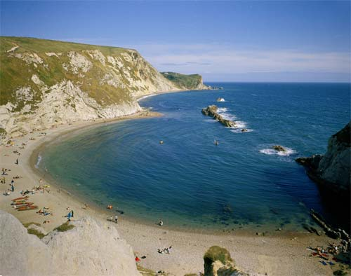

[**http://www.onegeology.org/extra/kids/images/tides.jpg**](http://www.onegeology.org/extra/kids/images/tides.jpg)

**Independent Research**

1. How does the geological structure of the coast influence the development of coastal landscapes?  
   <http://www.bgs.ac.uk/discoveringGeology/geologyOfBritain/viewer.html>
2. What effect will sea level rise have on coastlines?  
   <http://www.theguardian.com/environment/sea-level>

<http://www.assembly.wales/Research%20Documents/Coastal%20Erosion%20and%20Sea%20Level%20Rise%20-%20Quick%20guide-30012014-235792/qg12-0014-English.pdf>

<http://www.bgs.ac.uk/discoveringGeology/climateChange/general/coastalErosion.html>

1. Why is Bangladesh so at risk from coastal flooding?

<http://www.bbc.co.uk/schools/gcsebitesize/geography/water_rivers/river_flooding_management_rev6.shtml>

<http://coolgeography.co.uk/A-level/AQA/Year%2012/Rivers_Floods/Flooding/Bangladesh/Bangladesh.htm>

1. Find four images representing a range of mass movement along the coastline. Annotate them in detail and include examples of where they have occurred around the world
2. What is the difference between eustatic and isostatic sea level change?

**Pre Knowledge Topics - Coasts**

1. Use GIS (Google Earth) to map of a variety of coastal landscapes in the UK and around the world
2. Draw field sketches of contrasting coastlines
3. Use http://wtp2.appspot.com/wheresthepath.htm to measure rates of erosion over time along contrasting coastlines
4. Annotate images to show a range of approaches to coastal management and their environmental impact
5. Create a map of the sediment cells around the UK
6. Sketch and annotate a recurved spit to show its formation
7. Annotate diagrams to show the different types of erosion and transportation at the coast
8. Draw sketches of concordant and discordant coastlines
9. Draw and annotate the formation of a stump
10. Find the definition for the following words:

|  |  |
| --- | --- |
| **Term** | **Definition** |
| ***Abandon the line*** |  |
| ***Abrasion*** |  |
| ***Accretion*** |  |
| ***Advance the Line*** |  |
| ***Arch*** |  |
| ***Attrition*** |  |
| ***Attrition*** |  |
| ***Backwash*** |  |
| ***Bar*** |  |
| ***Benefit cost ratio*** |  |
| ***Berm*** |  |
| ***Beach nourishment*** |  |
| ***Blow –hole*** |  |
| ***Breaching*** |  |
| ***Char*** |  |
| ***Constructive waves*** |  |
| ***Concordant geology*** |  |
| ***Corrasion*** |  |
| ***Corrosion*** |  |
| ***Cusp*** |  |
| ***Cuspate foreland*** |  |
| ***Defence line*** |  |
| ***Deltas*** |  |
| ***Destructive waves*** |  |
| ***Differential erosion*** |  |
| ***Discordant geology*** |  |
| ***Diurnal range*** |  |
| ***Do Nothing*** |  |
| ***Downdrift*** |  |
| ***Dunes*** |  |
| ***Eustatic*** |  |
| ***Fetch*** |  |
| ***Fiord*** |  |
| ***Flocculation*** |  |
| ***Flood*** |  |
| ***Frequency*** |  |
| ***Gabion*** |  |
| ***Geo*** |  |
| ***Groyne*** |  |
| ***Halophytes*** |  |
| ***Hard engineering*** |  |
| ***High energy coast*** |  |
| ***Hold the line*** |  |
| ***Hydraulic action*** |  |
| ***Isostatic*** |  |
| ***Isthmus*** |  |
| ***Longshore drift*** |  |
| ***Low energy coast*** |  |
| ***Magnitude*** |  |
| ***Managed retreat*** |  |
| ***Mass Movement*** |  |
| ***Plagioclimax*** |  |
| ***Psammosere*** |  |
| ***Recession*** |  |
| ***Recurrence interval*** |  |
| ***Retreat the line*** |  |
| ***Return period*** |  |
| ***Revetment*** |  |
| ***Ria*** |  |
| ***Runnel*** |  |
| ***Saltation*** |  |
| ***Sediment cell*** |  |
| ***Sediment sink*** |  |
| ***Slumping*** |  |
| ***Soft Engineering*** |  |
| ***Spit*** |  |
| ***Spring tide*** |  |
| ***Stack*** |  |
| ***Subaerial erosion*** |  |
| ***Surges*** |  |
| ***Swash*** |  |
| ***Swell*** |  |
| ***Tidal bore*** |  |
| ***Tidal Range*** |  |
| ***Tombolo*** |  |
| ***Updrift*** |  |
| ***Wave cut platform*** |  |
| ***Wave crest*** |  |
| ***Wave energy*** |  |
| ***Wavelength*** |  |
| ***Wave period*** |  |
| ***Wave steepness*** |  |
| ***Wave refraction*** |  |
| ***Wave trough*** |  |
| ***Weathering*** |  |

**Chapter 3: Water Cycle/ Water Insecurity**

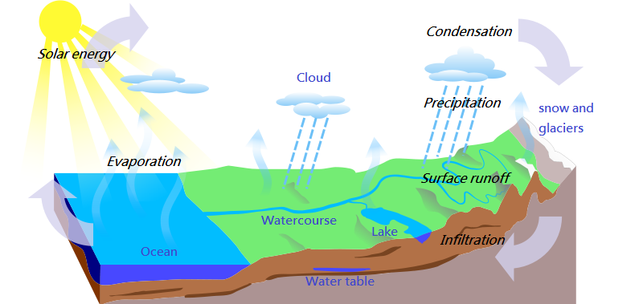

<http://quagroup.com/wp-content/uploads/Water_Cycle-en.png>

**Independent Research**

1. What affect can humans have on the hydrological cycle?
2. What is a storm hydrograph and what factors can impact it? (Physical and human)
3. How have humans contributed to drought in Australia?
4. How might climate change impact the hydrological cycle?
5. What are the human and physical causes of water insecurity?

<http://www.fao.org/nr/water/issues/scarcity.html>

<http://www.fao.org/nr/water/docs/wwd07brochure.pdf>

**Pre Knowledge Topics – Water Cycle/ Water insecurity**

1. Draw the hydrological cycle and label its inputs, outputs, stores and flows
2. Analyse patterns of water scarcity shown on this map:

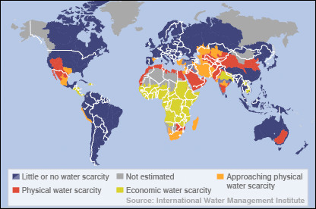

(http://news.bbc.co.uk/1/hi/sci/tech/5269296.stm)

1. Find an image of a dam and annotate with its advantages and disadvantages
2. Using the following website, which areas of the UK are most at risk of flooding?

<http://watermaps.environment-agency.gov.uk/wiyby/wiyby.aspx?topic=floodmap#x=357683&y=355134&scale=2>

1. Sketch a map of the River Nile with its main tributaries, annotate with key characteristics e.g. major dams, major population centers, political boundaries.
2. What issues may be present when a river flows through more than one country?
3. Why are treaties like ‘The Helsinki Rules on the Use of Water’ important in managing water supply?
4. Find the definition for the following words:

|  |  |
| --- | --- |
| **Aquifer** |  |
| **Desalination** |  |
| **El Nino** |  |
| **Economic scarcity** |  |
| **Geopolitical** |  |
| **Groundwater** |  |
| **High pressure** |  |
| **Infiltration** |  |
| **Irrigation** |  |
| **La Nina** |  |
| **Percolation** |  |
| **Physical Scarcity** |  |
| **Precipitation** |  |
| **Prevailing** |  |
| **Privatisation** |  |
| **Rainshadow** |  |
| **Relief rainfall** |  |
| **Riparian** |  |
| **Salinity** |  |
| **Spatial imbalance** |  |
| **Streamflow** |  |
| **Surface runoff** |  |
| **Urbanisation** |  |
| **Virtual water** |  |
| **Water pathways** |  |
| **Water rights** |  |
| **Water scarcity** |  |
| **Water stress** |  |
| **Water wars** |  |

**Chapter 4: Globalisation**

# Key information

In the last 30 years, globalisation has taken a real front seat in the concepts taught at A level geography. Changes in economy are at the forefront however changes in the environment, culture, demographics and politics of the world are also important and impact on areas at a range of scales.

**Key past influences**

* Since the discovery of the Americas, world trade and economy began to take shape.
* The colonialism of certain countries enabled the British Empire to control ¼ of the world bringing along British culture.
* The founding of the United Nations after the first world war allowed countries to work together easily.

**Continued influences and evolution of globalisation**

* Transnational Corporations (TNC): These are top firms with HQs usually in HICs however operate all over the world and are globally recogised (Coca Cola, Disney, Apple).
* Internet and IT: These have allowed design and manufacturing to be faster and easier. Jobs that typically humans would have done are now done online by less people- Allowing many high tech industries to be “footloose” and not reliant on being near by a resource or labour force.
* Transport: Now quicker, more efficient and low cost. The arrival of the 747 in the 1960s has revalutionised trade and movement of people.
* Growth of markets: Increase in urban living means more demand for trade, services and products.

**TASK**

[](https://www.google.co.uk/url?sa=i&rct=j&q=&esrc=s&source=images&cd=&cad=rja&uact=8&ved=0ahUKEwjiyPGEk4zMAhXGnA4KHe1iBxYQjRwIBw&url=https://en.wikipedia.org/wiki/File:Spider-Man_India.jpg&psig=AFQjCNG0TOMZbhUoy83vIjuKr3_L6jXK2g&ust=1460655264628835)

Spiderman- a comic superhero, has been reimaged for an Indian audience.

1. Research the characteristics of this Spiderman that are Indian rather than American.
2. What is the difference between economic and cultural globalisation? What does this Spiderman represent?

**Global groupings**

* Trade blocs: To trade easily between countries, certain agreements have been created. Examples are EU, NAFTA, CARICOM

[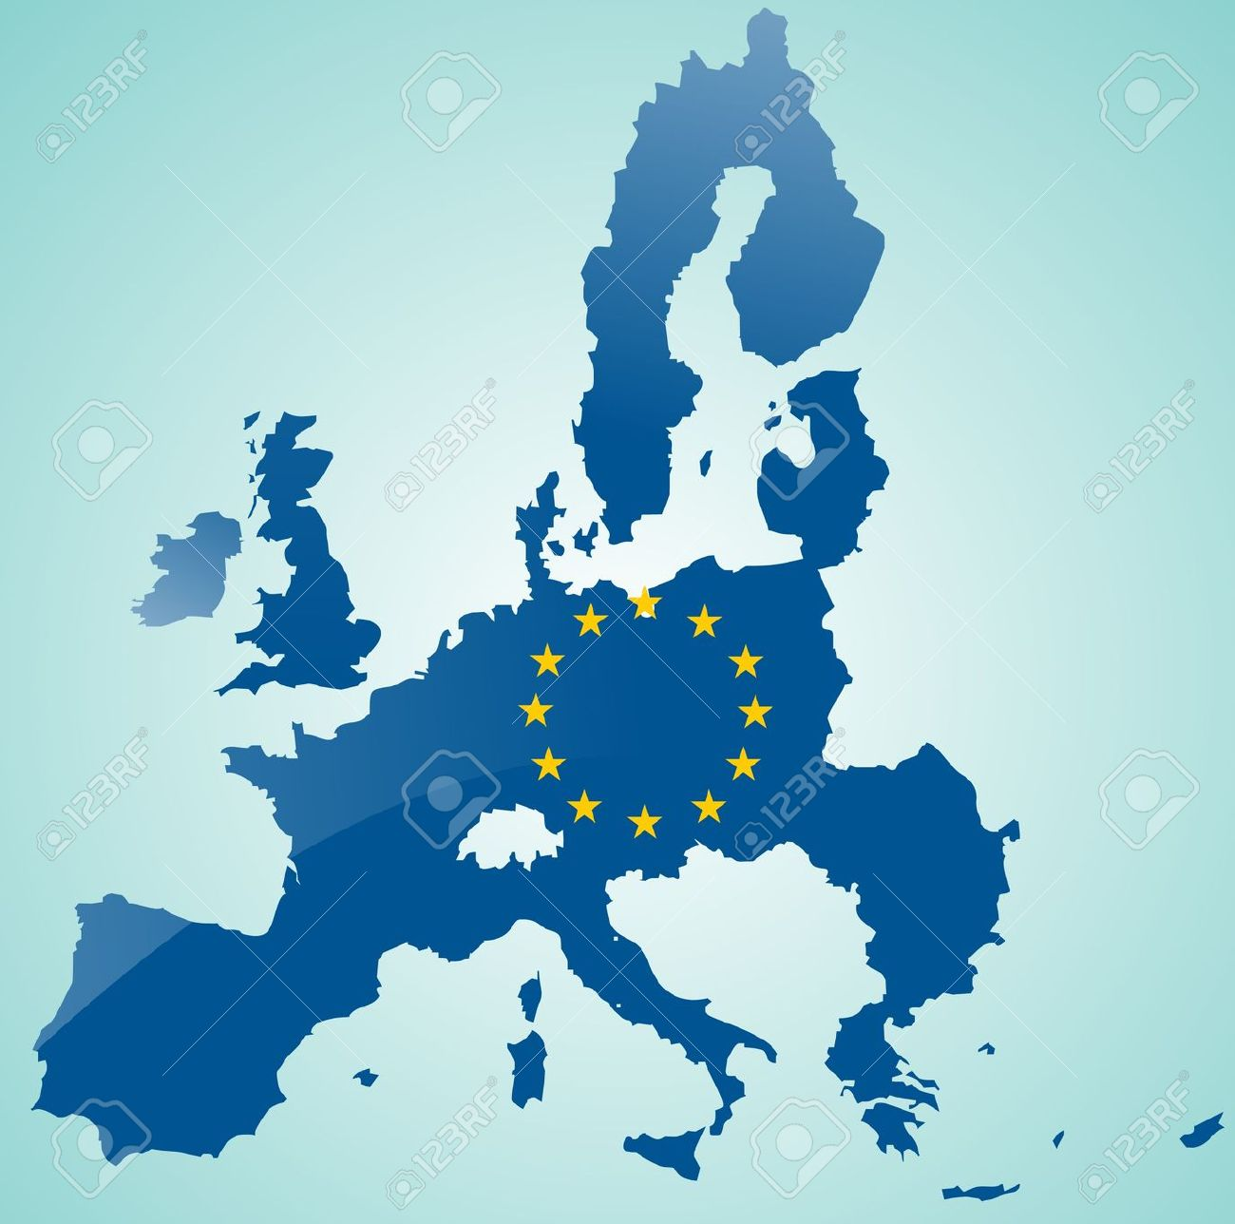](http://www.google.co.uk/url?sa=i&rct=j&q=&esrc=s&source=images&cd=&cad=rja&uact=8&ved=0ahUKEwjdp5uxlYzMAhVEgg8KHYSvBPsQjRwIBw&url=http://www.123rf.com/photo_8973431_map-of-european-union-with-flag-of-eu.html&bvm=bv.119408272,d.ZWU&psig=AFQjCNE9zkI6F52em5pptog60otbD3Uofg&ust=1460655882687435)

* Economic groupings: Countries are grouped together based on wealth and power. Example are LICs/HICs (LDC or HDCs), NICs, OPEC and OECD.

**TASK**

2. What do the acronyms above stand for?

**TNCs and Trade aims**

* They tend to operate where labour is cheap and regulations are lacking
* To gain government grants from countries that are attracting new business
* They operate inside local trade barriers and avoid tariffs
* They like to be near markets

**Positives to TNCs**

* Raising living standards – TNCs invest in the economies of many NICs and LICs
* Transfer of technology – south Korean firms e.g. Samsung have learned to design products for foreign markets
* Political stability – investment by TNCs has contributed to economic growth and political stability e.g. China
* Raising environmental awareness – due to large corporate image TNCs do respond to criticism e.g. Starbucks have their sustainability campaign

**Negatives to TNCs**

* Tax avoidance – many avoid paying full taxed in countries they operate in through concessions, e.g. Starbucks and Amazon
* Limited linkages – FDI does not always help developing nations economies
* Growing global wealth divide – selective investment in certain global areas is creating a widening divide e.g. Southeast Asia vs. sub-Saharan Africa
* Environmental disaster and destruction – example of Bhopal, India disaster in 1984

**TASK**

3. Create an annotated photo of either your family car or your living room with the various places where the parts/ features were manufactured.

4. Choose an example of a TNC and create a timeline of events since their foundation as a company. What have been the benefits that the company has brought to the countries involved. Examples could be Nike, Mattel, Disney or Tesco.

**Networks and hubs**

The term ‘global network’ refers to links between different countries in the world, this includes – flows of capital, traded goods, services, information (and people). Some areas are well connected i.e. high income areas, others poorly i.e. low income areas.

* A network is a model that shows how places are linked together. E.g. London Underground.
* A global hub is used to describe a place which is especially well connected. Connections between these hubs are called flows and include:
* Money- as major capital flows are routed through global stock markets
* Raw materials - e.g. food and oil traded between nations
* Manufactured goods and services - value of world trade is $70 trillion
* Information - internet has brought real-time communication between distant places
* People - movement of people still an issue due to border controls and immigration law

**TASK**

5. Create a case study of Easyjet- an example of a shrinking world. Include some background information, role of technology and current impact of the company.

**Being switched off**

* Many countries in the world are unable to access global networks.
* Specific conditions have caused them being switched off.

|  |  |
| --- | --- |
| Physical | Human |
| * Poor soil for farming * No coastline puts investors off as trade is harder * Vulnerability to hazards and climate change | * Low skills of the population * Poor literacy rates * Politically instability * Civil war |

**Chapter 5: Regeneration**

# Key Information

**Why *rebrand*?**

There are many reasons why areas need to rebrand and change their image. Some key definitions are:

Regeneration- This is the physical change of an urban or rural area. The intention is to attract investment and bring economic wealth in the area and bring in more visitors.

Re-Imaging- How areas construct and promote a more positive image to increase its popularity.

Rebranding- Helping change to the area to be more attractive to a different target audience.

Before an area rebrands itself, it must look into the following aspects:

* Environmental factors- improving derelict infrastructure
* Social factors- overcoming cycles of decline and poverty
* Economic factors- Improve investment and job opportunities
* Political factors- What money can be brought in from various initiatives and grants?

**CBD in decline**

* Many CBDs can fall into decline due a number of reasons

1. Increase in rent and costs/upkeep
2. Congestion in town centres puts people off coming in and spending money
3. The rise of out of town shopping centres and outlets
4. Edge of town science parks reducing the need for offices in the centre of town.

**TASK**

1. Create a cycle of decline for a town where the CBD is suffering. What are the knock on effects?
2. Using the photo of Birmingham below, research how the city has transformed itself.

[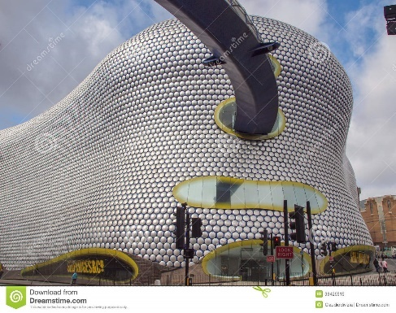](http://www.google.co.uk/url?sa=i&rct=j&q=&esrc=s&source=images&cd=&cad=rja&uact=8&ved=0ahUKEwjblb2HsYzMAhWCHg8KHUt7CN0QjRwIBw&url=http://www.dreamstime.com/royalty-free-stock-images-bullring-shopping-leisure-complex-birmingham-england-uk-september-new-bull-ring-centre-was-designed-future-systems-image36376889&psig=AFQjCNGoDzZk5pNf-NV09dEmIq_kXJzRSQ&ust=1460663317471600)

**Decline is countryside villages**

Although many countryside areas are deemed as idyllic, the rural community has been hit with many crisis’ and images of village life has been portrayed as difficult and sometimes boring. This is due to:

* Wide spread coverage of the food and mouth scandal in 2001, showing the nation horrible images of burning dead animals.
* Pressure groups and coverage of hunting
* Bad reputation- boring, sleeping, backward and unfriendly

**This decline has led to a number of challenges for rural areas**

* Affordable housing- often large farm houses or bought as second homes. This prices out first time buyers and a younger market
* Depopulation- younger residents moving out because of house prices, university or for job opportunities elsewhere.
* Changes in agriculture- low pay, long hours and increase of mechanisation
* Transport- difficult access and lack of reliant public transport

**Previous coalmining areas**

Between 1984 and 1997, 170,000 coal mining jobs were lost in England. This has led to a number of challenges in a previous thriving community:

* Ground contamination from the mines and now areas of dereliction
* No grounding for entrepreneurial skills or education as the population went into the coal mining business.
* Long term illnesses sue to the amount of time spent by some in the mines.

**Seaside issues**

Synoptic link- Tourism! As resorts tend to be seasonal in the UK, this has led to the decline of many seaside resort.

**TASK**

1. Create a timeline of decline for Blackpool. What have the impacts been? Have there been attempts to improve the area?

[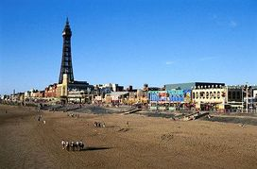](http://www.google.co.uk/url?sa=i&rct=j&q=&esrc=s&source=images&cd=&cad=rja&uact=8&ved=0ahUKEwj4m4rE-o3MAhVFlxoKHRRWDu4QjRwIBw&url=http://www.fotosearch.com/photos-images/blackpool.html&psig=AFQjCNF-f9fqNpvitAlK9uYTnxe2WvnEkw&ust=1460717406212858)

**Rebranding strategies**

Key definition- A stakeholder is an individual or group that has an interest in a particular project. This would be economically or emotionally.

**Two types of approaches**

* Top down approach where decisions are made by the authorities and then imposed on the specific people or places. The good things about this approach are that many considerations would be looked at and focus of the plans will be strategic.
* Bottom up approach is based on listening to locals and coming up with solutions. The advantage to this is that local will be in control and closely involved with the plans.
* A partnership approach is where a group of people come up with plans however they are made up from many stakeholders and will represent public, private and voluntary sectors.

**Rural rebranding strategies**

The countryside has a lot to offer and it is important that it is conserved and kept the way it is otherwise it would lose its appeal. When rebranding a rural community you have to think about:

[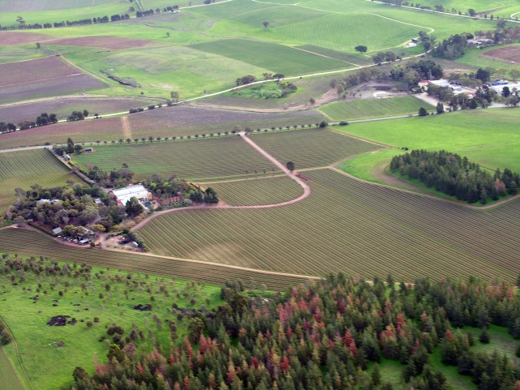](https://www.google.co.uk/url?sa=i&rct=j&q=&esrc=s&source=images&cd=&cad=rja&uact=8&ved=0ahUKEwiH8qGsgI7MAhXCNhoKHX36CPgQjRwIBw&url=https://en.wikipedia.org/wiki/Rural_area&bvm=bv.119408272,d.d2s&psig=AFQjCNHvKt2lenGcv_riY3a6r7Wi5EN0nw&ust=1460718964756688)

Cultural heritage

Location

Human capital

Social capital

Physical environment

**Different strategies used to rebrand the countryside**

* Creating a food town
* Diversifying the farm land- such as paintballing or festivals
* Growing organic crops
* Rural heritage and tourism
* On farm tourism- horse-riding, clay pigeon shooting or B&Bs
* Rural energy- HEP or solar plants
* Farm shops

**Case study – Eden project, St Austell**

Who were the stakeholders involved with its development?

Has the development been a success? Why?

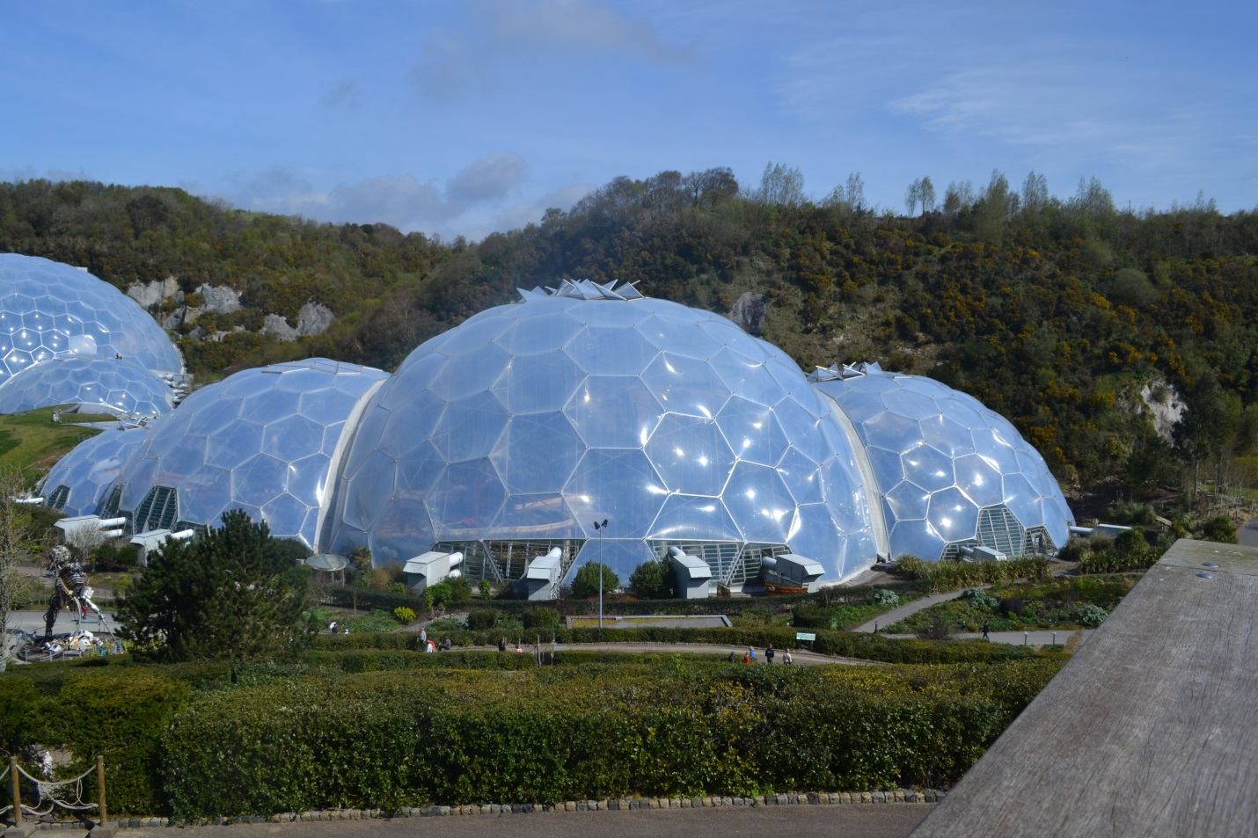

**Urban rebranding strategies**

Towns and cities thrive on culture and heritage in the UK and when rebranding, it is important to harness these features.

* Technology led enterprise
* Sport, art and culture- such as the Tate Modern at Margate
* Improvements ion retail- Bullring in Birmingham
* Improvement in public transport
* Themed events throughout the year- Christmas Markets are popular
* Food cities
* Redevelopment of warehouses- such as Royal Victoria docks and Docklands
* Creation of sustainable cities- Curitiba

**Sustainable rebranding**

More and more redevelopment and rebranding will involve some form of sustainable development.

Economy

Society

Environment

**Case study – Curitiba, Brazil**

[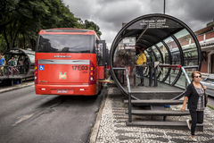](http://www.google.co.uk/url?sa=i&rct=j&q=&esrc=s&source=images&cd=&cad=rja&uact=8&ved=0ahUKEwiOnq3EhY7MAhVErRoKHV6LAVQQjRwIBw&url=http://www.dreamstime.com/stock-photos-public-transportation-famous-system-curitiba-parana-brazil-image40702073&bvm=bv.119408272,d.d2s&psig=AFQjCNEm1qyUQHt7JefttHeC8fe2fOZYAg&ust=1460720339977534)

**Research ways in which Curitiba has developed with sustainability in mind.**

**Evaluation involves looking at an area before and after rebranding**

1. Rebranding processes should begin with a detailed assessment, measuring the economic, environmental and social state of the place before rebranding starts.
2. Later evaluations can then measure any changes by comparing data – e.g. whether more residents are happy with the facilities after rebranding. They should also take into account the impact on different groups – e.g. local businesses and visitors.
3. Comparing the data can be a good way of measuring whether the rebranding has been successful, but it can never be completely reliable – e.g. residents might be happier, but that could be because the resident who weren’t happy with the rebranding have moved away.

**The World is Out There …..**

1. Check your local museums and visit one that has an exhibition related to Geography eg; Science museum or Natural History Museum in London and the Museum of London (development of a settlement over time)
2. Local museums are great sources of information on development of settlements over time, and local history / culture, including Barnet, Brent, Croydon, Kingston, Bromley, Hackney etc.
3. Any museums outside of London, such as The Shed in Bristol these are great for studying local geography.
4. Watch some key geographical programmes on TV or on DVD.
5. Read the National Geographical Magazine (this is very focused upon the United States) or take out a subscription to the Geographical Association for Geography Review. You could also subscribe to the RGS publication.
6. Follow some key players on Instagram and Twitter- Such as USGS, National Geographic and NASA.
7. <https://www.futurelearn.com/courses> - These are free online courses that anyone can join with many being based on topics you will study at A level. They are run by university's and are great background preparation for the students. Most of the courses have approximately 3 hrs study time a week.
8. Download news apps onto your phone and read on the go - The Telegraph has a great Travel section and so does The Daily Mail.
9. When visiting somewhere new – eg: on holiday- keep a journal of all the new geographical features you see and try to find out as much as you can about where you are visiting.
10. Use YouTube to watch documentaries on weather change and global warming.