Gradients on a curved graph

Plot each of these graphs and use a tangent to estimate the gradient for the stated x-value. Choose your own scales to use (1 square = 0.5 might be good to use on the x-axis) and remember to pay attention to them when finding the gradient!

a) y = x² Find the gradient where x = 2

b) y = x² + 2 Find the gradient where x = 2

c) y = x² – 5x Find the gradient where x = 3

d) y = x³ Find the gradient where x = 1

e) y = x³ + x² Find the gradient where x = -1

f) y = x³ – 4x² + 8x Find the gradient where x = 2

g) Show on each of your graphs any locations where the gradient is 0.
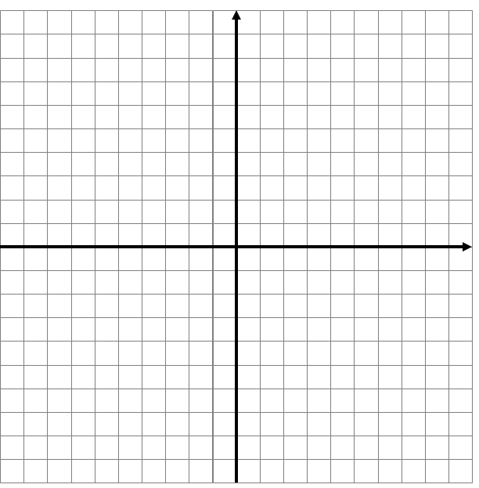
a)

b)

c)

d)

e)

f)

g) How do you know where the gradient is 0 on a graph?

______________________________________________________________________________________________________________________________________________________________________________________________________________________________________________________________________________________________________________________________________________________________________________________________________________________________________________________________________________________________________________________________________________________________________________________________________________
Gradients on a curved graph ANSWERS

Plot each of these graphs and use a tangent to estimate the gradient for the stated x-value. Choose your own scales to use (1 square = 0.5 might be good to use on the x-axis) and remember to pay attention to them when finding the gradient!

a) y = x² Find the gradient where x = 2
4 Gradient of 0 at (0,0)
b) y = x² + 2 Find the gradient where x = 2
4 Gradient of 0 at (0,2)
c) y = x² – 5x Find the gradient where x = 3
6 Gradient of 0 at (2.5,-6.25)
d) y = x³ Find the gradient where x = 1
1 Gradient of 0 at (0,0)
e) y = x³ + x² Find the gradient where x = -1
2 Gradient of 0 at (0,0) and (-²/₃,⁴/₂₇)
f) y = x³ – 4x² + 8x Find the gradient where x = 2
4 No gradient of 0 anywhere!
g) Show on each of your graphs any locations where the gradient is 0.

Be lenient with accuracy on these!!!

