How to use PearsonActiveLearn.com

- Log in using your own log in details or Username: Biostudent, Password: Drayton123
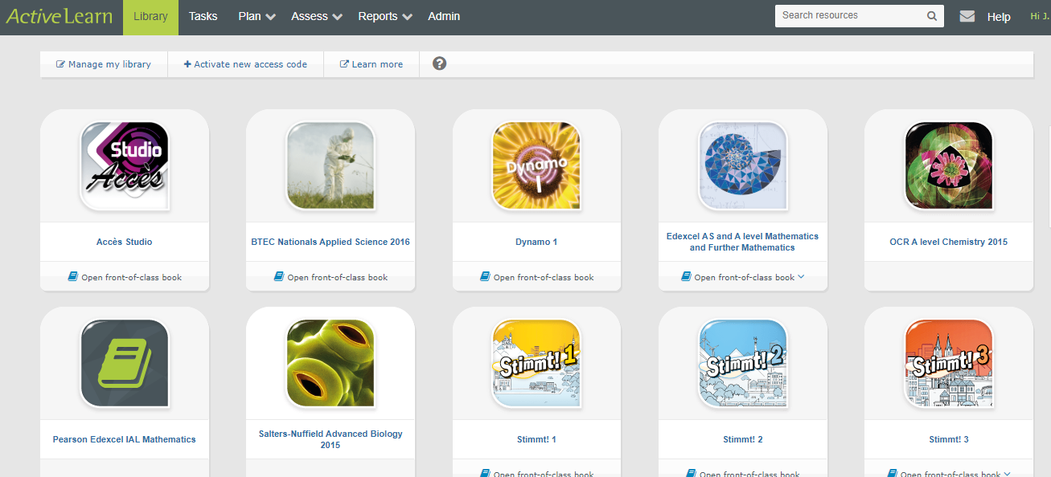
- Click on Salters Nuffied Advanced Biology 2015 in the library

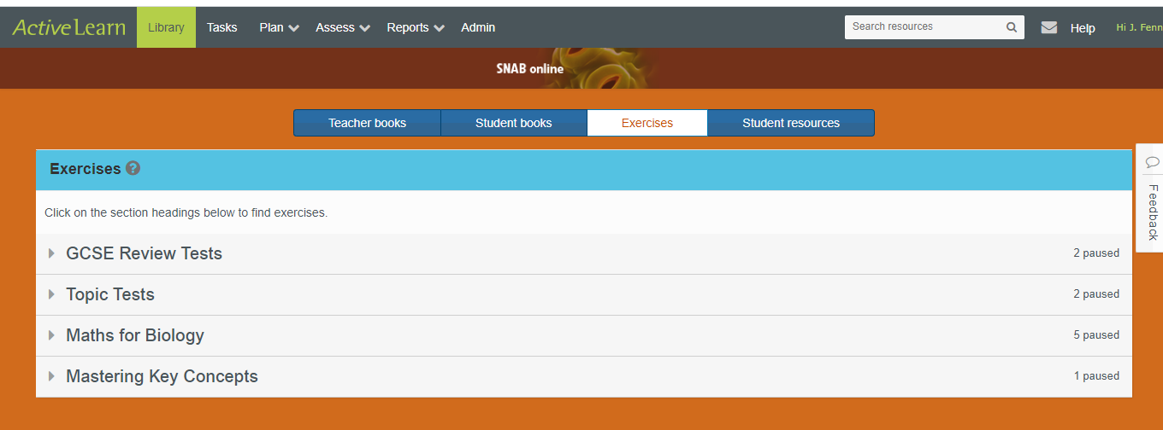
- Click exercises for you to do mini tests on the topics, go over your maths skills and watch animations on key skills that you might have identified as weak areas from your personal learning check lists.

- Click students resources for all of the activity sheets on the topics that you have been taught, for skills support sheets on practical and maths skills and for the glossary. Use the glossary to make yourself flashcards to test yourself on key terminology.

