British Empire and India Coursework booklet.
In the context of the years 1774 to 1905, was British rule in India more positive or negative?

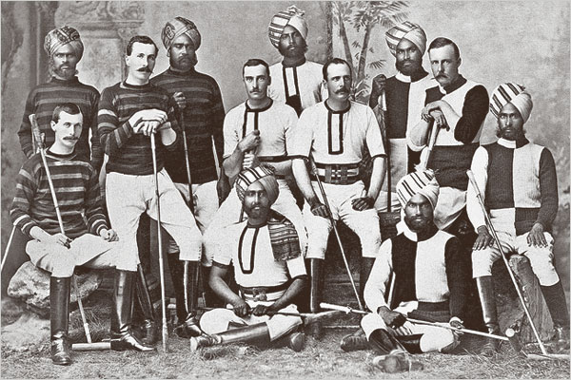
Contents page:
Key information: the essay, support, deadlines | 3
Background information, the historical context | 4
Was British rule positive or negative? A summary of the arguments | 9
Reading and research. Preparation for success | 11
AO1: What makes a good essay? How to structure your writing and what the examiners are looking for | 13
How to footnote and reference properly | 16
AO2: How to write primary source analysis | 17
AO3: How to write secondary source analysis | 18
MMR essay | 19
Primary source examples | 25
Secondary sources | 42

Key information
The essay
You need to produce coursework of a maximum word count of 4,500 words in length. It needs to include a main body that focuses on the title above, (or a variant of it). You also need to analyse three primary sources of different types, (e.g. painting, diary, government report), to determine their value in answering the question. You also need to examine two different historians’ interpretations of the period and say which you find the most convincing.
The mark is out of 40 and forms 20% of your final grade. The marks are broken down:
- AO1 – knowledge and understanding of the period. Making historical judgements. (20 marks)
- AO2 – analysis of primary source material for value. (10 marks)
- AO3 – evaluation of secondary interpretations. (10 marks)
The title above is a suggested one but you could change the start and end dates. You need to pick ones that are historically significant. They must however:
- Cover a minimum 100-year period
- Have a start date no later than 1807
Support
Depending on which essay you do, you will be ascribed a teacher within the department to work with and support you. Their role is to support and advise you, it is not to write the essay for you. They can direct you to suitable resources and advise on structure. You will be expected to meet regularly with your advisor, during these meetings you will be given specific tasks to complete in time for the next meeting. Our free time is very limited so failing to attend appointments or not completing work to deadline is not acceptable and could result in support being withdrawn.
Deadlines
Writing an essay like this should be done in four phases:
Reading and research – completed during the Summer term
- Completed during the end of year 12
- You should end up with a folder with notes, organised according to the structure of the essay
Structuring – by the end of Summer term
- A detailed plan of around 1,000 words should be completed by this stage, though the earlier this is done the better. This should include:
  - A completed introduction
  - Opening sentences for every paragraph in your essay
  - Not necessary to write a conclusion by this point
Writing – first draft completed by start of September
- A first draft of the essay should be completed by the start of September.
- You should be meeting your coursework advisor regularly during this half term so they can check on progress.
Proof reading and editing – final draft completed by the end of February half term 2018
- The drafting and editing process continues during the Autumn term. This is when you will be meeting most regularly with your coursework advisor and where they will be setting regular homework tasks relating to your coursework.
- By the end of Autumn term, you will hand in your completed coursework. In January, our time becomes significantly more constrained and the level of support we are able to offer will reduce. Leaving your work this late will cause you and us much stress!

The political history of India – who governed when?
This section should give you the context for your essay. Some of this information will be relevant to your answer but most of this is to give you an overview of the period of study.
The East India company as trading corporation.
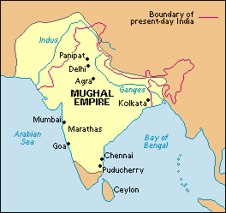
The British had a role in India since the formation of the East India Company (EIC) in 1600. It was a trading company with monopoly rights over trading goods like silk, spices and indigo in the East Indies, India and China. During the 17th century its sole focus was on trade and profit. Most of India was governed by the Islamic Mughal Empire, reaching the peak of its territorial power in 1707. Independent Tamil and Keralan princedoms existed in the far south. European merchants settled on the coast, Portugal mainly on the west coast around Goa, Britain and France on the East coast. They did so only with the permission and tolerance of the Mughals. It was here they opened what were called “factories” (actually trading hubs and deep water ports).

The rise of the EIC as political and military force
In the early 18th century, the Mughal Empire that governed India went in to decline, providing an opportunity for the Company to extend its power. At the same time, the British East India Company found itself in conflict with its French counterpart. The Carnatic Wars between the British and French trading companies and their Indian proxies ended in victory for the British by 1763 and France was forced out of India. The key battle in these wars was the Battle of Plessey in 1757 when Company forces, led by Robert Clive, defeated the French sponsored Nawab (Prince) of Bengal. As a result, the East India Company became the de facto rulers of Bengal (North-East) and their base of operations became Calcutta (Kolkata). The Company had been transformed from traders to governors with a private army of around 26,000 soldiers by 1767. Meanwhile, the Mughal Empire declined even further, retreating to the Northern areas of the Punjab, Sindh and Kashmir. The Hindu Maratha Empire became the dominant power in India with its power base in Maharashtra and around the centre of the country. The Hindu kingdom of Mysore also re-emerged in the South.
(Map below shows India by 1785. Mughal Empire in the North; Mizam, Mysore and Carnatic Kingdoms in the South; Maratha Confederacy in the middle; East India Company in Bengal, Circars and Madras – now called Chennai)
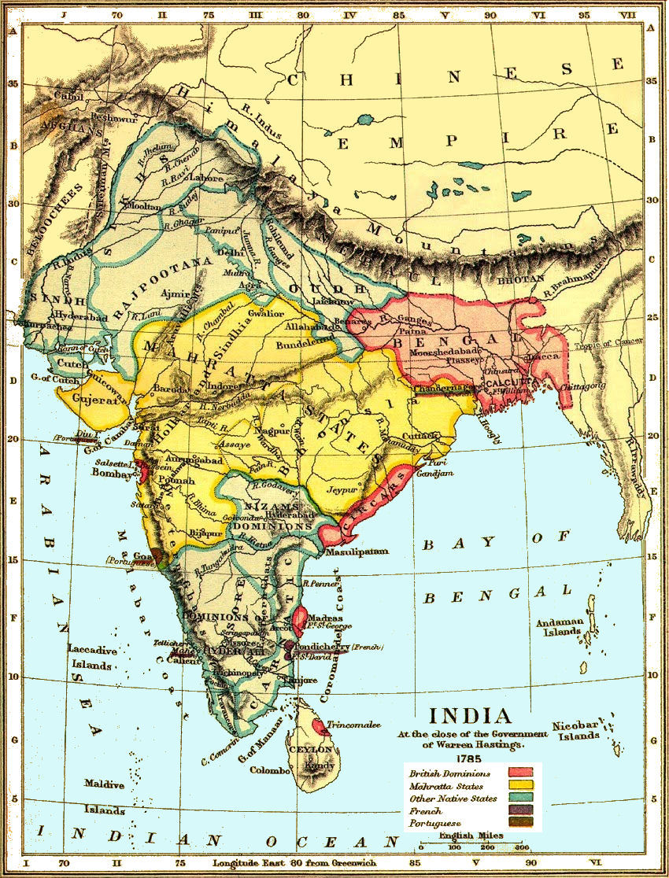

The extension of Company rule over India
The Company grew in military power and political influence. It used its wealth and a policy of “divide and rule” to exploit the cultural and particularly religious differences between different Indian ruling groups. The Anglo-Mysore wars saw the Company ally with the Marathas against the Mysore Empire, taking control of South India by 1805. Then the Company fought successfully against the Marathas and the Mughals, taking control of central India and chunks of Northern India. Where direct military rule could not be imposed, client states were set up with ruling puppets loyal to the Company. In 1776, the EIC had 67,000 soldiers under its command. By 1857, it had grown to 280,000 – almost entirely made up from low caste Indians, with some high caste Hindus and rich Muslims acting as officers. Indian soldiers serving the British were known as sepoys.
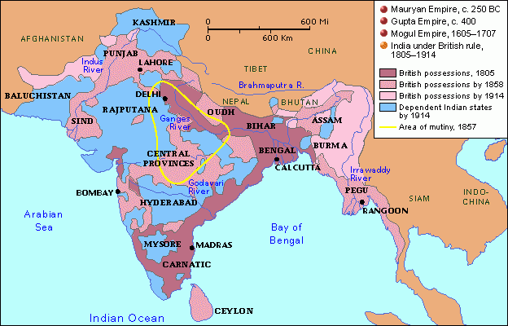
The extension of British Government control over the Company.
The Regulating Act 1773 and creation of Governor-Generals
The actions of the East India Company did not escape notice back in Britain. The Company became a byword for corruption and cruelty towards the people it nominally governed. Ambitious young men with the right connections in Britain could make massive fortunes by working for the Company (assuming they survived the voyage, the climate and endemic disease). While Company men made their fortune, the Company itself was heavily in debt to the Bank of England. Furthermore, despite ruling over huge chunks of Indian territory, Company men were merchants not administrators and they lacked the training or inclination to become effective rulers. India had become a colonial possession of national importance, yet it was not administered by the Crown, but by a private company. For these reasons, The Regulating Act of 1773 was passed that created the post of Governor-General and administration was centralised under his control. However, the changes were limited and the Governor-General was still selected by the Company, not the British government. Warren Hastings became the first Governor General in 1774.
Hastings’ impeachment, the extension of crown control
The conduct of the Company did not improve greatly in the 1780s, despite the attempts by Hastings to improve administration. He was scapegoated for its failings when he faced impeachment between 1788-1795. During the trial, the worst excesses of Company rule were brought to wider public attention. Hastings was acquitted, but not before he had exhausted his finances in mounting his defence. During the first half of the 19th century, the British government passed further Acts that strengthened Crown control and removed the monopoly rights of the Company, while the Company itself expanded its territory. By 1815, only the Sindh and the Punjab in the north west remained outside British control.
The Indian Rebellion 1857 and the Government of India Act 1858
In 1857 EIC sepoys mutinied, apparently over the use of rifle cartridges lined with cow and pork fat (which had to be bitten open in order pour gunpowder into the rifles), which was religiously offensive. While this may have been the trigger, there were deep underlying tensions over Company rule. The mutiny spread and turned into a wider rebellion against the British. The British response was swift and harsh. Atrocities were committed by both sides, including the massacre of women and children by sepoys at Cawnpore and the annihilation of entire villages by British forces in retribution. The rebellion was defeated and British control restored. It should also be pointed out that many sepoys remained loyal to the British.
As a consequence, the Company was deemed to be no longer capable of ruling India effectively. The Government of India Act, 1858 nationalised the East India Company and placed India’s administration directly under the British Crown, with future Governor-Generals to be appointed by Parliament.
The Raj: 1858-1947
This period of British rule was known as the Raj (literally translated from Hindi – Rule). India was under direct or indirect control of the British Crown and Government. The Governor-General was appointed by the monarch in order to govern from Calcutta (Kolkata) and was accountable to Parliament. Power was then devolved to nine provincial imperial offices, e.g. in Bombay (Mumbai) and Madras (Chennai). British India, which was the majority of the country, was under direct control of the Governor-General. The Princely States (for example in Hyderabad and Kashmir) were semi-autonomous, but were in practice British puppets.
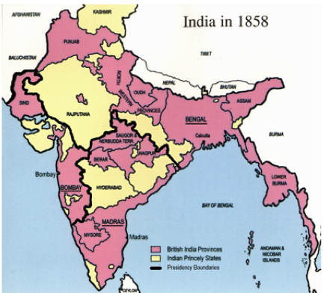
The Indian independence movement 1857-1947
Following the 1857 rebellion, independence movements grew throughout the country. They ranged from militant to moderate in outlook. These included the East India Association, formed by Dadabhai Naoroji in 1867 and Surendranath Banerjee’s Indian National Association, formed in 1876. The most important was the Indian National Congress. It was comprised of seventy-two Indian delegates who met in Bombay in 1885. Congress was a moderate organisation that did not initially demand full independence, instead it called for fairer representation of Indians within the British system of government and civil service, in fact Naoroji successfully contested the seat of Central Finsbury in the 1892 General Election, becoming the first Indian MP. By the early 20th century, Congress had split between moderates (Empire loyalists) and radicals (those who supported Swaraj – full independence). As the 20th century progressed, demands for independence grew and concessions were gradually granted by the British government. Crucial in this process was the leadership of Mohandas Ghandi. India gained full independence “at the stroke of the midnight hour” on 15th August 1947
Was British rule positive or negative?
Your job in this essay is to examine the impact of British rule and reach a conclusion on whether India and the Indian people benefitted or suffered as a result. Inevitably there is truth on both sides. The balance between positive and negative impact is controversial and is still vigorously debated. There has been much recent history writing on the topic, which makes it ideal for study.
The positive argument
Defenders of British rule (who are sometimes called apologists by their critics) point to:
ECONOMIC
- The creation of infrastructure including railways, telegraphs, canals and ports. They argue that this enabled India after independence to enjoy rapid economic growth.
- Encouraging a model of free market capitalism and free trade that has also generated growth
- The development of the mining, iron and steel industries.
POLITICAL
- A democratic legacy. The British model of rule encouraged a representative system of government. The Indian National Congress, formed in 1885 would go on to be the dominant political party of the 20th century.
- An efficient civil service and administrative structure, again based on the British model.
- A modern legal system based on habeas corpus and equality before the law.
- These aspects combined to create an Indian national consciousness for the first time. Before Britain arrived, “India” did not exist – it was instead a collection of princedoms with distinct cultural, religious and linguistic identities. India was therefore a British invention.
SOCIAL
- Progressive social reforms, including banning female infanticide, suttee (widow burning) and thugee (organised crime)
- The English language, which has also helped develop India’s global importance both economically and politically.
- An education system based on the British model, including primary education, private schools and universities
- Improving healthcare. The introduction of vaccination programmes, a fall in child mortality and a rise in life expectancy.
- British rule was actually quite benign compared to the alternatives. The Mughals, whom the British replaced were highly repressive and other European empires were distinctly worse.
- Imperialism was the default in the c19th. Whatever the wrongs of British rule, they should be judged by contemporary standards, not modern ones.
The negative argument:
The rebuttal is perhaps best captured by Dr. Shashi Tharoor’s comment that, “it’s a bit rich to enslave, maim and torture people for 200 years and celebrate that they’re democratic at the end of it." This argument is based upon:
ECONOMIC
- The fundamental basis of British rule in India was economic exploitation. Any infrastructure that was created was simply a by-product and was in fact built not for India’s benefit, but to enable the exploitation of raw materials.
- India already had a thriving economy before the British arrived. It at least as economically developed as Europe in the 17th century.
- India would always have become a key player in the global economy, even without British intervention, because of its location, size, large population and natural resources.
- British rule supressed the superior Indian textile industry since it was a competitor. Britain in fact de-industrialised India.
- Indian agriculture was reformed to benefit British interests. Farmers were encouraged or forced to grow single cash crops like cotton and tea. This made farmers more vulnerable to price fluctuations and therefore bankruptcy. The lack of diversification in crops increased the risk of famine.
- Britain drained India of wealth to support its own army and administration of the country. India was in fact paying for its own domination by the British. This is known as “drain theory”.
POLITICAL
- India may well have developed its own democratic forms of government without British intervention
- The policy of divide and rule during the colonisation phase of British rule deepened religious and cultural divisions. These tensions revealed themselves during the violence unleashed during partition and more recently with the rise of Hindu nationalism and the BJP (Bharatiya Janata Party)
- The administration of India, particularly during the EIC years was far from efficient. It could be chaotic, indifferent, even cruel. This is best demonstrated by regular famines that caused millions of deaths.
- British rule was based on military repression. The best demonstration is the conduct of British troops during and after the Indian Rebellion of 1857. Fundamentally, British rule was based on superior force, not consent.
SOCIAL
- British rule was also based on racist ideology – the “white man’s burden” as Rudyard Kipling described it. In other words, the responsibility of Europeans to bring civilisation to “backwards” nations and people.
- As a corollary of this, it was assumed that European values were superior to Indian ones and native culture, language and religion were supressed in favour of “superior” English ones.
- The social reforms attributed to the British were already underway in India and it was Indian progressives like Ram Rohan Roy who drove the end of suttee.
- The argument that Empire should not be judged by modern standards does not hold up. The later EIC and Raj existed in the post-Enlightenment era where human and civil rights were acknowledged. If contemporaries like Edmund Burke could criticise British rule for being repressive, then so can modern historians.
It’s also important to consider that the EIC and the Raj were different types of government. It is easier to argue that the Raj brought benefits while the EIC did not. One of the things you need to do in your essay is show an awareness of change over time. Contrasting the EIC with the Raj is the best way to do this.
Reading and research. Planning for success.
This is arguably the most important part of the process. If you get this right, writing the essay is fairly painless. If you do this badly, writing the essay becomes a slog.
Organisation
Get a separate coursework folder. All of your notes and resources should be kept here. It is your responsibility to keep this organised. You may well be asked by your advisor to bring your folder to meetings so they can check your organisation. Use dividers to organise your notes like this:
- ECONOMIC IMPACT
  - Infrastructure
  - Industry
  - Agriculture
  - Trade
  - Exploitation and drain theory
- POLITICAL IMPACT
  - Democracy
  - Civil service and administration
  - Legal system
  - The invention of India?
  - Consent or repression?
- SOCIAL IMPACT
  - Social reform
  - English language
  - Education
  - Famine
  - Health
  - Religion
  - White man’s burden? / Repression of native culture?
You should also organise the notes in each of these sub-sections chronologically. The mark scheme is very clear that you need to demonstrate an awareness of change over time. Be sure to differentiate between the East India Company and the Raj in your notes.
Back your work up regularly. It’s easy to lose a USB. Students have lost months of work before – don’t let that happen to you.

Step 1 – reading and collecting research notes
- Write each subheading at the top of a piece of paper, add to your research notes as you go.
- Start with the essays, articles and reviews included in this booklet. This will give you a broader overview of the topic.
- Start adding notes under the appropriate sub-headings. You should be looking for:
- Historians opinions and arguments. Look for good quotes you can use – remember to note down your reference as you go. (Author, source, date)
- Facts and statistics that support either side of the argument
- Make sure you are clear whether it relates to EIC or Raj and note it. Remember EIC until 1858, Raj after.
Wider reading.
There are two key texts that you should make an effort to read over the summer break:
- Empire: Niall Ferguson (2004)
- Inglorious Empire: Shashi Tharoor (2017)
These two texts give opposing views of the impact of British rule and have a huge amount of useful evidence that you could use in your essay
Other resources:
History Today website. We have a school subscription and there are thousands of searchable articles online, hundreds of which will be helpful to your research.
Username:
Password:
Step 2 – structuring your answer
Once you’ve read widely and collected a strong assortment of notes, you should have a fairly good understanding of the content. It’s now time to organise your notes into the shape of an essay. This means writing a detailed plan. The best way to do this is by writing the introduction and opening sentence of each paragraph in your essay. (You may not be ready to write your conclusion yet, that’s fine.) This means the essay will have a logical flow and direction. It also means you can break down your work load by writing one paragraph at a time, setting yourself small manageable targets for completion. The next section details how you should write the main part of your answer

AO1: The main body of the essay. How to write an effective essay.
AQA level descriptors with commentary:
AO1: 20 marks
Demonstrate, organise and communicate knowledge and understanding to analyse and evaluate the key features related to the periods studied, making substantiated judgements and exploring concepts, as relevant, of cause, consequence, change, continuity, similarity and significance.
NOTE: Historical investigation which fails to show an understanding of change and continuity within the context of approximately 100 years cannot be placed above Level 2 in AO1 (maximum 8 marks)
Level 5: 17 – 20
“The response demonstrates a very good understanding of change and continuity within the context of approximately 100 years and meets the full demands of the chosen question.”
The key part of this is the “understanding of change and continuity” – if you examine the differences between the EIC and Raj then you’ll satisfy this demand.
To “meet the full demands of the chosen question”, you must look focus on how Britain changed India for the better or worse and cover the full 100-year period. An essay that is too heavily weighted on either the EIC or the Raj will not get as high a mark. Give equal weighting to both in your writing.
“It is very well organised and effectively delivered.”
The introduction needs to clearly lay out the terms of your argument. (See below). Make sure each paragraph starts with a point of argument, never description. Link back to the question at the end of the paragraph.
“The supporting information is well-selected, specific and precise. It shows a very good understanding of key features, issues and concepts.”
Be selective with your use of evidence. Lengthy narrative, description or establishing of context must be avoided. Every piece of evidence and every historical argument must be related to positive or negative impact. If you want to digress, give background information or add an interesting but not entirely relevant detail, then use a footnote. Assume that your reader is an expert.
The answer is fully analytical with a balanced argument and well-substantiated judgement.
Your conclusion needs to carefully weigh the competing arguments over positive and negative impacts – you should reach a definitive judgement one way or the other. No fence sitting allowed. You might conclude that some aspects were positive, others negative. Or that the EIC was substantially different from the Raj. Or that whatever positives there were, were simply “by-products”. What was the justification for Empire building? Does it still hold true today? Were the positive impacts of Empire felt at the time, or are they only felt now? Was the undeniable suffering caused by violence and famine worth the price?

Effective introductions
Start by establishing the historical context of your essay. Why have you chosen those particular start and end dates? Be sure to differentiate between the EIC and the Raj – explain that the Indian Rebellion and the Government of India Act were turning points in the governance of India.
Next you should briefly lay out the historiography. What are the main schools of thought? Refer to the defenders of Empire, the Marxists and the nationalist historians. What are their main lines of argument and where do their views differ? Mr McCarthy’s example essay will be useful for this part.
Next you need to explain how you are going to structure the rest of your essay, this is called signposting. Make it clear how, section by section, your argument is going to unfold. What are the criteria that you are going to judge British rule by?
Effective main body structure:
The most logical approach would be to break the answer down like this, though the exact order of paragraphs doesn’t matter too much.
- ECONOMIC IMPACT
  - Infrastructure
  - Industry
  - Agriculture
  - Trade
  - Exploitation and drain theory
- POLITICAL IMPACT
  - Democracy
  - Civil service and administration
  - Legal system
  - The invention of India?
  - Consent or repression?
- SOCIAL IMPACT
  - Social reform
  - English language
  - Education
  - Famine
  - Health
  - Religion
  - White man’s burden? / Repression of native culture?
Each bullet point then forms one or two paragraphs within your main body. Remember you need to show awareness of change and continuity. Therefore, a chronological approach within each bullet point is advised, moving from impact of EIC to impact of the Raj. The paragraph should then end with a judgement on how far British rule was positive or negative
Effective main body paragraphs
Always open with a point of argument, never open with narrative or description:
- “Defenders of British rule also argue that it led to the development of infrastructure, the railways being the most commonly cited example.” =
- “The first major railway line was laid in 1853 between Bombay and Thune” =
- “Another criticism of British rule is their use of violence and repression in order to maintain control. The reprisals meted out after the Indian Mutiny were brutal.” =
- “In 1857 the Indian Rebellion took place. It was started when sepoys were asked to use cartridges lined with pig and cow fat…” =
Keep your evidence focused on the point. Avoid lengthy narrative and cut out evidence/description that does not support your point. You can use historians’ opinions, either quoted or paraphrased in here as well. Remember to footnote properly. (See below).
Close the paragraph with a judgement that links back to the question. This should be a mini-conclusion, e.g.
“Overall, the EIC did little to improve the infrastructure of India beyond the coasts. However, it is no coincidence that three of the most important cities in modern India; Kolcatta, Mumbai and Chennai were also the centres of EIC administration. Infrastructure projects greatly accelerated in number and complexity under the Raj and Ferguson is correct in identifying their positive legacy. However, at the time, the railways, canals and telegraphs were constructed not for the betterment of the Indian people, but to facilitate the exploitation of resources, movement of troops and co-ordination of British control.”
Then move on to your next point:
“Another contentious aspect of British rule is its impact on Indian industry. Under the EIC…”
Effective conclusions
If you’ve done everything else right, the conclusion should be easy. You need to reach an overall judgement. Some things you might consider include some of the points mentioned above:
- Which parts were positive, which negative? On which side of the scales does your judgement fall?
- How far was the EIC different from the Raj?
- Were the positives genuinely positive or simply “by-products”?
- What was the justification for Empire building? Does it still hold true today?
- Were the positive impacts of Empire felt at the time, or are they only felt now?
- Was the suffering caused by British rule worth the price?
Relate your conclusions to those of the historians you identified in the introduction. Whose arguments do you find the most convincing? This allows to link neatly to the next section of the essay, the source analysis and evaluation of interpretations.
How to footnote properly.
When to footnote:
- When directly quoting someone.
- When summarising or paraphrasing someone else’s opinion or factual evidence
- When you want to develop a point of your own, but don’t want to put it in the main body of your text. This should be done rarely.
For example:
Direct quotation: Arindita Ghosh described the railways as “arteries of extraction”.
Summary of ideas: Ferguson concludes that British rule was on balance more positive than negative, spreading democracy and bringing India in to the system of global free market capitalism.
How to footnote in Word
- Click: References; Insert Footnote.
or
- press alt+ctrl+f

The superscript number will appear next to the sentence you are footnoting. You can then type the reference in the footer. Clicking anywhere in the main text will take you back out of the footer. If you want to move the sentence you have footnoted to elsewhere in the essay, the footnote will move automatically.
Advice
Insert your footnotes as you go along, it saves you laboriously going back through your essay trying to remember where to put your references.
If your writing is going well and you don’t want to break up your flow, insert a footnote but put placeholder text in there to remind you what the reference was, e.g. “Ferg Emp”. Remember to tidy these up before you hand in your work.
If you are using the same source twice in succession, you can just type “ibid” in the footnote. For example, “Ferguson also refers to the construction of railways as being of benefit to India”
How to do your primary sources (AO2) – 10 marks
Analyse and evaluate appropriate source material, primary and/or contemporary to the period, within the historical context.
Level 5: 9–10 Provides a range of relevant and well-supported comments on the value of at least three sources of two or more different types used in the investigation to provide a balanced and convincing judgement on their merits in relation to the topic under investigation.
The examiners want you to determine how valuable a source is for your particular study. Your study is on whether or not British rule was positive or negative for India. So you need to explain the strengths and limitations of each source as evidence for helping you understand the impact of British rule.
You should tackle this the same way you would a source question on the Britain paper. You need to take into account:
Provenance (NOP). Who made the source? Are they an expert? Do they have personal or first-hand experience? Is their view representative of the whole? Do they have a particular agenda or purpose? Is their view reliable and objective? (Even the most biased, one-sided view is valuable for presenting a particular opinion.) Who was it made for? What is the purpose of the source?
Content What does the source directly tell you? Does that conform with what you know? Is the source accurate? You can bring in a little contextual knowledge to support or challenge the detail in the source
Tone and emphasis. What issues does the source emphasise? What does it gloss over or ignore? Link that to the purpose by asking why the source has that emphasis. The tone of a source (balanced, critical, dispassionate, persuasive, etc.) can be linked to provenance as well. Why has the author struck that particular tone?
Make sure you always relate back to value. How would you use this source to help with your investigation?
How to do your secondary sources (AO3) – 10 marks
Analyse and evaluate, in relation to the historical context, different ways in which aspects of the past have been interpreted.
Level 5: 9–10 Shows a very good understanding of the differing historical interpretations raised by the question. There is a strong, well-substantiated and convincing evaluation of two interpretations with reference to the time and/or context and the limitations placed on the historians.
“Shows a very good understanding of the differing historical interpretations raised by the question.”
You will have identified that there are different points of view about whether British rule was good or bad. These views will include the “defenders” of Empire (sometimes called apologists), such as Niall Fergusson, Andrew Roberts and Lawrence James. Their views are disputed by left-wing or Marxist historians such as Richard Gott and Peter Fryer. They are also disputed by Indian historians writing from a nationalist perspective such as Arindita Ghosh and Shashi Tharoor. You need to show that you understand the main arguments put forward by each side. While the Marxists and the Indian historians are both more critical of Empire, their emphasis might be different.
“There is a strong, well-substantiated and convincing evaluation of two interpretations…”
Your job is then to evaluate and criticise those different arguments. Which do you find more convincing? This makes AO3 like your source question on paper 1 – USA. Compare the interpretations put forward to each other and to your own research and clearly state which of the two interpretations you favour.
“…with reference to the time and/or context and the limitations placed on the historians.”
You need to show understanding of how and why each historian has come to this particular view.
Write this section like you would for a USA source question.
MMR Essay – Historiographical survey
This essay by renowned historian Mr McCarthy summarises some of the main arguments about whether or not British rule was positive or negative
In some respects the views of historians on the British Empire have come full circle over the last 70 years or so. Phillip Buckner argues that up until the 1950s the old romanticized, triumphalist Whiggish version of imperial history still had considerable traction; the empire it was argued, was a force for good, based on the liberal principles of Edmunde Burke and had helped to civilise and modernise the colonies. However this view came under increasing attack in the post imperial age from both Marxist and Nationalist historians who attempted to challenge what Frank McDonough had described as ‘British and Eurocentric myths’. The twentieth century belief in self-determination took hold in the latter part of the century. As it did so the British Empire became judged by a different set of standards. Empire was no longer the norm anywhere and the negative view of the Empire became the orthodoxy. However recently, the debate has reignited.
Historians like Niall Ferguson have attempted to revise this negative view, by focusing on the longer term legacies of the British Empire, and in particular its role in exporting principles of liberal democracy and global free trade. He has questioned the ‘negative’ legacy of empire, and pointed above all to the success of India and linked it to a direct consequence of British rule. Andrew Roberts has also celebrated the end of ‘the post Marxist phase of imperial historiography’. However this revisionism has prompted renewed attacks by the Left. Historians such as Richard Gott and the Marxist John Newsinger have attempted to refocus attention on the atrocities committed in Britain’s name. Kwasi Kwarteng the Conservative politician and writer has also attempted to challenge the revisionism of Ferguson et al. The issue remains a matter of serious debate.
Colin Cross in ‘The Fall of the British Empire’ writing in 1968 concluded that ‘on balance and admitting its many faults the British can be proud they once had an empire’ . This falls a long way short of imperial figures such as JS Mill who argued that the empire was ‘not only the purest in intention but one of the most beneficent acts ever known’, or as Curzon said the ‘greatest force for good the world has seen’. Nonetheless Cross’ view has been fiercely contested in the years that followed by Marxist historians and nationalist figures writing from the perspective of the colonies. They focused on exploitation, brutality, and cultural racism as the leitmotifs of empire.
One exponent of this view was Peter Fryer, an English Marxist. In his book ‘Black People in the British Empire’ he argues, that exploitation outweighed any positive legacies of empire and that early industrialisation in India was choked off by the British in the pursuit of profit. Given his political views his interpretation is unsurprising. He claims that for a large part of India, Empire proved disastrous, and that after the Battle of Plassey ‘mere trade was supplanted by naked and rapacious plunder’.
Fryer specifically tackles property laws arguing that under British rule a new revenue system was introduced, ‘undermining the agrarian economy and the self-governing village’. Fryer challenges the Whiggish view of colonial backwardness and claims that India was a great agricultural and manufacturing country, prosperous in textiles, and silks that were marketed in Europe. He argues that this was altered by British rule, which led to the ‘deindustrialisation of India’. The British he states ‘annihilated the Indian textile industry, a dangerous competitor existed and had to be destroyed’
Even contemporaries were aware of this. Lord Salisbury, three times Prime Minister who presided over the greatest expansion of the empire from 1885-1902 stated privately that ‘If our ancestors had cared for the rights of other people,’ he observed, ‘the British Empire would not have been made. Naturally its coercive and exploitative nature must be disguised. Bamboozle was better than bamboo, he considered, and ‘as India must be bled, the bleeding should be done judiciously.’ Lord Lytton, in 1876, condemning ‘humanitarian hysterics’ during the worst Victorian famine, stated that the stoppage of his 1876 durbar ‘would be more disastrous to the permanent interests of the Empire than twenty famines’. Orwell also argued that ‘in the British mouth ‘liberty’ ‘was part of the insufferable cant used to conceal the brutal realities of imperialism’. The Empire he said was ‘a despotism with theft as its final object’,
Fryer also argues that throughout British occupation millions could not get enough food. He cites the Indian Nationalist and socialist future Indian President, Jawaharlal Nehru, who claimed in 1938 that ‘those that had been under British rule the longest were the poorest’. Nehru also claimed that after 78 years of direct rule Britain ‘governed through naked coercion, and that a police mentality pervaded all areas of government’. He stated that the outstanding feature of British government was to ‘focus on everything that served to strengthen their economic and political grip’.
Writing much more recently, Niall Ferguson has questioned the view that the Empire was entirely bad in economic terms for the colonies. He states that ‘the notion that British imperialism tended to impoverish colonized countries seems inherently problematic’ He cites the example that in Ghana in 1955 British GDP per capita was 7 times greater but that currently, it is 28. The conclusion he draws is that poverty in modern day Africa is not the product of colonial legacy as the nationalists have argued. In fact he goes further arguing that where British institutions dominated in India, with little dilution, they were more prosperous, much more so than the existing Mughal urbanised societies. This seems to contradict the contemporary views of Jawaharlal Nehru.
Fryer also cites Kwame Nkrumah the first leader of Ghana and its predecessor the Gold Coast, the first country to ‘shake off the chains of colonial rule’. He claimed that in the last thirty years of British rule £300,000,000 was taken out of the country. In Nigeria he claimed out of 8 million children 7.3 had no education at all This Nkrumah claimed was the ‘legacy of underdevelopment bequeathed to black colonies in Africa’. However these views should be read in the light of the fact that in 1963 Nkrumah was awarded the Lenin prize by the Soviet Union, making him a reputable source for Fryer, less so for more orthodox historians.
More recently historians with a less left wing bias have supported some of these claims. The modern Cambridge historian Piers Brendon highlighted Governor Richard Casey’s shocked report on his province as the Raj neared its end’: ‘Bengal has, practically speaking, no irrigation or drainage, a medieval system of agriculture, no roads, no education, no cottage industries, completely inadequate hospitals… and no adequate to cope with distress. There are not even plans to make good these deficiencies’. In particular also there has been a much greater recognition of the atrocities committed in Britain’s name.
More recently the left wing John Newsinger in ‘The Blood never Dried’ sought to challenge the views of Ferguson and refocus on the atrocities committed across the empire. However
Ferguson clearly recognises the failings of the Empire. He has argued ‘that many charges can be levelled at the British empire’, and admits that when imperial authority was challenged the response was brutal. After the Indian Mutiny soldiers such as Garnet Wolseley did much to fulfil their vow to spill ‘barrels and barrels of the filth which flows in these niggers’ veins for every drop of blood’ they had shed. Furthermore Ferguson argues that when ‘famines struck the response was negligent’. Piers Brendon the Cambridge historian has claimed that the history of the Raj was punctuated by further famines, which caused tens of millions of deaths. Mike Davis has argued that these amounted to colonial ‘holocausts’, a view Brendon rejects. Nonetheless he says ‘the British failed lamentably in India, as they did in Ireland, in their duty of care’.
Brendon lists a long record of brutality. When crushing opposition in Ceylon in 1818, the British killed over one per cent of the population. In the wake of their retreat from Kabul in 1842, the British ‘meted out enough retributive homicide to earn the perpetual enmity of Afghanistan’. He argues that ‘Burma, Kenya and Iraq were subjugated with equal violence’. He claims that during the South African War the British allowed a sixth of the Boer population, mostly children, to die in concentration camps.
Furthermore Brendon argues that ‘the catalogue of gross imperial wrongdoing is not hard to extend.’ Cases of acquisitive aggression such as the opium wars and the rape of Matabeleland; acts of vandalism such as the burning of the Emperor’s Summer Palace in Beijing and the destruction of the Mahdi’s tomb at Omdurman and the slaughter of 10, 000 Mahdists; massacres such as occurred at Amritsar in 1919. Brendon reinforces the point saying that ‘one should also list evils, such as torture and looting, which were endemic throughout the Empire. As Phillipa Levine has written the Empire was not a kindly benevolent force compared to its rivals but a powerhouse always able to attempt to force its will through violence and coercion.
However the Left wing writer Richard Gott goes further. In his recent book he argues that the events outlined above are merely ‘the unavoidable tales’ events so dramatic they cannot be glossed over. However he claims the sheer scale and continuity of imperial repression has never been properly documented by British historians. As the historian Richard Drayton has argued ‘it is the privilege of conquerors to tell stories that flatter their own past’. He supports Gott’s view that violence was a central, constant and ubiquitous part of the making and keeping of the empire’.
Although Ferguson does not seek to minimise these events directly, he does focus on the liberal critique of these atrocities in England. Almost paradoxically, he claims that , the idea of liberty, is what sets the British Empire apart from other European empires. Obviously he does not mean that’ liberty’ was a principle of empire, since this would obviously be false. However he does state that even when there were atrocities committed there was a liberal critique in Britain that abhorred these acts. He claims that examples of the liberal critique are the abolition of slavery, the outrage at the massacre of Aborigines to name but two. Ferguson appears to make a distinction between the empire of the Hanoverians ‘amoral at best’ and the Victorians who dreamt not just of ruling the world but redeeming it, to bring light to what they called the dark continent. The difficulty with this is one that Ferguson recognises himself.
Firstly, there was a distinction between London progressive liberals and the Anglo Indians or settlers who ‘increasingly used the language of the American South. Secondly the influence of these progressive liberals like Richard Cobden was limited. They existed but did not really effect change. Gallagher and Robinson, the departure point for most serious historians according to Darwin, argued that the period between 1815 – 70 traditionally seen as ‘An Age of Reform’ was ineffective. This assessment chimes more with the views of Marxists like Fryer, and more recently, Newsinger who argued that the abolition of slavery was not caused by any liberal critique. Rather that slavery had become an economic millstone around the neck of the British. That it made economic sense to abandon it. Clearly given their political views this is an unsurprising interpretation. However the historian Andrew Porter has also written that ‘the pressure to abolish slavery may have come from the humanitarians but until they were able to add a ‘capitalist’ argument to their armoury emancipation was unlikely. In any event the replacement for many was the plight of the indentured labourer .Immigration from India to the West Indies was over 500,000. They left as ‘Indentured workers. This system was little better than the slave system.
However Ferguson takes the view that these atrocities should not result in myopia in regard to the more positive legacies. He has clearly questioned the prevailing view of empire as being wholly negative. He claims the difficulty with upselling the empire is that the benefits are taken for granted and that the sins of the empire, death, slavery, indentured labour, imprisonment, and brutality are more obviously emotive. For Ferguson the question is not whether British imperialism is without a blemish – obviously this is not the case-, but rather could there have been a less bloody path to modernity. ‘Could the ‘benefits of international exchange have been possible without empire? Could you have ‘globalisation without gunboats’?
He argues that the Empire was largely responsible for exporting global capitalism, which he sees as a tremendous force for good. In so doing he argues that no organization in history has done more to impose western norms of law, order and governance around the world. He points to the English language, property law, English and Scottish banking, the limited state, representative assemblies, and the idea of liberty as positive legacies of the Empire.
The key example he cites is India. He argues that the largest democracy in the world ‘owes more than it is fashionable to acknowledge to British rule’ He argues that in India elite schools, universities, civil service, army, press and parliamentary system all still have discernibly British models. Frank McDonough has stated that Even Gandhi accepted that British rule ‘modernised India, opened its people up to new ideas and helped in the development of a new India. Railways, free elections, constitutions
Brendon takes a similar view claiming Lord Curzon worked indefatigably as Viceroy to give India measures of justice, reform and social improvement. He cites Curzon’s achievements as fostering commerce, expanding communications, developing irrigation, relieving famine, encouraging education, and promoting efficiency. In Malaya Brendon argues that he British They constructed roads and railways. They erected buildings and created enterprises, notably the tin smelting industry. They invested in education, sanitation, irrigation and power generation.
Another important conclusion drawn by Ferguson is that ‘pax Britannica’ delivered sustained peace for a number of years stating that ‘though it fought many small wars, the empire maintained a global peace unmatched before or since’. He has contended that a liberal empire ‘is more necessary in the twenty first century than ever before’ to keep the world safe and better administered. Kwasi Kwarteng in his book Ghosts of Empire also rejects this view. He argues that Britain’s empire was not liberal in the sense of being a plural democratic society. In fact the British empire was anti- democratic’ and that ‘much of the instability in the world is a product of its legacy’ This has echoes of the Marxist view that the ‘First world war was a war for the redistribution of the loot from the scramble for Africa’ articulated by Fryer. That as the predominant empire of the time, the one to catch, as it were, The British Empire was a direct cause of the hideous conflict of the Great War.Ultimately Kwarteng dismisses Ferguson’s analysis that the British Empire was the ‘ champion of free market liberalism and deomocracy is ‘misleading’ and pays too little attention to ‘ what the empire was really like’ or to the ideas that motivated the people that administered it’.
Perhaps more convincing is Ferguson’s view that those empires that adopted alternative models- the Russian and the Chinese- imposed incalculable misery on their subject peoples. He argues that without a British empire something would have taken its place, and probably something far worse. George Orwell, acknowledged that the British Empire was much better than any other. He argued it was vastly superior, in moral terms, to the French, German, Portuguese and Dutch empires, and it bore no resemblance to the ‘vampire empire’ created by King Leopold of the Belgians in the Congo, which was responsible for perhaps 10 million deaths, let alone to the genocidal Nazi empire or to Japan’s vicious and corrupt Greater East-Asia Co-Prosperity Sphere. Furthermore during decolonisation there was nothing to compare with the bitter wars that the French fought before extricating themselves from Vietnam and Algeria. Ronald Hyam recently called the end of empire ‘a quiet and easy death’. Richard Gott contests this view. His view is that we may come to consider that Britain’s ‘ imperial experience bears comparison with the exploits of Genghis Khan or Attila the Hun’ and concludes that ‘ the rulers of the empire may one day be perceived to rank alongside the dictators of the 20th century as the authors of crimes against humanity’
Another more obvious defence is the view that in some respects Britain civilised parts of the Empire. Brendon argues that Britain frequently felt obliged to put her principles into practice. In most cases, British empire-builders took their civilizing mission seriously. ‘Often they saw this as a matter of subduing ‘barbarism’ and ‘savagery’. Thus in India they did their best to eradicate thuggee and suttee In New Zealand they suppressed cannibalism and the traffic in tattooed Maori heads – traders had taken to bidding for them when they were still attached to shoulders. In Hong Kong they tried to stop foot-binding and infanticide.’
However contrasted against this what Buckner has called the ‘head-on fundamental racism embodied in the British Empire. Frank McDonough states that all non-whites had the indignity of being seen as inferior. Edward Said in ‘Orientalism’ went so far as to argue that the West, in this case, the British Empire went so far as the deliberate ‘remaking’ of knowledge, that the aim was ‘reshaping colonial minds’. It was another way of securing control. He argues that ‘those who wished to converse in public had to accept the terms of discourse or be regarded as ignoramuses’. In the 1980’s Paul Gilroy argued that ‘ because there ain’t no black on the Union Jack a reference to an old national Front slogan, that the treatment of non-whites from the empire has been the cause of poor race relations ever since. Again Richard Gott goes further. He argues that the annihilations of peoples carried out by twentieth century dictators clearly had its precedents in the British Empire. He argues that the racist ideologies that underpinned Empire helped the construction of later ideologies in Europe. For Gott advanced technology in the twentieth century merely ‘ enlarged the scale of what had gone before.
Richard Drayton criticises Gott for being one eyed and failing to address the role in Empire of ‘collaboration’. He claims the empire was made by more than violence. This aspect of Empire has been seen by some historians as in some way limiting Britain’s responsibility for any negative legacy. Gallagher and Robinson argued that Britain pursued the ‘least effortful way of pursuing interests’ and popularized the concept of ‘ the informal empire’, one not controlled by any central authority. The historian PJ Marshall rejected the Indian nationalist account of the British as alien aggressors, seizing power by brute force and impoverishing all of India. He argues that the British were not in full control but instead were players in what was primarily an Indian play and in which their rise to power depended upon excellent cooperation with Indian elites partnership with Indian bankers and raised revenue through local tax administrators’. John Darwin while not denying responsibility has argued that the British influence ‘was almost never possible without some form of alliance or understanding with the rulers and peoples who claimed to control the areas concerned’. However writing more recently he makes clear that ‘energetic diplomacy worked in some places, more coercive methods required elsewhere. If the locals would not open the door the door would be battered down’. Kwasi Kwarteng acknowledges that the empire was nothing more than a ‘series of improvisations, with very little unifying ideology’ However rather than drawing the conclusion that this limited responsibility he argues the opposite. Rather ‘that anarchic individualism and paternalism led to messy outcomes. Rather than see the limited state as a positive export to empire Kwarteng sees its operation in the colonies as dangerous. Citing the Sudan, Kashmir and Burma among others, he claims that two may individual officials wielded immense power and that this ultimately led to chaos.
In conclusion the debate over the merits and legacy of empire remains fierce. According to the Scottish conservative writer Alan Massie, writing after the handover of Hong Kong, the British Empire had been ‘a force for good unrivalled in the modern world’. Western Europe lived on the legacy of Rome, he said, and ‘our Empire leaves at least as rich a legacy to the whole world.’ Few would fully endorse this assessment now. John Darwin’s view that ‘an imperial policy, consensual, coherent and focused was always a pipe dream’ is clearly correct and it is clear that the results were different depending on the ‘empire concerned, be it the Settler empire, Indian empire, or crown colony empire. Piers Brendon suggests that ‘the moral balance sheet of the British Empire is a chaotic mixture of black and red’, but that much of the imperial legacy was ‘failed states and internecine strife’. The philosopher Bertrand Russell’s view that the Empire was ‘a cesspool for British moral refuse’ is perhaps overstated but, the British Empire was in grave moral deficit. This is an obvious conclusion when judged against twenty first century morals, less clear when judged against nineteenth century ones imbued in eugenics and social darwinism. Britain’s conquests were necessarily violent and its subsequent occupations were usually repressive. Imperial powers lack legitimacy and govern irresponsibly, relying on force, collaboration and propaganda. But no there is no vindication, even that formulated by Ferguson, of a legacy of liberal democracy and global free trade. As Edward Gibbons said in his Essay on the Study of Literature (1761) long before the apogee of the British Empire , ‘the history of human empires is the history of misery’
Appendix 1: Primary source examples.
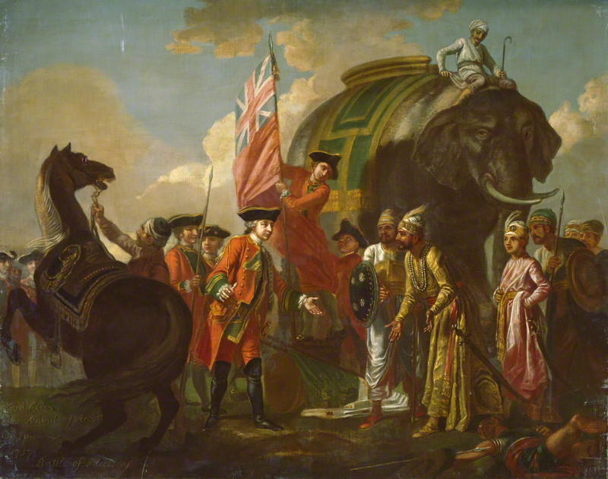
Robert Clive and Mir Jafar after the Battle of Plessey, 1757. By Francis Hayman (who had never visited India). First displayed in 1762. Mir Jafar had supported Clive against the French backed force during the battle. Jafar was rewarded with being appointed the new Nawab of Bengal while Clive became Governor.
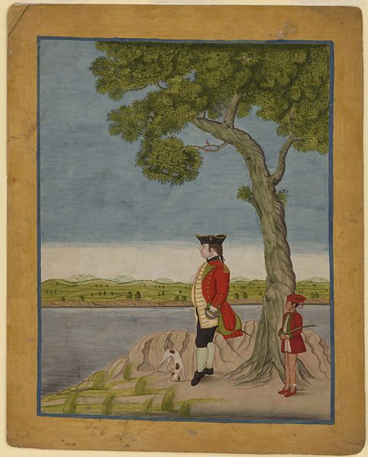
A painting of an East India Company official, unknown Indian artist, approximately c1770. The painting is the Mughal Murshidbad style (note the lack of perspective) but shows clear western influences, particularly the tree, influenced by English watercolourists.
From Lord William Bentinck on the Suppression of Sati, 8 November 1829. Bentinck was Governor-General of India between 1828-1835. This is an excerpt from a document presented to the rest of the East India Company administration outlining his policy on Sati (Suttee).
I have now to submit for the consideration of Council the draft of a regulation enacting the abolition of satis... It is only in the previous processes, or during the actual performance of the rite, when the feelings of all may be more or less roused to a high degree of excitement, that I apprehend the possibility of affray or of acts of violence through an indiscreet and injudicious exercise of authority. It seemed to me prudent, therefore, that the police, in the first instance, should warn and advise, but not forcibly prohibit, and if the sati, in defiance of this notice, were performed, that a report should be made to the magistrate, who would summon the parties and proceed as in any other case of crime....
The first and primary object of my heart is the benefit of the Hindus. I know nothing so important to the improvement of their future condition as the establishment of a purer morality, whatever their belief, and a more just conception of the will of God. The first step to this better understanding will be dissociation of religious belief and practice from blood and murder. They will then, when no longer under this brutalizing excitement, view with more calmness acknowledged truths. They will see that there can be no inconsistency in the ways of Providence, that to the command received as divine by all races of` men, "No innocent blood shall be spilt," there can be no exception; and when they shall have been convinced of the error of this first and most criminal of their customs, may it not be hoped that others, which stand in the way of their improvement, may likewise pass away, and that, thus emancipated from those chains and shackles upon their minds and actions, they may no longer continue, as they have done, the slaves of every foreign conqueror, but that they may assume their first places among the great families of mankind? I disown in these remarks, or in this measure, any view whatever to conversion to our own faith. I write and feel as a legislator for the Hindus, and as I believe many enlightened Hindus think and feel.
Descending from these higher considerations, it cannot be a dishonest ambition that the Government of which I form a part should have the credit of an act which is to wash out a foul stain upon British rule, and to stay the sacrifice of humanity and justice to a doubtful expediency; and finally, as a branch of the general administration of the Empire, I may be permitted to feel deeply anxious that our course shall be in accordance with the noble example set to us by the British Government at home, and that the adaptation, when practicable to the circumstances of this vast Indian population, of the same enlightened principles, may promote here as well as there the general prosperity, and may exalt the character of our nation.

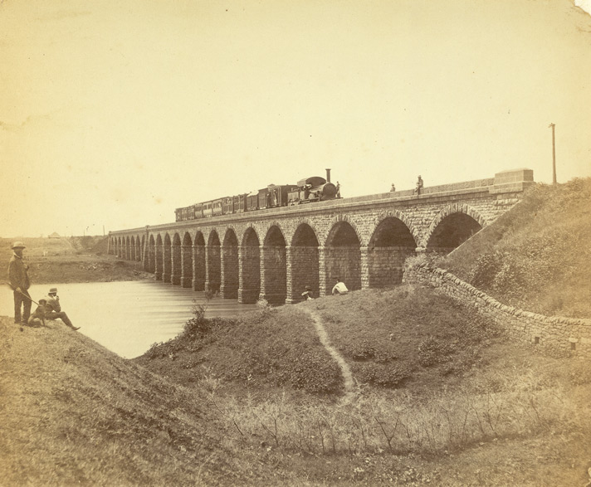Dapoorie Viaduct. Photography, unknown British photographer, 1855. Picture shows Dapoorie Viaduct over Mula River near Dapodie, which is a suburb of Pune.
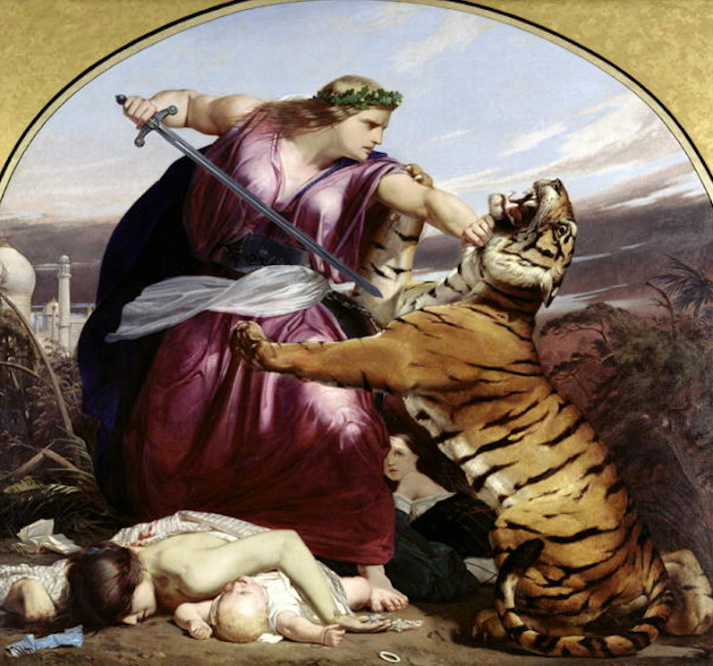
“Retribution” by Edward Armitage. Oil on canvas. 1858.
Commentary on the painting by J. Beavington Atkinson, in 1880:
“The figure personifies Britannia in the act of overthrowing the Bengal Tiger, the symbol of the bloodthirsty Sepoy. The carnage of war is seen around. The composition, it will be observed, is strictly symmetric, the forms are massive, the treatment is broad, the action dramatic, the idea noble. Such is the school with which Mr. Armitage has become identified.”
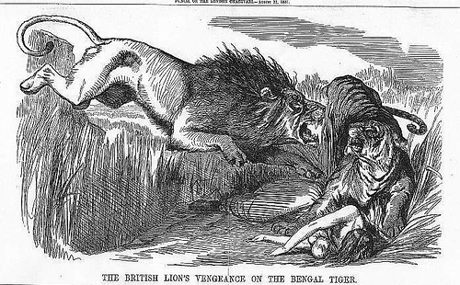
“The British Lions Vengeance on the Bengal Tiger”. Punch Magazine, 1858.
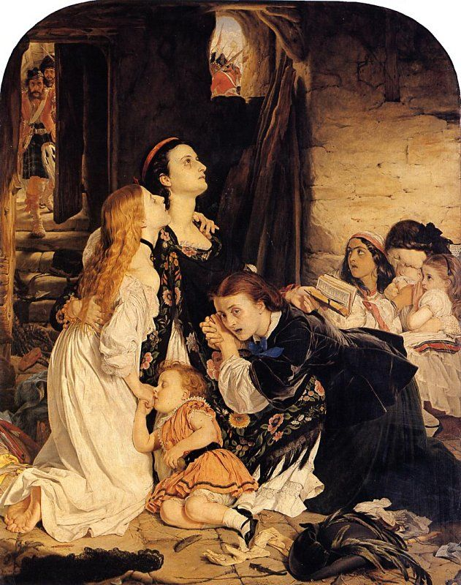
In Memoriam by Joseph Noel Patton. 1858. In the original painting, Patton had painted sepoys arriving to rape the women. This caused a sensation when it was first displayed in London and Patton painted over the sepoys and replaced them with Highlanders coming to the rescue, seen in this picture. An excellent analysis of this painting can be found at:
http://newhistories.group.shef.ac.uk/wordpress/wordpress/what-can-joseph-noel-paton%E2%80%99s-in-memoriam-tell-us-about-the-indian-mutiny/
From The Atlantic, an American news journal. Journalist Charles Creighton Hazewell reports on the aftermath of the Indian Mutiny. The Atlantic Monthly, Volume 01, No. 2, December, 1857
The settlement of the country, after these long disturbances, cannot be expected to take place at once; civil government has been too much interrupted to resume immediately its ordinary operation. But as this great revolt has had in very small degree the character of a popular rising, and as the vast mass of natives are in general not discontented with the English rule, order will be reëstablished with comparative rapidity, and the course of life will before many months resume much of its accustomed aspect.
The struggle of the trained and ambitious classes against the English power will but have served to confirm it. The revolt overcome, the last great danger menacing English security in India will have disappeared. England will have learnt much from the trials she has had to pass through, and that essential changes will take place within a few years in the constitution of the Indian government there can be no doubt. But it is to be remembered that for the past thirty years, English rule in India has been, with all its defects, an enlightened and beneficent rule. The crimes with which it has been charged, the crimes of which it has been guilty, are small in amount, compared with the good it has effected. Moreover, they are not the result of inherent vices in the system of government, so much as of the character of exceptional individuals employed to carry out that system, and of the native character itself.—But on these points we do not propose now to enter.
If the close of this revolt be not stained with retaliating cruelties, if English soldiers remember mercy, then the whole history of this time will be a proud addition to the annals of England. For though it will display the incompetency and the folly of her governments, it will show how these were remedied by the energy and spirit of individuals; it will tell of the daring and gallantry of her men, of their patient endurance, of their undaunted courage, and it will tell, too, with a voice full of tears, of the sorrows, and of the brave and tender hearts, and of the unshaken religious faith supporting them to the end, of the women who died in the hands of their enemies. The names of Havelock and Lawrence will be reckoned in the list of England's worthies, and the story of the garrison of Cawnpore will be treasured up forever among England's saddest and most touching memories.
Statement of Mohammed Ali Khan, a captured sepoy mutineer. This was his statement made shortly before he was executed in 1857
BACKGROUND INFO: Mahomed Ali Khan, a trained engineer, had gone to Britain twice as part of diplomatic delegations. Having just quit service to the East India Company in disgust at its racist discrimination against him. The following excerpt comes from the memoir of a Scottish soldier who fought in India to suppress Indians in 1857. In late February 1858 at Oonao, his regiment, the 93rd Highlanders, captured Mohammed Ali Khan who, disguised as a plum-cake vendor under the name Jamie Green, was scouting out their positions on behalf of the Indian army based in Lucknow , the capital of Awadh. Forbes-Mitchell recorded Mohammed Ali Khan's life-story just before the British executed him without trial. [Michael Fisher]
'I am the chief engineer of the army of Lucknow , and came out on a reconnoitring expedition, but Allah has not blessed my enterprise. I intended to have left on my return to Lucknow this evening, and if fate had been propitious, I would have reached it before sunrise to-morrow, for I had got all the information which was wanted; but I was tempted to visit Oonao once more, being on the direct road to Lucknow...and it was my misfortune to encounter that son of a defiled wretch who, to save his own neck from the gallows (for he first sold the English), now wishes to divert attention from his former rascality by selling the lives of his own countrymen and co-religionists.'"
"You ask me...what my name is, and state that you intend to write an account of my misfortune to your friends in Scotland . Well, I have no objection. The people of England ,--and by England I mean Scotland as well—are just, and some of them may pity the fate of this servant of Allah. I have friends in both London and Edinburgh , for I have twice visited both places. My name is Mahomed Ali Khan. I belong to one of the best families of Rohilcund, and was educated in the Bareilly College , and took the senior place in all English subjects. From Bareilly College I passed to the Government Engineering College at Roorkee, and studied engineering for the Company's service, and passed out the senior student of my year, having gained may marks in excess of all the European pupils, both civil and military. But what was the result? I was nominated to the rank of jemadar of the Company's engineers, and sent to serve with a company on detached duty on the hill roads as a native commissioned officer, but actually subordinate to a European sergeant, a man who was my inferior in every way, except, perhaps, in mere brute strength, a man of little or no education, who would never have risen above the grade of a working-joiner in England. Like most ignorant men in authority, he exhibited all the faults of the Europeans which most irritate and disgust us, arrogance, insolence, and selfishness. Unless you learn the language of my countrymen, and mix with the better-educated people of this country, you will never understand nor estimate at its full extent the mischief which one such man does to your national reputation. One such example is enough to confirm all that your worst enemies can say about your national selfishness and arrogance, and makes the people treat your pretensions to liberality and sympathy as mere hypocrisy. I had not jointed the Company's service from any desire for wealth, but from the hope of gaining honourable service; yet on the very threshold of that service I met with nothing but disgrace and dishonour, having to serve under a man whom I hated, yea, worst than hated, whom I despised. I wrote to my father, and requested his permission to resign, and he agreed with me that I, the descendant of princes, could not serve the Company under conditions such as I have describes. I resigned the service and returned home, intending to offer my services to his late Majesty Nussir-ood-Deen, King of Oude; but just when I reached Lucknow I was informed that his Highness Jung Bahadoor of Nepal, who is now at Goruckpore with an army of Goorkhas coming to assist in the loot of Lucknow, was about to visit England, and required a secretary well acquainted with the English language. I at once applied for the post, and being well backed by recommendations both from native princes and English officials, I secured the appointment, and in the suite of the Maharaja I landed in England for the first time, and, among other places, we visited Edinburgh, where your regiment, the Ninety-Third Highlanders, formed the guard of honour for the reception of his Highness. Little did I think when I saw a kilted regiment for the first time, that I should ever be a prisoner in their tents in the plains of Hindustan; but who can predict or avoid his fate?
"Well, I returned to India , and filled several posts at different native courts till 1854, when I was again asked to visit England in the suite of Azeemoolla Khan, whose name you must have often heard in connection with this mutiny and rebellion. On the death of the Peishwa, the Nana had appointed Azeemoolla Khan to be his agent. He, like myself, had received a good education in English, under Gunga Deen, head-master of the Government school at Cawnpore . Azeemoolla was confident that, if he could visit England, he would be able to have the decrees of Lord Dalhousie against his master reversed, and when I joined him he was about to start for England, well supplied with money to engage the best lawyers, and also to bribe high officials, if necessary. But I need not give you any account of our mission. You already know that, so far as London drawing-rooms went, it proved a social success, but as far as gaining our end a political failure; and we left England after spending over £50,000, to return to India via Constantiople in 1855. From Constantinople we visited the Crimea, where we witnessed the assault and defeat of the English on the 18 th of June, and were much struck by the wretched state of both armies in front of Sebastopol . Thence we returned to Constantinople, and there met certain real or pretended Russian agents, who made large promises of material support if Azeemoolla could stir up a rebellion in India . It was then that I and Azeemoolla formed the resolution of attempting to overthrow the Company's Government, and, Shook'r Khooda! we have succeeded in doing that; for from the newspapers that you lent me, I see that the Company's raj has gone, and that their charter for robbery and confiscation will not be renewed. Although we have failed to wrest the county from the English, I hope we have done some good, and that our lives will not be sacrificed in vain; for I believe direct government under the English parliament will be more just than that of the Company, and that there is yet a future before my oppressed and downtrodden countrymen, although I shall not live to see it.
"I do not speak, sahib , to flatter you or to gain your favour. I have already gained that, and I know that you cannot help me any further than you are doing, and that if you could, your sense of duty would not let you. I know I must die; but the unexpected kindness which you have shown to me has caused me to speak my mind. I came to this tent with hatred in my heart, and curses on my lips; but your kindness to me, unfortunate, has made me, for the second time since I left Lucknow , ashamed of the atrocities committed during this rebellion. The first time was a Cawnpore a few days ago, when Colonel Napier of the Engineers was directing the blowing up of the Hindoo temples on the Cawnpore ghat , and a deputation of Hindoo priests came to him to beg that the temples might not be destroyed. 'Now, listen to me,' said Colonel Napier in reply to them; 'you were all here when our women and children were murdered, and you also well know that we are not destroying these temples for vengeance, but for military considerations connected with the safety of the bridge of boats. But if any man among you can prove to me that he did a single act of kindness to any Christian man, woman, or child, nay, if he can even prove that he uttered one word of intercession for the life of any one of them, I pledge myself to spare the temple where he worships.' I was standing in the crowd close to Colonel Napier at the time, and I thought it was bravely spoken. There was no reply, and the cowardly Brahmins slunk away...I was so impressed with the justness of Napier's remarks that I too turned away, ashamed."
On this I asked him, "Were you in Cawnpore when the Mutiny broke out?" To which he replied: "No, thank God! I was in my home in Rohilcund; and my hands are unstained by the blood of any one, excepting those who have fallen in the field of battle. I knew that the storm was about to burst, and had gone to place my wife and children in safety, and I was in my village when I heard the news of the mutinies t Meerut and Bareilly . I immediately hastened to join the Bareilly brigade, and marched with them for Delhi . There I was appointed engineer-in-chief, and set about strengthening the defences by the aid of a party of the Company's engineers which had mutinied on the march from Roorkee to Meerut . I remained in Delhi till it was taken by the English in September. I then made my way to Lucknow with as many men as I could collect of the scattered forces. We first marched to Muttra, where we were obliged to halt till I threw a bridge of boats across the Jumna for the retreat of the army. We had still a force of over thirty thousand men under the command of Prince Feroz Shah and General Bukht Khan. As soon as I reached Lucknow I was honoured with the post of chief-engineer. I was in Lucknow in November when your regiment assisted to relieve the Residency. I saw the horrible slaughter in the Secundrabagh. I had directed the defences of that place the night before, and was looking on from the Shah Nujeff when you assaulted it. I had posted over three thousand of the best troops in Lucknow in the Secundrabagh, as it was the key of the position, and not a man escaped. I nearly fainted; my liver turned to water when I saw the green flag pulled down, and a Highland bonnet set up on the flag-staff which I had erected the night before. I knew then that all was over, and directed the guns of the Shah Nujeff to open fire on the Secundrabagh. Since then I have planned and superintended the construction of all the defensive works in and around Lucknow . You will see them when you return, and if the sepoys and artillerymen stand firmly behind them, many of the English army will lose the number of their mess, as you call it, before you again become masters of Lucknow ."
SOURCE: Forbes-Mitchell, William, Reminiscences of the Great Mutiny 1857-59 (London: Macmillan, 1894)

Dadabhai Naoroji: The Benefits of British Rule, a short essay published in 1871. Naoroji was one of the co-founders of the Indian National Congress and the first Indian to sit as an MP in Westminster.
The Benefits of British Rule for India:
In the Cause of Humanity: Abolition of suttee and infanticide. Destruction of Dacoits, Thugs, Pindarees, and other such pests of Indian society. Allowing remarriage of Hindu widows, and charitable aid in time of famine. Glorious work all this, of which any nation may well be proud, and such as has not fallen to the lot of any people in the history of mankind.
In the Cause of Civilization: Education, both male and female. Though yet only partial, an inestimable blessing as far as it has gone, and leading gradually to the destruction of superstition, and many moral and social evils. Resuscitation of India's own noble literature, modified and refined by the enlightenment of the West.
Politically: Peace and order. Freedom of speech and liberty of the press. Higher political knowledge and aspirations. Improvement of government in the native states. Security of life and property. Freedom from oppression caused by the caprice or greed of despotic rulers, and from devastation by war. Equal justice between man and man (sometimes vitiated by partiality to Europeans). Services of highly educated administrators, who have achieved the above-mentioned results.
Materially: Loans for railways and irrigation. Development of a few valuable products, such as indigo, tea, coffee, silk, etc. Increase of exports. Telegraphs.
Generally: A slowly growing desire of late to treat India equitably, and as a country held in trust. Good intentions. No nation on the face of the earth has ever had the opportunity of achieving such a glorious work as this. I hope in the credit side of the account I have done no injustice, and if I have omitted any item which anyone may think of importance, I shall have the greatest pleasure in inserting it. I appreciate, and so do my countrymen, what England has done for India, and I know that it is only in British hands that her regeneration can be accomplished. Now for the debit side.
The Detriments of British Rule:
In the Cause of Humanity: Nothing. Everything, therefore, is in your favor under this heading.
In the Cause of Civilization: As I have said already, there has been a failure to do as much as might have been done, but I put nothing to the debit. Much has been done, though.
Politically: Repeated breach of pledges to give the natives a fair and reasonable share in the higher administration of their own country, which has much shaken confidence in the good faith of the British word. Political aspirations and the legitimate claim to have a reasonable voice in the legislation and the imposition and disbursement of taxes, met to a very slight degree, thus treating the natives of India not as British subjects, in whom representation is a birthright. Consequent on the above, an utter disregard of the feelings and views of the natives. The great moral evil of the drain of wisdom and practical administration, leaving none to guide the rising generation.
Financially: All attention is engrossed in devising new modes of taxation, without any adequate effort to increase the means of the people to pay; and the consequent vexation and oppressiveness of the taxes imposed, imperial and local. Inequitable financial relations between England and India, i.e., the political debt of ,100,000,000 clapped on India's shoulders, and all home charges also, though the British Exchequer contributes nearly ,3,000,000 to the expense of the colonies.
Materially: The political drain, up to this time, from India to England, of above ,500,000,000, at the lowest computation, in principal alone, which with interest would be some thousands of millions. The further continuation of this drain at the rate, at present, of above ,12,000,000 per annum, with a tendency to increase. The consequent continuous impoverishment and exhaustion of the country, except so far as it has been very partially relieved and replenished by the railway and irrigation loans, and the windfall of the consequences of the American war, since 1850. Even with this relief, the material condition of India is such that the great mass of the poor have hardly tuppence a day and a few rags, or a scanty subsistence. The famines that were in their power to prevent, if they had done their duty, as a good and intelligent government. The policy adopted during the last fifteen years of building railways, irrigation works, etc., is hopeful, has already resulted in much good to your credit, and if persevered in, gratitude and contentment will follow. An increase of exports without adequate compensation; loss of manufacturing industry and skill. Here I end the debit side.
Summary: To sum up the whole, the British rule has been: morally, a great blessing; politically, peace and order on one hand, blunders on the other; materially, impoverishment, relieved as far as the railway and other loans go. The natives call the British system "Sakar ki Churi," the knife of sugar. That is to say, there is no oppression, it is all smooth and sweet, but it is the knife, notwithstanding. I mention this that you should know these feelings. Our great misfortune is that you do not know our wants. When you will know our real wishes, I have not the least doubt that you would do justice. The genius and spirit of the British people is fair play and justice.
From the Penny Illustrated Paper, February 14th 1874. Reporting on the Bihar famine of 1873-1874. The Bihar famine was dealt with very effectively by the Bengal government, and despite the claim of the source, there were no mortalities. However the Lieutenant Governor of Bengal, Sir Richard Temple was criticised for being too generous with famine relief.
THE BENGAL FAMINE.
Queen Victoria, ever compassionate when any of her subjects are overtaken by distress, has acted well up to her title of Empress of India. Her Majesty has headed the Bengal Famine Relief Fund with a subscription of £1000. Right warmly did the Calcutta meeting cheer on the 4th last, when the Viceroy announced the generous gift from the Queen.
Lord Northbrook’s alarming statement at the meeting in question plainly showed how urgent it is that the people of England should at once follow the example of her majesty and send a stream of money flowing to swell the relief fund started not a moment too soon, by Lord Mayor Lusk. The Viceroy declared that the failure of crops affected a population exceeding that of Great Britain. Notwithstanding the rain, a population exceeding that of Ireland must suffer protracted and severe distress. He warmly represented the people’s patience and the powerful claims which their affliction gave on their rulers and urged that assistance should be obtained by the public. The meeting subscribed £13,000. Sir Richard Temple has telegraphed that there is severe distress among 1,500,000 persons who are without help. There is great mortality and depopulation.
By Lt-Col. Richard Osbourne, a civil servant working in the North West Provinces in India. Here he describes the Great Famine of 1876-1878 From The Contemporary Review, Summer 1878 a quarterly news journal. He was a witness to these events and a critic of British Policy, particularly Sir Richard Temple’s refusal to grant sufficient famine relief.
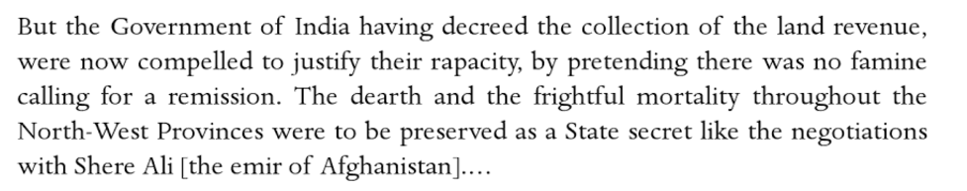
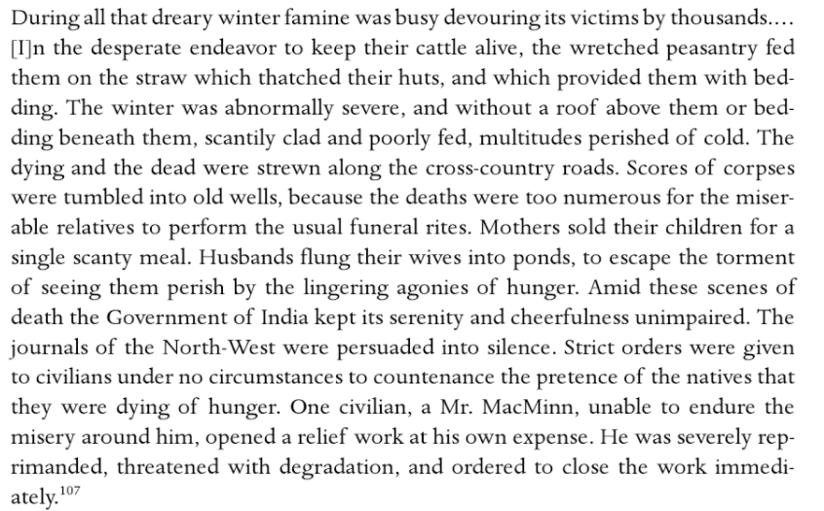
From the resolutions of the Indian National Congress, published in 1885
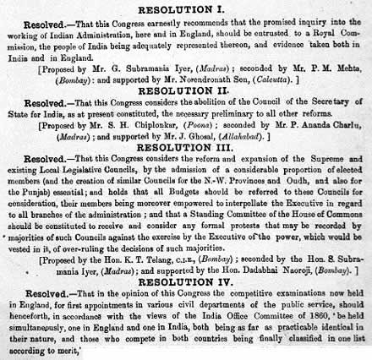
The Garden at Bombay University. Photograph, c1890. Recoloured.
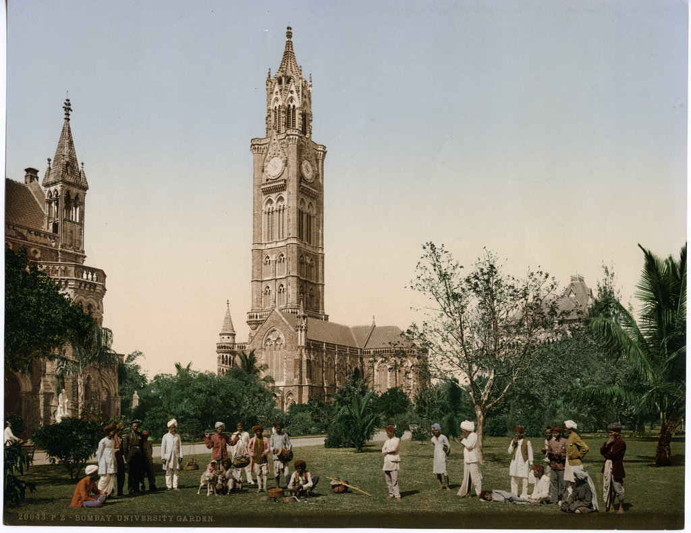
Extract from a government report describing the situation on the North West Frontier of India in 1895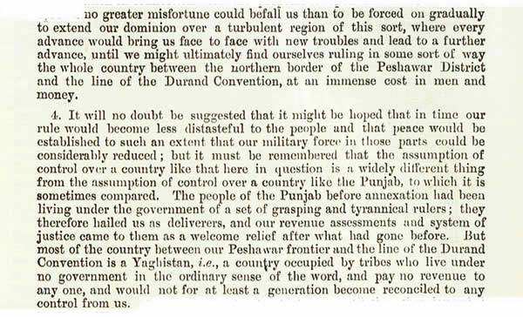
The Hyderabad Contingent Polo Team, photograph taken in 1900.
From a speech to the Indian National Congress in 1907 by Bal Gangadhar Tilak (1856-1920)
Two new words have recently come into existence with regard to our politics, and they are Moderates and Extremists. These words have a specific relation to time, and they, therefore, will change with time. The Extremists of today will be Moderates tomorrow, Just as the Moderates of today were Extremists yesterday. When the National Congress was first started and Mr. Dadabhai's views, which now go for Moderates, were given to the public, he was styled an Extremist, so that you will see that the term Extremist is an expression of progress.
One thing is granted, namely, that this government does not suit us. The government of one country by another can never be a successful, and therefore, a permanent government. There is no difference of opinion about this fundamental proposition between the old and new schools. One fact is that this alien government has ruined the country. In the beginning, all of us were taken by surprise. We were almost dazed. We thought that everything that the rulers did was for our good and that this English government has descended from the clouds to save us…
We have perceived one fact, that the whole of this administration, which is carried on by a handful of Englishmen, is carried on with our assistance. We are all in subordinate service. This whole government is carried on with our assistance and they try to keep us in ignorance of our power of cooperation between ourselves by which that which is in our own hands at present can be claimed by us and administered by us. The point is to have the entire control in our hands. I want to have the key of my house, and not merely one stranger turned out of it. Self-government is our goal; we want a control over our administrative machinery. We don't want to become clerks and remain [clerks]. At present, we are clerks and willing instruments of our own oppression in the hands of' an alien government, and that government is ruling over us not by its innate strength but by keeping us in ignorance and blindness to the perception of this fact.

Appendix 2: Secondary sources.
Empire – Niall Ferguson (2004)
Guardian review by Linda Colley – “In to the belly of the beast”
Empire, it seems, is coming out of the closet. For decades, it has mainly provoked condemnation or at best discreet nostalgia. But no longer. At one level, there is now a new Museum of the British Empire in Bristol and a welter of new books on the subject. At another, politicians and pundits in Washington and London are talking openly about the desirability of reordering the less fortunate parts of the world, by force if necessary. And now we have Niall Ferguson's new television series, of which this is the book, arguing in 1066 and All That fashion that Britain's version of empire was more a "good thing" than a bad, an essential engine of modernity.
As history (and as television), Empire exhibits all of Ferguson's customary virtues. It is clever. It is audacious and pacily written. It surveys a broad span of time and is characterised throughout by a strong understanding of economics. But is it right?
Certainly the organisation is a miracle of concision. Ferguson divides his near 400-year story into six chapters/programmes. He starts with Britain's own commerce and consumerism, its lust for sugar drawing it to the Caribbean, its taste for fine fabrics, spices and tea enticing it into India. He then looks at the role of voluntary and involuntary emigration, among blacks and whites, and at missionaries and reformers. Chapters four and five deal with the hardworking bureaucrats and patrician proconsuls, and with the quantum rise in military coercive capacity in the late 19th century; how the Maxim gun and later the aeroplane scattered rebellious, ill-equipped colonial subjects across red-soaked battlefields like "dirty bits of newspaper".
The final chapter tells how the European powers became caught up and consumed after 1914 by the same kinds of hi-tech violence they had previously launched against other continents. It was this crisis, Ferguson argues, and the emergence of other, newer empires, Japan, Germany, and the United States - rather than the actions and aspirations of colonial nationalists - that terminally undermined Britain's own brand of global supremacy. Empire itself, however, endured: and this, he concludes, is all to the good.
Throughout, Ferguson offers a bracing corrective to those cruder critics who persist in analysing the empire only in terms of racism, violence and exploitation. He draws attention, as others have done, to its episodes of idealism, creativity and administrative integrity, to its many examples of overlap and collaborations between different peoples, and above all to its historical context. He is almost certainly correct in arguing that the alternative to Britain's global inroads would not have been a pure, unsullied world, but rather the emergence of other empires that might have been worse.
Yet this kind of balance-sheet approach to empire has its limitations. Enquiring whether this or any other empire was a "good" or a "bad" thing is historically bogus, because answers to this question vary so much according to when, what and who you choose to look at, and, critically, according to who you are. Focus, for example, on Britain's role in the slave trade in the 18th century, and its empire seems an early holocaust. But concentrate instead on how Royal Navy seamen sacrificed their time and lives hunting down other countries' slavers in the 19th century, and one can feel proud of Pax Britannica. Look at how the British covered India with railroads, and it is easy to view them as modernisers. Look, however, at the abysmal levels of mass illiteracy in the subcontinent they left behind in 1947, and they appear rather differently. Ferguson knows this, of course, and is too good a historian to omit the dark sides of his subject: but he does stack the deck.
He devotes very limited space to the empire's earlier, more amoral centuries, preferring to focus on the Victorians and their successors. So while the destruction of native Americans by English colonists' germs and guns in the 17th century gets two paragraphs, heroic David Livingstone receives more than a dozen pages. Ferguson also exaggerates the degree to which British imperialism was distinctive and better. The idea, for instance, that it was the Victorians who invented the notion that overseas initiatives should be for God not gain would have astounded those French, Portuguese and Spanish Catholic Fathers who had earlier devoted far more care to the indigenous peoples of the Americas than many of their Anglo, Protestant competitors.
The most problematic issue raised but not resolved here, however, is the question of what criteria are to be invoked when assessing empire. Doubtless many of the Normans who invaded England in 1066 were decent chaps and they arguably made it a more efficient state, but the English themselves still referred for centuries to the "Norman yoke". By the same token, those who were once on the receiving end of British imperial invasions are less likely than us to view them in a positive light. Ferguson argues this is short-sighted because, whatever its faults, British empire fostered globalisation, overseas investment and free trade and - in the long run - this raised levels of prosperity all round. Possibly so: but individual human beings do not live by the free market alone and nor do they live in the long run. The immediate impact of British imperial free-trading was often the collapse of local indigenous industries which were in no position to compete, and a consequent destruction of livelihoods and communities.
This points to the tension at the heart of empire. Its exponents may seek (as many Britons genuinely did) to make the world a better place, but they also want to dominate. The Victorians wanted to spread the gospel of free trade, but they also wanted to continue being the premier workshop of the world. In much the same way, contemporary America wants (often with the best of intentions) the world to be wide open to its ideas, exports and technologies, but not if this means third-world nations developing weapons of mass destruction or the Europeans competing in space.
One of the reasons why we all need to stop approaching empire in simple "good" or "bad" thing terms, and instead think intelligently and enquiringly about its many and intrinsic paradoxes, is that versions of the phenomenon are still with us. Ferguson argues that the United States should cease being in denial about its imperial status and face up to its global responsibilities. The rest of us could also profitably cease being in denial. The British especially have no excuse for forgetting that empire is a most complex and persistent beast. And it has claws.

Review by Professor Andrew Porter in Reviews in History.ac.uk
Niall Ferguson is a glutton for exposure. From January to mid-February 2003 six one-hour television programmes, four lectures to substantial audiences in the University of London’s Senate House, and a large glossy book have been devoted to his theme of ‘empire’ or, as he also puts it, ‘how Britain made the modern world’. Elsewhere, for example in The Times (6-7 January 2003), there have been extracts taken from the book. What was the point of all this activity, including as it did a two year crash-course in selected reading from the recent subject literature and extensive globe-trotting? Was its upshot, as Ferguson asks of the empire itself, ‘a good or a bad thing’?

Considering the published output, as with ‘the empire’ of the past, this is in many respects a pointless question, for the answer depends on where questioners stand and what in particular they choose to look at. From the point of view of personal enrichment, Ferguson himself doubtless found the operation of the free media market a very good thing, as will his publisher. In terms of entertainment, pleasure, a measure of general interest or instruction, and stimulation, many of the 2.5 million viewers of Channel 4’s offerings will have felt themselves well rewarded, if two Daily Telegraph reviews (10 and 24 January 2003) and a column after the first episode by William Rees-Mogg in The Times are anything to judge by. Others, who as one might naturally expect received nothing from the proceeds, either were soothed by Ferguson’s Scottish lilts and burrs, or were driven to apoplectic outbursts. Among the latter was Jon Wilson in The Guardian (8 February 2003), condemning (with an alliteration worthy of Ferguson himself) what appeared to him a ‘glossy glorification of imperial violence’, possessing a tendency to ‘encourage policy based on a version of the history of empire that is simply wrong’.(1)
Such points about the reception of Ferguson’s work in their limited way parallel the historic experience and impact of empire itself. It was almost everywhere far too multi-faceted or ambiguous for the application of crude general labels, ‘good’ or ‘bad’, to do justice to the complex issues involved. This was from the start an insurmountable problem for a subject rightly treated as global in scope, which also demanded a chronological coverage from the late sixteenth to the early twenty-first century. Although Ferguson devotes significantly more space to the period after circa 1800, the problem remains.
However, doing justice to complex issues can also be understood in different ways. The demonstration of complexity may take the form of impressing audiences with inescapable detail, illustrating in the process the inadequacy of current generalizations and conventional views. Alternatively, it can entail the ruthless imposition of dominant themes on a heap of fact, winnowing and threshing until a mountain of factual chaff has been bagged and fairly stored in its proper – subordinate – place. Ferguson evidently wishes to do both of these things. Fond of phrases such as ‘most people assume’, ‘nowadays it is quite common to think’, he sees himself as a new radical, despatching to its resting place a tired conventional wisdom that holds empire to have been always either exploitative, or unnecessary, and everywhere thoroughly wasteful for both colonisers and colonised (pp. xviii-xix). This he does by drawing out the legacies of Britain’s empire. He offsets the brutality and destruction associated with slavery, piracy, and events such as the Morant Bay rebellion (1865) or the Amritsar massacre (1919), with factual information to illustrate the triumph of capitalism, the spread of parliamentary institutions, the growth of literacy, recognition of the virtues of the minimal state, and the rule of law (pp. xxiv-xxv). The dominant theme he wields in order to corral untidy detail is that of ‘globalization’, a process in which Britain’s empire more than any other agency promoted ‘the optimal allocation of labour, capital and goods in the world’ (p. xx). Ferguson has no doubt that Empire ‘enhanced global welfare – in other words was a Good Thing’.
In both cases, Ferguson metes out rough justice to complexity. It is easy to find examples of conventionally wholly critical or uncritical judgements on empire, but Ferguson is misguided in assuming that these persist in the absence of an historical literature providing material for more discriminating and nuanced assessments of empire’s record. The survival and persistence of those judgements reflect not persuasion but inadequate reading and thought, conditions unlikely to be disturbed by the appearance of a new set of no less conventional views. Ferguson’s own ‘on-balance-beneficial’ legacy of empire offers no new insight but rather the refurbishment of a much older conventional – some would say Whiggish – wisdom. Far from updating our view of empire, in highlighting the interplay of ‘liberty’ and ‘slavery’, Ferguson looks backward to an outdated literature, and at times is consequently wide of the mark – as when assessing the significance of the Durham Report as ‘the book which saved the empire’ (pp. 111-13). As for ‘globalization’, now well-established as a fashionable resort for the conceptually starved, what does one make of the claim that it optimises the allocation of material resources? When one man’s optimum can so easily encompass another’s poverty, just as orthodoxy and heresy may be interchangeable, these can too easily become weasel words, traps for the unwary even if the statistics of measurement such as GDP are to be relied upon, which often they are not. Arrangements optimal for the continued working of a system of exchange may not necessarily be so when assessed in terms of individual or even communal wellbeing.
Inevitably there will be those who wonder whether such over-simplifications are not merely the product of a television producer’s requirements triumphing over the historian’s need for greater attention to the difficulty of presenting major historical problems in any visual format. After all, Ferguson’s book is very much the book of the film, a fleshier version of what is for the most part clearly spelt out on the screen. There is little evidence of an opportunity being taken to refine arguments rather than thicken narrative. For example, the movement from British abolition of the slave trade to the emancipation of the empire’s slaves was far less smooth and confident than is suggested here (p. 122). Sir Charles Dilke’s book Problems of Greater Britain (Macmillan; London, 1890) is mentioned, but not his earlier Greater Britain (Macmillan; London, 1868), presumably because that would upset an argument linking the term ‘Greater Britain’ to J. R. Seeley’s Expansion of England (London; Macmillan) published in 1883 (pp. 246-7).
That said, however, the visual aspects of the programmes and the illustrations in the book are often splendid and fresh to the eye. The programmes are certainly best seen well spaced. Consecutive videos are too likely to impress viewers with the limits to both the range of available visual devices and the film-maker’s budget. There are many suns setting, plenty of light on water, frequent shots of Ferguson in boats or canoes, the sound of his foot-fall on floorboards crossing to a window or to a mahogany table for displaying a document. Cuttings, for example from the same colourful Indian scene, provide the backdrop or continuity on more than one occasion. The book in one respect at least is more modest – readers are not treated to the screen’s many instances of full-frontal Ferguson poised to make eye contact with a key pronouncement about liberty or slaves. Nevertheless, precisely the same points are made on the page, decked out with the same catchy or demotic phraseology. Ferguson has a quick eye for the riveting analogy – New South Wales, ‘the eighteenth-century equivalent of Mars’, where Australians ‘started out as a nation of shoplifters’ (pp. 103, 106). Arresting, yes, but not always apposite (for reasons which, in this case, Joseph Banks might have explained), and so at risk of disguising reality with cosmetic flippancy.
It is strange that someone such as Ferguson, well-acquainted with thinking about virtual history, other possible outcomes to any chance sequence of events, and alternative futures, should comprehensively ignore this analytical dimension in the case of empire. Occasional references are made, for instance, to the possibility of a French not a British victory in mid-eighteenth-century India. In calculating imperial Britain’s favourable legacy, the twentieth-century alternative empires of Germany, Italy and Japan are cited to provide horrific counterweights, had they managed to turn conquest into more than temporary colonial controls. At the same time, however, Ferguson seems to believe that for most areas of the world the experience of imperial rule offered the only way to the future. This begs many questions. Why, for example, should one assume that eighteenth-century India could not have evolved its own economic path, with distributions of capital, labour and goods ‘optimal’ in the eyes of its own elites however different from the criteria of liberal western political economists? The work of regional historians gives grounds for disputing such an assumption, and thus for questioning perceptions of backwardness and modernity conditioned in the west, but Ferguson does not pay it any attention.
After alternative histories, it is perhaps worth probing further Ferguson’s use of the term ‘globalization’. How is it to be understood, either in chronological terms, or functionally? His terminology refers to ‘modern globalization’ (pp. xix-xx), but also to earlier eras or phases of globalization. Sometimes these appear to be separated out and discontinuous, but he also knits them together in a single period and process. Should globalization be taken to mean little more than the far-flung existence of even limited economic activity involving a major power’s (e.g. Britain’s) nationals? Or is it to be understood as an active process of territorial integration into a world-wide market economy? In both cases, ‘globalization’ is apparently a continuing feature, albeit one, Ferguson seems to suggest, in which the phase 1850-1914 was characterised by the economic equalization of incomes, and the second half of the twentieth century was one of mounting economic divergence and inequality. There is a fuzziness here in the handling of globalization, whether as concept, descriptive category, or economic process, that needs to be cleared away.
This need for clarity is further indicated by Ferguson’s lack of sustained attention to the history of globalization stretching back well before 1815. There is much in the history of the seventeenth and eighteenth centuries to support the view that a process of globalization was also then underway. Ferguson himself refers in passing to the seventeenth century’s ‘globalization with gunboats’ (p.18). Doubtless the balance of power and wealth among, and so the contribution made by, participating states was then different from that which developed later on; and ‘globalization’ had perhaps not yet become global in its reach. It may be debated whether there was a distinctly ‘early modern globalization’, or merely an earlier phase of a single process. It is more important, however, to recognise that the prominence of war and economic protection or monopolization meant that the characteristics of that earlier age were very different from, and the process of globalization was largely driven by forces unlike, those that Ferguson suggests operated during the British-dominated phase of globalization after 1850.
If it is accepted that there was an early modern globalization under way well before the French Revolutionary and Napoleonic wars, that its momentum owed much to war both internationally and on local colonial frontiers, and that the prominent role of Britain in the Caribbean, North America, and parts of Asia means that it too deserves the ghastly appellation of ‘Anglobalization’ (p. xxiii), then this has implications for Ferguson’s portrayal of the post-1850 period. From then onwards Ferguson seems to allow that the global accumulation of wealth was promoted only by an increasing absence of restraint on the movement of people (labour migration), the flow of capital (external investment), and produce from land (overseas commerce). This argument is unpersuasive because it ignores the role of war, economic protection, and strategic calculation, persisting from that earlier period, in the continuing growth of a global economy. Britain’s many colonial wars in the nineteenth century and beyond were an essential aid to the incorporation of new territories into her own empire, and to the expansion of free trade both within her colonies and into areas beyond the reach of her direct rule. Furthermore, in Ferguson’s contemporary age of ‘modern globalization’, echoes of the early modern period are to be found in the way in which world economic patterns are decisively shaped by the protectionist agenda of the United States and the states which have come to make up the European Union, notably in respect of their domestic agriculture.

This last observation directs us not only to the compatibility of continuing globalization with partially-closed economies, but also to the limitations of free trade arrangements historically associated with the pursuit of an open global economy. Contrary to much current thinking, Ferguson wishes us to accept that the priority attached by Britain to free trade, free labour migration, and unfettered capital movements, was beneficial to Britain itself, to its empire, and to the world at large. The extension of her empire not least contributed to the global growth of GDP, because Britain was the ‘least protectionist’ of all the great powers. By this yardstick, the British empire was ‘a good thing’, British rule being largely supportive of economic growth. It can surely be argued that this simple standard requires a more critical consideration than Ferguson ever suggests that it might need.
Two points are fundamental. First, it is surely necessary to bear in mind that the pattern of free trade, particularly in the form of unlimited exchange of foodstuffs and raw materials for manufactured capital and consumer goods, generally operates over any significant period of time to the decided disadvantage of commodity producers. Free trade might become one of the pillars of ‘Anglobalization’ but at the same time was likely to restrict and impoverish the less economically ‘modernised’ party. The second follows from that: free trade cannot necessarily be equated with freedom of choice and opportunity. For example, the time at which any territory is drawn through the opening up of its trade into the globalizing economy can have a critical impact on its future development. The great variety of combinations of climate, geographical position, and natural endowment of resources, inevitably mean that each territory may be more or less well-placed to find its own niche in the range of economic openings prevailing at any one time. Hence, as Donald Denoon demonstrated in his Settler Capitalism (Clarendon; Oxford, 1983), temperate lands of white settlement, faced with exclusion from industrial and manufacturing options, not only evolved their own forms of capitalism but did so largely irrespective of their colonial or independent status. Moreover the distribution of any gains within individual states was often not directed to equalizing incomes. Ferguson is to be applauded for his realism in calling on historians at least to consider not ideal worlds but inescapably imperfect worlds, in which the option of ‘Anglobalization’ was if not the best, then perhaps the least worst course available. However, the reality of the imperialism of free trade that underlay this option was far more constraining and less benign than Ferguson seems to acknowledge. It was, of course, greatly to Britain’s own advantage as the world’s major industrial power for much of the nineteenth century that she should insist on the expansion of free trade, while at the same time facing little serious competition in the new markets she was exploiting.
A last comment relates still more directly to the persistent issue of costs and benefits. As befits any public performer, Ferguson is fond of catching his audience’s attention with striking juxtapositions of images and arguments. Stark intellectual polarities, however, can be a snare and delusion especially in the history of empire, so riddled as it is with complexities and ambiguity. In seeking to argue that the empire was not economically bad for both Britain and her colonies, Ferguson sets up an Aunt Sally no less grand and vulnerable than that constructed by some of the historians he criticises. Consider his inclusion in the bibliography to Chapter 5 of Robert Huttenback’s and Lance Davis’s Mammon and the Pursuit of Empire (Cambridge University Press; Cambridge), a book extensively debated when it appeared in 1986. Its messages have nonetheless not been taken heed of here. Whatever the problems presented by that work (and they were numerous), Davis and Huttenback confirmed above all the need to ask of imperial commitments and colonial possessions who benefited, from what, and when. In demonstrating that fortunately-placed individuals, particular social classes and identifiable types of business, in both metropole and colonies, gained or lost in varying degrees and at different times, they argued convincingly for a more discriminating and modulated scrutiny of the empire’s political economy than was then available. They also proved beyond doubt the crucial incidence of taxation and the costs of defence to any assessment of costs and benefits. Ferguson, however, seems in effect to argue that the association of global economic growth with both the element of redistribution inherent in the workings of a free-market system, and the existence of Britain’s free-trade empire, were sufficient – as Lewis Carroll would put it – for all to have prizes. That surely represents a significant retreat from the ground so usefully opened up to debate some fifteen years ago.

Review by Max Hastings in the Telegraph – “The right way to run an Empire”.
Most modern British schoolchildren are taught that imperialism was an unalloyed evil, of which slavery was the most conspicuous manifestation. Niall Ferguson is not blind to the shortcomings of the British Empire, but he argues that it brought trade and uncorrupt institutions to vast tracts of the globe.
In 1955 British per capita GDP was just seven times greater than that of Zambia. Today it is roughly 28 times. Most Africans are less well-off than under British rule, even if they have a vote and are no longer excluded from white clubs.
In 1946 there were 74 independent countries in the world. In 1995 there were 192. Such fragmentation has created a host of nation states too small to be economically effective. Almost the only advantage many former imperial possessions enjoy is a grasp of the English language. "No organisation in history has done more to promote the free movement of goods, capital and labour than the British Empire in the 19th and 20th centuries…to impose Western norms of law, order and governance around the world," says the author.
The British did not invent empire, indeed they were late venturers where the Spanish and Dutch had gone before. They began as predators and pirates, and found themselves, almost to their own surprise, masters of a substantial part of the known earth by the early 19th century: "They had robbed the Spaniards, copied the Dutch, beaten the French and plundered the Indians. Now they ruled supreme."
Ferguson's work is a handsomely illustrated by-product of a forthcoming Channel 4 series. It should not, however, be dismissed as a mere telly spin-off. This is an elegant and thoughtful survey of a great historic achievement. An achievement that has, characteristically, been snubbed by the iniquitous National Lottery, which has recently given money to an organisation for helping asylum-seekers, while refusing aid to John Letts's new Museum of the British Empire in Bristol.
Ferguson's book does not stint in recording imperial lapses and causes for shame, but it finally offers rich sources of pride. The British people did not merely exploit overseas investment, but themselves migrated in large numbers to build new lives on the other side of the world. In the 17th and 18th centuries, some 700,000 people left the mother country. At its peak in the 1640s, emigration was above two per 1,000. By the late 19th century, the colonies had become the indispensable ports of last resort for scapegrace younger sons and fallen idols unmasked by Sherlock Holmes.
In discussing the breakaway of the transatlantic colonies, Ferguson dismisses the notion that the Americans suffered substantial fiscal burdens to justify their alienation. Indeed, they were notable beneficiaries of free trade with Britain. The issue was the social and political treatment of the colonists by an insensitive government at home. "We won't be their Negroes," snarled John Adams. Yet at least a fifth of Americans remained loyal to the crown through the War of Independence. It is interesting that well over a century later, the megalomaniac Cecil Rhodes dreamed of restoring the United States to British dominion.
Ferguson reserves his harshest criticism for some aspects of British rule in India. It is difficult for any reasonable person today not to acknowledge the Great Mutiny of 1857 as a legitimate uprising by Indians against foreign despotism, enlightened or otherwise. Ferguson likens the behaviour of some of the British suppressing the Mutiny to that of Nazi SS men. He cites the example of a young Indian boy supporting a tottering old man, pleading for mercy from a British officer at the gates of Lucknow. The soldier simply cocked his revolver against the boy's head and pressed the trigger. Once, twice, three times, it misfired. At the fourth attempt, the officer killed the Indian. The only mitigation, says the author, is that British soldiers who saw the deed loudly reproached the killer.
The British tolerated famines which killed millions in India almost as indulgently as those which devastated Ireland. Their biggest mistake in the 20th century was to focus the attention of the Raj upon the native rulers, a doomed caste, and to ignore the rising educated Indian middle class. Upmarket Indians were as indifferent to the welfare of their own masses as the British, but they would not tolerate chronic slights to themselves: "Indian nationalism was fuelled not by the impoverishment of the many, but by the rejection of the privileged few," says Ferguson.
In his account of the imperial experience during the First World War, he highlights a point also made by Hew Strachan in his recent history of the conflict. John Buchan wrote a splendid romance, Greenmantle, about a German attempt to raise the Muslim world against the British. Yet this was not a fantasy, but a serious objective of the Kaiser's minions. It was frustrated partly because Englishmen like T. E. Lawrence proved incomparably more skilful in winning Arab hearts than were the Germans.
Britain lost its empire amid the exhaustion of will and resources that followed two world wars. The United States was implacably hostile, and only belatedly moderated its view when it saw that communism presented a vastly graver peril to civilisation. In the 19th century, British imperial defence costs had been amazingly low, and were easily financed by income from the nation's huge overseas investments. These were liquidated, with remarkable selflessness, to deliver the world from the Kaiser and later Hitler, while America made a healthy profit from its participation in both world wars.
After 1945, the Empire ceased to be a source of wealth to Britain, and became a cash drain. More than that, a new generation of Englishmen of whom the former Burma policeman George Orwell was not the least, simply did not believe any longer in their divine right to rule brown and black peoples.
It is ironic that just when schoolteachers' fervour against British imperialism is at its most shrill, not a few Western policy-makers are thinking furiously about empire's virtues. Ferguson compares Osama bin Laden to the Mahdi. When the dervishes threatened Egypt in 1898, Kitchener marched an army up the Nile, liberally supplied with maxim guns. He administered no end of a lesson at Omdurman, although Winston Churchill was only one of those who recoiled from the ruthlessness of the victors' conduct. Thereafter, the British governed the Sudan in exemplary fashion for half a century, through a tiny civil service second only in quality to that which ruled India.
Ferguson suggests that the United States is today attempting to create a pax Americana with many of the objectives of its British predecessor, but lacks the confidence or coherence to adopt long-term policies. In Somalia, Haiti, Kosovo, Afghanistan, Americans have intervened in the interests of local and international stability, but refuse to acknowledge the requirement to stick with a society once they have involved themselves in its destinies.
Perhaps if the United States learned to enjoy its power more, it might exercise it more effectively and sensitively. Winning a war in, for instance, Iraq, is the easy part of modern imperialism. Americans must also learn to master the harder part - making the conquered society work afterwards. That is, if they want to do half as well as the British did in preserving global peace.
Inglorious Empire – Shashi Tharoor (2017)
Review by Diarmaid Ferriter in the Irish Times
Chronicling the evils of British imperialism is imperative given the impact and legacy of that imperialism, and given the dishonest and selective nostalgia about it, not to mention downright ignorance. Almost 60 per cent of Britons were proud of the British Empire and almost 50 per cent thought it had made the colonies better off – a manifestation of what the scholar Paul Gilroy has termed postcolonial melancholia – according to a YouGov poll in 2014.
Inglorious Empire, by Shashi Tharoor, a United Nations diplomat turned Indian National Congress MP in New Delhi, adds to a growing list of books on what the British did to India, most recently Jon Wilson’s India Conquered: Britain’s Raj and the Chaos of Empire. Wilson underlines how the British view of themselves as conquerors generated a racist delusion of “victor’s sovereignty”, an argument still fuelled by the current wave of empire nostalgia.
Tharoor notes, somewhat quietly in a footnote towards the end, that Wilson’s effort was published “just as this book was going to press” and “makes much the same case” about the extent to which Britain benefited from imperial rule at the expense of the conquered.
The growing library is justified; Britain’s exploitative, racist imperial project in India was awesome in its savagery and vindictiveness, what Tharoor calls a “long and shameless record of rapacity”. The recent books are a welcome antidote to the nauseating righteousness and condescension pedalled by Niall Ferguson in his 2003 book Empire, which argues that British imperialism gave to the world its admirable and distinctive features (language, banking, representative assemblies, the idea of liberty) and that India, “the world’s largest democracy, owes more than it is fashionable to acknowledge to British rule”.
Tharoor sets out energetically, bluntly and hurriedly the litany of exploitation and theft, and the support given to the East India Company. This was before the Government of India Act of 1858 led the British crown to assume direct control. The company had a private army of 260,000 at the start of the 19th century, and the champions of the British industrial revolution plundered India’s thriving manufacturing industries.
Under British rule India’s share of world manufacturing exports fell from 27 per cent to 2 per cent as East India employees made colossal fortunes. The marquess of Salisbury, secretary of state for India in the 1870s, remarked that “India is to be bled”, and by the end of the 19th century it was Britain’s biggest source of revenue.
“To stop is dangerous; to recede ruin” was the logic, as enunciated early by Robert Clive, commander in chief of British India in the mid-18th century. The Indian shipping industry was destroyed and Indian currency manipulated while tariffs and regulations were skewed to favour British industry.
British boast
Tharoor also demolishes the British boast that it left India in 1947 a functioning democracy. And although he might exaggerate the extent to which precolonial village self-rule was ideal (“a society of little societies” in the soft phrase of Jon Wilson), he does expose the hollowness of Queen Victoria’s 1858 proclamation that “in their prosperity will be our strength, in their contentment our security and in their gratitude our best reward”.
This fostered a court culture for Indian princes to follow, and there were many dissolute rajas, but just 4 per cent of the coveted positions in the Indian civil service were filled by Indians as late as 1930. The nationalist leader Jawaharlal Nehru was cutting in his dismissal of a civil service that was “neither Indian, nor civil, nor a service”.
By 1890 about 6,000 British officials ruled 250 million Indians, but there was also a “cravenness, cupidity, opportunism and lack of organized resistance on the part of the vanquished”.
Ultimately, it was the rise of Mahatma Gandhi and his promotion of the moral values derived from satyagraha (nonviolent resistance) that “proved a repudiation of British liberalism and not its vindication”.
Racial theories
India’s native newspapers were also devoured. In 1875 an estimated 475 newspapers existed, most owned and edited by Indians, but severe restrictions were placed on their operations and editors. British racial theories were in full flow in relation to railway matters, with legislation making it impossible for Indian workshops to design and manufacture locomotives.
Racism was also reflected in the penal code: “there had never been a taboo against homosexuality in Indian culture and practice until the British Victorians introduced one.” Crucially, Britain also “helped solidify and perpetuate the iniquities of the caste system”, which was made out to be more uniform and pervasive than it had been. Religion became a useful means of divide and rule, with the fostering of a two-nation theory that eventually divided the country and made partition inevitable; one million were killed and 17 million displaced.
Tharoor’s assertion that “stories abound” of Hindu and Muslim communities “habitually working together in pre-colonial times” is a bit loose and ambiguous, but Lord Oliver, the secretary of state in the 1920s, admitted a predominant bias in British officialdom in favour of the Muslim community to offset Hindu nationalism. The British also sponsored a Shia-Sunni divide in Lucknow and generally transformed religious differences into public, political and legal issues.
There are also reminders of the vile racism of Winston Churchill: “I hate Indians. They are a beastly people with a beastly religion . . . Let the Viceroy sit on the back of a giant elephant and trample Gandhi into the dirt.” Tharoor seeks to demolish the myth of “enlightened despotism” given brutalities like the Jallianwala Bagh massacre of 1919, with soldiers “emptying their magazines into the shrieking, wailing, then stampeding crowd with trained precision”. It is a pity he does not give the context for the comment of William Joynson-Hicks, home secretary in the 1928 Conservative government of Stanley Baldwin, that “we conquered India by the sword and by the sword we shall hold it. I am not such a hypocrite to say we hold India for the Indians.”
Up to 35 million died unnecessarily in famines; London ate India’s bread while India starved, and in 1943 nearly four million Bengalis died. It was their own fault, according to the odious Churchill, for “breeding like rabbits”. Collectively, these famines amounted to a “British colonial holocaust”.
Tharoor finds the argument that modernisation could not have taken place in India without British imperialism to be “particularly galling”. In response to the claim that empire laid the foundations for eventual success in a future globalised world, he quite rightly observes that “human beings do not live in the long run; they live, and suffer, in the here and now”. And although the “gift” of the English language cannot be denied (“I am after all using it as I write”), there was only a 16 per cent literacy rate at the time of Indian independence.
Inglorious Empire is not, however, a polished effort; it seems rushed. Tharoor admits the decision to write it, following online reaction to a provocative lecture he gave at Oxford, was “made rashly”, and it shows. It is too derivative and at times sloppy and sketchy, and the over-reliance on anecdote does not generate confidence. (“The story is told – I cannot pinpoint the source”; “There is a story – perhaps apocryphal”). He generalises when there is no need to, and the book becomes too repetitive (“Let’s look at the numbers one last time”).
There are also too many sweeping assertions: “By the early 1800s India had been reduced from a land of artisans, traders, warriors and merchants functioning in thriving and complex commercial networks into an agrarian society of peasants and moneylenders.”
Unromanticised history
Still, the book is a timely reminder of the need “to start teaching unromanticized colonial history in British schools”, as “the British public is woefully ignorant of the realties of the British empire”. The book is helpful as a deconstruction of Niall Ferguson’s argument, because the evidence Tharoor piles high – mostly by synthesising the work of others – is overwhelming.
Indeed, it is so staggering that it becomes quite exhausting, but that should not merit too much sympathy for the well-connected, -heeled and -staffed Tharoor. He thanks his “two tireless researchers . . . who bore the brunt of the load” and a staff that “backed me up in a hundred vital ways throughout the writing of this book”.
Tharoor also had the generous hospitality and support of “His Majesty Jigme Khesar Namgyel Wangchuck, King of Bhutan”, without whom “I would have been unable to write this book or finish it within deadline”.
Isn’t it well for him?
Review by Victor Mallet in the Financial Times
India, surprisingly, does not loom large in the history taught in most British schools. This is not simply a matter of children having the wrong idea about the two centuries of exploitation that financed the British empire and many of its wars; often, they have no idea at all. Even the victims — or, more properly, their descendants, the nearly 2bn people of the Indian subcontinent — have only a hazy notion of the horrors inflicted during the colonial period.
Shashi Tharoor seems at first glance an improbable advocate to redress the balance. A writer and politician born in London and educated at English-language schools in India, he speaks in a languid, upper-class English drawl and confesses to a love of tea, cricket and PG Wodehouse, all of which the British imported to their richest colony. Inglorious Empire had its origins in an Oxford Union debate in 2015; Tharoor argued playfully that “Britain Owes Reparations to Her Former Colonies” and then found his speech had gone viral back in India. A Congress member of parliament, he was lauded even by his political rival Narendra Modi, the Bharatiya Janata party prime minister.
Tharoor convincingly demolishes some of the more persistent myths about Britain’s supposedly civilising mission in India, echoing William Dalrymple’s laments over the looting of the country by the East India Company and the rise of British racism in the 19th century, and rejecting Niall Ferguson’s defence of imperialism as a force for free trade and the rule of law.
Summoning evidence from British and American historians as well as Indian thinkers, Tharoor charts the destruction of pre-colonial systems of government by the British and their ubiquitous ledgers and rule books; the punitive taxation of farmers and mismanagement of famines in which millions died; the imposition of laws against homosexuality and sedition used to this day by authoritarian Indian governments; and the extreme protectionism (in everything from textiles to shipbuilding) that crippled India’s world-class manufacturing sectors and its pre-existing international trade networks. “Britain’s Industrial Revolution,” he writes, “was built on the destruction of India’s thriving manufacturing industries.”
The statistics are worth repeating, the more so because India is now often neglected in favour of China when historians recall the economic dominance of Asia. When the East India Company was established in 1600, Britain accounted for 1.8 per cent of global gross domestic product and India for 23 per cent. India was one of the richest and most industrialised economies. In 1750, India and China together accounted for nearly three-quarters of world industrial output, but India “was transformed by the process of imperial rule into one of the poorest, most backward, illiterate and diseased societies on earth by the time of our independence in 1947”. By then, India’s share of world GDP was just 3 per cent, while Britain’s was three times as high.
Tharoor, a former UN diplomat who lost the 2006 race for the secretary-general post to Ban Ki-moon, accepts that bad colonial government by the British is no excuse for bad government by Indians (including those of his own party, the Congress) in the 70 years since independence.
But he does want us to understand the origins of the difficulties that confronted India after 1947. His most damning argument is that the British policy of divide and rule, as well as the colonialist obsession with rigid classification, entrenched the previously ill-defined distinctions between Hindus and Muslims, as well as between Hindu castes and between Sunni and Shia Islam, and so set the stage for the violent “shambles of that original Brexit” — the departure of the British from India — and the subsequent militarisation of the newborn nation of Pakistan.
“The creation and perpetuation of Hindu-Muslim antagonism was the most significant accomplishment of British imperial policy: the project of divide et impera would reach its culmination in the horrors of Partition that eventually accompanied the collapse of British authority in 1947.”
This is a grave charge, and a well-argued one. If the more nostalgic Brexiters think trading with former colonial nations will in some way compensate for the costs of leaving the EU, they should first examine the blood-soaked history of their country’s relationship with India. It could be a revelation.
“But what about the railways” article by Shashi Tharoor in the Guardian. 8th March 2017
Many modern apologists for British colonial rule in India no longer contest the basic facts of imperial exploitation and plunder, rapacity and loot, which are too deeply documented to be challengeable. Instead they offer a counter-argument: granted, the British took what they could for 200 years, but didn’t they also leave behind a great deal of lasting benefit? In particular, political unity and democracy, the rule of law, railways, English education, even tea and cricket?
Indeed, the British like to point out that the very idea of “India” as one entity (now three, but one during the British Raj), instead of multiple warring principalities and statelets, is the incontestable contribution of British imperial rule.
Unfortunately for this argument, throughout the history of the subcontinent, there has existed an impulsion for unity. The idea of India is as old as the Vedas, the earliest Hindu scriptures, which describe “Bharatvarsha” as the land between the Himalayas and the seas. If this “sacred geography” is essentially a Hindu idea, Maulana Azad has written of how Indian Muslims, whether Pathans from the north-west or Tamils from the south, were all seen by Arabs as “Hindis”, hailing from a recognisable civilisational space. Numerous Indian rulers had sought to unite the territory, with the Mauryas (three centuries before Christ) and the Mughals coming the closest by ruling almost 90% of the subcontinent. Had the British not completed the job, there is little doubt that some Indian ruler, emulating his forerunners, would have done so.
Far from crediting Britain for India’s unity and enduring parliamentary democracy, the facts point clearly to policies that undermined it – the dismantling of existing political institutions, the fomenting of communal division and systematic political discrimination with a view to maintaining British domination.
In the years after 1757, the British astutely fomented cleavages among the Indian princes, and steadily consolidated their dominion through a policy of divide and rule. Later, in 1857, the sight of Hindu and Muslim soldiers rebelling together, willing to pledge joint allegiance to the enfeebled Mughal monarch, alarmed the British, who concluded that pitting the two groups against one another was the most effective way to ensure the unchallenged continuance of empire. As early as 1859, the then British governor of Bombay, Lord Elphinstone, advised London that “Divide et impera was the old Roman maxim, and it should be ours”.
Since the British came from a hierarchical society with an entrenched class system, they instinctively looked for a similar one in India. The effort to understand ethnic, religious, sectarian and caste differences among Britain’s subjects inevitably became an exercise in defining, dividing and perpetuating these differences. Thus colonial administrators regularly wrote reports and conducted censuses that classified Indians in ever-more bewilderingly narrow terms, based on their language, religion, sect, caste, sub-caste, ethnicity and skin colour. Not only were ideas of community reified, but also entire new communities were created by people who had not consciously thought of themselves as particularly different from others around them.
Large-scale conflicts between Hindus and Muslims (religiously defined), only began under colonial rule; many other kinds of social strife were labelled as religious due to the colonists’ orientalist assumption that religion was the fundamental division in Indian society.
It is questionable whether a totalising Hindu or Muslim identity existed in any meaningful sense in India before the 19th century. Yet the creation and perpetuation of Hindu–Muslim antagonism was the most significant accomplishment of British imperial policy: the project of divide et impera would reach its culmination in the collapse of British authority in 1947. Partition left behind a million dead, 13 million displaced, billions of rupees of property destroyed, and the flames of communal hatred blazing hotly across the ravaged land. No greater indictment of the failures of British rule in India can be found than the tragic manner of its ending.

Nor did Britain work to promote democratic institutions under imperial rule, as it liked to pretend. Instead of building self-government from the village level up, the East India Company destroyed what existed. The British ran government, tax collection, and administered what passed for justice. Indians were excluded from all of these functions. When the crown eventually took charge of the country, it devolved smidgens of government authority, from the top, to unelected provincial and central “legislative” councils whose members represented a tiny educated elite, had no accountability to the masses, passed no meaningful legislation, exercised no real power and satisfied themselves they had been consulted by the government even if they took no actual decisions.
As late as 1920, under the Montagu-Chelmsford “reforms”, Indian representatives on the councils – elected by a franchise so restricted and selective that only one in 250 Indians had the right to vote – would exercise control over subjects the British did not care about, like education and health, while real power, including taxation, law and order and the authority to nullify any vote by the Indian legislators, would rest with the British governor of the provinces.
Democracy, in other words, had to be prised from the reluctant grasp of the British by Indian nationalists. It is a bit rich to oppress, torture, imprison, enslave, deport and proscribe a people for 200 years, and then take credit for the fact that they are democratic at the end of it.
A corollary of the argument that Britain gave India political unity and democracy is that it established the rule of law in the country. This was, in many ways, central to the British self-conception of imperial purpose; Kipling, that flatulent voice of Victorian imperialism, would wax eloquent on the noble duty to bring law to those without it. But British law had to be imposed upon an older and more complex civilisation with its own legal culture, and the British used coercion and cruelty to get their way. And in the colonial era, the rule of law was not exactly impartial.
Crimes committed by whites against Indians attracted minimal punishment; an Englishmen who shot dead his Indian servant got six months’ jail time and a modest fine (then about 100 rupees), while an Indian convicted of attempted rape against an Englishwoman was sentenced to 20 years of rigorous imprisonment. In the entire two centuries of British rule, only three cases can be found of Englishmen executed for murdering Indians, while the murders of thousands more at British hands went unpunished.
The death of an Indian at British hands was always an accident, and that of a Briton because of an Indian’s actions always a capital crime. When a British master kicked an Indian servant in the stomach – a not uncommon form of conduct in those days – the Indian’s resultant death from a ruptured spleen would be blamed on his having an enlarged spleen as a result of malaria. Punch wrote an entire ode to The Stout British Boot as the favoured instrument of keeping the natives in order.
Political dissidence was legally repressed through various acts, including a sedition law far more rigorous than its British equivalent. The penal code contained 49 articles on crimes relating to dissent against the state (and only 11 on crimes involving death).
Of course the British did give India the English language, the benefits of which persist to this day. Or did they? The English language was not a deliberate gift to India, but again an instrument of colonialism, imparted to Indians only to facilitate the tasks of the English. In his notorious 1835 Minute on Education, Lord Macaulay articulated the classic reason for teaching English, but only to a small minority of Indians: “We must do our best to form a class who may be interpreters between us and the millions whom we govern; a class of persons, Indians in blood and colour, but English in taste, in opinions, in morals and in intellect.”
The language was taught to a few to serve as intermediaries between the rulers and the ruled. The British had no desire to educate the Indian masses, nor were they willing to budget for such an expense. That Indians seized the English language and turned it into an instrument for our own liberation – using it to express nationalist sentiments against the British – was to their credit, not by British design.
The construction of the Indian Railways is often pointed to by apologists for empire as one of the ways in which British colonialism benefited the subcontinent, ignoring the obvious fact that many countries also built railways without having to go to the trouble and expense of being colonised to do so. But the facts are even more damning.
The railways were first conceived of by the East India Company, like everything else in that firm’s calculations, for its own benefit. Governor General Lord Hardinge argued in 1843 that the railways would be beneficial “to the commerce, government and military control of the country”. In their very conception and construction, the Indian railways were a colonial scam. British shareholders made absurd amounts of money by investing in the railways, where the government guaranteed returns double those of government stocks, paid entirely from Indian, and not British, taxes. It was a splendid racket for Britons, at the expense of the Indian taxpayer.
The railways were intended principally to transport extracted resources – coal, iron ore, cotton and so on – to ports for the British to ship home to use in their factories. The movement of people was incidental, except when it served colonial interests; and the third-class compartments, with their wooden benches and total absence of amenities, into which Indians were herded, attracted horrified comment even at the time.
And, of course, racism reigned; though whites-only compartments were soon done away with on grounds of economic viability, Indians found the available affordable space grossly inadequate for their numbers. (A marvellous post-independence cartoon captured the situation perfectly: it showed an overcrowded train, with people hanging off it, clinging to the windows, squatting perilously on the roof, and spilling out of their third-class compartments, while two Britons in sola topis sit in an empty first-class compartment saying to each other, “My dear chap, there’s nobody on this train!”)
Nor were Indians employed in the railways. The prevailing view was that the railways would have to be staffed almost exclusively by Europeans to “protect investments”. This was especially true of signalmen, and those who operated and repaired the steam trains, but the policy was extended to the absurd level that even in the early 20th century all the key employees, from directors of the Railway Board to ticket-collectors, were white men – whose salaries and benefits were also paid at European, not Indian, levels and largely repatriated back to England.
Racism combined with British economic interests to undermine efficiency. The railway workshops in Jamalpur in Bengal and Ajmer in Rajputana were established in 1862 to maintain the trains, but their Indian mechanics became so adept that in 1878 they started designing and building their own locomotives. Their success increasingly alarmed the British, since the Indian locomotives were just as good, and a great deal cheaper, than the British-made ones. In 1912, therefore, the British passed an act of parliament explicitly making it impossible for Indian workshops to design and manufacture locomotives. Between 1854 and 1947, India imported around 14,400 locomotives from England, and another 3,000 from Canada, the US and Germany, but made none in India after 1912. After independence, 35 years later, the old technical knowledge was so completely lost to India that the Indian Railways had to go cap-in-hand to the British to guide them on setting up a locomotive factory in India again. There was, however, a fitting postscript to this saga. The principal technology consultants for Britain’s railways, the London-based Rendel, today rely extensively on Indian technical expertise, provided to them by Rites, a subsidiary of the Indian Railways.
The process of colonial rule in India meant economic exploitation and ruin to millions, the destruction of thriving industries, the systematic denial of opportunities to compete, the elimination of indigenous institutions of governance, the transformation of lifestyles and patterns of living that had flourished since time immemorial, and the obliteration of the most precious possessions of the colonised, their identities and their self-respect. In 1600, when the East India Company was established, Britain was producing just 1.8% of the world’s GDP, while India was generating some 23% (27% by 1700). By 1940, after nearly two centuries of the Raj, Britain accounted for nearly 10% of world GDP, while India had been reduced to a poor “third-world” country, destitute and starving, a global poster child of poverty and famine. The British left a society with 16% literacy, a life expectancy of 27, practically no domestic industry and over 90% living below what today we would call the poverty line.
The India the British entered was a wealthy, thriving and commercialising society: that was why the East India Company was interested in it in the first place. Far from being backward or underdeveloped, pre-colonial India exported high quality manufactured goods much sought after by Britain’s fashionable society. The British elite wore Indian linen and silks, decorated their homes with Indian chintz and decorative textiles, and craved Indian spices and seasonings. In the 17th and 18th centuries, British shopkeepers tried to pass off shoddy English-made textiles as Indian in order to charge higher prices for them.
The story of India, at different phases of its several-thousand-year-old civilisational history, is replete with great educational institutions, magnificent cities ahead of any conurbations of their time anywhere in the world, pioneering inventions, world-class manufacturing and industry, and abundant prosperity – in short, all the markers of successful modernity today – and there is no earthly reason why this could not again have been the case, if its resources had not been drained away by the British.
If there were positive byproducts for Indians from the institutions the British established and ran in India in their own interests, they were never intended to benefit Indians. Today Indians cannot live without the railways; the Indian authorities have reversed British policies and they are used principally to transport people, with freight bearing ever higher charges in order to subsidise the passengers (exactly the opposite of British practice).
This is why Britain’s historical amnesia about the rapacity of its rule in India is so deplorable. Recent years have seen the rise of what the scholar Paul Gilroy called “postcolonial melancholia”, the yearning for the glories of Empire, with a 2014 YouGov poll finding 59% of respondents thought the British empire was “something to be proud of”, and only 19% were “ashamed” of its misdeeds.
All this is not intended to have any bearing on today’s Indo-British relationship. That is now between two sovereign and equal nations, not between an imperial overlord and oppressed subjects; indeed, British prime minister Theresa May recently visited India to seek investment in her post-Brexit economy. As I’ve often argued, you don’t need to seek revenge upon history. History is its own revenge.
“Sorry, Shashi Tharoor, but Britain doesn’t owe India any reparations” article in the Spectator by Patrick French, 5th August 2015
As one of a parade of speakers debating the British empire at the Oxford Union, Shashi Tharoor cannot have expected his short speech to be viewed more than three million times. Reparations, he told his audience, ‘are a tool for you to atone for the wrongs that have been done. Let me say with the greatest possible respect: it’s a bit rich to oppress, enslave, kill, torture, maim people for 200 years and then celebrate the fact that they are democratic at the end of it.’ Tharoor, an MP in the opposition Congress party, was lauded by the Indian prime minister Narendra Modi, who said, ‘What he spoke there reflected the sentiments of the citizens of India.’ It was an inauspicious omen for Modi’s visit to Britain later this year, the first by an Indian prime minister in nearly a decade.
Reparations for war have a long history – the British liked to impose them at the drop of a hat, for example billing the Tibetan government Rs. 2.5 million after invading Tibet in 1904. Compensation for larger and more nebulous crimes is, like many ideas now floating in the intellectual ether, American in origin. In Martin Luther King Jr’s 1963 speech at the Lincoln Memorial, he said the promise of ‘life, liberty and the pursuit of happiness’ was not being fulfilled: ‘It is obvious today that America has defaulted on this promissory note, insofar as her citizens of color are concerned.’ Ta-Nehisi Coates returned to the theme last year with an influential article in the Atlantic suggesting the US needed a ‘national reckoning’ over the debts of slavery. Coates has a point: anyone who passes time in the southern states of America or in the Caribbean will notice the enduring consequences of chattel slavery.
Tharoor’s demand that Britain should pay reparations to India for historic damage rests, though, on insecure foundations. He observed that India’s share of the world economy dropped from 23 to 4 per cent during the centuries of informal and formal British rule. This change had more to do with the rapid economic transformation of western Europe by the Industrial Revolution than it did with adjustments inside India: a largely agricultural economy could not match an industrialising one. His claim rests on the ‘drain theory’ — that Britain sucked away India’s prosperity — proposed by late 19th century nationalists like the Liberal MP Dadabhai Naoroji. When India gained independence and the ‘drain’ stopped, there was no sign of the promised surplus.
Tharoor argued that Britain owed a debt of £1.25 billion to the Indian government at the end of the second world war for the 2.5 million volunteers who had fought the Axis powers, but it was ‘never actually paid.’ Not only was this debt honoured, but it formed an essential part of Jawaharlal Nehru’s early economic planning. The governor of the Reserve Bank of India later complained that the new prime minister had run through the sterling balances ‘as if there was no tomorrow.’
Tharoor concluded his witty and entertaining speech by saying his concern was not monetary value, but ‘the principle that reparations are owed’ – saying he would be happy for India to be paid £1 a year by Britain for the next 200 years. It was here that he betrayed the essential frivolity of his case. He was appealing not for the rebalancing of entrenched global financial structures that date to the 18th century, but for moral victory. Like a surface-to-air missile, he locked on to the spot where he knew his well-heeled Oxford Union audience would be most vulnerable: postcolonial guilt. It did the speaker no harm that his voice is of the orotund type heard in early television documentaries about the royal family. Tharoor told an Indian TV anchor that so many of the audience trooped through the yes lobby in support of his reparations motion that the ‘swank dinner’ following the debate was delayed.

The irony of the case for compensation is that it would have made little sense to those who were actually subjects of the British empire. Indian politicians in the 21st century sometimes appear to be more anti-imperialist than their predecessors who risked their lives for independence in the 1930s and 40s. For much of his public career, Gandhi viewed the empire as a guarantor of his civil rights. Even after spending eleven years in British jails, Nehru was happy to toast the King Emperor and to make sure the Union Jack was not lowered when the Indian tricolor was raised. The Indian National Congress, the forerunner of Tharoor’s party, was for most of its existence a collaborationist movement. India’s hereditary princes were almost without exception imperialists. Only a small number of people in the 20th century sought the violent overthrow of British rule in India. Even nationalists who were infuriated by the structural racism inherent in the empire often saw empire as a progressive force. British rule in India was an act of complicity, a joint venture between the elites of the two nations. Today, all of that historical complexity has been forgotten: an attack on the empire by a politician is a risk-free way of ensuring cross-party unity and vigorous applause.
Paying a token reparation of £1 a year would be an absurdity. It presupposes that the government which might have arisen in India in the absence of the British would have been preferable to the one that resulted. Particularly, it supposes that the alternative regime would have produced comparable stability for the growth of internal trade. At the start of the 18th century after the depredations of the Mughal emperor Aurangzeb, the subcontinent was in a state of bitter, broken conflict. In its wake, outsiders from Europe were able to pay mercenaries to assert dominance on their behalf. Looking forward towards the period after independence in 1947, there is nothing in the conduct of the Congress party during their long decades in power to suggest they might have used compensation wisely or well. The 1970s marked a growth rate in India of below 1 per cent. Nor is there the slightest chance that an expression of British remorse for long forgotten political choices, which occurred at a different time and in an entirely different historical context, would engender any respect in India, a country with no tradition of contrition. Being an Indian politician means never having to say you’re sorry.
THE MAKING OF INDIA: THE UNTOLD STORY OF BRITISH ENTERPRISE Kartar Lalvani (2016)
Review by John Preston in the Daily Mail 17th March 2016
Before you read this review, it's important that we get a couple of things straight. The first is that Kartar Lalvani is himself Indian. The second is that, as far as I can tell, he is not mad. The reason both these things are so important is that for more than half a century scarcely anybody - let alone an Indian - has dared suggest that British rule in India was anything other than an utter disaster. In his preface, Lalvani notes sadly that he's been living in England for more than 50 years and in that time 'I have not encountered a single native Brit who has stated any form of belief that the British benefited India'. Received wisdom - carefully nurtured by generations of Lefty academics - holds that Britain, the wicked colonial oppressor, sucked the wealth out of India, crushing the poor Indians under their boot heels at the same time. As the founder of Vitabiotics, 'Britain's most successful vitamin company', Dr Lalvani is presumably a very busy man.
Yet he feels so strongly that British rule in India has been unfairly vilified that he's produced a scrupulously researched examination of its achievements. One of the main charges against the British is that they looted India of many of its assets.
Nonsense, insists Lalvani. If anyone looted India, it was the Persians - by the time the British arrived, the country's coffers were almost empty. If anyone looted India, it was the Persians - by the time the British arrived, the country's coffers were almost empty But surely India has always been dogged by the most appalling poverty? Isn't that also a legacy of British rule? Not according to Lalvani. As he points out, it's now almost 70 years since the British left India and the poverty is almost as bad as it's ever been.
If there is a villain to be fingered here - someone responsible for keeping India bumping along the bottom - it's not a representative of British rule. Instead, we should be pointing accusingly at none other than Jawaharlal Nehru, India's first prime minister who is generally reckoned to be the father of the nation. It was Nehru who cravenly sucked up to Stalin - a far greater brute than any Brit. 'As a result, India's pace of industrial growth was seriously stunted, depriving the country of precious financial development funds from the U.S. and European nations.' Lalvani is only limbering up, though. It isn't until he gets into what the British did for India's infrastructure that he really hits his stride.
Not only did the British give India a legal system, an efficient police force, an apolitical army and a smooth running - if astonishingly bureaucratic - civil service, but just look at the concrete benefits they provided. Let's start with roads. In 1836, work began to construct a highway between Calcutta and Lahore - that's 1,423 miles. When it was finally completed almost 30 years later 'wheeled carriages could roll across the land' for the first time. Not only that, trees had been planted every 60 ft along the way 'to provide beautification and much-needed shade to travellers'. And then, of course, there were the railways. In a section entitled Awe-Inspiring Railways Statistics, Lalvani lists how India's railway network came to cover the map. He's right; the statistics really are awe-inspiring. In 1853, there were a mere 21 miles of railway in India. Ten years later, there were 2,512. Jump forward 20 years, and that figure has gone up to 10,000 miles, and another 20 years later to 26,378.
The British built more railways in India than America, France, Germany and other European colonialists built in all their colonies. And in order to do so, they had to build bridges - lots and lots of bridges. At this point it's worth recalling Franklin D. Roosevelt's quote: 'There can be little doubt that in many ways the story of bridge building is the story of civilisation. By it, we can readily measure a people's progress.' In fact, the British had been building bridges in India long before the railways came along. In 1811, the first iron bridge in British India was built across the Gomti River at Lucknow - the design was based on a bridge over the River Wear in Sunderland. When it was shipped to India, it became the largest single structure ever exported from Britain. It consisting of 2,627 pieces, of which just 19 arrived broken.
To build the Simla railway that led from the plains up to the cooler hill country, the track had to climb almost 500 ft - requiring the construction of 103 tunnels. And this for a railway that was a mere 60 miles long. In the late 1700s, the British decided to construct a mint in Calcutta. Behind a colonnaded facade inspired by the Temple of Minerva in Athens, steam-driven machines stamped out 200,000 coins every eight hours. A few years later they built another equally grand mint in Bombay. When an Indian engineer at the Bombay mint came to London in the 1840s, he took one look at the Royal Mint and pronounced it to be 'much inferior'.
Inevitably, a history like this is going to be on the selective side. For instance, there's barely any mention of a thoroughly discreditable episode such as the opium trade, while the Indian Mutiny also passes in a convenient blur. But even so, it's still hard - indeed almost impossible - not to be struck by how much the British sought to improve India. Of course, their ideas of what constituted improvements were very British ones, yet many of the institutions they introduced are still functioning pretty well today. And when the time eventually came for the British to leave India in 1947, power was relinquished with 'for the most part good grace and mutual respect' - unlike a lot of other countries one could mention.
After reading a book as bracingly controversial as this, you may find yourself in need of some refreshment - a cup of tea, perhaps. As you are waiting for the kettle to boil, you could reflect on how it was the British who introduced tea to India, turning the country into the biggest tea producer in the world in little more than a century. And from there you might go on to chalk up a few other achievements: the introduction of coffee, sugar, fresh drinking water, public toilets... Doubtless there will be those who dismiss Dr Lalvani as the worst kind of imperialist lackey. But I defy anyone with a modicum of open-mindedness not to read The Making Of India and concede, however grudgingly, that he just might have a point.
The Tears of the Rajas: Mutiny, Money and Marriage in India 1805–1905 by Ferdinand Mount (2015)
“British India — the scene of repeated war crimes throughout the 19th century” Review by William Dalrymple in the Spectator 14th March 2015
William Dalrymple’s review of The Tears of the Rajas by Ferdinand Mount reminds us that the British empire was erected on the dead bodies of hundreds of thousands of its Indian subjects
‘Sometimes, strolling through the ruins of earlier civilisations, we idly wonder what it must have been like to live through the end of one of them,’ writes Ferdinand Mount at the end of The Tears of the Rajas. ‘Now we know for ourselves.’
This is a long, wonderfully discursive and reassuringly old-fashioned book which tells the story of the British in India through the lives of one British family — the author’s ancestors, the Lows of Clatto in Fife. The Lows also happen to be the ancestors of Mount’s cousin, David Cameron.
The action opens in 1805, in the aftermath of the Second Maratha War, when the East India Company had established its dominant military position through most of the Indian interior. The narrative takes us through to 1905, just as it was becoming clear that, despite Curzon’s efforts, the Raj could not go on for ever and independence would sooner or later be inevitable.
At the centre of the book lies the quietly determined figure of General John Low, whose life spanned the century between 1788 and 1880. A cultured man who spoke fluent Persian, Hindustani and French, as well as being a talented flautist, the general was one of those people who had a talent for popping up in all the most important events of his age. Initially, as a junior officer, he was at the fringe of things, present but almost invisible at crucial moments in imperial history such as the Vellore Mutiny of 1806 and the little remembered but successful British invasion of Dutch-held Java in 1810–11. Few of hisletters survive from this period, so initially he is a somewhat ghostly figure, flitting in and out of a narrative dominated by his superior officers.
However, as he rose through the ranks Low became a more substantial presence, both in terms of determining events and in recording them in his own correspondence. By the middle of the book he has moved to centre stage, fighting in the Maratha wars, toppling in turn the Maratha Peshwa, the Rajah of Nagpur, the Rani of Jhansi and the Nawab of Avadh, advising against the First Afghan War and playing a crucial role in the brutal suppression of the Great Mutiny of 1857.

Through Low we witness the power of the East India Company growing with speed, as it dispatched its different Asian enemies one by one, its tentacles reaching across the globe, until it became by the end of the 18th century a major international player in its own right. To the east it ferried opium to China, fighting the opium wars in order to seize an offshore base at Hong Kong and safeguard its profitable monopoly in narcotics. To the west it shipped Chinese tea to Massachusetts, where its dumping in Boston Harbour triggered the American war of independence.
For it was not the British government that seized India, but an unregulated private company, headquartered in one London office. Mount writes:
The British empire in India was the creation of merchants and it was still at heart a commercial enterprise, which had to operate at profit and respond to the ups and downs of the market. Behind the epaulettes and the jingle of harness, the levees and the balls at Government House, lay the hard calculus of the City of London.
By early 1857, the Company directly ruled about two thirds of the subcontinent, had trained up a private army of around 260,000 — twice the size of the British army — and was able to marshal more firepower than any nation state in Asia. It was ‘an empire within an empire’, as one of its directors admitted, and by the early 20th century, ‘Company shares were a kind of global reserve currency.’
Mount relates this remarkable story with a gentle wit, a lightness of touch, a boyish enthusiasm as well as a genius for the telling pen-portrait. His writing has a charm that makes even the most meandering digression a pleasure to read, even if his style occasionally veers towards the Victorian, perhaps in sympathy with his sources. Spellings of Indian names frequently cling to their 19th-century British manglings, so the beautiful and sacred Narmada river is here referred to, somewhat eccentrically, as the ‘Nerbudda’. Indians are often ‘natives’, people who have the temerity to oppose the British are ‘the enemy’, unless they are Marathas, in which case they are, in addition, ‘fierce little warriors’ whose rajas are often ‘ghastly characters’ or ‘remarkably nasty pieces of work’, who indulge in ‘treachery, murder, especially fratricide, slaphappy extravagance and debauchery, only tempered by equally extravagant religious observances’.Their attempts at unified action ‘bore less resemblance to a confederacy than they did to a sack of rabid ferrets’.
Nevertheless, despite a fondness for such language, The Tears of the Rajas may not be a good present for patriots with high blood pressure, for some of its revelations will probably alarm dewy-eyed empire nostalgists. While Mount is often amazed at the scale of the heist his Scottish forebears pulled off in India, his story, like some great Indian river slowly winding its way through the plains, is in no hurry to reach its destination; and while it certainly washes its way past wonders, it also takes us past banks filled with pyres of burning bodies.
The horrors begin early and continue popping up in chapter after chapter. At the end of the Vellore Mutiny, 300 mutinous sepoys who surrendered were hustled into a fives court where they were tied together and gunned down at a range of 30 yards. The horrors continued as Java was invaded, and various Indian princely states were overtaken and annexed. The violent climax came with the Great Uprising of 1857, when the Company found itself threatened by the largest and bloodiest anti-colonial revolt against any European empire anywhere in the world in the entire course of the 19th century. Of the 139,000 sepoys of the Bengal army all but 7,796 turned against their British masters. In many places the sepoys were supported by widespread civilian rebellion. Atrocities abounded on both sides, but the British crushed the uprising with a particularly merciless severity.

The bloodiest moment of all came in September 1857, when British forces attacked and retook the besieged city of Delhi. They proceeded to massacre not just the rebel sepoys but also the ordinary citizens of the Mughal capital. In one neighbourhood alone, Kucha Chelan, some 1,400 unarmed citizens were cut down. ‘The orders went out to shoot every soul,’ recorded one young officer. ‘It was literally murder.’ Delhi, a bustling and sophisticated city of half a million souls, was left an empty ruin. In the aftermath, Low’s son-in-law, Theo Metcalfe, turned into what today we would call a war criminal, shooting and hanging survivors with abandon:
Theo erected a gallows in the grounds of Metcalfe house made out of the blackened timbers of his beloved home… Refugees sheltering in mosques would be plucked out and executed.
The general’s son, William Malcolm Low, was also implicated in the mass hanging of civilians.
It is a remarkable story, and cumulatively amounts to an epic panorama of British Indian history much more substantial than the ‘collection of Indian tales, a human jungle book’, which Mount modestly describes as his aim in the introduction. Instead it shows, as well as any book I’ve ever read on the subject, how much Britain lost in 1947 as the Indian empire imploded — but also the jaw-dropping scale of the violence, cruelty, racism and war crimes it had taken to found and maintain that Raj by brute force. For we must never forget that, in the final analysis, our empire was built by the sword and erected over the dead bodies of tens if not hundreds of thousands of our Indian subjects
The East India Company: The original corporate raiders article in the Guardian 4th March 2015
One of the very first Indian words to enter the English language was the Hindustani slang for plunder: “loot”. According to the Oxford English Dictionary, this word was rarely heard outside the plains of north India until the late 18th century, when it suddenly became a common term across Britain. To understand how and why it took root and flourished in so distant a landscape, one need only visit Powis Castle.
The last hereditary Welsh prince, Owain Gruffydd ap Gwenwynwyn, built Powis castle as a craggy fort in the 13th century; the estate was his reward for abandoning Wales to the rule of the English monarchy. But its most spectacular treasures date from a much later period of English conquest and appropriation: Powis is simply awash with loot from India, room after room of imperial plunder, extracted by the East India Company in the 18th century.
There are more Mughal artefacts stacked in this private house in the Welsh countryside than are on display at any one place in India – even the National Museum in Delhi. The riches include hookahs of burnished gold inlaid with empurpled ebony; superbly inscribed spinels and jewelled daggers; gleaming rubies the colour of pigeon’s blood and scatterings of lizard-green emeralds. There are talwars set with yellow topaz, ornaments of jade and ivory; silken hangings, statues of Hindu gods and coats of elephant armour.
Such is the dazzle of these treasures that, as a visitor last summer, I nearly missed the huge framed canvas that explains how they came to be here. The picture hangs in the shadows at the top of a dark, oak-panelled staircase. It is not a masterpiece, but it does repay close study. An effete Indian prince, wearing cloth of gold, sits high on his throne under a silken canopy. On his left stand scimitar and spear carrying officers from his own army; to his right, a group of powdered and periwigged Georgian gentlemen. The prince is eagerly thrusting a scroll into the hands of a statesmanlike, slightly overweight Englishman in a red frock coat.
The painting shows a scene from August 1765, when the young Mughal emperor Shah Alam, exiled from Delhi and defeated by East India Company troops, was forced into what we would now call an act of involuntary privatisation. The scroll is an order to dismiss his own Mughal revenue officials in Bengal, Bihar and Orissa, and replace them with a set of English traders appointed by Robert Clive – the new governor of Bengal – and the directors of the EIC, who the document describes as “the high and mighty, the noblest of exalted nobles, the chief of illustrious warriors, our faithful servants and sincere well-wishers, worthy of our royal favours, the English Company”. The collecting of Mughal taxes was henceforth subcontracted to a powerful multinational corporation – whose revenue-collecting operations were protected by its own private army.
It was at this moment that the East India Company (EIC) ceased to be a conventional corporation, trading and silks and spices, and became something much more unusual. Within a few years, 250 company clerks backed by the military force of 20,000 locally recruited Indian soldiers had become the effective rulers of Bengal. An international corporation was transforming itself into an aggressive colonial power.
Using its rapidly growing security force – its army had grown to 260,000 men by 1803 – it swiftly subdued and seized an entire subcontinent. Astonishingly, this took less than half a century. The first serious territorial conquests began in Bengal in 1756; 47 years later, the company’s reach extended as far north as the Mughal capital of Delhi, and almost all of India south of that city was by then effectively ruled from a boardroom in the City of London. “What honour is left to us?” asked a Mughal official named Narayan Singh, shortly after 1765, “when we have to take orders from a handful of traders who have not yet learned to wash their bottoms?”
We still talk about the British conquering India, but that phrase disguises a more sinister reality. It was not the British government that seized India at the end of the 18th century, but a dangerously unregulated private company headquartered in one small office, five windows wide, in London, and managed in India by an unstable sociopath – Clive.
In many ways the EIC was a model of corporate efficiency: 100 years into its history, it had only 35 permanent employees in its head office. Nevertheless, that skeleton staff executed a corporate coup unparalleled in history: the military conquest, subjugation and plunder of vast tracts of southern Asia. It almost certainly remains the supreme act of corporate violence in world history. For all the power wielded today by the world’s largest corporations – whether ExxonMobil, Walmart or Google – they are tame beasts compared with the ravaging territorial appetites of the militarised East India Company. Yet if history shows anything, it is that in the intimate dance between the power of the state and that of the corporation, while the latter can be regulated, it will use all the resources in its power to resist.
When it suited, the EIC made much of its legal separation from the government. It argued forcefully, and successfully, that the document signed by Shah Alam – known as the Diwani – was the legal property of the company, not the Crown, even though the government had spent a massive sum on naval and military operations protecting the EIC’s Indian acquisitions. But the MPs who voted to uphold this legal distinction were not exactly neutral: nearly a quarter of them held company stock, which would have plummeted in value had the Crown taken over. For the same reason, the need to protect the company from foreign competition became a major aim of British foreign policy.
The transaction depicted in the painting was to have catastrophic consequences. As with all such corporations, then as now, the EIC was answerable only to its shareholders. With no stake in the just governance of the region, or its long-term wellbeing, the company’s rule quickly turned into the straightforward pillage of Bengal, and the rapid transfer westwards of its wealth.
Before long the province, already devastated by war, was struck down by the famine of 1769, then further ruined by high taxation. Company tax collectors were guilty of what today would be described as human rights violations. A senior official of the old Mughal regime in Bengal wrote in his diaries: “Indians were tortured to disclose their treasure; cities, towns and villages ransacked; jaghires and provinces purloined: these were the ‘delights’ and ‘religions’ of the directors and their servants.”
Bengal’s wealth rapidly drained into Britain, while its prosperous weavers and artisans were coerced “like so many slaves” by their new masters, and its markets flooded with British products. A proportion of the loot of Bengal went directly into Clive’s pocket. He returned to Britain with a personal fortune – then valued at £234,000 – that made him the richest self-made man in Europe. After the Battle of Plassey in 1757, a victory that owed more to treachery, forged contracts, bankers and bribes than military prowess, he transferred to the EIC treasury no less than £2.5m seized from the defeated rulers of Bengal – in today’s currency, around £23m for Clive and £250m for the company.
No great sophistication was required. The entire contents of the Bengal treasury were simply loaded into 100 boats and punted down the Ganges from the Nawab of Bengal’s palace to Fort William, the company’s Calcutta headquarters. A portion of the proceeds was later spent rebuilding Powis.
The painting at Powis that shows the granting of the Diwani is suitably deceptive: the painter, Benjamin West, had never been to India. Even at the time, a reviewer noted that the mosque in the background bore a suspiciously strong resemblance “to our venerable dome of St Paul”. In reality, there had been no grand public ceremony. The transfer took place privately, inside Clive’s tent, which had just been erected on the parade ground of the newly seized Mughal fort at Allahabad. As for Shah Alam’s silken throne, it was in fact Clive’s armchair, which for the occasion had been hoisted on to his dining room table and covered with a chintz bedspread.
Later, the British dignified the document by calling it the Treaty of Allahabad, though Clive had dictated the terms and a terrified Shah Alam had simply waved them through. As the contemporary Mughal historian Sayyid Ghulam Husain Khan put it: “A business of such magnitude, as left neither pretence nor subterfuge, and which at any other time would have required the sending of wise ambassadors and able negotiators, as well as much parley and conference with the East India Company and the King of England, and much negotiation and contention with the ministers, was done and finished in less time than would usually have been taken up for the sale of a jack-ass, or a beast of burden, or a head of cattle.”
By the time the original painting was shown at the Royal Academy in 1795, however, no Englishman who had witnessed the scene was alive to point this out. Clive, hounded by envious parliamentary colleagues and widely reviled for corruption, committed suicide in 1774 by slitting his own throat with a paperknife some months before the canvas was completed. He was buried in secret, on a frosty November night, in an unmarked vault in the Shropshire village of Morton Say. Many years ago, workmen digging up the parquet floor came across Clive’s bones, and after some discussion it was decided to quietly put them to rest again where they lay. Here they remain, marked today by a small, discreet wall plaque inscribed: “PRIMUS IN INDIS.”
Today, as the company’s most articulate recent critic, Nick Robins, has pointed out, the site of the company’s headquarters in Leadenhall Street lies underneath Richard Rogers’s glass and metal Lloyd’s building. Unlike Clive’s burial place, no blue plaque marks the site of what Macaulay called “the greatest corporation in the world”, and certainly the only one to equal the Mughals by seizing political power across wide swaths of south Asia. But anyone seeking a monument to the company’s legacy need only look around. No contemporary corporation could duplicate its brutality, but many have attempted to match its success at bending state power to their own ends.
The people of Allahabad have also chosen to forget this episode in their history. The red sandstone Mughal fort where the treaty was extracted from Shah Alam – a much larger fort than those visited by tourists in Lahore, Agra or Delhi – is still a closed-off military zone and, when I visited it late last year, neither the guards at the gate nor their officers knew anything of the events that had taken place there; none of the sentries had even heard of the company whose cannons still dot the parade ground where Clive’s tent was erected.
Instead, all their conversation was focused firmly on the future, and the reception India’s prime minister, Narendra Modi, had just received on his trip to America. One of the guards proudly showed me the headlines in the local edition of the Times of India, announcing that Allahabad had been among the subjects discussed in the White House by Modi and President Obama. The sentries were optimistic. India was finally coming back into its own, they said, “after 800 years of slavery”. The Mughals, the EIC and the Raj had all receded into memory and Allahabad was now going to be part of India’s resurrection. “Soon we will be a great country,” said one of the sentries, “and our Allahabad also will be a great city.”
At the height of the Victorian period there was a strong sense of embarrassment about the shady mercantile way the British had founded the Raj. The Victorians thought the real stuff of history was the politics of the nation state. This, not the economics of corrupt corporations, they believed was the fundamental unit of analysis and the major driver of change in human affairs. Moreover, they liked to think of the empire as a mission civilisatrice: a benign national transfer of knowledge, railways and the arts of civilisation from west to east, and there was a calculated and deliberate amnesia about the corporate looting that opened British rule in India.
A second picture, this one commissioned to hang in the House of Commons, shows how the official memory of this process was spun and subtly reworked. It hangs now in St Stephen’s Hall, the echoing reception area of parliament. I came across it by chance late this summer, while waiting there to see an MP.
The painting was part of a series of murals entitled the Building of Britain. It features what the hanging committee at the time regarded as the highlights and turning points of British history: King Alfred defeating the Danes in 877, the parliamentary union of England and Scotland in 1707, and so on. The image in this series which deals with India does not, however, show the handing over of the Diwani but an earlier scene, where again a Mughal prince is sitting on a raised dais, under a canopy. Again, we are in a court setting, with bowing attendants on all sides and trumpets blowing, and again an Englishman is standing in front of the Mughal. But this time the balance of power is very different.
Sir Thomas Roe, the ambassador sent by James I to the Mughal court, is shown appearing before the Emperor Jahangir in 1614 – at a time when the Mughal empire was still at its richest and most powerful. Jahangir inherited from his father Akbar one of the two wealthiest polities in the world, rivalled only by Ming China. His lands stretched through most of India, all of what is now Pakistan and Bangladesh, and most of Afghanistan. He ruled over five times the population commanded by the Ottomans – roughly 100 million people. His capitals were the megacities of their day.
In Milton’s Paradise Lost, the great Mughal cities of Jahangir’s India are shown to Adam as future marvels of divine design. This was no understatement: Agra, with a population approaching 700,000, dwarfed all of the cities of Europe, while Lahore was larger than London, Paris, Lisbon, Madrid and Rome combined. This was a time when India accounted for around a quarter of all global manufacturing. In contrast, Britain then contributed less than 2% to global GDP, and the East India Company was so small that it was still operating from the home of its governor, Sir Thomas Smythe, with a permanent staff of only six. It did, however, already possess 30 tall ships and own its own dockyard at Deptford on the Thames.
Jahangir’s father Akbar had flirted with a project to civilise India’s European immigrants, whom he described as “an assemblage of savages”, but later dropped the plan as unworkable. Jahangir, who had a taste for exotica and wild beasts, welcomed Sir Thomas Roe with the same enthusiasm he had shown for the arrival of the first turkey in India, and questioned Roe closely on the distant, foggy island he came from, and the strange things that went on there.
For the committee who planned the House of Commons paintings, this marked the beginning of British engagement with India: two nation states coming into direct contact for the first time. Yet, in reality, British relations with India began not with diplomacy and the meeting of envoys, but with trade. On 24 September, 1599, 80 merchants and adventurers met at the Founders Hall in the City of London and agreed to petition Queen Elizabeth I to start up a company. A year later, the Governor and Company of Merchants trading to the East Indies, a group of 218 men, received a royal charter, giving them a monopoly for 15 years over “trade to the East”.
The charter authorised the setting up of what was then a radical new type of business: not a family partnership – until then the norm over most of the globe – but a joint-stock company that could issue tradeable shares on the open market to any number of investors, a mechanism capable of realising much larger amounts of capital. The first chartered joint-stock company was the Muscovy Company, which received its charter in 1555. The East India Company was founded 44 years later. No mention was made in the charter of the EIC holding overseas territory, but it did give the company the right “to wage war” where necessary.
Six years before Roe’s expedition, on 28 August 1608, William Hawkins had landed at Surat, the first commander of a company vessel to set foot on Indian soil. Hawkins, a bibulous sea dog, made his way to Agra, where he accepted a wife offered to him by the emperor, and brought her back to England. This was a version of history the House of Commons hanging committee chose to forget.
The rapid rise of the East India Company was made possible by the catastrophically rapid decline of the Mughals during the 18th century. As late as 1739, when Clive was only 14 years old, the Mughals still ruled a vast empire that stretched from Kabul to Madras. But in that year, the Persian adventurer Nadir Shah descended the Khyber Pass with 150,000 of his cavalry and defeated a Mughal army of 1.5 million men. Three months later, Nadir Shah returned to Persia carrying the pick of the treasures the Mughal empire had amassed in its 200 years of conquest: a caravan of riches that included Shah Jahan’s magnificent peacock throne, the Koh-i-Noor, the largest diamond in the world, as well as its “sister”, the Darya Nur, and “700 elephants, 4,000 camels and 12,000 horses carrying wagons all laden with gold, silver and precious stones”, worth an estimated £87.5m in the currency of the time. This haul was many times more valuable than that later extracted by Clive from the peripheral province of Bengal.
The destruction of Mughal power by Nadir Shah, and his removal of the funds that had financed it, quickly led to the disintegration of the empire. That same year, the French Compagnie des Indes began minting its own coins, and soon, without anyone to stop them, both the French and the English were drilling their own sepoys and militarising their operations. Before long the EIC was straddling the globe. Almost single-handedly, it reversed the balance of trade, which from Roman times on had led to a continual drain of western bullion eastwards. The EIC ferried opium to China, and in due course fought the opium wars in order to seize an offshore base at Hong Kong and safeguard its profitable monopoly in narcotics. To the west it shipped Chinese tea to Massachusetts, where its dumping in Boston harbour triggered the American war of independence.
By 1803, when the EIC captured the Mughal capital of Delhi, it had trained up a private security force of around 260,000- twice the size of the British army – and marshalled more firepower than any nation state in Asia. It was “an empire within an empire”, as one of its directors admitted. It had also by this stage created a vast and sophisticated administration and civil service, built much of London’s docklands and come close to generating nearly half of Britain’s trade. No wonder that the EIC now referred to itself as “the grandest society of merchants in the Universe”.
Yet, like more recent mega-corporations, the EIC proved at once hugely powerful and oddly vulnerable to economic uncertainty. Only seven years after the granting of the Diwani, when the company’s share price had doubled overnight after it acquired the wealth of the treasury of Bengal, the East India bubble burst after plunder and famine in Bengal led to massive shortfalls in expected land revenues. The EIC was left with debts of £1.5m and a bill of £1m unpaid tax owed to the Crown. When knowledge of this became public, 30 banks collapsed like dominoes across Europe, bringing trade to a standstill.
In a scene that seems horribly familiar to us today, this hyper-aggressive corporation had to come clean and ask for a massive government bailout. On 15 July 1772, the directors of the East India Company applied to the Bank of England for a loan of £400,000. A fortnight later, they returned, asking for an additional £300,000. The bank raised only £200,000. By August, the directors were whispering to the government that they would actually need an unprecedented sum of a further £1m. The official report the following year, written by Edmund Burke, foresaw that the EIC’s financial problems could potentially “like a mill-stone, drag [the government] down into an unfathomable abyss … This cursed Company would, at last, like a viper, be the destruction of the country which fostered it at its bosom.”
The East India Company really was too big to fail. So it was that in 1773 it was saved by history’s first mega-bailout
But unlike Lehman Brothers, the East India Company really was too big to fail. So it was that in 1773, the world’s first aggressive multinational corporation was saved by history’s first mega-bailout – the first example of a nation state extracting, as its price for saving a failing corporation, the right to regulate and severely rein it in.
In Allahabad, I hired a small dinghy from beneath the fort’s walls and asked the boatman to row me upstream. It was that beautiful moment, an hour before sunset, that north Indians call godhulibela – cow-dust time – and the Yamuna glittered in the evening light as brightly as any of the gems of Powis. Egrets picked their way along the banks, past pilgrims taking a dip near the auspicious point of confluence, where the Yamuna meets the Ganges. Ranks of little boys with fishing lines stood among the holy men and the pilgrims, engaged in the less mystical task of trying to hook catfish. Parakeets swooped out of cavities in the battlements, mynahs called to roost.
For 40 minutes we drifted slowly, the water gently lapping against the sides of the boat, past the mile-long succession of mighty towers and projecting bastions of the fort, each decorated with superb Mughal kiosks, lattices and finials. It seemed impossible that a single London corporation, however ruthless and aggressive, could have conquered an empire that was so magnificently strong, so confident in its own strength and brilliance and effortless sense of beauty.
Historians propose many reasons: the fracturing of Mughal India into tiny, competing states; the military edge that the industrial revolution had given the European powers. But perhaps most crucial was the support that the East India Company enjoyed from the British parliament. The relationship between them grew steadily more symbiotic throughout the 18th century. Returned nabobs like Clive used their wealth to buy both MPs and parliamentary seats – the famous Rotten Boroughs. In turn, parliament backed the company with state power: the ships and soldiers that were needed when the French and British East India Companies trained their guns on each other.
As I drifted on past the fort walls, I thought about the nexus between corporations and politicians in India today – which has delivered individual fortunes to rival those amassed by Clive and his fellow company directors. The country today has 6.9% of the world’s thousand or so billionaires, though its gross domestic product is only 2.1% of world GDP. The total wealth of India’s billionaires is equivalent to around 10% of the nation’s GDP – while the comparable ratio for China’s billionaires is less than 3%. More importantly, many of these fortunes have been created by manipulating state power – using political influence to secure rights to land and minerals, “flexibility” in regulation, and protection from foreign competition.
Multinationals still have villainous reputations in India, and with good reason; the many thousands of dead and injured in the Bhopal gas disaster of 1984 cannot be easily forgotten; the gas plant’s owner, the American multinational, Union Carbide, has managed to avoid prosecution or the payment of any meaningful compensation in the 30 years since. But the biggest Indian corporations, such as Reliance, Tata, DLF and Adani have shown themselves far more skilled than their foreign competitors in influencing Indian policymakers and the media. Reliance is now India’s biggest media company, as well as its biggest conglomerate; its owner, Mukesh Ambani, has unprecedented political access and power.
The last five years of India’s Congress party government were marked by a succession of corruption scandals that ranged from land and mineral giveaways to the corrupt sale of mobile phone spectrum at a fraction of its value. The consequent public disgust was the principal reason for the Congress party’s catastrophic defeat in the general election last May, though the country’s crony capitalists are unlikely to suffer as a result.
Estimated to have cost $4.9bn – perhaps the second most expensive ballot in democratic history after the US presidential election in 2012 – it brought Narendra Modi to power on a tidal wave of corporate donations. Exact figures are hard to come by, but Modi’s Bharatiya Janata party (BJP), is estimated to have spent at least $1bn on print and broadcast advertising alone. Of these donations, around 90% comes from unlisted corporate sources, given in return for who knows what undeclared promises of access and favours. The sheer strength of Modi’s new government means that those corporate backers may not be able to extract all they had hoped for, but there will certainly be rewards for the money donated.
In September, the governor of India’s central bank, Raghuram Rajan, made a speech in Mumbai expressing his anxieties about corporate money eroding the integrity of parliament: “Even as our democracy and our economy have become more vibrant,” he said, “an important issue in the recent election was whether we had substituted the crony socialism of the past with crony capitalism, where the rich and the influential are alleged to have received land, natural resources and spectrum in return for payoffs to venal politicians. By killing transparency and competition, crony capitalism is harmful to free enterprise, and economic growth. And by substituting special interests for the public interest, it is harmful to democratic expression.”
His anxieties were remarkably like those expressed in Britain more than 200 years earlier, when the East India Company had become synonymous with ostentatious wealth and political corruption: “What is England now?” fumed the Whig litterateur Horace Walpole, “A sink of Indian wealth.” In 1767 the company bought off parliamentary opposition by donating £400,000 to the Crown in return for its continued right to govern Bengal. But the anger against it finally reached ignition point on 13 February 1788, at the impeachment, for looting and corruption, of Clive’s successor as governor of Bengal, Warren Hastings. It was the nearest the British ever got to putting the EIC on trial, and they did so with one of their greatest orators at the helm – Edmund Burke.
Burke, leading the prosecution, railed against the way the returned company “nabobs” (or “nobs”, both corruptions of the Urdu word “Nawab”) were buying parliamentary influence, not just by bribing MPs to vote for their interests, but by corruptly using their Indian plunder to bribe their way into parliamentary office: “To-day the Commons of Great Britain prosecutes the delinquents of India,” thundered Burke, referring to the returned nabobs. “Tomorrow these delinquents of India may be the Commons of Great Britain.”
Burke thus correctly identified what remains today one of the great anxieties of modern liberal democracies: the ability of a ruthless corporation corruptly to buy a legislature. And just as corporations now recruit retired politicians in order to exploit their establishment contacts and use their influence, so did the East India Company. So it was, for example, that Lord Cornwallis, the man who oversaw the loss of the American colonies to Washington, was recruited by the EIC to oversee its Indian territories. As one observer wrote: “Of all human conditions, perhaps the most brilliant and at the same time the most anomalous, is that of the Governor General of British India. A private English gentleman, and the servant of a joint-stock company, during the brief period of his government he is the deputed sovereign of the greatest empire in the world; the ruler of a hundred million men; while dependant kings and princes bow down to him with a deferential awe and submission. There is nothing in history analogous to this position …”
Hastings survived his impeachment, but parliament did finally remove the EIC from power following the great Indian Uprising of 1857, some 90 years after the granting of the Diwani and 60 years after Hastings’s own trial. On 10 May 1857, the EIC’s own security forces rose up against their employer and on successfully crushing the insurgency, after nine uncertain months, the company distinguished itself for a final time by hanging and murdering tens of thousands of suspected rebels in the bazaar towns that lined the Ganges – probably the most bloody episode in the entire history of British colonialism.
Enough was enough. The same parliament that had done so much to enable the EIC to rise to unprecedented power, finally gobbled up its own baby. The British state, alerted to the dangers posed by corporate greed and incompetence, successfully tamed history’s most voracious corporation. In 1859, it was again within the walls of Allahabad Fort that the governor general, Lord Canning, formally announced that the company’s Indian possessions would be nationalised and pass into the control of the British Crown. Queen Victoria, rather than the directors of the EIC would henceforth be ruler of India.
The East India Company limped on in its amputated form for another 15 years, finally shutting down in 1874. Its brand name is now owned by a Gujarati businessman who uses it to sell “condiments and fine foods” from a showroom in London’s West End. Meanwhile, in a nice piece of historical and karmic symmetry, the current occupant of Powis Castle is married to a Bengali woman and photographs of a very Indian wedding were proudly on show in the Powis tearoom. This means that Clive’s descendants and inheritors will be half-Indian.
Today we are back to a world that would be familiar to Sir Thomas Roe, where the wealth of the west has begun again to drain eastwards, in the way it did from Roman times until the birth of the East India Company. When a British prime minister (or French president) visits India, he no longer comes as Clive did, to dictate terms. In fact, negotiation of any kind has passed from the agenda. Like Roe, he comes as a supplicant begging for business, and with him come the CEOs of his country’s biggest corporations.
The idea of the joint-stock company is arguably one of Britain’s most important exports to India
For the corporation – a revolutionary European invention contemporaneous with the beginnings of European colonialism, and which helped give Europe its competitive edge – has continued to thrive long after the collapse of European imperialism. When historians discuss the legacy of British colonialism in India, they usually mention democracy, the rule of law, railways, tea and cricket. Yet the idea of the joint-stock company is arguably one of Britain’s most important exports to India, and the one that has for better or worse changed South Asia as much any other European idea. Its influence certainly outweighs that of communism and Protestant Christianity, and possibly even that of democracy.
Companies and corporations now occupy the time and energy of more Indians than any institution other than the family. This should come as no surprise: as Ira Jackson, the former director of Harvard’s Centre for Business and Government, recently noted, corporations and their leaders have today “displaced politics and politicians as … the new high priests and oligarchs of our system”. Covertly, companies still govern the lives of a significant proportion of the human race.
The 300-year-old question of how to cope with the power and perils of large multinational corporations remains today without a clear answer: it is not clear how a nation state can adequately protect itself and its citizens from corporate excess. As the international subprime bubble and bank collapses of 2007-2009 have so recently demonstrated, just as corporations can shape the destiny of nations, they can also drag down their economies. In all, US and European banks lost more than $1tn on toxic assets from January 2007 to September 2009. What Burke feared the East India Company would do to England in 1772 actually happened to Iceland in 2008-11, when the systemic collapse of all three of the country’s major privately owned commercial banks brought the country to the brink of complete bankruptcy. A powerful corporation can still overwhelm or subvert a state every bit as effectively as the East India Company did in Bengal in 1765.
Corporate influence, with its fatal mix of power, money and unaccountability, is particularly potent and dangerous in frail states where corporations are insufficiently or ineffectually regulated, and where the purchasing power of a large company can outbid or overwhelm an underfunded government. This would seem to have been the case under the Congress government that ruled India until last year. Yet as we have seen in London, media organisations can still bend under the influence of corporations such as HSBC – while Sir Malcolm Rifkind’s boast about opening British embassies for the benefit of Chinese firms shows that the nexus between business and politics is as tight as it has ever been.
The East India Company no longer exists, and it has, thankfully, no exact modern equivalent. Walmart, which is the world’s largest corporation in revenue terms, does not number among its assets a fleet of nuclear submarines; neither Facebook nor Shell possesses regiments of infantry. Yet the East India Company – the first great multinational corporation, and the first to run amok – was the ultimate model for many of today’s joint-stock corporations. The most powerful among them do not need their own armies: they can rely on governments to protect their interests and bail them out. The East India Company remains history’s most terrifying warning about the potential for the abuse of corporate power – and the insidious means by which the interests of shareholders become those of the state. Three hundred and fifteen years after its founding, its story has never been more current.

Arindita Ghosh. The Big Question. BBC. 8/5/16. Television.
Niall Ferguson. Empire. (2004)
Ibid

