T3 Linkage Exam Questions
Q1.
Salmon are fish that produce gametes by meiosis.
Crossing over during meiosis produces new combinations of alleles in the gametes.
A female salmon has the genotype Aa for one gene and Bb for another gene.
Both of these genes are found on the same chromosome and are linked.
The diagrams show possible arrangements of these genes on one of the chromosomes of this female salmon.
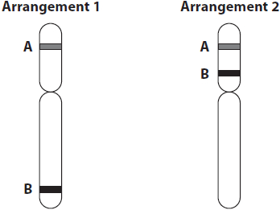
State and justify which arrangement is most likely to produce the results shown in the table.
(3)
.............................................................................................................................................
.............................................................................................................................................
.............................................................................................................................................
.............................................................................................................................................
.............................................................................................................................................
.............................................................................................................................................
.............................................................................................................................................
.............................................................................................................................................
.............................................................................................................................................

(Total for question = 3 marks)

Q2.
The diagram shows two homologous chromosomes from a man.
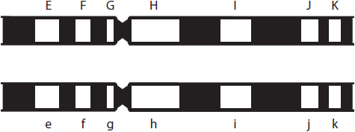
The white regions are the loci of seven genes involved in different phenotypic traits.
The letters E-K and e-k represent the alleles present at each locus.
Alleles F and G are
(1)
A autosomal and complementary
B autosomal and linked
C sex-linked and dominant
D sex-linked and epigenetic

(Total for question = 1 mark)

Q3.
During growth, cells divide by mitosis. Many organisms also carry out meiosis to enable sexual reproduction.
Meiosis is involved in the production of sperm cells.
Crossing over during meiosis can result in genetic variation.
Explain how crossing over can lead to genetic variation.
(3)
.............................................................................................................................................
.............................................................................................................................................
.............................................................................................................................................
.............................................................................................................................................
.............................................................................................................................................
.............................................................................................................................................
.............................................................................................................................................
.............................................................................................................................................
.............................................................................................................................................

(Total for question = 3 marks)

Q4.
Sperm are produced from stem cells in a process that involves several cycles of mitosis and a single cycle of meiosis, as shown in the diagram.
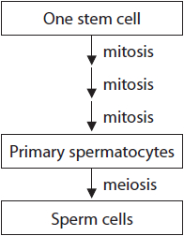
(i) State what is meant by the term stem cell.
(2)
.............................................................................................................................................
.............................................................................................................................................
.............................................................................................................................................
.............................................................................................................................................
.............................................................................................................................................
.............................................................................................................................................
(ii) Compare and contrast the results of mitosis and meiosis in the production of sperm cells from stem cells.
(4)
.............................................................................................................................................
.............................................................................................................................................
.............................................................................................................................................
.............................................................................................................................................
.............................................................................................................................................
.............................................................................................................................................
.............................................................................................................................................
.............................................................................................................................................
.............................................................................................................................................
.............................................................................................................................................
.............................................................................................................................................
.............................................................................................................................................

(Total for question = 6 marks)

Q5.
Salmon are fish that produce gametes by meiosis.
Crossing over during meiosis produces new combinations of alleles in the gametes.
A female salmon has the genotype Aa for one gene and Bb for another gene.
Both of these genes are found on the same chromosome and are linked.
A female salmon can produce up to 1 600 eggs per year for up to 11 years.
Calculate the maximum number of egg cells that this female salmon could produce containing the allele combination AB in this time.
(2)
Answer ...........................................................

(Total for question = 2 marks)

Q6.
Males produce large numbers of sperm cells each with a different genotype.
Describe how the variation in sperm cell genotype arises.
(3)
.............................................................................................................................................
.............................................................................................................................................
.............................................................................................................................................
.............................................................................................................................................
.............................................................................................................................................
.............................................................................................................................................
.............................................................................................................................................
.............................................................................................................................................
.............................................................................................................................................

Q7.
Children are different from their parents due to genetic variation and other factors.
Genetic variation can be the result of meiosis and random fertilisation of gametes.
Variation between children and their parents is affected by linkage of genes.
Explain why some genes show linkage and others show sex-linkage.
(3)
.............................................................................................................................................
.............................................................................................................................................
.............................................................................................................................................
.............................................................................................................................................
.............................................................................................................................................
.............................................................................................................................................
.............................................................................................................................................
.............................................................................................................................................
.............................................................................................................................................
.............................................................................................................................................
.............................................................................................................................................

(Total for question = 3 marks)

Q8.
The zebrafish (Danio rerio) has been studied as a model for vertebrate development.
Zebrafish have a variety of types of stripes and fin shape phenotypes.
Wild type zebrafish are homozygous for the black stripe and short fin phenotypes.
The photograph shows a wild type zebrafish.
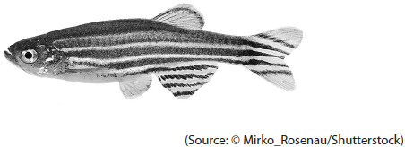
Melanin pattern (stripes or spots) and fin length (long or short) are controlled by different genes.
Parents heterozygous for both these genes (DdNn) were crossed.
The table shows the expected genotypes of the parental gametes and the genotypes and phenotypes of the offspring.
The expected genotypes and phenotypes assume that genes for spots and long fins are inherited independently of each other.
(i) Complete the table by filling in the missing genotypes and phenotypes.
(2)
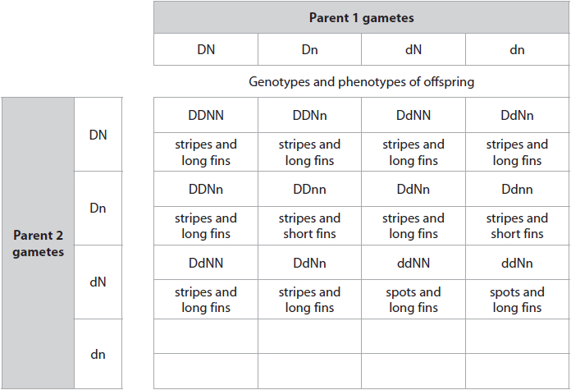
(ii) The table contains the observed and expected results of this cross.
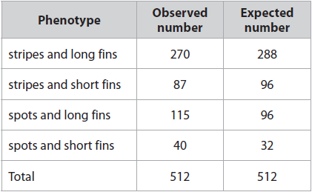
Calculate a value for chi squared (χ2).
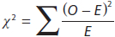
(3)
Answer ...........................................................
(iii) Some critical values for the chi squared test (χ2) are given in the table.
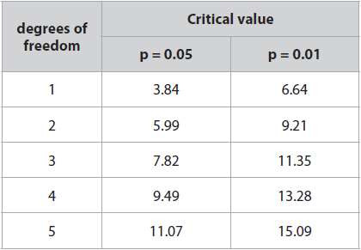
State a conclusion that can be drawn from the results of this cross.
(2)
.............................................................................................................................................
.............................................................................................................................................
.............................................................................................................................................
.............................................................................................................................................
.............................................................................................................................................
.............................................................................................................................................

(Total for question = 7 marks)

Q9.
The colour of animal fur can be determined by both genotype and environment.
A gene for fur colour is found at a locus.
(i) State what is meant by the term locus.
(1)
.............................................................................................................................................
.............................................................................................................................................
(ii) The darkness of an animal's fur colour could be due to polygenic inheritance.
Explain how polygenic inheritance could affect the darkness of the fur.
(2)
.............................................................................................................................................
.............................................................................................................................................
.............................................................................................................................................
.............................................................................................................................................
.............................................................................................................................................
.............................................................................................................................................
.............................................................................................................................................

Q10.
The sex of a mammal is determined by a pair of sex chromosomes. There are two types of sex chromosome known as X and Y.
(i) Which row in the table correctly shows the sex chromosomes found in the male and female gametes of mammals?
(1)
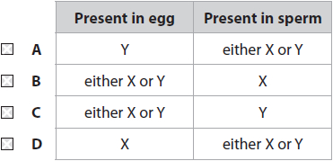
(ii) Explain why genes found on the sex chromosome pair have a pattern of inheritance that is different from genes found on other chromosome pairs.
(2)
.............................................................................................................................................
.............................................................................................................................................
.............................................................................................................................................
.............................................................................................................................................
.............................................................................................................................................
.............................................................................................................................................
.............................................................................................................................................

(Total for question = 3 marks)

Q11.
Colour blindness in humans is an example of a sex-linked condition.
(i) Which of the following is another example of a sex-linked condition in humans?
(1)
A atherosclerosis
B cystic fibrosis
C haemophilia
D lung cancer
(ii) In Australia, 8% of males are colour blind compared with 0.4% of females.
Explain why colour blindness is more common in males than in females.
(2)
.............................................................................................................................................
.............................................................................................................................................
.............................................................................................................................................
.............................................................................................................................................
.............................................................................................................................................
.............................................................................................................................................
.............................................................................................................................................
.............................................................................................................................................

Q12.
Domestic cats have a gene for fur colour that is found only on the X chromosome.
This gene has two alleles, one producing orange fur and the other producing black fur.
Tortoiseshell cats have patches of orange fur and patches of black fur. This pattern of fur colouration is usually found only in female cats.
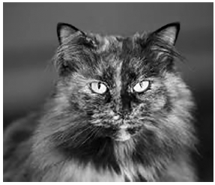
With the help of a genetic diagram to explain why the tortoiseshell cat in the photograph is unlikely to be male.
(3)
.............................................................................................................................................
.............................................................................................................................................
.............................................................................................................................................
.............................................................................................................................................
.............................................................................................................................................
.............................................................................................................................................
.............................................................................................................................................

Q13.
It is difficult to tell the sex of young chickens. This can be overcome by breeding programmes that allow the sex of the chicken to determine the visible features.
In birds the sex chromosomes are Z and W. Males are ZZ and females are ZW.
Head colour in chickens is a sex-linked characteristic carried only on the Z chromosome.
The dominant allele gives bar-headed chickens and the recessive allele gives black-headed chickens.
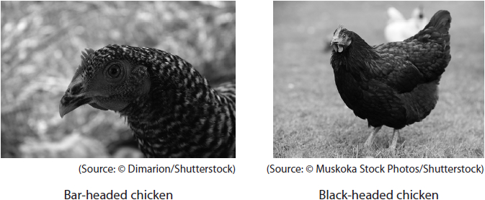
(i) Which of the following is the genotype of a black-headed female chicken?
(1)
A Z^{B}Z^{b}
B Z^{b}Z^{b}
C Z^{b}W
D Z^{B}W^{b}
(ii) A bar-headed female chicken was crossed with a black-headed male chicken.
Draw a genetic diagram to show the genotypes and phenotypes of the offspring produced by this cross.
(3)
(iii) Male chickens produced by this cross were crossed with a bar-headed female chicken.
Deduce why this cross will produce both bar-headed and black-headed females.
(3)
.............................................................................................................................................
.............................................................................................................................................
.............................................................................................................................................
.............................................................................................................................................
.............................................................................................................................................
.............................................................................................................................................
.............................................................................................................................................
.............................................................................................................................................
.............................................................................................................................................

(Total for question = 7 marks)

Q1.
No Examiner's Report available for this question

Q2.
No Examiner's Report available for this question

Q3.
This question required candidates to explain how genetic variation can be established through crossing over. Whilst many candidates appreciated that there was an exchange of genetic material, not all made it clear where the exchange occurred.
This is a strong answer which gains full marks.
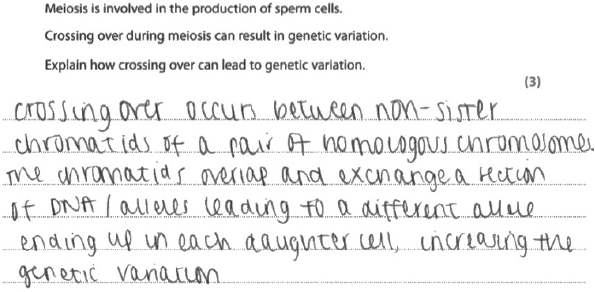
Results Plus: Examiner Comments
The candidate has informed us that genetic material is being swapped and has correctly told us where the exchange has occurred. This is in the order of the second, then third marking points on the first and second lines, and subsequently the first marking point on the third into the fourth line.

Results Plus: Examiner Tip
Be careful not to just repeat what is in the question. The last line here refers to genetic variation rather than different allele combinations which would not be an alternative for the last marking point.

This example did not achieve any marks, and illustrates a common confusion shown by many candidates.
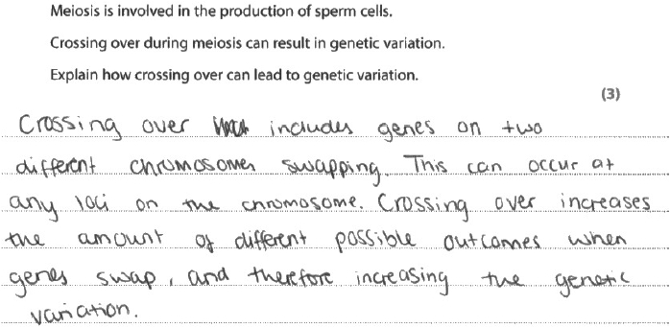
Results Plus: Examiner Comments
Initially the candidate refers to genes swapping over. This was not considered an alternative for the first marking point. The reference to different chromosomes would have needed to be suitably qualified to gain the second marking point.

Results Plus: Examiner Tip
Make sure that the difference between gene and allele is fully appreciated.

Q4.
(i)
Most candidates had a good idea of what a stem cell is and provided good statements that gained both marks.
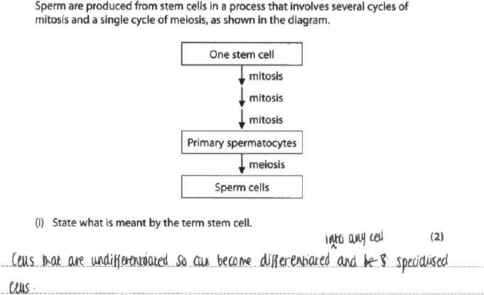
Results Plus: Examiner Comments
A concise answer that gains both marks.

Results Plus: Examiner Tip
As you learn your Biology make sure you understand and can use relevant biological terms.

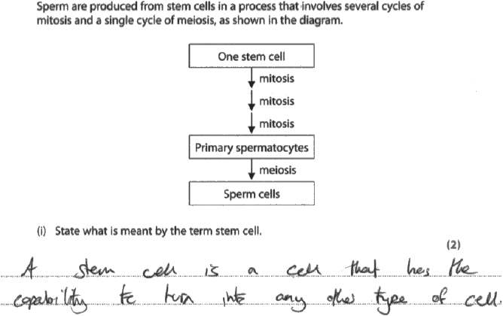
Results Plus: Examiner Comments
This response did not gain any marks; 'the ability to turn into any other cell' was not sufficient for MP2.

Results Plus: Examiner Tip
Think carefully about the way you express scientific ideas. It is very easy to write an answer that lacks sufficient clarity to gain marks.

(ii)
Candidates were asked to compare and contrast the results of meiosis and mitosis. Candidates generally gained marking point 2 recalling that mitosis produces diploid cells and meiosis produces haploid cells.
Although few candidates described the overall contribution of mitosis and meiosis to sperm cell numbers (MP4) a number gained the allowed alternative answer gaining MP4 for a correct description of the number of daughter cells.
Many candidates described mitosis as producing 'identical daughter cells' and 'meiosis producing non-identical daughter cells'; this was not sufficient for marking point 3. To gain MP3 it had to be clear that candidates were talking about genetically identical and genetically non-identical daughter cells.
Very few commented on the idea that both mitosis and meiosis increase the number of cells for MP1.
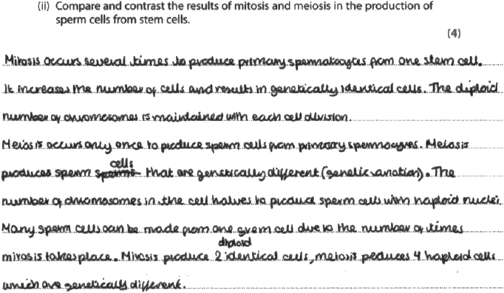
Results Plus: Examiner Comments
This response gained all four marks, although each mark point had to be pieced together.

Results Plus: Examiner Tip
When asked to compare and contrast try to include each comparison or contrast in the same sentence e.g. mitosis produces diploid cells whereas meiosis results in haploid cells'.
Alternatively, consider using a table format.

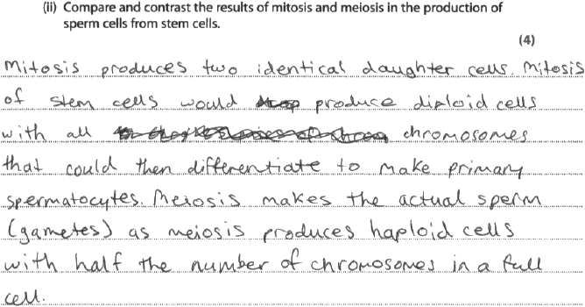
Results Plus: Examiner Comments
For this response the candidate gained one mark, MP2.
A full comparison was not made for MP3 and 4, and it was not clear that meiosis results in an increase in the number of cells, so MP1 could not be awarded.

Q5.
No Examiner's Report available for this question

Q6.
No Examiner's Report available for this question

Q7.
This question required candidates to explain why some genes were linked and some sex-linked. It was rare to see answers that considered why multiple genes need to be on the same chromosome, but most wrote about both linkage and sex-linkage. For many candidates, their knowledge of sex-linkage tended to be more thorough than that of linkage.
This response initially gives a description of linkage which is credit worthy. It then correctly refers to sex-linkage, so two marks were gained.
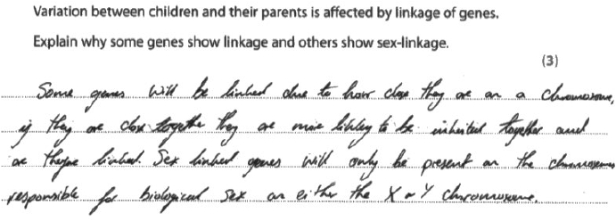

Q8.
(i) This question was well answered by the majority of candidates.
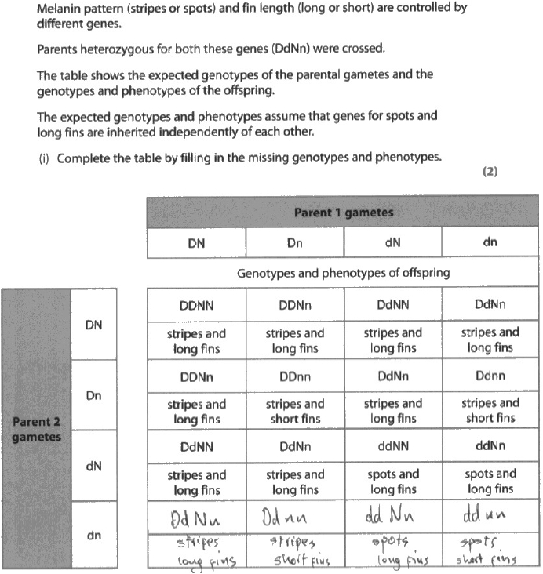
Results Plus: Examiner Comments
This is a clear example of a correctly completed table that gained both marks.

(ii) Many candidates were able to calculate a value for chi squared. A frequently seen error wasto divide the (O-E)² value by the total (512).
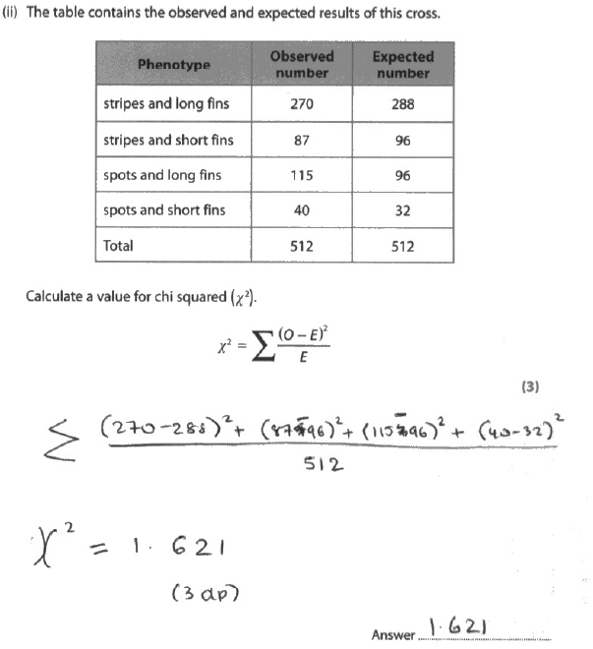
Results Plus: Examiner Comments
This example illustrates a fairly common mistake seen in candidate responses. Rather than dividing each (O-E)² by E the candidate assummed the (O-E)² values and divided by the total number of individuals observed.

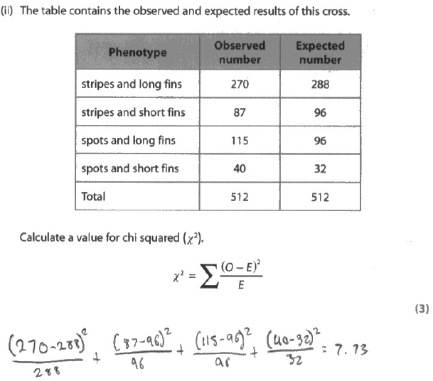
Results Plus: Examiner Comments
This response gained all three available marks for a correct answer. The workings are also clearly laid out so intermediate marks couldhave been awarded if the final answer had been incorrect.

Results Plus: Examiner Tip
It is a good idea to put your final answer on the answer line. Examiners will look elsewhere for the answer. However, if the workings are not clear or two different answers are seen they cannot pick and choose which workings or answer to mark. The risk then is that you do not gain the marks.

(iii) Candidates often correctly stated that their calculated value was less than the critical value of 7.82 and gained Mark Point 1. Many of these candidates then went on to provide a generic answer, suggesting the null hypothesis could be accepted or rejected. However, in this case a null hypothesis had not been provided. To gain a second mark candidates needed to say something about the results. They could suggest that the observed results are not different to the expected results (Mark Point 2) or they could suggest that the traits are inherited independently of each other (Mark Point 3). A number of candidates made comments such as 'therefore there is no difference between the phenotypes' or 'therefore the genes are independently inherited'. Neither statement is correct and did not gain Mark Point 2 or 3.
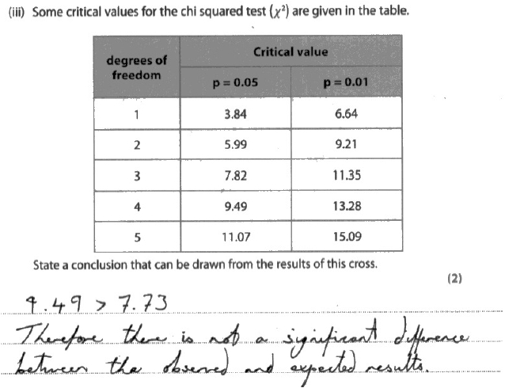
Results Plus: Examiner Comments
In this response the wrong critical value has been selected. The degrees of freedom for the data provided is 4 – 1 = 3. At p = 0.05 this means the critical value is 7.82. The candidate has however, gone on and made a correct statement about the results and gains Mark Point 2.

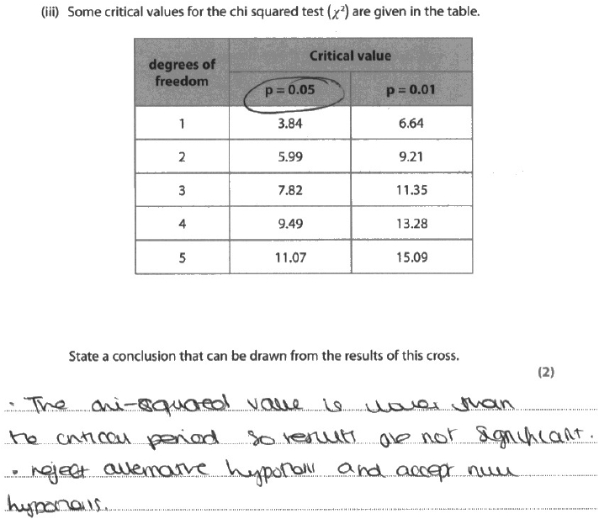
Results Plus: Examiner Comments
This response gained no marks. Even allowing for poor language it is not possible to award Mark Point 1 as there is no reference to 7.82 or 3 degrees of freedom. The statement about alternative and null hypothesis was ignored. Candidates were not given a null hypothesis (or a hypothesis) so cannot make a statement about whether or not to accept or reject it.

Q9.
No Examiner's Report available for this question

Q10.
(ii)
In the reformed specification, sex linkage is a required learning objective in Topic 3; however, it seems to have been poorly understood, with the vast majority of candidates struggling to express their understanding of how it works.
The question asked why genes carried on sex chromosomes have a different pattern of inheritance than genes on other chromosome pairs.
It did appear that many candidates confused sex chromosomes with sex cells or gametes. Many also wrote at length about sex chromosomes not undergoing crossing over or about the inheritance of gender.
Many candidates referred to the Y chromosome being small and having less genes without explaining the effects that would have on patterns of inheritance. Few referred correctly to alleles and loci.
Only a small minority explained that there are genes on the X chromosome missing from the Y chromosome, and fewer still went on to say that the male only inherits one allele.
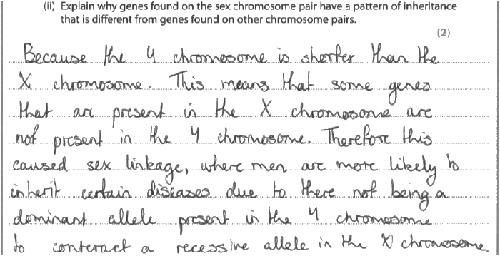
Results Plus: Examiner Comments
A good effort – this was given 1/2 marks – but came close to gaining full marks. One mark was given for there being genes on the X chromosome that are not on the Y chromosome. However, the point that there would not be a dominant allele on the Y chromosome to counter a recessive allele on the X chromosome did not make it clear that there would be no allele at all for that gene on the Y chromosome.

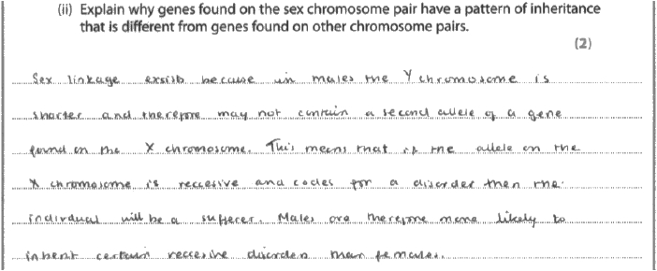
Results Plus: Examiner Comments
This answer gained full marks – 2/2. One mark for there not being an allele for some genes found on the X chromosome and one mark for the idea that if the allele on the X chromosome in males is recessive and linked to a disorder, then it will be expressed.

Q11.
No Examiner's Report available for this question

Q12.
No Examiner's Report available for this question

Q13.
(ii)
Many candidates were able to draw a Punnett square to show this sex-linked cross. Marks were lost if the phenotypes were not stated. Some candidates did not realise that there are no alleles for head colour on the W chromosome.
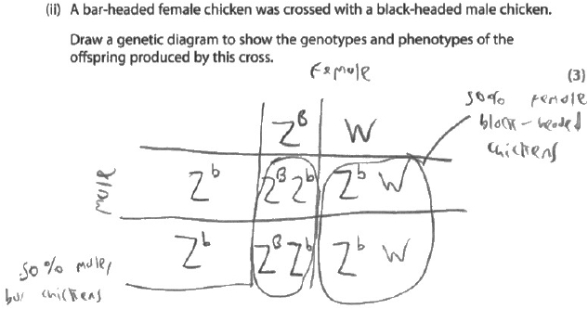
Results Plus: Examiner Comments
This response gained all 3 marks.

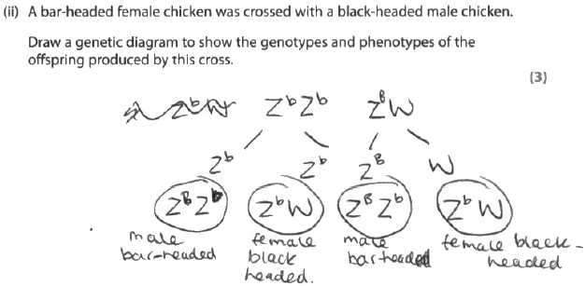
Results Plus: Examiner Comments
This response used a different format to gain 3 marks.

Results Plus: Examiner Tip
Remember to give all aspects of the phenotype when answering a question on genetic crosses.

(iii)
This question asked candidates to deduce why a particular cross would produce both bar-headed and black-headed females. Candidates found it difficult to describe why this would happen. Many of the candidates who did score used Punnett square to demonstrate the cross.
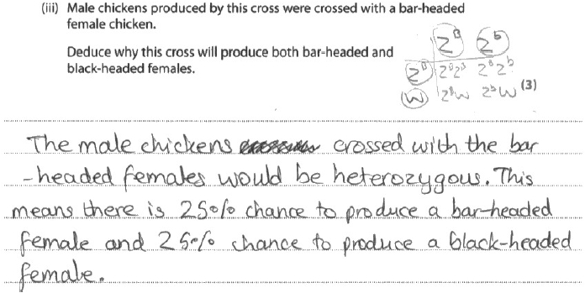
Results Plus: Examiner Comments
This response gained 2 marks. The fact that the male is heterozygous was clearly stated and the Punnett square demonstrates how the alleles are inherited by the female.

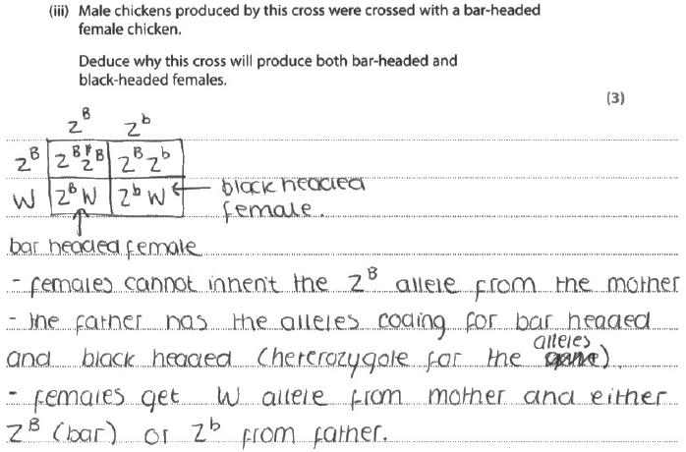
Results Plus: Examiner Comments
This response gains 2 marks. The text explains that the male is heterozygous and the female will inherit B or b from the male. This is reinforced by the Punnett square.

Mark Scheme
Q1.
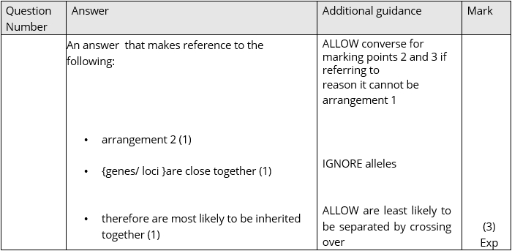

Q2.

Q3.
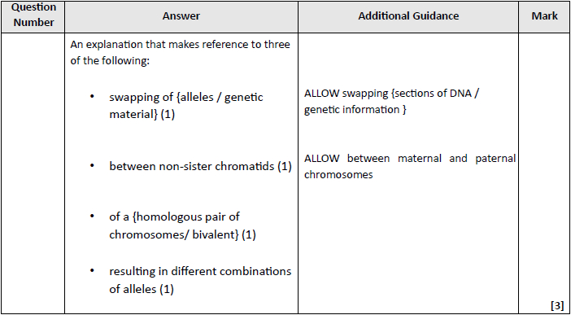

Q4.
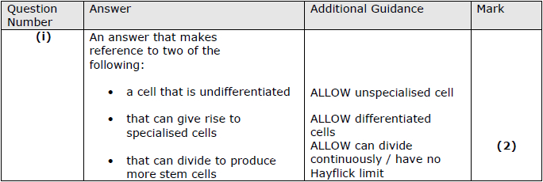
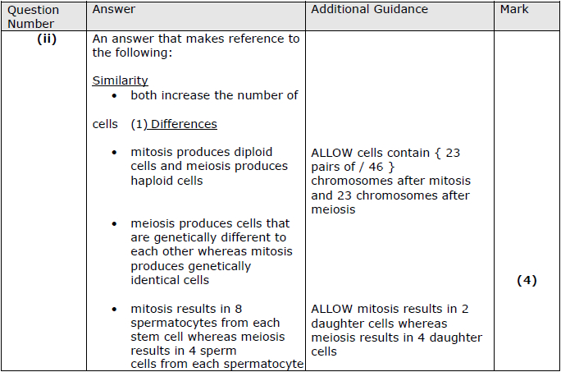

Q5.
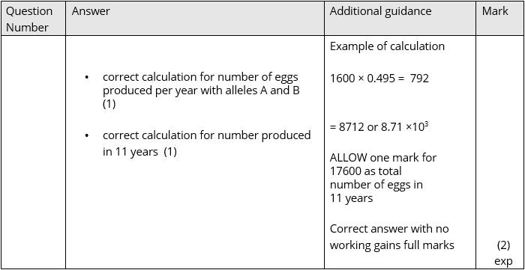

Q6.
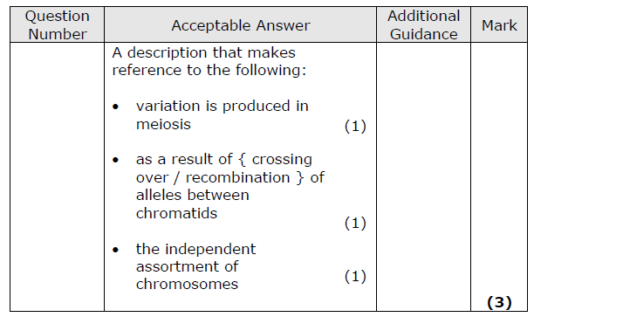

Q7.
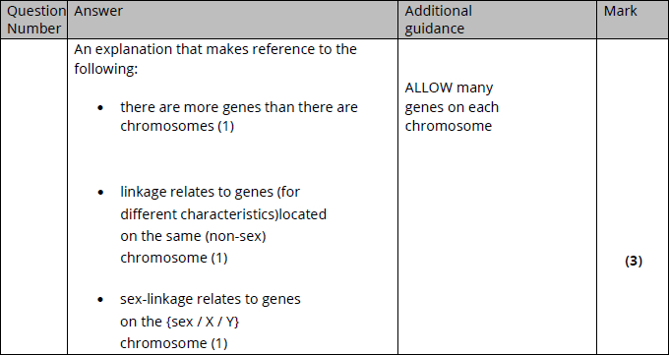

Q8.
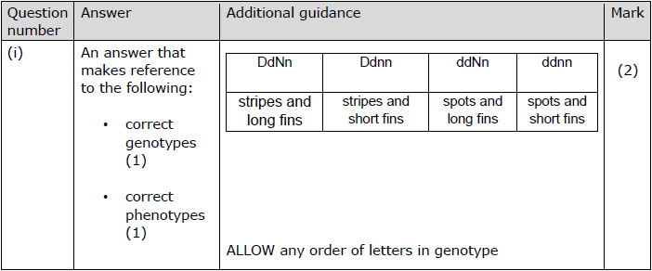
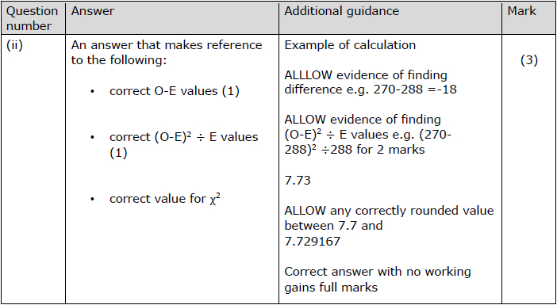
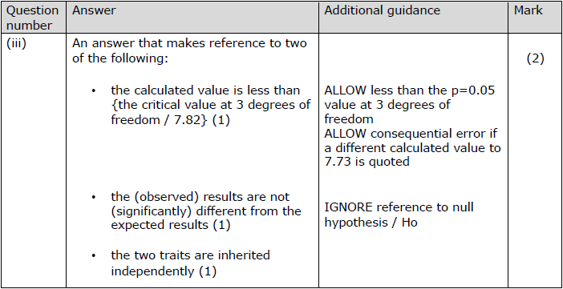

Q9.
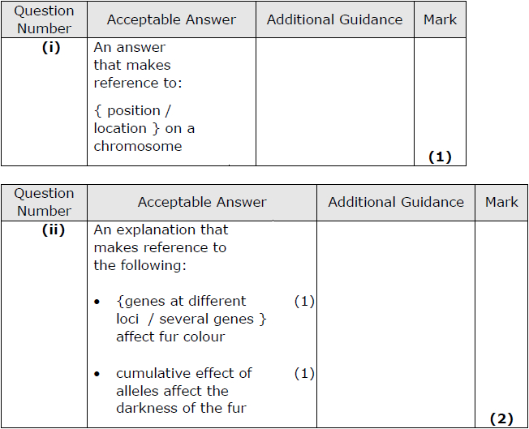

Q10.
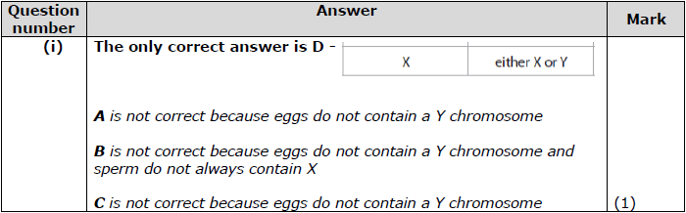
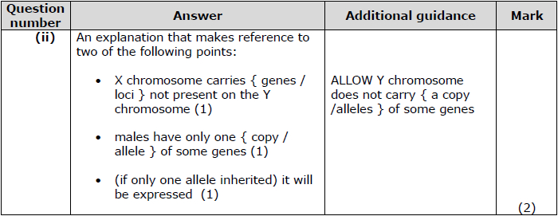

Q11.
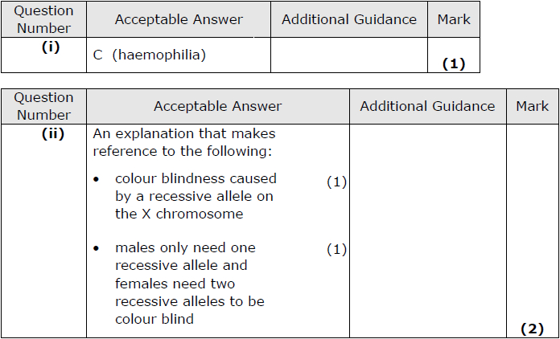

Q12.
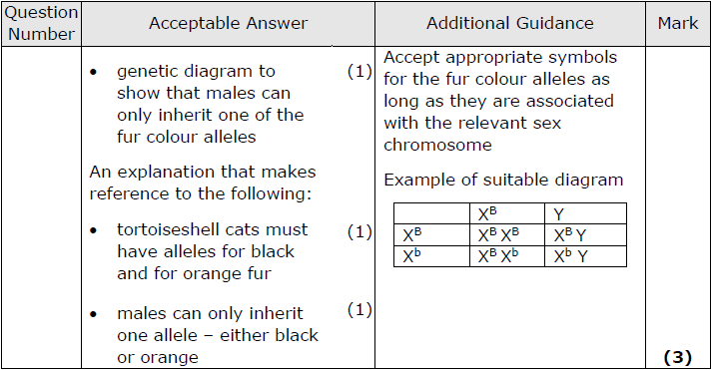

Q13.
