Photosynthesis and Energy Transfer Exam Questions
Q1.
In some commercial glasshouses, the concentration of carbon dioxide in the atmosphere is increased.
Explain why this increase in carbon dioxide concentration affects the growth of plants in glasshouses.
(3)
.............................................................................................................................................
.............................................................................................................................................
.............................................................................................................................................
.............................................................................................................................................
.............................................................................................................................................
.............................................................................................................................................
.............................................................................................................................................
.............................................................................................................................................
.............................................................................................................................................
.............................................................................................................................................
.............................................................................................................................................
.............................................................................................................................................

(Total for question = 3 marks)

Q2.
The scientific article you have studied is adapted from a chapter in the book Oxygen.
Use the information from the scientific article and your own knowledge to answer the following question.
Explain how chloroplasts are adapted for their role in photosynthesis (paragraphs 9 and 10).
(4)
.............................................................................................................................................
.............................................................................................................................................
.............................................................................................................................................
.............................................................................................................................................
.............................................................................................................................................
.............................................................................................................................................
.............................................................................................................................................
.............................................................................................................................................
.............................................................................................................................................

(Total for question = 4 marks)

Q3.
Photosynthesis in green plants involves light-dependent reactions and the Calvin cycle.
The Calvin cycle uses the products of the light-dependent reactions.
(i) State the location of the Calvin cycle.
(1)
.............................................................................................................................................
(ii) Describe the roles of the products of the light-dependent reactions in the Calvin cycle.
(3)
.............................................................................................................................................
.............................................................................................................................................
.............................................................................................................................................
.............................................................................................................................................
.............................................................................................................................................
.............................................................................................................................................
.............................................................................................................................................
.............................................................................................................................................
.............................................................................................................................................

(Total for question = 4 marks)

Q4.
Explain the importance of RUBISCO to the productivity of an ecosystem.
(2)
.............................................................................................................................................
.............................................................................................................................................
.............................................................................................................................................
.............................................................................................................................................
.............................................................................................................................................
.............................................................................................................................................
.............................................................................................................................................
.............................................................................................................................................
.............................................................................................................................................
.............................................................................................................................................

(Total for question = 2 marks)

Q5.
The photograph shows heather, Calluna vulgaris, a plant that grows on moorland.
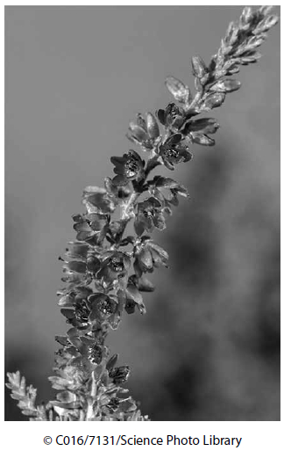
In an investigation into the net primary productivity of heather, all the vegetation on an area of two different moorlands, A and B, was removed by burning. The dry biomass, in g m⁻², was then measured each year for a period of 20 years.
(a) Give an equation that shows the relationship between gross primary productivity, net primary productivity and respiration.
(1)
.............................................................................................................................................
.............................................................................................................................................
(b) The graph shows the change in the mean dry biomass of the heather plants during the 20 year period.
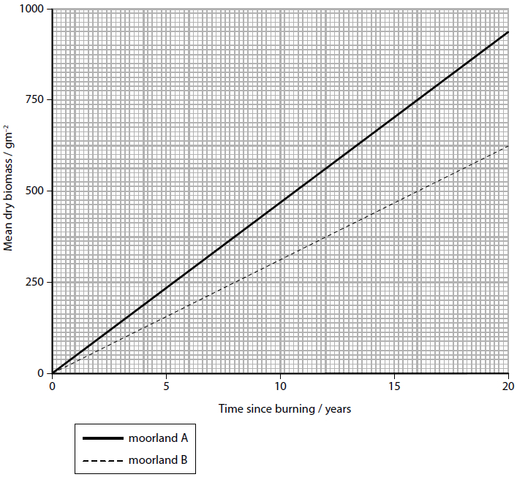
(i) Describe a method that could be used to obtain the mean dry biomass of the heather plants in year 20.
(2)
.............................................................................................................................................
.............................................................................................................................................
.............................................................................................................................................
.............................................................................................................................................
(ii) The total solar radiation reaching moorland A was 3 144 000 kJ m⁻² yr⁻¹. Each gram of dry heather contains 22.186 kJ.
Calculate the percentage efficiency of heather plants from moorland A at converting solar radiation into dry biomass.
(2)
Answer ...........................................................
(iii) After the burning of the moorland, a process of succession occurred.
The following information shows some of the changes found over the 20 years.
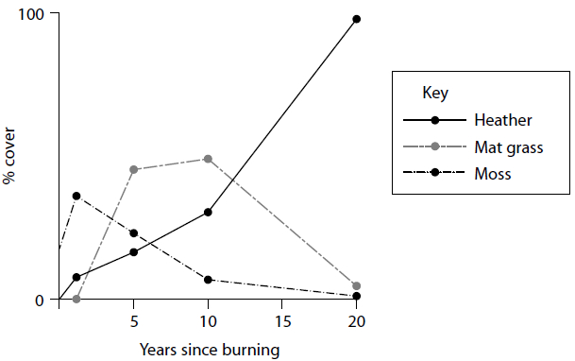
Analyse the data to explain the changes shown.
(3)
.............................................................................................................................................
.............................................................................................................................................
.............................................................................................................................................
.............................................................................................................................................
.............................................................................................................................................
.............................................................................................................................................

(Total for question = 8 marks)

Q6.
The species of seagrass, Posidonia oceanica, is endemic to the Mediterranean Sea.
The photograph shows part of an underwater seagrass meadow.
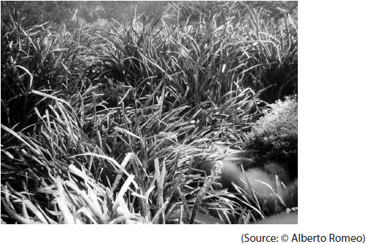
Seagrass cannot survive if the water becomes warmer or more acidic.
Seagrass in the Mediterranean Sea has declined by 34% in the last 50 years.
(i) Explain why the increase in greenhouse gases is leading to a decrease in the growth of seagrass.
(3)
.............................................................................................................................................
.............................................................................................................................................
.............................................................................................................................................
.............................................................................................................................................
.............................................................................................................................................
.............................................................................................................................................
.............................................................................................................................................
.............................................................................................................................................
.............................................................................................................................................
(ii) Discuss the possible effects of a reduction in seagrass on animals living in the Mediterranean Sea.
(4)
.............................................................................................................................................
.............................................................................................................................................
.............................................................................................................................................
.............................................................................................................................................
.............................................................................................................................................
.............................................................................................................................................
.............................................................................................................................................
.............................................................................................................................................
.............................................................................................................................................
.............................................................................................................................................
.............................................................................................................................................
.............................................................................................................................................
(iii) Seagrass is long-living and more resistant to breakdown by microorganisms than plants living in the rainforest.
Explain why maintaining a healthy population of seagrass reduces the release of carbon dioxide into the atmosphere.
(3)
.............................................................................................................................................
.............................................................................................................................................
.............................................................................................................................................
.............................................................................................................................................
.............................................................................................................................................
.............................................................................................................................................
.............................................................................................................................................
.............................................................................................................................................
.............................................................................................................................................
.............................................................................................................................................
.............................................................................................................................................
.............................................................................................................................................
.............................................................................................................................................
.............................................................................................................................................

(Total for question = 10 marks)

Mark Scheme
Q1.
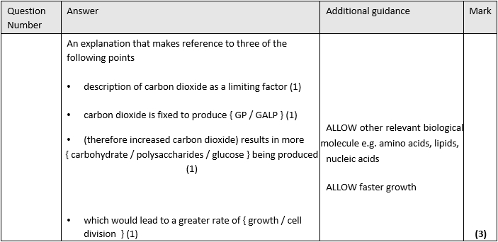

Q2.
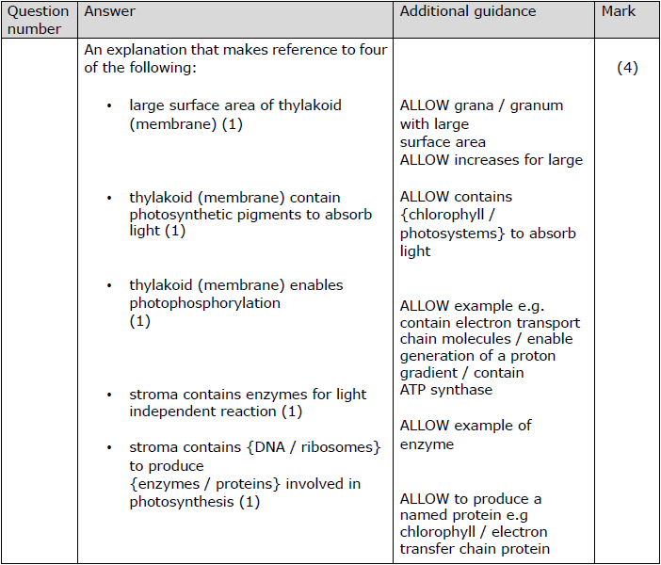

Q3.
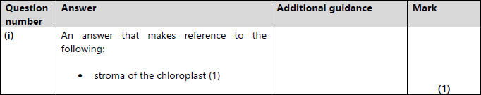
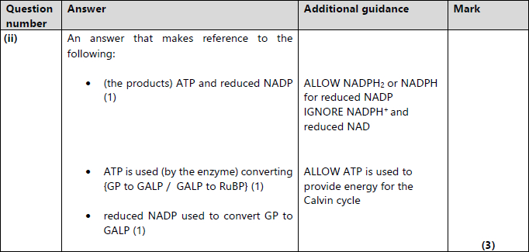

Q4.
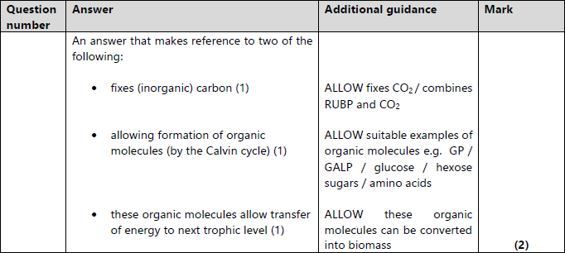

Q5.
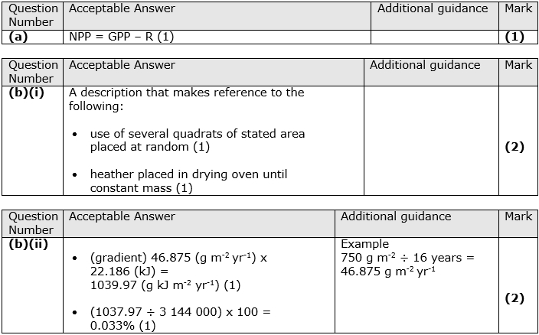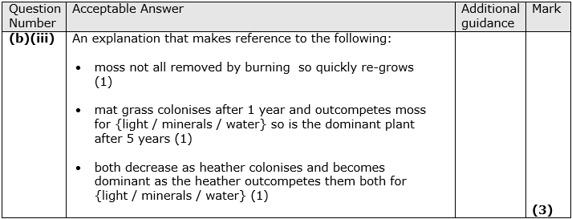

Q6.
