Practical Skill Exam Questions
Q1.
Some plants are adapted to grow in shady conditions.
A study was carried out to compare the effect of growing in different light intensities on rates of photosynthesis of plants.
The plants are rated for levels of shade tolerance.
Plant seedlings of nine species were grown in either 25% or 5% of full sunlight. All other abiotic factors were controlled.
These seedlings were grown for six weeks and then exposed to full sunlight for 15 minutes. The rate of photosynthesis was measured during the exposure to full light.
The table shows the results of this investigation for four species of plant.
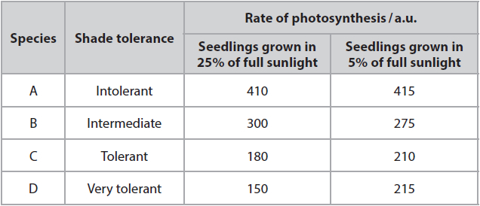
* Differences in the rate of photosynthesis may be due to the light-dependent reactions in chloroplasts.
Devise an investigation to compare the rate of the light-dependent reaction in shade tolerant and shade intolerant plants grown at different light intensities.
(6)
.............................................................................................................................................
.............................................................................................................................................
.............................................................................................................................................
.............................................................................................................................................
.............................................................................................................................................
.............................................................................................................................................
.............................................................................................................................................
.............................................................................................................................................
.............................................................................................................................................
.............................................................................................................................................
.............................................................................................................................................
.............................................................................................................................................
.............................................................................................................................................
.............................................................................................................................................
.............................................................................................................................................
.............................................................................................................................................
.............................................................................................................................................
.............................................................................................................................................
.............................................................................................................................................
.............................................................................................................................................

(Total for question = 6 marks)

Q2.
*Lead ions can be toxic to plants.
Different plants are killed by different concentrations of lead ions.
The toxic concentrations for different plant categories are shown in the table.
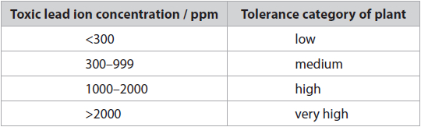
Devise a laboratory investigation to determine the tolerance category of tomato plants to lead ions.
(6)
.............................................................................................................................................
.............................................................................................................................................
.............................................................................................................................................
.............................................................................................................................................
.............................................................................................................................................
.............................................................................................................................................
.............................................................................................................................................
.............................................................................................................................................
.............................................................................................................................................
.............................................................................................................................................
.............................................................................................................................................
.............................................................................................................................................
.............................................................................................................................................
.............................................................................................................................................
.............................................................................................................................................
.............................................................................................................................................
.............................................................................................................................................
.............................................................................................................................................
.............................................................................................................................................
.............................................................................................................................................
.............................................................................................................................................
.............................................................................................................................................
.............................................................................................................................................

(Total for question = 6 marks)

Q3.
Lipoprotein lipase is an enzyme found in different tissues including the brain.
Lipoprotein lipase can be extracted from brain tissue to investigate the effect of temperature on the rate of reaction of this enzyme.
(i) State what is meant by the term Q₁₀ temperature coefficient.
(1)
.............................................................................................................................................
.............................................................................................................................................
.............................................................................................................................................
(ii) Devise an investigation to determine Q₁₀ for an extract of lipoprotein lipase enzyme.
(5)
.............................................................................................................................................
.............................................................................................................................................
.............................................................................................................................................
.............................................................................................................................................
.............................................................................................................................................
.............................................................................................................................................
.............................................................................................................................................
.............................................................................................................................................
.............................................................................................................................................
.............................................................................................................................................
.............................................................................................................................................
.............................................................................................................................................
.............................................................................................................................................
.............................................................................................................................................
.............................................................................................................................................
.............................................................................................................................................

(Total for question = 6 marks)

Q4.
Kapok (Ceiba pentandra) is a tree.
Kapok produces seed pods containing waxy fibres made of cellulose covered in lignin.
These fibres are used as fillings for cushions.
(i) Describe the arrangement of glucose monomers in a cellulose molecule.
(2)
.............................................................................................................................................
.............................................................................................................................................
.............................................................................................................................................
.............................................................................................................................................
.............................................................................................................................................
.............................................................................................................................................
.............................................................................................................................................
.............................................................................................................................................
.............................................................................................................................................
(ii) Devise a method to find the relationship between the actual diameter and the tensile strength of kapok fibres.
(6)
.............................................................................................................................................
.............................................................................................................................................
.............................................................................................................................................
.............................................................................................................................................
.............................................................................................................................................
.............................................................................................................................................
.............................................................................................................................................
.............................................................................................................................................
.............................................................................................................................................
.............................................................................................................................................
.............................................................................................................................................
.............................................................................................................................................
.............................................................................................................................................
.............................................................................................................................................
.............................................................................................................................................
.............................................................................................................................................
.............................................................................................................................................
.............................................................................................................................................

(Total for question = 8 marks)

Examiner's Report
Q1.
This level-based question asked candidates to compare the rate of photosynthesis in two types of plant at different light intensities. They were expected to use the Hill reaction.
Many candidates gave a Level 2 answer, using both types of plants at different light intensities, and correctly describing the Hill reaction. The better candidates were able to achieve Level 3.
Candidates who simply described the Hill reaction were limited to Level 1 as they were not modifying the investigation or making any linkages or scientific reasoning.
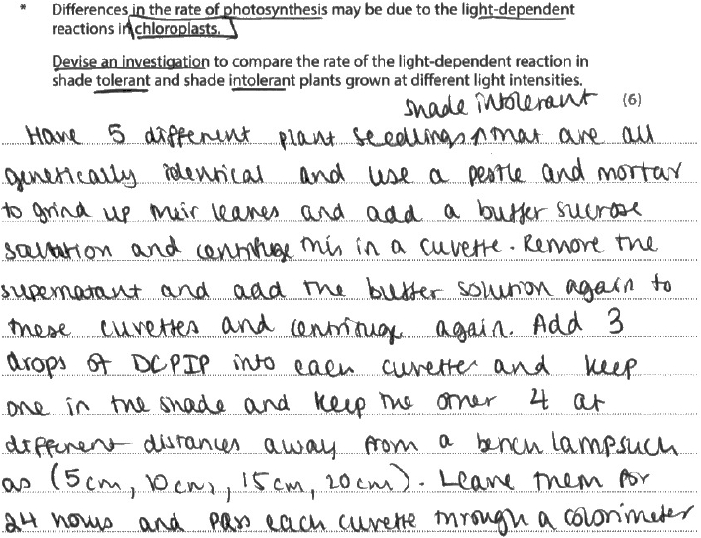
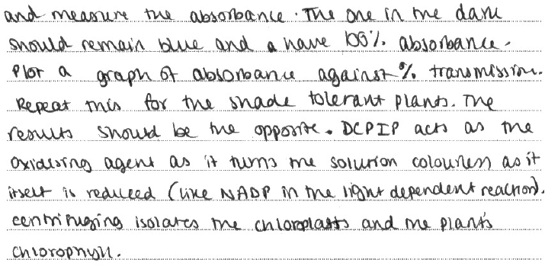
Results Plus: Examiner Comments
A response that correctly describes using the Hill reaction on the two types of plants at different light intensities. Factors that need to be identified are clearly described. The role of DCPIP is explained.
Level 3 – 5 marks

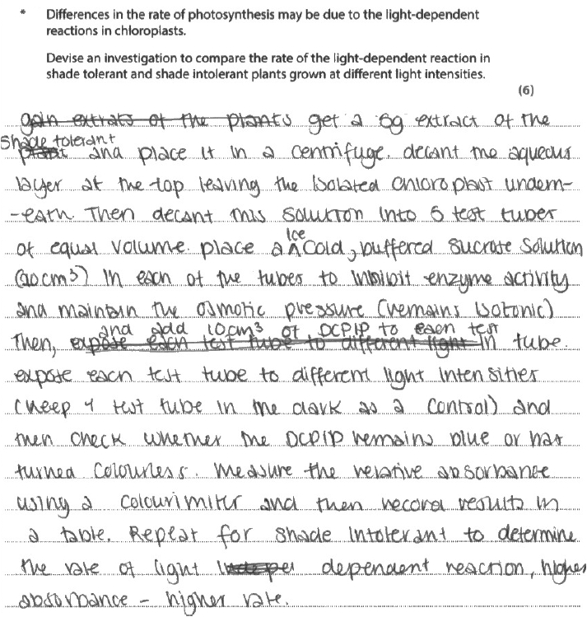
Results Plus: Examiner Comments
A good level 2 answer.
4 marks.

Q2.
In this experimental design question the investigative context related to the tolerance of tomato plants to toxic lead ions. Generally the responses showed a good understanding of the importance of controlling variables and of repeats, and sensible practical setups were described involving tomato plants grown with different concentrations of lead. In many cases the method involved growing the plants in soil, but use of mineral ion solutions (a Core Practical technique) would allow for tighter control of variables and aid the measurement of the dependent variable (DV). In many cases a specific and measurable DV was not identified, perhaps because candidates were unsure how to measure whether the plant was alive; the examiners were willing to accept any reasonable measurements suggested by candidates, length or mass being typical examples (with a decrease taken to indicate the death of the plant). Most answers focused on the control of variables and the practical details of the method, placing most candidates at level 2.
Many candidates lost sight of the fact that the objective of the investigation was very specific: to determine the tolerance category of the tomato plants. Numerical data regarding lead concentrations was provided so it was expected that these be taken into account, firstly in the experimental method devised and secondly in the clear description of how the results would be used to determine the tolerance category. Those who attempted to refer to the lead concentrations given did not always do so successfully: methods involving four lead concentrations of "2000" were frequently seen, with candidates failing to specify which precise concentration within these ranges should be used. Few candidates produced level 3 answers in which they recognised that testing the boundary concentrations (300, 999 and 2000) was necessary to determine the category. It was also rare to see a clear and specific explanation of how the experimental results would be used to determine the category.
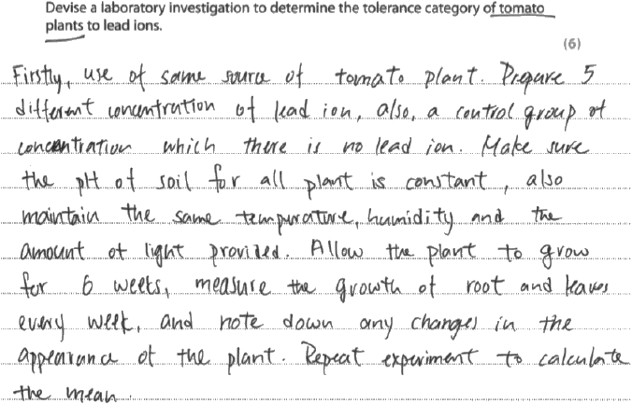
Results Plus: Examiner Comments
This is a level 1 answer, scoring 2 marks. The candidate makes sensible use of tomato plants and lead ions, showing consideration of the context of the question. There is also an appreciation of the need to control variables and the role of repeats. However, there is no clear practical technique described, no indication of appropriate concentrations of lead to be used, and no specific dependent variable identified (measuring 'growth' is not clearly defined). Inclusion of at least one of these features would have helped this answer move to level 2.

Results Plus: Examiner Tip
In an experimental design question, ensure that you give a clear method and identify a measurable dependent variable.
The Core Practicals you carry out during the course allow you to build up a 'toolkit' of practical techniques that you should be able to apply and adapt to new situations.

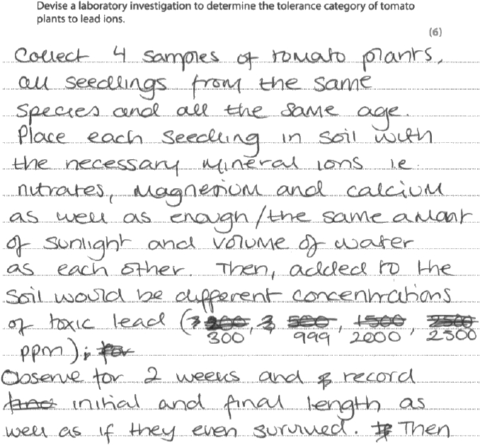

Results Plus: Examiner Comments
This was a level 3 answer, scoring 5 marks. Tomato plants and lead ions are used appropriately and several variables are controlled. There is an appreciation that an adequate concentration of other necessary ions should be provided, although this would be better controlled by growing the plants in solution rather than in soil. The length of the plant is identified as a measurable dependent variable. Most importantly, the candidate has analysed the data provided and recognised that the concentrations at the boundaries between the tolerance categories (ie. 300, 999 and 2000 ppm) are important in classifying the plant. This is a key feature that identifies this as a level 3 answer, albeit at the weaker end of level 3.

Results Plus: Examiner Tip
Remember that you are expected to be able to analyse and interpret scientific information: you must make good use of data provided.

Q3.
(i) and (ii) Very few students appeared to know what is meant by the term Q₁₀ temperature coefficient (core practical 12). This meant they failed to gain a mark for part (i) and struggled to gain marks for part (ii).
The response below was a good example of a response produced by a student who understands what Q₁₀ is. This response gained MP1 (lines 1 and 6) for control of two suitable temperatures; MP3 for control of lipase concentration (stated concentration in line 4); MP4 for measurement of the triglyceride / fatty acid concentration at stated times (lines 8 to 10); The equation given on lines 14 and 15 was allowed for MP6. Although the equation should have referred to rates of reaction marking point 5 was for calculating or finding the rate of reaction. This response does not gain MP5 but it was felt that activity could be accepted in place of rate allowing MP6.
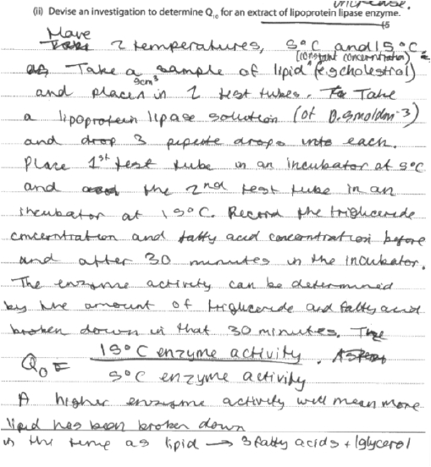

Q4.
No Examiner's Report available for this question

Mark Scheme
Q1.
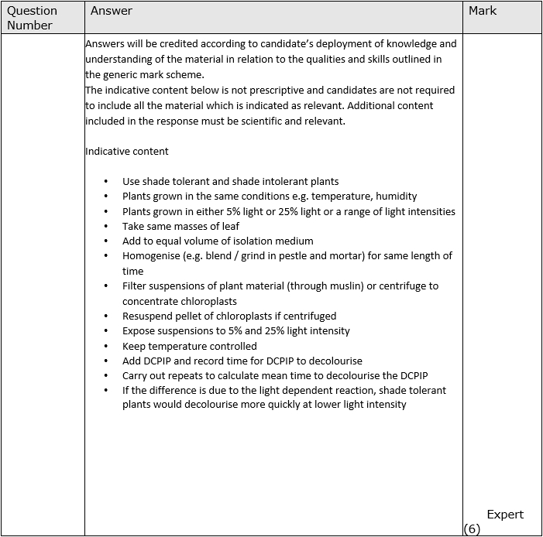
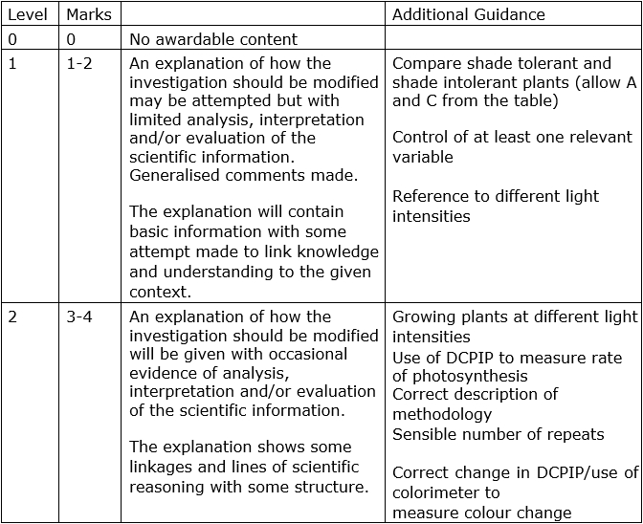
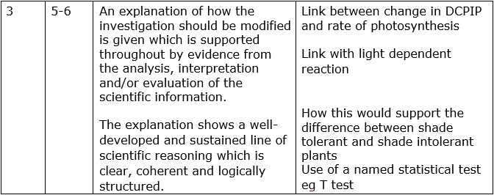

Q2.
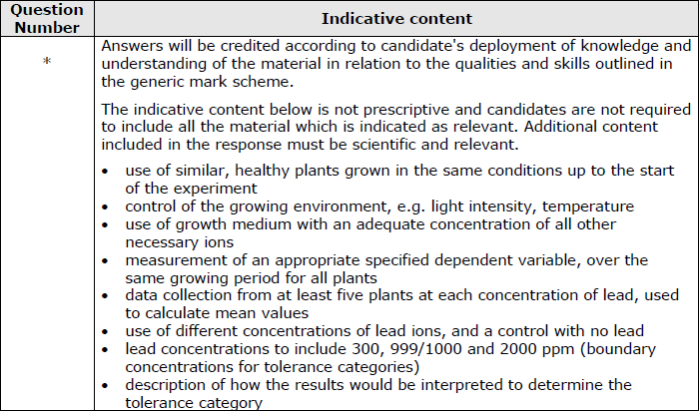
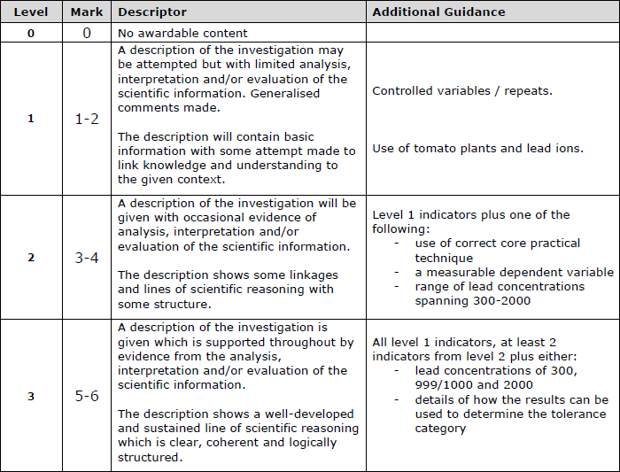

Q3.
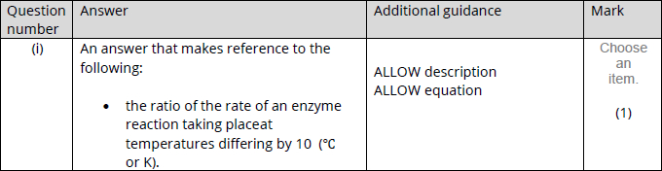
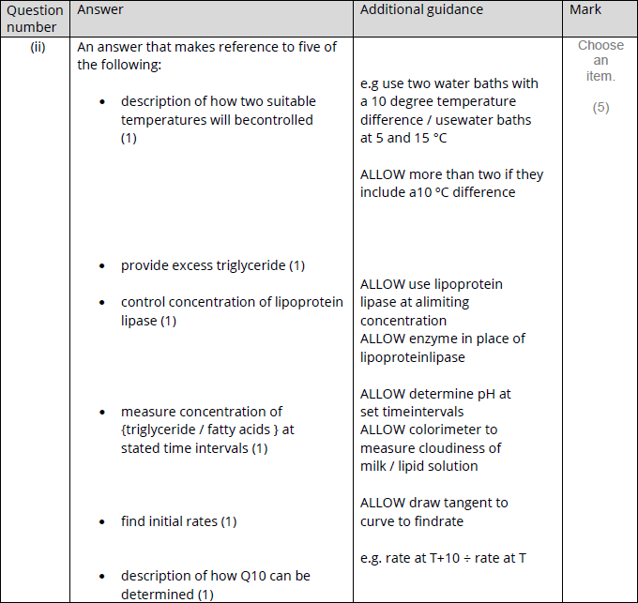

Q4.
