Proteins and Enzymes Questions
Q1.
Blood plasma contains many different proteins. Prothrombin is a plasma protein that is involved in the blood clotting process.
(i) The protein prothrombin is composed of monomers called amino acids.
Complete the diagram to show the structure of an amino acid.
(2)
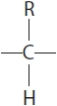
(ii) Name the products formed when several amino acids are joined together.
(1)
.............................................................................................................................................

(Total for question = 3 marks)

Q2.
Collagen is a fibrous protein.
Explain how the structure of collagen is related to its function.
(4)
.............................................................................................................................................
.............................................................................................................................................
.............................................................................................................................................
.............................................................................................................................................
.............................................................................................................................................
.............................................................................................................................................
.............................................................................................................................................
.............................................................................................................................................
.............................................................................................................................................
.............................................................................................................................................

Q3.
Plasmin is an enzyme that digests fibrin.
Plasmin is produced, in the blood, from an inactive form of the enzyme called plasminogen.
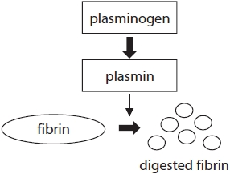
Pharmaceutical companies have developed drugs that inhibit the activity of plasmin.
One of these drugs, tranexamic acid, is used in surgery to reduce blood loss.
The active site of the plasmin enzyme binds to the amino acid lysine on the fibrin protein molecule.
Plasmin binds to part of the fibrin molecule in order to break down the fibrin. The diagrams show the structure of lysine in the fibrin polypeptide and the structure of tranexamic acid.
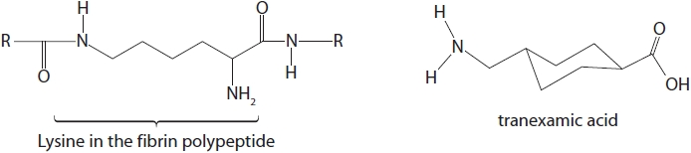
Deduce why tranexamic acid prevents plasmin breaking down fibrin.
(3)
.............................................................................................................................................
.............................................................................................................................................
.............................................................................................................................................
.............................................................................................................................................
.............................................................................................................................................
.............................................................................................................................................
.............................................................................................................................................
.............................................................................................................................................
.............................................................................................................................................
.............................................................................................................................................
.............................................................................................................................................

(Total for question = 3 marks)

Q4.
(i) Many of the proteins synthesised become extracellular enzymes.
Describe what happens to these proteins following the process of translation until they are released from the cell.
(3)
.............................................................................................................................................
.............................................................................................................................................
.............................................................................................................................................
.............................................................................................................................................
.............................................................................................................................................
.............................................................................................................................................
.............................................................................................................................................
.............................................................................................................................................
.............................................................................................................................................
(ii) Cells in people with these diseases produce incorrectly folded enzyme molecules.
Explain why enzymes that are incorrectly folded cannot carry out their function.
(3)
.............................................................................................................................................
.............................................................................................................................................
.............................................................................................................................................
.............................................................................................................................................
.............................................................................................................................................
.............................................................................................................................................
.............................................................................................................................................
.............................................................................................................................................
.............................................................................................................................................

(Total for question = 6 marks)

Q5.
L-dopa forms a colourless solution in water. Dopa oxidase is an enzyme that converts L-dopa into dopachrome, which is red.
A colorimeter can be used to study this reaction. As the red colour appears, the amount of light absorbed by the solution increases.
(a) The graph shows the course of a reaction in which there was an enzyme concentration of 20 (arbitrary units) of reaction mixture.
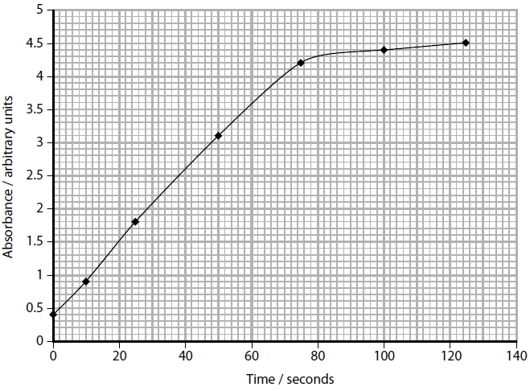
Calculate the initial rate of reaction for this concentration of enzyme.
(3)
Answer ...........................................................
(b) In another study, a student used this procedure with a range of enzyme concentrations. The results are shown in the table below.
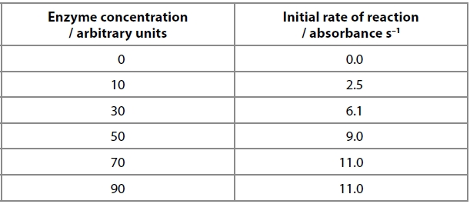
Explain the effect of enzyme concentration on the initial rate of this reaction.
(3)
.............................................................................................................................................
.............................................................................................................................................
.............................................................................................................................................
.............................................................................................................................................
.............................................................................................................................................
.............................................................................................................................................

(Total for question = 6 marks)

Q6.
Trypsin is an enzyme found in many groups of living organisms.
Trypsin specifically acts on a polypeptide to form amino acids.
In an experiment, the effect of enzyme concentration on the activity of human trypsin was measured.
The results are shown in the graph.
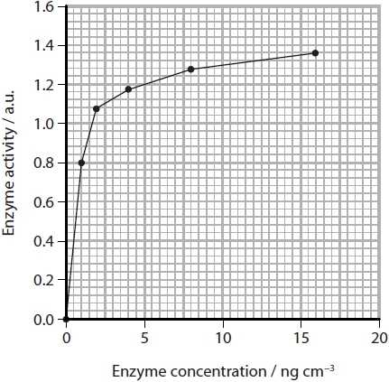
Explain which range of enzyme concentrations should be used to compare the activity of trypsin from different species.
(2)
.............................................................................................................................................
.............................................................................................................................................
.............................................................................................................................................
.............................................................................................................................................
.............................................................................................................................................
.............................................................................................................................................

(Total for question = 2 marks)

Mark Scheme
Q1.
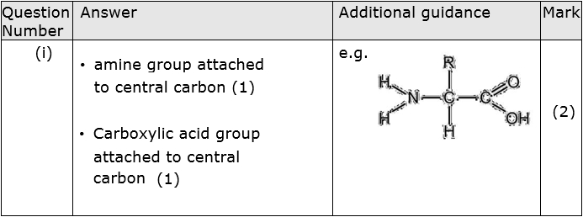
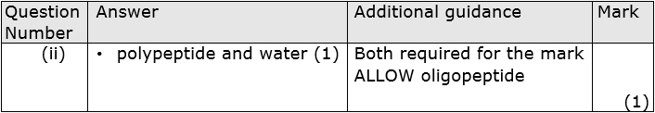

Q2.
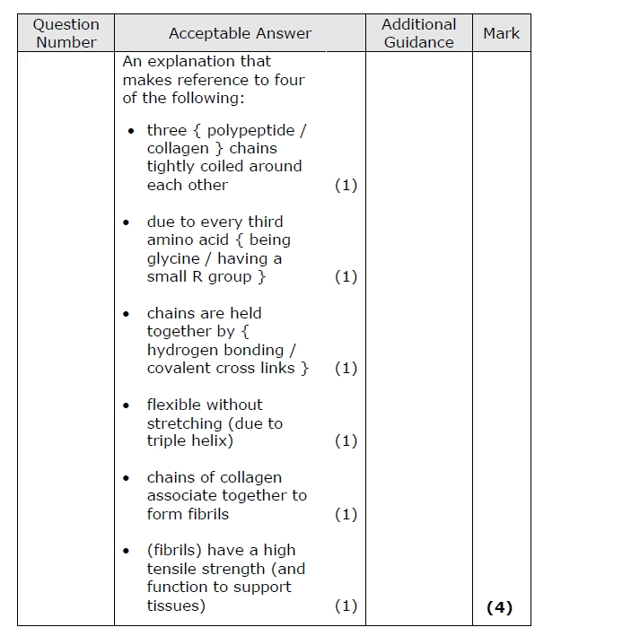

Q3.
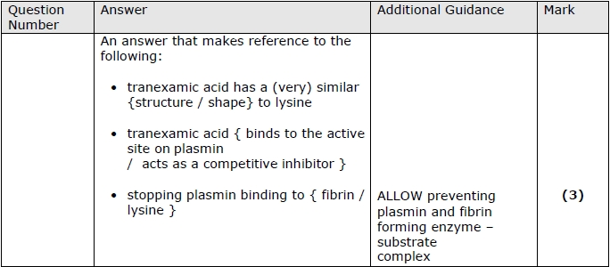

Q4.
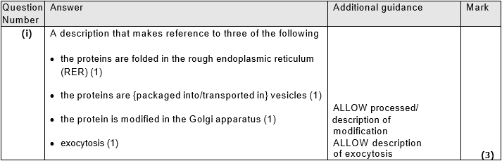
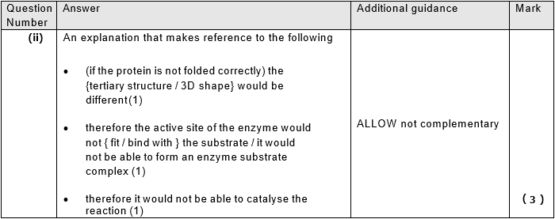

Q5.
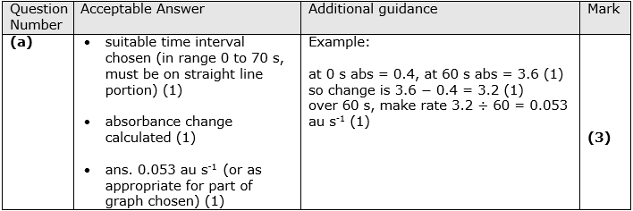
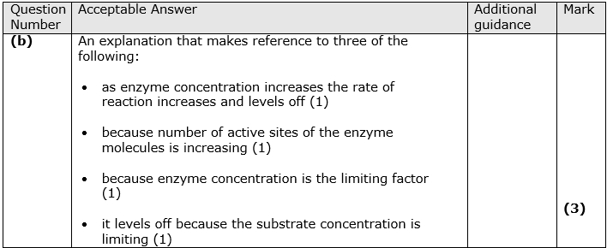

Q6.
