RER, Golgi and Spirometer Questions
Q1. Cattle are affected by a condition called mastitis.
Mastitis is caused by Staphylococcus aureus, a species of bacteria.
A different species of bacteria, Staphylococcus simulans, produces lysostaphin, an enzyme with antimicrobial properties.
Lysostaphin prevents infection by S. aureus.
Scientists have introduced the gene coding for lysostaphin into the genome of cattle.
Messenger RNA coding for lysostaphin is translated at a ribosome in the cells of cattle to produce a polypeptide.
(i) This polypeptide is processed inside the cells to produce the active enzyme. The enzyme is then secreted from the cells.
Describe how the cells process this polypeptide and secrete it as an enzyme.
(4)
.............................................................................................................................................
.............................................................................................................................................
.............................................................................................................................................
.............................................................................................................................................
.............................................................................................................................................
.............................................................................................................................................
.............................................................................................................................................
.............................................................................................................................................
(ii) Muscle tissue samples and milk from the cattle were tested for the presence of lysostaphin.
Deduce why lysostaphin was present in the milk but not in muscle tissue.
(4)
.............................................................................................................................................
.............................................................................................................................................
.............................................................................................................................................
.............................................................................................................................................
.............................................................................................................................................
.............................................................................................................................................
.............................................................................................................................................
.............................................................................................................................................
.............................................................................................................................................
.............................................................................................................................................
.............................................................................................................................................
.............................................................................................................................................

(Total for question = 8 marks)

Q2. The pancreas is an organ in mammals that secretes enzymes and hormones.
In an experiment, cells of the pancreas were provided with amino acids labelled with a radioactive element called tritium.
The graph below shows the distribution of tritium within different organelles in the cells over a period of 120 minutes.
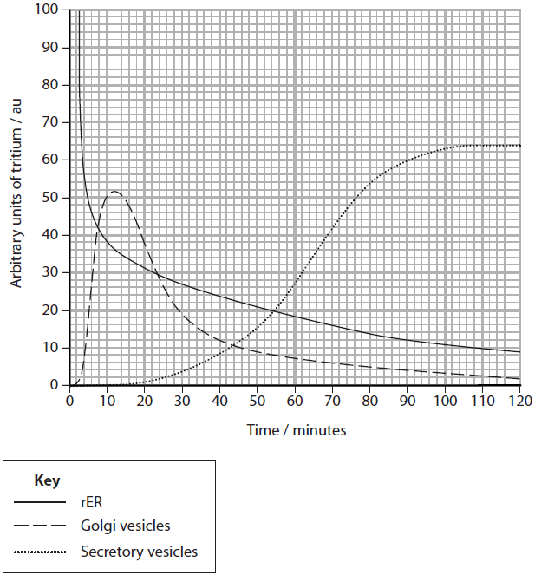
(i) Calculate the rate at which tritium moved out of the Golgi apparatus between 12 and 25 minutes.
(2)
Answer ...........................................................

Q3. Organisms can be classified into three domains: Archaea, Bacteria and Eukaryota. Fungi belong to the domain Eukaryota.
(a) (i) State two differences between the structure of cells of organisms belonging to the Eukaryota domain and those belonging to the Bacteria domain.
(2)
1
.............................................................................................................................................
2
.............................................................................................................................................
(ii) Name an organelle found in the cells of both eukaryotic and prokaryotic organisms.
(1)
.............................................................................................................................................
(c) Fungi produce different enzymes that can digest starch or cellulose.
Using your knowledge of the structure of starch and cellulose, suggest why it is necessary for fungi to produce different enzymes to digest these two substances.
(4)
.............................................................................................................................................
.............................................................................................................................................
.............................................................................................................................................
.............................................................................................................................................
.............................................................................................................................................
.............................................................................................................................................
.............................................................................................................................................
.............................................................................................................................................
.............................................................................................................................................
.............................................................................................................................................
.............................................................................................................................................
.............................................................................................................................................
Q4. A newborn baby can respond to infections.
Interferon is involved in the response to viral infections.
(i) The influenza virus can be lethal to mice.
The effects of interferon on influenza infection in mice was investigated.
Mice were infected with influenza virus and then given interferon.
The results of the investigation are shown in the table.
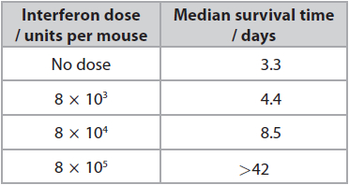
Explain these results.
(3)
.............................................................................................................................................
.............................................................................................................................................
.............................................................................................................................................
.............................................................................................................................................
.............................................................................................................................................
.............................................................................................................................................
.............................................................................................................................................
.............................................................................................................................................
.............................................................................................................................................
(ii) Interferon can be used to treat people with viral hepatitis.
Interferon can be made by animal cells or by genetically modified bacteria.
The table shows information about interferon made by these animal cells and genetically modified bacteria.
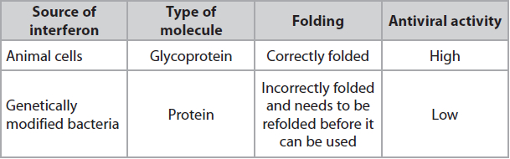
Explain why the interferon made by genetically modified bacteria is different from the interferon made by animal cells.
(2)
.............................................................................................................................................
.............................................................................................................................................
.............................................................................................................................................
.............................................................................................................................................
.............................................................................................................................................
.............................................................................................................................................

Q5. Cystic fibrosis is a condition that affects breathing.
A person breathed air in and out of the air chamber of a piece of apparatus.
Measurements were made of changes in the volume of air in the chamber. The carbon dioxide produced was removed from the chamber. The changes in volume were recorded on the trace shown in the diagram.
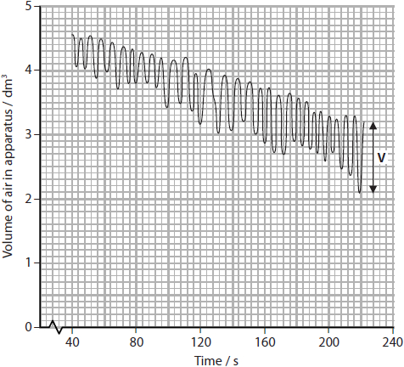
(i) Which of the following is the name of this piece of apparatus?
(1)
A colorimeter
B potometer
C respirometer
D spirometer
(ii) Which of the following is shown by the label V on the trace?
(1)
A alveolar volume
B tidal volume
C total lung volume
D ventilation rate
(iii) Which of the following is the breathing rate in breaths per minute between 80 and 120 seconds?
(1)
A 6 breaths min⁻¹
B 9 breaths min⁻¹
C 12 breaths min⁻¹
D 16 breaths min⁻¹
(iv) Calculate the rate of oxygen uptake between 80 and 120 seconds.
(3)
Answer ........................................................... cm³ min⁻¹

(Total for question = 6 marks)

Q6. Athletic competitions often take place during the summer months when ambient temperatures are high.
High ambient temperatures affect marathon runners.
Heat stress occurs when the core body temperature rises above 40 °C.
When running a marathon, both heart rate and stroke volume increase.
The graph shows the effect of exercise intensity on stroke volume for marathon runners.
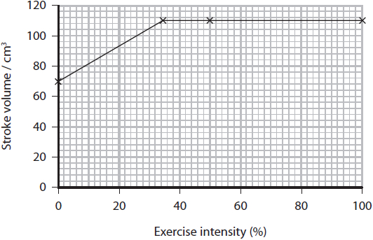
(i) Cardiac output is the product of stroke volume and heart rate.
During a race, a marathon runner's exercise intensity increased from 0 to 100%. The table shows the effect on the runner's heart rate.
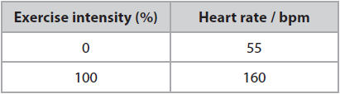
Calculate the increase in cardiac output for a marathon runner during a race.
Give your answer in dm³ min⁻¹.
(2)
........................................................... dm³ min⁻¹
(ii) Explain why it is necessary for the cardiac output of marathon runners to increase during a race.
(2)
.............................................................................................................................................
.............................................................................................................................................
.............................................................................................................................................
.............................................................................................................................................
.............................................................................................................................................
.............................................................................................................................................
.............................................................................................................................................
.............................................................................................................................................
Q7. Actin and collagen are both proteins.
The diagram shows two filaments of actin from a muscle fibre. Each filament is a
polymer of repeating globular protein units.
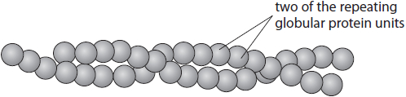
Compare and contrast the structures of an actin filament and collagen.
(3)
.............................................................................................................................................
.............................................................................................................................................
.............................................................................................................................................
.............................................................................................................................................
.............................................................................................................................................
.............................................................................................................................................
.............................................................................................................................................
.............................................................................................................................................
.............................................................................................................................................

(Total for question = 3 marks)

Mark Scheme
Q1.
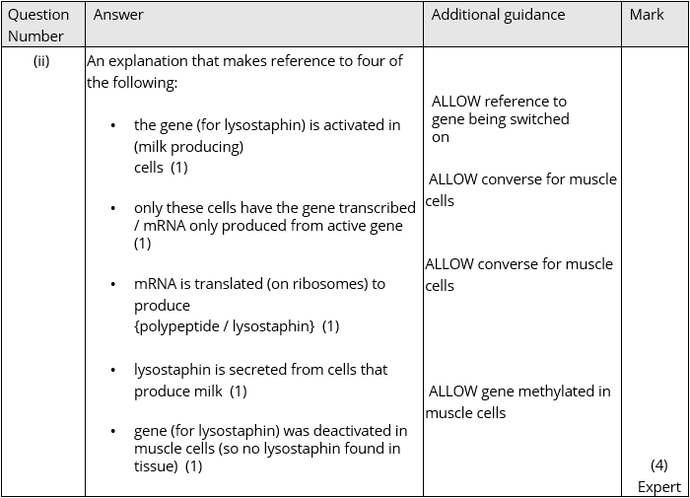

Q2.
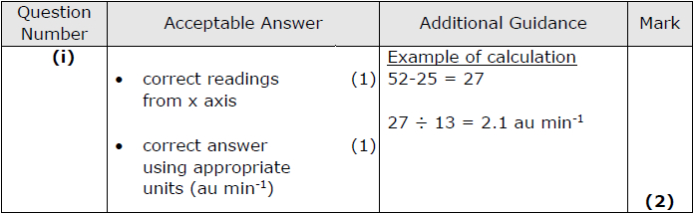
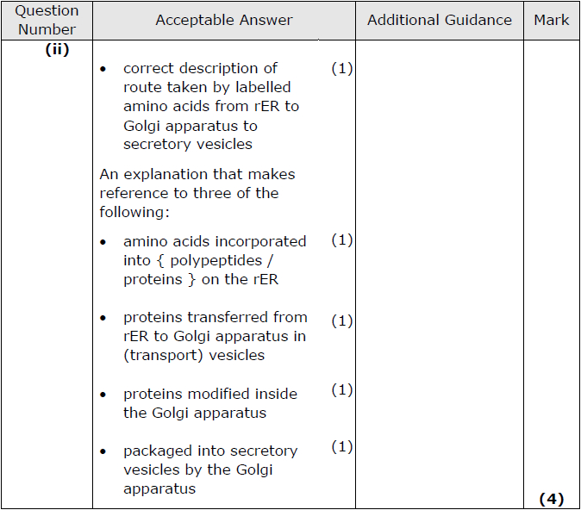

Q3.
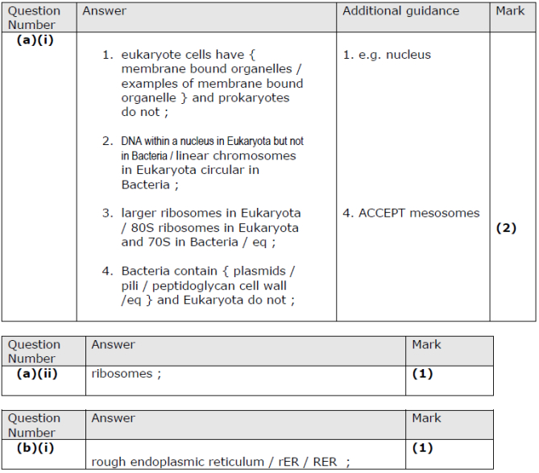
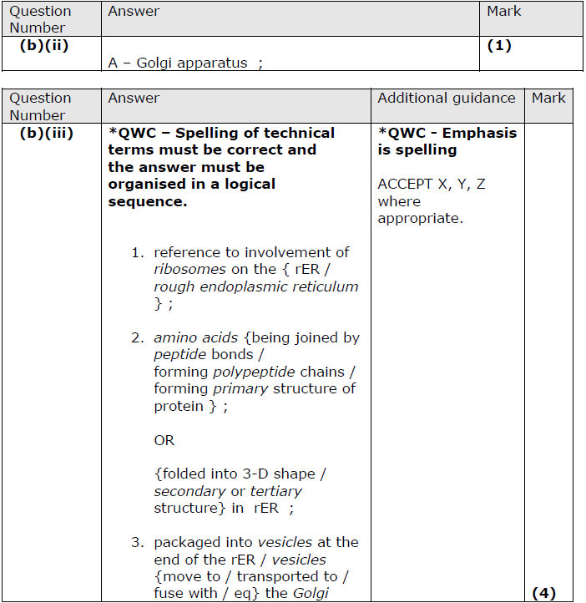
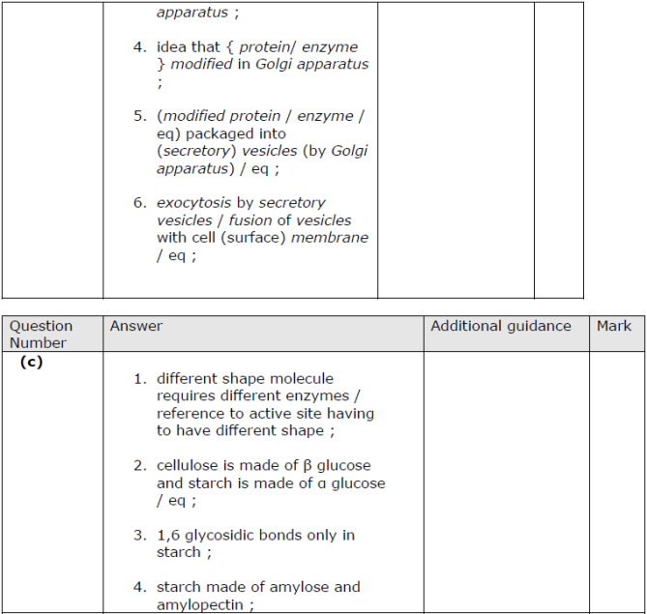
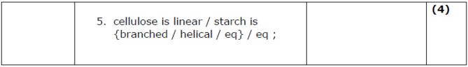

Q4.
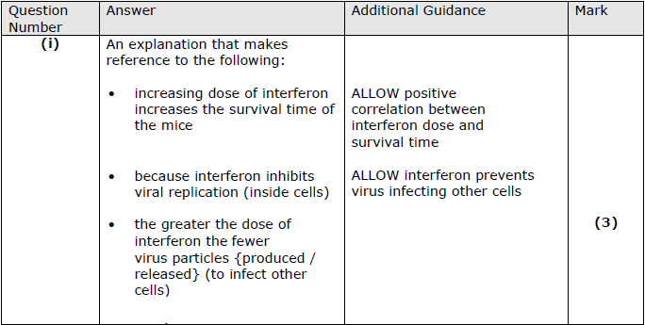
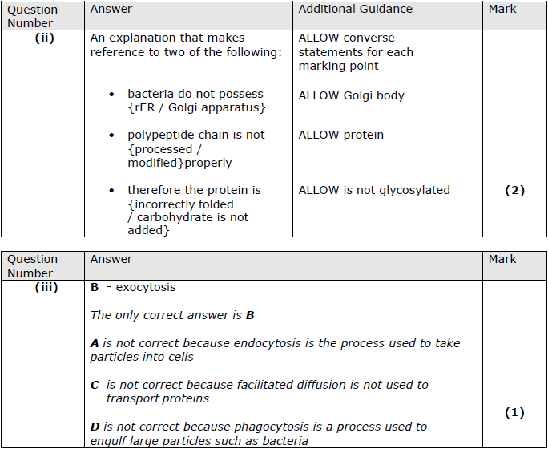

Q5.
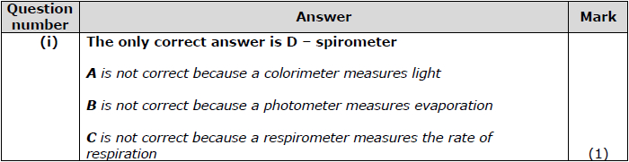
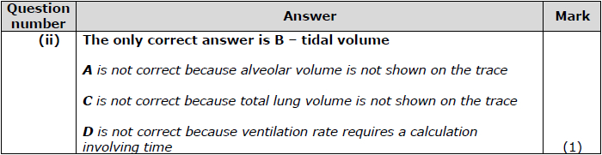
30
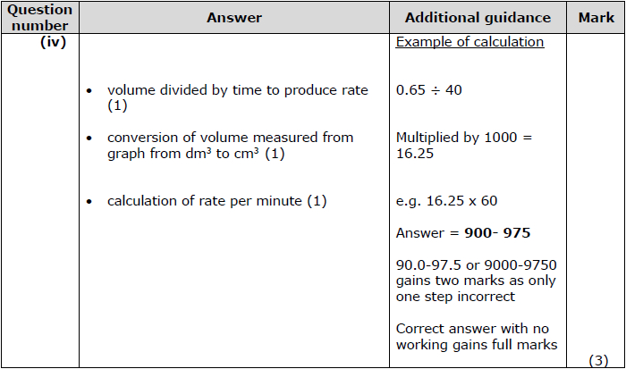

Q6.
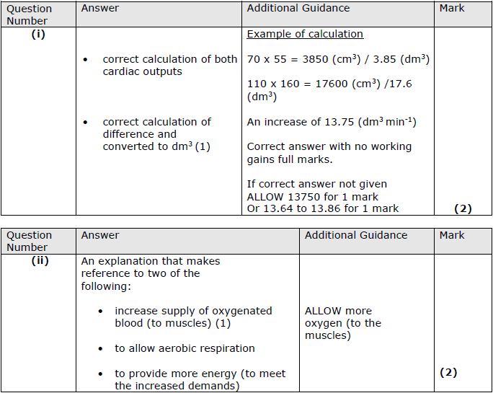

Q7.
