9Revision Exercises A2 Year 2
Edexcel Biology A (Salters Nuffield)

Topic 7: Run for your Life

Specifications points are displayed in blue like this
Exercises to Complete are displayed in black with this
7.1 Know the way in which muscles, tendons, the skeleton and ligaments interact to enable movement, including antagonistic muscle pairs, extensors and flexors.

- Compare the structure and function of Tendons and Ligaments

- Compare Bone tissue and Cartilage tissue

- Explain the term Antagonistic Muscle pairs

- Give four roles of a Mammalian Endoskeleton

- Draw a diagram of a knee joint labelled with structures and functions

7.2 Understand the process of contraction of skeletal muscle in terms of the sliding filament theory, including the role of actin, myosin, troponin, tropomyosin, calcium ions (Ca2+), ATP and ATPase.

- Describe the interaction between Actin and Myosin during muscle contraction. You may include a diagram

- Describe the interaction between troponin and tropomyosin when a skeletal muscle fibre contracts

- Describe the role of calcium ions during skeletal muscle contraction

- Describe the role of ATP in the contraction of a muscle fibre.

7.3 i) Understand the overall reaction of aerobic respiration as splitting of the respiratory substrate, to release carbon dioxide as a waste product and reuniting of hydrogen with atmospheric oxygen with the release of a large amount of energy.

ii) Understand that respiration is a many-stepped process with each step controlled and catalysed by a specific intracellular enzyme.

- The diagram below shows a metabolic process consisting of three steps. Each letter represents a different substance and each number a different enzyme.

.
Describe and explain the functions of enzymes in this metabolic process

7.4 Understand the roles of glycolysis in aerobic and anaerobic respiration, including the phosphorylation of hexoses, the production of ATP, reduced coenzyme, pyruvate and lactate

- Describe Glycolysis

- Explain The fate of Pyruvate without the availability of Oxygen

7.5 Understand the role of the link reaction and the Krebs cycle in the complete oxidation of glucose and formation of carbon dioxide

- Where does the Link Reaction take place?

- What are the products of the Link Reaction?

The diagram below shows some of the stages in the Krebs cycle.

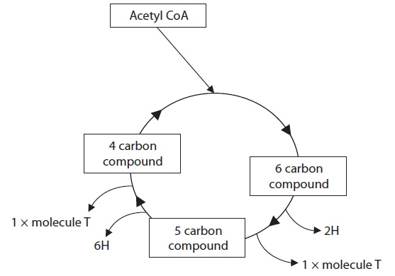

- Name molecule T and use the information in the Krebs cycle diagram to give a reason for your answer.

- Using information in the diagram, suggest what would happen in the Krebs cycle if acetyl CoA became unavailable

- Name the unnamed 4,5 and 6 carbon compounds in the diagram

7.6 Understand how ATP is synthesised by oxidative phosphorylation associated with the electron transport chain in mitochondria, including the role of chemiosmosis and ATP synthase.

- Explain what is meant by the term oxidative phosphorylation.

- Give the role of ATP synthase in Chemiosmosis

7.7 Understand what happens to lactate after a period of anaerobic respiration in animals.

- Explain the term Oxygen debt

CORE PRACTICAL 16:
Investigate rate of respiration.

- Give an account of how to practically investigate the rate of respiration in maggots.

7.8 i) Know the myogenic nature of cardiac muscle.

- Define the term Myogenic

ii) Understand how the normal electrical activity of the heart coordinates the heart beat, including the roles of the sinoatrial node (SAN), the atrioventricular node (AVN), the bundle of His and the Purkyne fibres.

- Explain the electrical control of the heart and the purpose of the AV delay

iii) Understand how the use of electrocardiograms (ECGs) can aid the diagnosis of cardiovascular disease (CVD) and other heart conditions.

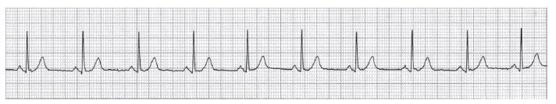

- This person had a resting heart rate of 74 beats per minute. Calculate the time taken for this ECG. Show your working.
- Give an example of a CVD condition that could be diagnosed from an ECG trace.

7.9 i) Be able to calculate cardiac output.

- Give the formula for working out cardiac output

ii) Understand how variations in ventilation and cardiac output enable rapid delivery of oxygen to tissues and the removal of carbon dioxide from them, including how the heart rate and ventilation rate are controlled and the roles of the cardiovascular control centre and the ventilation centre in the medulla oblongata.

- Give a detailed account of the physiological changes that take place when responding to exercise and how they are brought about.

CORE PRACTICAL 17:
Investigate the effects of exercise on tidal volume, breathing rate, respiratory minute ventilation and oxygen consumption using data from spirometer traces.

- Give an account of how you could use a Spirometer trace to monitor the effects of exercise.

7.10 i) Know the structure of a muscle fibre.

- Draw a well labelled diagram to show the structure of a muscle fibre

ii) Understand the structural and physiological differences between fast and slow twitch muscle fibres.

- Compare fast twitch and slow twitch muscle fibres

7.11 i) Understand what is meant by negative feedback and positive feedback control.
ii) Understand the principle of negative feedback in maintaining systems within narrow limits.

- Explain how the pH of the blood of a sprinter is returned to its original level after a race.

7.12 Understand homeostasis and its importance in maintaining the body in a state of dynamic equilibrium during exercise, including the role of the hypothalamus and the mechanisms of thermoregulation.

- Explain how increased sweating is brought about and how it is involved in the regulation of body temperature

7.13 Understand the analysis and interpretation of data relating to possible disadvantages of exercising too much and exercising too little) recognising correlation and causal relationships.

- Evaluate the value of exercise to human health.

7.14 Understand how medical technology, including the use of keyhole surgery and prostheses, is enabling those with injuries and disabilities to participate in sports.

Hurdlers can damage their cruciate ligaments. This is an injury that can be repaired using keyhole surgery.

- What is the function of the cruciate ligament?

- Why might someone prefer to have this injury repaired through keyhole surgery?

7.15 Be able to discuss different ethical positions relating to whether the use of performance-enhancing substances by athletes is acceptable.

- Suggest two ethical reasons why the use of drugs, such as EPO, should be banned
from sport.

- Compare the absolutist view of performance enhancing drugs with the rationalist view

7.16 Understand how genes can be switched on and off by DNA transcription factors including hormones.

- What is a Transcription factor?

- Explain how transcription factors may cause the somatic cells to be converted into iPS cells (a new type of stem cell)

