Revision Tasks: Topic 8
Complete these along with your normal revision/practice papers and you’ll be well prepared for topic 8. Make it colourful and decorate your room with them, it’ll look gorgeous!
- Make a flow diagram of the stages of a reflex arc.
- Make a flow diagram showing the stages in transmission across a synapse.
- Define summation, giving the 2 types.
- Explain how Hubel and Weisel investigated visual development and what the results tell us.
- Summarise the process of habituation and describe how it can be tested ethically.
- Explain how IAA affects the cells on the shaded side of shoots.
- Explain how a neuron becomes myelinated and the effect this has on impulse transmission.
- Complete the following tables:

Type of neurone | Sketch and key features
Motor  Sensory  Relay | 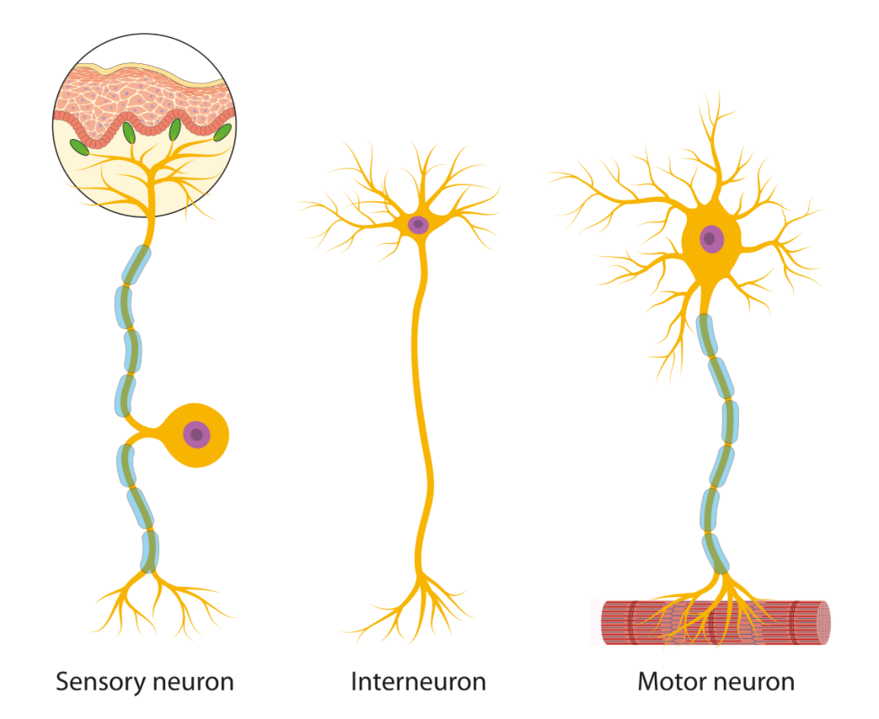

 | Bright light | Dim light
Circular muscles of iris
Radial muscles of iris
Pupil size

Rod cell in the dark | Rod cell in the light
- Explain the term ‘dark adaptation’
- Explain how impulses are conducted along a myelinated neurone.
Features of nervous transmission in animals | Features of hormonal transmission in animals | Features of hormonal transmission in plants

- Label the oscilloscope trace showing which channels are open/closed, which ions are moving where and what each stage is called.
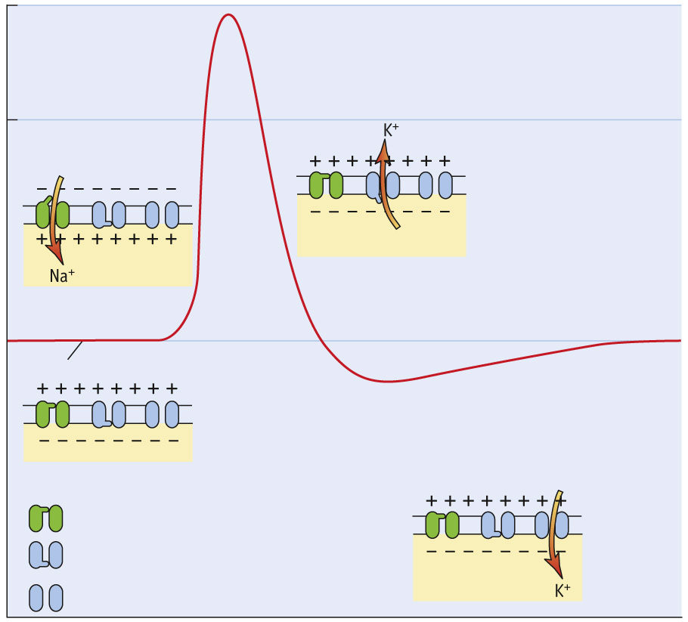

Method of studying the brain | How it works (in outline) | Why it is useful/what it tells us/ drawbacks or limitations
Electrical stimulation

fMRI scan

Brain damage patients

MRI scan

CT scan

FOR USING ANIMALS IN SCIENTIFIC RESEARCH | AGAINST USING ANIMALS IN SCIENTIFIC RESEARCH

Potential uses for the human genome project | Possible ethical problems/issues to consider

 | DEPRESSION | PARKINSON’S DISEASE
Neurotransmitter involved
Causes
Symptoms
Treatments

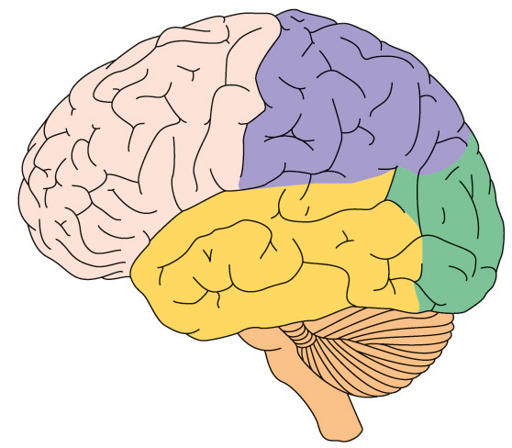
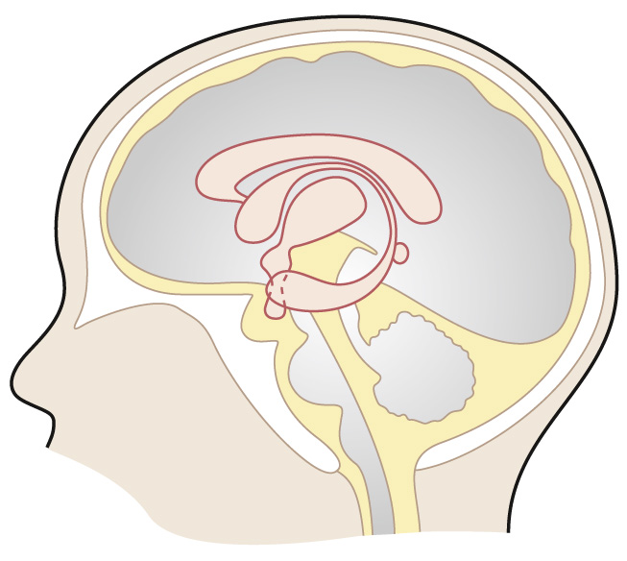
- Label these diagrams of the brain giving the functions of the 4 regions named in the specification.

- Add labels and annotations to explain what this diagram shows:
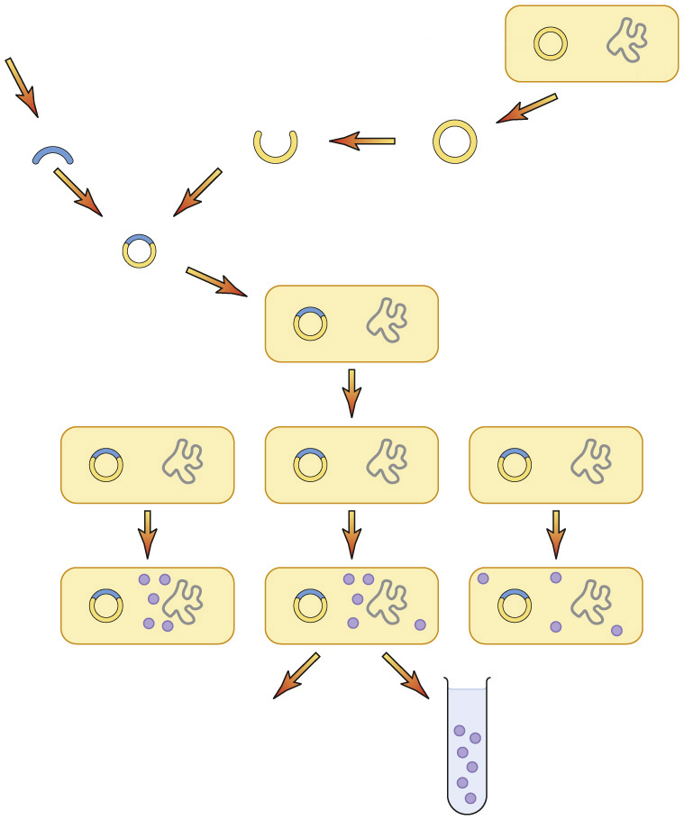
- How could the process above be used and what are the possible concerns associated with it?

 | Short day plants |  | Long day plants
How they are affected by high levels of P_{FR}
Example
Phytochrome is:  Phytochrome is found in: |  | Phytochrome interconversion diagram: (P_{R} and P_{FR})

