Scientific Article 2025 Exam Questions On Potential Topics
Q1.
During the development of the mammalian heart, there is a hole between the left ventricle and the right ventricle.
This hole usually becomes sealed before the mammal is born. If it is not sealed, the mammal will become easily tired due to a lack of energy.
Explain why a mammal born with a hole between the two ventricles will have these symptoms.
(3)
.............................................................................................................................................
.............................................................................................................................................
.............................................................................................................................................
.............................................................................................................................................
.............................................................................................................................................
.............................................................................................................................................
.............................................................................................................................................
.............................................................................................................................................

(Total for question = 3 marks)

Q2.
Thrombophilia is a condition that increases the risk of blood clots forming.
This condition increases the risk of venous thromboembolism (VTE), a condition where
a blood clot forms in a vein. Thrombophilia due to the production of overactive factor V
can be inherited.
Factor V is involved in the conversion of prothrombin to thrombin.
(i) Describe the role of thrombin in blood clotting.
(3)
.............................................................................................................................................
.............................................................................................................................................
.............................................................................................................................................
.............................................................................................................................................
.............................................................................................................................................
.............................................................................................................................................
.............................................................................................................................................
.............................................................................................................................................
.............................................................................................................................................
(ii) Explain why a mutation in the gene coding for the protein factor V may increase the risk of VTE.
(3)
.............................................................................................................................................
.............................................................................................................................................
.............................................................................................................................................
.............................................................................................................................................
.............................................................................................................................................
.............................................................................................................................................
.............................................................................................................................................
.............................................................................................................................................
.............................................................................................................................................

(Total for question = 6 marks)

Q3.
The squid is an invertebrate animal that lives in the sea.
The photograph shows a squid.
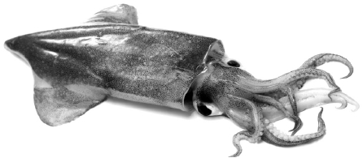
(Source: © bonchan/Shutterstock)
The diagram shows the circulatory system of a squid.
The gills contain gas exchange surfaces.
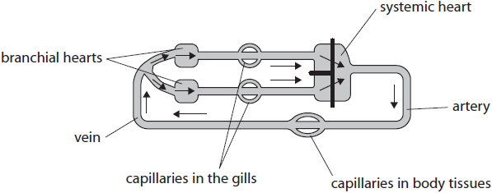
(i) Compare and contrast the circulatory systems of a squid and a human.
(3)
.............................................................................................................................................
.............................................................................................................................................
.............................................................................................................................................
.............................................................................................................................................
.............................................................................................................................................
.............................................................................................................................................
.............................................................................................................................................
.............................................................................................................................................
.............................................................................................................................................
(ii) A student wished to investigate the effect of caffeine on the heart rate of some vertebrate and invertebrate organisms.
Describe two potential ethical issues which should be considered before the selection of organisms to include in this investigation.
(2)
.............................................................................................................................................
.............................................................................................................................................
.............................................................................................................................................
.............................................................................................................................................
.............................................................................................................................................
.............................................................................................................................................
.............................................................................................................................................
.............................................................................................................................................
.............................................................................................................................................

(Total for question = 5 marks)

Q4.
Fibrin is involved in the formation of blood clots.
Thrombin is an enzyme that converts fibrinogen to fibrin.
The table shows the results of an investigation into the fibrinogen concentrations in the blood of males and females with and without cardiovascular disease (CVD).
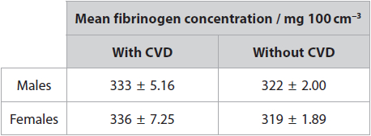
(i) Explain how the results of this investigation could be used to identify individuals at risk of CVD.
(3)
.............................................................................................................................................
.............................................................................................................................................
.............................................................................................................................................
.............................................................................................................................................
.............................................................................................................................................
.............................................................................................................................................
.............................................................................................................................................
.............................................................................................................................................
.............................................................................................................................................
.............................................................................................................................................
(ii) Explain how changes in fibrinogen concentration might be a risk factor for CVD.
(3)
.............................................................................................................................................
.............................................................................................................................................
.............................................................................................................................................
.............................................................................................................................................
.............................................................................................................................................
.............................................................................................................................................
.............................................................................................................................................
.............................................................................................................................................
.............................................................................................................................................

(Total for question = 6 marks)

Q5.
A baby was born with an abnormal heart. The diagram shows the heart of this baby. There is a hole in the septum between the two ventricles.
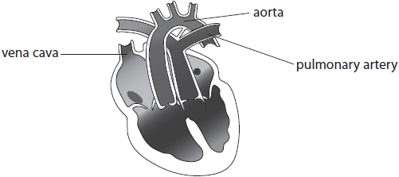
(i) Identify the problem with the blood vessels of this heart.
(1)
.............................................................................................................................................
.............................................................................................................................................
.............................................................................................................................................
.............................................................................................................................................
(ii) The baby survived because of the hole in the septum of the heart.
Explain how the hole in the septum allowed this baby to survive.
(3)
.............................................................................................................................................
.............................................................................................................................................
.............................................................................................................................................
.............................................................................................................................................
.............................................................................................................................................
.............................................................................................................................................
.............................................................................................................................................
.............................................................................................................................................
.............................................................................................................................................
.............................................................................................................................................
.............................................................................................................................................

(Total for question = 4 marks)

Q6.
Leptin is a protein hormone with a role in the control of appetite in humans.
The leptin gene is located on chromosome 17.
(i) State what is meant by the term gene.
(2)
.............................................................................................................................................
.............................................................................................................................................
.............................................................................................................................................
.............................................................................................................................................
(ii) Describe the role of tRNA in the production of leptin.
(3)
.............................................................................................................................................
.............................................................................................................................................
.............................................................................................................................................
.............................................................................................................................................
.............................................................................................................................................
.............................................................................................................................................
.............................................................................................................................................
.............................................................................................................................................
.............................................................................................................................................
(iii) Describe how the primary structure of leptin enables it to be soluble in water.
(3)
.............................................................................................................................................
.............................................................................................................................................
.............................................................................................................................................
.............................................................................................................................................
.............................................................................................................................................
.............................................................................................................................................
.............................................................................................................................................
.............................................................................................................................................
.............................................................................................................................................
.............................................................................................................................................

(Total for question = 8 marks)

Q7.
Some fish live in very cold parts of the sea where ice can form.
Many of these fish produce anti-freeze proteins, which help to stop ice forming inside the fish.
Some fish produce another anti-freeze protein, called AFP II.
The tissues of these fish were tested for the presence of AFP II and the mRNA coding for AFP II.
The results are shown in the table.
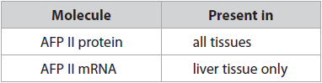
Explain the distribution of the AFP II protein and AFP II mRNA.
(4)
.............................................................................................................................................
.............................................................................................................................................
.............................................................................................................................................
.............................................................................................................................................
.............................................................................................................................................
.............................................................................................................................................
.............................................................................................................................................
.............................................................................................................................................
.............................................................................................................................................
.............................................................................................................................................
.............................................................................................................................................
.............................................................................................................................................
.............................................................................................................................................

(Total for question = 4 marks)

Q8.
Fertilisation in humans involves the fusion of a sperm cell with an egg cell.
Cell division of the fertilised cell produces a ball of totipotent cells.
(i) Give the meaning of the term totipotent cell.
(2)
.............................................................................................................................................
.............................................................................................................................................
.............................................................................................................................................
.............................................................................................................................................
.............................................................................................................................................
.............................................................................................................................................
.............................................................................................................................................
.............................................................................................................................................
.............................................................................................................................................
(ii) This ball of cells continues to divide to form the embryo. The cells of the embryo become specialised to form tissues and organs.
Describe how cells become specialised.
(3)
.............................................................................................................................................
.............................................................................................................................................
.............................................................................................................................................
.............................................................................................................................................
.............................................................................................................................................
.............................................................................................................................................
.............................................................................................................................................
.............................................................................................................................................
.............................................................................................................................................
.............................................................................................................................................

(Total for question = 5 marks)

Q9.
Mitochondria are organelles found in eukaryotic cells.
The diagram shows a mitochondrion.
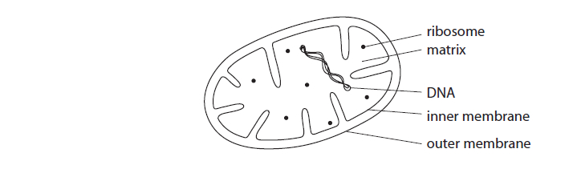
(a) Where in the mitrochondrion does the Krebs cycle take place?
(1)
A inner membrane
B matrix
C outer membrane
D ribosome
(b) Compare and contrast the structure of a prokaryotic with that of a mitochondrion, as shown in the diagram.
(3)
.............................................................................................................................................
.............................................................................................................................................
.............................................................................................................................................
.............................................................................................................................................
.............................................................................................................................................
.............................................................................................................................................
.............................................................................................................................................
.............................................................................................................................................
.............................................................................................................................................
.............................................................................................................................................

Q10.
All known organisms can be placed into one of the three domains of life.
The table shows some information about the three different domains.
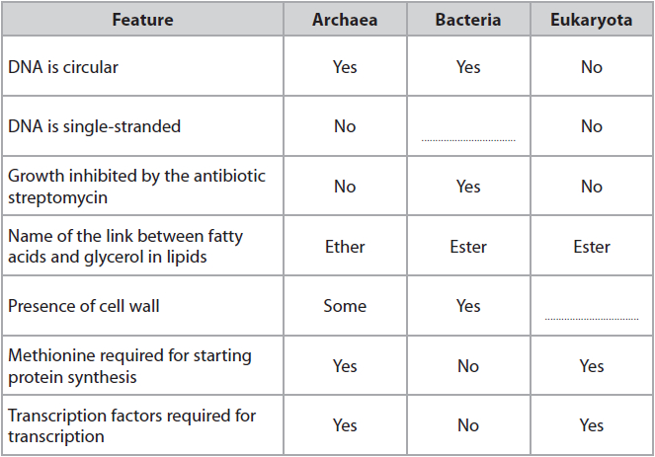
Explain how the information in the table can be used to show that the Archaea are more closely related to the Eukaryota than to the Bacteria.
(3)
.............................................................................................................................................
.............................................................................................................................................
.............................................................................................................................................
.............................................................................................................................................
.............................................................................................................................................
.............................................................................................................................................
.............................................................................................................................................
.............................................................................................................................................
.............................................................................................................................................
.............................................................................................................................................
.............................................................................................................................................

(Total for question = 3 marks)

Q11.
Sloths are mammals found in Central and South America.
The map shows the distribution of two species of sloth.
There are currently two major populations of C. hoffmanni in South America.
B. pygmaeus is restricted to an island off the coast of Central America.
Each population occupies different habitats.
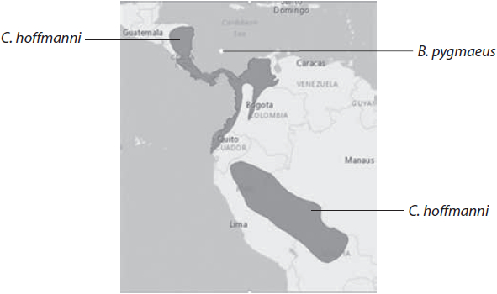
Discuss why the number of sloth species may change in the future.
(6)
.............................................................................................................................................
.............................................................................................................................................
.............................................................................................................................................
.............................................................................................................................................
.............................................................................................................................................
.............................................................................................................................................
.............................................................................................................................................
.............................................................................................................................................
.............................................................................................................................................
.............................................................................................................................................
.............................................................................................................................................
.............................................................................................................................................
.............................................................................................................................................
.............................................................................................................................................
.............................................................................................................................................
.............................................................................................................................................
.............................................................................................................................................
.............................................................................................................................................

(Total for question = 6 marks)

Q12.
A new species of mosquito has evolved in the tunnels of the London Underground. These mosquitoes are believed to be the descendants of bird-biting mosquitoes which colonised the tunnels 100 hundred years ago. The mosquitoes now feed on rats, mice and human beings instead of birds.
(a) Place a cross in the box next to the best definition of a species.
(1)
A individuals can interbreed to produce fertile offspring
B individuals can interbreed to produce hybrid offspring
C individuals can interbreed to produce sterile offspring
D individuals can interbreed to produce offspring
(b) Explain how this species of mosquito may have evolved.
(5)
.............................................................................................................................................
.............................................................................................................................................
.............................................................................................................................................
.............................................................................................................................................
.............................................................................................................................................
.............................................................................................................................................
.............................................................................................................................................
.............................................................................................................................................
.............................................................................................................................................
.............................................................................................................................................

(Total for question = 6 marks)

Q13.
The scientific article you have studied is adapted from a chapter in the book Oxygen.
Use the information from the scientific article and your own knowledge to answer the following question.
The structure of the oxygen-evolving complex is similar to that of catalase, 'it looks as if it evolved from two catalase enzymes lashed together' (paragraph 17).
Explain how proteomics and genomics could be used to support the suggestion that the oxygen-evolving complex evolved from catalase.
(4)
.............................................................................................................................................
.............................................................................................................................................
.............................................................................................................................................
.............................................................................................................................................
.............................................................................................................................................
.............................................................................................................................................
.............................................................................................................................................
.............................................................................................................................................
.............................................................................................................................................

(Total for question = 4 marks)

Q14.
Cellular respiration is a metabolic process essential for life.
(a) Respiration in maggots is similar to respiration in humans.
In an investigation, three maggots were placed in a respirometer as shown.
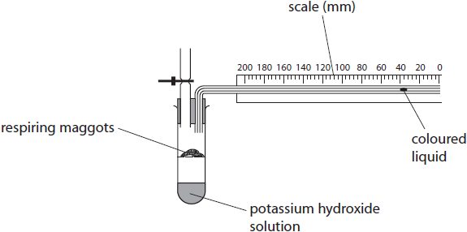
The maggots respired aerobically for 20 minutes in this respirometer.
Explain why the coloured liquid moved to the left during the 20 minutes of this investigation.
(2)
.............................................................................................................................................
.............................................................................................................................................
.............................................................................................................................................
.............................................................................................................................................
.............................................................................................................................................
.............................................................................................................................................
(b) Devise an investigation, using a respirometer, to find the optimum temperature for respiration in maggots.
(5)
.............................................................................................................................................
.............................................................................................................................................
.............................................................................................................................................
.............................................................................................................................................
.............................................................................................................................................
.............................................................................................................................................
.............................................................................................................................................
.............................................................................................................................................
.............................................................................................................................................
.............................................................................................................................................
.............................................................................................................................................
.............................................................................................................................................
.............................................................................................................................................
.............................................................................................................................................

(Total for question = 7 marks)

Q15.
Athletic competitions often take place during the summer months when ambient temperatures are high.
High ambient temperatures affect marathon runners.
Heat stress occurs when the core body temperature rises above 40 °C.
Describe how thermoregulatory mechanisms are controlled to help marathon runners avoid heat stress.
(4)
.............................................................................................................................................
.............................................................................................................................................
.............................................................................................................................................
.............................................................................................................................................
.............................................................................................................................................
.............................................................................................................................................
.............................................................................................................................................
.............................................................................................................................................
.............................................................................................................................................
.............................................................................................................................................
.............................................................................................................................................
.............................................................................................................................................

(Total for question = 4 marks)

Q16.
The effect of environmental temperature and exercise on the rate of sweating was studied.
The graph shows the results for one person.
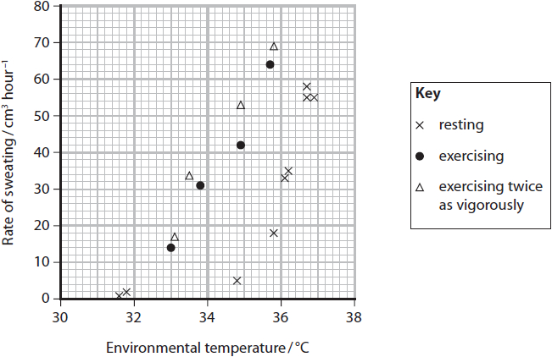
Comment on the results of this study.
(4)
.............................................................................................................................................
.............................................................................................................................................
.............................................................................................................................................
.............................................................................................................................................
.............................................................................................................................................
.............................................................................................................................................
.............................................................................................................................................
.............................................................................................................................................
.............................................................................................................................................
.............................................................................................................................................
.............................................................................................................................................
.............................................................................................................................................

(Total for question = 4 marks)

Q17.
Cellular respiration is a metabolic process essential for life.
The diagram represents part of aerobic respiration in a muscle cell.
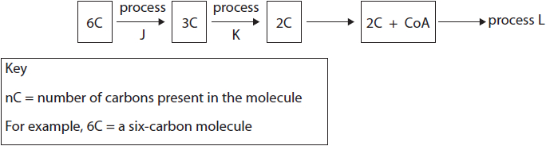
(i) Name two products, other than the three-carbon molecule (3C), that are formed by process J.
(1)
.............................................................................................................................................
.............................................................................................................................................
(ii) Describe what would happen to the three-carbon molecule (3C) if process K stopped.
(2)
.............................................................................................................................................
.............................................................................................................................................
.............................................................................................................................................
.............................................................................................................................................
.............................................................................................................................................
.............................................................................................................................................
.............................................................................................................................................
.............................................................................................................................................
.............................................................................................................................................
(iii) Which one of the following represents process L?
(1)
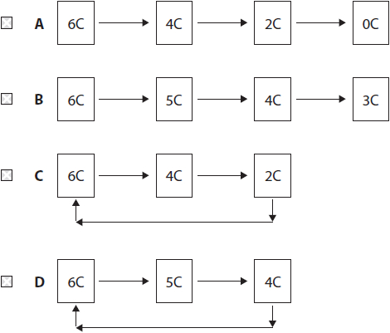

(Total for question = 4 marks)

Q18.
Athletic competitions often take place during the summer months when ambient temperatures are high.
High ambient temperatures affect marathon runners.
Heat stress occurs when the core body temperature rises above 40 °C.
Physical and physiological differences between males and females affect thermoregulation.
The graph shows the effect of a mean increase in body temperature on the rate of sweat production by males and females.
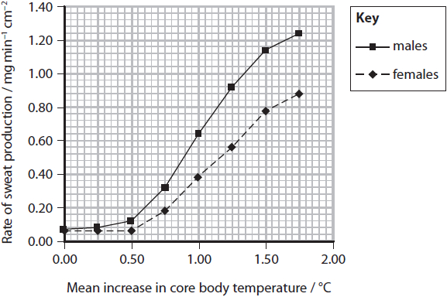
Female marathon runners have smaller bodies, with a larger ratio of skin surface to body mass than males.
Male marathon runners have less body fat than females: 5–11% compared with 10–15%.
Comment on how gender could affect thermoregulation in marathon runners.
(4)
.............................................................................................................................................
.............................................................................................................................................
.............................................................................................................................................
.............................................................................................................................................
.............................................................................................................................................
.............................................................................................................................................
.............................................................................................................................................
.............................................................................................................................................
.............................................................................................................................................
.............................................................................................................................................

(Total for question = 4 marks)

Q19.
The maintenance of blood glucose levels is an example of homeostasis.
State what is meant by the term homeostasis.
(1)
.............................................................................................................................................
.............................................................................................................................................
.............................................................................................................................................

Q20.
The junction between the end of a motor neurone and a muscle myofibril is a modified synapse.
The diagram shows this neuromuscular junction.
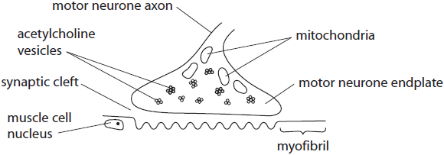
Describe how the neurotransmitter crosses this synapse.
(2)
.............................................................................................................................................
.............................................................................................................................................
.............................................................................................................................................
.............................................................................................................................................
.............................................................................................................................................
.............................................................................................................................................

(Total for question = 2 marks)

Q21.
The scientific article you have studied is adapted from several sources.
Use the information from the scientific article and your own knowledge to answer the following questions.
The reward system in humans involves the neurotransmitter dopamine pathway (paragraph 7).
Describe how dopamine acts as a neurotransmitter.
(4)
.............................................................................................................................................
.............................................................................................................................................
.............................................................................................................................................
.............................................................................................................................................
.............................................................................................................................................
.............................................................................................................................................
.............................................................................................................................................
.............................................................................................................................................
.............................................................................................................................................
.............................................................................................................................................
.............................................................................................................................................
.............................................................................................................................................

(Total for question = 4 marks)

Q22.
Serotonin is found in the brain and is important in health and wellbeing.
An imbalance of serotonin can lead to problems such as depression. An individual with symptoms of depression may have low serotonin levels in the brain.
The use of drugs such as MDMA (ecstasy) can cause an imbalance of chemicals in the brain.
(i) Describe how the use of MDMA could affect the transmission of impulses in the brain.
(2)
.............................................................................................................................................
.............................................................................................................................................
.............................................................................................................................................
.............................................................................................................................................
.............................................................................................................................................
.............................................................................................................................................
.............................................................................................................................................
(ii) Individuals who use MDMA may develop the symptoms of depression.
Explain how the use of MDMA could result in the development of these symptoms.
(2)
.............................................................................................................................................
.............................................................................................................................................
.............................................................................................................................................
.............................................................................................................................................
.............................................................................................................................................
.............................................................................................................................................
.............................................................................................................................................

(Total for question = 4 marks)

Q23.
The human brain is an organ that has a range of functions.
There are various types of scan that can be used to study the brain.
(i) Describe why a region of the brain might appear lighter in an image obtained by a functional magnetic resonance image (fMRI) scan.
(3)
.............................................................................................................................................
.............................................................................................................................................
.............................................................................................................................................
.............................................................................................................................................
.............................................................................................................................................
.............................................................................................................................................
.............................................................................................................................................
.............................................................................................................................................
.............................................................................................................................................
(ii) One scan combines positron emission tomography (PET) and computed tomography (CT). This scan can be used to show whether a person has cancer.
Describe why a combined PET and CT scan may be better for diagnosing cancer than a PET or CT scan on its own.
(3)
.............................................................................................................................................
.............................................................................................................................................
.............................................................................................................................................
.............................................................................................................................................
.............................................................................................................................................
.............................................................................................................................................
.............................................................................................................................................
.............................................................................................................................................
.............................................................................................................................................

(Total for question = 6 marks)

Q24.
Haemophilia is a genetic disorder where blood does not clot normally.
It can be treated by injecting factor VIII, a protein involved in the blood-clotting process that is not produced by people with haemophilia type A.
Bacteria can be genetically modified to produce factor VIII.
(a) The diagram shows some of the steps involved in genetically modifying bacteria to produce factor VIII.
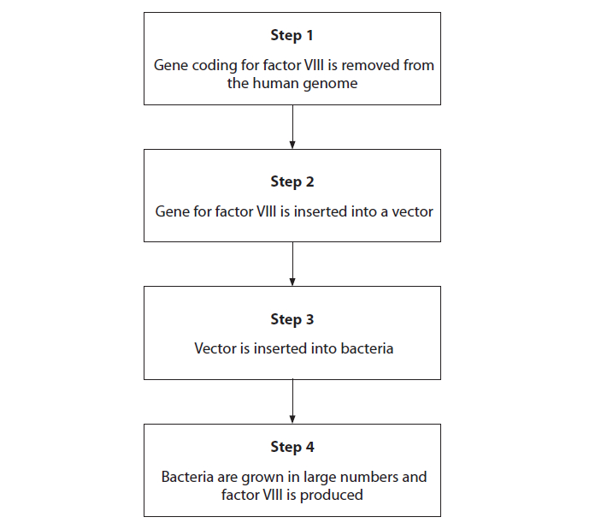
(i) Describe the difference between a gene and the genome
(2)
.............................................................................................................................................
.............................................................................................................................................
.............................................................................................................................................
.............................................................................................................................................
.............................................................................................................................................
(ii) Give the name of the type of enzyme that would be used to insert the gene into the DNA of the vector at Step 2.
(1)
.............................................................................................................................................
(iii) Give an example of a suitable vector that would be used in Step 2 or 3.
(1)
.............................................................................................................................................
(iv) Describe how the genetically modified bacteria would use the gene from the human genome to produced factor VIII in Step 4.
(2)
.............................................................................................................................................
.............................................................................................................................................
.............................................................................................................................................
.............................................................................................................................................
.............................................................................................................................................
.............................................................................................................................................
.............................................................................................................................................
(b) Factor VIII is required for the activation of prothrombin.
Explain why the blood-clotting process does not take place normally when a person with haemophilia type A cuts their hand.
(3)
.............................................................................................................................................
.............................................................................................................................................
.............................................................................................................................................
.............................................................................................................................................
.............................................................................................................................................
.............................................................................................................................................
.............................................................................................................................................
.............................................................................................................................................
.............................................................................................................................................
.............................................................................................................................................
.............................................................................................................................................
.............................................................................................................................................

(Total for question = 9 marks)

Q25.
Cells in the human brain use glucose as a respiratory substrate.
PET, MRI and fMRI are methods for scanning the brain.
PET uses labelled glucose. This glucose can be detected so that PET can be used to identify brain tumours.
(i) Describe the advantages of using PET and fMRI rather than MRI scans to investigate a possible tumour in the brain.
(2)
.............................................................................................................................................
.............................................................................................................................................
.............................................................................................................................................
.............................................................................................................................................
.............................................................................................................................................
.............................................................................................................................................
(ii) The images show brain scans produced from two imaging techniques other than PET.
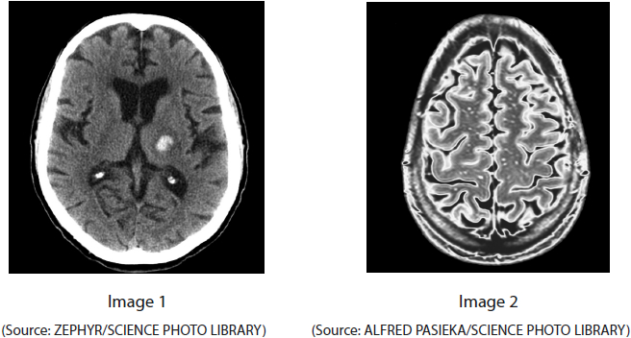
State how image 1 can be identified as being produced by CT and image 2 by MRI.
(1)
.............................................................................................................................................
.............................................................................................................................................

(Total for question = 3 marks)

Q26.
Acetylcholinesterase is an enzyme involved in regulating the transmission of nerve impulses across some synapses.
Alzheimer's disease is associated with the loss of neurones that produce acetylcholine.
It has been suggested that inhibitors of acetylcholinesterase may be useful in the treatment of Alzheimer's disease.
(i) Explain why inhibitors of acetylcholinesterase could be useful in the treatment of Alzheimer's disease.
(3)
.............................................................................................................................................
.............................................................................................................................................
.............................................................................................................................................
.............................................................................................................................................
.............................................................................................................................................
.............................................................................................................................................
.............................................................................................................................................
.............................................................................................................................................
.............................................................................................................................................
(ii) Trials of a new inhibitor were carried out using tissue cultures.
The effect of the concentration of the inhibitor on acetylcholinesterase activity and cell viability was measured.
Percentage cell viability was measured as the percentage of cells that were not killed by the inhibitor.
The graph shows the results for this inhibitor.
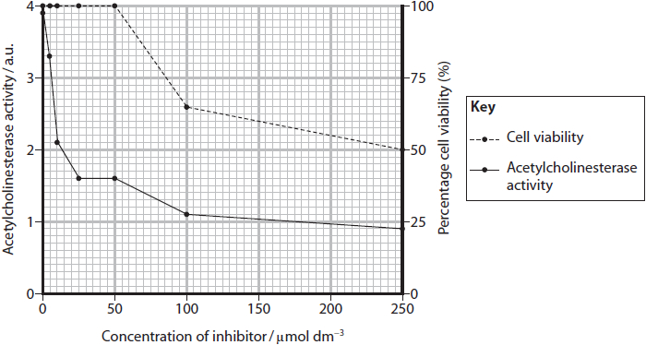
State and justify a suitable concentration of inhibitor to use in clinical trials.
(3)
.............................................................................................................................................
.............................................................................................................................................
.............................................................................................................................................
.............................................................................................................................................
.............................................................................................................................................
.............................................................................................................................................
.............................................................................................................................................
.............................................................................................................................................
.............................................................................................................................................

(Total for question = 6 marks)

Q27.
Glucosaminoglycans (GAGs) are the by-products of chemical reactions inside cells. GAGs are broken down by enzymes inside lysosomes in cells.
Mucopolysaccharidosis type I (MPS I) is a genetic condition that results in the build-up of GAGs inside cells.
MPS I affects the production of enzyme G that breaks down GAGs inside lysosomes.
More than 50 different mutations in the gene for enzyme G have been found to result in MPS I. Most of these mutations involve changing a single base in the gene.
A biotechnology company is developing a method of repairing the mutations in the gene for enzyme G.
The method being developed is called CRISPR-Cas9.
In this method, a short sequence of RNA binds to the DNA containing the mutation responsible for MPS I.
This RNA acts as a guide to enable the Cas9 enzyme to bind to DNA.
This enzyme can then cut and repair the DNA, removing the mutation.
(i) Describe how scientists could produce this short sequence of RNA needed to treat someone with MPS I.
(2)
.............................................................................................................................................
.............................................................................................................................................
.............................................................................................................................................
.............................................................................................................................................
.............................................................................................................................................
(ii) Explain why the use of CRISPR-Cas9 technology can be described as personalised medicine.
(2)
.............................................................................................................................................
.............................................................................................................................................
.............................................................................................................................................
.............................................................................................................................................
.............................................................................................................................................
.............................................................................................................................................

(Total for question = 4 marks)

Mark Scheme
Q1.
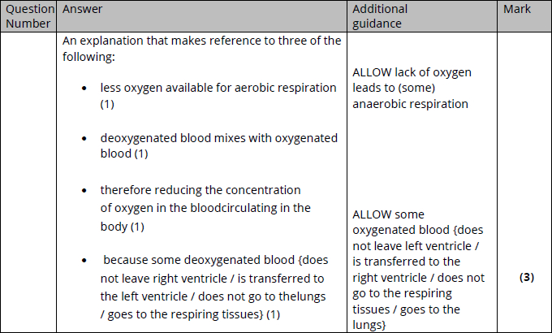

Q2.
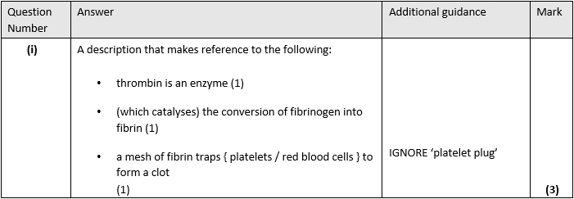
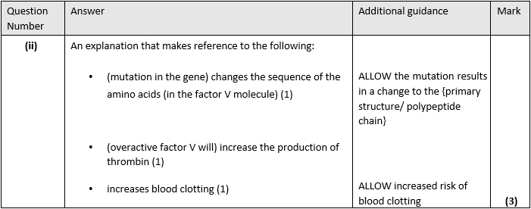

Q3.
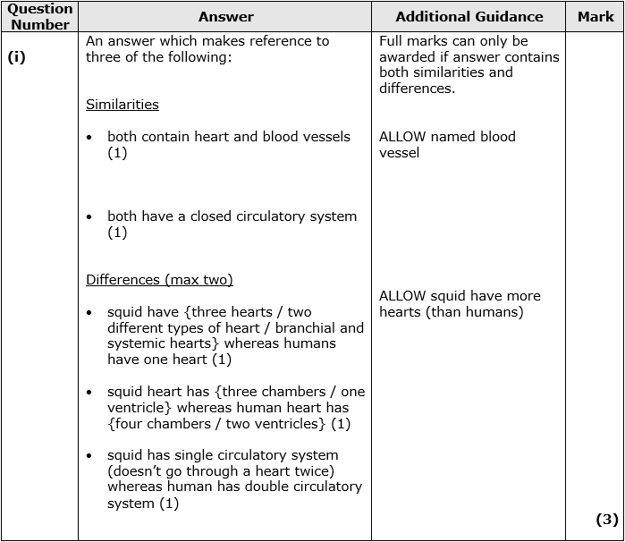
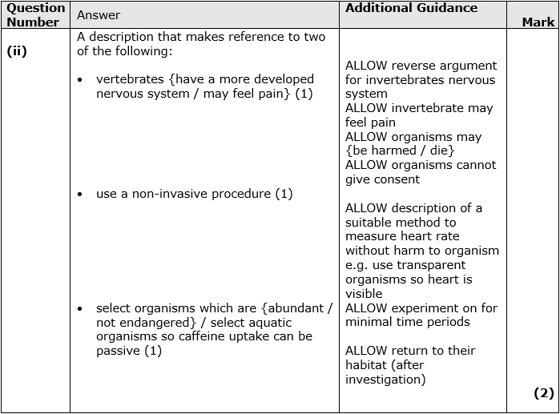

Q4.
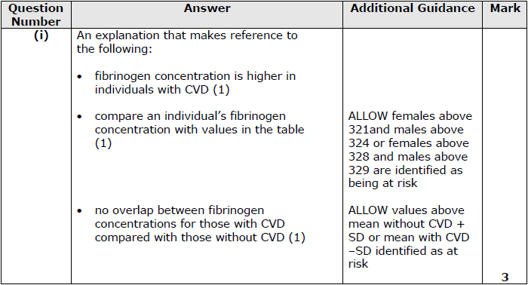
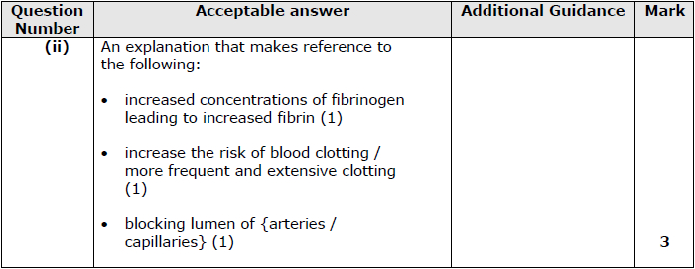

Q5.
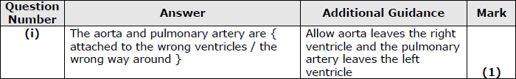
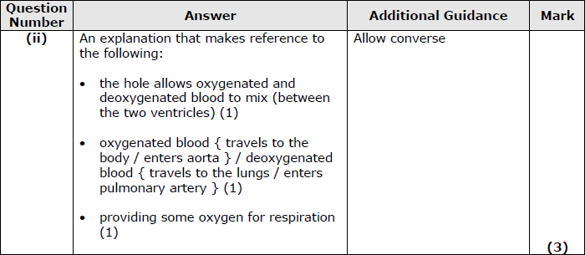

Q6.
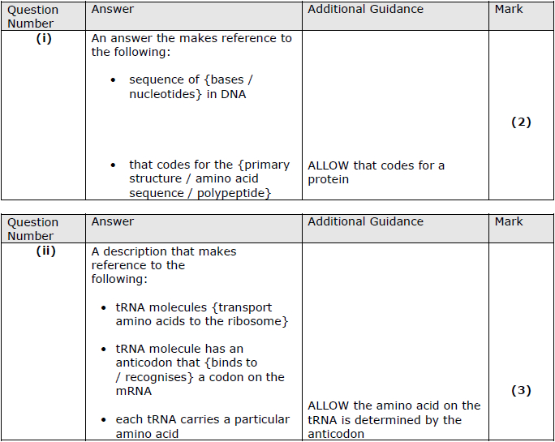
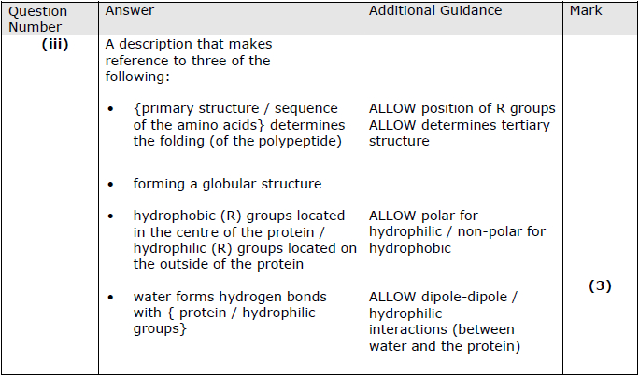

Q7.
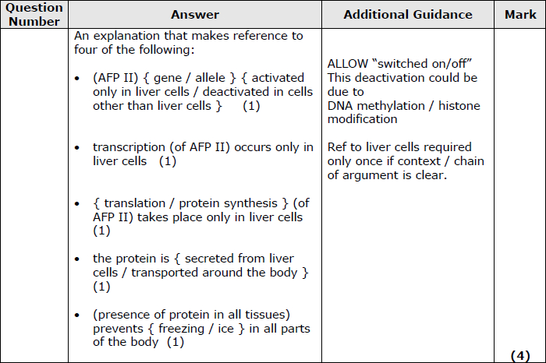

Q8.
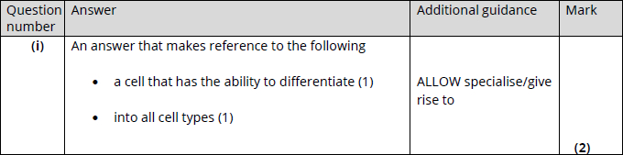
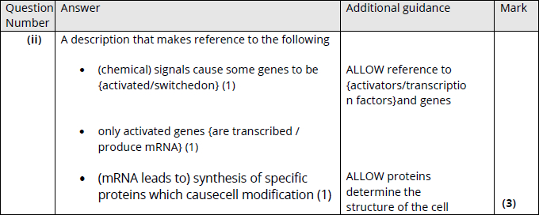

Q9.
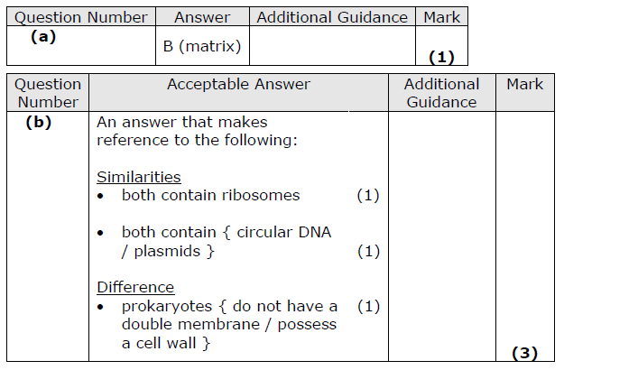

Q10.
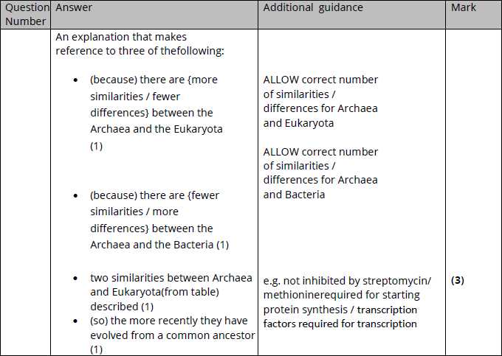

Q11.
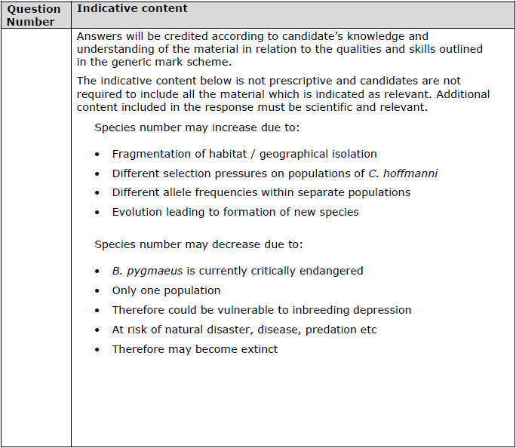
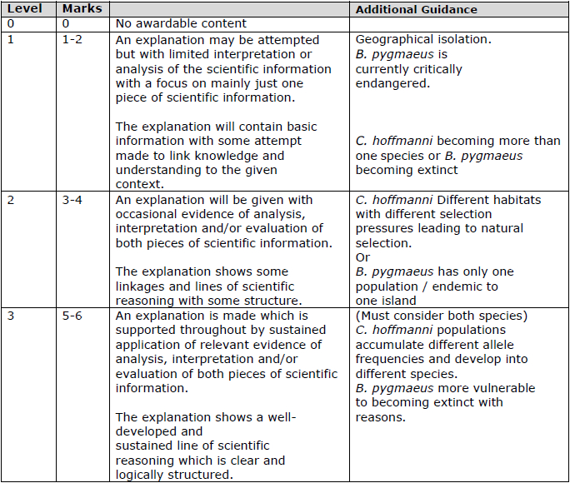

Q12.
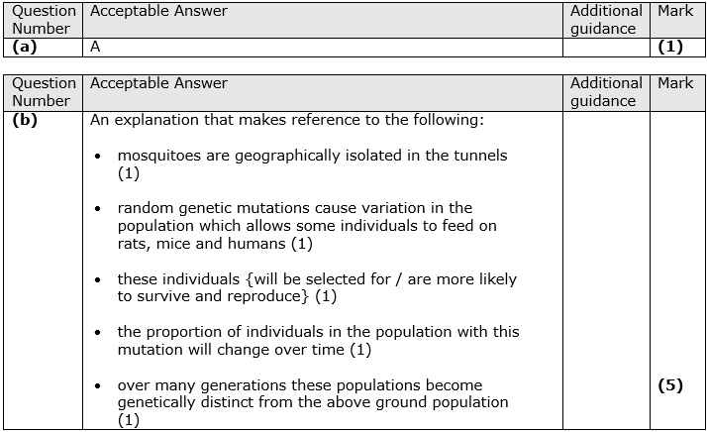

Q13.
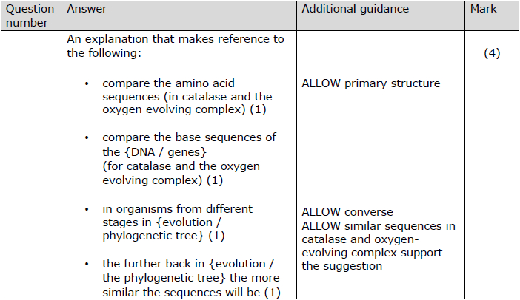

Q14.
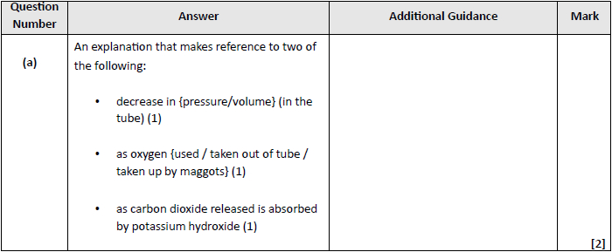
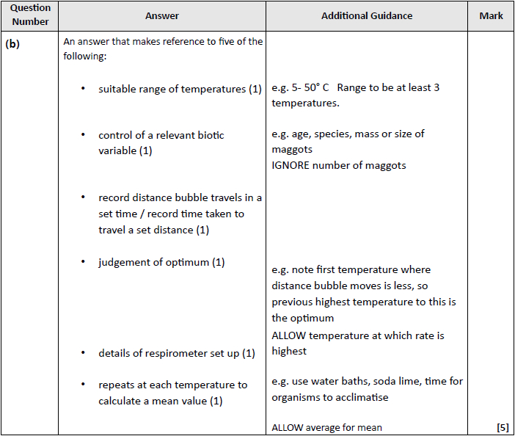

Q15.
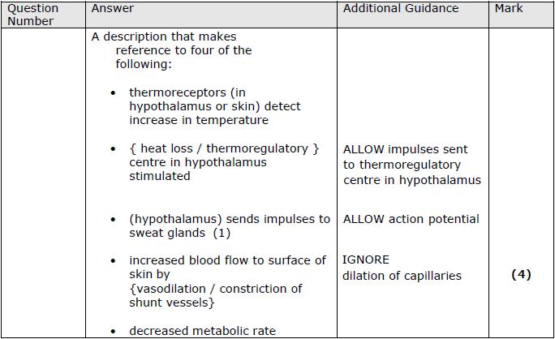

Q16.
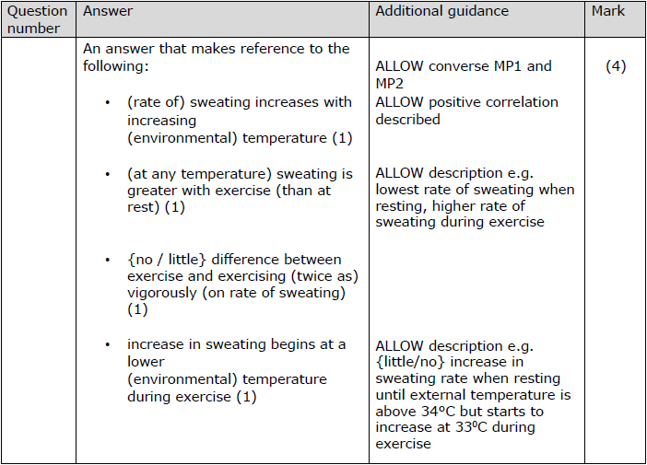

Q17.
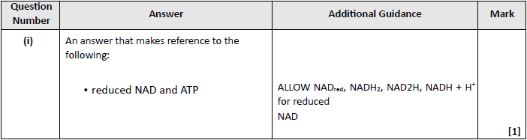
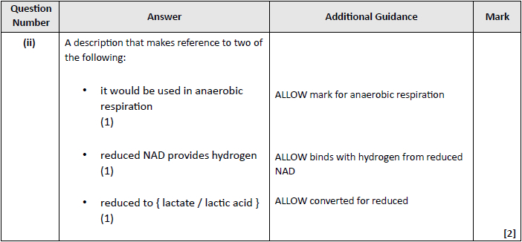
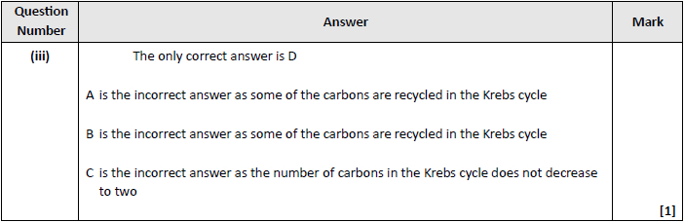

Q18.
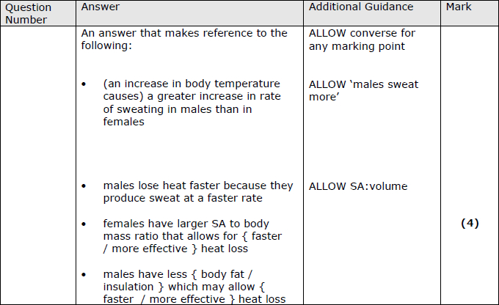

Q19.
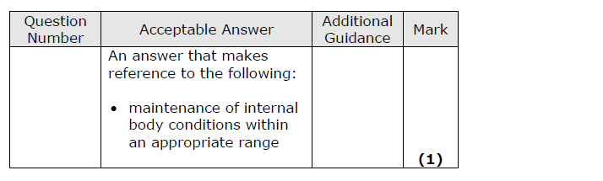

Q20.
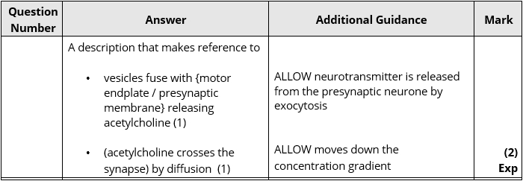

Q21.
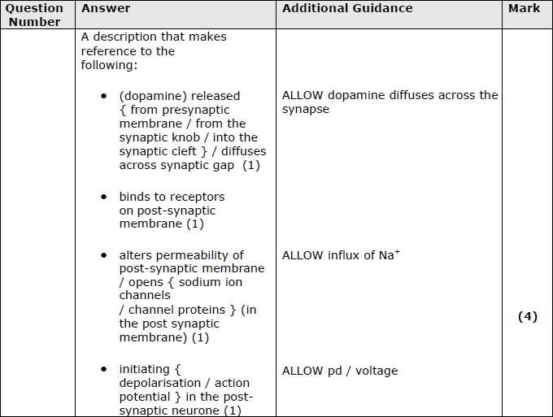

Q22.
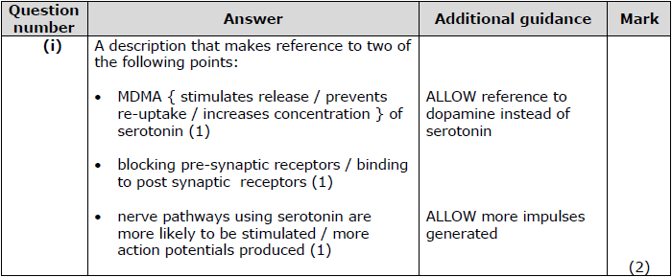
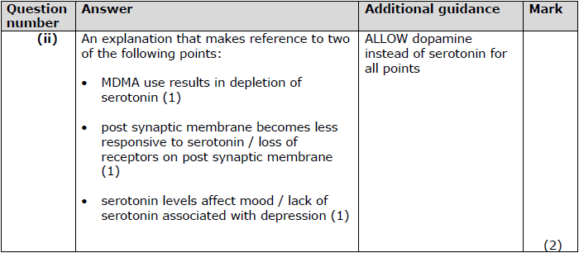

Q23.
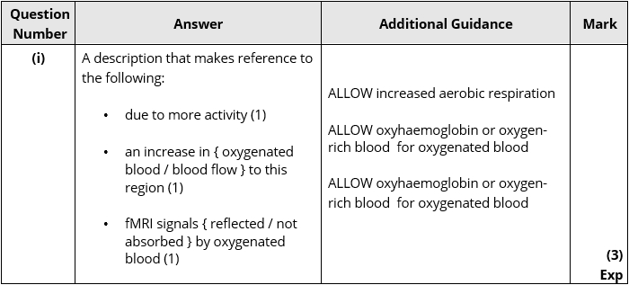
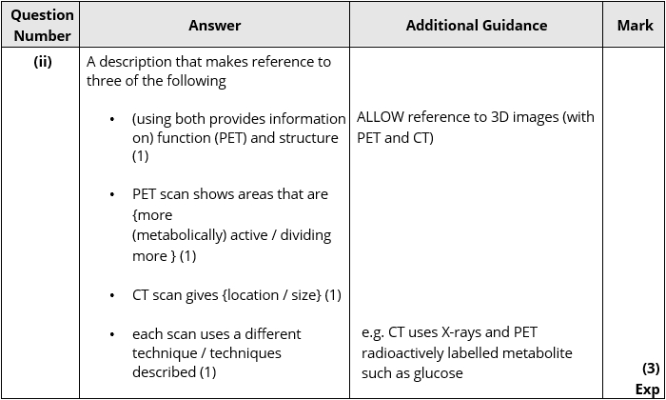

Q24.
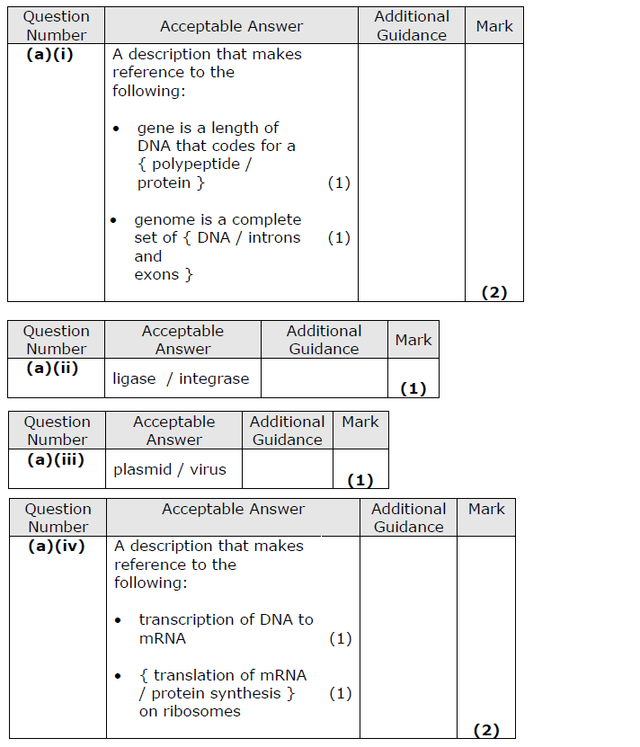
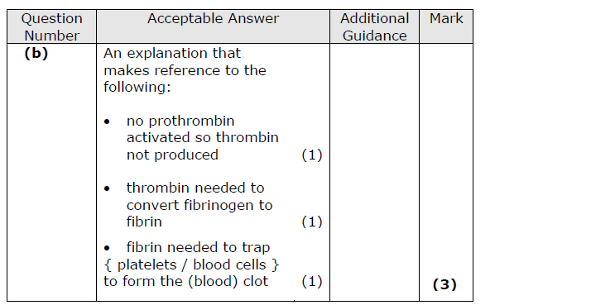

Q25.
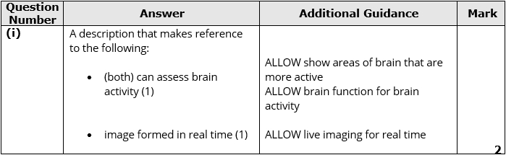
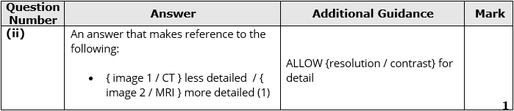

Q26.
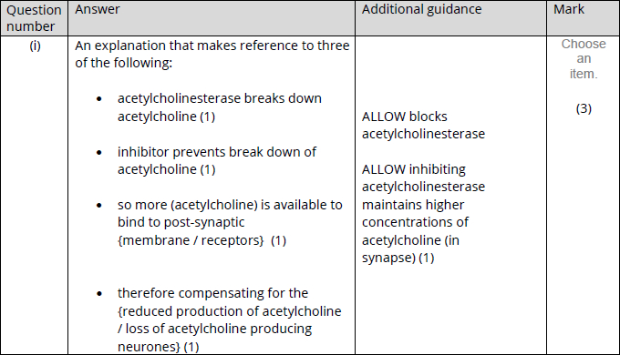
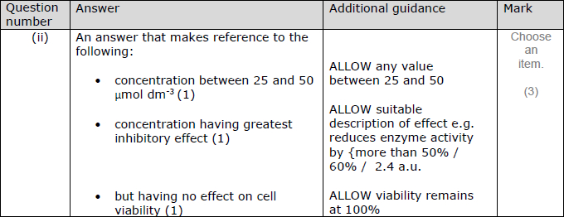

Q27.
