AQA

A Level Physics

Turning Points in Physics
Prep Work and Homework
Special Relativity

Name: …………………………………………………………

Teacher: ……………………………………………………..

CONTENT | PAGE
3.1 Michelson-Morley experiment | 3
3.2 Special Relativity Qualitatively and Inertia Frames of Reference | 10
3.3 Time Dilation and the Rossi-Hall Observations | 16
3.4 Length Contraction | 21
3.5 Mass and Energy | 24
Assignment 1. The Ultimate Speed Experiment | 31

How to use this Pack

These packs are to be used alongside the topic ‘Turning Points in Physics’. The content within this topic is tested in Paper 3 of you’re A-Level Examinations.
The content in this topic is meant to be harder that what you have covered so far and will require you to make links between a variety of topics from Year 12 and 13.

These packs are designed to support your understanding throughout the topic. Before class you should complete the tasks indicated in Sections A, B and C of that lesson. These should take around an hour. Following the lesson you should consolidate your understanding using the resources provided in lesson and those linked in Section D.

The Assignments at the back of the pack are there to test the knowledge you have acquired in lessons.

The Textbook referenced in this pack can be found here.
3.1 Michelson-Morley experiment

Section A: Pre-Requisite Knowledge
Please make sure you are confident with the following material before the lesson. Use the linked resources to review if you are unsure.

Topic | Kerboodle Textbook | CGP Textbook | Media
Double Slit Experiment | 76-81 |  | Young’s Double Slit Experiment
Interference/Superposition | 58-59 |  | Superposition
Reflection and Refraction | 56-57 |  | Refraction and TIR

Once you are happy with the above please move on to Section B.

Section B: Pre-Lesson Questions
Attempt, mark and correct the questions below to check your pre-requisite knowledge. This should be done before the lesson.

Q1.
Two waves with amplitudes a and 3a interfere.
The ratio 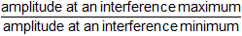 is
A 2
B 3
C 4
D infinity
(Total 1 mark)

Q2.
In a double slit interference arrangement the fringe spacing is w when the wavelength of the radiation is λ, the distance between the double slits is s and the distance between the slits and the plane of the observed fringes is D. In which one of the following cases would the fringe spacing also be w?

 | wave length | distance between slits | distance between slits and fringes
A | 2λ | 2s | 2D
B | 2λ | 4s | 2D
C | 2λ | 2s | 4D
D | 4λ | 2s | 2D
(Total 1 mark)
Q3.
A microwave transmitter is used to direct microwaves of wavelength 30 mm along a line XY. A metal plate is positioned at right angles to XY with its mid-point on the line, as shown.
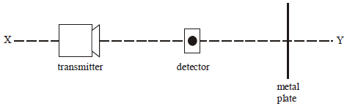
When a detector is moved gradually along XY, its reading alternates between maxima and minima. Which one of the following statements is not correct?
A The distance between two minima could be 15 mm.
B The distance between two maxima could be 30 mm.
C The distance between a minimum and a maximum could be 30 mm.
D The distance between a minimum and a maximum could be 37.5 mm.
(Total 1 mark)

Q4.
The diagram shows a ray of light travelling in air and incident on a glass block of refractive index 1.5
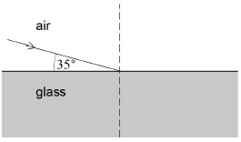
What is the angle of refraction in the glass?

A | 22.5°
B | 23.3°
C | 33.1°
D | 59.4°
(Total 1 mark)
Q5.

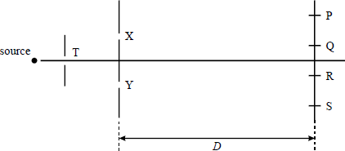
Coherent monochromatic light of wavelength λ emerges from the slits X and Y to form dark fringes at P, Q, R and S in a double slit apparatus. Which one of the following statements is true?
A When the distance D is increased, the separation of the fringes increases.
B When the distance between X and Y is increased, the separation of the fringes increases.
C When the width of the slit T is decreased, the separation of the fringes decreases.
D There is a dark fringe at P because (YP − XP) is 2λ .
(Total 1 mark)

Q6.
(a) The diagram below shows schematically an arrangement for producing interference fringes using a double slit.
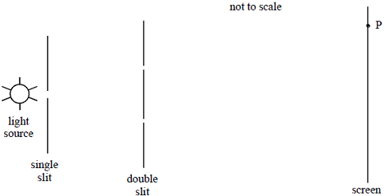
A dark fringe (minimum intensity) is observed at the point labelled P.
(i) Show clearly on the diagram the distance that is equal to the path difference between the light rays from the two slits to the point P.
(1)
(ii) Explain how the path difference determines that the light intensity at point P is a minimum.
______________________________________________________________
______________________________________________________________
______________________________________________________________
______________________________________________________________
______________________________________________________________
______________________________________________________________
______________________________________________________________
(3)
(iii) Explain briefly the role of diffraction in producing the interference patterns (You may draw a sketch to support your explanation if you wish.)
______________________________________________________________
______________________________________________________________
______________________________________________________________
______________________________________________________________
(2)

(b) In one experiment the separation of the slits is 4.0 × 10^{–4} m. The distance from the slits to the screen is 0.60 m.
Calculate the distance between the centres of two adjacent dark fringes when light of wavelength 5.5 × 10^{–7} m is used.

(2)
(c) A student has learned that electrons behave like waves and decides to try demonstrate this using the arrangement in the diagram above. The lamp is replaced by a source of electrons and the system is evacuated.
The student accelerates the electrons to a velocity of 1.4 × 10⁶ m s^{–1}. The beam of electrons is then incident on the double slits. The electrons produce light when incident on the screen.
mass of an electron = 9.1 × 10^{–31} kg
Planck constant = 6.6 × 10^{–34} J s
(i) Calculate the de Broglie wavelength associated with the electrons.

(3)
(ii) Explain briefly, with an appropriate calculation, why the student would be unsuccessful in demonstrating observable interference using the slit separation of 4.0 × 10^{–4} m.
______________________________________________________________
______________________________________________________________
(2)
(Total 13 marks)

Q7.
The graph shows the variation of displacement of the particles with distance along a stationary transverse wave at time t = 0 when the displacement of the particles is greatest. The period of the vibrations causing the wave is 0.040 s.
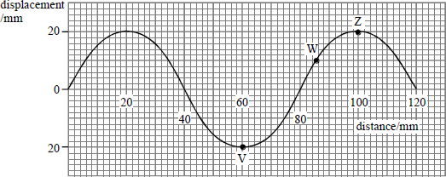
(a) Using the same axes,
(i) draw the appearance of the wave at t = 0.010 s, labelling this graph B,
(ii) draw the appearance of the wave at t = 0.020 s, labelling this graph C,
(iii) show an antinode labelled A and a node labelled N.
(3)
(b) (i) Describe the motion of the particle at V, giving its frequency and amplitude.
______________________________________________________________
______________________________________________________________
(ii) State the amplitude of the particle at W and its phase relations with the particle at V and the particle at Z.
______________________________________________________________
______________________________________________________________
______________________________________________________________
(6)

(Total 9 marks)

Section C: Pre-Lesson Context
Research the prompts below in advance of the lesson (making notes on these in optional) to give you some context for the upcoming lesson.

- What is the luminiferous ether and why was it postulated in the 17th Century?
- Why was the concept of a luminiferous ether falling out of favour by the 18th Century?
- What did Albert Abraham Michelson win his Nobel Prize for in 1907?

Section D: Post Lesson Follow up tasks
Use the resources linked below to review, practice and go beyond the lesson.

Lesson | Lesson Title | Specification | Resources  Where resources are web-based they will be hyperlinked
3.1 | Michelson-Morley experiment | 3.12.3.1  The Michelson-Morley experiment | Textbook page(s): 39-40  Review:  - YouTube: Michelson-Morley Experiment  - YouTube: Neil deGrasse Tyson explains  Practice:  - Seneca Learning Section(s): 12.3.1  - Attempt Question(s) 1 and 2 on page 40 of the Turning Points Textbook.  Extend:  - Isaac Physics: The Michelson-Morley Experiment  - Video: What is Aether?  - Video: General Relativity Explained

3.2 Special Relativity and Inertia Frames of Reference

Section A: Pre-Requisite Knowledge
Please make sure you are confident with the following material before the lesson. Use the linked resources to review if you are unsure.

Topic | Kerboodle Textbook | CGP Textbook | Media
The Equations of Motion | 118-124 |  | SUVAT – Newtons Equations of Motion
Newtons Laws (1st, 2nd, 3rd) | 138-140, 161 |  | Newton’s Laws Explained

Once you are happy with the above please move on to Section B.

Section B: Pre-Lesson Questions
Attempt, mark and correct the questions below to check your pre-requisite knowledge. This should be done before the lesson.

Q1.
A deep-space probe travelling forward at constant speed is briefly acted on by a force at right angles to its motion.
What is the effect of this force on the forward speed and sideways speed of this probe?

A | its forward speed increases and sideways speed increases
B | its forward speed decreases and sideways speed increases
C | its forward speed is unchanged and sideways speed increases
D | its forward speed decreases and sideways speed is unchanged
(Total 1 mark)

Q2.
A lift and its passengers with a total mass of 500 kg accelerates upwards at 2 m s^{–2} as shown. Assume that g = 10 m s^{–2}.
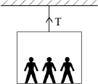
What is the tension in the cable?

A | 1000 N
B | 4000 N
C | 5000 N
D | 6000 N
(Total 1 mark)
Q3.
A car accelerates uniformly from rest along a straight road. Which graph shows the variation of displacement x of the car with time t?

A | 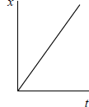 | B | 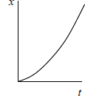 | C | 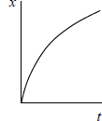 | D | 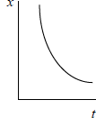

A
B
C
D
(Total 1 mark)

Q4.
Which row gives two features of graphs that provide the same information?

 | Feature 1 | Feature 2
A | Gradient of a displacement–time graph | Area under a velocity–time graph
B | Gradient of a displacement–time graph | Area under an acceleration–time graph
C | Gradient of a velocity–time graph | Area under a displacement–time graph
D | Gradient of a velocity–time graph | Area under an acceleration–time graph
(Total 1 mark)
Q5.
A girl jogs at 2.0 m s^{–1} in a straight line for 30 seconds, turns around and returns to her starting point 20 seconds later.
What is her average velocity and average speed?

 | Average velocity/m s^{–1} | Average speed/m s^{–1}
A | 0 m s⁻¹ | 2.4 m s⁻¹
B | 0 m s⁻¹ | 2.5 m s⁻¹
C | 1.0 m s⁻¹ | 2.0 m s⁻¹
D | 2.5 m s⁻¹ | 2.5 m s⁻¹
(Total 1 mark)
Q6.
The diagram shows a car travelling at a constant velocity along a horizontal road.
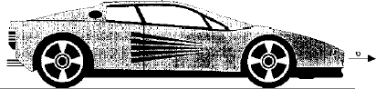
(a) (i) Draw and label arrows on the diagram representing the forces acting on the car.
(ii) Referring to Newton’s Laws of motion, explain why the car is travelling at constant velocity.
______________________________________________________________
______________________________________________________________
______________________________________________________________
______________________________________________________________
(5)
(b) The car has an effective power output of 18 kW and is travelling at a constant velocity of 10 m s^{–1}. Show that the total resistive force acting is 1800 N.
___________________________________________________________________
___________________________________________________________________
___________________________________________________________________
(1)
(c) The total resistive force consists of two components. One of these is a constant frictional force of 250 N and the other is the force of air resistance, which is proportional to the square of the car’s speed.
Calculate
(i) the force of air resistance when the car is travelling at 10 m s^{–1},
______________________________________________________________
______________________________________________________________
(ii) the force of air resistance when the car is travelling at 20 m s^{–1},
______________________________________________________________
______________________________________________________________
(iii) the effective output power of the car required to maintain a constant speed of
20 m s^{–1} in a horizontal road.
______________________________________________________________
______________________________________________________________
______________________________________________________________
(4)
(Total 10 marks)
Q7.
(a) (i) Define acceleration.
______________________________________________________________

(ii) State why acceleration is a vector quantity.
______________________________________________________________
(2)
(b) State what feature of a velocity-time graph may be used to calculate
(i) acceleration,
______________________________________________________________
(ii) displacement.
______________________________________________________________
(2)
(c) The graph in Figure 1 shows how the displacement of a runner from a fixed point, along a straight track, varies with time. (4)
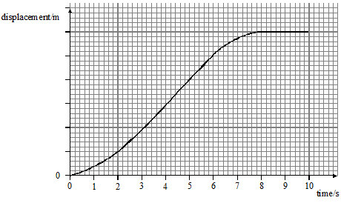
Figure 1
Without calculation, sketch on the grid in Figure 2 a graph to show how the velocity of the same runner varies over the same period. The time scales are the same on both graphs.
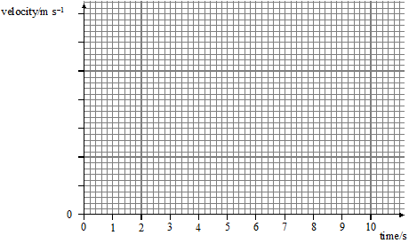
Figure 2
(Total 8 marks)
Section C: Pre-Lesson Context
Research the prompts below in advance of the lesson (making notes on these in optional) to give you some context for the upcoming lesson.

- What is meant by relative motion?
- Would there be any way to tell you were moving (at a constant velocity) if you were in a sealed box?

Section D: Post Lesson Follow up tasks
Use the resources linked below to review, practice and go beyond the lesson.

Lesson | Lesson Title | Specification | Resources  Where resources are web-based they will be hyperlinked
3.2 | Special Relativity and Inertia Frames of Reference | 3.12.3.2 Einstein’s theory of special relativity | Textbook page(s): 41  Review:  - YouTube: Relative Motion and Inertial Reference Frames  - YouTube: Why is Relativity Hard?  Practice:  - Seneca Learning Section(s): 12.3.2  Extend:  - Isaac Physics: Accelerating Particles  - Video: Space-Time Diagrams

3.3 Time Dilation and the Rossi-Hall Observations

Section A: Pre-Requisite Knowledge
Please make sure you are confident with the following material before the lesson. Use the linked resources to review if you are unsure.

Topic | Kerboodle Textbook | CGP Textbook | Media
Particles (muons, decay) | 18-23 |  | Leptons: Electrons, Positrons and Muons
Reflection (light) | 56 |  | Wave Properties

Once you are happy with the above please move on to Section B.

Section B: Pre-Lesson Questions
Attempt, mark and correct the questions below to check your pre-requisite knowledge. This should be done before the lesson.
Q1.
Which of the following statements about muons is incorrect?

A | A muon is a lepton.
B | A muon has a greater mass than an electron.
C | If a muon and an electron each have the same de Broglie wavelength then they each have the same momentum.
D | A muon with the same momentum as an electron has a larger kinetic energy than the electron.
(Total 1 mark)
Q2.
The decay of a neutral kaon K⁰ is given by the equation
K⁰ → X + Y + v̅_{e}
What are X and Y?

 | X and Y
A | e⁺ and e–
B | μ⁺ and e–
C | π⁺ and e–
D | π– and e⁺
(Total 1 mark)
Q3.
When a nucleus of the radioactive isotope decays, a β– particle and an electron antineutrino are emitted.
How many protons and neutrons are there in the resulting daughter nucleus?

 | Number of protons | Number of neutons
A | 28 | 65
B | 29 | 65
C | 29 | 36
D | 30 | 35
(Total 1 mark)
Q4.
Which row shows the correct interactions experienced by a hadron or a lepton?

 | Particle | Strong interaction | Weak interaction
A | Hadron | Yes | Yes
B | Lepton | Yes | Yes
C | Hadron | Yes | No
D | Lepton | Yes | No
(Total 1 mark)
Q5.
Two gamma photons are produced when a muon and an antimuon annihilate each other.
What is the minimum frequency of the gamma radiation that could be produced?

A | 2.55 × 10¹⁶ Hz
B | 5.10 × 10¹⁶ Hz
C | 2.55 × 10²² Hz
D | 5.10 × 10²² Hz
(Total 1 mark)

Q6.
A glass plate surrounded by air is made up of two parallel sided sheets of glass in perfect contact as shown in the figure. Medium 1, the top sheet of glass, has a smaller refractive index than medium 2.
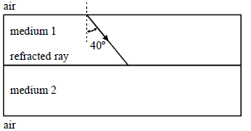
(a) A ray of light in air is incident on the top sheet of glass and is refracted at an angle of 40° as shown in the figure. At the boundary between medium 1 and medium 2 some light is transmitted and the remainder reflected.
On the figure, sketch without calculation, the following:
(i) the path followed by the transmitted ray showing it entering from the air at the top and emerging into the air at the bottom;
(ii) the path followed by the reflected ray showing it emerging from medium 1 into the air.
(4)
(b) The refractive index of medium 1 is 1.35 and that of medium 2 is 1.65.
(i) Calculate the angle of incidence where the ray enters medium 1 from the air.
______________________________________________________________
______________________________________________________________
______________________________________________________________
______________________________________________________________
(ii) Calculate the angle of refraction at the boundary between medium 1 and medium 2.
______________________________________________________________
______________________________________________________________
______________________________________________________________
______________________________________________________________
______________________________________________________________
______________________________________________________________
(5)

(c) Total internal reflection will not occur for any ray incident in medium 1 at the boundary with medium 2.
Explain, without calculation, why this statement is true.
___________________________________________________________________
___________________________________________________________________
___________________________________________________________________
(1)
(Total 10 marks)
Q7.
(a) A particle is made up from an anti-up quark and a down quark.
(i) Name the classification of particles that has this type of structure.
______________________________________________________________
(1)
(ii) Find the charge on the particle.

(1)
(iii) State the baryon number of the particle.

(1)
(b) A suggested decay for the positive muon (µ⁺) is
µ⁺ → e⁺ + v_{e}
Showing your reasoning clearly, deduce whether this decay satisfies the conservation rules that relate to baryon number, lepton number and charge.
Baryon number _____________________________________________________
Lepton number _____________________________________________________
Charge ____________________________________________________________
(3)
(Total 6 marks)

Section C: Pre-Lesson Context
Research the prompts below in advance of the lesson (making notes on these in optional) to give you some context for the upcoming lesson.

- How did Rossi and Hall get readings of muons higher up in the atmosphere in 1941?
- What are Lorentz Transformations?
- What was Einstein’s ‘light clock’?

Section D: Post Lesson Follow up tasks
Use the resources linked below to review, practice and go beyond the lesson.

Lesson | Lesson Title | Specification | Resources  Where resources are web-based they will be hyperlinked
3.3 | Time Dilation and the Rossi-Hall Observations | 3.12.3.3  Time dilation | Textbook page(s): 41-42, 43  Review:  - YouTube: Time Dilation  - YouTube: Impossible Muons  Practice:  - Seneca Learning Section(s): 12.3.3  - Practice Question(s) 1 and 3 on page 49 of the Turning Points Textbook.  Extend:  - Isaac Physics: Light Clock  - Video: The Lorentz Transformation  - Video: Is Time Travel Possible?

3.4 Length Contraction

Section A: Pre-Requisite Knowledge
Please make sure you are confident with the following material before the lesson. Use the linked resources to review if you are unsure.

Topic | Kerboodle Textbook | CGP Textbook | Media
Maths: Limits | - |  | How to find the limit at infinity

Once you are happy with the above please move on to Section B.

Section B: Pre-Lesson Questions
Attempt, mark and correct the questions below to check your pre-requisite knowledge. This should be done before the lesson.
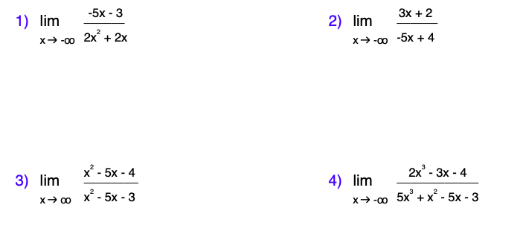
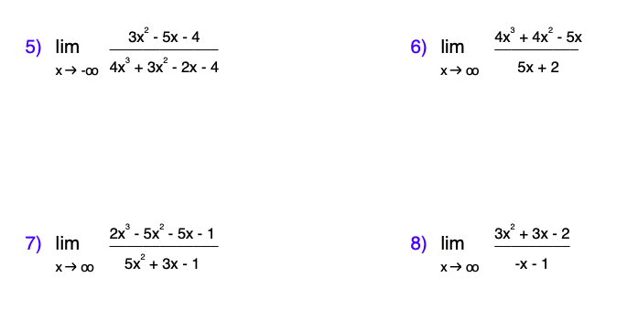
Section C: Pre-Lesson Context
Research the prompts below in advance of the lesson (making notes on these in optional) to give you some context for the upcoming lesson.

- What objects do we know of that travel at close to the speed of light?
- What is Einstein’s Twin paradox?

Section D: Post Lesson Follow up tasks
Use the resources linked below to review, practice and go beyond the lesson.

Lesson | Lesson Title | Specification | Resources  Where resources are web-based they will be hyperlinked
3.4 | Length Contraction | 3.12.3.4 Length contraction | Textbook page(s): 42-44  Review:  - YouTube: Length Contraction  - YouTube: Time Dilation and Length Contraction  Practice:  - Seneca Learning Section(s): 12.3.4  - Attempt Question(s) 3, 4 and 5 on page 44 of the Turning Points Textbook.  - Practice Question(s) 2 on page 49 of the Turning Points Textbook.  Extend:  - Isaac Physics: Speed of Electron in an Electric Field  - Video: Einstein’s Twin Paradox  - Podcast: Einstein’s Theory of Special Relativity

3.5 Mass and Energy

Section A: Pre-Requisite Knowledge
Please make sure you are confident with the following material before the lesson. Use the linked resources to review if you are unsure.

Topic | Kerboodle Textbook | CGP Textbook | Media
Conservation of Momentum | 161-163 |  | Conservation of Linear Momentum
Mass-energy conservation | 10 |  | The Conservation of Mass Energy
Interpreting Oscilloscopes | 54-55 |  | How to Read an Oscilloscope

Once you are happy with the above please move on to Section B.

Section B: Pre-Lesson Questions
Attempt, mark and correct the questions below to check your pre-requisite knowledge. This should be done before the lesson.
Q1.
A car of mass 580 kg collides with the rear of a stationary van of mass 1200 kg.
Following the collision, the van moves with a velocity of 6.20 m s^{–1} and the car recoils in the opposite direction with a velocity of 1.60 m s^{–1}.
What is the initial speed of the car?

A | 5.43 m s^{–1}
B | 11.2 m s^{–1}
C | 12.8 m s^{–1}
D | 14.4 m s^{–1}
(Total 1 mark)
Q2.
The graph shows how the resultant force F on a football, which is initially at rest, varies with time t.
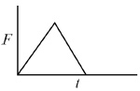
Which graph shows how the momentum p of the football varies with time t?
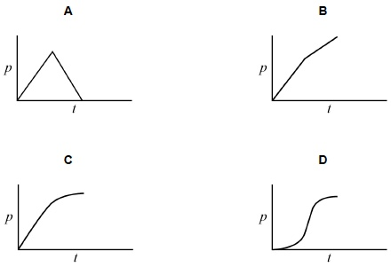

A
B
C
D
(Total 1 mark)
Q3.
In the reaction shown, a proton and a deuterium nucleus, , fuse together to form a helium nucleus,
What is the value of Q, the energy released in this reaction?
mass of a proton = 1.00728 u
mass of a nucleus = 2.01355 u
mass of a nucleus = 3.01493 u
A 5.0 MeV
B 5.5 MeV
C 6.0 MeV
D 6.5 MeV
(Total 1 mark)

Q4.
Trolley T₁, of mass 2.0 kg, collides on a horizontal surface with trolley T₂, which is also of mass 2.0 kg. The collision is elastic. Before the collision T₁ was moving at 4.0 m s^{–1} and T₂ was at rest.
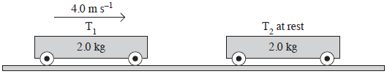
Which one of the following statements is correct?
Immediately after the collision
A T₁ is at rest and T₂ moves at 4.0 m s^{–1}.
B T₁ will rebound from T₂ at 4.0 m s^{–1}.
C T₁ and T₂ will both move at 2.8 m s^{–1}.
D T₁ and T₂ will both move at 1.4 m s^{–1}.
(Total 1 mark)
Q5.
The diagram shows a strobe photograph of a mark on a trolley X, moving from right to left, in collision with another trolley Y which had no mark on it.
After the collision both trolleys are in motion together.
Which one of the following is consistent with the photograph?
A Trolley Y has the same mass as trolley X and was initially stationary
B Trolley Y had a smaller mass than X and was moving from right to left
C Trolley Y had the same mass and was initially moving left to right at the same speed as trolley X
D Trolley Y had the same mass and was initially moving left to right at a higher speed than trolley X
(Total 1 mark)

Q6.
(a) (i) State the principle of conservation of momentum.
______________________________________________________________
______________________________________________________________
(2)
(ii) Explain briefly how an elastic collision is different from an inelastic collision.
______________________________________________________________
______________________________________________________________
(1)
(b) Describe and explain what happens when a moving particle collides elastically with a stationary particle of equal mass.
___________________________________________________________________
___________________________________________________________________
___________________________________________________________________
___________________________________________________________________
___________________________________________________________________
___________________________________________________________________
(3)
(c) The diagram below shows an astronaut undertaking a space-walk. The astronaut is tethered by a rope to a spacecraft of mass 4.0 × 10⁴ kg. The spacecraft is moving at constant velocity.
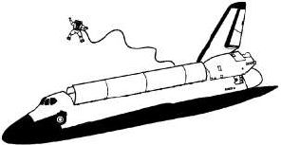
The astronaut and spacesuit have a total mass of 130 kg. The change in velocity of the astronaut after pushing off is 1.80 m s^{–1}.
(i) Determine the velocity change of the spacecraft.

(2)

(ii) The astronaut pushes for 0.60 s in achieving this speed. Calculate the average power developed by the astronaut. Neglect the change in motion of the spacecraft.

(3)
(iii) The rope eventually becomes taut. Suggest what would happen next.
______________________________________________________________
______________________________________________________________
______________________________________________________________
______________________________________________________________
(2)
(Total 13 marks)
Q7.
The diagram below shows an ac waveform that is displayed on an oscilloscope screen.
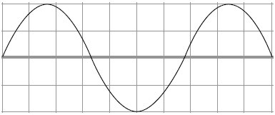
The time base of the oscilloscope is set at 1.5 ms per division and the y-gain at 1.5 V per division.
(a) For the ac waveform shown,
(i) Calculate the frequency
______________________________________________________________
______________________________________________________________
______________________________________________________________
______________________________________________________________
answer ____________________ Hz
(3)
(ii) Calculate the peak voltage
______________________________________________________________
______________________________________________________________
______________________________________________________________
______________________________________________________________
answer ____________________ V
(2)
(iii) the rms voltage
______________________________________________________________
______________________________________________________________
______________________________________________________________
______________________________________________________________
answer ____________________ V
(2)
(b) State and explain the effect on the oscilloscope trace if the time base is switched off.
___________________________________________________________________
___________________________________________________________________
___________________________________________________________________
___________________________________________________________________
___________________________________________________________________
___________________________________________________________________
(2)
(Total 9 marks)

Section C: Pre-Lesson Context
Research the prompts below in advance of the lesson (making notes on these in optional) to give you some context for the upcoming lesson.

- Who is William Bertozzi?
- How does mass-energy conservation relate to atomic bombs?
- How was Einstein’s theory of Special Relativity received by the Scientific community in 1905?

Section D: Post Lesson Follow up tasks
Use the resources linked below to review, practice and go beyond the lesson.

Lesson | Lesson Title | Specification | Resources  Where resources are web-based they will be hyperlinked
3.5 | Mass and Energy | 3.12.3.5  Mass and Energy | Textbook page(s): 44-46  Review:  - YouTube: Mass-Energy Equivalence  - YouTube: Special Relativity (Full Topic Review)  Practice:  - Seneca Learning Section(s): 12.3.5  - Attempt Question(s) 6 on page 45 of the Turning Points Textbook.  - Attempt Question(s) 7 and 8 on page 46 of the Turning Points Textbook.  - Attempt Assignment 1  - Practice Question(s) 4 on page 49 of the Turning Points Textbook.  Extend:  - Isaac Physics: Einstein’s Tower  - Video: How to break to the Speed of Light  - Article: Hubble Telescope Discovers a Light-Bending 'Einstein Ring' in Space

Assignment 1: The Ultimate Speed Experiment

Aim: To understand how at Bertozzi obtained the measurements in his experiment in order to plot his graph of $\frac{v^{2}}{c^{2}}$ versus kinetic energy for an electron at speeds close to c.

Context:
Bertozzi used a Van de Graaff generator to accelerate bunches of electrons, generated by thermionic emission, along the tube of a linear accelerator (linac) 8.4m long. On reaching the end of the tube, the bunch of electrons hit a target aluminium disc (Figure A1). The time of flight of the electrons would be measured to determine the electron speed.
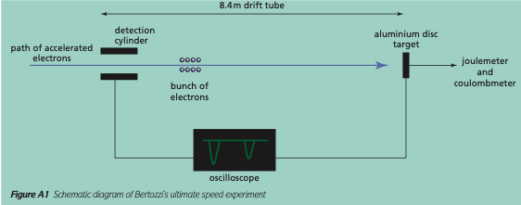
A detection cylinder connected by a cable to an oscilloscope was used to register the passage of
a bunch of electrons at the start of the drift tube. The same oscilloscope would be connected to the aluminium disc by a cable of the same length in order to detect the arrival of the electrons at the disc. The time of flight could then be measured from the oscilloscope and the electron speed calculated.

The experiment took place in two stages. For the first three sets of data, Bertozzi used only the Van de Graaff to accelerate the electrons through 0.5, 1.0 and 1.5MV, and he then allowed the electrons to drift at their final constant speed along the 8.4m linac tube, which was kept switched off. In the second stage of the experiment, Bertozzi used both the Van de Graaff and the first section of the linac to accelerate the electrons with voltages of 4.5 and 15MV. However, since the first section of the linac was 1.0m long, this meant that the electrons travelled a distance of 7.4m at a constant speed.

In theory, the kinetic energy of an electron is determined by the accelerating voltage, so that if an electron is accelerated by 4.5MV it should have 4.5MeV of energy. However, Bertozzi wanted to
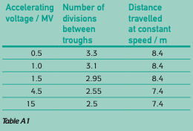
be sure that this still applied to electrons travelling close to the speed of light. He connected the aluminium disc to a calibrated thermocouple and a coulombmeter, so that he could determine the energy transferred to the disc for a known number of electrons hitting the disc. He was able to show using this direct method that the measured kinetic energy of an electron was in close agreement with the theoretical value determined from the accelerating voltage.

Bunches of electrons were generated at a rate of 120 bunches per second and the oscilloscope was set at a frequency so that the trace on the oscilloscope screen, showing the start and end pulses, was stationary. The number of divisions between the two troughs on the oscilloscope trace for different accelerating voltages is shown in Table A1. The time per division is 0.98×10⁻⁸ s.
Activity 1:
Determine the speed v of the electrons to two significant figures for the different accelerating voltages.

Activity 2:
Plot a graph of $\frac{v^{2}}{c^{2}}$versus electron energy in MeV.
(You may use excel or do this by hand – just ask me for graph paper!)

Go Beyond Activity (optional):
Bertozzi used calorimetry to measure the energy of an electron accelerated through 1.5MV. The thermocouple connected to the aluminium disc was connected to a meter that was calibrated at 0.8J per division. Also connected to the aluminium disc was a coulombmeter containing a capacitor that became charged by the bunches of electrons being absorbed by the disc. On reaching a charge of 7.6×10⁻⁸ C, the capacitor discharged, registering a ‘click’ on the coulombmeter. The capacitor then recharged and the process repeated. After 80 clicks of the coulombmeter, the reading on the meter connected to the thermocouple was recorded at 12.5 divisions.

Task: Use the calorimetry measurement to determine the kinetic energy of an electron in the beam that has been accelerated by 1.5 MV.
Determine the percentage difference between this value and the kinetic energy value of the electron determined from the accelerating voltage.

