T8.1-8.6 nerve impulses, rods and cones, synapses, IAA Exam Questions
Q1.
The nervous system contains myelinated and unmyelinated neurones.
The diagram below shows a myelinated sensory neurone.
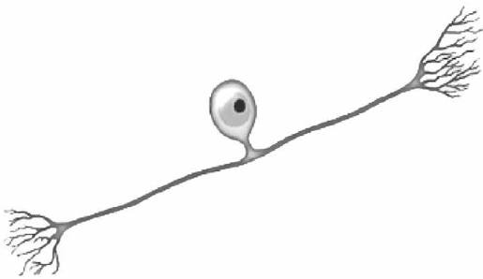
(a) Give one feature, shown in the diagram, that identifies this cell as a sensory neurone.
(1)
.............................................................................................................................................
.............................................................................................................................................
(b) The table shows the conduction velocity of a nerve impulse along a myelinated and an unmyelinated neurone, each with a diameter of 5 μm.
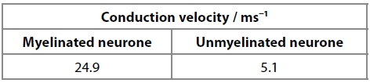
Explain why there is a difference in the conduction velocity of these neurones.
(5)
.............................................................................................................................................
.............................................................................................................................................
.............................................................................................................................................
.............................................................................................................................................
.............................................................................................................................................
.............................................................................................................................................
.............................................................................................................................................
.............................................................................................................................................
.............................................................................................................................................
.............................................................................................................................................

(Total for question = 6 marks)

Q2.
Opioids are used to treat moderate to severe pain. They are a group of drugs synthesised from morphine.
(a) Opioids and morphine both affect the size of the pupil of the eye.
The graph shows the effects of these drugs on the diameter of the pupil following exposure to a flash of light.
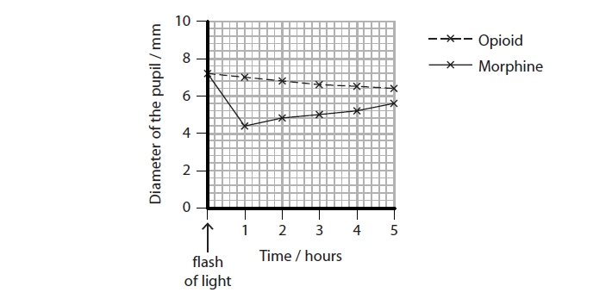
Calculate the rate of change in pupil diameter between one and five hours after exposure to light for those individuals who had taken morphine.
(2)
Answer ........................................................... mm h⁻¹
(ii) Explain the effect of opioids on the diameter of the pupil, between one and five hours after exposure to a flash of light.
(3)
.............................................................................................................................................
.............................................................................................................................................
.............................................................................................................................................
.............................................................................................................................................
.............................................................................................................................................
.............................................................................................................................................
.............................................................................................................................................
.............................................................................................................................................
.............................................................................................................................................
(iii) Comment on reasons why the results of this investigation may not prove that any changes in pupil size were the direct result of either the opioid or morphine.
(4)
.............................................................................................................................................
.............................................................................................................................................
.............................................................................................................................................
.............................................................................................................................................
.............................................................................................................................................
.............................................................................................................................................
.............................................................................................................................................
.............................................................................................................................................
.............................................................................................................................................
.............................................................................................................................................
.............................................................................................................................................
.............................................................................................................................................

(Total for question = 9 marks)

Q3.
The muscles of the earthworm (Lumbricus terrestris) contract when it is touched. This is known as the withdrawal response.
Contraction of the muscle in the withdrawal response is stimulated by nerve impulses. These nerve impulses can be detected using electrodes.
Explain the electrical changes in an axon that allow these nerve impulses to be detected.
(4)
.............................................................................................................................................
.............................................................................................................................................
.............................................................................................................................................
.............................................................................................................................................
.............................................................................................................................................
.............................................................................................................................................
.............................................................................................................................................
.............................................................................................................................................
.............................................................................................................................................
.............................................................................................................................................
.............................................................................................................................................
.............................................................................................................................................
.............................................................................................................................................

(Total for question = 4 marks)

Q4.
The neurones of the central nervous system contain TAU proteins. These proteins help to maintain cell structure.
In humans, six different TAU proteins can be produced from a single gene.
Parkinson's disease has been linked to the different forms of the TAU proteins present in neurones.
Scientists are studying the effect of these different TAU proteins in animal models.
One model used is the fruit fly, Drosophila.
In another investigation, the effect of these TAU proteins and age on the conduction of nerve impulses along the axon of neurones was studied.
The length of time between impulses was measured for Drosophila flies of different ages.
The results are shown in the graph.
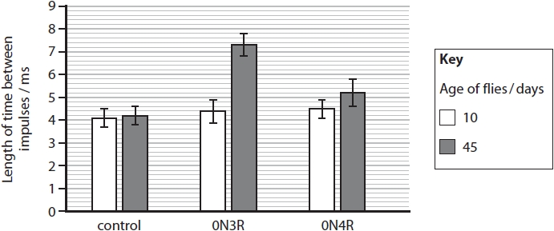
Determine the effect of these TAU proteins on the maximum frequency at which nerve impulses can be conducted along the axon of the neurone.
(4)
.............................................................................................................................................
.............................................................................................................................................
.............................................................................................................................................
.............................................................................................................................................
.............................................................................................................................................
.............................................................................................................................................
.............................................................................................................................................
.............................................................................................................................................
.............................................................................................................................................
.............................................................................................................................................
.............................................................................................................................................

(Total for question = 4 marks)

Q5.
The diagram shows part of the membrane of the outer segment of a rod cell.
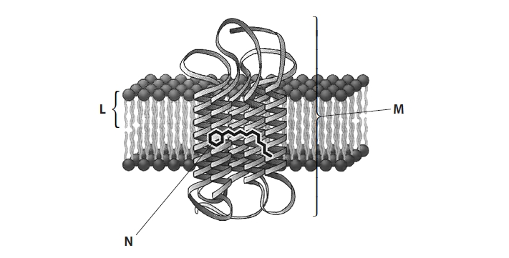
(a) Which of the following is the part labelled L?
(1)
A fatty acid tail
B phosphate head
C phospholipid
D phospholipid bilayer
(b) (i) Give the name of the visual pigment labelled M.
(1)
.............................................................................................................................................
(ii) Give the name of the light-absorbing part of the visual pigment labelled N.
(1)
.............................................................................................................................................
(c) Describe how the absorption of light by the part labelled N results in an action potential in the optic nerve.
(3)
.............................................................................................................................................
.............................................................................................................................................
.............................................................................................................................................
.............................................................................................................................................
.............................................................................................................................................
.............................................................................................................................................
.............................................................................................................................................
.............................................................................................................................................
.............................................................................................................................................
.............................................................................................................................................
.............................................................................................................................................
.............................................................................................................................................

(Total for question = 6 marks)

Q6.
An experiment was carried out to investigate mineral deficiencies on the growth of seedlings.
The effects of two mineral deficiencies on two different species of plant were investigated.
Test tubes were half filled with an aqueous gel containing a mineral solution without calcium ions. Seeds of rice or fenugreek were placed separately in these test tubes.
These test tubes were placed by a window for two weeks to allow the seeds to germinate and the seedlings to grow.
This was repeated using test tubes containing mineral solution without magnesium ions.
The only source of light provided for the plants was from outside the window. All of the seedlings grew towards the window.
Explain the reason for this response of these seedlings to light.
(3)
.............................................................................................................................................
.............................................................................................................................................
.............................................................................................................................................
.............................................................................................................................................
.............................................................................................................................................
.............................................................................................................................................
.............................................................................................................................................
.............................................................................................................................................
.............................................................................................................................................
.............................................................................................................................................
.............................................................................................................................................
.............................................................................................................................................
.............................................................................................................................................
.............................................................................................................................................

Q7.
Plants can respond to and use light.
The photograph shows a seedling starting to grow from a germinating seed.
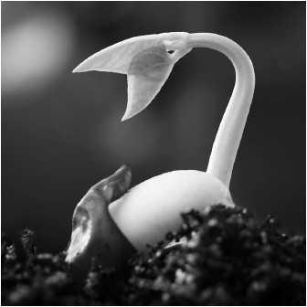
Describe the role of IAA (auxin) in the phototropic response of plants.
(4)
.............................................................................................................................................
.............................................................................................................................................
.............................................................................................................................................
.............................................................................................................................................
.............................................................................................................................................
.............................................................................................................................................
.............................................................................................................................................
.............................................................................................................................................
.............................................................................................................................................
.............................................................................................................................................
.............................................................................................................................................
.............................................................................................................................................

(Total for question = 4 marks)

Mark Scheme
Q1.
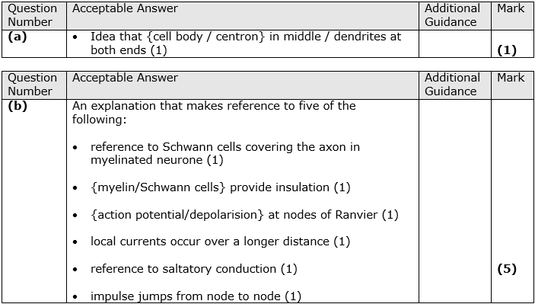

Q2.
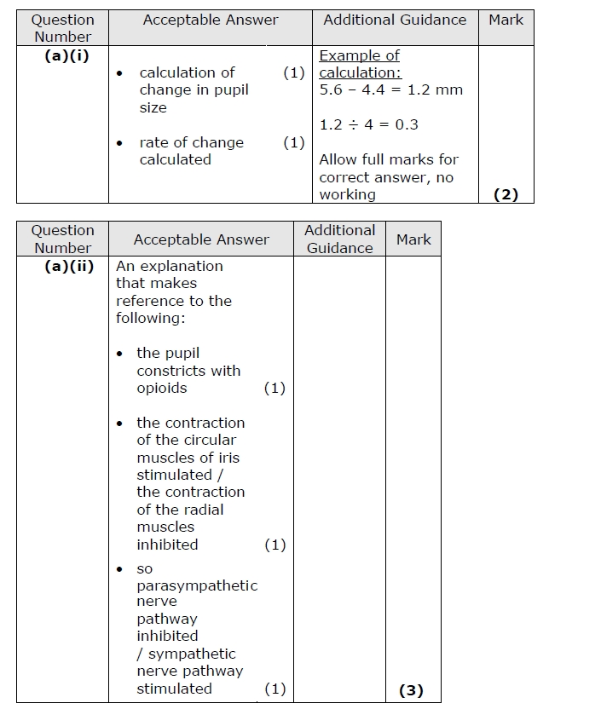
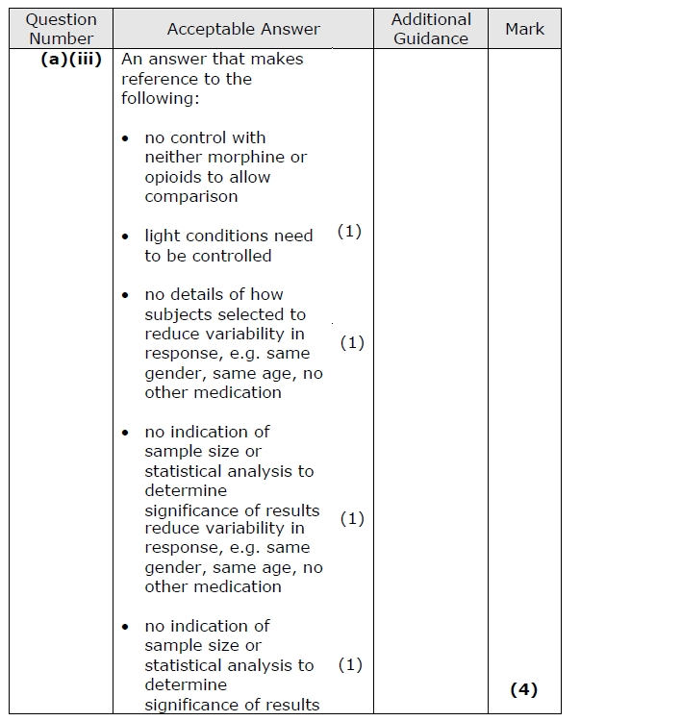

Q3.
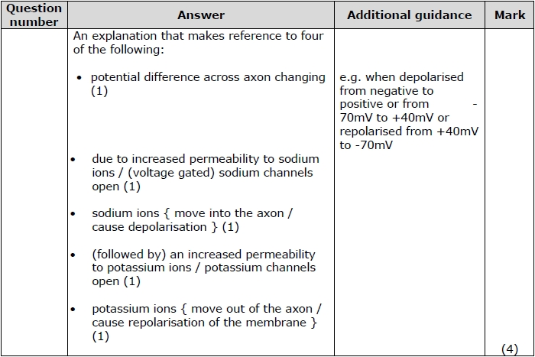

Q4.
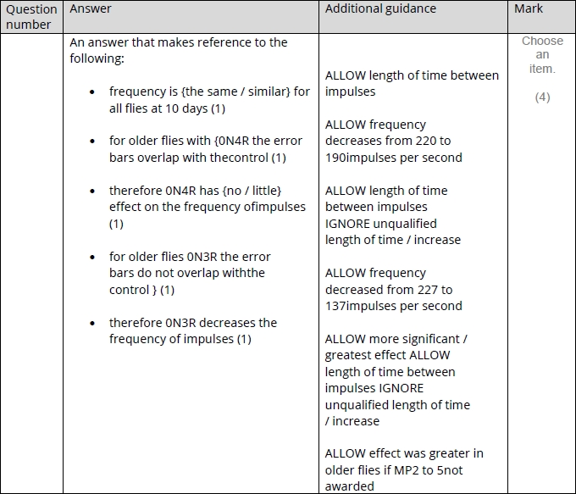

Q5.
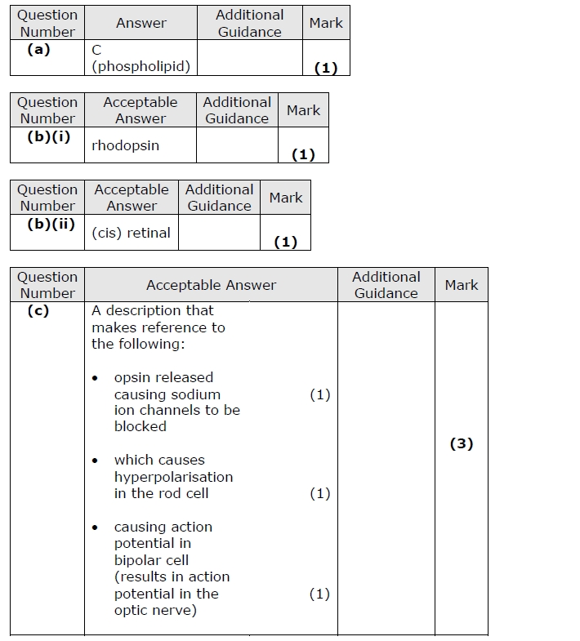

Q6.
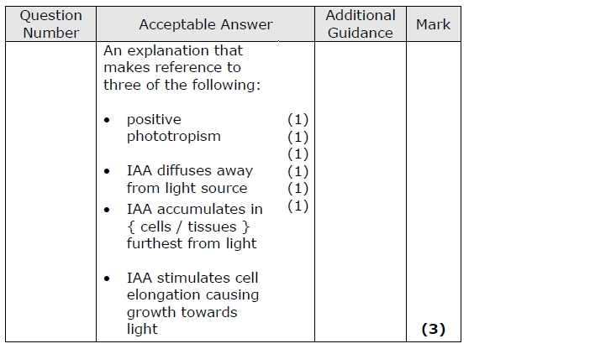

Q7.
