BIOLOGY EXAM QUESTIONS BOOKLET

TOPIC 1

Centre Number |  | 12416
Candidate Number
Candidate forename |  | Candidate surname
Class
Teachers’ initials

Qu | Concept | Skill focus | Total Mark | Marks ach’d | Traffic Light | *Follow up task completed
1 | Monosaccharide Condensation | Recall  Data Analysis | 6
2 | Clotting | Recall | 4
3 | Cardiac Cycle | Data Analysis  Calculation | 7
4 | Mass Transport  Blood Pressure | Recall  Data Analysis | 7
5 | Risk Factors  Obesity Indicators | Recall  Calculation | 13
6 | Atherosclerosis  Plant Statins | Recall | 9
7 | Blood Vessels | Recall | 8
8 | Correlation/Cause  LDL/HDL | Recall  Data Analysis | 13
9 | Caffeine Prac | Data Analysis  Recall | 9
10 | Vit C Prac | Recall  QWC | 8
11 | Carbohydrates | Recall  OWC | 10
12 | CVD and drug treatments | Application and data analysis | 11
13 | Study design | Application | 13

*If the exam question has been traffic lighted as amber or red then you still need to work on this concept or skill area. You must follow this up by completing a task from below. Add the letter of the follow up task completed in the last column of the grid on your front page. Add the evidence in this booklet.

Potential review tasks include (increase in difficulty as you go down):

- Make notes on the concept of the question using a variety of different resources such as the various A-level textbooks in the library (not just the core SNAB textbook).

- Complete a worksheet on the skill or concept such as a worksheet from the Biozone booklet in the library. SNAB also has workbooks available to buy.

- Complete a Biological skills support sheet on the concept or skill from pearsonactivelearn.com

- Find another exam question on this concept or skill using the Biology exam question database on Moodle (password is Biology). Then google Edexcel SNAB Biology A past papers.

- Summarise the rules for answering a similar style of question using the examiners reports for exam questions on this concept or skill. Use the exam question database on Moodle as above to help you find the exam questions on this concept or skill and then find the examiner’s report for it.

- Make your own exam question and mark scheme on the concept or skill. Use current mark schemes to help you.

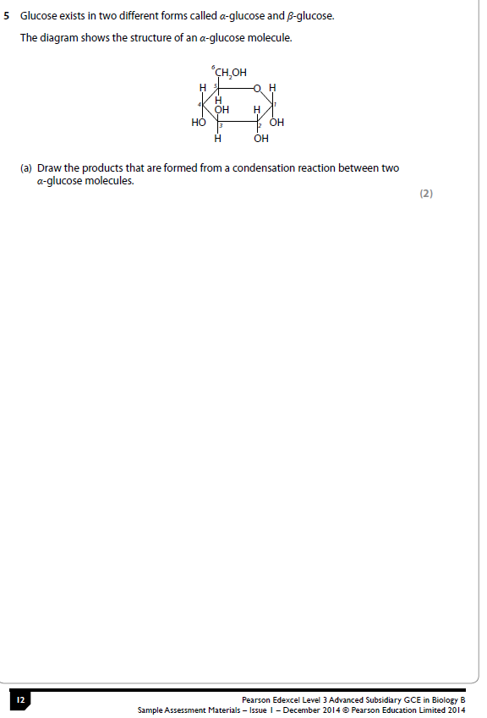
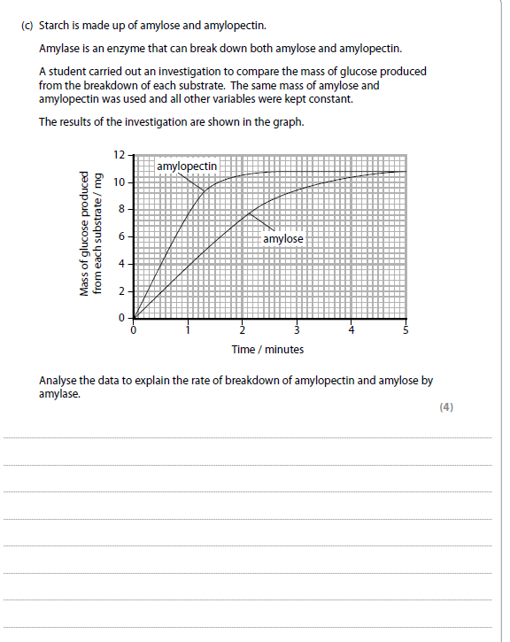
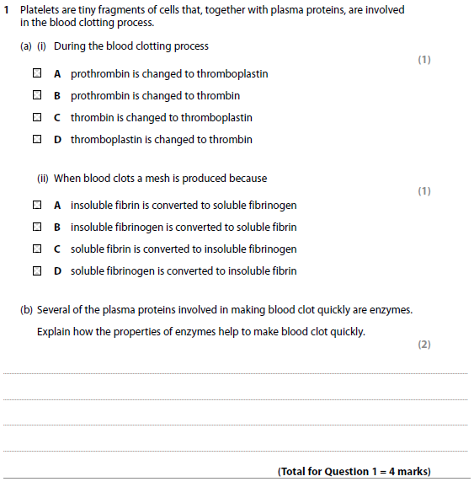

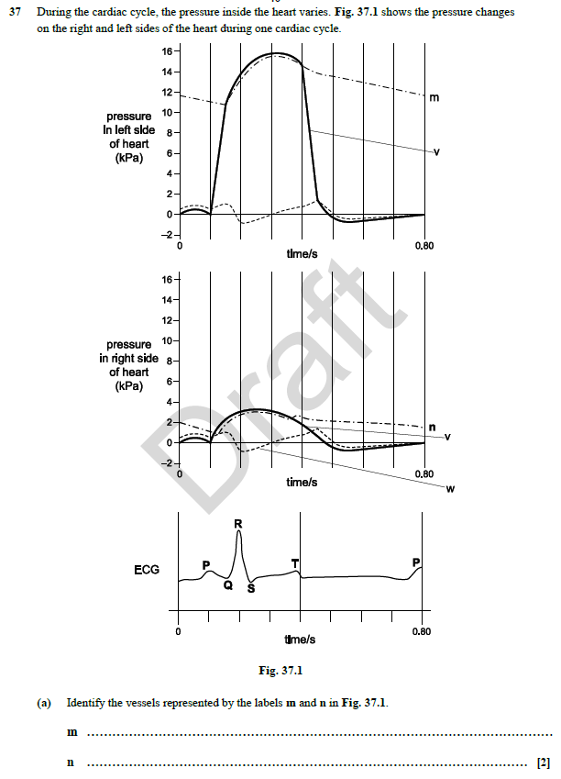

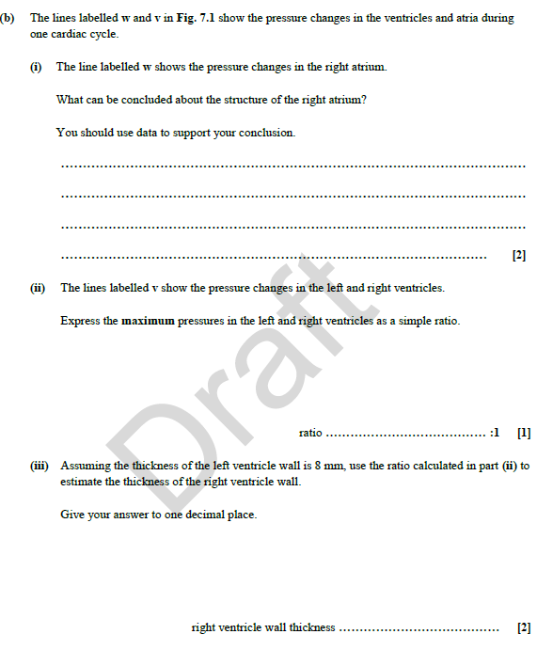

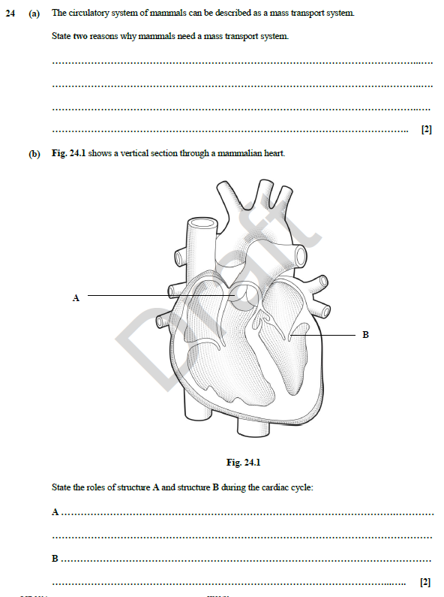

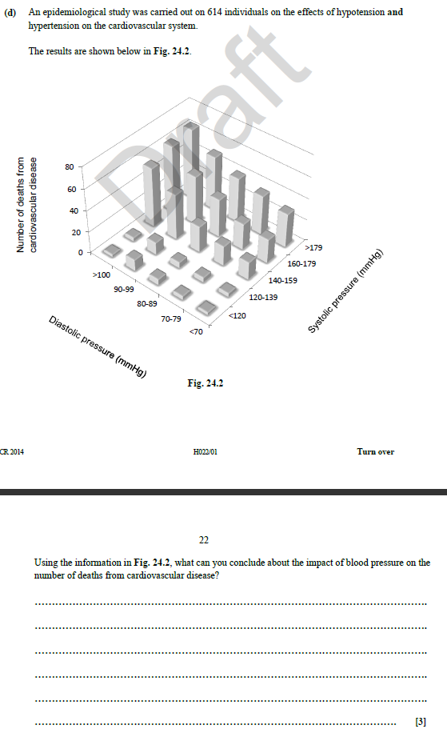

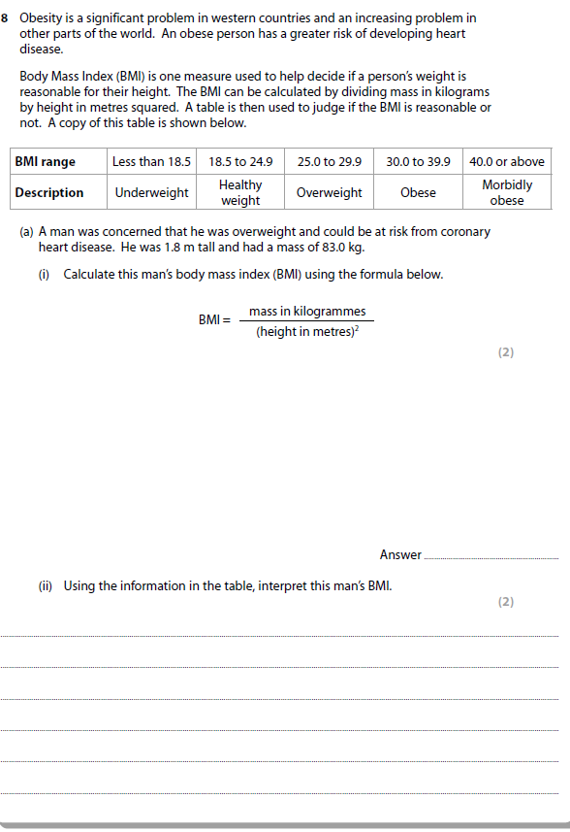

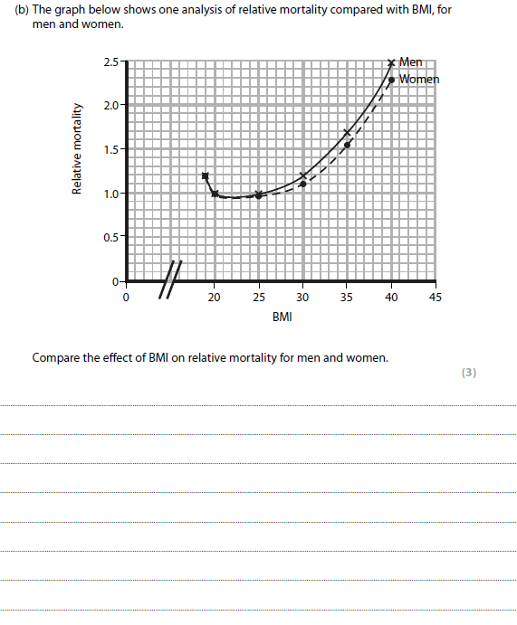

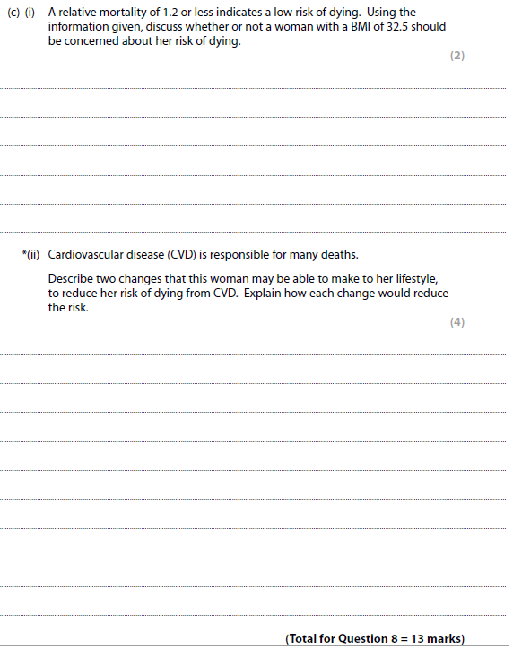

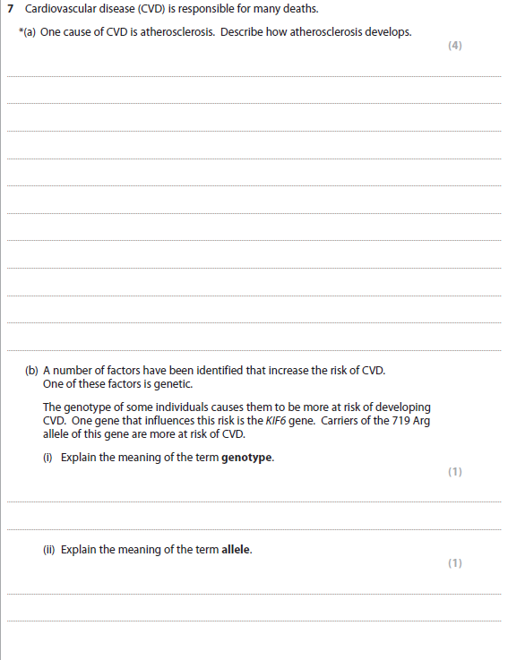

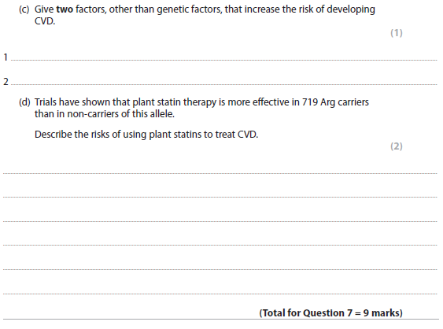

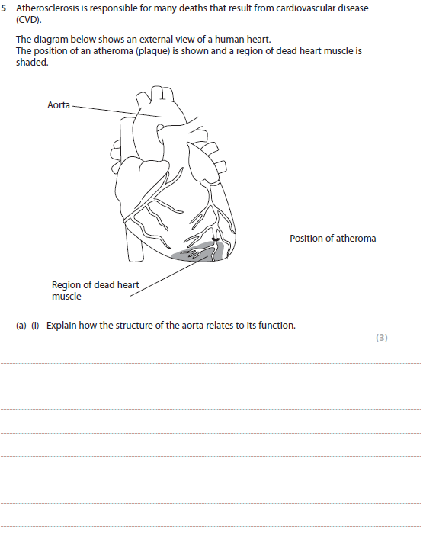

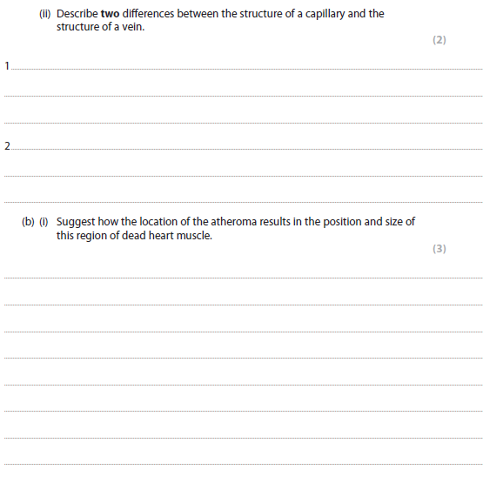

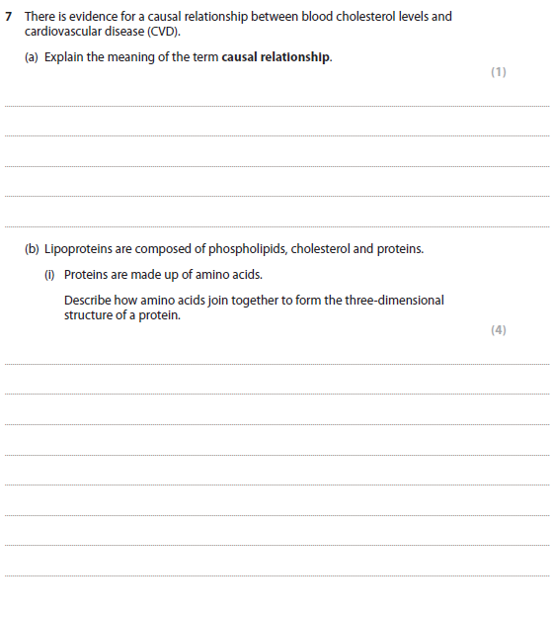

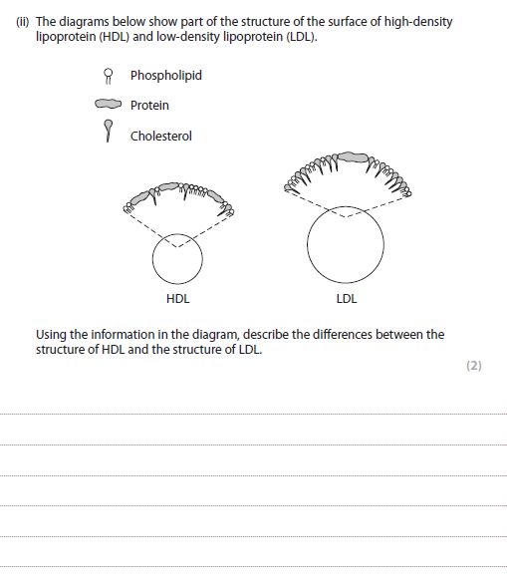

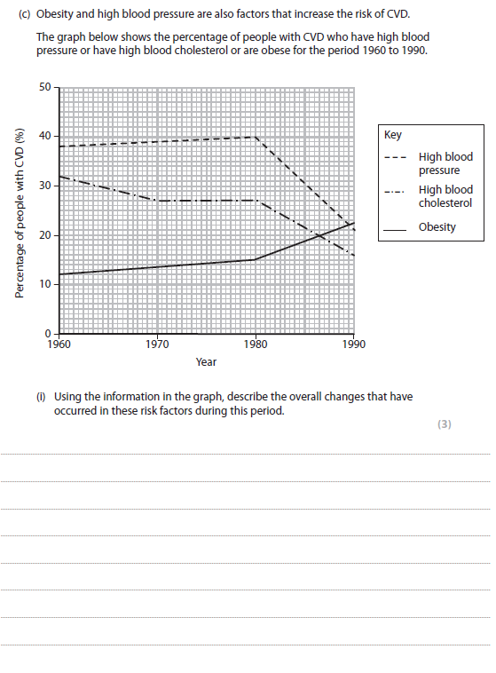

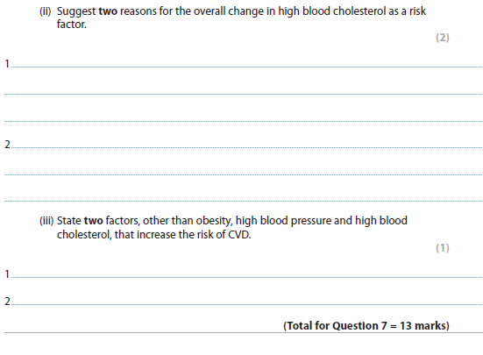
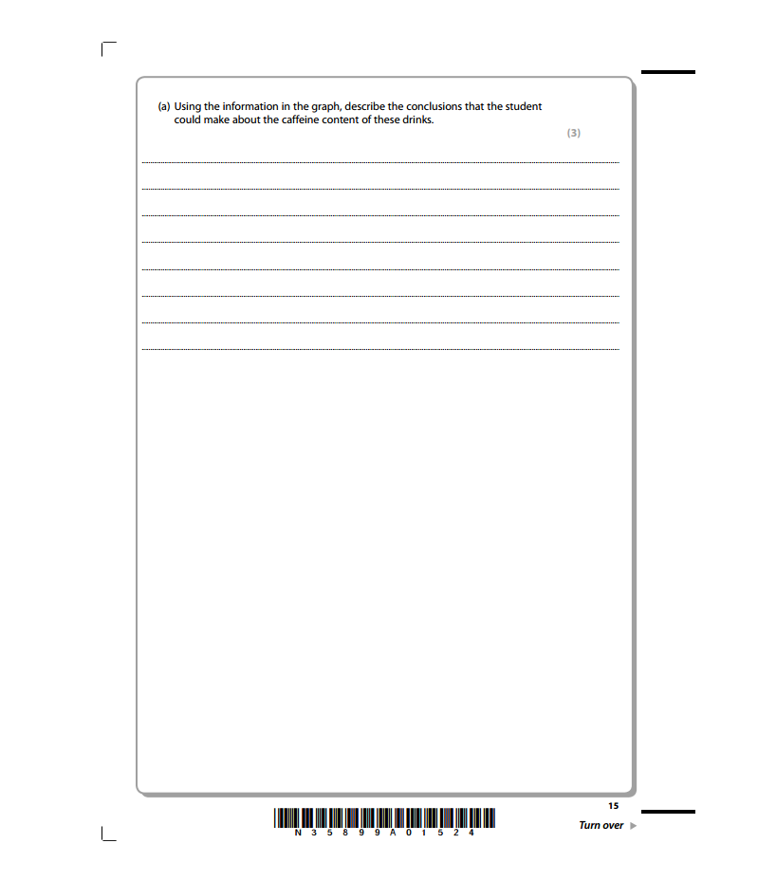
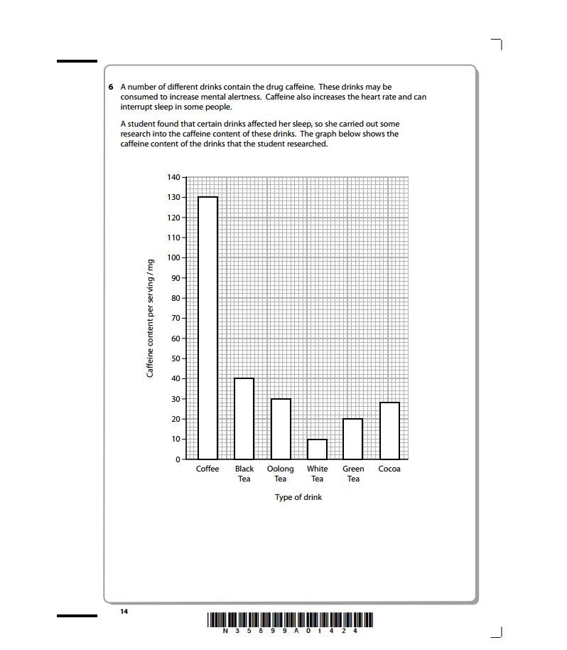
Q. 6

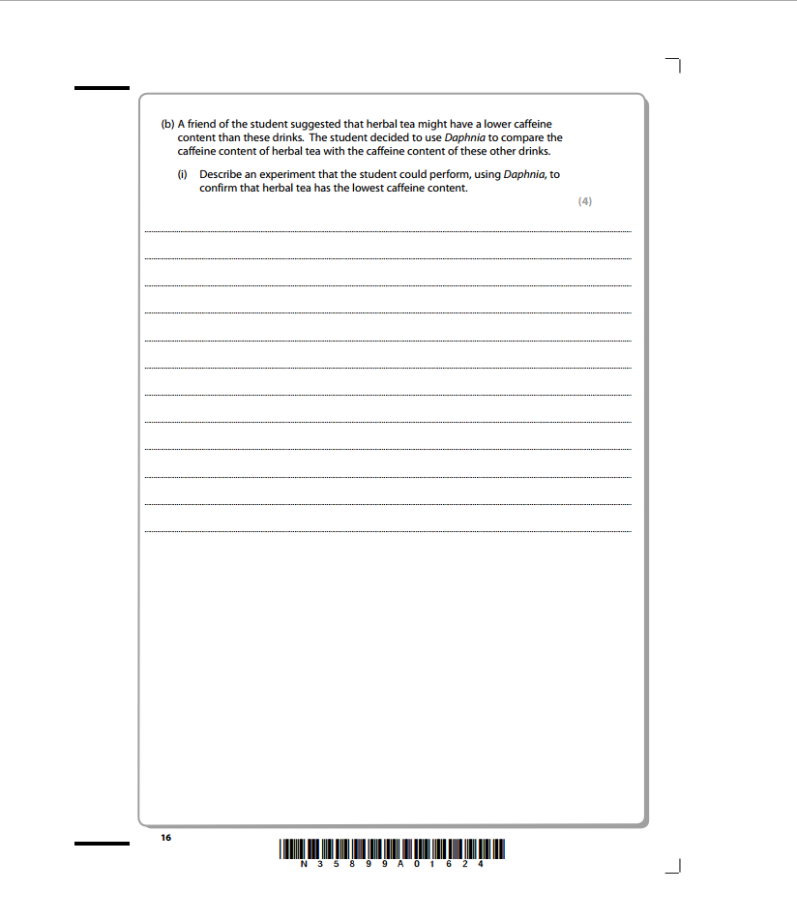

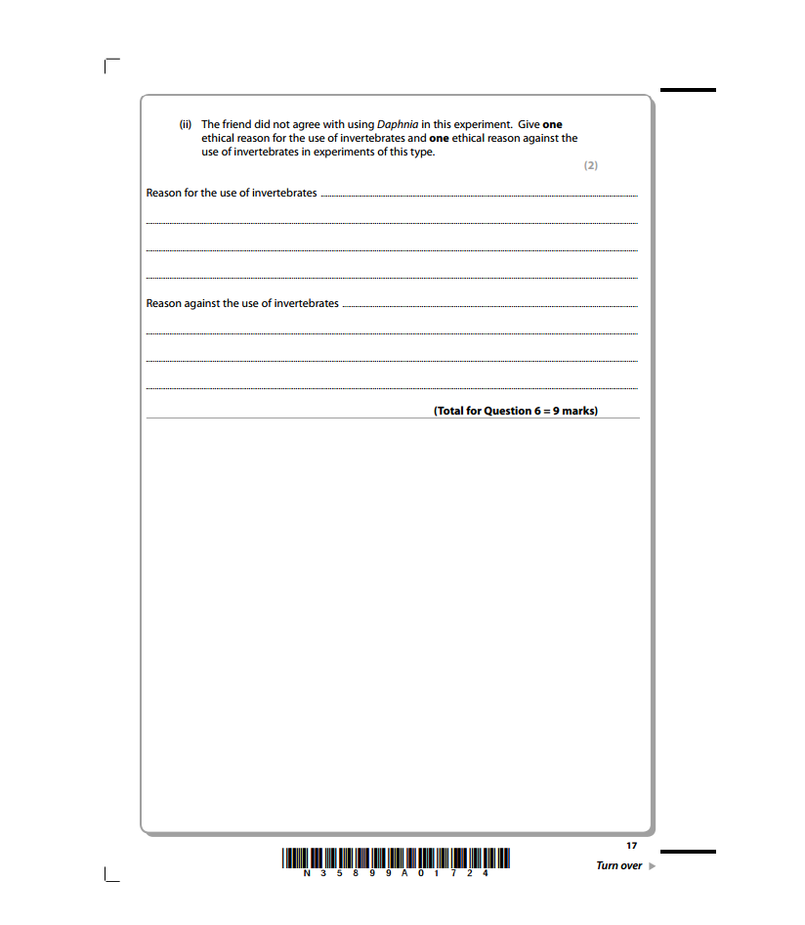

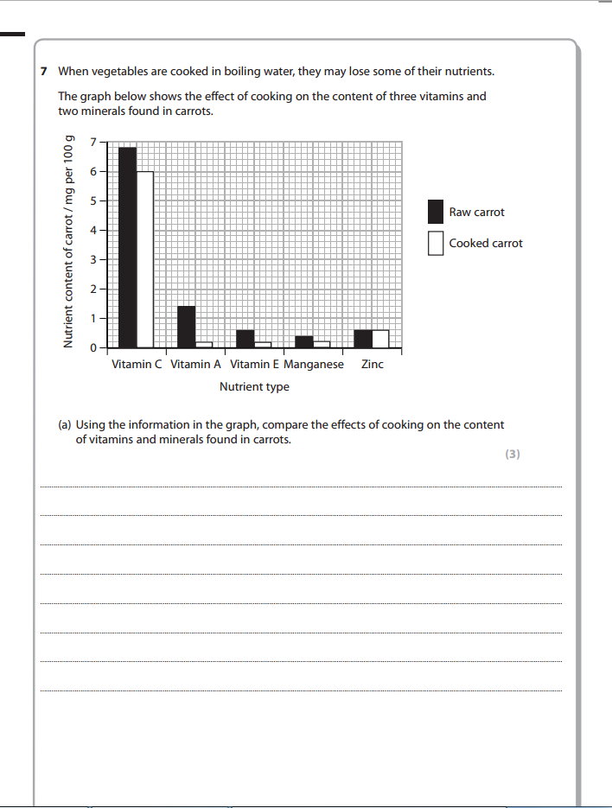

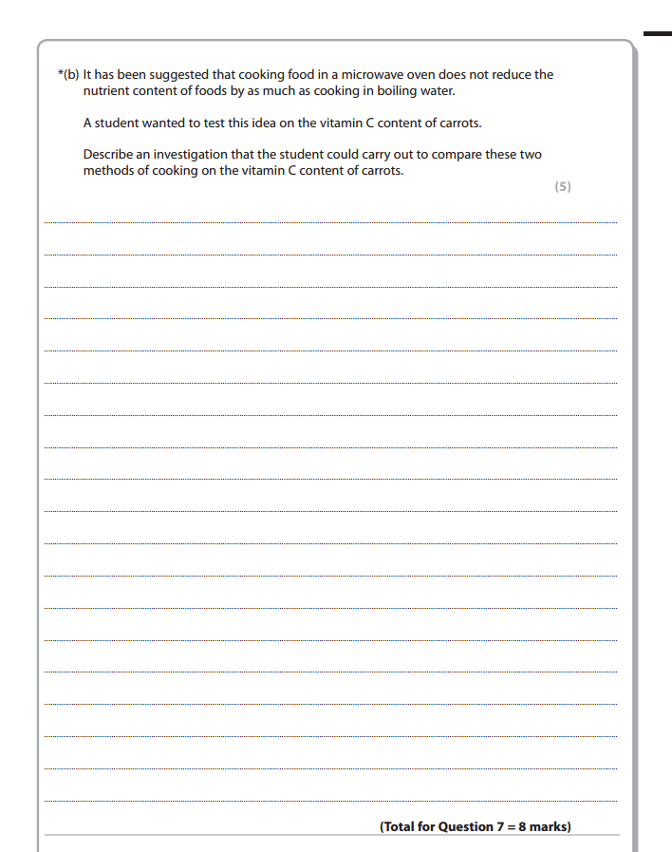

Q11.
Enzymes act as biological catalysts.
Amylase is an enzyme present in saliva that catalyses the hydrolysis of starch into maltose.
*(a) Describe the structure of starch.
(5)
.............................................................................................................................................
.............................................................................................................................................
.............................................................................................................................................
.............................................................................................................................................
.............................................................................................................................................
.............................................................................................................................................
.............................................................................................................................................
.............................................................................................................................................
.............................................................................................................................................
.............................................................................................................................................
.............................................................................................................................................
.............................................................................................................................................
(b) Explain the meaning of the following terms.
(i) Catalyst
(2)
.............................................................................................................................................
.............................................................................................................................................
.............................................................................................................................................
.............................................................................................................................................
.............................................................................................................................................
.............................................................................................................................................
(ii) Hydrolysis
(2)
.............................................................................................................................................
.............................................................................................................................................
.............................................................................................................................................
.............................................................................................................................................
.............................................................................................................................................
.............................................................................................................................................
(c) Bread contains a high proportion of starch. If bread is chewed for a long period of time it begins to taste sweet.
Suggest why bread tastes sweet after chewing for a long period of time.
(1)
.............................................................................................................................................
.............................................................................................................................................
.............................................................................................................................................
.............................................................................................................................................
(Total for question = 10 marks)
Q12.
(a) Some foods and drinks contain plant statins.
Explain the benefits of plant statins to human health.
(2)
.............................................................................................................................................
.............................................................................................................................................
.............................................................................................................................................
.............................................................................................................................................
.............................................................................................................................................
.............................................................................................................................................
(b) In a three-year study, the percentage of patients with CVD (cardiovascular disease) who were using different types of drugs was recorded.
The graph below shows the results of this study.
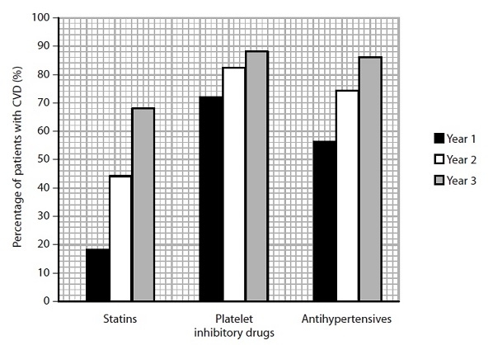
(i) Suggest why there was an increase in the percentage of patients taking statins over the three years of the study.
(2)
.............................................................................................................................................
.............................................................................................................................................
.............................................................................................................................................
.............................................................................................................................................
.............................................................................................................................................
.............................................................................................................................................
(ii) Using the information in the graph, compare the change in the use of platelet inhibitory drugs with the change in the use of antihypertensives, over the three years of this study.
(3)
.............................................................................................................................................
.............................................................................................................................................
.............................................................................................................................................
.............................................................................................................................................
.............................................................................................................................................
.............................................................................................................................................
.............................................................................................................................................
.............................................................................................................................................
(c) Explain why patients with CVD would take each of the following drugs.
(i) Platelet inhibitory drugs such as aspirin
(2)
.............................................................................................................................................
.............................................................................................................................................
.............................................................................................................................................
.............................................................................................................................................
.............................................................................................................................................
.............................................................................................................................................
(ii) Antihypertensives such as beta-blockers
(2)
.............................................................................................................................................
.............................................................................................................................................
.............................................................................................................................................
.............................................................................................................................................
.............................................................................................................................................
.............................................................................................................................................
(Total for question = 11 marks)

Q13.
Researchers collected data to study the relationship between the time spent watching television and coronary heart disease (CHD).
A total of 12 608 men and women, aged between 45 and 79 years, took part. None of them had previously had a stroke or heart attack.
(a) The table below shows the categories in the questionnaire that each person completed.
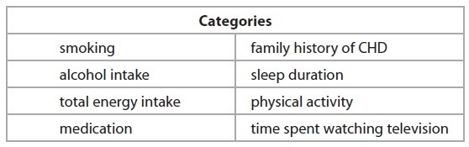
(i) Suggest why people who had not had strokes or heart attacks were selected for this study.
(1)
.............................................................................................................................................
.............................................................................................................................................
.............................................................................................................................................
.............................................................................................................................................
(ii) Suggest why people were asked to provide the researchers with information based on the categories shown in the table.
(2)
.............................................................................................................................................
.............................................................................................................................................
.............................................................................................................................................
.............................................................................................................................................
.............................................................................................................................................
.............................................................................................................................................
(b) The table below shows the categories in the questionnaire that each person completed.
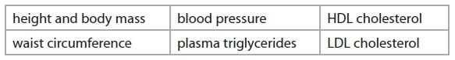
(i) Suggest why these data were collected.
(2)
.............................................................................................................................................
.............................................................................................................................................
.............................................................................................................................................
.............................................................................................................................................
.............................................................................................................................................
.............................................................................................................................................
(ii) Suggest why these data might be considered to be more accurate than the information in the questionnaire.
(3)
.............................................................................................................................................
.............................................................................................................................................
.............................................................................................................................................
.............................................................................................................................................
.............................................................................................................................................
.............................................................................................................................................
.............................................................................................................................................
.............................................................................................................................................
.............................................................................................................................................
(c) This study was funded by the government and charities supporting research into heart diseases and strokes.
Suggest why it was important that none of the funding came from drug companies or television manufacturers.
(2)
.............................................................................................................................................
.............................................................................................................................................
.............................................................................................................................................
.............................................................................................................................................
.............................................................................................................................................
.............................................................................................................................................
(d) The researchers carried out the study over a period of 10 years.
They found that there was a positive correlation between the number of hours spent watching television and the risk of developing coronary heart disease.
A journalist wrote an article about the results of this study with the title 'Watching television causes heart disease'.
Is this statement valid? Give an explanation for your answer.
(3)
.............................................................................................................................................
.............................................................................................................................................
.............................................................................................................................................
.............................................................................................................................................
.............................................................................................................................................
.............................................................................................................................................
.............................................................................................................................................
.............................................................................................................................................
(Total for question = 13 marks)

TOPIC 1 QU BOOKLET

MARK SCHEME
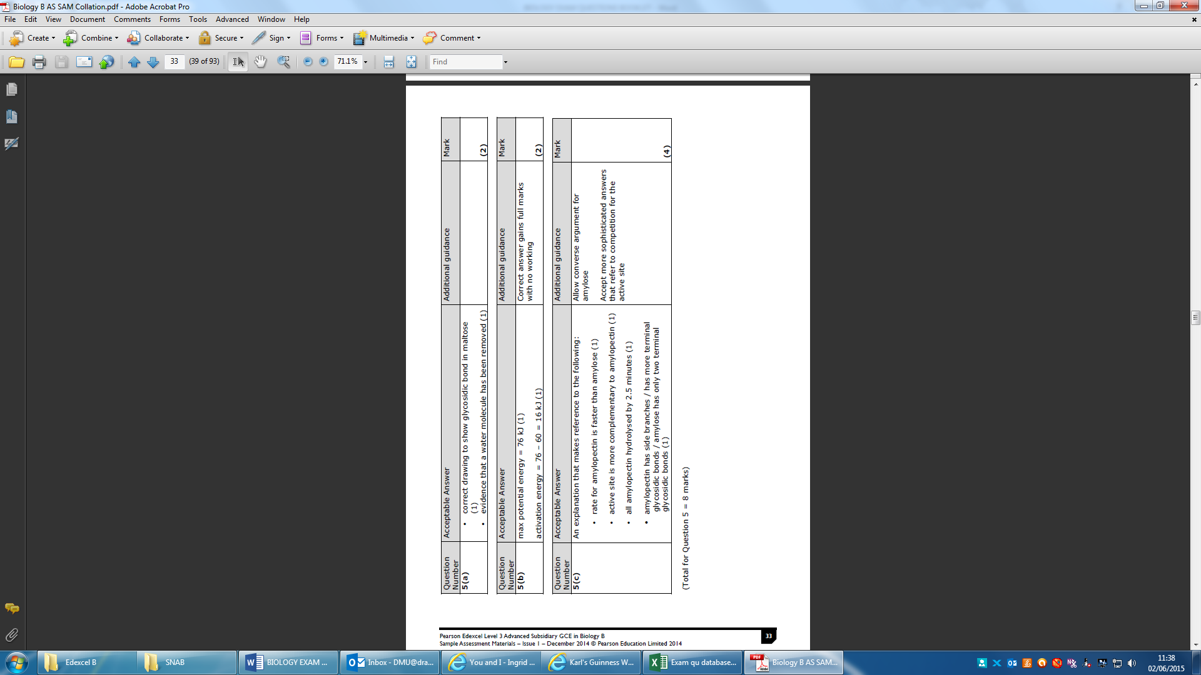
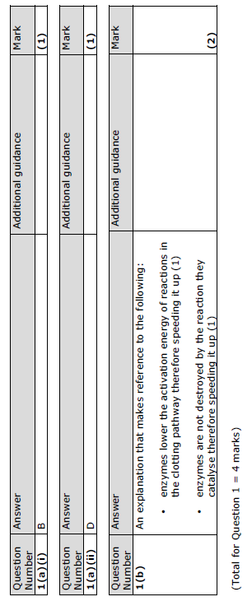

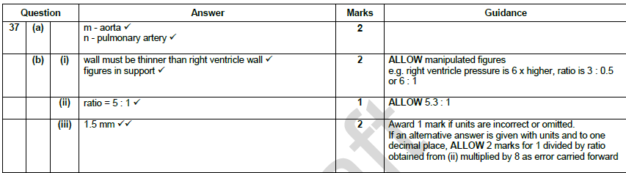
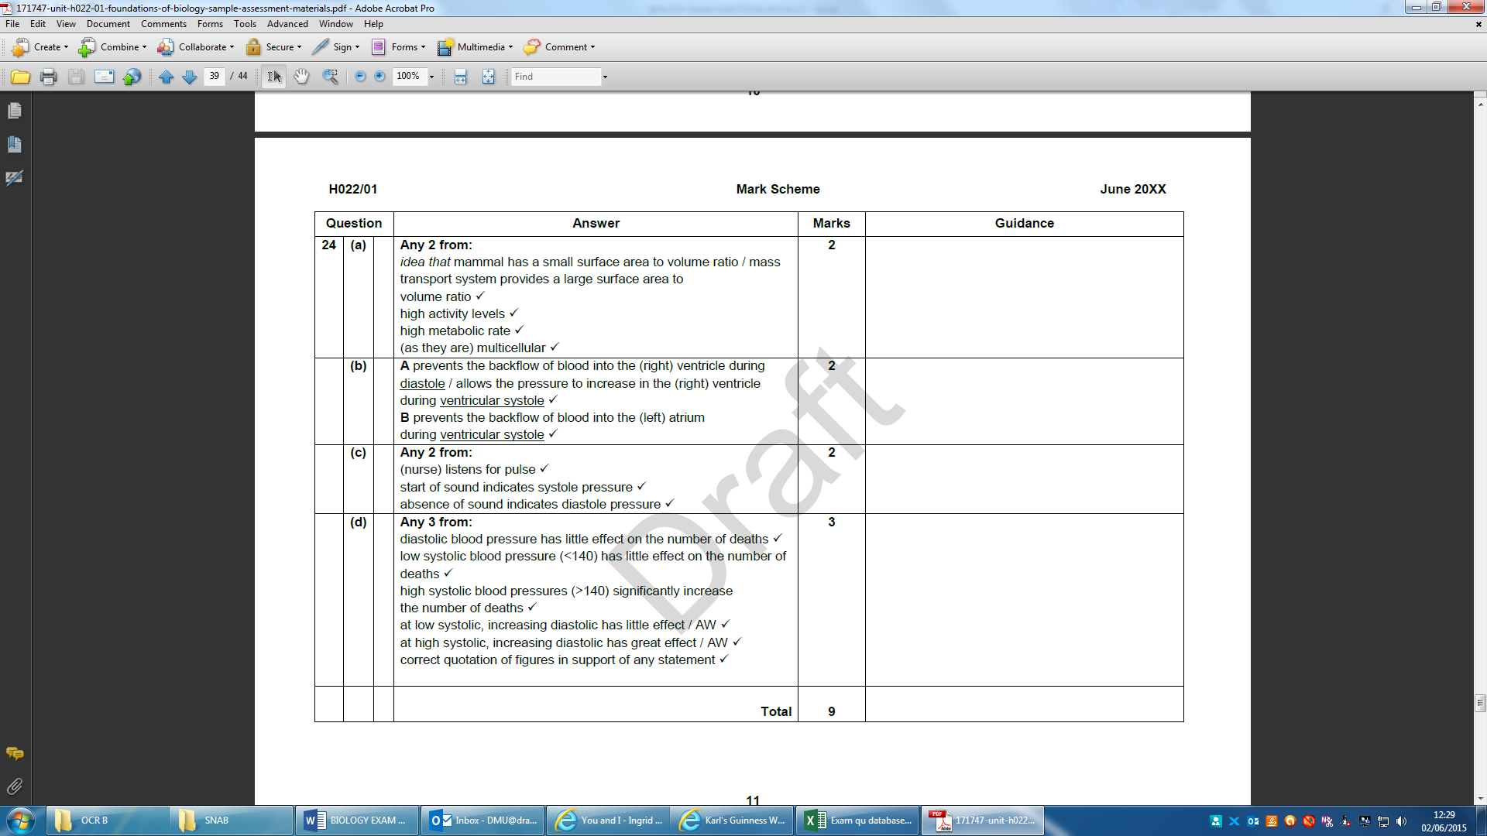

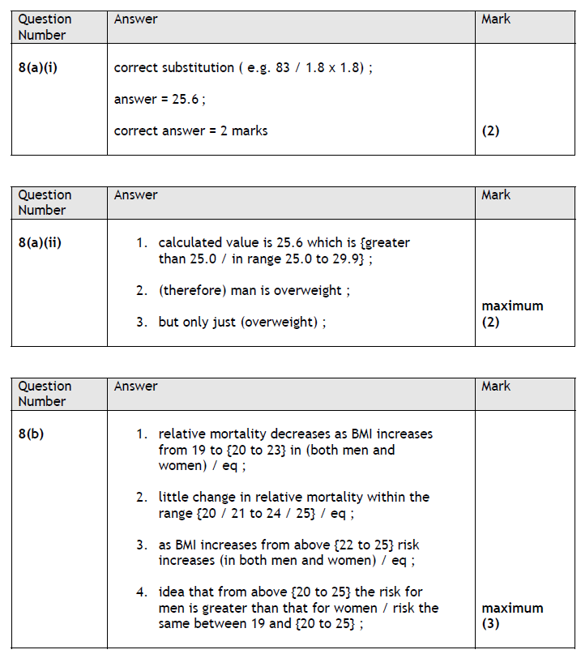

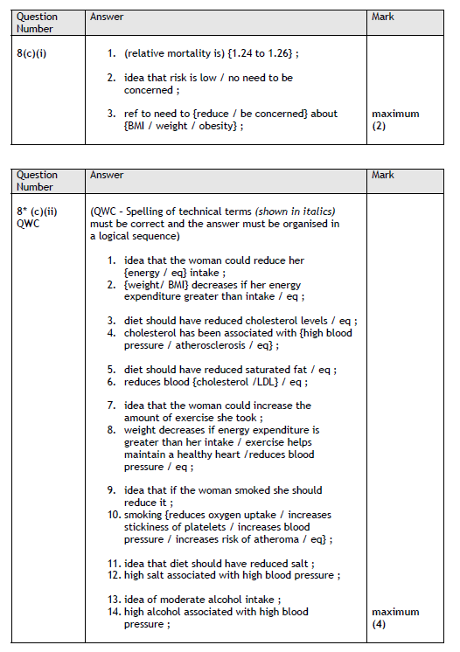

T6 t6rgtg6r

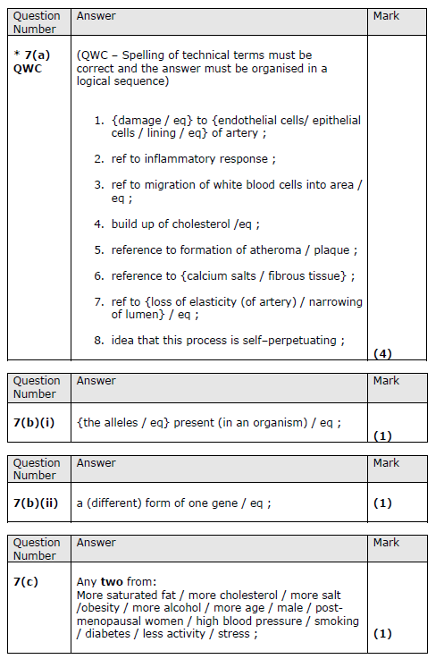
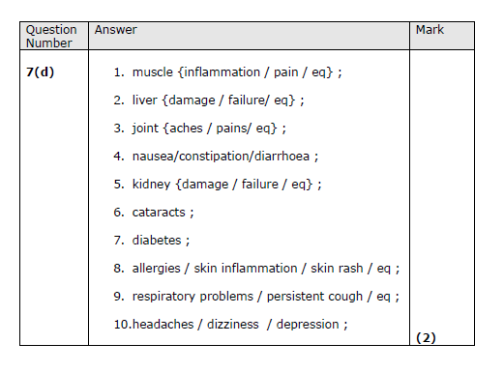

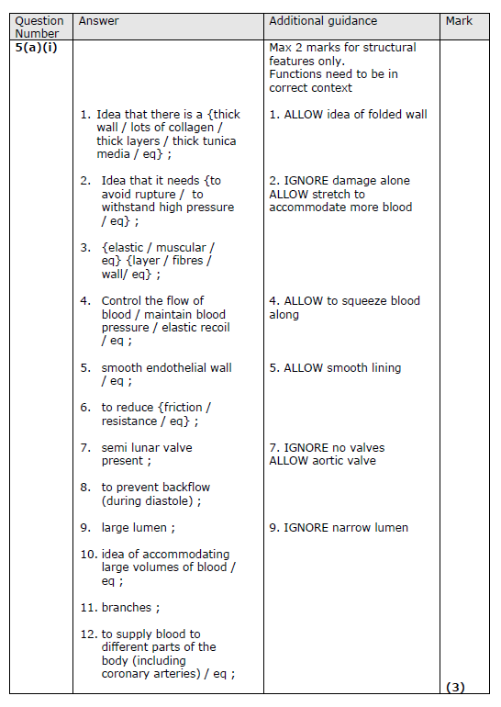

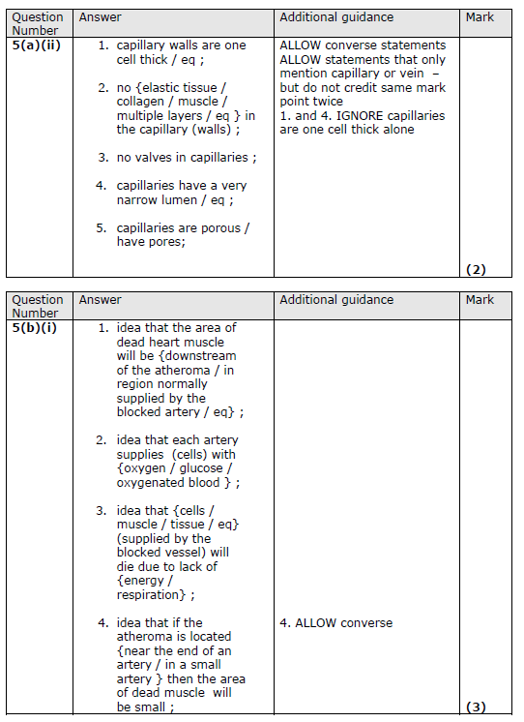

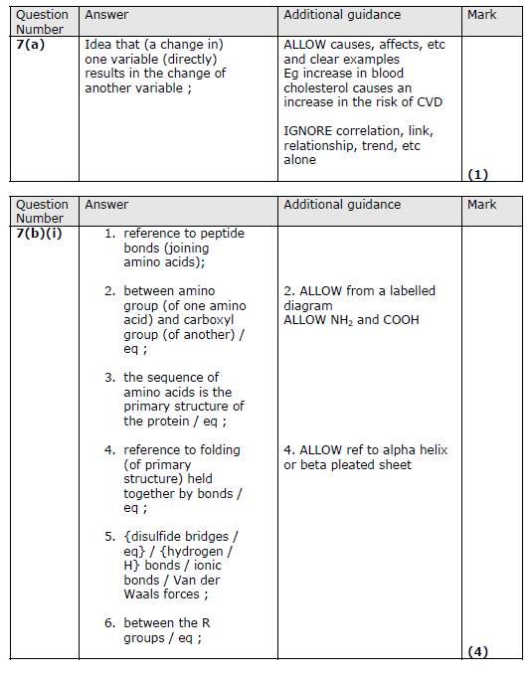

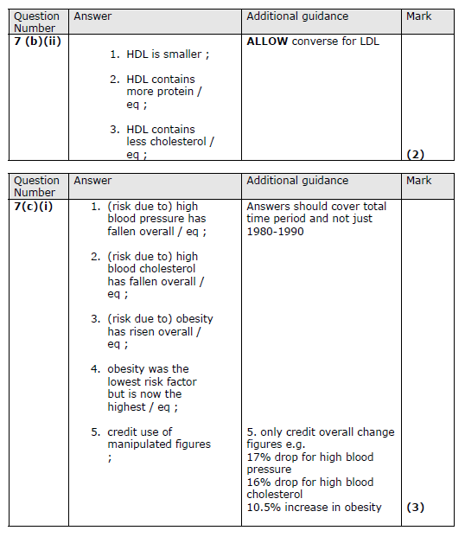

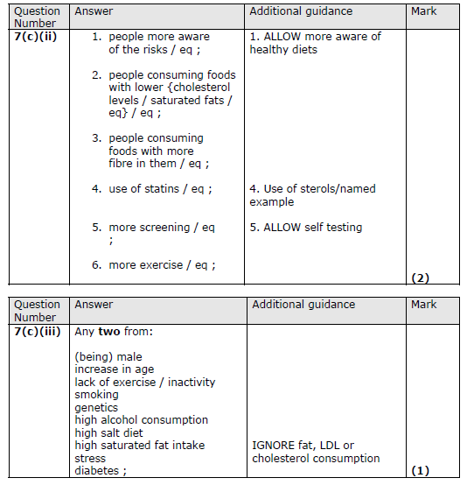

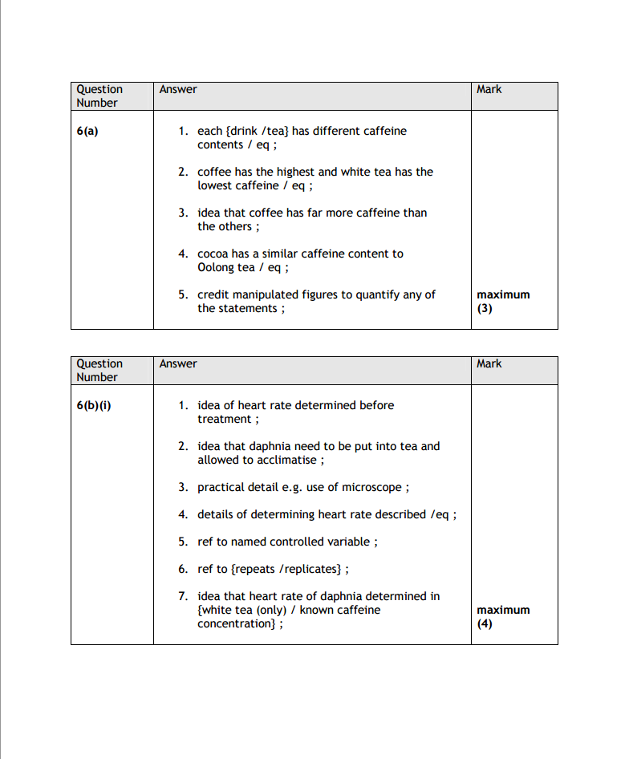

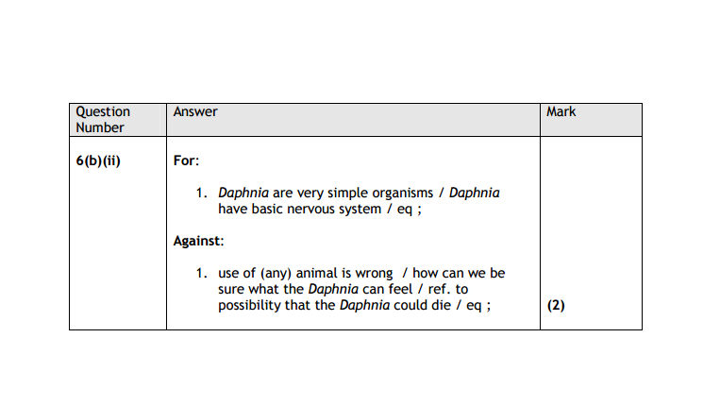

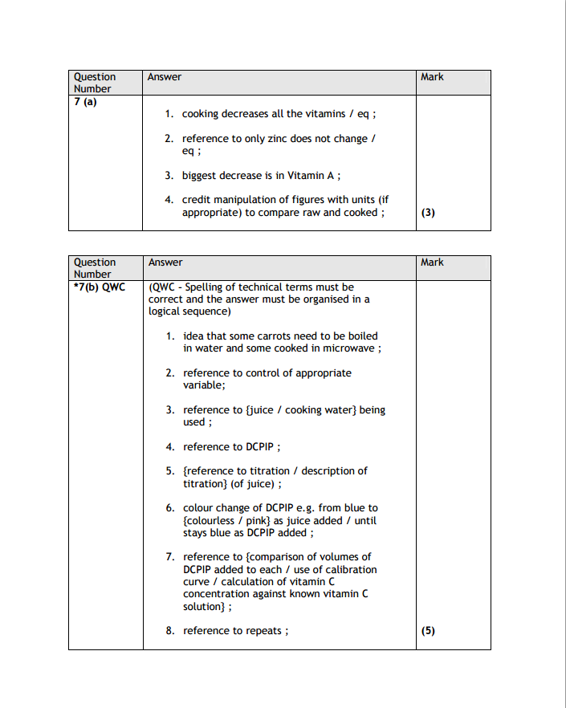

Q11.
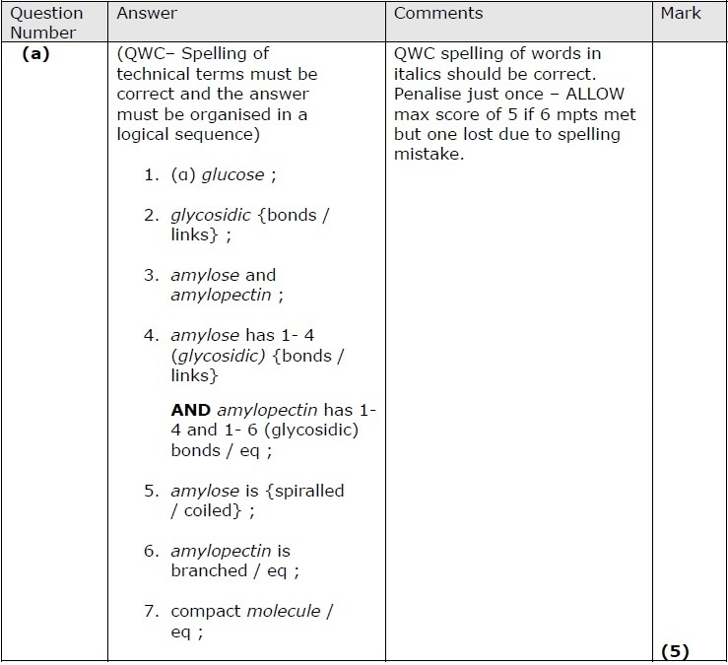
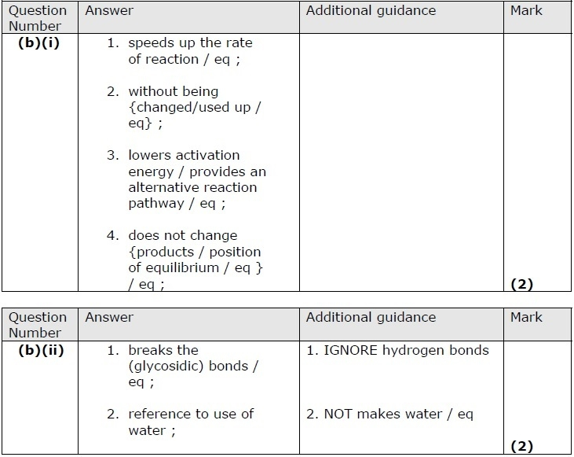
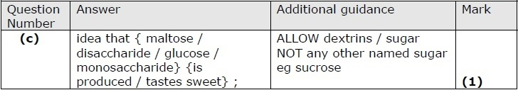

Q12.
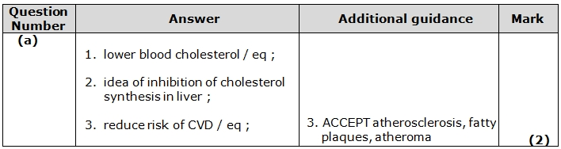
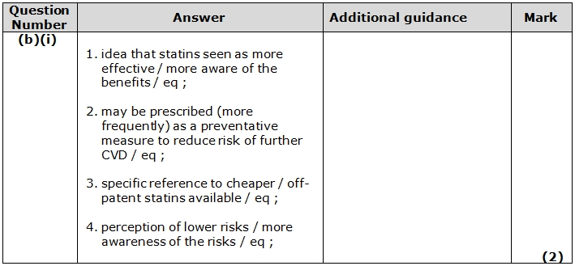
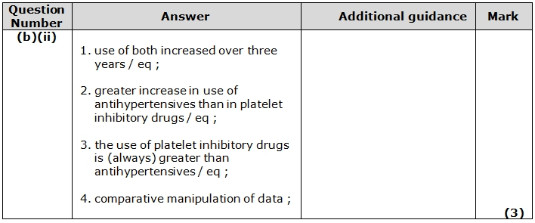
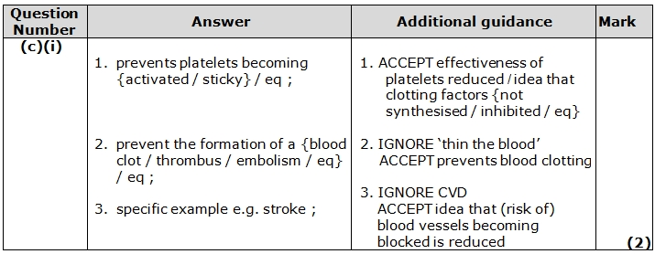
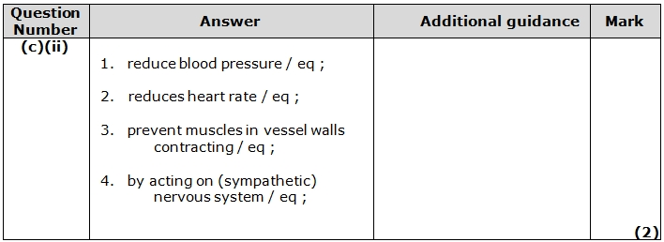

Q13.
