BIOLOGY EXAM QUESTIONS BOOKLET



TOPIC 2

Centre Number |  | 12416
Candidate Number
Candidate forename |  | Candidate surname
Class
Teachers’ initials

Qu | Concept | Skill focus | Total Mark | Marks ach’d | Traffic Light | *Follow up task completed
1 | Gas exchange | QWC | 6
2 | Protein structure | QWC | 5
3 | Membrane structure and transport | Recall  Application | 13
4 | Enzymes | Calculation  Graph | 8
5 | Enzymes | Graph & Core Prac | 10
6 | Cell membranes | Core Prac | 12
7 | Protein Synthesis | Recall | 8
8 | Mutations and cell mem | Application | 12
9 | DNA Replication | Application | 7
10 | Inheritance | Analysis, Apply & recall
11 | Genetic Screening & Gene Therapy | Recall  Application | 10
*If the exam question has been traffic lighted as amber or red then you still need to work on this concept or skill area. You must follow this up by completing a task from below. Add the letter of the follow up task completed in the last column of the grid on your front page. Add the evidence in this booklet.

Potential review tasks include (increase in difficulty as you go down):

- Make notes on the concept of the question using a variety of different resources such as the various A-level textbooks in the library (not just the core SNAB textbook).

- Complete a worksheet on the skill or concept such as a worksheet from the Biozone booklet in the library. SNAB also has workbooks available to buy.

- Complete a Biological skills support sheet on the concept or skill from pearsonactivelearn.com

- Find another exam question on this concept or skill using the Biology exam question database on Moodle (password is Biology). Then google Edexcel SNAB Biology A past papers.

- Summarise the rules for answering a similar style of question using the examiners reports for exam questions on this concept or skill. Use the exam question database on Moodle as above to help you find the exam questions on this concept or skill and then find the examiner’s report for it.

- Make your own exam question and mark scheme on the concept or skill. Use current mark schemes to help you.

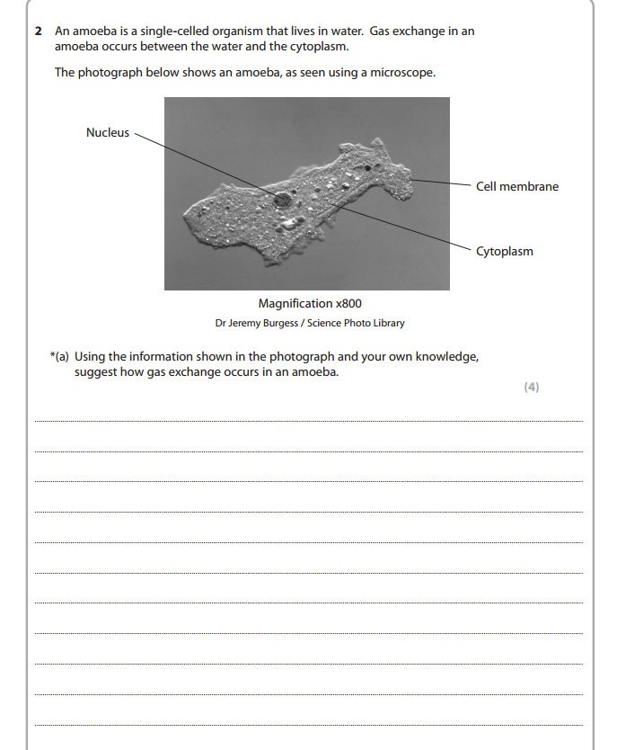
1
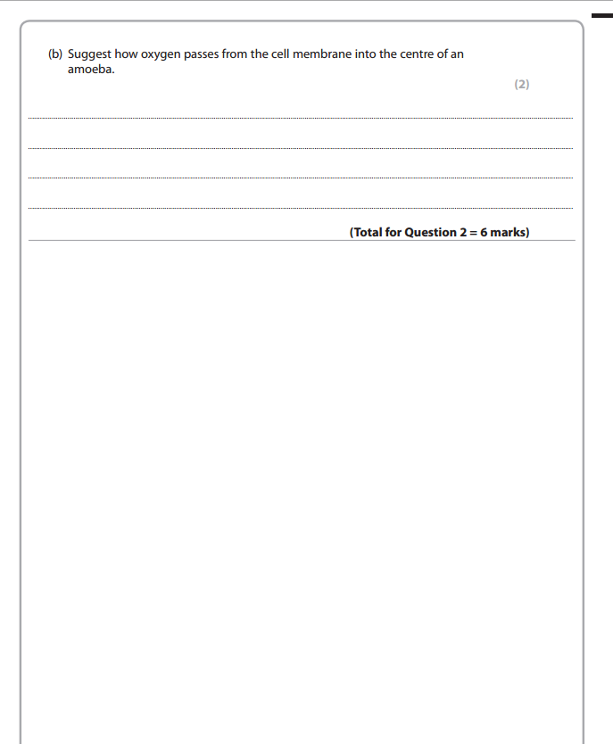

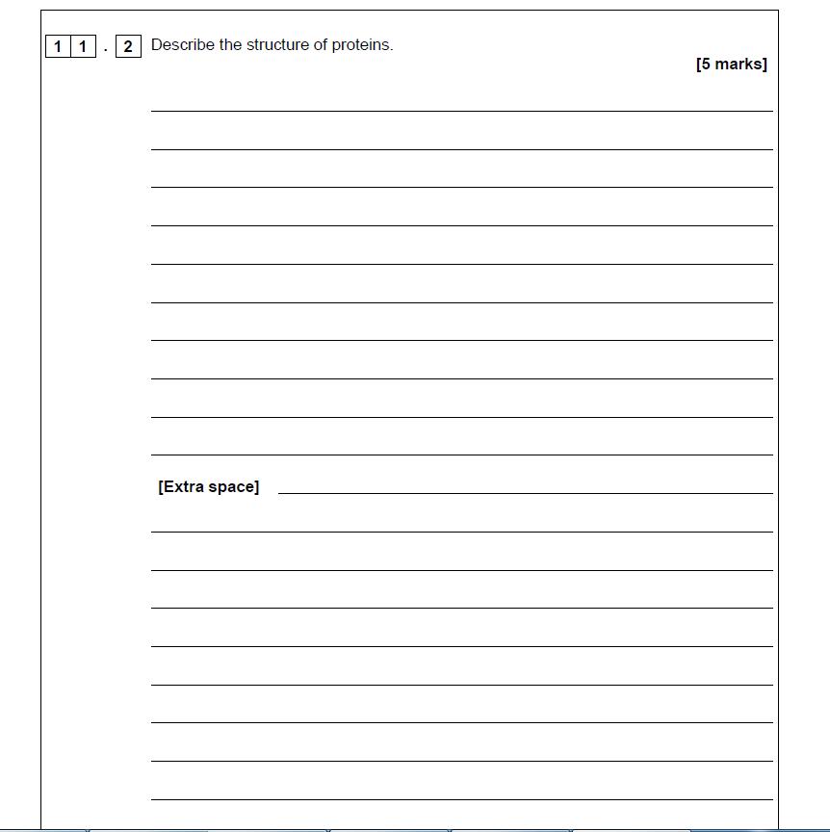

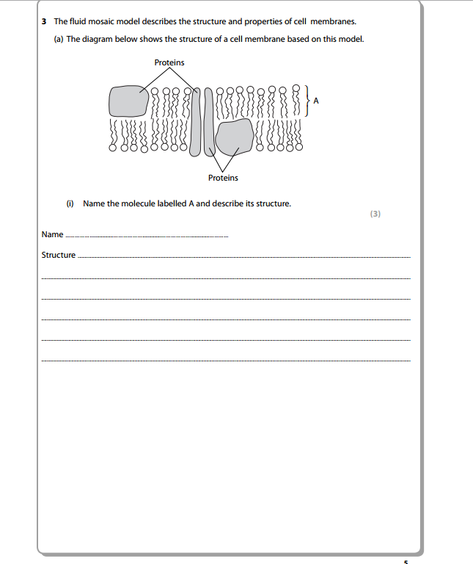
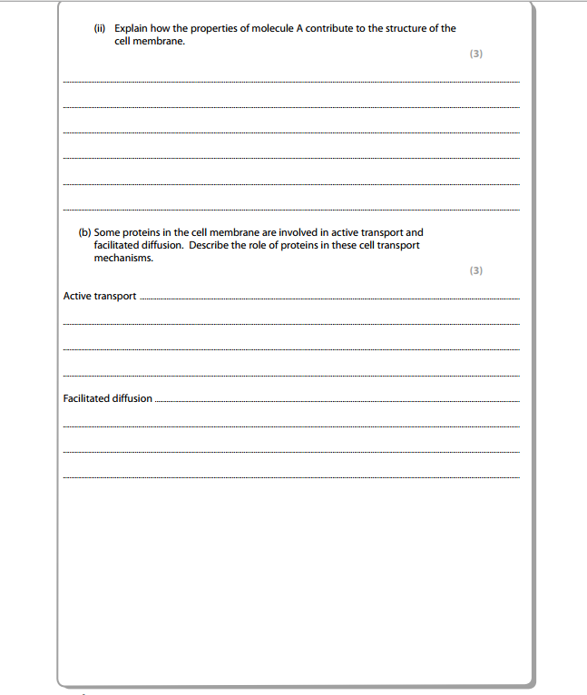
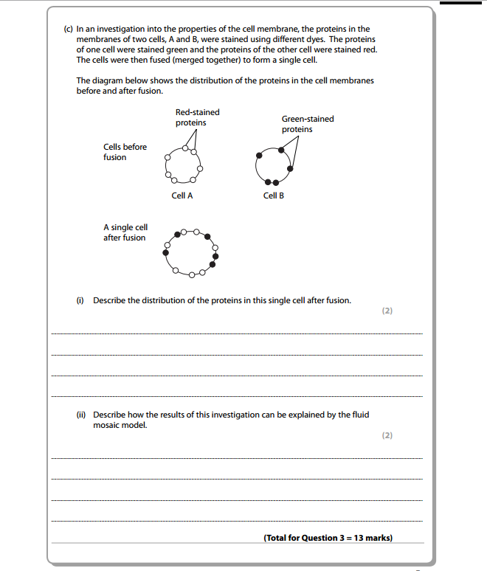
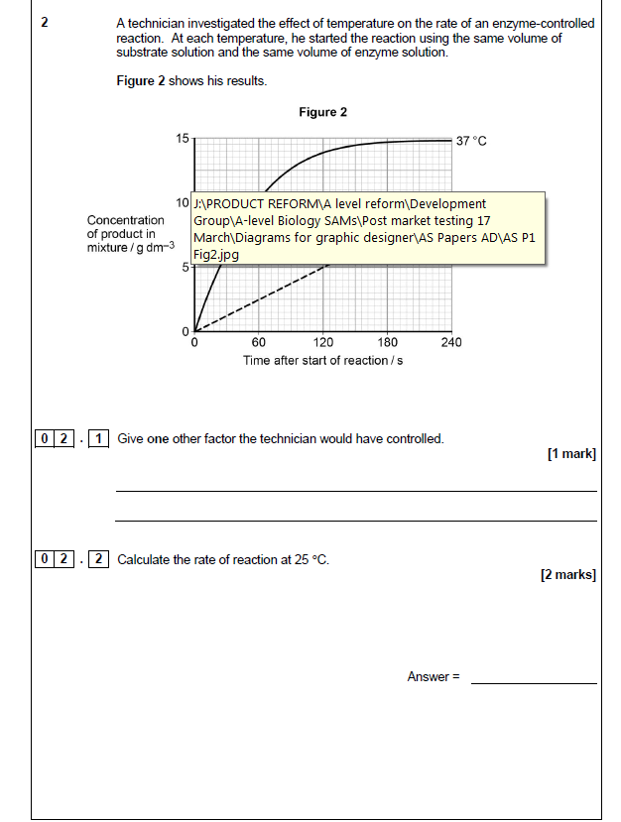

4
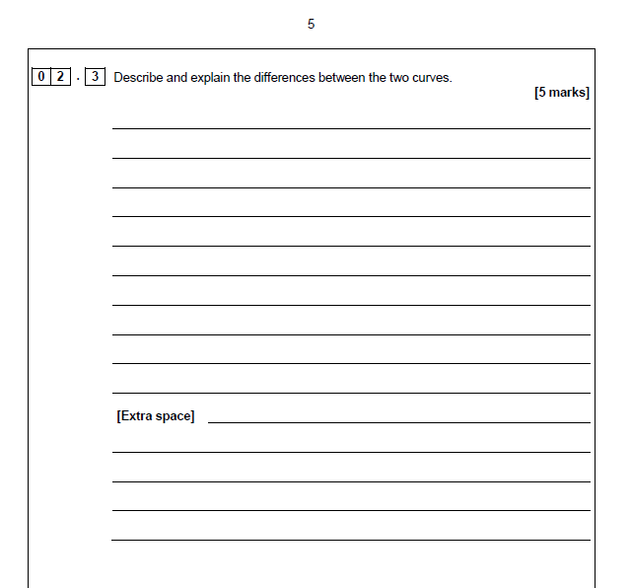

Q5 Enzymes
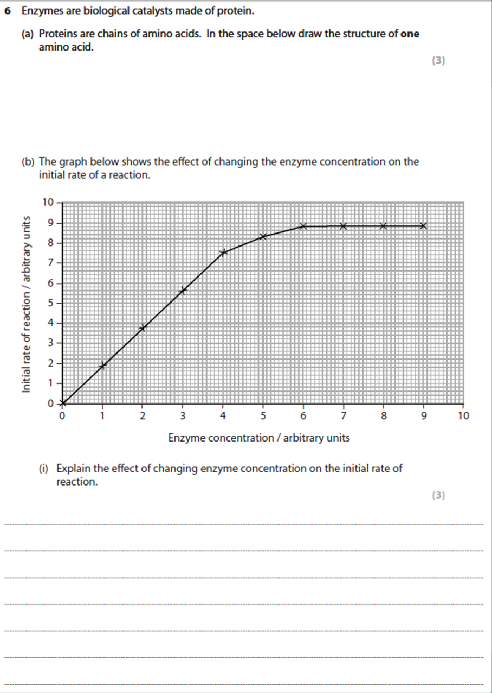

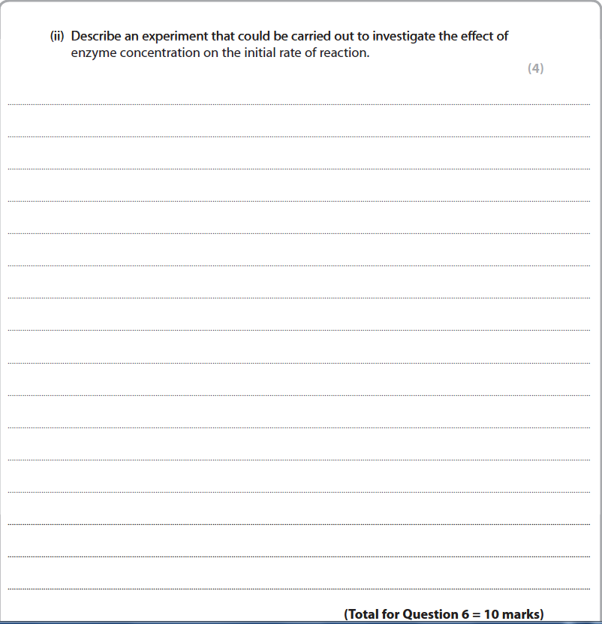

Q6 Membranes
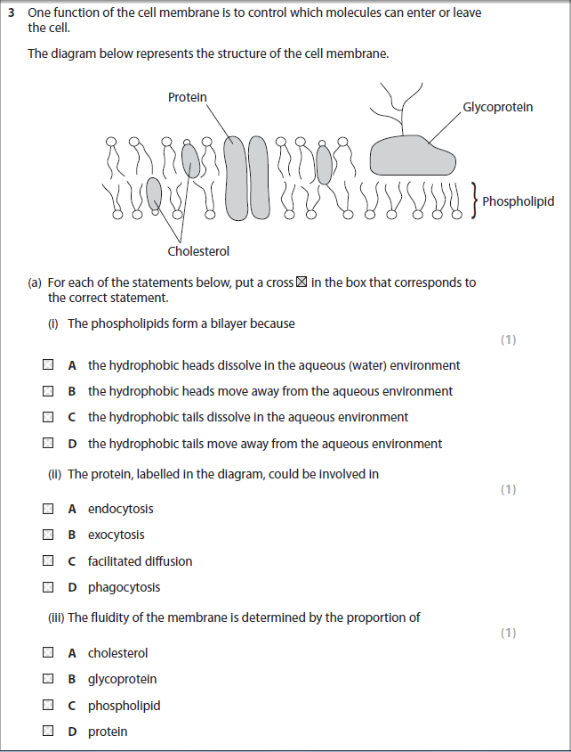

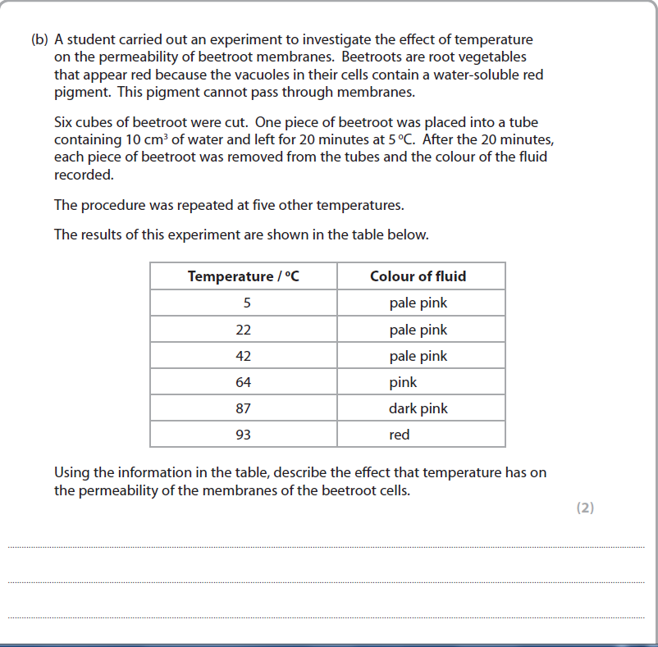

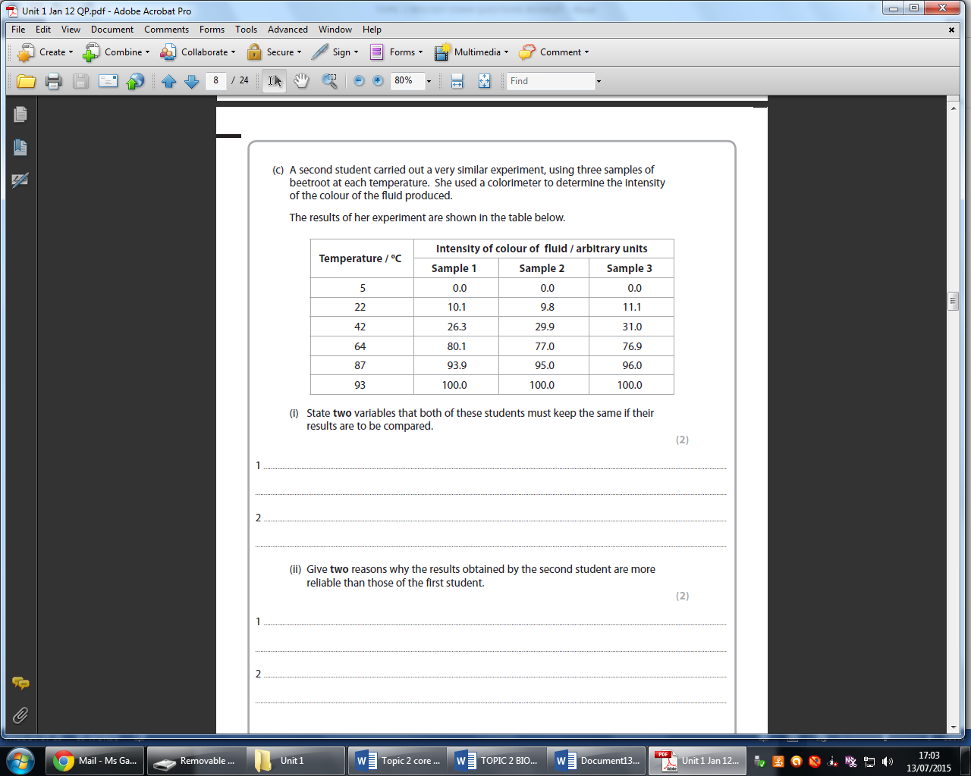

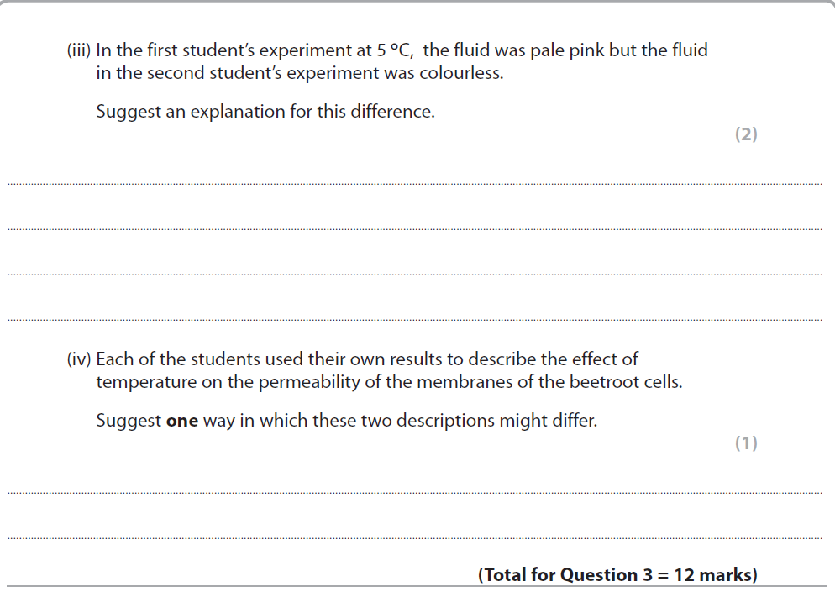

Q7 Protein Synthesis
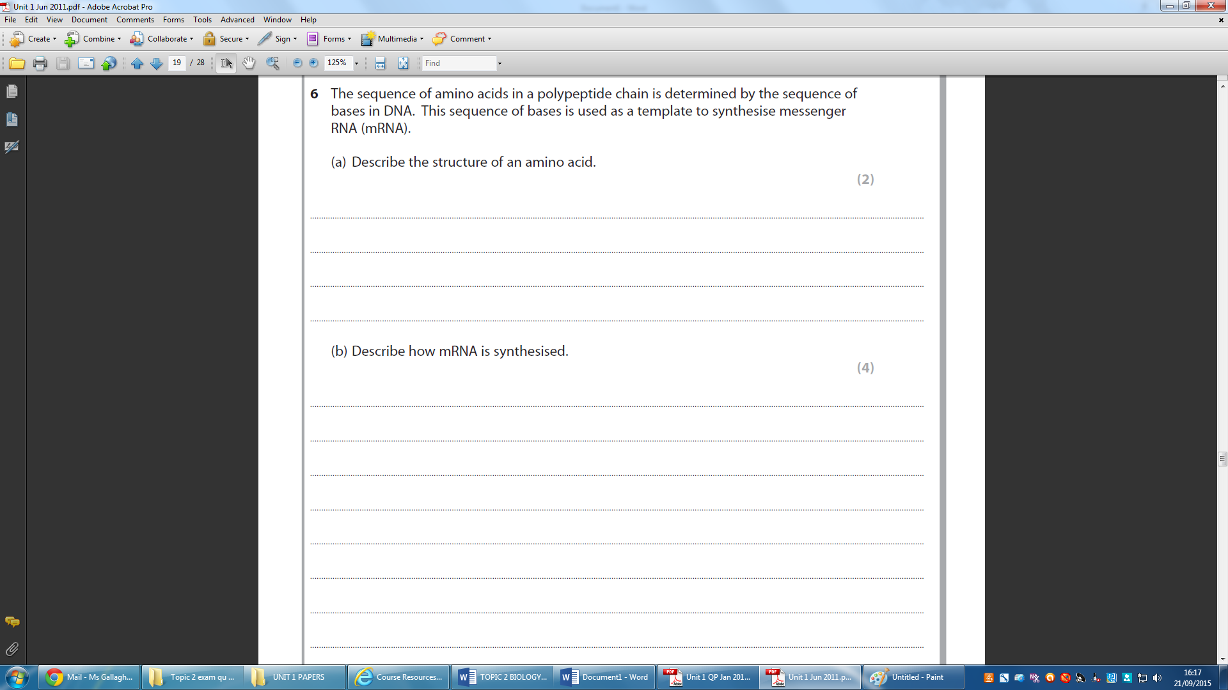

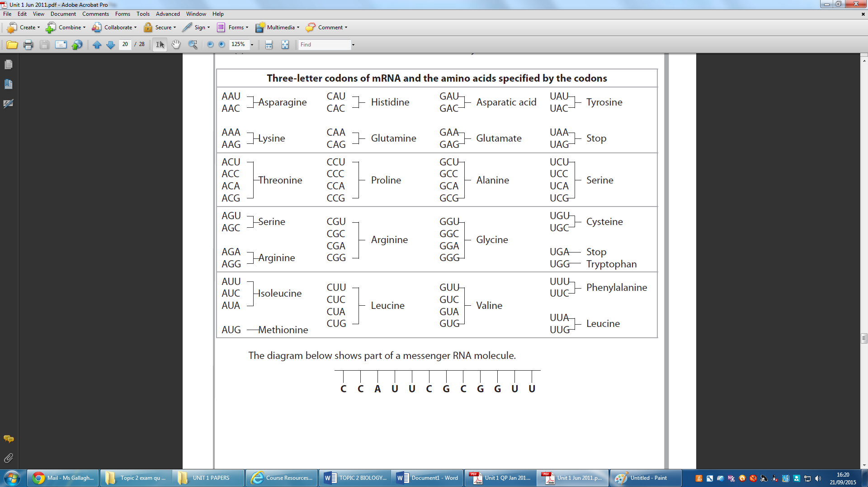
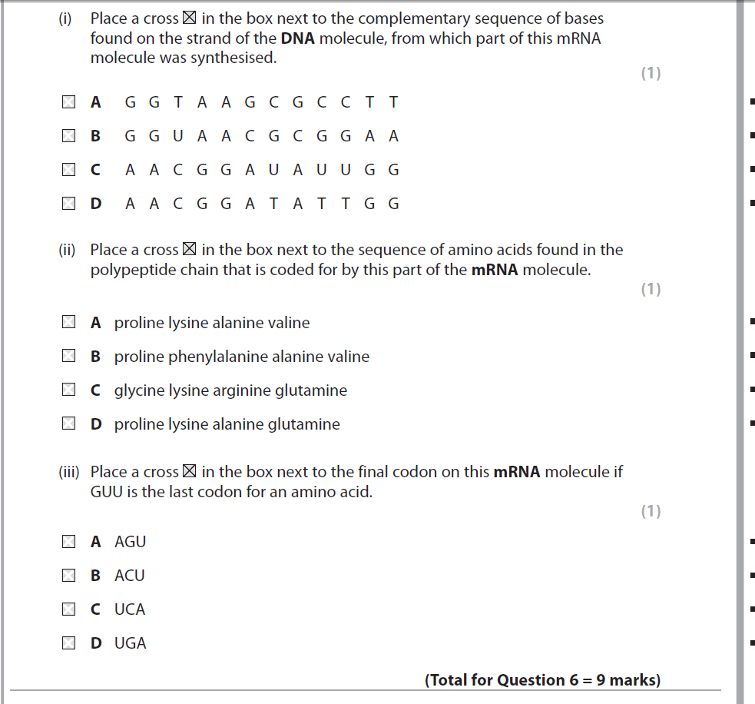
DO NOT ANSWER PART (i)

Q8 Mutations and cell membranes
Cystic fibrosis is a genetic disease caused by mutations in the CFTR gene. This disease can be classified according to the effect of the different gene mutations on the CFTR protein.
The table below shows the classification of cystic fibrosis.
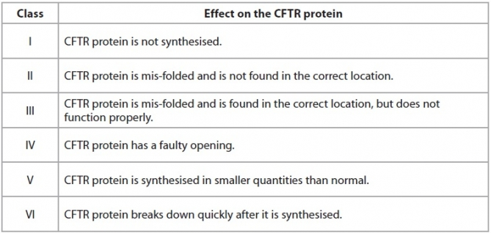
(a) For class I cystic fibrosis, suggest how a mutation in the CFTR gene could result in no CFTR protein being synthesised.
(2)
..............................................................................................................................................
..............................................................................................................................................
..............................................................................................................................................
..............................................................................................................................................
..............................................................................................................................................
..............................................................................................................................................
..............................................................................................................................................
..............................................................................................................................................
(b) Class II cystic fibrosis results from the CFTR protein being located in the wrong place.
Describe the correct location for the CFTR protein.
(2)
..............................................................................................................................................
..............................................................................................................................................
..............................................................................................................................................
..............................................................................................................................................
(c) The mutation causing class III cystic fibrosis results in a change in the primary structure of the CFTR protein.
Explain why this would result in the CFTR protein being mis-folded.
(2)
..............................................................................................................................................
..............................................................................................................................................
..............................................................................................................................................
..............................................................................................................................................
..............................................................................................................................................
..............................................................................................................................................
(d) For class IV cystic fibrosis, explain why a faulty opening of the CFTR protein would affect the functioning of this protein.
(2)
..............................................................................................................................................
..............................................................................................................................................
..............................................................................................................................................
..............................................................................................................................................
..............................................................................................................................................
..............................................................................................................................................
(e) For a person with class V cystic fibrosis, describe the effect of having smaller quantities of CFTR protein.
(2)
..............................................................................................................................................
..............................................................................................................................................
..............................................................................................................................................
..............................................................................................................................................
..............................................................................................................................................
..............................................................................................................................................
(f ) For class VI cystic fibrosis, suggest how the CFTR protein is broken down.
(2)
..............................................................................................................................................
..............................................................................................................................................
..............................................................................................................................................
..............................................................................................................................................
..............................................................................................................................................
..............................................................................................................................................
(Total for Question = 12 marks)

Qu 9 DNA Replication
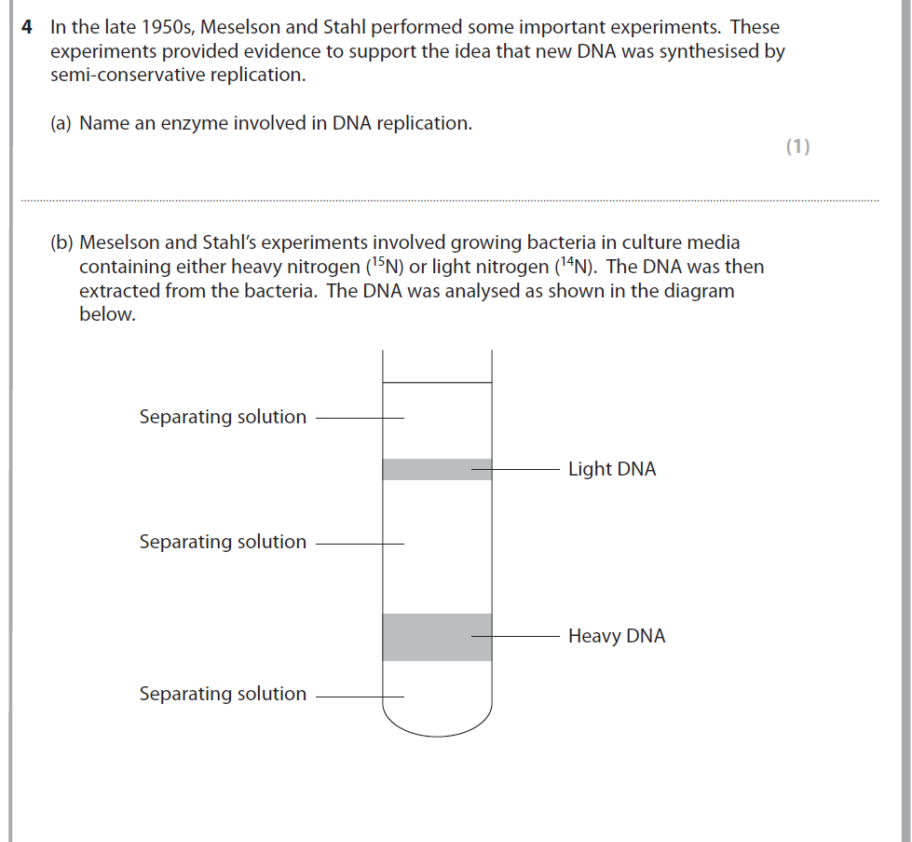

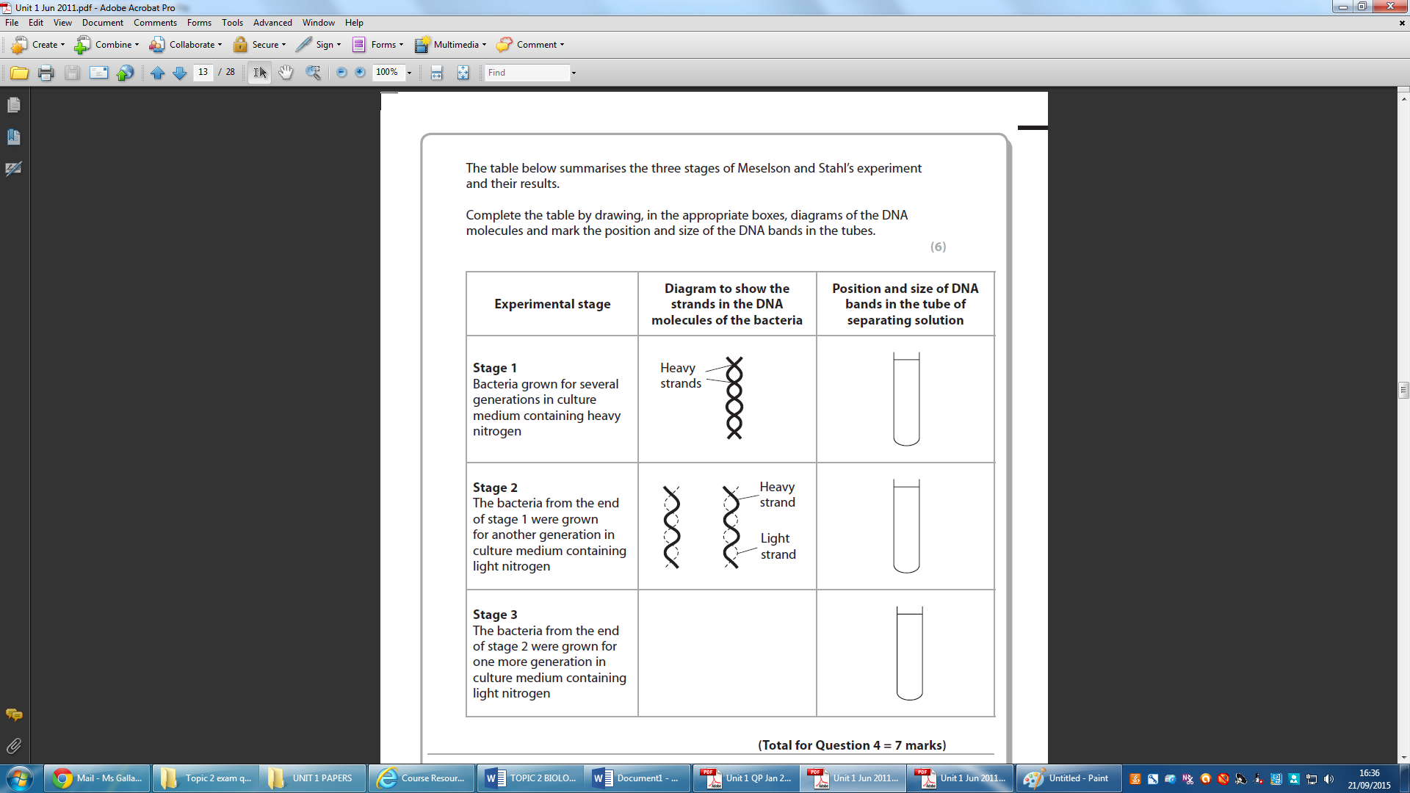

Q10 Inheritance
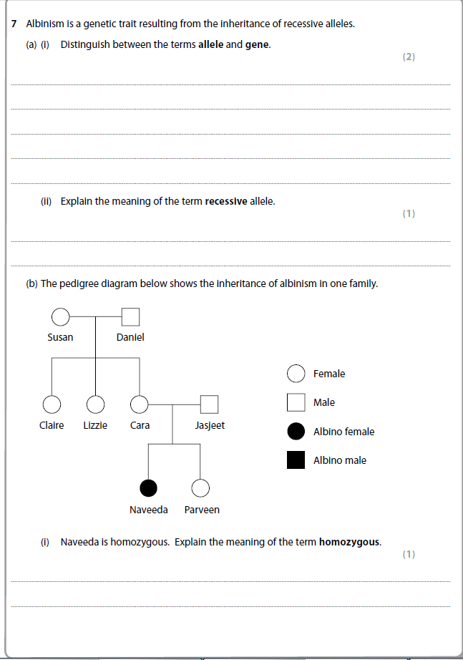

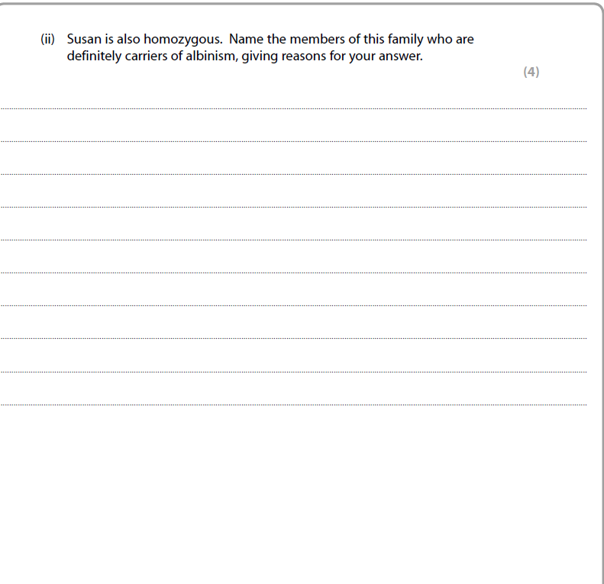

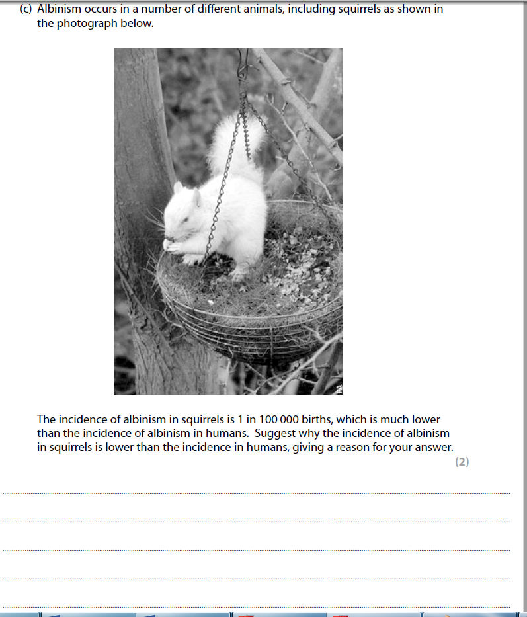

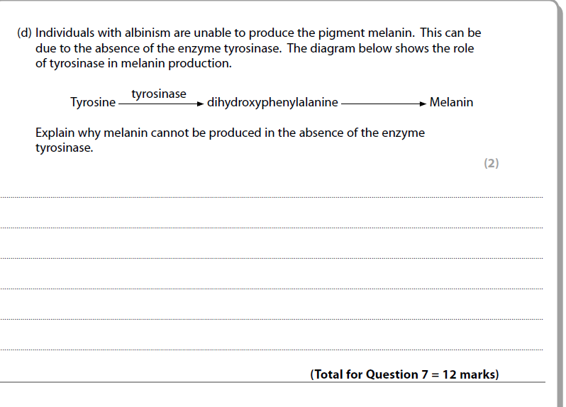

Q11 Genetic Screening & Gene Therapy

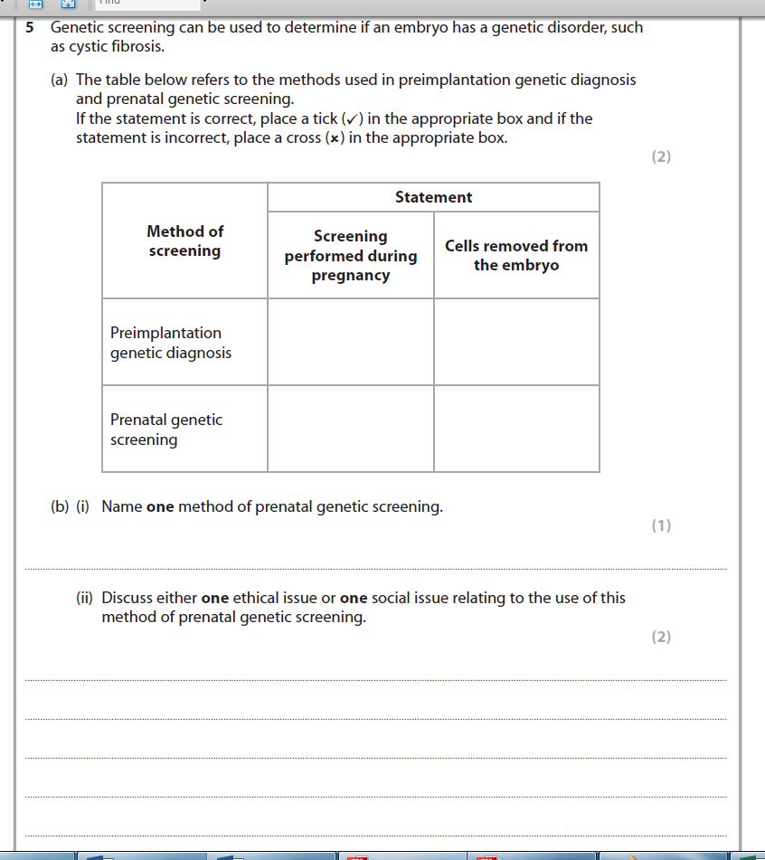

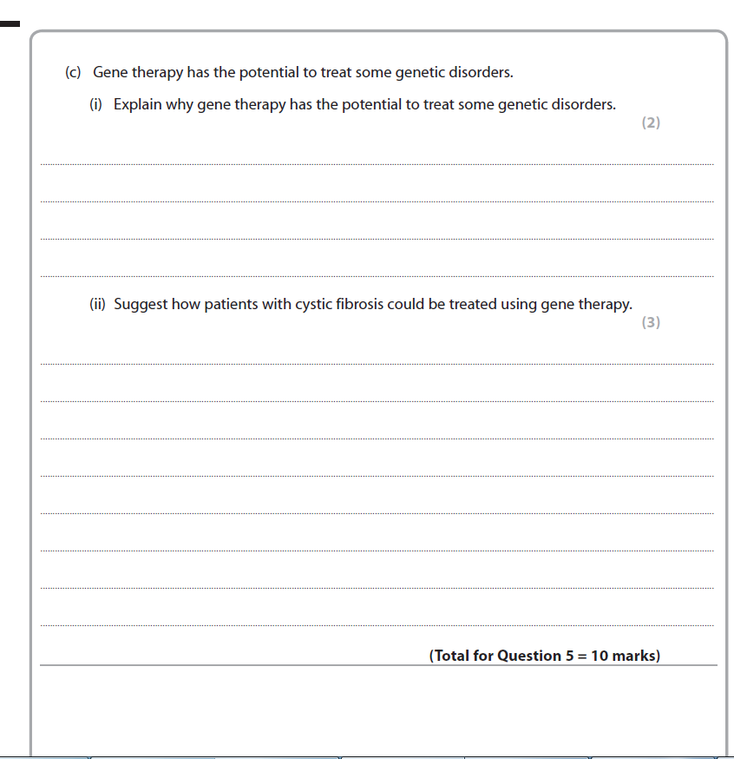

TOPIC 2 MARK SCHEME
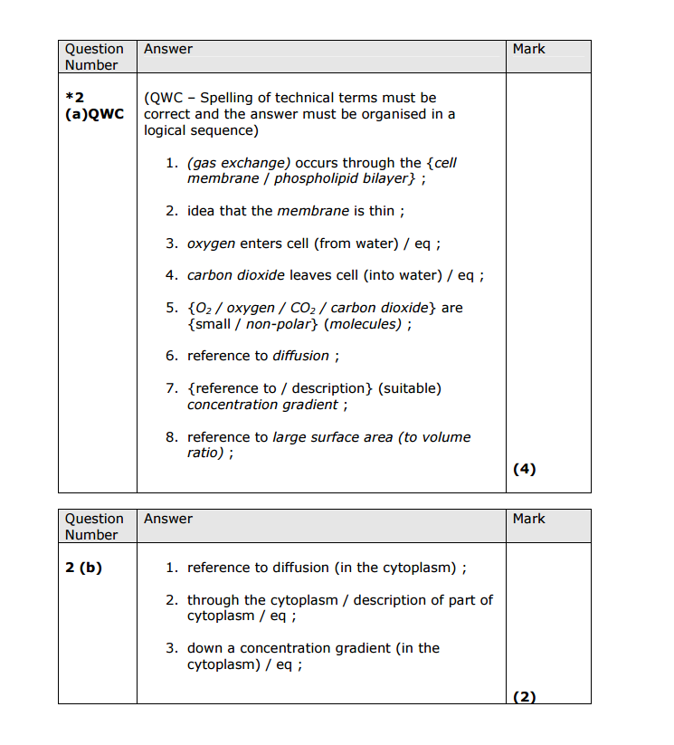
1
1

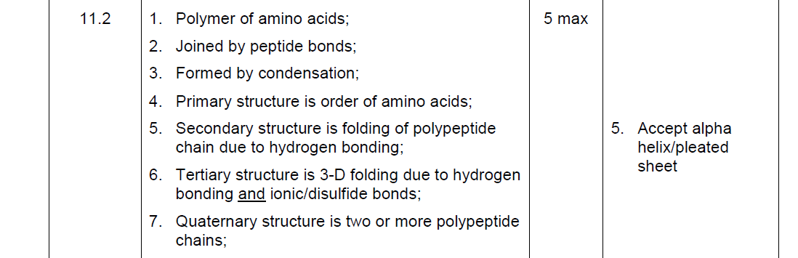

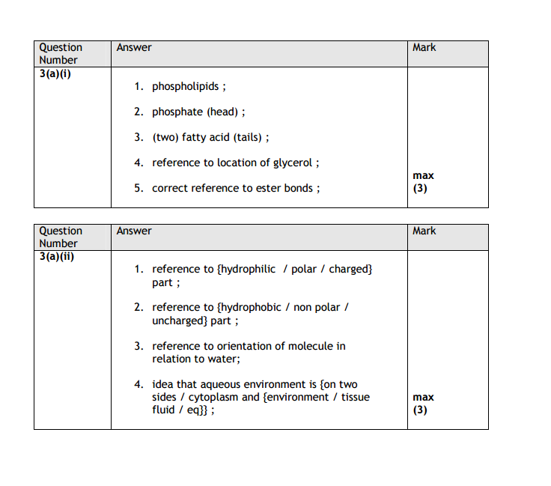

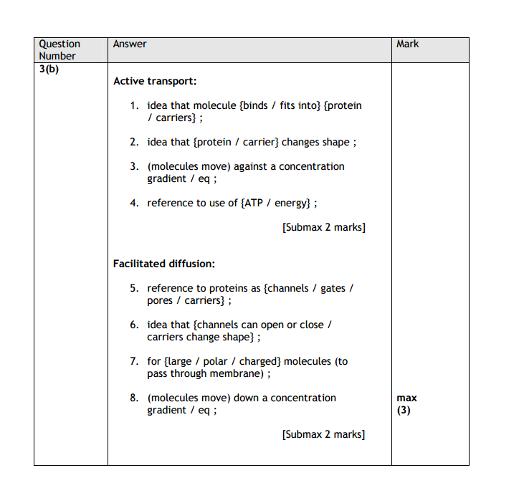

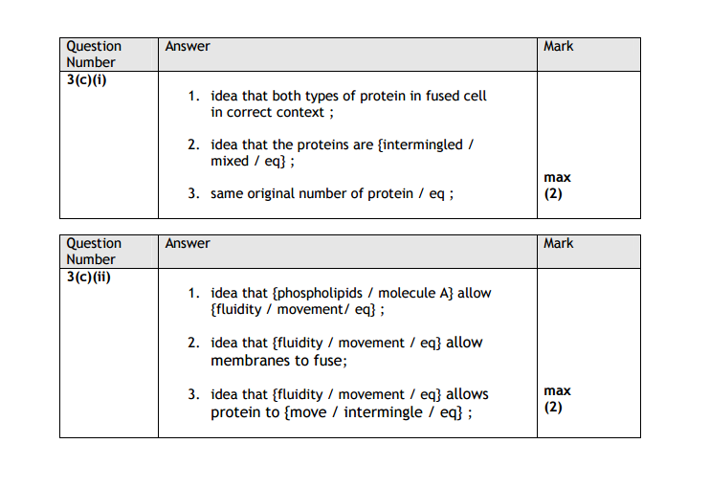

Q4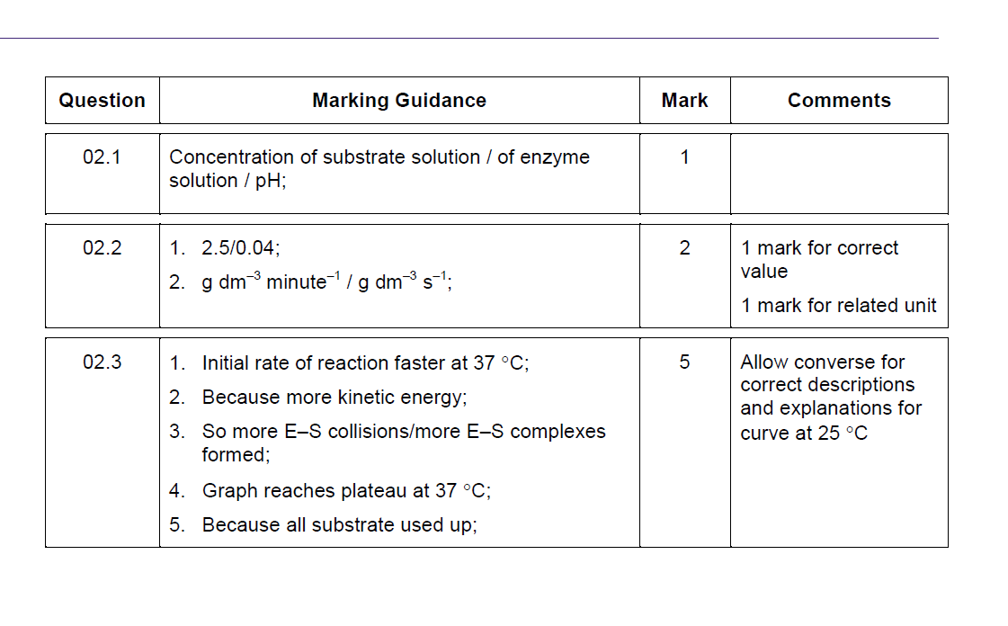

Q5 Enzymes {June 13}

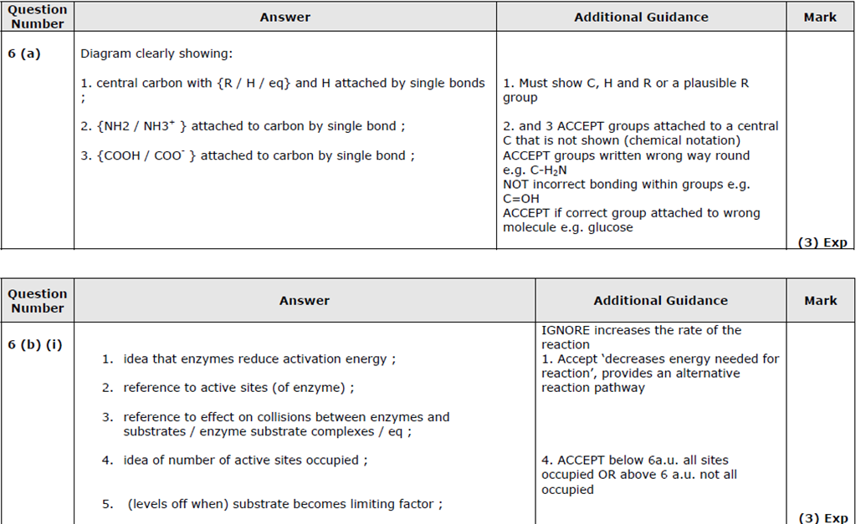

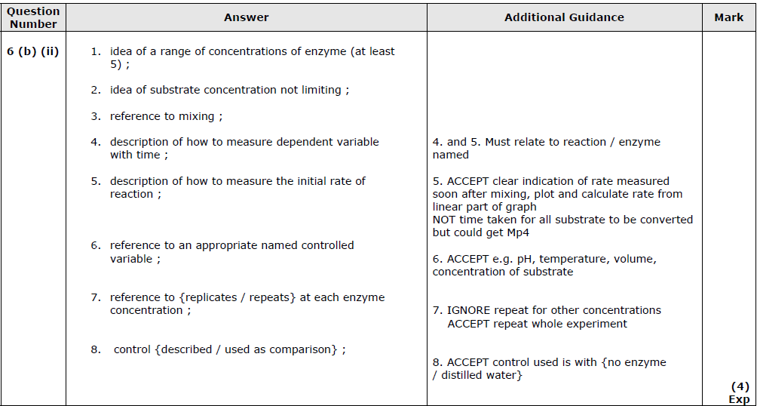

Q6 Cell Membranes {Q3Jan 12}
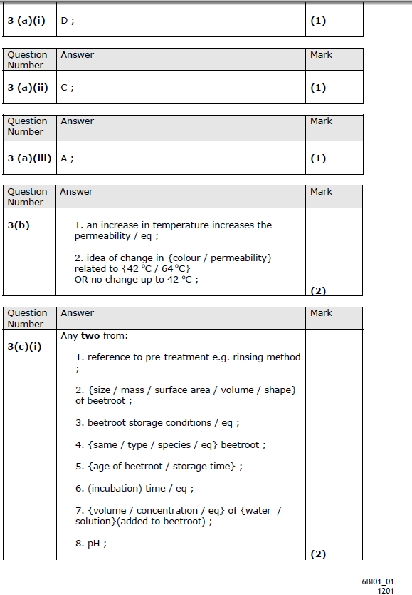
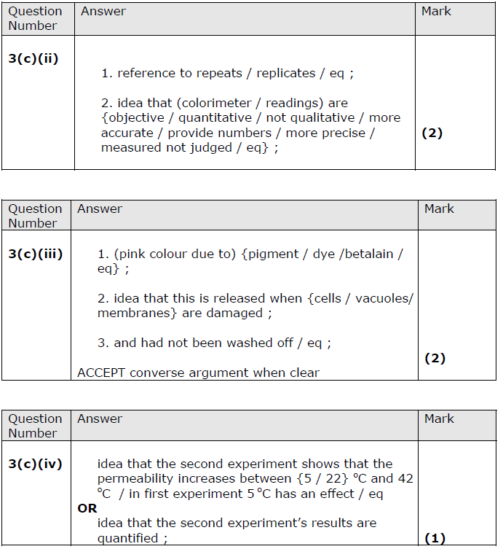

Q7 Protein Synthesis {Q6 Jun 11}
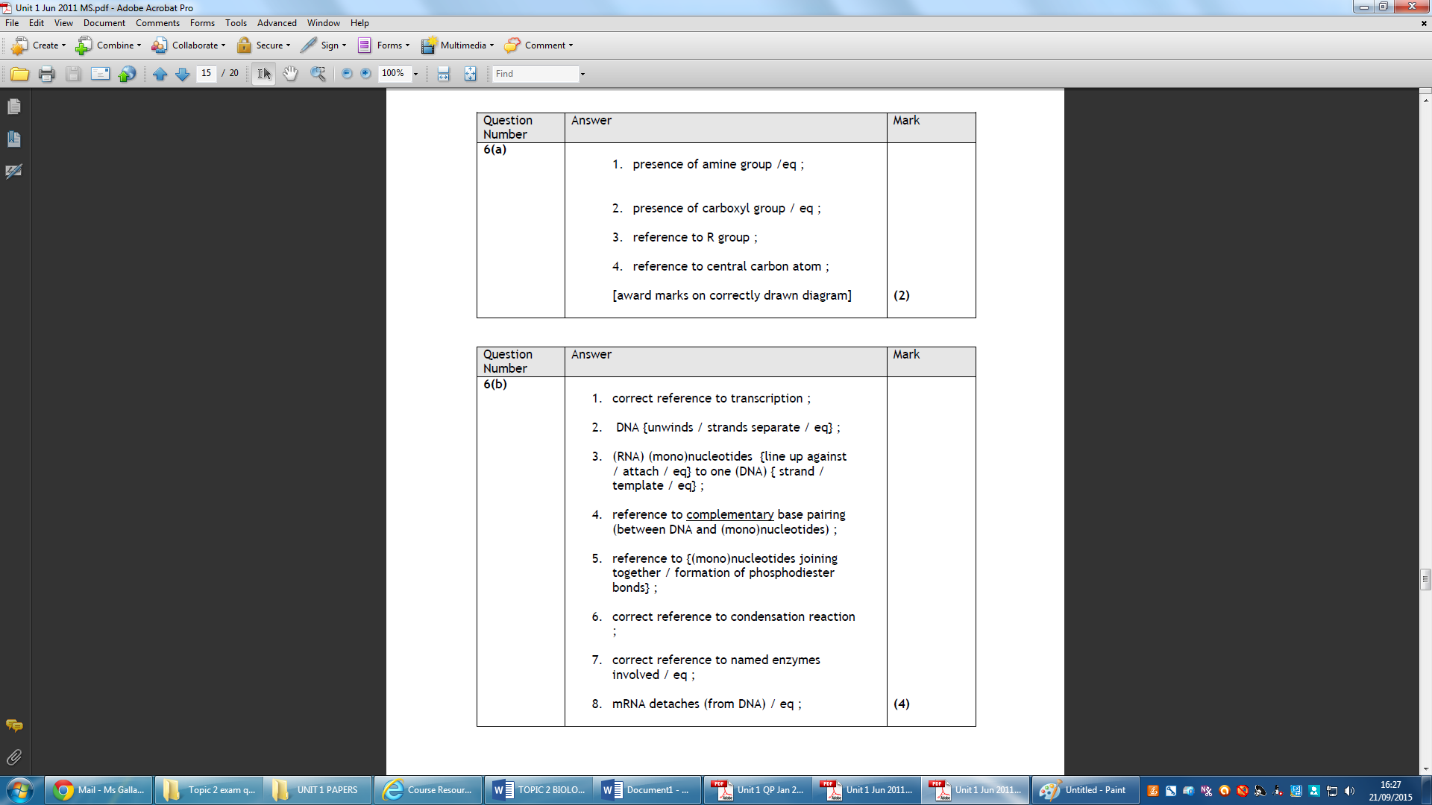

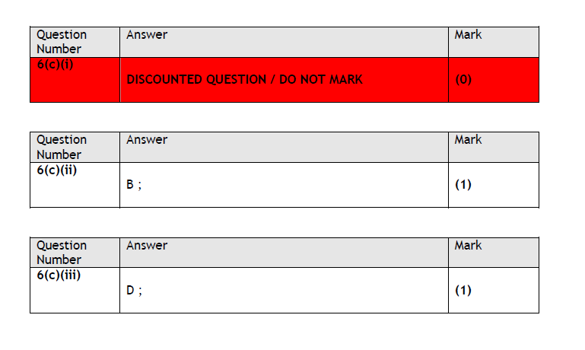

Q8 Mutations and cell membranes.
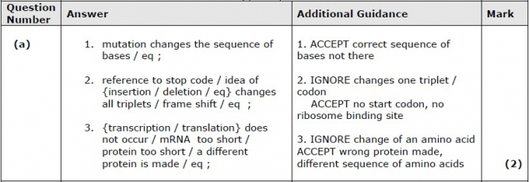
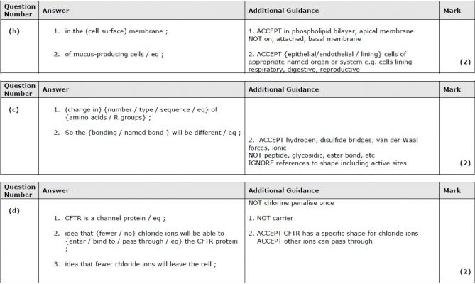
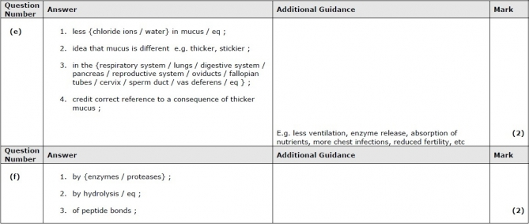

Q9: DNA Replication {Q4 Jun11}

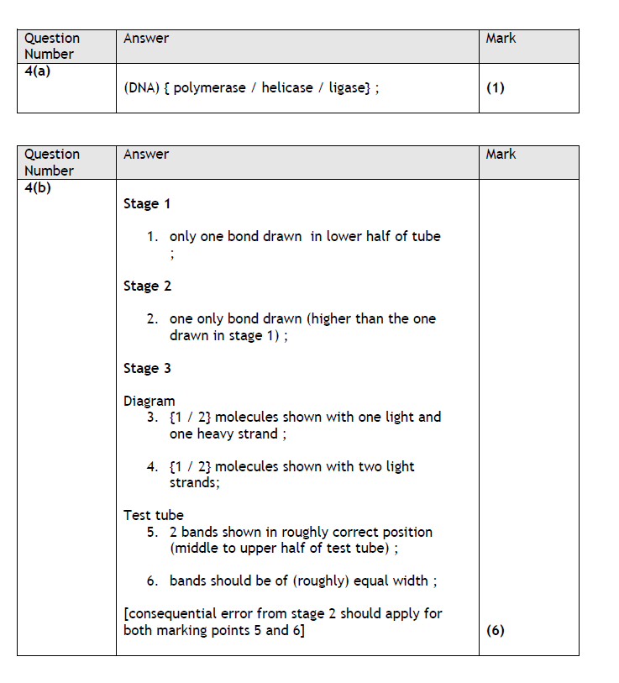

Q10 Inheritance {Q7 Jun 09}
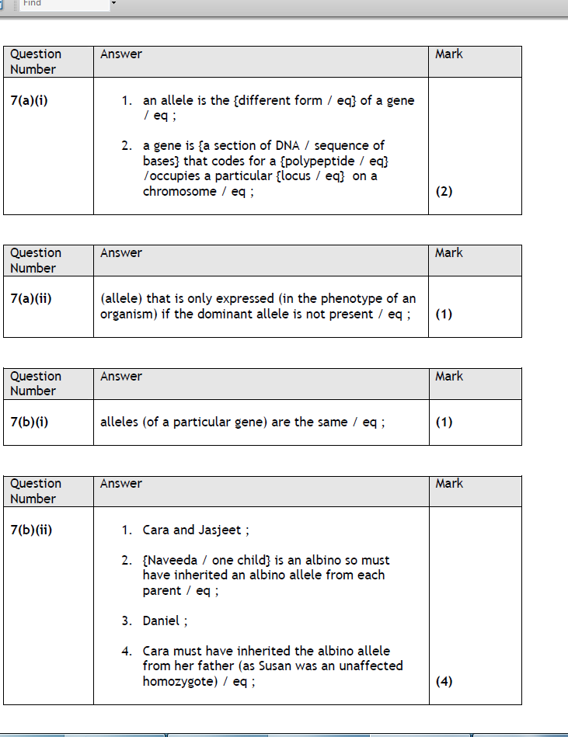

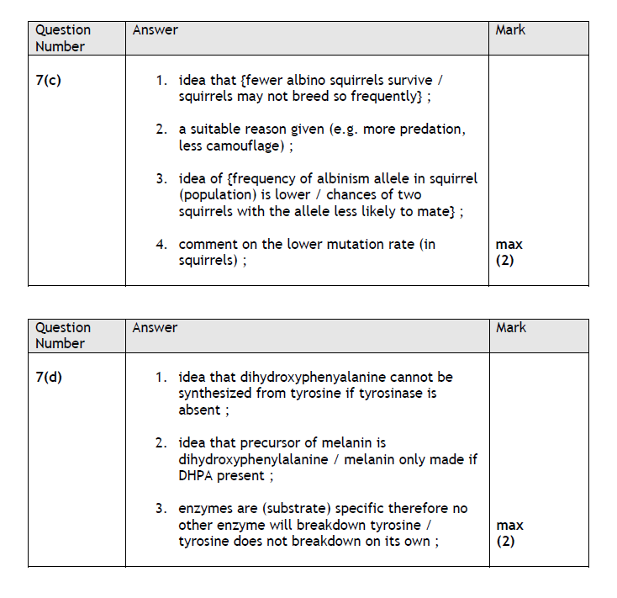

Q11 Genetic Screening & Gene Therapy {Q5 Jan 12}
