BIOLOGY EXAM QUESTIONS BOOKLET



TOPIC 3

Centre Number |  | 12416
Candidate Number
Candidate forename |  | Candidate surname
Class
Teachers’ initials

Qu | Concept | Skill focus | Total Mark | Marks ach’d | Traffic Light | *follow up task completed
1 | Prokaryotes and Eukaryotes | QWC | 13
2 | Meiosis and gamete structure | Recall  Data Analysis | 11
3 | Meiosis | Recall | 8
4 | Mitosis + root tip core practical | Application  Calculation | 6
5 | Mitosis + root tip core practical | Data analysis  QWC | 14
6 | Stem cells | Recall | 9
7 | Totipotency | Graph  Recall | 12
8 | Epigenetics (cancer) | Recall  Graph | 11
9 | Polgenic inheritance | Graph  Calculation | 9
10 | Epigenetics | Graph  Calculations | 6

*If the exam question has been traffic lighted as amber or red then you still need to work on this concept or skill area. You must follow this up by completing a task from below. Add the letter of the follow up task completed in the last column of the grid on your front page. Add the evidence in this booklet.

Potential review tasks include (increase in difficulty as you go down):

- Make notes on the concept of the question using a variety of different resources such as the various A-level textbooks in the library (not just the core SNAB textbook).

- Complete a worksheet on the skill or concept such as a worksheet from the Biozone booklet in the library. SNAB also has workbooks available to buy.

- Complete a Biological skills support sheet on the concept or skill from pearsonactivelearn.com

- Find another exam question on this concept or skill using the Biology exam question database on Moodle (password is Biology). Then google Edexcel SNAB Biology A past papers.

- Summarise the rules for answering a similar style of question using the examiners reports for exam questions on this concept or skill. Use the exam question database on Moodle as above to help you find the exam questions on this concept or skill and then find the examiner’s report for it.

- Make your own exam question and mark scheme on the concept or skill. Use current mark schemes to help you.

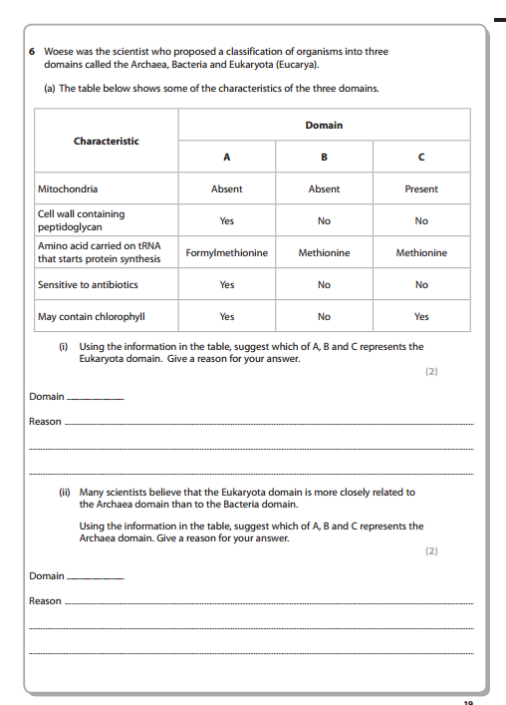
1
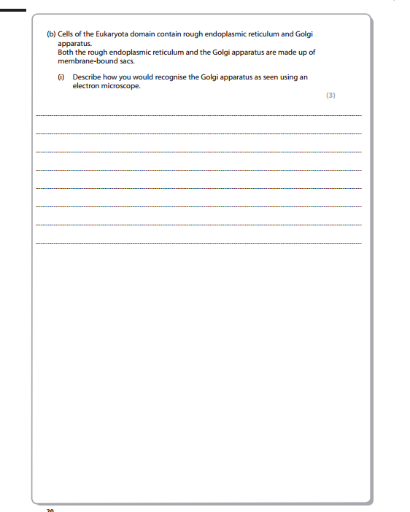
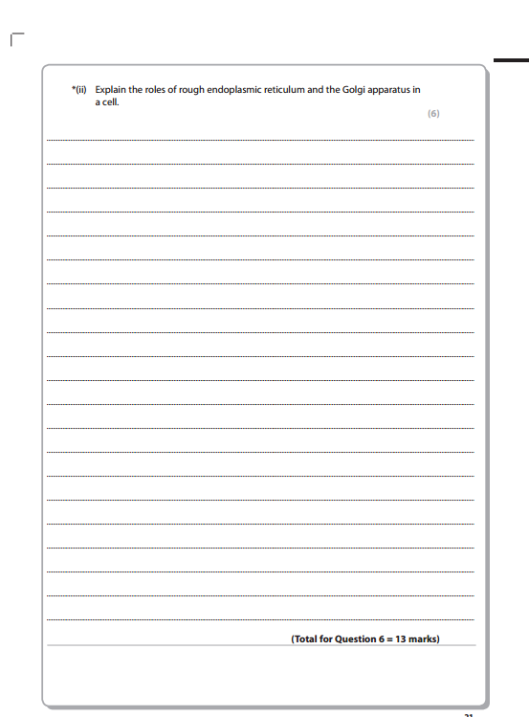
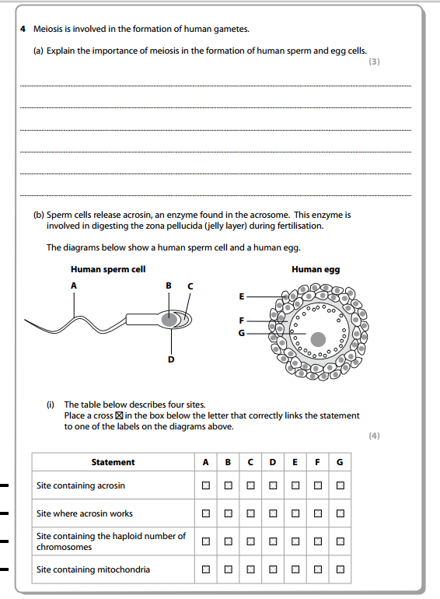
2
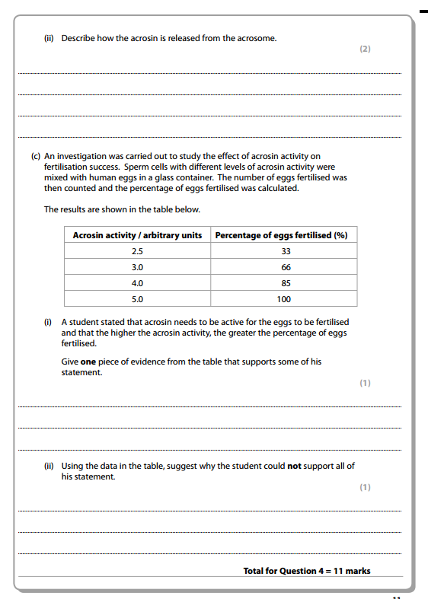
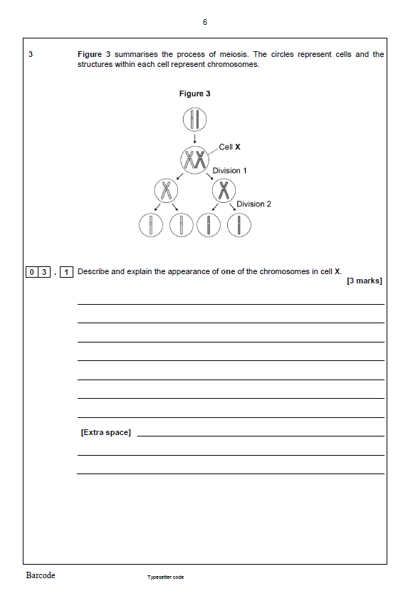

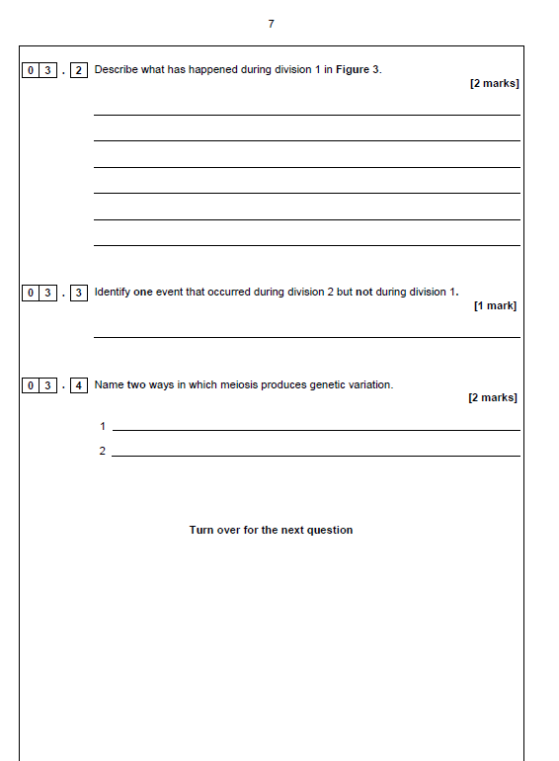
4
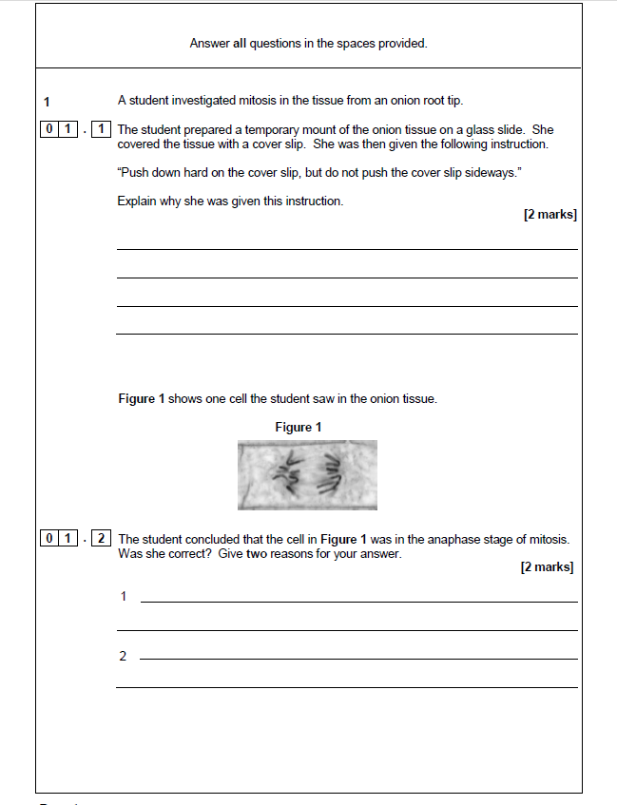

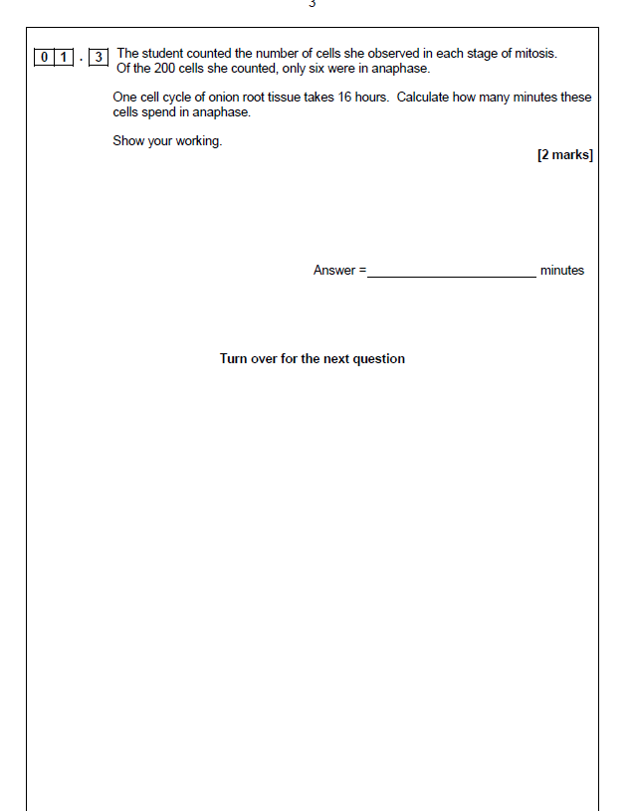

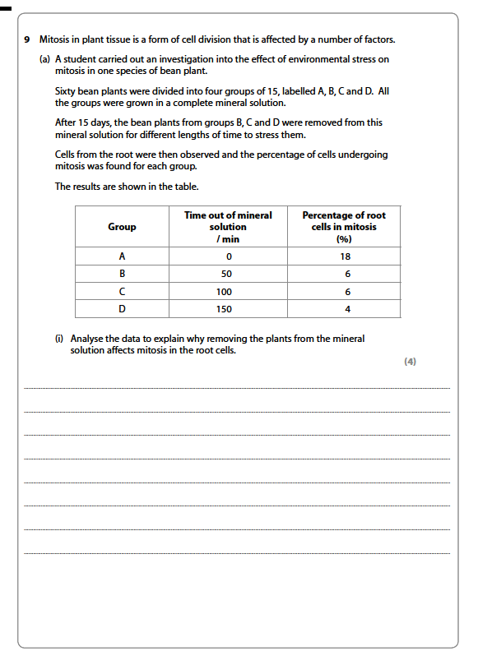
5
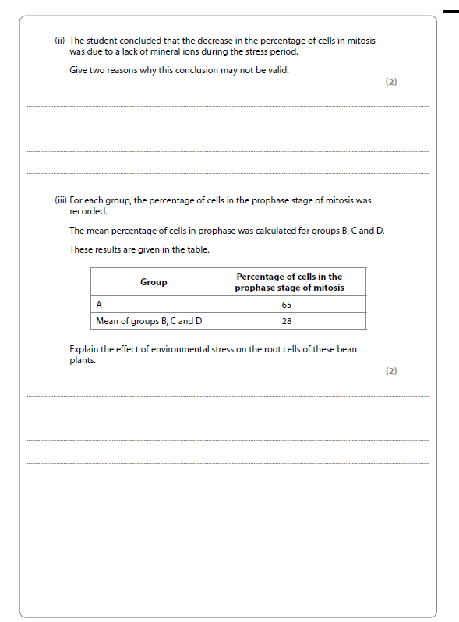
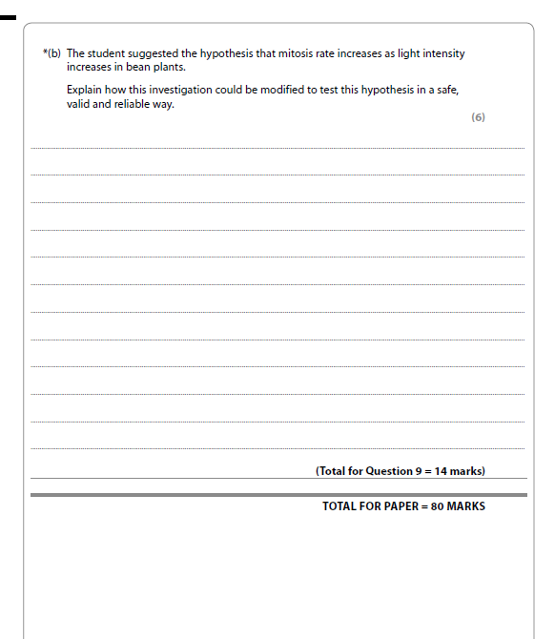
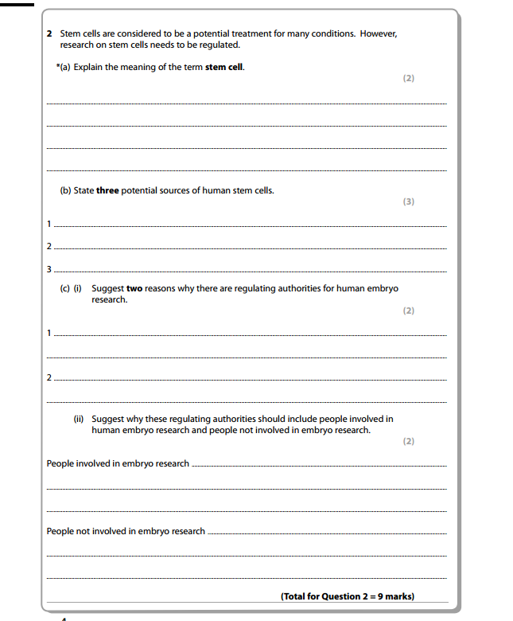
6

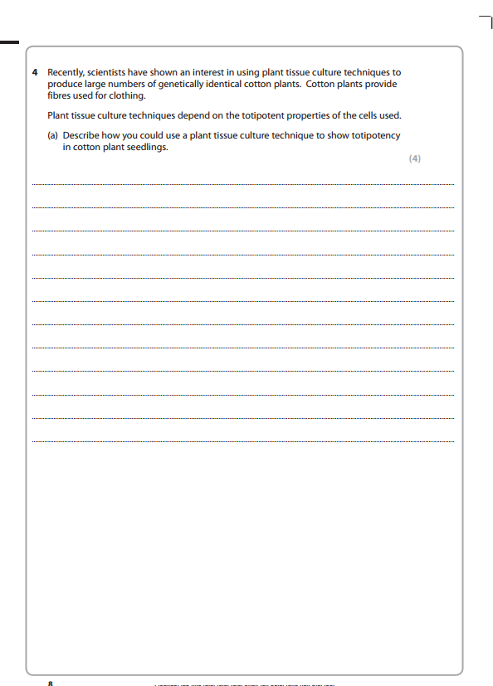
7
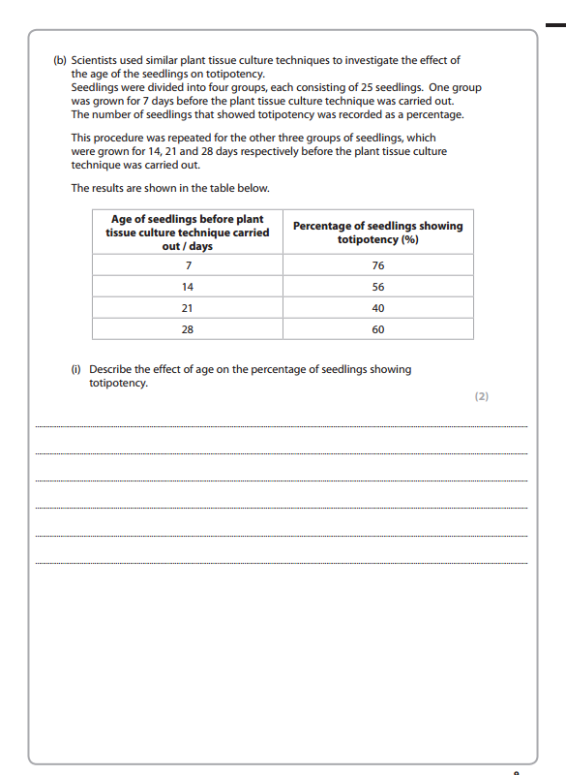
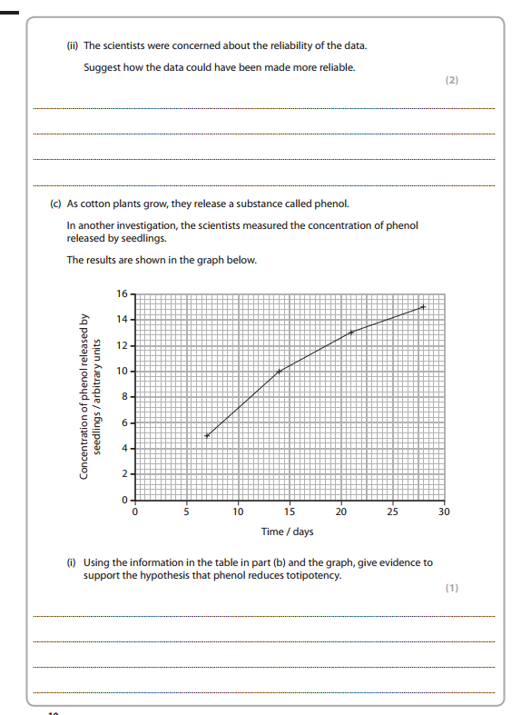
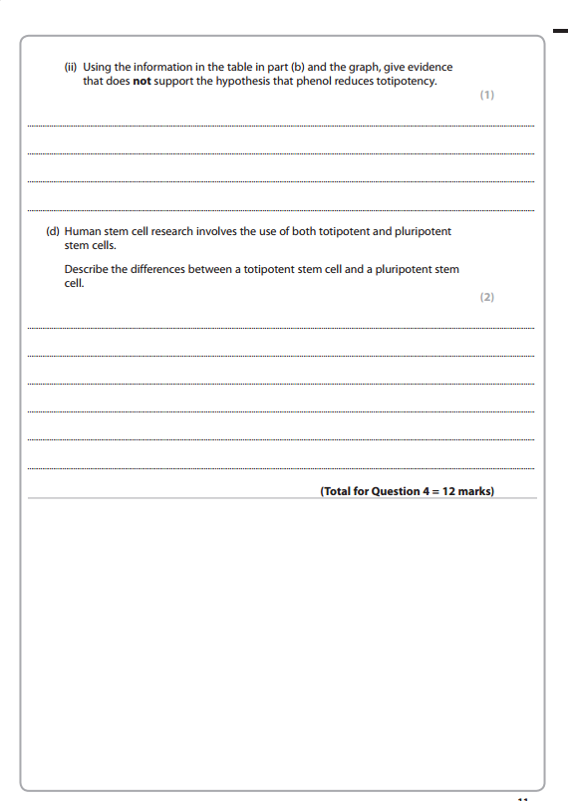
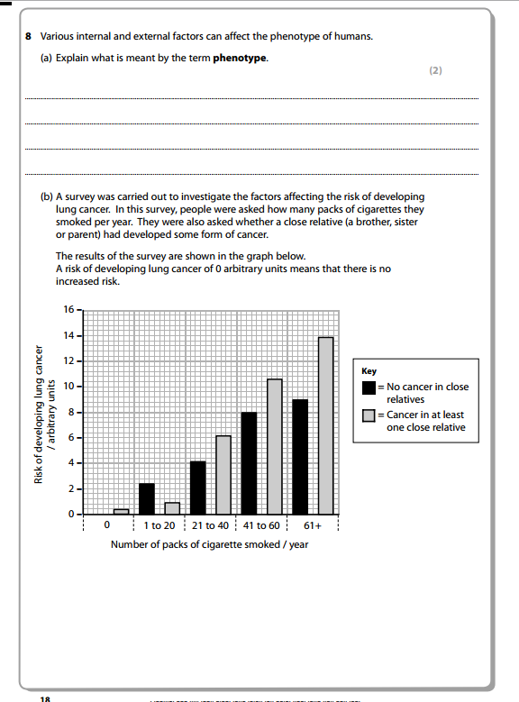
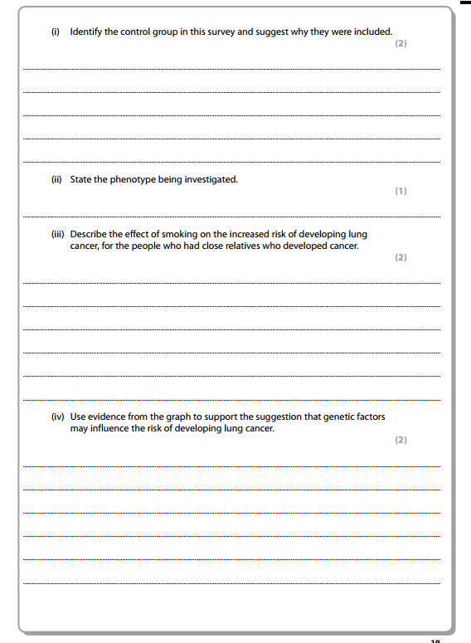

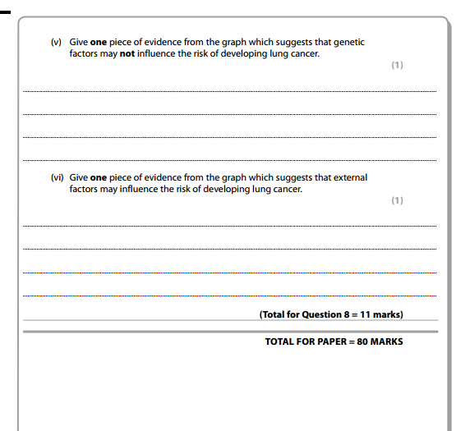
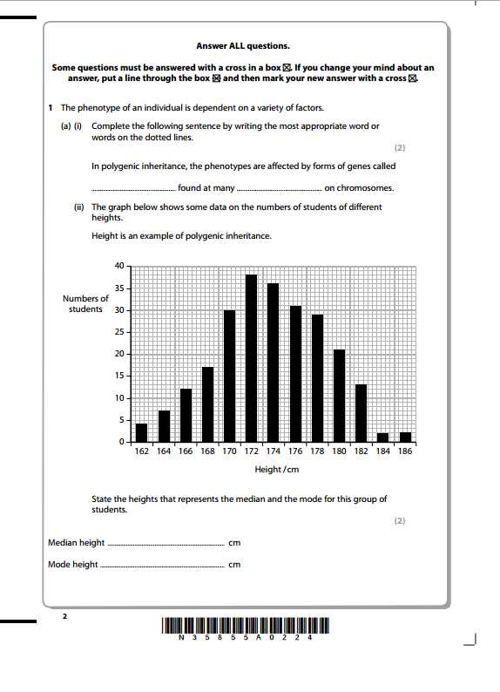
9

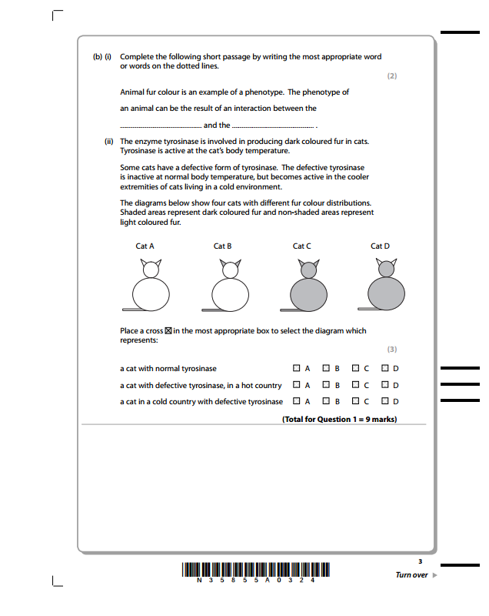
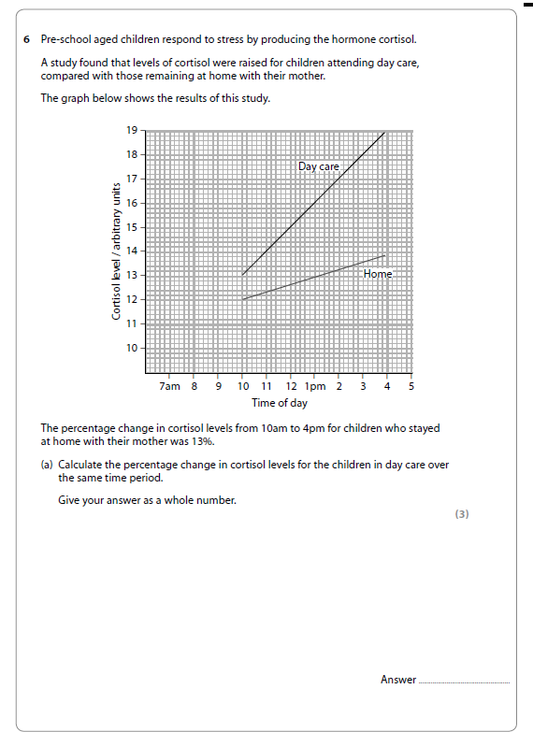
10

