BIOLOGY EXAM QUESTIONS BOOKLET



TOPIC 4

Centre Number |  | 12416
Candidate Number
Candidate forename |  | Candidate surname
Class
Teachers’ initials

Qu | Concept | Skill focus | Total Mark | Marks ach’d | Traffic Light | *follow up task completed
1 | Biodiversity and captive breeding | Recall, QWC | 10
2 | Drug trials | Interpretation  Calculation | 8
3 | Plant fibre strength core practical | Recall  Interpretation | 12
4 | Mineral ions core practical | Recall, QWC  interpretation | 10
5 | Domains, taxonomy | Recall | 11
6 | Plant structures  Sustainability | Application | 11
7 | Diversity index | Calculation  Application | 9
8 | Antimicrobial properties of plants core practical | Recall  Application | 12
9 | Captive breeding and reintroduction | QWC  Graph | 12
10 | Hardy-Weinberg | Calculation | 2
11 | Cell structure and cellulose | Recall and QWC | 11
12 | Natural selection | Recall and application | 10

*If the exam question has been traffic lighted as amber or red then you still need to work on this concept or skill area. You must follow this up by completing a task from below. Add the letter of the follow up task completed in the last column of the grid on your front page. Add the evidence in this booklet.

Potential review tasks include (increase in difficulty as you go down):

- Make notes on the concept of the question using a variety of different resources such as the various A-level textbooks in the library (not just the core SNAB textbook).

- Complete a worksheet on the skill or concept such as a worksheet from the Biozone booklet in the library. SNAB also has workbooks available to buy.

- Complete a Biological skills support sheet on the concept or skill from pearsonactivelearn.com

- Find another exam question on this concept or skill using the Biology exam question database on Moodle (password is Biology). Then google Edexcel SNAB Biology A past papers.

- Summarise the rules for answering a similar style of question using the examiners reports for exam questions on this concept or skill. Use the exam question database on Moodle as above to help you find the exam questions on this concept or skill and then find the examiner’s report for it.

- Make your own exam question and mark scheme on the concept or skill. Use current mark schemes to help you.

4

5

9

10

Q11.
Plant cells are organised into tissues, organs and systems.
(a) The diagram below shows a plant cell, as seen using an electron microscope.
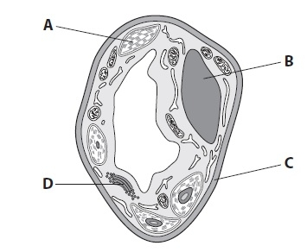

For each of the following questions, place a cross () in the box that identifies the structure.
(i) The structure that modifies protein into glycoprotein is

(1)
A B C D
(ii) The structure, other than the nucleus, that contains DNA is

(1)
A B C D
(iii) The structure that would not be present in the anaphase stage of mitosis is

(1)
A B C D
(b) Plants contain xylem tissue.
(i) Explain what is meant by the term tissue.
(2)
.............................................................................................................................................
.............................................................................................................................................
.............................................................................................................................................
.............................................................................................................................................
(ii) Describe the functions of xylem.
(2)
.............................................................................................................................................
.............................................................................................................................................
.............................................................................................................................................
.............................................................................................................................................
* (c) Plant cells may contain cellulose.
Describe the structure of a cellulose microfibril.
(4)
.............................................................................................................................................
.............................................................................................................................................
.............................................................................................................................................
.............................................................................................................................................
.............................................................................................................................................
.............................................................................................................................................
.............................................................................................................................................
.............................................................................................................................................
(Total for question = 11 marks)

Q 12.
Natural selection can lead to adaptation and evolution.
Ladybird beetles are insects that feed on other insects such as greenfly.
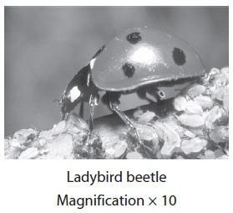
(a) The table below shows two possible adaptations for ladybird beetles due to natural selection.
Place a cross () in the box that best describes whether the adaptation is behavioural, anatomical or physiological.
(2)
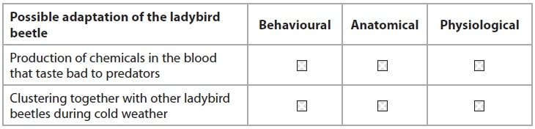
(b) The flow chart below shows some stages of natural selection, using the ladybird beetle as an example.
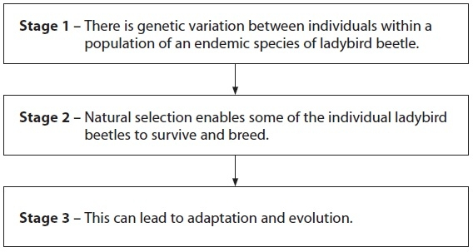
(i) Explain what is meant by the term endemic in stage 1.
(1)
.............................................................................................................................................
.............................................................................................................................................
.............................................................................................................................................
.............................................................................................................................................
(ii) Suggest how genetic variation occurs within a population of ladybird beetles in stage 1.
(3)
.............................................................................................................................................
.............................................................................................................................................
.............................................................................................................................................
.............................................................................................................................................
.............................................................................................................................................
.............................................................................................................................................
(iii) Explain what could occur in stage 2 to bring about adaptation in the ladybird beetle population.
(4)
.............................................................................................................................................
.............................................................................................................................................
.............................................................................................................................................
.............................................................................................................................................
.............................................................................................................................................
.............................................................................................................................................
.............................................................................................................................................
.............................................................................................................................................
(Total for question = 10 marks)

TOPIC 4 EXAM QU BOOKLET
MARK SCHEME

4

5

9
10

Q11.
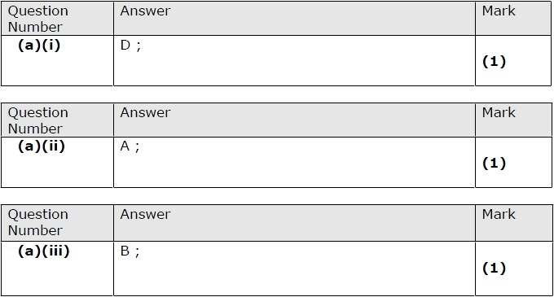
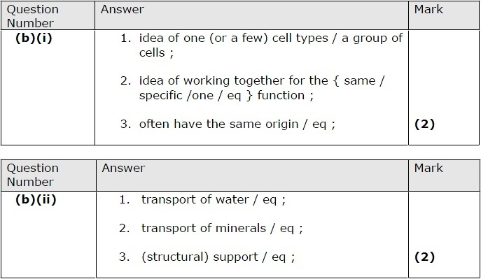
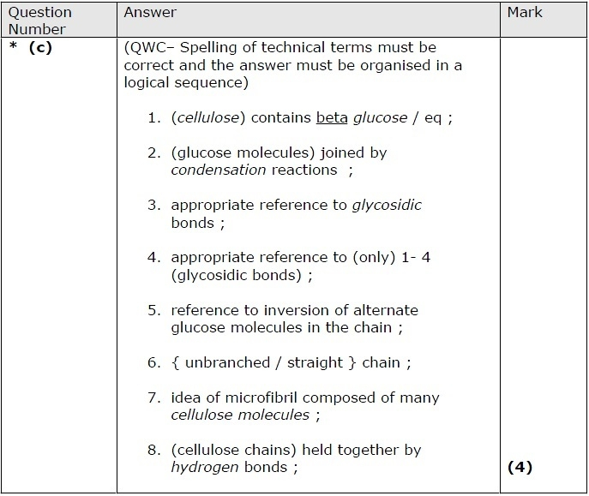

Q12.
