Topic 4 Data Analysis Exam Questions
Q1.
Tuberculosis (TB) is an infectious disease caused by mycobacteria.
Individuals infected with M. tuberculosis can be treated with antibiotics.
Four of the antibiotics used to treat TB are shown in the table.
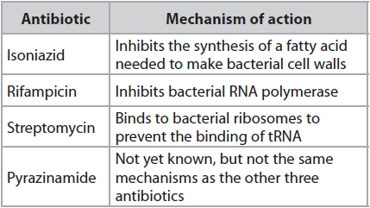
In one clinical trial lasting six months, the effect of treating TB with these antibiotics was investigated.
All patients were treated with all four antibiotics for two months. Then they were treated with different pairs of antibiotics or isoniazid alone for a further four months.
All patients were free of any signs of active TB at the end of the clinical trial.
The design of the trial and the percentage of these patients with TB three years after the trial ended are shown in the diagram.
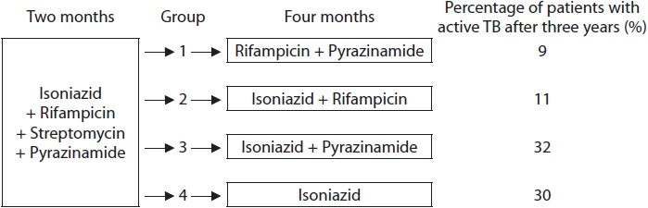
Analyse the data to comment on the effectiveness of these antibiotics for the treatment of TB.
(6)
.............................................................................................................................................
.............................................................................................................................................
.............................................................................................................................................
.............................................................................................................................................
.............................................................................................................................................
.............................................................................................................................................
.............................................................................................................................................
.............................................................................................................................................
.............................................................................................................................................
.............................................................................................................................................
.............................................................................................................................................
.............................................................................................................................................
.............................................................................................................................................
.............................................................................................................................................
.............................................................................................................................................
.............................................................................................................................................
.............................................................................................................................................
.............................................................................................................................................

(Total for question = 6 marks)

Q2.
Many plants produce chemicals that have antimicrobial properties.
The suitability of using wood from three types of tree to make kitchen chopping boards was investigated.
In this investigation, 50 cm³ of a bacterial culture was added to 100 g of wood chippings from each of three types of tree.
The growth of bacteria was measured at the start (Day 0), and then after 1, 2, 4 and 8 days.
The results are shown in the graph.
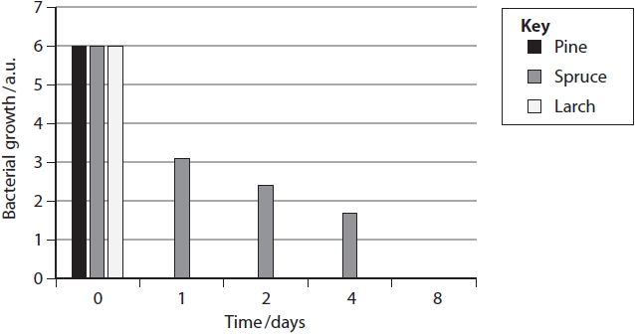
Temperature and the moisture content of wood from pine trees can affect bacterial growth.
Graph 1 shows the effect of temperature on bacterial growth.
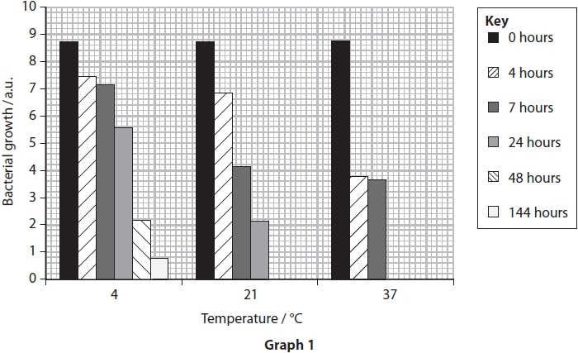
Graph 2 shows the effect of temperature on the moisture content of wood.
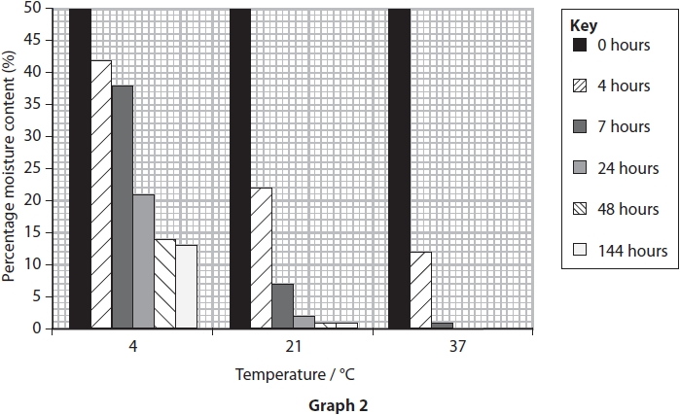
Analyse the data to deduce the effects of these two factors on bacterial growth on wood from pine trees.
(4)
.............................................................................................................................................
.............................................................................................................................................
.............................................................................................................................................
.............................................................................................................................................
.............................................................................................................................................
.............................................................................................................................................
.............................................................................................................................................
.............................................................................................................................................
.............................................................................................................................................
.............................................................................................................................................
.............................................................................................................................................
.............................................................................................................................................
.............................................................................................................................................
.............................................................................................................................................
.............................................................................................................................................
.............................................................................................................................................

(Total for question = 4 marks)

Q3.
Svalbard Global Seed Vault (SGSV) is a seed bank. It keeps seeds from almost 4000 species of plants, focussing on food crops such as wheat, rice and maize.
The purpose of SGSV is to store seeds for use in the future, 50 or more years from now.
Seeds from three varieties of maize were tested to see the effects of long periods of storage. The results of these tests are shown in the graph.
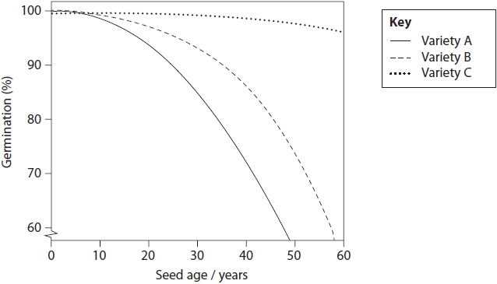
Explain how SGSV could make use of these results.
(3)
.............................................................................................................................................
.............................................................................................................................................
.............................................................................................................................................
.............................................................................................................................................
.............................................................................................................................................
.............................................................................................................................................
.............................................................................................................................................
.............................................................................................................................................
.............................................................................................................................................
.............................................................................................................................................
.............................................................................................................................................
.............................................................................................................................................

(Total for question = 3 marks)

Q4.
Seed banks store seeds to conserve different varieties of plants.
Seeds are stored for long periods of time in conditions that allow them to be germinated when required.
An investigation was carried out to study the effect of storage time on wheat seeds of two different varieties.
Wheat seeds of one variety, P, were collected and divided into six groups, each with the same number of seeds. Each group of seeds was stored in an atmosphere of 80% humidity at a temperature of 42 °C.
Each group was stored in these conditions for different lengths of time. One group of seeds was germinated immediately after collection. This was the control group.
After storage, the seeds were planted in suitable conditions to allow germination. The number of seeds that germinated was found and the mean percentage germination calculated.
This was repeated using wheat seeds of a different variety, Q.
All other variables were kept constant.
The results are shown in the table.
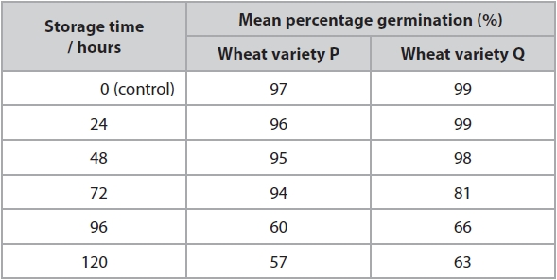
(i) Describe the effect of storage time on the germination of seeds for these two varieties of wheat.
(3)
.............................................................................................................................................
.............................................................................................................................................
.............................................................................................................................................
.............................................................................................................................................
.............................................................................................................................................
.............................................................................................................................................
.............................................................................................................................................
.............................................................................................................................................
.............................................................................................................................................
(ii) Explain how the results for the control were useful in this investigation.
(2)
.............................................................................................................................................
.............................................................................................................................................
.............................................................................................................................................
.............................................................................................................................................
.............................................................................................................................................
.............................................................................................................................................

(Total for question = 5 marks)

Q5.
Extracts of the plant St John's wort have also been used to treat depression.
A double blind trial compared the effectiveness of treating depression using a SSRI, an extract of St John's wort, and a placebo.
Depression was measured using the Hamilton Rating Scale for Depression (HRSD).
The higher the HRSD score the greater the depression.
The table shows the results of this trial.
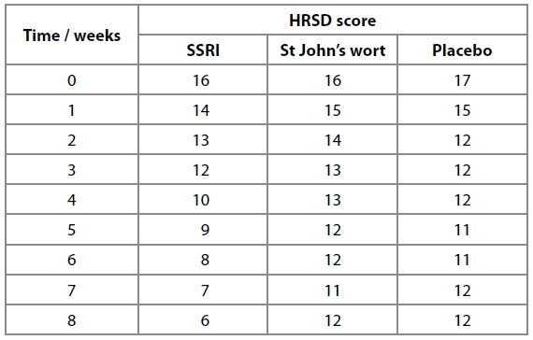
(i) State what is meant by the term double blind.
(1)
.............................................................................................................................................
.............................................................................................................................................
(ii) Analyse the data in the table to compare the effectiveness of these three treatments for depression.
(3)
.............................................................................................................................................
.............................................................................................................................................
.............................................................................................................................................
.............................................................................................................................................
.............................................................................................................................................
.............................................................................................................................................
(iii) Double blind trials give scientists confidence in the results collected.
Explain two ways the design of this trial could be improved in order to increase confidence in the results.
(4)
.............................................................................................................................................
.............................................................................................................................................
.............................................................................................................................................
.............................................................................................................................................
.............................................................................................................................................
.............................................................................................................................................
.............................................................................................................................................
.............................................................................................................................................

(Total for question = 8 marks)

