BIOLOGY EXAM QUESTIONS BOOKLET



TOPIC 5

Centre Number |  | 12416
Candidate Number
Candidate forename |  | Candidate surname
Class
Teachers’ initials

Qu | Concept | Skill focus | Total Mark | Marks ach’d | Traffic Light | *Follow up task completed
1 | Abiotic and biotic factors and sampling | Recall  Graph | 10
2 | Niche and sampling | Recall  Data analysis | 12
3 | Sampling | Recall  Numeracy | 13
4 | Succession | Application | 13
5 | Photosynthesis | Recall and Graph | 13
6 | Photosynthesis and chloroplasts | Recall | 11
7 | core practical - chloroplasts | Recall | 8
8 | GPP NPP | Recall  Numeracy | 10
9 | Climate change evidence | Data analysis | 11
10 | The effect of temp on organisms | Data analysis  Application | 10
11 | Natural Selection | Synoptic  QWC | 13
12 | Enzymes and temperature | Data analysis  Application | 11
13 | Investigating the effect of temp on organisms | Data analysis | 12
14 | Core practical – Q10 | Data analysis  Application | 4
15 | Biofuels | QWC | 10

*If the exam question has been traffic lighted as amber or red then you still need to
work on this concept or skill area. You must follow this up by completing a task from below. Add the letter of the follow up task completed in the last column of the grid on your front page. Add the evidence in this booklet.

Potential review tasks include (increase in difficulty as you go down):

- Make notes on the concept of the question using a variety of different resources such as the various A-level textbooks in the library (not just the core SNAB textbook).

- Complete a worksheet on the skill or concept such as a worksheet from the Biozone booklet in the library. SNAB also has workbooks available to buy.

- Complete a Biological skills support sheet on the concept or skill from pearsonactivelearn.com

- Find another exam question on this concept or skill using the Biology exam question database on Moodle (password is Biology). Then google Edexcel SNAB Biology A past papers.

- Summarise the rules for answering a similar style of question using the examiners reports for exam questions on this concept or skill. Use the exam question database on Moodle as above to help you find the exam questions on this concept or skill and then find the examiner’s report for it.

- Make your own exam question and mark scheme on the concept or skill. Use current mark schemes to help you.

Q1.
A wetland is an area where the soil is saturated with moisture either permanently or seasonally. The distribution and abundance of organisms in a wetland will be influenced by various abiotic factors including the degree of saturation of the soil by water. Within most wetlands, there will be areas which are relatively dry and other areas which are submerged under water throughout the year.
(a) (i) Explain why the degree of saturation of the soil by water is considered to be an abiotic factor.
(1)
.............................................................................................................................................
.............................................................................................................................................
(ii) Place a cross in the box next to the biotic factor that might influence the distribution and abundance of organisms in a wetland.
(1)
A Mineral availability
B pH
C Predation
D Water temperature
(b) A group of students studied an area of wetland. They placed twenty 1m² quadrats on a line from a relatively dry area to an area where there was free-standing water. Each quadrat was divided up into 25 smaller sections.
(i) Place a cross in the box next to the term that describes the technique that uses a line of quadrats to investigate the distribution of organisms.
(1)
A Transact
B Transcript
C Transect
D Transept
(ii) Suggest why the quadrats were divided up into 25 smaller sections.
(2)
.............................................................................................................................................
.............................................................................................................................................
.............................................................................................................................................
.............................................................................................................................................
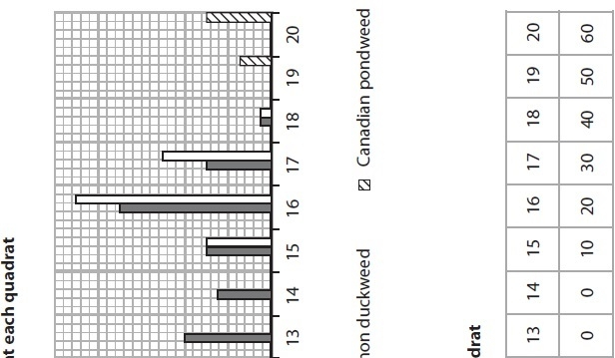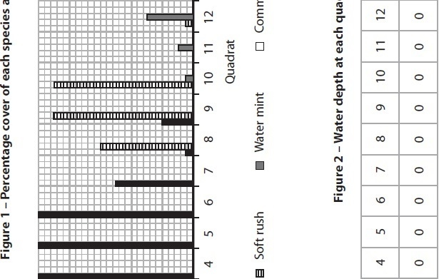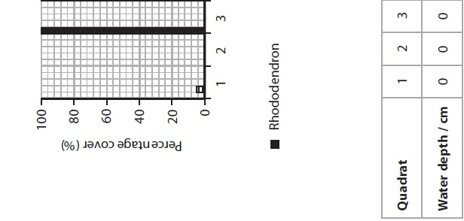

(iii) The students estimated the percentage cover of each of five species of plant within each quadrat. They also measured the depth of free-standing water.
The results of this part of the study are shown in Figure 1 and Figure 2.
Use the data in Figure 1 and Figure 2 to complete the table below.
(2)
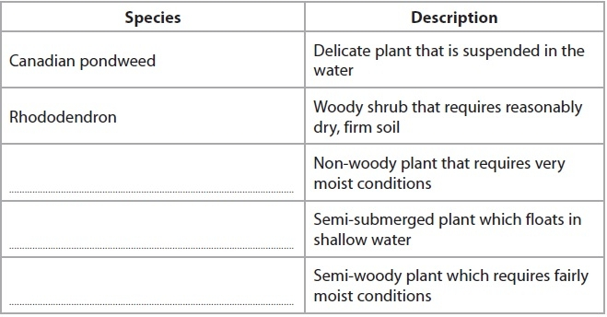
(iv) Suggest why the students were not able to draw valid conclusions about the effect of saturation of the soil by water on the distribution of the five plant species.
(3)
.............................................................................................................................................
.............................................................................................................................................
.............................................................................................................................................
.............................................................................................................................................
.............................................................................................................................................
.............................................................................................................................................
.............................................................................................................................................
.............................................................................................................................................
(Total for question = 10 marks)

Q2.
The sea anemone, Anthopleura elegantissima, occupies a niche at the secondary and
tertiary consumer levels in a food web on the shores of North America.
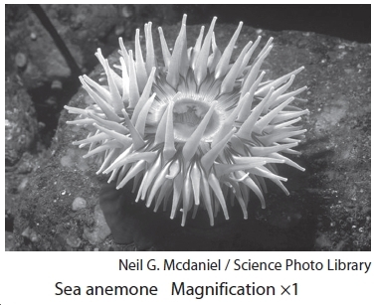
At high tide, the sea anemone is active and feeds on a variety of small invertebrate
animals and fish. It paralyses its prey using stinging cells on tentacles. The food
is then passed into the gut of the sea anemone for digestion by enzymes. The
anemones also form the food of various carnivores.
At low tide, the anemones are exposed on the rocks of the shore where they remain
stationary until the water returns at high tide.
During this exposure, the tentacles and body of each anemone are contracted into a
rounded mass.
(a) Explain what is meant by the term niche, using the sea anemone Anthopleura
elegantissima as an example.
(3)
.............................................................................................................................................
.............................................................................................................................................
.............................................................................................................................................
.............................................................................................................................................
.............................................................................................................................................
.............................................................................................................................................
.............................................................................................................................................
.............................................................................................................................................
.............................................................................................................................................
.............................................................................................................................................
(b) Suggest and explain why the anemones contract when exposed at low tide.
(3)
.............................................................................................................................................
.............................................................................................................................................
.............................................................................................................................................
.............................................................................................................................................
.............................................................................................................................................
.............................................................................................................................................
.............................................................................................................................................
.............................................................................................................................................
(c) Line transects were used to study the effects of abiotic factors on the distribution
of A. elegantissima on a rocky shore. In this study, line transects were taken from
the upper shore to the low water mark.
The mean results from these line transects are shown in the table below.
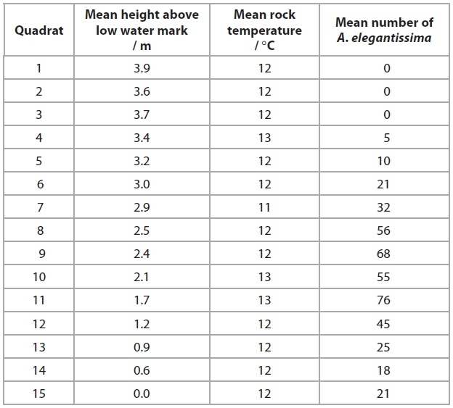
(i) Place a cross in the box next to the term that describes the type of sampling that uses line transects to study the distribution of A. elegantissima.
(1)
A controlled
B random
C systematic
D trial and error
(ii) Describe and suggest explanations for the effects of these two abiotic factors on the distribution of A. elegantissima on this shore.
(3)
.............................................................................................................................................
.............................................................................................................................................
.............................................................................................................................................
.............................................................................................................................................
.............................................................................................................................................
.............................................................................................................................................
.............................................................................................................................................
.............................................................................................................................................
.............................................................................................................................................
(iii) Suggest how these data could be analysed to assess the relationship between the two abiotic factors, shown in the table, and the distribution of A. elegantissima on this shore.
(2)
.............................................................................................................................................
.............................................................................................................................................
.............................................................................................................................................
.............................................................................................................................................
.............................................................................................................................................
.............................................................................................................................................
.............................................................................................................................................
.............................................................................................................................................
.............................................................................................................................................
.............................................................................................................................................
.............................................................................................................................................
(Total for question = 12 marks)

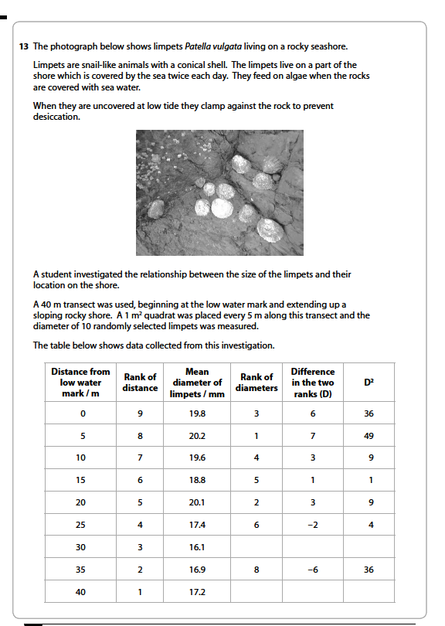
3

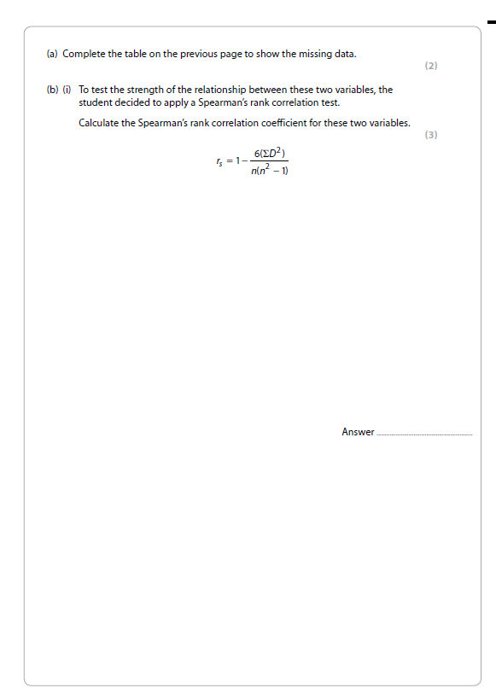

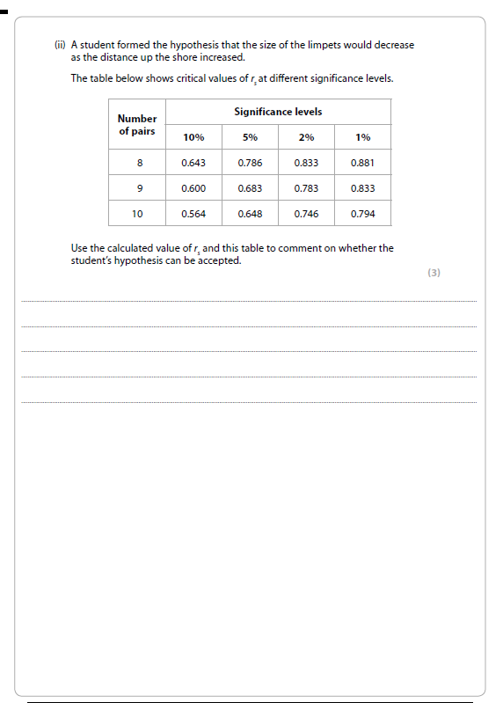



Q4.
Surtsey is a newly-formed volcanic island. The volcanic eruption finished in 1967. The island is protected so that it can be used to study succession on volcanic islands.
The photograph below shows the plants on part of the island about 10 years after the island was formed.
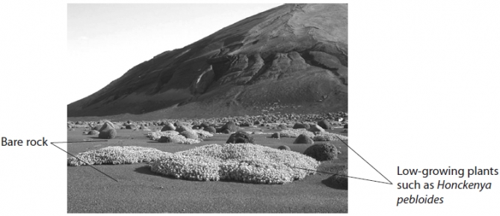
(a) State what is meant by the term succession.
(1)
.............................................................................................................................................
.............................................................................................................................................
.............................................................................................................................................
(b) Suggest how this part of the island may have appeared five years before and five years after this photograph was taken. Give reasons for your answer.
(4)
Five years before
.............................................................................................................................................
.............................................................................................................................................
.............................................................................................................................................
.............................................................................................................................................
Five years after
.............................................................................................................................................
.............................................................................................................................................
.............................................................................................................................................
.............................................................................................................................................
(c) (i) Describe how to carry out a study to compare the distribution of Honckenya pebloides on two different parts of the island.
(4)
.............................................................................................................................................
.............................................................................................................................................
.............................................................................................................................................
.............................................................................................................................................
.............................................................................................................................................
.............................................................................................................................................
.............................................................................................................................................
.............................................................................................................................................
.............................................................................................................................................
.............................................................................................................................................
(ii) Water availability affects the distribution of Honckenya pebloides.
Describe how water availability could be investigated in these two parts of the island.
(2)
.............................................................................................................................................
.............................................................................................................................................
.............................................................................................................................................
.............................................................................................................................................
(d) In 1985, the lesser black-backed gull colonised this island.
A large increase in the number of species of plants was recorded after these birds colonised the island.
Suggest an explanation for this increase in the number of species of plants.
(2)
.............................................................................................................................................
.............................................................................................................................................
.............................................................................................................................................
.............................................................................................................................................
.............................................................................................................................................
.............................................................................................................................................
.............................................................................................................................................
.............................................................................................................................................

(Total for question = 13 marks)

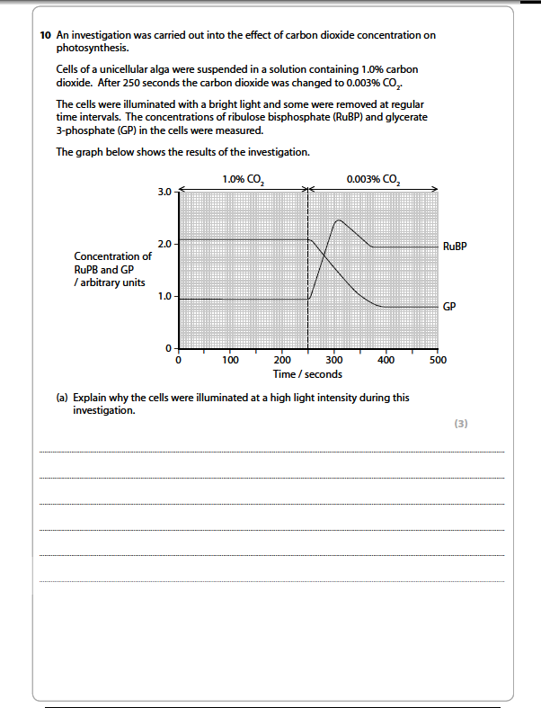
5

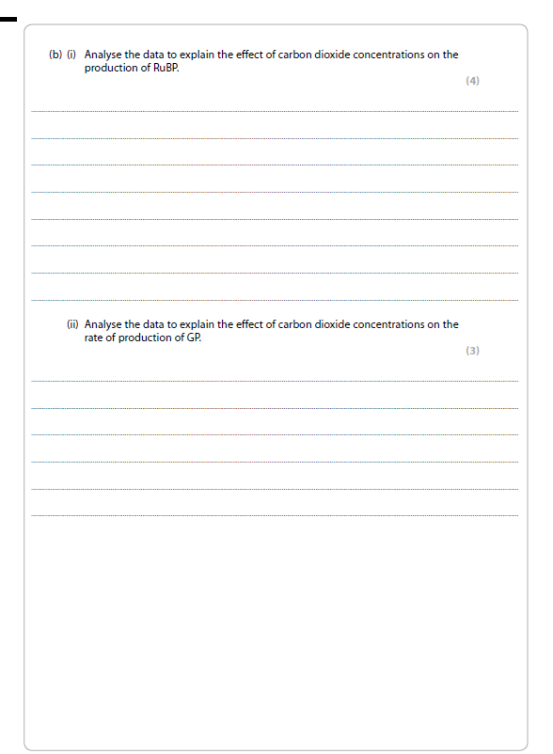
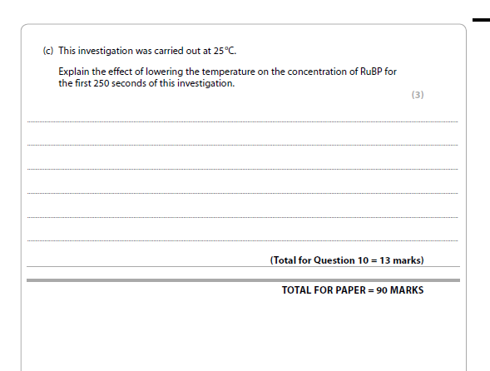

Q6.
The diagram below summarises the interconversion of ATP and ADP.
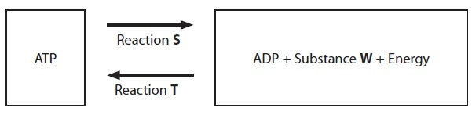
(a) Place a cross in the box that identifies each of the following.
(3)
(i) Substance W
A carbon dioxide
B an electron
C inorganic phosphate
D a proton
(ii) Reaction S
A carboxylation
B hydrolysis
C phosphorylation
D photolysis
(iii) Reaction T
A carboxylation
B hydrolysis
C phosphorylation
D photolysis
(b) Reaction T occurs in a chloroplast. Describe the structures in a chloroplast that are involved in this reaction.
(3)
.............................................................................................................................................
.............................................................................................................................................
.............................................................................................................................................
.............................................................................................................................................
.............................................................................................................................................
.............................................................................................................................................
.............................................................................................................................................
.............................................................................................................................................
(c) The energy released by reaction S is used to form GALP (glyceraldehyde 3-phosphate) during the Calvin cycle.
Plant cell walls contain cellulose molecules.
Suggest how GALP may be used to synthesise cellulose.
(5)
.............................................................................................................................................
.............................................................................................................................................
.............................................................................................................................................
.............................................................................................................................................
.............................................................................................................................................
.............................................................................................................................................
.............................................................................................................................................
.............................................................................................................................................
.............................................................................................................................................
.............................................................................................................................................
.............................................................................................................................................
(Total for question = 11 marks)

7

Q8.
Farmers find it helpful to know the productivity of their land.
The diagram below shows the relationship between GPP (gross primary productivity), NPP (net primary productivity) and R (plant respiration) for an area of grassland.
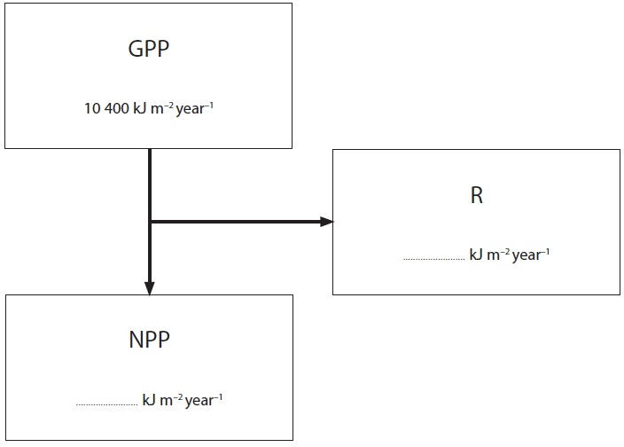
(a) The efficiency of the transfer of energy from GPP to NPP for this grassland is 45%.
(i) Calculate the values for NPP and R. Write your answers in the diagram above.
(2)
(ii) Using the information given, explain the relationship between GPP and NPP.
(3)
.............................................................................................................................................
.............................................................................................................................................
.............................................................................................................................................
.............................................................................................................................................
.............................................................................................................................................
.............................................................................................................................................
.............................................................................................................................................
.............................................................................................................................................
(b) Suggest why NPP values would be of use to a farmer who wanted to use this land for cattle.
(3)
.............................................................................................................................................
.............................................................................................................................................
.............................................................................................................................................
.............................................................................................................................................
.............................................................................................................................................
.............................................................................................................................................
.............................................................................................................................................
.............................................................................................................................................
.............................................................................................................................................
.............................................................................................................................................
(c) The units (kJ m⁻² year⁻¹) used in the diagram show a rate of energy production. Suggest why this is more useful than measurements of biomass in the grassland on a particular day.
(2)
.............................................................................................................................................
.............................................................................................................................................
.............................................................................................................................................
.............................................................................................................................................
(Total for Question = 10 marks)

Q9.
If a tree trunk is cut across horizontally, growth rings can be seen in the cut surface. The most significant factor that affects the formation of growth rings is environmental temperature. In regions where there is an annual cycle of seasonal temperature changes, it is possible to estimate the year in which a particular ring was formed.
In Nepal, there is an annual seasonal cycle of three distinct periods that is shown in the table below. 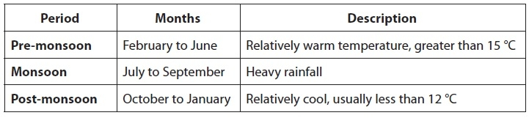

Data from growth ring studies and other sources have been used to estimate the changes in environmental temperature in Nepal during the past 400 years.
The estimated temperatures for the pre-monsoon and post-monsoon periods are shown in the graphs below.
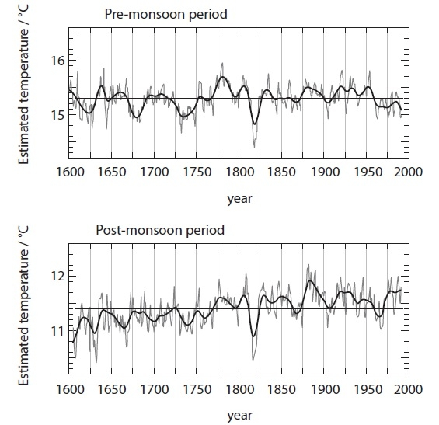
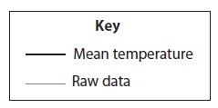
(a) Place a cross in the box next to the term used to describe the scientific study of tree growth rings.
(1)
A climatology
B dendrochronology
C ecology
D ethnobiology
(b) Compare the changes in mean environmental temperature between the pre-monsoon and the post-monsoon periods from 1600 to 2000.
(3)
.............................................................................................................................................
.............................................................................................................................................
.............................................................................................................................................
.............................................................................................................................................
.............................................................................................................................................
.............................................................................................................................................
.............................................................................................................................................
.............................................................................................................................................
.............................................................................................................................................
.............................................................................................................................................
(c) (i) Suggest how scientists could use these data to predict future climate change.
(3)
.............................................................................................................................................
.............................................................................................................................................
.............................................................................................................................................
.............................................................................................................................................
.............................................................................................................................................
.............................................................................................................................................
.............................................................................................................................................
.............................................................................................................................................
(ii) Suggest why some scientists may not be convinced that these data can be used to predict future climate change.
(3)
.............................................................................................................................................
.............................................................................................................................................
.............................................................................................................................................
.............................................................................................................................................
.............................................................................................................................................
.............................................................................................................................................
.............................................................................................................................................
.............................................................................................................................................
(d) Suggest one source of evidence, apart from growth ring studies, that could be used to estimate changes in mean environmental temperature in Nepal during the past 400 years.
(1)
.............................................................................................................................................
.............................................................................................................................................
.............................................................................................................................................
(Total for question = 11 marks)

Q10.
The mean global temperature is expected to increase as a result of climate change. The graph below shows the predicted changes in mean temperature in New Zealand, during the 21st century. A higher and lower estimate of these changes have been made.
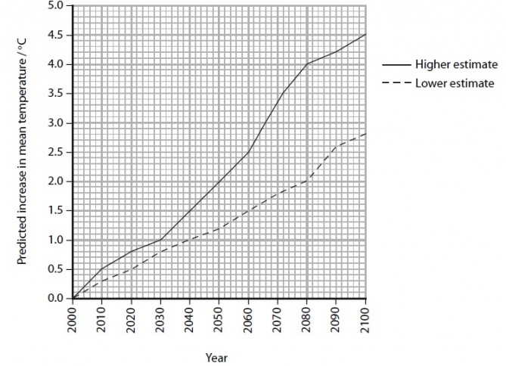
(a) (i) Explain how increases in carbon dioxide and methane, released into the atmosphere, may be contributing towards the estimated changes in mean temperature shown in the graph.
(3)
.............................................................................................................................................
.............................................................................................................................................
.............................................................................................................................................
.............................................................................................................................................
.............................................................................................................................................
.............................................................................................................................................
.............................................................................................................................................
.............................................................................................................................................
(ii) Suggest why a higher estimate and a lower estimate were made.
(1)
.............................................................................................................................................
.............................................................................................................................................
.............................................................................................................................................
.............................................................................................................................................
(b) Tuataras are reptiles found only on a group of small islands off the coast of mainland New Zealand. Adult tuataras grow to approximately 65 cm in length. They feed on small mammals, bird chicks and invertebrates such as insects and worms.
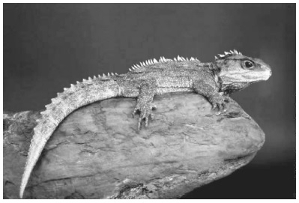
Tuataras build nests in which their eggs are laid. The gender (sex) of the tuatara, that hatches from an egg, is determined by the incubation temperature in the nest. A temperature of 22 ºC or above will mean that a male tuatara will hatch. Female tuataras only hatch from eggs incubated below 22 ºC.
During the breeding season in 2000, the temperature of the nests ranged between 18 ºC and 24 ºC.
(i) Suggest how the changes in the mean temperature, shown in the graph on page 6, might affect the tuataras on the islands off the coast of New Zealand.
(4)
.............................................................................................................................................
.............................................................................................................................................
.............................................................................................................................................
.............................................................................................................................................
.............................................................................................................................................
.............................................................................................................................................
.............................................................................................................................................
.............................................................................................................................................
.............................................................................................................................................
.............................................................................................................................................
(ii) Suggest how other animal populations on these islands might be affected by changes in the tuatara population.
(2)
.............................................................................................................................................
.............................................................................................................................................
.............................................................................................................................................
.............................................................................................................................................
.............................................................................................................................................
.............................................................................................................................................
(Total for question = 10 marks)

Q11.
Rhododendrons are shrubby plants that are widely distributed throughout the northern hemisphere.
The flowering periods and habitats of two species of rhododendron, found on Yakushima Island in Japan, are shown in the table below.
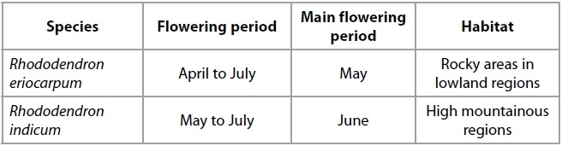
Where these populations overlap, hybrid plants are found that have arisen as a result of cross-fertilisation between these two species. These hybrid plants are capable of flowering and producing viable seeds.
(a) Suggest why some scientists might prefer to classify Rhododendron eriocarpum and Rhododendron indicum as varieties within the same species rather than as two separate species.
(3)
.............................................................................................................................................
.............................................................................................................................................
.............................................................................................................................................
.............................................................................................................................................
.............................................................................................................................................
.............................................................................................................................................
.............................................................................................................................................
.............................................................................................................................................
(b) (i) Explain what is meant by the term genetic diversity in a species.
(2)
.............................................................................................................................................
.............................................................................................................................................
.............................................................................................................................................
.............................................................................................................................................
(ii) Explain why there is likely to be a greater genetic diversity in the hybrid plants than in either of the two separate species.
(2)
.............................................................................................................................................
.............................................................................................................................................
.............................................................................................................................................
.............................................................................................................................................
.............................................................................................................................................
.............................................................................................................................................
*(c) Explain how the two different species of Rhododendron on Yakushima Island may have evolved from a single population of an ancestral species.
(6)
.............................................................................................................................................
.............................................................................................................................................
.............................................................................................................................................
.............................................................................................................................................
.............................................................................................................................................
.............................................................................................................................................
.............................................................................................................................................
.............................................................................................................................................
.............................................................................................................................................
.............................................................................................................................................
.............................................................................................................................................
.............................................................................................................................................
.............................................................................................................................................
.............................................................................................................................................
(Total for question = 13 marks)

Q12.
Bacteria are involved in the decomposition of organic matter.
(a) Place a cross in the box next to the type of chemical reaction that takes place in decomposition.
(1)
A condensation
B esterification
C hydrolysis
D polymerisation
(b) An investigation was carried out to study the rate of decomposition of leaves from ash trees and beech trees.
Five piles of each type of leaf were placed outside on the ground and each pile was covered with a heavy bucket. Each pile of leaves had a mass of 10 grams.
Every few weeks, one pile of each type of leaf was removed and weighed.
The table below shows the results of this investigation.
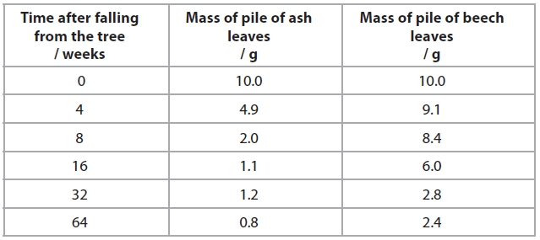
(i) Place a cross in the box next to the reason for using five piles of ash leaves in this investigation.
(1)
A to calculate a mean
B to give a range of values for the independent variable
C to make the investigation valid
D to produce reliable data
(ii) A student made the following conclusions from these results.
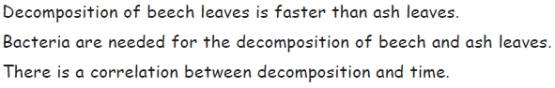
Place a cross in the box next to the number of correct conclusions made by this student.
(1)
A none
B one
C two
D three
(iii) Explain why there is a decrease in mass of the leaves.
(4)
.............................................................................................................................................
.............................................................................................................................................
.............................................................................................................................................
.............................................................................................................................................
.............................................................................................................................................
.............................................................................................................................................
.............................................................................................................................................
.............................................................................................................................................
.............................................................................................................................................
.............................................................................................................................................
(iv) Suggest what effect an increase in temperature would have on the rate of decomposition of these leaves. Give an explanation for your answer.
(4)
.............................................................................................................................................
.............................................................................................................................................
.............................................................................................................................................
.............................................................................................................................................
.............................................................................................................................................
.............................................................................................................................................
.............................................................................................................................................
.............................................................................................................................................
.............................................................................................................................................
.............................................................................................................................................
.............................................................................................................................................
.............................................................................................................................................
.............................................................................................................................................
.............................................................................................................................................
.............................................................................................................................................
.............................................................................................................................................

(Total for question = 11 marks)

Q13.
Plant growth involves mitosis, cell division and cell differentiation and is influenced by environmental factors such as temperature.
(a) The diagram below shows the stages in the growth of a root in a plant seedling.
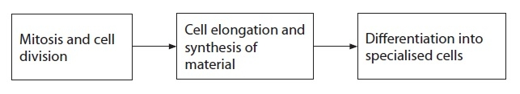
(i) Place a cross in the box next to the correct sequence of stages in mitosis.
(1)
A Metaphase, anaphase, prophase, telophase
B Prophase, anaphase, metaphase, telophase
C Prophase, metaphase, anaphase, telophase
D Telophase, metaphase, anaphase, prophase
ii) Place a cross in the box next to the material that would be synthesised to form the cell wall of the seedlings.
(1)
A Cellulose
B Cholesterol
C Glycogen
D Thrombin
(iii) Place a cross in the box next to the tissue that would form the vessels in a root, following differentiation.
(1)
A Chorion
B Endothelium
C Sclerenchyma
D Xylem
(b) A student carried out an investigation into the effect of temperature on the growth of plant seedlings. The two species that she chose for the study were sea plantain, Plantago maritima and bog sedge, Kobresia simpliciuscula.
Sets of seeds from each of these species of plant were germinated at 18 ºC. As soon as they germinated, the seedlings were placed in three temperature-controlled rooms at 10 ºC, 14 ºC and 18 ºC. They were allowed to grow for 50 days. Samples of seedlings were taken at 5-day intervals and their mean dry masses were recorded.
The results of this investigation are shown in the tables below.
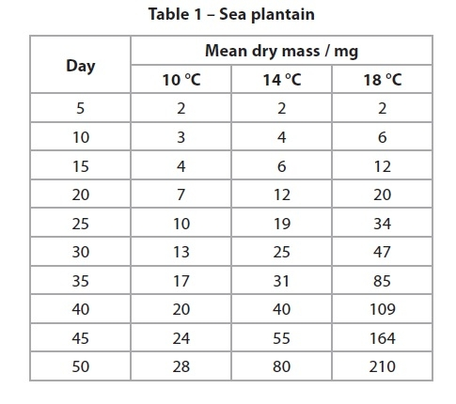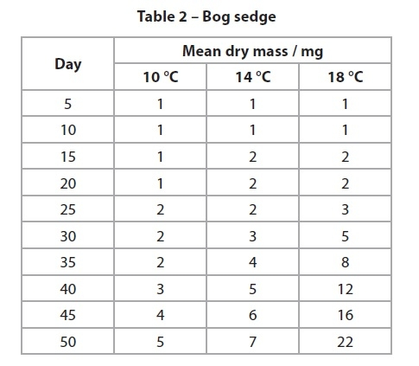
(i) Suggest how these results could be displayed in order to compare the effect of temperature on the growth of seedlings of these two species.
(3)
.............................................................................................................................................
.............................................................................................................................................
.............................................................................................................................................
.............................................................................................................................................
.............................................................................................................................................
.............................................................................................................................................
.............................................................................................................................................
.............................................................................................................................................
(ii) Suggest why all of the seeds were germinated at 18 ºC before being placed in the temperature-controlled rooms.
(2)
.............................................................................................................................................
.............................................................................................................................................
.............................................................................................................................................
.............................................................................................................................................
.............................................................................................................................................
.............................................................................................................................................
(iii) Use the data in the tables to suggest which of the two species is better adapted for growth at a wide range of latitudes (distance from the equator). Give reasons for your choice.
(4)
.............................................................................................................................................
.............................................................................................................................................
.............................................................................................................................................
.............................................................................................................................................
.............................................................................................................................................
.............................................................................................................................................
.............................................................................................................................................
.............................................................................................................................................
.............................................................................................................................................
.............................................................................................................................................
.............................................................................................................................................
.............................................................................................................................................
(Total for question = 12 marks)

Qu 14

Data was taken to determine the effect of temperature on the rate of respiration in a goldfish. It is in the table below. Calculate the Q10 for this data. Round to the nearest whole number.

This is the equation for calculating Q10:

Q15.
The carbon cycle describes the movement of carbon within an ecosystem.
In this cycle, carbon neutral processes do not change the concentration of carbon dioxide in the atmosphere.
The table below shows the main sources and combustion products of some fuels.
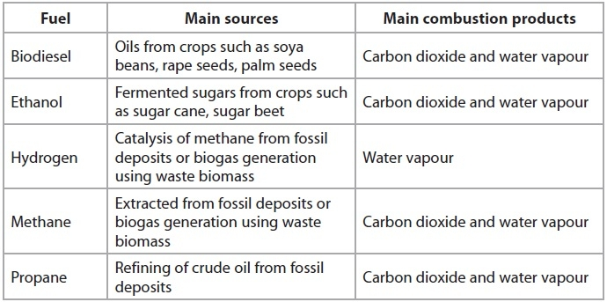
(a) Place a cross in the box next to the names of the four fuels, shown in the table, that could be considered to be biofuels.
(1)
A biodiesel, ethanol, hydrogen, methane
B biodiesel, ethanol, hydrogen, propane
C biodiesel, ethanol, methane, propane
D biodiesel, hydrogen, methane, propane
*(b) Large areas of land may need to be cleared in order to produce biofuels. This might involve deforestation.
Discuss why the production of biofuels may not be carbon neutral.
(5)
.............................................................................................................................................
.............................................................................................................................................
.............................................................................................................................................
.............................................................................................................................................
.............................................................................................................................................
.............................................................................................................................................
.............................................................................................................................................
.............................................................................................................................................
.............................................................................................................................................
.............................................................................................................................................
.............................................................................................................................................
.............................................................................................................................................
(c) Explain how the combustion products, from the burning of fuels, may lead to global warming.
(4)
.............................................................................................................................................
.............................................................................................................................................
.............................................................................................................................................
.............................................................................................................................................
.............................................................................................................................................
.............................................................................................................................................
.............................................................................................................................................
.............................................................................................................................................
.............................................................................................................................................
.............................................................................................................................................
(Total for Question = 10 marks)

