Questions
Q1.
A pathologist can use a number of methods to estimate the time of death of a body found at a crime scene.
The graph below shows variation in the body temperature of a living person over a period of 24 hours.
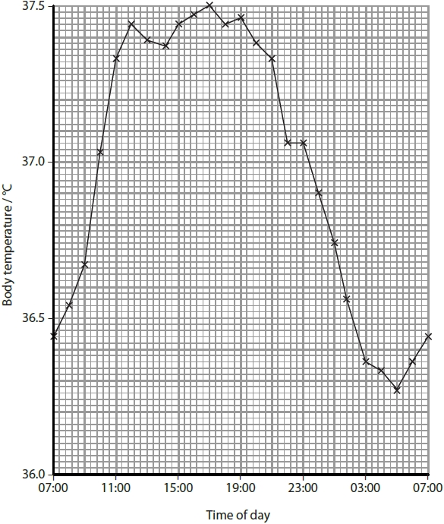
(i) Using the information in the graph, calculate the maximum change in body temperature over this period of 24 hours.
(2)
........................................................... °C
(ii) Suggest how a pathologist could use the information in this graph to estimate the time of death of a body at a crime scene.
(2)
.............................................................................................................................................
.............................................................................................................................................
.............................................................................................................................................
.............................................................................................................................................
.............................................................................................................................................
.............................................................................................................................................
.............................................................................................................................................
.............................................................................................................................................
.............................................................................................................................................

(Total for question = 4 marks)

Q2.
Blood infection caused by the bacterium, methicillin-resistant Staphylococcus aureus (MRSA), has become a major concern in hospitals. This infection can be difficult to treat due to increasing resistance of MRSA to bacteriostatic and bactericidal antibiotics.
(a) Explain what is meant by the terms bacteriostatic antibiotic and bactericidal antibiotic.
(3)
.............................................................................................................................................
.............................................................................................................................................
.............................................................................................................................................
.............................................................................................................................................
.............................................................................................................................................
.............................................................................................................................................
.............................................................................................................................................
.............................................................................................................................................
(b) The graph below shows the occurrence of MRSA infection in four hospitals, A, B, C, and D for the period from April 2001 to March 2005. The rate of MRSA infection in each hospital during each six-month period was recorded.
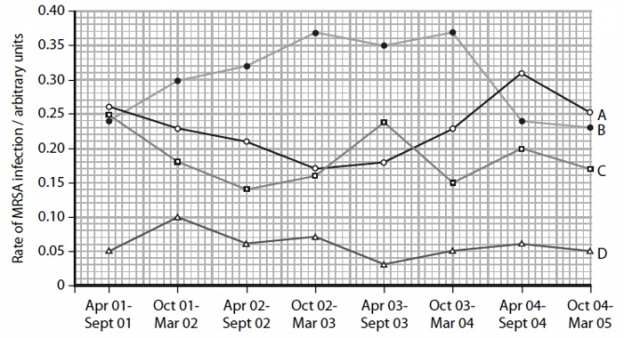
Compare the rates of MRSA infection in hospital A with those in hospital B.
(3)
.............................................................................................................................................
.............................................................................................................................................
.............................................................................................................................................
.............................................................................................................................................
.............................................................................................................................................
.............................................................................................................................................
.............................................................................................................................................
.............................................................................................................................................
(c) MRSA is present on the skin of approximately 1 in 3 of all patients entering hospitals for treatment.
(i) Describe the most significant difference between the rate of MRSA infection in hospital D compared with those of the other three hospitals.
(1)
.............................................................................................................................................
.............................................................................................................................................
.............................................................................................................................................
(ii) Suggest why the rate of MRSA infection in hospital D differs from the rates in the other hospitals.
(3)
.............................................................................................................................................
.............................................................................................................................................
.............................................................................................................................................
.............................................................................................................................................
.............................................................................................................................................
.............................................................................................................................................
.............................................................................................................................................
.............................................................................................................................................
(Total for question = 10 marks)

Q3.
In the immune response, antibodies are produced that are specific to the antigens of
the pathogen causing the infection.
(a) Place a cross in the box next to the type of cell that produces antibodies as part
of the immune response.
(1)
A erythrocyte
B macrophage
C plasma cell
D thrombocyte
(b) In pigs, the disease known as post-weaning multisystematic syndrome (PWMS)
is caused by the PCV2 virus. Common symptoms of PWMS include weight loss,
breathing difficulties and enlargement of the lymph nodes. Most pigs diagnosed
with PWMS will have to be destroyed.
A new vaccine has been developed to give gilts (female pigs having their first
pregnancy) active immunity against PWMS. To test this vaccine, gilts were divided
into two groups, A and B.
Group A gilts were vaccinated against PWMS on day 0, at the start of pregnancy.
A second vaccination was given on day 20. A final vaccination was given on
day 140, approximately 20 days before they were due to give birth.
Group B gilts were given no vaccine.
The graph below shows the results of blood tests to measure the concentration of
PCV2 antibodies in these two groups.
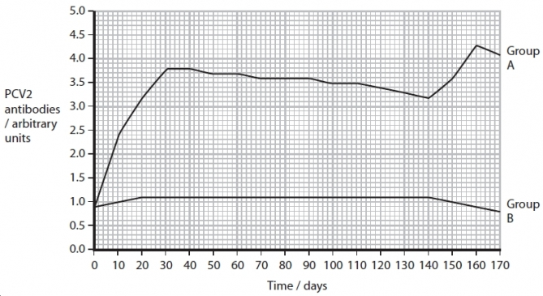
(i) Describe how the vaccine gives active immunity against PWMS.
(3)
.............................................................................................................................................
.............................................................................................................................................
.............................................................................................................................................
.............................................................................................................................................
.............................................................................................................................................
.............................................................................................................................................
(ii) Apart from having no vaccine, suggest how group B should be treated during
the test. Give reasons for your answer.
(3)
.............................................................................................................................................
.............................................................................................................................................
.............................................................................................................................................
.............................................................................................................................................
.............................................................................................................................................
.............................................................................................................................................
.............................................................................................................................................
.............................................................................................................................................
(iii) Compare the changes in concentrations of PCV2 antibodies in the blood of
the two groups of gilts during pregnancy.
(3)
.............................................................................................................................................
.............................................................................................................................................
.............................................................................................................................................
.............................................................................................................................................
.............................................................................................................................................
.............................................................................................................................................
.............................................................................................................................................
.............................................................................................................................................
.............................................................................................................................................
.............................................................................................................................................
.............................................................................................................................................
.............................................................................................................................................
(iv) The table below shows the concentration of PCV2 antibodies detected in
the piglets produced by the two groups of gilts, during the first 40 days after
birth.
Age of piglets  / days | Concentration of PCV2 antibodies  / arbitrary units | %%%
Age of piglets  / days | Group A piglets |  | Group B piglets
0 | 3.9 |  | 0.7
10 | 3.2 |  | 0.8
20 | 3.0 |  | 2.6
40 | 2.9 |  | 2.9
Suggest reasons for the changes in the concentrations of PCV2 antibodies in
group A and group B piglets.
(3)
.............................................................................................................................................
.............................................................................................................................................
.............................................................................................................................................
.............................................................................................................................................
.............................................................................................................................................
.............................................................................................................................................
.............................................................................................................................................
.............................................................................................................................................
.............................................................................................................................................
.............................................................................................................................................
(Total for question = 13 marks)

Examiner's Report
Q1.
(i)
The y axis gave some candidates a problem as the intervals were a bit different from previous graphs. We allowed a range of values between 36.26 and 36.28 for the reading at 07:00.
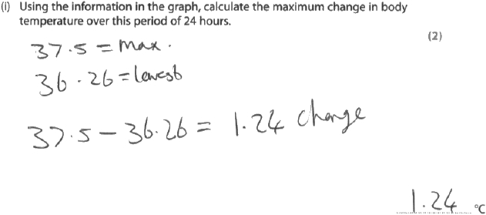
Results Plus: Examiner Comments
A clearly laid out calculation using acceptable values read from the graph.

Results Plus: Examiner Tip
Always show your working.

(ii)
This question turned out to be the most challenging question on the paper with the majority of candidates struggling to pick up two marks.
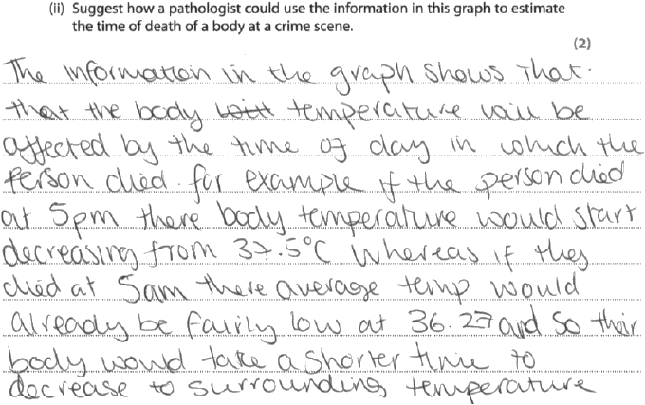
Results Plus: Examiner Comments
This candidate clearly understood the graph and its role and made one of the better attempts at answering this question.

Q2.
Part (a) proved to be straightforward and was answered well by most candidates. In part (b), a simple comparison of the main trends shown in the two hospitals was expected. Many candidates tried to describe each line separately, quoting data at each time period.
(b)
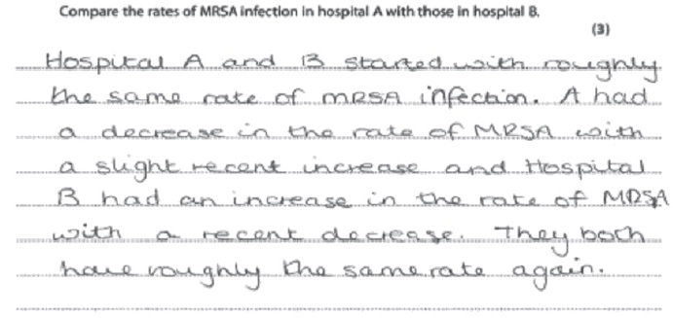
Results Plus: Examiner Comments
A clear, concise comparison which can be awarded 2 marks. A third mark could have been awarded if the candidate had referred to the relatively small difference at the start using figures from the graph.

Most candidates were able to give acceptable answers to parts (c)(i) and (c)(ii).

Q3.
(b) (iii) The average mark for this question was low. Despite 'comparison' questions appearing in both AS and A2 papers and our feedback in examiner reports, candidates are still approaching questions of this type by writing two descriptions. At A2 we will not piece candidate's answers together - they have to write pairs of comparative statements to be awarded the marks.
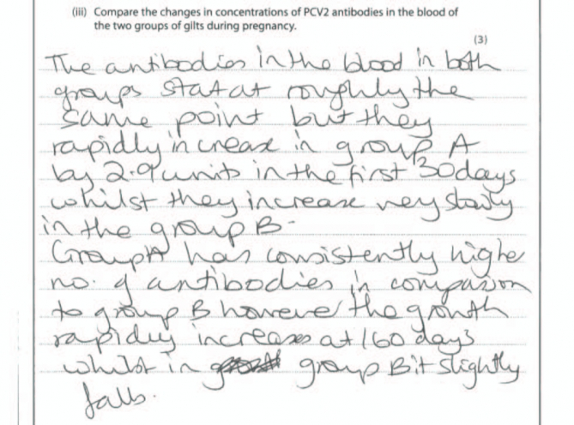
Results Plus: Examiner Comments
This candidate did attempt to write a comparison but could not be awarded some of the marks as values from the x axis were not read accurately enough.

Results Plus: Examiner Tip
You must quote values from the x axis in any description or comparison that you write, but they must be correct.

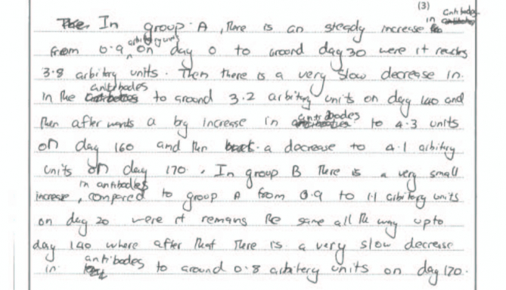
Results Plus: Examiner Comments
This response is typical of candidates who wrote two descriptions.

Results Plus: Examiner Tip
When answering a question where you are asked to compare something, you must write each sentence to include a matched piece of information for both things that you have been asked to compare. Do not write two descriptions.

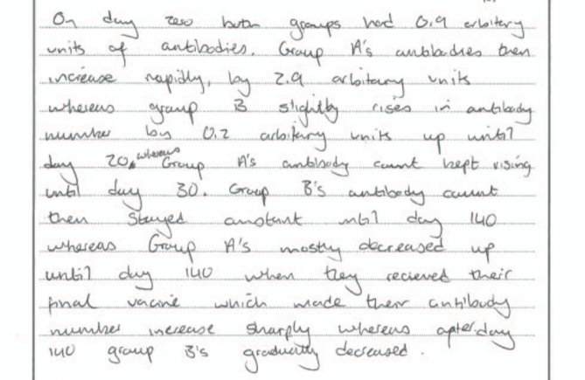
Results Plus: Examiner Comments
There were some good comparisons.

Results Plus: Examiner Tip
The use of the word 'whereas' is very useful in sentences that are making comparisons.

(b) (i-ii) Question (b)(i) was another question where candidates wrote everything they knew about the topic, initiating an immune response, without actually answering the question to tell us how vaccines work. Part (ii) saw a range of responses, but candidates rarely used the mark allocation for this question to give enough information to score all 3 marks.
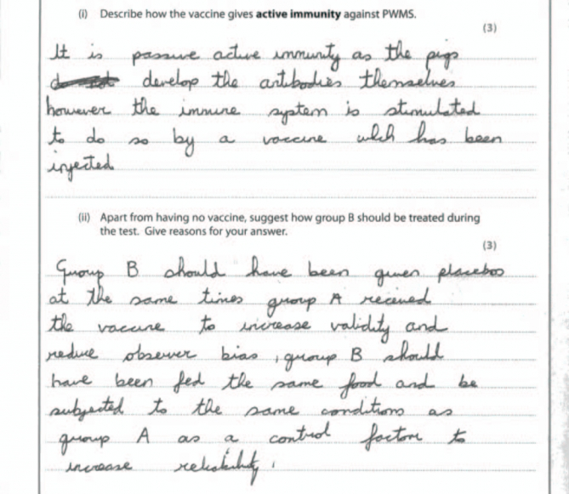
Results Plus: Examiner Comments
Although part (ii) did score all 3 marks, this response illustrates how many candidates do not appreciate the meanings of reliability and validity.

Results Plus: Examiner Tip
You must use the terms reliability and validity correctly. It is no good writing both in the vague hope that one will be correct, as the wrong term will negate the mark for the correct one.

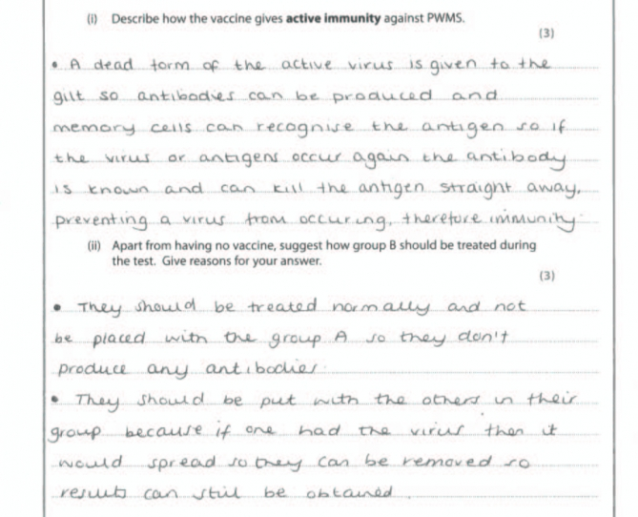
Results Plus: Examiner Comments
A number of candidates referred to a dead virus being used.

Results Plus: Examiner Tip
Remember that viruses are non-living particles. If they are not living then they cannot be killed or be dead.

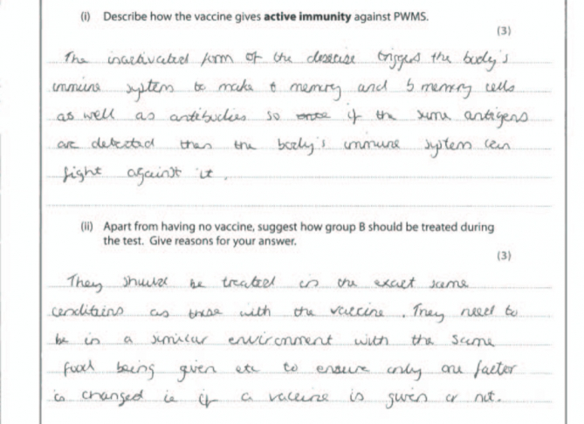
Results Plus: Examiner Comments
This response illustrates another common mistake in expression. The vaccine contained the virus not the disease or the PWMS and certainly not the bacteria.

(b) (iv) Candidates who thought carefully about the data scored highly in this question. Unfortunately, many candidates failed to acknowledge the low levels of antibody in the newborn Group B piglets so did not appreciate that some antibodies must have been passed on to them from their mothers.
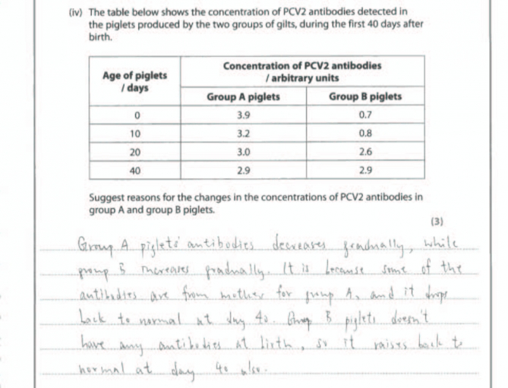
Results Plus: Examiner Comments
This response was typical of candidates who did not read the stem of the question carefully enough. We saw a number of descriptions of the data instead of explanations.

Results Plus: Examiner Tip
Before you start writing your answer, check that you have identified the question command word correctly.

Mark Scheme
Q1.
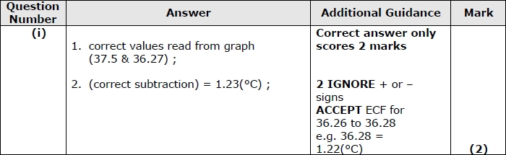
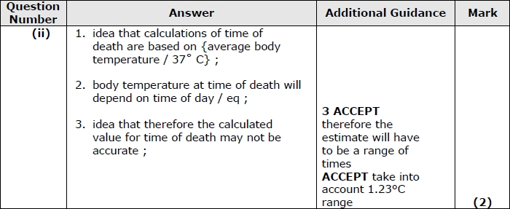

Q2.
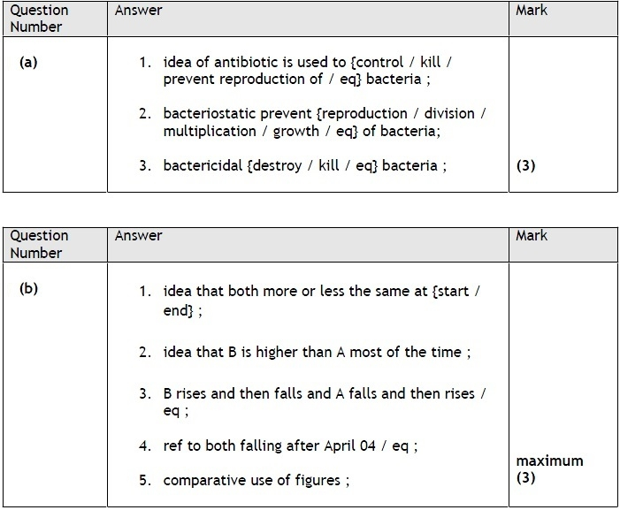
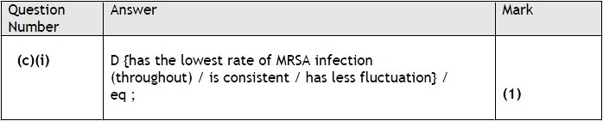
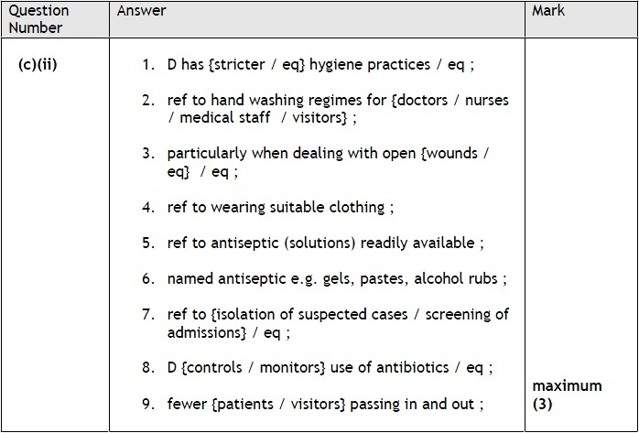

Q3.

