BIOLOGY EXAM QUESTIONS BOOKLET

TOPIC 6
Centre Number |  | 12416
Candidate Number
Candidate forename |  | Candidate surname
Class
Teachers’ initials

Qu | Concept | Skill focus | Total Mark | Marks ach’d | Traffic Light | *Follow up task completed
1 | DNA profiling | Application and QWC | 12
2 | DNA profiling | Synoptic | 10
3 | Non-specific immune response | Application | 13
4 | Specific immunity | Application | 9
5 | Specific immunity | Application  Synoptic | 13
6 | Viruses and bacteria | Application, data analysis | 10
7 | Antibiotics | Application, QWC | 10
8 | Antibiotics | Application, investigative | 10
9 | HIV | Application | 12
10 | HIV | Application, QWC | 11
11 | TB | Application, synoptic | 13
12 | HIV and drugs | Application,  Numeracy | 12
13 | Forensic entomology | Application, data analysis | 10
14 | Rigor mortis | Application | 7
15 | Temp and time of death | Data application | 9

*If the exam question has been traffic lighted as amber or red then you still need to work on this concept or skill area. You must follow this up by completing a task from below. Add the letter of the follow up task completed in the last column of the grid on your front page. Add the evidence in this booklet.

Potential review tasks include (increase in difficulty as you go down):

- Make notes on the concept of the question using a variety of different resources such as the various A-level textbooks in the library (not just the core SNAB textbook).

- Complete a worksheet on the skill or concept such as a worksheet from the Biozone booklet in the library. SNAB also has workbooks available to buy.

- Complete a Biological skills support sheet on the concept or skill from pearsonactivelearn.com

- Find another exam question on this concept or skill using the Biology exam question database on Moodle (password is Biology). Then google Edexcel SNAB Biology A past papers.

- Summarise the rules for answering a similar style of question using the examiners reports for exam questions on this concept or skill. Use the exam question database on Moodle as above to help you find the exam questions on this concept or skill and then find the examiner’s report for it.

- Make your own exam question and mark scheme on the concept or skill. Use current mark schemes to help you.

Q1.
The Atlantic tomcod is a fish found in the rivers of North America.
The photograph below shows an Atlantic tomcod.
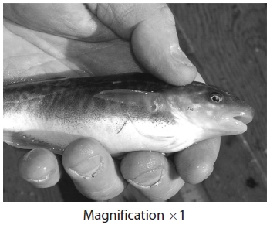
Atlantic tomcod in the Hudson River are able to survive high levels of polychlorinated biphenyls (PCBs). PCBs enter the water from industrial processes.
One group of scientists identified a mutation in the DNA of these fish. They found that the AHR2 gene had six bases missing. This mutation was rarely found in Atlantic tomcod in the unpolluted St. Lawrence River.
(a) Suggest how scientists in other countries learnt of these findings.
(2)
.............................................................................................................................................
.............................................................................................................................................
.............................................................................................................................................
.............................................................................................................................................
.............................................................................................................................................
.............................................................................................................................................
*(b) (i) Describe how the DNA and protein of Atlantic tomcod from the Hudson River could be compared with the DNA and protein of Atlantic tomcod from the St. Lawrence River.
(6)
.............................................................................................................................................
.............................................................................................................................................
.............................................................................................................................................
.............................................................................................................................................
.............................................................................................................................................
.............................................................................................................................................
.............................................................................................................................................
.............................................................................................................................................
.............................................................................................................................................
.............................................................................................................................................
.............................................................................................................................................
.............................................................................................................................................
.............................................................................................................................................
.............................................................................................................................................
(ii) Suggest one similarity in the DNA of the Atlantic tomcod from these two rivers.
Give an explanation for your answer.
(2)
.............................................................................................................................................
............................................................................................................................................. .............................................................................................................................................
.............................................................................................................................................
.............................................................................................................................................
.............................................................................................................................................
(iii) Suggest one difference in the protein of the Atlantic tomcod from these two rivers.
Give an explanation for your answer.
(2)
.............................................................................................................................................
.............................................................................................................................................
.............................................................................................................................................
.............................................................................................................................................
.............................................................................................................................................
.............................................................................................................................................

(Total for question = 12 marks)
Q2.
During DNA profiling, the polymerase chain reaction (PCR) can be used to amplify a sample of DNA.
The diagram below shows how substances X, Y and Z are involved in the PCR. It also gives the temperature treatments T1, T2 and T3 at various stages.
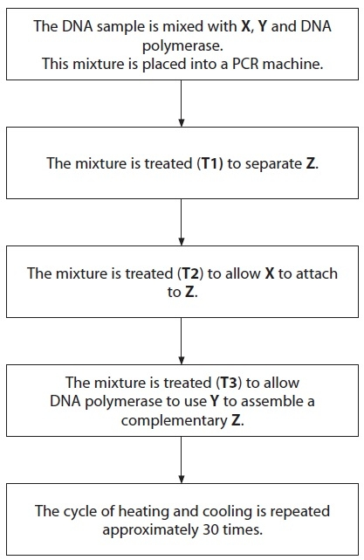
(a) Name substances X, Y and Z.
(3)
Substance X ......................................................................................................
Substance Y ......................................................................................................
Substance Z ......................................................................................................
(b) Place a cross in the box next to the correct statements for treatments T1, T2 and T3.
(3)
(i) Treatment T1
A heated to 90-95 ºC
B heated to 75 ºC
C cooled to 55-60 ºC
D cooled to 4 ºC
(ii) Treatment T2
A heated to 90-95 ºC
B heated to 75 ºC
C cooled to 55-60 ºC
D cooled to 4 ºC
(iii) Treatment T3
A heated to 90-95 ºC
B heated to 75 ºC
C cooled to 55-60 ºC
D cooled to 4 ºC
(c) Suggest reasons for each of the following.
(i) DNA polymerase from human sources is not suitable for use in a PCR machine.
(2)
.............................................................................................................................................
.............................................................................................................................................
.............................................................................................................................................
.............................................................................................................................................
(ii) Species of plants cannot be identified from woody (xylem) material using PCR and DNA profiling.
(2)
.............................................................................................................................................
.............................................................................................................................................
.............................................................................................................................................
.............................................................................................................................................
(Total for question = 10 marks)
Q3.
Histamine and the proteins interferon and lysozyme are involved in the non-specific responses to infection.
(a) (i) Describe how the production and action of interferon differs from the production and action of lysozyme.
(3)
.............................................................................................................................................

............................................................................................................................................ .............................................................................................................................................
.............................................................................................................................................
.............................................................................................................................................
.............................................................................................................................................
.............................................................................................................................................
.............................................................................................................................................
(ii) Suggest why the protein structure of lysozyme is important to the way in which it acts against pathogens.
(4)
.............................................................................................................................................
.............................................................................................................................................
.............................................................................................................................................
.............................................................................................................................................
.............................................................................................................................................
.............................................................................................................................................
.............................................................................................................................................
.............................................................................................................................................
.............................................................................................................................................
.............................................................................................................................................
.............................................................................................................................................
.............................................................................................................................................
(b) Following a bite by an insect, the area around the bite may show signs of inflammation as histamine is released.
(i) Explain why an insect bite, which breaks the surface of the skin, may lead to inflammation around the injury.
(3)
.............................................................................................................................................
.............................................................................................................................................
.............................................................................................................................................
.............................................................................................................................................
.............................................................................................................................................
.............................................................................................................................................
.............................................................................................................................................
.............................................................................................................................................
(ii) In order to reduce inflammation, a cream containing antihistamines might be applied to the skin, around an insect bite.
Suggest why applying this cream might be better than taking tablets containing antihistamines.
(3)
.............................................................................................................................................
.............................................................................................................................................
.............................................................................................................................................
.............................................................................................................................................
.............................................................................................................................................
.............................................................................................................................................
.............................................................................................................................................
.............................................................................................................................................
(Total for question = 13 marks)

Q4.
The human body responds to infection by bacteria in a number of ways.
The non-specific response includes phagocytosis and lysozyme action, which can be followed by the specific immune response. The specific immune response requires antigen presentation by macrophages.
(a) Explain how phagocytosis and lysozyme action lead to antigen presentation by macrophages.
(4)
.............................................................................................................................................
.............................................................................................................................................
.............................................................................................................................................
.............................................................................................................................................
.............................................................................................................................................
.............................................................................................................................................
.............................................................................................................................................
.............................................................................................................................................
.............................................................................................................................................
.............................................................................................................................................
.............................................................................................................................................
.............................................................................................................................................
(b) Explain how macrophages present antigens to T helper cells.
(2)
.............................................................................................................................................
.............................................................................................................................................
.............................................................................................................................................
.............................................................................................................................................
.............................................................................................................................................
.............................................................................................................................................
.............................................................................................................................................
.............................................................................................................................................
(c) There is an 'evolutionary race' between some bacteria, such as Mycobacterium tuberculosis (TB), and their hosts.
Suggest how this could affect antigen presentation to T helper cells.
Give an explanation for your answer.
(3)
.............................................................................................................................................
.............................................................................................................................................
.............................................................................................................................................
.............................................................................................................................................
.............................................................................................................................................
.............................................................................................................................................
.............................................................................................................................................
.............................................................................................................................................

(Total for question = 9 marks)

Q5.
Bacteria and viruses can cause human diseases.
(a) Distinguish between the structure of bacteria and viruses
(3)
.............................................................................................................................................
.............................................................................................................................................
.............................................................................................................................................
.............................................................................................................................................
.............................................................................................................................................
.............................................................................................................................................
(b) Infection with a bacterium can result in the development of active immunity to that bacterium. This results in the production of antibodies by plasma cells.
(i) Describe how infection with a bacterium results in the production of plasma cells.
(4)
.............................................................................................................................................
.............................................................................................................................................
.............................................................................................................................................
.............................................................................................................................................
.............................................................................................................................................
.............................................................................................................................................
.............................................................................................................................................
.............................................................................................................................................
(ii) Explain how antibodies help a person to recover from an infection.
(2)
.............................................................................................................................................
.............................................................................................................................................
.............................................................................................................................................
.............................................................................................................................................
.............................................................................................................................................
.............................................................................................................................................
(iii) A person who has had an organ transplant has to take immunosuppressive drugs. This prevents the immune system from destroying the organ transplant. Some of these drugs work by inhibiting the production of cytokines.
Suggest what effect these drugs could have on a person infected with a bacterium or a virus.
(4)
.............................................................................................................................................
.............................................................................................................................................
.............................................................................................................................................
.............................................................................................................................................
.............................................................................................................................................
.............................................................................................................................................
.............................................................................................................................................
.............................................................................................................................................
.............................................................................................................................................
.............................................................................................................................................
(Total for Question = 13 marks)

Q6.
(a) The table below gives some of the features of bacteria and viruses.
Place one tick () in each row to indicate whether the feature is found in bacteria only, viruses only or both bacteria and viruses.
(3)
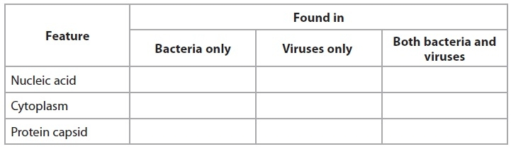
(b) In human populations, the bacterium, Helicobacter pylori, is associated with the development of severe chronic atrophic gastritis (SCAG) in the stomach. SCAG is the first step that can lead to the most common form of stomach cancer.
The table below shows the reported new cases of stomach cancer in 2006 in the UK.
The mean rate of stomach acid secretion for each age group is also shown.
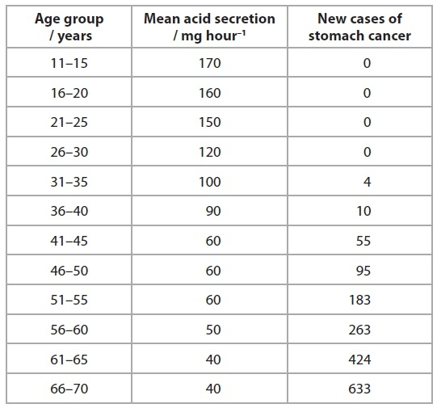
(i) Suggest why patients with SCAG may be given antibiotics as part of their treatment.
(2)
.............................................................................................................................................
.............................................................................................................................................
.............................................................................................................................................
.............................................................................................................................................
.............................................................................................................................................
.............................................................................................................................................
.............................................................................................................................................
.............................................................................................................................................
*(ii) Using the information about SCAG and the data, describe and suggest explanations for the trends shown in the table.
(5)
.............................................................................................................................................
.............................................................................................................................................
.............................................................................................................................................
.............................................................................................................................................
.............................................................................................................................................
.............................................................................................................................................
.............................................................................................................................................
.............................................................................................................................................
.............................................................................................................................................
.............................................................................................................................................
.............................................................................................................................................
.............................................................................................................................................
.............................................................................................................................................
.............................................................................................................................................
.............................................................................................................................................
.............................................................................................................................................
(Total for question = 10 marks)
Q7.
Blood infection caused by the bacterium, methicillin-resistant Staphylococcus aureus (MRSA), has become a major concern in hospitals. This infection can be difficult to treat due to increasing resistance of MRSA to bacteriostatic and bactericidal antibiotics.
(a) Explain what is meant by the terms bacteriostatic antibiotic and bactericidal antibiotic.
(3)
.............................................................................................................................................
.............................................................................................................................................
.............................................................................................................................................
.............................................................................................................................................
.............................................................................................................................................
.............................................................................................................................................
.............................................................................................................................................
.............................................................................................................................................
(b) The graph below shows the occurrence of MRSA infection in four hospitals, A, B, C, and D for the period from April 2001 to March 2005. The rate of MRSA infection in each hospital during each six-month period was recorded.
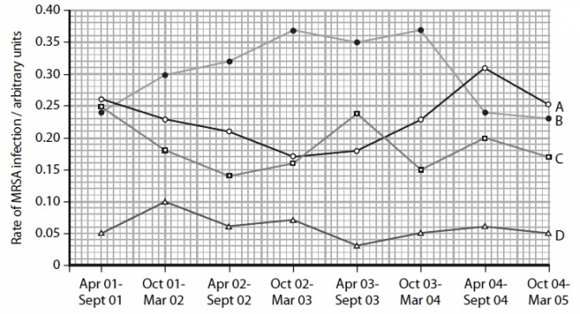
Compare the rates of MRSA infection in hospital A with those in hospital B.
(3)
.............................................................................................................................................
.............................................................................................................................................
.............................................................................................................................................
.............................................................................................................................................
.............................................................................................................................................
.............................................................................................................................................
.............................................................................................................................................
.............................................................................................................................................
(c) MRSA is present on the skin of approximately 1 in 3 of all patients entering hospitals for treatment.
(i) Describe the most significant difference between the rate of MRSA infection in hospital D compared with those of the other three hospitals.
(1)
.............................................................................................................................................
.............................................................................................................................................
.............................................................................................................................................
(ii) Suggest why the rate of MRSA infection in hospital D differs from the rates in the other hospitals.
(3)
.............................................................................................................................................
.............................................................................................................................................
.............................................................................................................................................
.............................................................................................................................................
.............................................................................................................................................
.............................................................................................................................................
.............................................................................................................................................
.............................................................................................................................................
(Total for question = 10 marks)

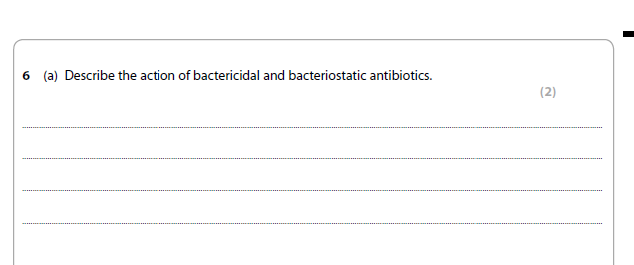
Q8.

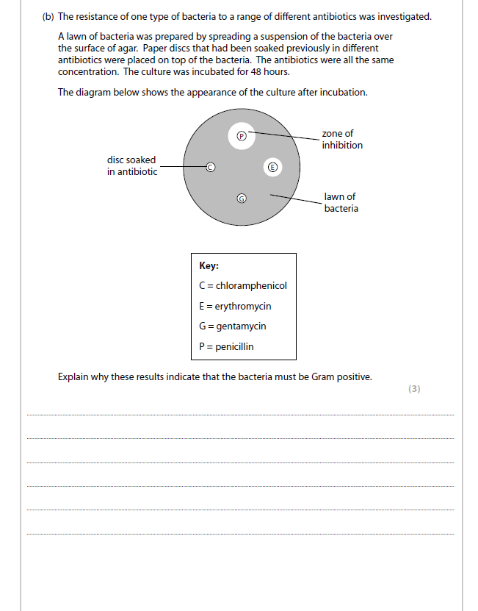

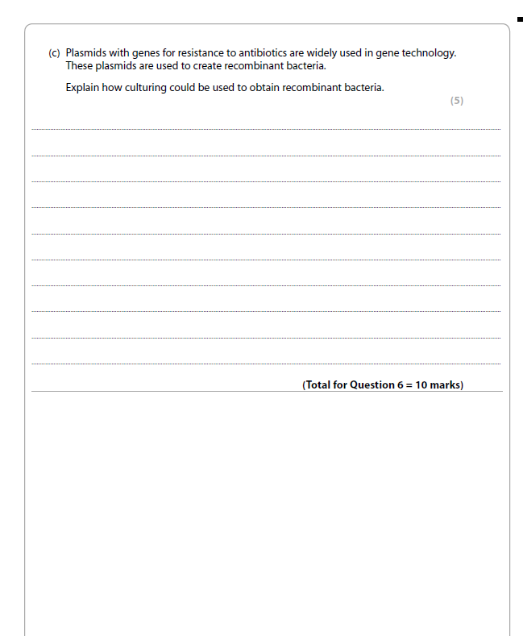

Q9.

Infection with human immunodeficiency virus (HIV) can lead to the condition known as AIDS. In this condition, part of the immune system is destroyed.
(a) The genetic material in HIV consists of two strands of RNA.
Place a cross in the box next to the term used to describe each of the sub-units in a molecule of RNA.
(1)
A amino acid
B inorganic phosphate
C nucleotide
D saccharide
(b) (i) Name two types of cell that HIV enters in the immune system.
(2)
.............................................................................................................................................
.............................................................................................................................................
(ii) Explain how HIV is able to enter these cells.
(3)
.............................................................................................................................................
.............................................................................................................................................
.............................................................................................................................................
.............................................................................................................................................
.............................................................................................................................................
.............................................................................................................................................
.............................................................................................................................................
.............................................................................................................................................
.............................................................................................................................................
.............................................................................................................................................
(iii) Describe the sequence of events following infection of these cells by HIV, that may lead to the death of the patient.
(6)
.............................................................................................................................................
.............................................................................................................................................
.............................................................................................................................................
.............................................................................................................................................
.............................................................................................................................................
.............................................................................................................................................
.............................................................................................................................................
.............................................................................................................................................
.............................................................................................................................................
.............................................................................................................................................
.............................................................................................................................................
.............................................................................................................................................
.............................................................................................................................................
.............................................................................................................................................
.............................................................................................................................................
.............................................................................................................................................
.............................................................................................................................................
.............................................................................................................................................
(Total for question = 12 marks)

Q10.
Anti-viral drugs have been developed to treat patients infected with Human Immunodeficiency Virus (HIV).
The diagram below shows the structure of HIV.
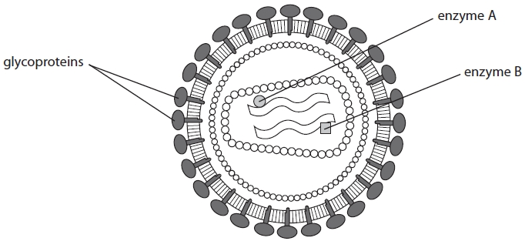
(a) A glycoprotein has a carbohydrate attached to a protein molecule.
Describe the three-dimensional structure of a glycoprotein.
(3)
.............................................................................................................................................
.............................................................................................................................................
.............................................................................................................................................
.............................................................................................................................................
.............................................................................................................................................
.............................................................................................................................................
.............................................................................................................................................
.............................................................................................................................................
.............................................................................................................................................
(b) Some anti-viral drugs prevent HIV entering the host cells.
Suggest how these anti-viral drugs could prevent HIV entering the host cells.
(3)
.............................................................................................................................................
.............................................................................................................................................
.............................................................................................................................................
.............................................................................................................................................
.............................................................................................................................................
.............................................................................................................................................
.............................................................................................................................................
*(c) Describe how the enzymes shown in the diagram are involved in HIV infection.
(5)
.............................................................................................................................................
.............................................................................................................................................
.............................................................................................................................................
.............................................................................................................................................
.............................................................................................................................................
.............................................................................................................................................
.............................................................................................................................................
.............................................................................................................................................
.............................................................................................................................................
.............................................................................................................................................
.............................................................................................................................................
.............................................................................................................................................
.............................................................................................................................................
.............................................................................................................................................
.............................................................................................................................................

(Total for question = 11 marks)

Q11.
Human diseases can be caused by many different types of organism, such as bacteria and viruses.
(a) Give two differences between the genetic material of bacteria and viruses.
(2)
.............................................................................................................................................
.............................................................................................................................................
.............................................................................................................................................
.............................................................................................................................................
(b) Tuberculosis (TB) is caused when droplets, containing the bacterium Mycobacterium tuberculosis, are inhaled into the lungs.
In the lungs, large numbers of the bacterium are formed rapidly. These can be ingested by macrophages. Eventually, tubercles (tissue masses), containing dormant bacteria inside macrophages, may form.
(i) Describe how macrophages ingest the bacteria.
(2)
.............................................................................................................................................
.............................................................................................................................................
.............................................................................................................................................
.............................................................................................................................................
.............................................................................................................................................
(ii) Suggest why treatment with antibiotics may not be effective against the dormant bacteria in the tubercles.
(2)
.............................................................................................................................................
.............................................................................................................................................
.............................................................................................................................................
.............................................................................................................................................
.............................................................................................................................................
(iii) TB can be prevented by vaccination. Explain how a person can develop artificial active immunity following vaccination.
(3)
.............................................................................................................................................
.............................................................................................................................................
.............................................................................................................................................
.............................................................................................................................................
.............................................................................................................................................
.............................................................................................................................................
.............................................................................................................................................
.............................................................................................................................................
(c) In a person with TB, the dormant bacteria in tubercles may be activated after several years. The bacteria multiply rapidly, resulting in severe lung damage.
The bacteria are released from the tubercles. These bacteria can inhibit the activity of T cells and infect other organs.
Explain why the activity of these bacteria and the inhibition of T cells means that a person may quickly develop severe symptoms leading to death.
(4)
.............................................................................................................................................
.............................................................................................................................................
.............................................................................................................................................
.............................................................................................................................................
.............................................................................................................................................
.............................................................................................................................................
.............................................................................................................................................
.............................................................................................................................................
.............................................................................................................................................
.............................................................................................................................................
.............................................................................................................................................
.............................................................................................................................................
(Total for Question = 13 marks)

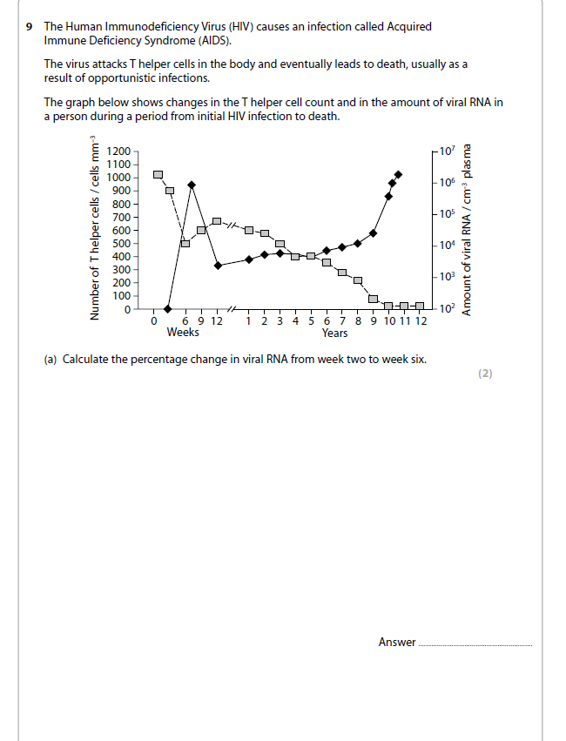
Q12.



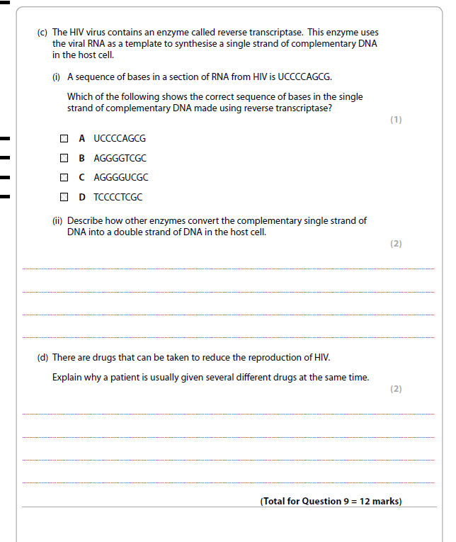

13. The graph below shows the growth of two species of fly larvae on a dead body. The temperature was kept at 22 °C.
(a)(i) Give one factor, other than temperature, that could affect the growth of insect larvae on a dead body.
...........................................................................................................................(1)
(ii) Suggest and explain reasons why the time since death that larvae first appear on a body is different for each species.
...........................................................................................................................
...........................................................................................................................
...........................................................................................................................
...........................................................................................................................
...........................................................................................................................
...........................................................................................................................
............................................................................................................................(4)
(b) The growth of the larvae is affected by temperature as shown in Table 1. The effects of temperature are given as the number of days ahead (+) or behind (–) their development at 22 °C.
Table 1
 | Effect on development / days
Temperature / °C | House fly | Flesh fly
12 | –4 | –4
27 | +1 | +1.5
Two dead bodies were found at the same address and evidence was needed to decide whether they died at the same time. One was found in a boiler room with a temperature of 27 °C and the other was found in an outside shed where the temperature was 12 °C.
Insect larvae from both bodies were collected, identified and measured. The results are shown in Table 2.
Table 2
 | Mean length of larvae /mm
Site of body | House fly | Flesh fly
Boiler room | 23 | 45
Shed | 6 | 23
(i) Use the information in the graph, Table 1 and Table 2 for flesh fly larvae to estimate the time of death for the body in the boiler room. The estimate using house fly larvae has been done for you.
 | Length /mm | Suggested  time since  death at  22 °C / days | Adjustment for  27 °C / days | Estimated  actual time  since death  /days
House fly | 23 | 9 | 1 | 8
Flesh fly
(ii) Use the measurements of larvae from the body in the shed to provide evidence that the two deaths occurred at approximately the same time.
...........................................................................................................................
...........................................................................................................................
...........................................................................................................................
...........................................................................................................................
...........................................................................................................................(3)(Total 10 marks)

14

15. Forensic scientists use several different types of evidence to estimate the time of death of a body.
(a) Place a cross in the boxes next to the two types of evidence that could be used by a forensic scientist to estimate the time of death of a body.
A Degree of muscle contraction
B Length of fingernails
C Signs of decomposition
D Skin pigmentation (2)
(b) The core temperature of a body can also be used to estimate the time of death. This can be recorded by measuring the temperature of the rectum.
The table below shows the mean core temperature, measured at 2-hour intervals after death, using data from a large number of bodies. The standard deviation from each of the means is also shown.
Time after death  / hours | Mean core temperature  / °C | Standard deviation from  the mean / °C
2 | 36.7 | 0.9
4 | 36.0 | 1.1
6 | 35.3 | 1.3
8 | 31.3 | 1.5
10 | 29.6 | 1.7
12 | 28.1 | 2.0
14 | 26.7 | 2.3
16 | 25.5 | 2.6
18 | 25.0 | 2.9
20 | 23.6 | 3.1
22 | 22.8 | 3.3
24 | 22.3 | 3.4
26 | 21.8 | 3.4

Explain what the data indicates about the reliability of using core temperature to estimate the time of death.
.....................................................................................................................................
.....................................................................................................................................
.....................................................................................................................................
.....................................................................................................................................
.....................................................................................................................................
.....................................................................................................................................
.....................................................................................................................................
.....................................................................................................................................
.....................................................................................................................................
.....................................................................................................................................(4)

(c) Suggest three factors that could influence the rate at which a body cools after death.
1 ....................................................................................................................................
2 ....................................................................................................................................
3 .....................................................................................................................................(3)
(Total 9 marks)

TOPIC 6 EXAM QU BOOKLET
MARK SCHEME
Q1.
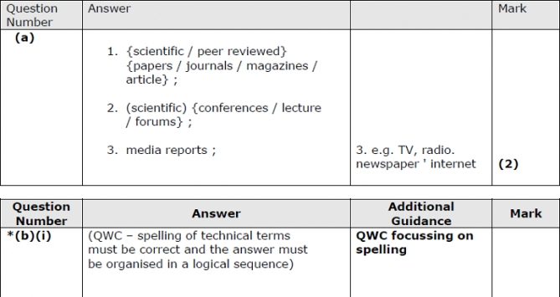
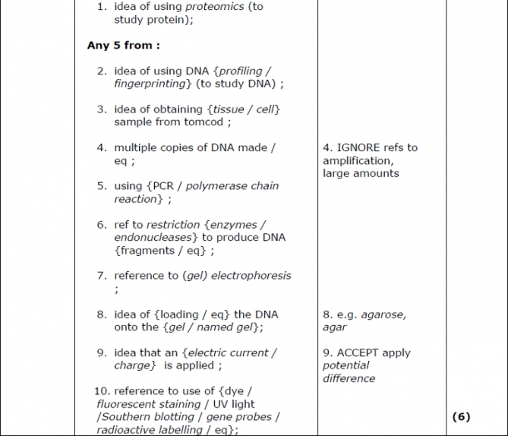
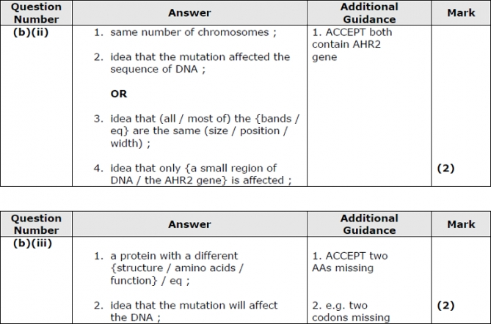

Q2.

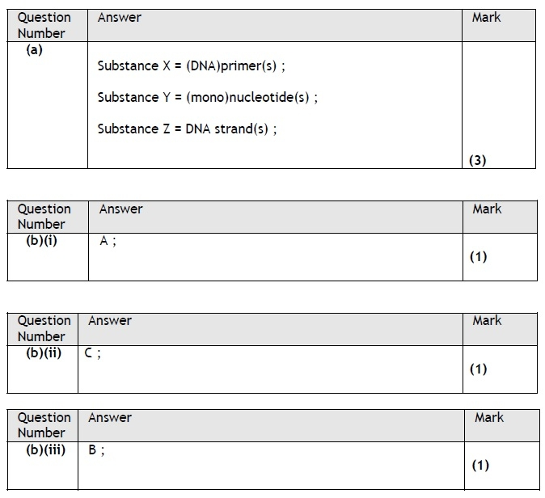
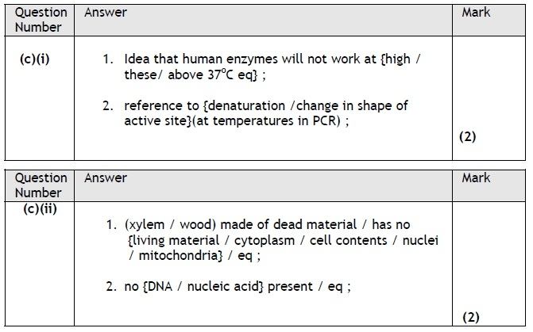

Q3.
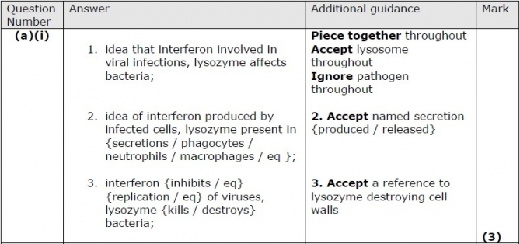
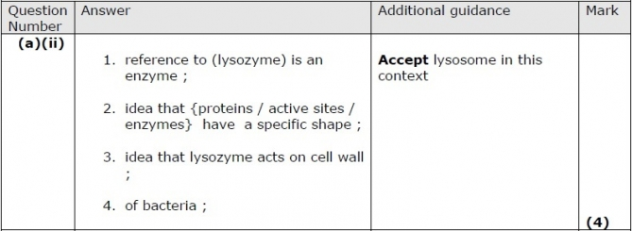
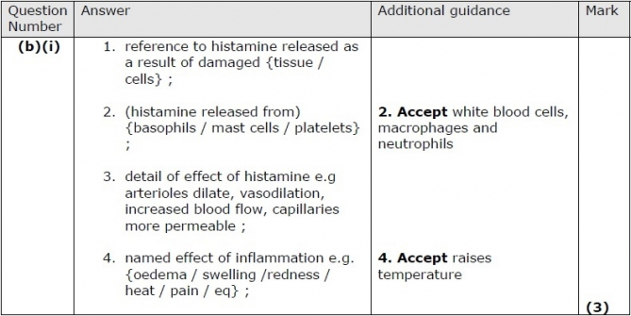
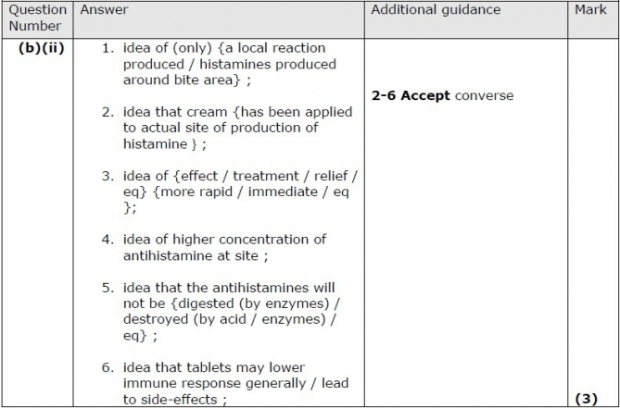

Q4.
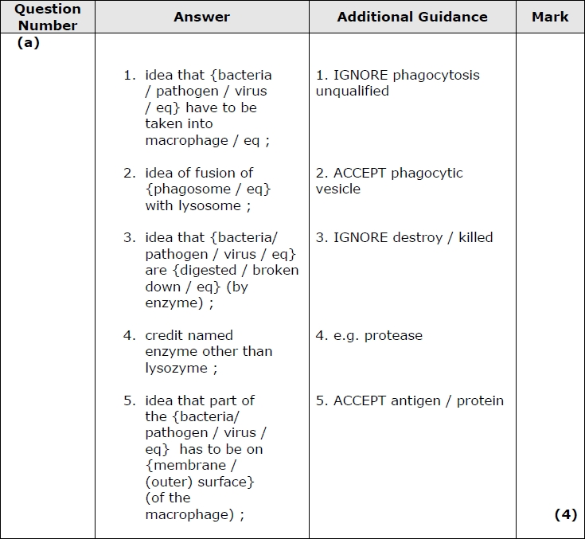
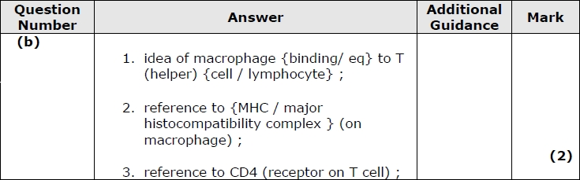
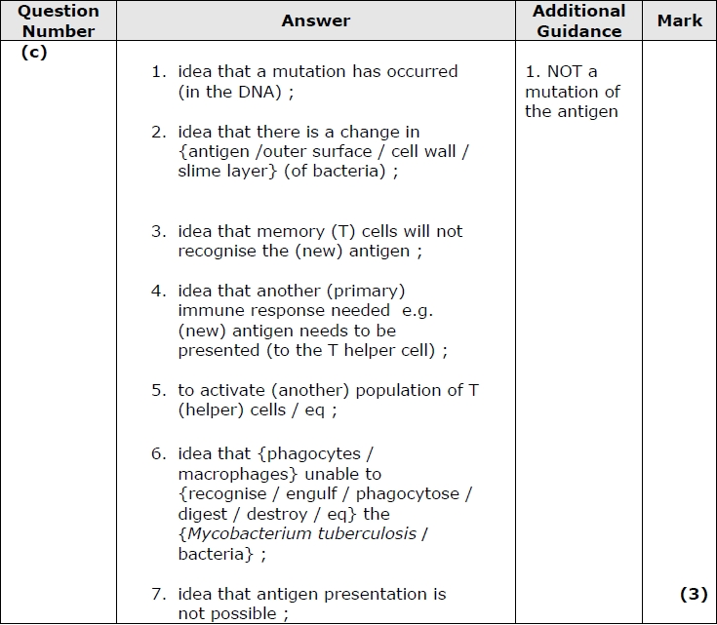

Q5.
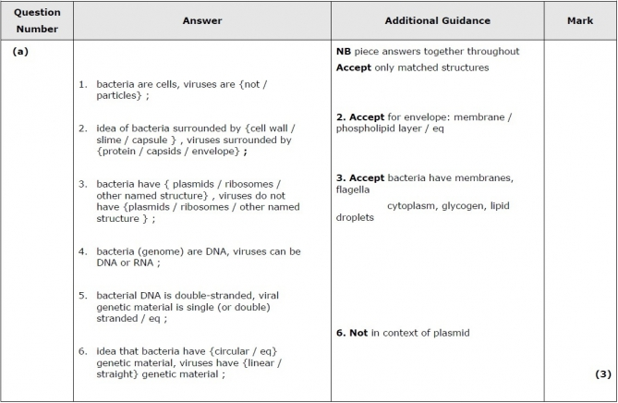
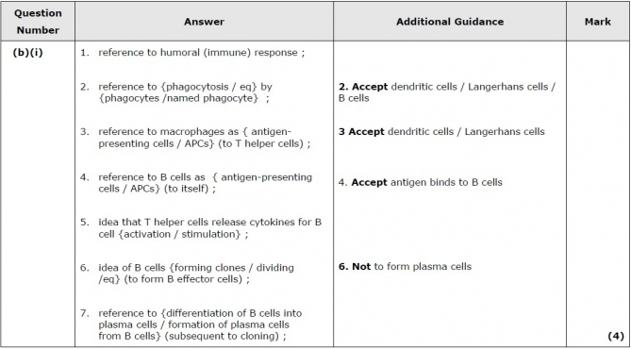
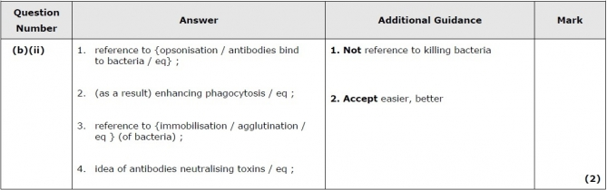
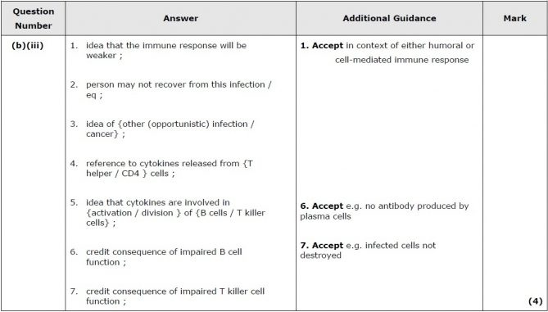

Q6.

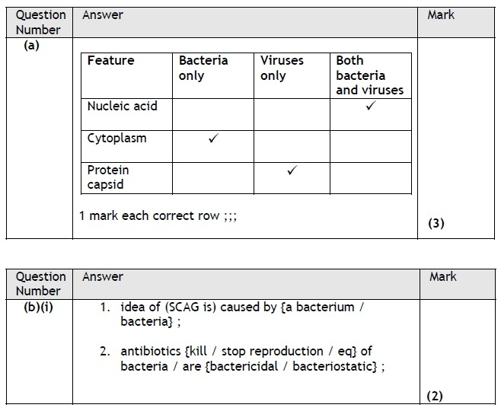
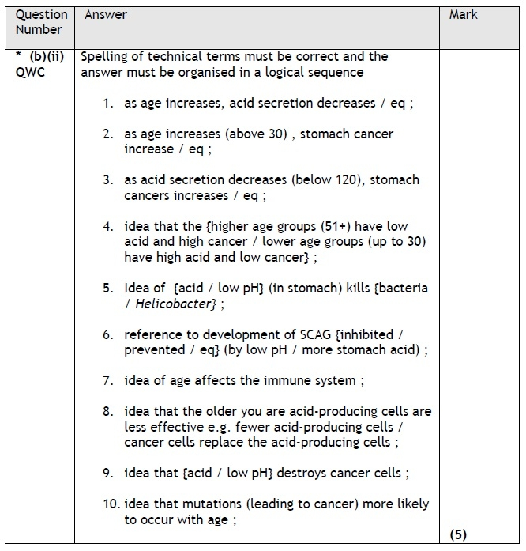

Q7:
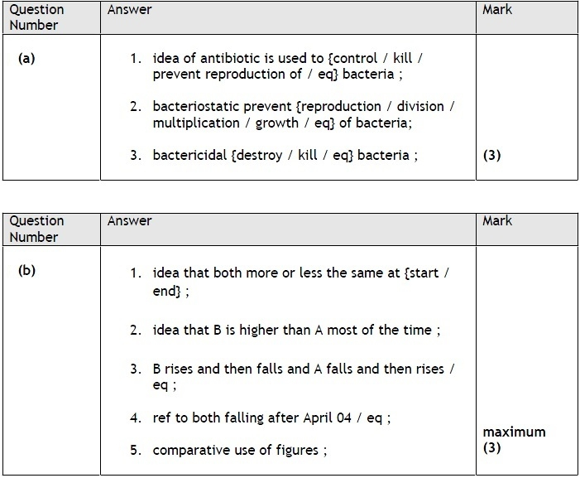
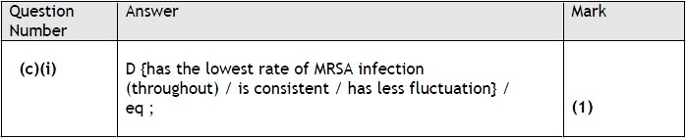
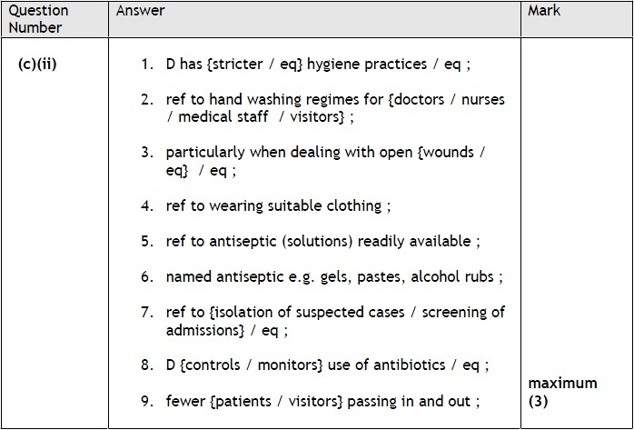

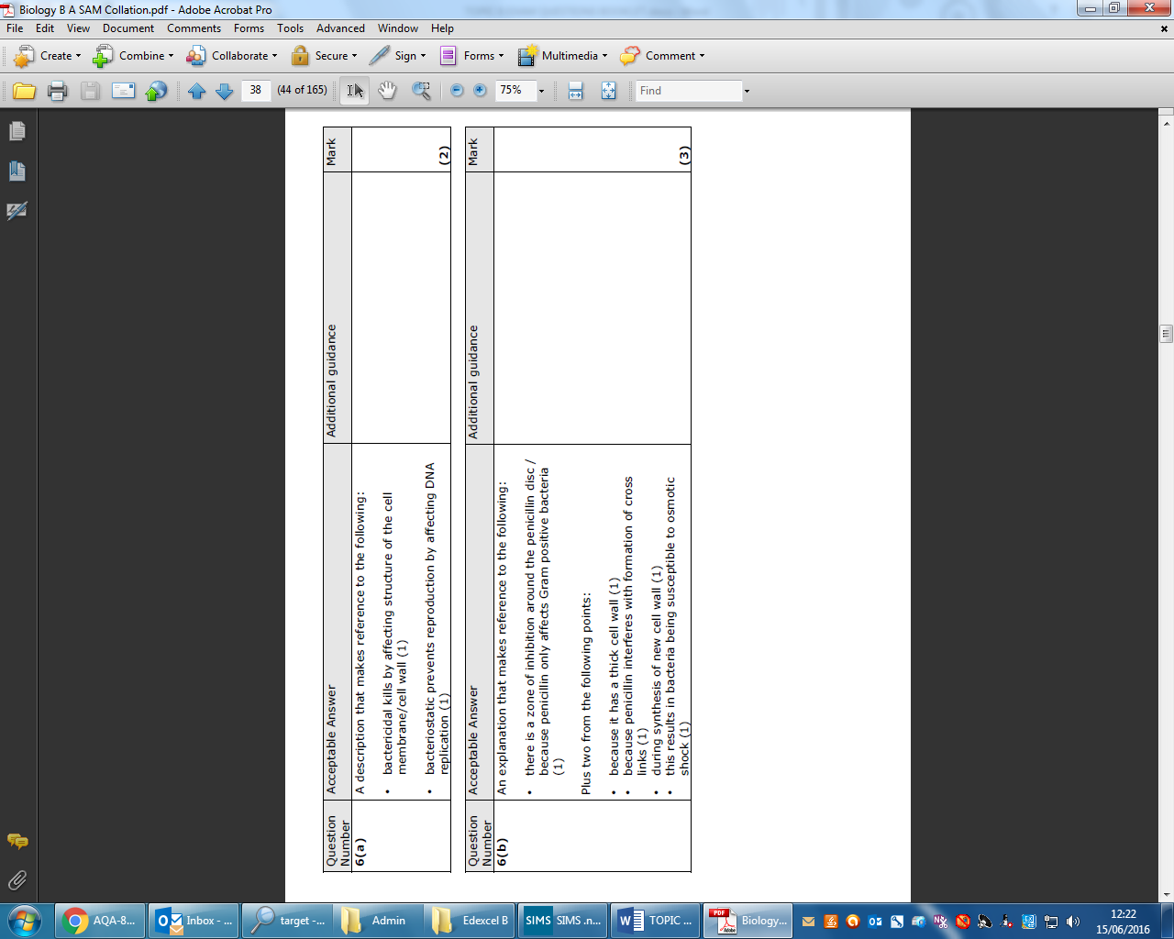
Q8.

Q9.

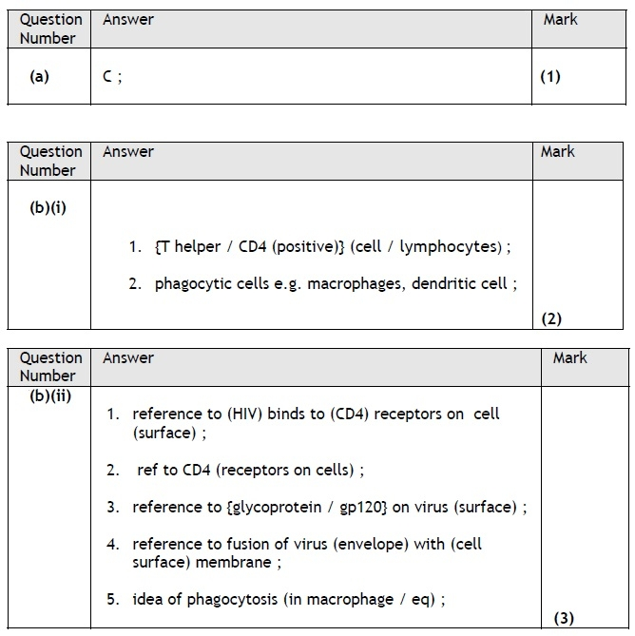
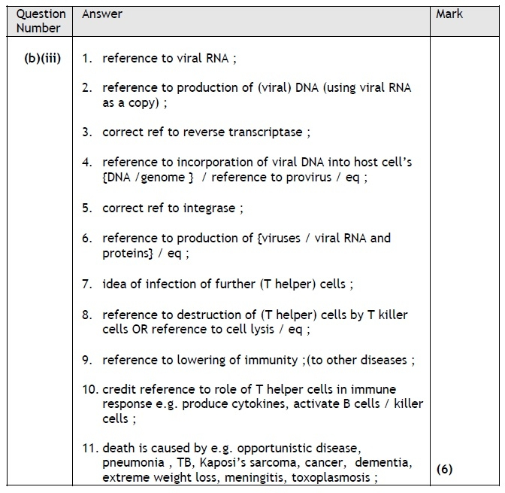

Q10.
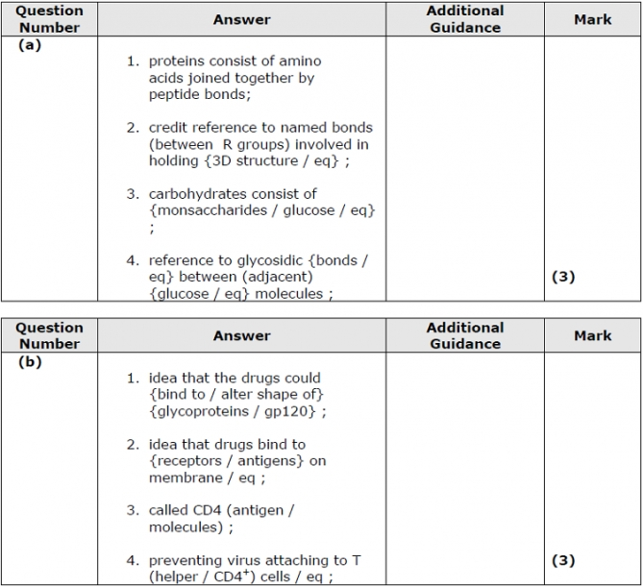
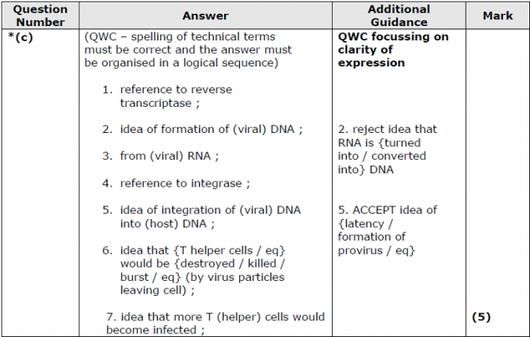

Q11.
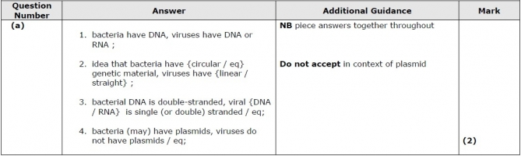
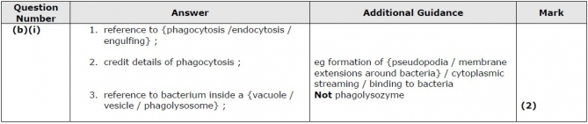
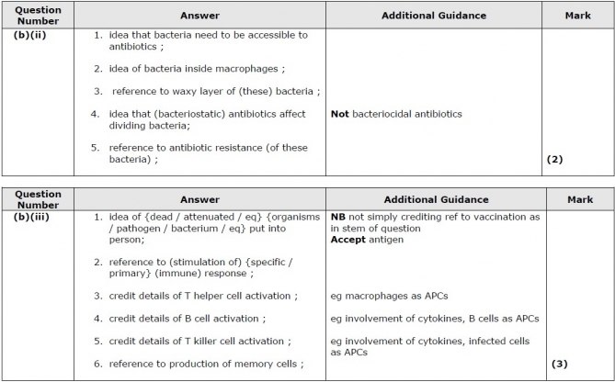
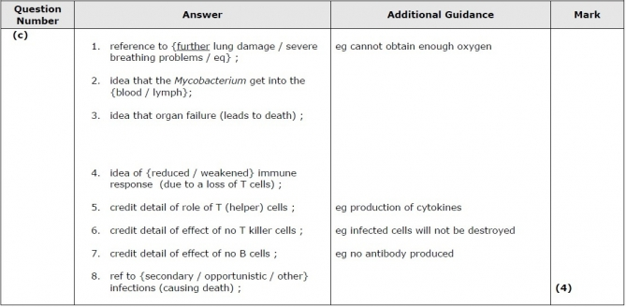

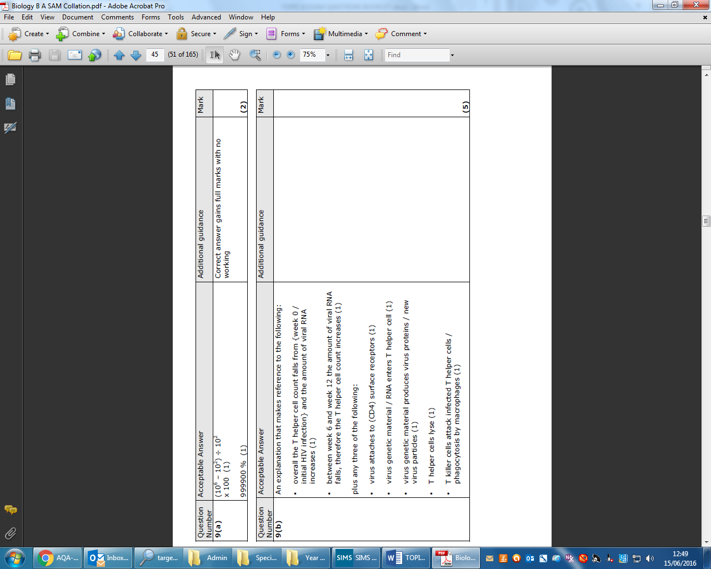
Q12.



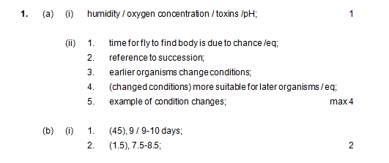
13
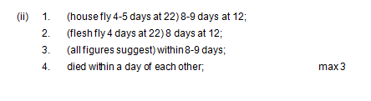

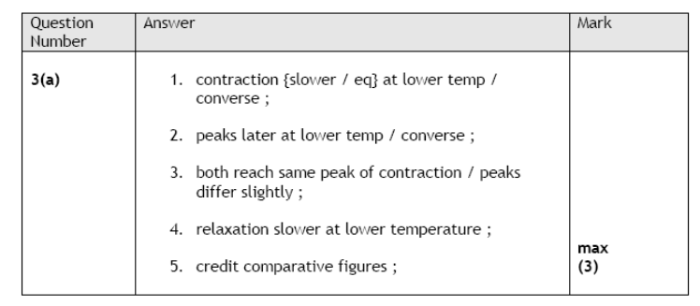
14

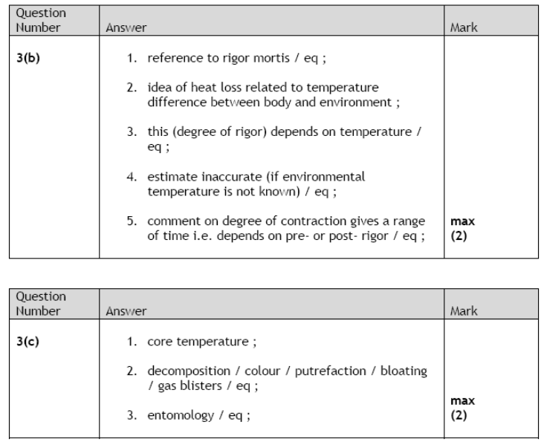

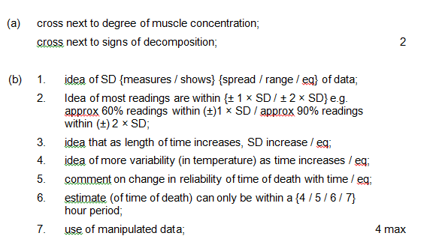
15

