BIOLOGY EXAM QUESTIONS BOOKLET



TOPIC 7

Centre Number |  | 12416
Candidate Number
Candidate forename |  | Candidate surname
Class
Teachers’ initials

Qu | Concept | Skill focus | Total Mark | Marks ach’d | Traffic Light | *Follow up task completed
1 | Joints | Recall | 9
2 | Muscles | Recall  QWC | 13
3 | Respiration | Recall | 6
4 | Respiration | Graph | 9
5 | Respiration | Core practical | 10
6 | Control of heart rate | QWC Graph | 11
7 | Control of heart rate | QWC | 8
8 | Muscles | Recall | 10
9 | Ventilation rate | Data analysis  Recall | 13
10 | Spirometer | Core practical | 14
11 | Thermoregulation and exercise | Graph  Analysis | 9
12 | Exercise and joints | Application | 7
13 | Transcription factors | Application | 9

*If the exam question has been traffic lighted as amber or red then you still need to work on this concept or skill area. You must follow this up by completing a task from below. Add the letter of the follow up task completed in the last column of the grid on your front page. Add the evidence in this booklet.

Potential review tasks include (increase in difficulty as you go down):

- Make notes on the concept of the question using a variety of different resources such as the various A-level textbooks in the library (not just the core SNAB textbook).

- Complete a worksheet on the skill or concept such as a worksheet from the Biozone booklet in the library. SNAB also has workbooks available to buy.

- Complete a Biological skills support sheet on the concept or skill from pearsonactivelearn.com

- Find another exam question on this concept or skill using the Biology exam question database on Moodle (password is Biology). Then google Edexcel SNAB Biology A past papers.

- Summarise the rules for answering a similar style of question using the examiners reports for exam questions on this concept or skill. Use the exam question database on Moodle as above to help you find the exam questions on this concept or skill and then find the examiner’s report for it.

- Make your own exam question and mark scheme on the concept or skill. Use current mark schemes to help you.

2
3

4

5

6

7

8

Q9.
When exercise begins, both ventilation rate and heart rate increase. This supplies more oxygen to muscles.
(a) (i) Describe how breathing rate and tidal volume can be determined from a spirometer trace.
(3)
.............................................................................................................................................
.............................................................................................................................................
.............................................................................................................................................
.............................................................................................................................................
.............................................................................................................................................
.............................................................................................................................................
.............................................................................................................................................
.............................................................................................................................................
.............................................................................................................................................
.............................................................................................................................................
(ii) Explain how you would use breathing rate and tidal volume to calculate ventilation rate.
(1)
.............................................................................................................................................
.............................................................................................................................................
.............................................................................................................................................
(b) An investigation was carried out to study the changes in oxygen uptake by the blood in the lungs after the first ten seconds of exercise.
Men with artificial pacemakers agreed to exercise with their heart rate controlled at 50 beats per minute. The ventilation rate and the oxygen uptake at rest were measured. These were also measured, after the first ten seconds of exercise and the differences recorded.
This was repeated with the heart rate controlled at 100 beats per minute.
The results are shown in the table below.
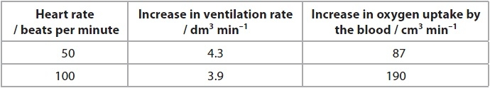
(i) State one factor, other than heart rate, that could have affected the rate at which blood passed through the heart.
(1)
.............................................................................................................................................
.............................................................................................................................................
(ii) Using the information in the table, describe the effect of an increase in heart rate on both the ventilation rate and oxygen uptake by the blood, after the first ten seconds of exercise.
(3)
.............................................................................................................................................
.............................................................................................................................................
.............................................................................................................................................
.............................................................................................................................................
.............................................................................................................................................
.............................................................................................................................................
(iii) Explain how an increased heart rate results in increased uptake of oxygen by the blood in the lungs.
(3)
.............................................................................................................................................
.............................................................................................................................................
.............................................................................................................................................
.............................................................................................................................................
.............................................................................................................................................
.............................................................................................................................................
.............................................................................................................................................
.............................................................................................................................................
(iv) What conclusions could be drawn from the results of this investigation?
(2)
.............................................................................................................................................
.............................................................................................................................................
.............................................................................................................................................
.............................................................................................................................................
.............................................................................................................................................
.............................................................................................................................................
.............................................................................................................................................
(Total for question = 13 marks)

Q10.
*(a) A spirometer can be used to measure tidal volumes and breathing rates.
The diagram below shows a spirometer.
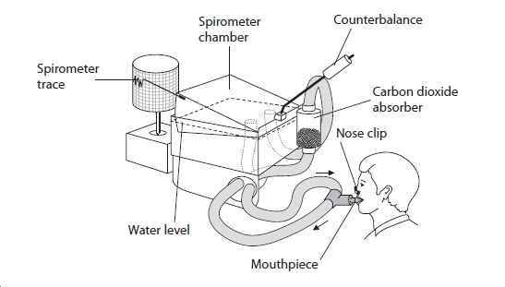
Explain how you would use the traces from this spirometer to compare the tidal volumes and breathing rates of male and female human subjects.
(6)
.............................................................................................................................................
.............................................................................................................................................
.............................................................................................................................................
.............................................................................................................................................
.............................................................................................................................................
.............................................................................................................................................
.............................................................................................................................................
.............................................................................................................................................
.............................................................................................................................................
.............................................................................................................................................
.............................................................................................................................................
.............................................................................................................................................
.............................................................................................................................................
(b) The peak expiratory flow (PEF) is a measure of how fast a person can breathe out.
This can indicate any obstruction in the airways of the lungs. It is measured using a peak flow meter.
The graph below shows the expected PEF values for people aged 15 to 85 years of various heights.
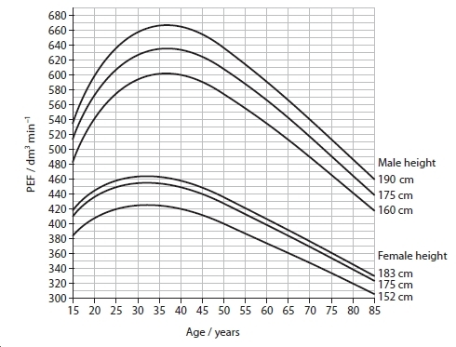
(i) Using the information in the graph, describe the effect of age on PEF.
(4)
.............................................................................................................................................
.............................................................................................................................................
.............................................................................................................................................
.............................................................................................................................................
.............................................................................................................................................
(ii) Using the information in the graph, give one reason for the difference in PEF values between ages 35 years and 85 years.
(1)
.............................................................................................................................................
.............................................................................................................................................
(iii) If a person with asthma has a PEF 30% below the expected value, it may indicate that their asthma is not under control.
A 52-year old man with asthma has a PEF reading of 350 dm³ min⁻¹.
Using the information in the graph, state whether or not his asthma is being kept under control. Give a reason for your answer.
(2)
.............................................................................................................................................
.............................................................................................................................................
.............................................................................................................................................
.............................................................................................................................................
(iv) Give one other piece of information that is needed before an accurate diagnosis of his asthma can be made.
(1)
.............................................................................................................................................
.............................................................................................................................................
(Total for question = 14 marks)

Q11.
Marathon runners can have difficulty with thermoregulation over the course of a 26 mile race, particularly on a hot day. Two marathon runners, A and B, had their core temperatures recorded during a race.
The graph below shows the core temperatures recorded during the race.
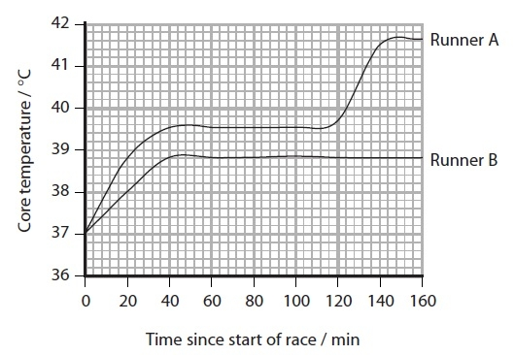
(a) Suggest an explanation for the change in core temperatures of both runners in the first 30 minutes of the race.
(2)
.............................................................................................................................................
.............................................................................................................................................
.............................................................................................................................................
.............................................................................................................................................
.............................................................................................................................................
(b) Suggest an explanation for the constant core temperatures of both runners between 60 and 100 minutes of this race.
(5)
.............................................................................................................................................
.............................................................................................................................................
.............................................................................................................................................
.............................................................................................................................................
.............................................................................................................................................
.............................................................................................................................................
.............................................................................................................................................
.............................................................................................................................................
.............................................................................................................................................
.............................................................................................................................................
.............................................................................................................................................
.............................................................................................................................................
.............................................................................................................................................
.............................................................................................................................................
.............................................................................................................................................
.............................................................................................................................................
(c) During this race, runner A lost 3.02 kg of water and runner B lost 2.43 kg of water.
Using the information in the question and your own knowledge, suggest reasons for the change in core temperature of runner A after 120 minutes.
(2)
.............................................................................................................................................
.............................................................................................................................................
.............................................................................................................................................
.............................................................................................................................................
.............................................................................................................................................
.............................................................................................................................................
(Total for question = 9 marks)

Q12.
(a) The knee and the elbow are both hinge joints.
The diagram below shows an elbow joint.
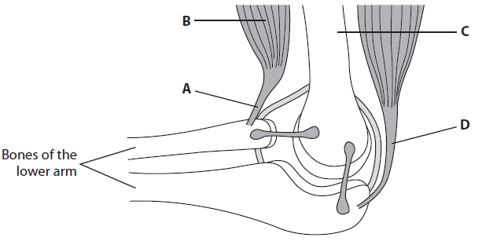
For each of the following questions, place a cross in the box that identifies the structure.
(i) The tendon attached to the flexor muscle is
(1)
A
B
C
D
(ii) A ligament is attached to
(1)
A
B
C
D
(iii) The structure with cells containing many nuclei is
(1)
A
B
C
D
(b) Moderate exercise is good for the health of a person.
(i) Give two reasons why too little exercise may not be good for the health of a person.
(2)
.............................................................................................................................................
.............................................................................................................................................
.............................................................................................................................................
.............................................................................................................................................
.............................................................................................................................................
.............................................................................................................................................
(ii) Give two reasons why too much exercise may not be good for the health of a person.
(2)
.............................................................................................................................................
.............................................................................................................................................
.............................................................................................................................................
.............................................................................................................................................
.............................................................................................................................................
.............................................................................................................................................

(Total for question = 7 marks)

Q13.
Induced pluripotent stem cells (iPS cells) are a new type of stem cell.
(a) To produce iPS cells, four genes that code for different transcription factors are added to the genome of somatic (body) cells. The transcription factors produced cause the somatic cells to be converted into iPS cells.
(i) Suggest why it may be better to produce differentiated cells from iPS cells than from pluripotent stem cells.
(2)
.............................................................................................................................................
.............................................................................................................................................
.............................................................................................................................................
.............................................................................................................................................
.............................................................................................................................................
.............................................................................................................................................
(ii) Explain how these transcription factors may cause the somatic cells to be converted into iPS cells.
(4)
.............................................................................................................................................
.............................................................................................................................................
.............................................................................................................................................
.............................................................................................................................................
.............................................................................................................................................
.............................................................................................................................................
.............................................................................................................................................
.............................................................................................................................................
.............................................................................................................................................
.............................................................................................................................................
.............................................................................................................................................
.............................................................................................................................................
(b) In 2013, it was discovered that a mixture of seven chemicals could be added to somatic cells to cause them to develop into iPS cells rather than the need to add genes to their genome.
Suggest how a valid comparison of these two techniques could be carried out to discover which may be more effective for converting somatic cells into iPS cells.
(3)
.............................................................................................................................................
.............................................................................................................................................
.............................................................................................................................................
.............................................................................................................................................
.............................................................................................................................................
.............................................................................................................................................
.............................................................................................................................................
.............................................................................................................................................
.............................................................................................................................................
.............................................................................................................................................

(Total for question = 9 marks)

