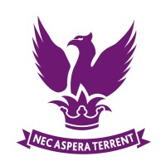
Drayton Manor High School
A-level Further Mathematics
Year 12 into Year 13 Summer Work

- Make sure you have completed all the exercises in chapter 1 of the Core Pure 2 textbook, including the mixed exercise.

- (If you were not in the feedback lesson) Correct your UCAS exam paper, complete the QLA and answer the feedback questions.

- Answer questions 1, 2, 3, 8, 9 and 10 in the 2023 AS paper. (The other questions were included in the UCAS exam.)

You should bring all of these to the first lesson back in year 13.

If you have any questions, please e-mail Dr Blair
ANB@draytonmanorhighschool.co.uk

