BIOLOGY YEAR 2

CORE PRACTICALS



Centre Number |  | 12416
Candidate Number
Candidate forename |  | Candidate surname
Class
Teachers’ initials

Core practical number | Criteria met? (Y/N/WT) |  |  |  |  |  |  |  |  |  |  |  | Topic | Exam qu
Core practical number | 1a | 2a | 2b | 2c | 2d | 3a | 3b | 3c | 4a | 4b | 5a | 5b | Topic | Exam qu
10 |  |  |  |  |  |  |  |  |  |  |  |  | 5 | 3
11 |  |  |  |  |  |  |  |  |  |  |  |  | 5 | 7
12 |  |  |  |  |  |  |  |  |  |  |  |  | 5 | 13
13 |  |  |  |  |  |  |  |  |  |  |  |  | 5 | 14
14 |  |  |  |  |  |  |  |  |  |  |  |  | 6 | 6
15 |  |  |  |  |  |  |  |  |  |  |  |  | 6 | 7
16 |  |  |  |  |  |  |  |  |  |  |  |  | 7 | 5
17 |  |  |  |  |  |  |  |  |  |  |  |  | 7 | 7
18 |  |  |  |  |  |  |  |  |  |  |  |  | 8 | 8

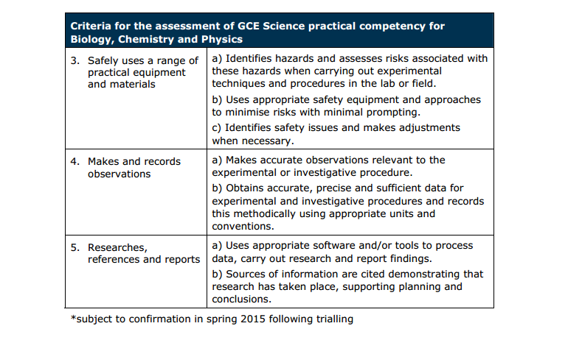

TOPIC 5

CORE PRACTICAL 10: Carry out a study on the ecology of a habitat, including using quadrats and transects to determine distribution and abundance of organisms, and measuring abiotic factors appropriate to the habitat.
CPAC criteria focus for the lesson:

(2a) correctly uses appropriate instrumentation, apparatus and materials to carry out investigative procedures, experimental techniques and procedures with minimal assistance.
(3a) Identifies hazards and assesses risks associated with these hazards when carrying out experimental techniques and procedures in the field
(5a) Uses appropriate software and/or tools to process data, carry out research and report findings.

Looking for patterns
Purpose
- To carry out a study on the ecology of a habitat.
- To develop practical skills.
Observing patterns
Have you ever walked into a wood and noticed that the vegetation changes as you enter? Why do the bluebells only occur under the trees? Or have you been clambering over a rocky shore and spotted that the seaweeds grow in distinctive bands, and that you only find mussels when the tide is far out? What causes these patterns in plant and animal distribution? When ecologists study habitats they try to account for plant and animal distribution, correlating them to the abiotic and biotic factors that are affecting the habitat.
Abiotic means ‘non-living’ and examples of abiotic factors include light intensity, slope, humidity, wind exposure, edaphic (soil) characteristics, such as pH and soil moisture, and many more. Biotic means ‘living’ and examples of biotic factors include competition, grazing and predation. All species of plants and animals you encounter in the wild are very well adapted to the set of conditions encountered in their usual habitat. If they weren’t they would either grow somewhere else or become extinct.
Studying patterns
Look around your local habitats and spot any patterns in distribution and abundance of organisms. You do not need to go far; you might notice something in your school grounds or the local park. You might have a look at the distribution of plants in trampled areas of the sports field or grass paths; are there any patterns that you could investigate?
1 Scientific questions and information research
- State what you are going to investigate – once you have identified a pattern and thought about why it might have come about, you should express this as a question to answer, a problem to investigate or a hypothesis to test.
- Research relevant information – once you have described the pattern, you need to use appropriate biological ideas to suggest an explanation for the pattern and to help you decide on the question or hypothesis you are going to investigate. You will also need to research how you will carry out the practical work and methods other people have used to investigate similar problems. Read the information on pages 2 and 3, which briefly mention some of the techniques that could be used. There is more detail in Practical Skills Support Sheet 6 – ecological sampling. You can also look at the weblinks that accompany this activity for more information about sampling techniques. SAPS and the Field Studies Council websites have online resources for students including detailed information on fieldwork techniques.
When you write up your plan remember to give full details of any information sources you use and comment on their reliability.
2 Planning and experimental design
- Design an experiment that you can use to complete your investigation – use the Developing Practical Skills Support on SNAB Online to help you plan a fieldwork investigation to test your idea.
When planning any investigation you need to:
- decide what data you are going to collect
- select a procedure that uses suitable apparatus and methods to test your question or problem
- say what measurements you will make, how they will be made, and the level of accuracy that you can expect in your measurements
- ensure you are going to collect valid data
- identify any variables that may affect the outcome of the experiment and, where possible, controls or allows for them
- identify any potential sources of error (systematic or random) and how errors can be minimised.
- decide how you will analyse the data once it has been collected
- complete a risk assessment and decide on steps to avoid or minimise any risks, including both risks to the organisms and environments being sampled (injury, death, discomfort, damage) and any risks for the researcher undertaking the investigation
- conduct a trial to inform your planning.
Have your plan checked by your teacher/lecturer before you start the fieldwork.
3 Carrying out practical work safely and ethically
Either use the plan you have created after it has been checked by your teacher/lecturer or use a method supplied by your teacher/lecturer. If unexpected ethical or safety issues arise deal with them sensibly, taking advice where needed and make a note of them. Note any possible errors.
4 Analysis and interpretation of data
When you have collected your data, you must present it in an appropriate way to help you to identify any patterns in the data. For transect data you can draw kite diagrams by hand or use a computer programme.
Analyse your data to reveal any patterns and explain the main relationships between species and abiotic factors, using scientific knowledge and statistics. Determine if your original hypothesis was correct. If you are comparing mean values for two sites you can determine if there are significant differences between the means by using a t-test. If you have suitable data, you can calculate correlation coefficients between your biotic and abiotic data. For example, you can see if there is a significant positive or negative correlation between the factor you think is responsible for the pattern and the distribution of the organisms you have recorded. Remember that correlations do not prove cause and effect.
For information on correlation coefficients, t-tests and other statistical techniques see the Maths and Stats Support.
5 Conclusion and evaluation
In your write-up, interpret your results using biological principles and concepts. Support any conclusions you make with results. Discuss the limitations of your results and conclusions based upon them, and suggest modifications that you could make to the procedure.
Some techniques for studying patterns
Completing a transect study
One of the easiest patterns to spot is zonation in vegetation and animal distribution – as you go from one place to another the vegetation and animal distribution changes. A zonation can often be explained by a gradual change (a gradient) in one or more physical or abiotic factors. A transect is often used to study zonation in vegetation or non-mobile animal distribution. A transect is a line along which systematic samples can be taken (Figure 1) usually using quadrats to determine the areas where the distribution and abundance of an organism will be sampled.
When planning a transect study you need to be sure you are collecting valid data that will test your hypothesis. You need to make the following decisions.
- The most appropriate sampling method to use (for example, random or systematic sampling).
- The position and length of any transect to use. You need to make sure your transect extends far enough to sample all the possible zones.
- The size and number of quadrats to use, and their positioning.
- The species of plants and animals you are to record. You can focus on those which would enable you to test the hypothesis under investigation (you may need to find out more about the species concerned using secondary sources).
- The method to use for measuring the abundance of each species.
- The abiotic factor(s) you are going to record. Although you may be investigating the correlation between, for example, soil moisture and the distribution of plant species, there may be other factors that could affect the distribution of organisms. It is not possible to control these variables, but you can measure them and take them into account when analysing your results.
- The appropriate method for measuring the abiotic factor(s).
- How the data will be analysed.
- How to avoid or minimise any risks when completing the fieldwork.
A pilot study in advance of the main data collection will help you make these decisions.
For details on sampling techniques, see Practical Skills Support 6 – ecological sampling – and the weblinks that accompany this activity for more detail on the use of quadrats and other sampling techniques.
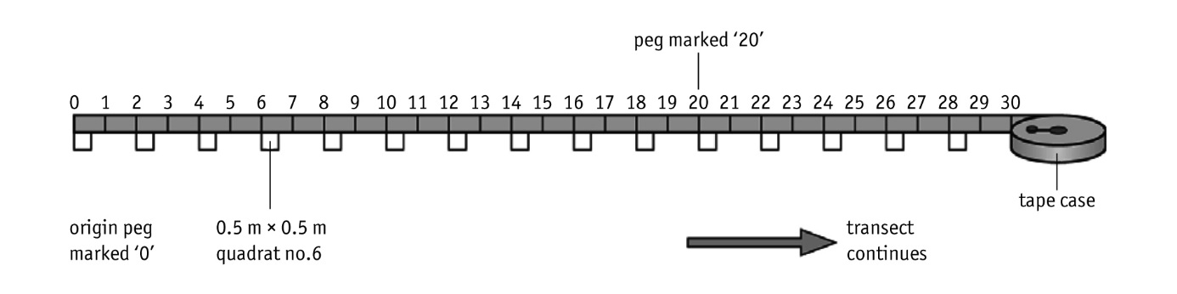
Figure 1 One way of laying out a tape measure for a transect study. Quadrats are laid down at regular intervals along the tape and the abundance of species within each quadrat is recorded.
Comparing two sites
Frequently, ecologists may notice a distinct pattern that does not show a gradual change and may be related to one or more factors at the two sites. For example, the vegetation in one area of a field may be very different to the rest of the field, or the species found upstream and downstream of an outflow pipe discharging into a river may seem to differ. A transect may not be the best method for this type of investigation; instead random sampling of each area may be more appropriate with comparison of the data collected for each area. Quadrats are frequently used to sample a larger area: information recorded from quadrats provides a representative sample of organisms' distribution and abundance for the whole area.

STUDENT NOTES:





CORE PRACTICAL 11: Investigate photosynthesis using isolated chloroplasts (the Hill reaction).
CPAC criteria focus for the lesson:

(2b) Carries out techniques or procedures methodically, in sequence and in combination, identifying practical issues and making adjustments when necessary.
(2d) selects appropriate equipment and measurement strategies in order to ensure suitable accurate results.
(3b) Uses appropriate safety equipment and approaches to minimise risks with minimum with minimal prompting.

Investigating photosynthesis
Purpose
- To investigate experimentally the link between the light-dependent and light-independent reactions.
Safety
DCPIP solution can stain, so avoid skin contact.
Wear eye protection.
Ensure the centrifuge has stopped before inserting or removing the tubes.
Write a risk assessment including any safety precautions. Discuss this with your teacher
before starting.
YOU NEED
- Fresh green spinach, lettuce or cabbage leaves  - Scissors  - Cold pestle and mortar (or blender or food mixer) which has been kept in a freezer compartment for 15–30 minutes (if left too long the extract may freeze)  - Muslin or fine nylon mesh  - Filter funnel  - Centrifuge and centrifuge tubes  - Ice-water-salt bath  - Glass rod or Pasteur pipette | - Measuring cylinder, 20 cm³  - Beaker, 100 cm³  - Pipettes, 5 cm³ and 1 cm³  - Bench lamp with 100 W bulb  - 0.05 M phosphate buffer solution, pH 7.0  - Isolation medium (sucrose and KCl in phosphate buffer)  - DCPIP solution
Using isolated chloroplasts
It is fairly easy to show that plants produce oxygen and starch in photosynthesis. At KS4 you may have collected the gas given off by Canadian pondweed (Elodea) and tested leaves for starch. It is not quite so easy to demonstrate the other reactions in photosynthesis. In this experiment, DCPIP
(2,6-dichlorophenolindophenol), a blue dye, acts as an electron acceptor and becomes colourless when reduced. DCPIP solution is added to isolated chloroplasts allowing any reducing agent produced by the chloroplasts to be detected. In the cell, NADP is the electron acceptor that is reduced in the light-dependent reactions and provides electrons and hydrogen for the light-independent reactions. This reaction was first demonstrated in 1938 by Robert (known as Robin) Hill and is often called the Hill Reaction.
1 Scientific questions and information research
Before you start the experiment you should research the background science relevant to the light-dependent and light-independent reactions of photosynthesis. You should think about the role of DCPIP in the experiment. It may help to look back at Activity 1.25 which used DCPIP to investigate the content of vitamin C in fruit juice.
Read through the procedure and predict what will happen in each of the five tubes, and give a reason to explain your prediction.
2 Planning and experimental design
Go through the procedure below and consider the following points. Explain your answers in each case.
- Is the apparatus and procedure appropriate for the investigation?
- What observations or measurements will you make and how will they be made?
- Are there any safety issues in the use of the apparatus?
- How would you reduce any risks identified?
Procedure
Isolating chloroplasts
Follow the instructions below to isolate chloroplasts from leaves. This may have already been done for you.
NB Keep solutions and apparatus constantly cold during the extraction procedure, steps 1–8, to preserve enzyme activity. The extraction should also be carried out as quickly as possible.
1 Cut three small green spinach, lettuce or cabbage leaves into small pieces with scissors, but discard the tough midribs and leaf stalks. Place in a cold mortar or blender containing 20 cm³ of cold isolation medium (scale up quantities for blender if necessary).
2 Grind vigorously and rapidly (or blend for about 10 s).
3 Place four layers of muslin or nylon in a funnel and wet with cold isolation medium.
4 Filter the mixture through the funnel into the beaker and pour the filtrate into pre-cooled centrifuge tubes supported in an ice-water-salt bath. Gather the edges of the muslin, wring thoroughly into the beaker and add filtrate to the tubes.
5 Check that each centrifuge tube contains about the same volume of filtrate.
6 Centrifuge the tubes for sufficient time to get a small pellet of chloroplasts (10 minutes at high speed should be sufficient).
7 Pour off the liquid (supernatant) into a boiling tube being careful not to lose the pellet. Re-suspend the pellet with about 2 cm³ of isolation medium, using a glass rod. Squirting in and out of a Pasteur pipette five or six times gives a uniform suspension.
8 Store this leaf extract in an ice-water-salt bath and use as soon as possible.
Using the chloroplasts
9 Read all the instructions before you start.
Note: The DCPIP solution should be used at room temperature.
10 Set up five labelled tubes as follows:
Tube | Leaf extract/  cm³ | Supernatant/cm³ | Isolation medium/cm³ | Distilled water/cm³ | DCPIP solution/cm³
1 | 0.5 | – | – | – | 5
2 | – | – | 0.5 | – | 5
3 | 0.5 | – | – | – | 5
4 | 0.5 | – | – | 5 | –
5 | – | 0.5 | – | – | 5
11 When the DCPIP is added to the extract, shake the tube and note the time. Place tubes 1, 2 and 4 about 12–15 cm from a bright light (100 W). Place tube 3 in darkness. Note any changes observed in the five tubes. Make any appropriate measurements to allow comparisons between the tubes.
12 Describe any unexpected safety issues that arose in carrying out the practical work. Explain how you dealt with them, including any advice you sought in dealing with them.
Analysis and interpretation of data
Present all your results in the most suitable format.
Conclusion and evaluation
In the write-up of your experiment, make sure your report includes:
- a clear conclusion to your work which is supported by evidence from the data and your own biological knowledge
- comments on how valid your conclusion is
- comments on the accuracy and precision of the results obtained in this experiment
- comments on whether or not the outcome of your work was as you expected – and if it wasn’t, try to explain why not
- discussion about any safety precautions you took during the experiment
- descriptions of any modifications you made to the procedure and how the experiment could be improved.
Questions
Q1 The rate of photosynthesis in intact leaves can be limited by several factors, including light, temperature and carbon dioxide. Which of these factors will have little effect on the reducing capacity of the leaf extract?
Q2 Describe how you might extend this practical to investigate the effect of light intensity on the light-dependent reactions of photosynthesis.

STUDENT NOTES:

CORE PRACTICAL 12: Investigate the effect of temperature on the initial rate of an enzyme-catalysed reaction, to include Q10.
CPAC criteria focus for the lesson:

(2c) identifies and controls significant quantitative variables where applicable, and plans approaches to take account of variables that cannot readily be controlled.
(4b) Obtains accurate, precise and sufficient data for experimental and investigative procedures and records this methodically using appropriate units and conventions.
(5b) sources of information are cited demonstrating that research has taken place, supporting planning and conclusions.

Investigating the effect of temperature on enzyme activity
Purpose
- To investigate the effect of temperature on the initial rate of reaction of an enzyme-controlled reaction.
- To calculate Q₁₀ for an enzyme-controlled reaction.
Safety


Hydrogen peroxide is an irritant and dangerous if swallowed.
Wear eye protection and avoid contact with skin or clothes.
Write a risk assessment including any safety precautions. Discuss this with your teacher
before starting. See CLEAPSS Student Safety Sheet 57 for further information.
Initial rate of reaction and Q₁₀
In this activity you will plan and carry out an investigation into the effect of temperature on the initial rate of an enzyme-catalysed reaction, which can be quantified by calculating the temperature coefficient for the reaction. This is known as the Q_{10.} It indicates how much the rate of reaction increases with a 10 °C increase in temperature. You will be focusing on the enzyme catalase, which is found in almost all living tissues. Catalase breaks down hydrogen peroxide (H₂O₂), a toxic metabolic by-product, into water and oxygen. Collecting and measuring the volume of oxygen gas produced is relatively easy and can be used to work out the rate of reaction.
Scientific questions and information research
Research relevant information and state what you are going to investigate.
Before you start planning your experiment you should decide what effect you think temperature will have on the rate of breakdown of hydrogen peroxide catalysed by the enzyme catalase. Write down your idea as a question or hypothesis that you can answer or test and support your idea with biological knowledge. If you present your idea as a question make a prediction about the answer to the question. To help you decide on what you are going to investigate and how you will carry out the practical work you might need to research the background science and methods people have used to investigate similar problems. You will need to consider how to calculate initial rates of reaction and also Q₁₀.
Planning and experimental design
Design an experiment to test your idea or hypothesis and write a detailed plan to use during the investigation. Your experiment will need to give you sufficient data to determine initial rate of reaction at different temperatures. Your experimental data should also allow you to calculate Q₁₀ for the reaction. If possible, trial the reaction and the equipment before you embark on detailed planning, as this will allow you to be more realistic, and spot any design flaws. Trialling can help establish volumes, concentrations, timings and practical set-ups to use in your method.
THE FOLLOWING EQUIPMENT WILL BE AVAILABLE
- Soaked peas  - Hydrogen peroxide solution  - Distilled water  - Crushed ice  - 10 cm³ syringes  - Rubber tubing  - Screw clip or three-way tap  - Test tubes  - Boiling tubes  - 100 and 250 cm³ beakers  - Graduated pipettes  - Syringes  - Measuring cylinders | - Thermometers  - Stopclocks  - Delivery tubes with bungs to fit the boiling tubes or test tubes  - Access to a balance  - Glass rods  - Forceps  - Water baths at a range of temperatures  - Pestle and mortar  - Clamp stand with boss and clamp  - Other basic laboratory equipment, i.e. Bunsen burners, test tube racks, etc.  - You may have access to a gas syringe
You do not have to use all of the equipment listed. You should get your plan checked by your teacher/lecturer before starting the practical work, but it can be modified during the investigation.
Make sure your plan:
- includes apparatus and a method that will validly answer your question or test your hypothesis
- identifies the independent and dependent variables
- identifies any other variables that may affect the outcome of the experiment and, where possible, controls or allows for them
- includes the range of values you will use for the independent variable and the range you might expect to find for the dependent variable
- has a fully explained control, if appropriate
- includes replicates, if appropriate, and an explanation of why these are necessary
- says exactly what measurements you will make and how they will be made to ensure valid, accurate and precise results are obtained
- says how you will process your data, including how you will calculate initial rate of reaction and how you will use this to calculate Q₁₀
- provides information about any possible sources of error and how these can be minimised
- includes your risk assessment that identifies any safety issues and describes how any risks will be reduced.
Have your plan checked by your teacher/lecturer before you start the experiment.
Performing the experiment
Either use the plan you have created after it has been checked by your teacher/lecturer or use a method supplied by your teacher/lecturer.
Analysis and interpretation of data
Present your results in the most appropriate way in order to show how the initial rate of reaction varies with temperature.
Calculate a Q₁₀ value for the enzyme catalase (remember that you can only do this up to the optimum temperature; beyond this the Q₁₀ relationship does not hold).
Conclusion and evaluation
Explain any trends or patterns with evidence from your data. Discuss your findings with reference to your question or problem.
State a clear conclusion to your work, summarising what you have found. Support your statements with evidence from your results and relevant biological knowledge.
Comment on any systematic or random errors in the data.
Evaluate your experimental apparatus and methods, commenting on the accuracy and precision of your results.
Propose any changes to the procedure that would improve the quality of the results.
Suggest further experimental work you could carry out to extend your understanding of enzyme activity and temperature.

STUDENT NOTES:

CORE PRACTICAL 13: Investigate the effects of temperature on the development of organisms (such as seedling growth rate, brine shrimp hatch rates).
CPAC criteria focus for the lesson:

(1a) Correctly follows instructions to carry out the experimental techniques or procedures.
(2d) selects appropriate equipment and measurement strategies in order to ensure suitable accurate results.
(4a) Makes accurate observations relevant to the experimental or investigative procedure.

The effect of temperature on the hatching success of brine shrimps
Purpose
- To investigate the effect of temperature on the hatching success of brine shrimps.
Safety
Write a risk assessment detailing any safety precautions. Include consideration of any
ethical issues arising from the use of living organisms. Discuss this with your teacher
before starting.
Wash your hands thoroughly after handling the organisms and before you leave the
laboratory.
Brine shrimps
Brine shrimps are small, salt water crustaceans; the adults are about 8 mm in length. They are relatively easy to keep in the laboratory and will produce dormant egg cysts that hatch to produce young shrimp larvae.
YOU NEED
- Brine shrimp egg cysts  - 2 g sea salt for each treatment  - 100 cm³ de-chlorinated water for each treatment  - 40 cm³ beaker of salt water  - 100 cm³ beakers (one for each temperature to be tested)  - Water baths or incubators (one for each temperature to be investigated) | - Stirring rod  - Magnifying glass  - Pair of forceps  - Fine glass pipette  - Bright light  - Access to refrigerator  - Sheet of graph paper 3 cm × 4 cm
To find out more about brine shrimps, visit the British Ecological Society website, which you can access by going to the weblinks for this activity.
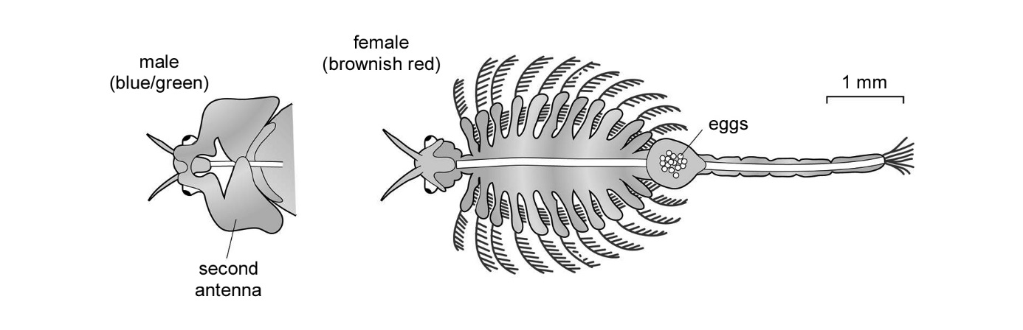
Figure 1 Drawings to show the features of a brine shrimp.
Planning and experimental design
Read through the procedure provided below and assess its suitability for investigating the effect of temperature on the hatching of brine shrimps. Make sure you think about the following points: variables, suitability of the apparatus and method to provide accurate and precise results, and any sources of error. Write a risk assessment as detailed in the safety notes above.
Procedure
1 Decide on a range of temperatures from 5 °C to 35 °C to be tested.
2 Place 2 g of sea salt into a 100 cm³ beaker.
3 Add 100 cm³ of de-chlorinated water and stir until the salt completely dissolves.
4 Label the beaker with the temperature at which it will be incubated.
5 Place a tiny pinch of egg cysts onto a large sheet of white paper.
6 Wet the piece of graph paper using a few drops of salt water. Dab the paper onto the white sheet to pick up approximately 40 eggs. This will look like a tiny shake of pepper. Use a magnifying glass to count the eggs. Cut the graph paper so that there are exactly 40 eggs.
7 Put the paper with the 40 eggs into the beaker (eggs-side down). After 3 minutes, use a pair of forceps to gently remove the paper, making sure that all the egg cysts have washed off into the water.
8 Repeat steps 2 to 7 for all the temperatures that are to be investigated.
9 If possible, replicate the treatments.
10 Incubate the beakers at the appropriate temperatures. In the ICT Support there is a datalogging sheet on monitoring temperature in a long-term investigation. Set an alarm to remind you to check your brine shrimps at the same time on three or four successive days.
11 The next day count the number of hatched larvae in each of the beakers. To do this, place a bright light next to the beaker. Any larvae will swim towards the light. Using a fine glass pipette, reversed with the tip inserted into the teat, catch the hatched brine shrimps and place them in a small beaker of salt water. Repeat the counting daily. Brine shrimps are very delicate and care must be taken when handling them. Finally, release the young brine shrimps into a salt water aquarium.
12 Record the number of larvae that have successfully hatched at each temperature.
13 Write-up your experiment making sure your report includes:
- a discussion of any safety precautions taken
- comments on the ethical issues arising from the use of living organisms
- results presented in the most appropriate way
- an explanation of any patterns in the data using evidence from the data and your own biological knowledge
- details of any statistical analysis of the results
- comments on how valid your conclusion is
- comments on how you ensured that the results obtained in this experiment were accurate and precise
- suggestions for how you could have improved the quality of your results.
Once you have completed your investigation you could use the Developing Practical Skills Self-evaluation Sheet to reflect on what you have done in this practical.

STUDENT NOTES:

TOPIC 6

CORE PRACTICAL 14: Use gel electrophoresis to separate DNA fragments of different length.
CPAC criteria focus for the lesson:

(2b) Carries out techniques or procedures methodically, in sequence and in combination, identifying practical issues and making adjustments when necessary.
(3a) Identifies hazards and assesses risks associated with these hazards when carrying out experimental techniques and procedures in the field
(5a) Uses appropriate software and/or tools to process data, carry out research and report findings.

Practical DNA gel electrophoresis
Purpose
- To use restriction enzymes to create DNA fragments and gel electrophoresis to separate DNA fragments of different sizes.
Safety
Write a risk assessment detailing any safety precautions. Discuss this with your teacher
before starting.
Be sure to use only the HT (high tension) power supply provided, limited to <5 mA. This delivers voltages up to 500 V, so take extra care that you do not touch any parts of the apparatus connected to such a high voltage.
Ensure the HT is turned off as soon as the experiment is complete.
Procedure
You may have the opportunity to complete experimental work using restriction enzymes and gel electrophoresis or you may use the simulation of this practical activity. To find out more about the techniques and equipment used in these practicals you can visit the websites listed in the weblinks for this activity. You may combine this activity with Activity 6.1, DNA photocopying: the polymerase chain reaction.

STUDENT NOTES:

CORE PRACTICAL 15: Investigate the effect of different antibiotics on bacteria.
CPAC criteria focus for the lesson:

(1a) Correctly follows instructions to carry out the experimental techniques or procedures.
(2c) identifies and controls significant quantitative variables where applicable, and plans approaches to take account of variables that cannot readily be controlled.
(3b) Uses appropriate safety equipment and approaches to minimise risks with minimum with minimal prompting.

Which antibiotic is most effective?
Purpose
- To investigate the effect of different antibiotics on bacteria.
Introduction
When a bacterial infection is diagnosed antibiotics may be prescribed. Different antibiotics are not equally effective against all bacteria, so the correct antibiotic must be selected for a particular bacterial infection. In some cases the most effective antibiotic is known, but in other cases tests need to be carried out by a pathology department. In this activity you will be testing the effectiveness of several types of antibiotics on bacteria.
Safety
Some general points about conditions in the lab when preparing for microbiology practical
work are listed below:
- Wear eye protection.
- No eating, drinking, licking labels, nor chewing gum, pencils or pens.
- Cover any cuts or broken skin with a waterproof plaster before starting the practical work.
- Clear and clean the work surface that will be your workstation with a suitable disinfectant.
- Light a Bunsen burner at your workstation so there is an updraft away from the bench surface.
- Wash your hands with warm water and soap before and after the practical work.
- Collect all the equipment you will need, making sure glassware, Petri dishes, pipettes, agar, etc. are sterile.
- A jar/beaker of disinfectant should be available at each workstation for disposal of contaminated items.
See CLEAPSS Student Safety Sheet 1 and the microbiology section in the CLEAPSS biology handbook for further details.
Do NOT open the Petri dishes once they have been incubated.
Scientific questions and information research
- State what you are going to investigate – you should express this as a question to answer, a problem to investigate or a hypothesis to test.
- Research relevant information – to help you decide how you will carry out the practical work, you might need to research the background science and methods people have used to investigate similar problems. The activity completed in Topic 4 investigating antibacterial properties of plants will provide a good start. When you write up your plan remember to give full details of any information sources you use and comment on their reliability.
Planning and experimental design
The standard method of doing this is to put discs of blotting paper soaked in the various antibiotics onto an agar plate that has been inoculated with the bacteria. Alternatively, a mast ring (a ring of paper with several ‘arms’, each treated with a different antibiotic) can be used.
- Design an experiment that you can use to complete your investigation – the Developing Practical Skills Support on SNAB Online will help you plan your investigation.
You will be provided with the following equipment:
- Agar plate seeded with known bacteria
- Sterile Pasteur pipette
- Bunsen burner
- Beaker of disinfectant (1% solution of Virkon™ or equivalent)
- Bactericidal soap
- Paper towels
- Marker pen
- Forceps
- Mast ring or antibiotic impregnated paper discs
- Adhesive tape
- Incubator set at 30 °C.
Make sure your plan includes a risk assessment that identifies potential safety issues and how they can be minimised.
Have your plan checked by your teacher/lecturer before you start the experiment.
Analysis and interpretation of data
- Collect data from other members of the class. Note which bacterial cultures and which antibiotics were used in each case.
- Calculate means and/or median values for each antibiotic and bacterium culture.
- Present your results in the most appropriate way including any calculated values.
- Summarise any trends or patterns in the class results.
See Maths and Stats Support Sheet 7 – averages, and Maths and Stats Support Sheet 1 – presenting data – tables in the support section of SNAB Online. Remember to record a suitable number of significant figures in measured and calculated values. If you have repeated measurements use these to comment on the significance of your results. See Maths and Stats Support Sheet 9 for an introduction to statistical tests.
Conclusion and evaluation
In the write-up of your experiment, make sure you:
- state a clear conclusion to your work that explains your data: remember to use evidence from the data and your own biological knowledge
- comment on the accuracy, precision and validity of your results
- comment on the validity of your conclusion
- comment on whether or not the outcome of your work was as you expected: if it was not, try to explain why not
- compare your conclusions with information available from other sources so that you can see if your conclusions agree or disagree with those of other scientists
- discuss any safety precautions you took during the experiment
- describe any modifications you would make to improve the quality of your results.
Questions
Q1 What factors determine the diameter of the inhibition zones?
Q2 Why were you told to incubate the plates at 30 °C, when human body temperature is 37 °C?
Q3 If you were working in a hospital laboratory and you had just carried out this test on bacteria isolated from sick patients, would you always choose the antibiotic that gave the biggest inhibition zone? Are there any other factors you would need to consider?

STUDENT NOTES:

TOPIC 7

CORE PRACTICAL 16: Investigate rate of respiration
CPAC criteria focus for the lesson:

(2c) identifies and controls significant quantitative variables where applicable, and plans approaches to take account of variables that cannot readily be controlled.
3(a) Identifies hazards and assesses risks associated with these hazards when carrying out experimental techniques and procedures in the field
(4b) Obtains accurate, precise and sufficient data for experimental and investigative procedures and records this methodically using appropriate units and conventions.

Measuring the rate of oxygen uptake
Purpose
- To investigate the uptake of oxygen in respiration.
- To measure the rate at which an organism respires.
- To develop practical skills.
Safety
Wear eye protection and disposable gloves when handling soda lime.
Soda lime is corrosive. Do not handle directly; use a spatula. See CLEAPSS Student
Safety Sheet 31 for further details.
Write a risk assessment including any safety precautions. Discuss this with your teacher
before starting.
Wash your hands thoroughly after handling living organisms.
YOU NEED
- Respirometer (see Figures 1 and 2)  - 5 g of actively respiring organisms  - Soda lime  - Coloured liquid  - Dropping pipette | - Fine permanent marker pen (as lines must be very thin)  - Solvent (to remove the marker)  - Cotton wool  - Stopclock
Respirometers
Respirometers range from relatively simple pieces of equipment used in school science labs with seeds or invertebrates, to elaborate devices the size of a room used to measure respiration rates in humans living near-normal lives over a period of several days. In this practical you will be using a very simple respirometer, while considering the advantages of some of the slightly more complex ones.
1 Scientific questions and information research
Before you start the experiment you should:
- Research relevant information about the design and use of respirometers.
Look at the respirometer in Figure 1. Annotate the diagram to show what each component does or make a list of the components shown for this respirometer and suggest their functions.
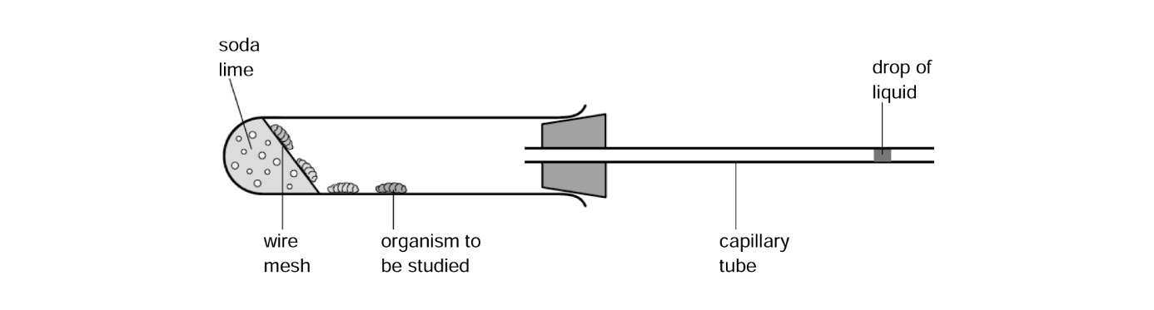
Figure 1 A very simple respirometer.
Study Figure 2 on page 2, and Figure 7.31 on page 149 of Student Book 2 that show two other types of respirometer. Make a table to compare the advantages and disadvantages of the three types of respirometer to help you think about the type of apparatus you will use.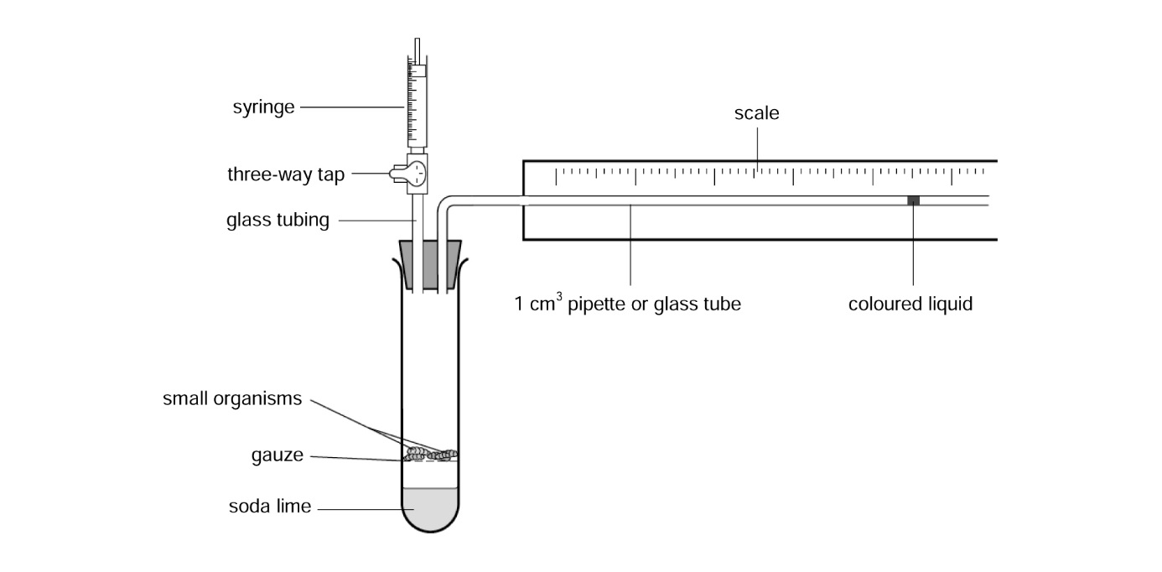
Figure 2 A simple respirometer using a boiling tube.
- Research relevant information about factors that will affect the rate of respiration.
- State what you are going to investigate. You should express this as a question to answer, a problem to investigate or a hypothesis to test.
2 Planning and experimental design
1 Find out what living organisms you will be using and investigate the temperature range of their normal environment. This will allow you to consider temperature as a possible variable to investigate or to control.
2 Find out the dimensions of the apparatus that you will be using, and the size and mass of the organisms; this will allow you to consider the mass or numbers of organisms as possible variables to investigate or to control.
3 Find out the dimensions of the capillary tube, pipette or other glass tube that your apparatus uses. Check if it has a scale associated with it, and what units of length and volume you will be working with.
4 Read through the steps in the given procedure. This procedure uses the type of respirometer shown in Figure 2. If you use a different design you may need to modify the procedure.
a State what you expect to happen to the drop of liquid and why. In your answer, explain in detail what happens to the oxygen molecules, the carbon dioxide molecules and the pressure in the tube containing the liquid.
b For the variable you will be investigating decide how you will modify the procedure to test your hypothesis. Predict what you expect to happen to the oxygen uptake as the independent variable is changed.
c Decide if all the other variables have been identified and, where possible, controlled or allowed for.
d Write a risk assessment for the practical work and make sure you consider how you will handle the living organisms to avoid stress (even rough handling of germinating seeds could affect their respiration) and what will happen to organisms, such as woodlice, after the investigation.
e Draw up a table for your results and consider the most appropriate graph to present your likely data.
Procedure
1 Assemble the apparatus as shown in Figure 2.
2 Place 5 g of maggots, woodlice, or germinating peas or seeds into the boiling tube and replace the bung. Handle live animals with care to avoid harming them.
3 Introduce a drop of marker fluid into the pipette using a dropping pipette. Open the connection (three-way tap) to the syringe and move the fluid to a convenient place on the pipette if needed (i.e. towards the end of the scale that is furthest from the test tube).
4 Mark the starting position of the fluid on the pipette with a fine permanent pen.
5 Isolate the respirometer by closing the connection to the syringe and the atmosphere, and immediately start the stopclock. Mark the position of the fluid on the pipette at 1 minute intervals for 5 minutes.
6 At the end of 5 minutes open the connection to the outside air.
7 Measure the distance travelled by the liquid during each minute (the distance from one mark to the next on your pipette).
8 If your tube does not have volumes marked onto it you will need to convert the distance moved into volume of oxygen used. (Remember the volume used = πr² × distance moved, where r = the radius of the hole in the pipette.)
9 Record your results in a suitable table.
10 Calculate the mean rate of oxygen uptake during the 5 minutes.
11 Collect mean rate of oxygen uptake results from other groups in the class. Note the range of data recorded for mean oxygen uptake.
4 Analysis and interpretation of data
- Draw a graph that shows the mean rate of oxygen taken up against the variable you have investigated, for example the mass (or numbers) of organisms or temperature. Take care to use appropriate units. A scatter diagram may be the best choice to present your data; you should be able to justify why this might be the best choice.
- Decide if any correlation, positive or negative, is evident between your two variables and use a statistical test to determine if the correlation is significant.
5 Conclusion and evaluation
- Explain any correlation evident from the analysis using your biological knowledge.
- State a clear conclusion and comment on the validity of your conclusion. In your discussion, you may wish to suggest:
- why a range of mean oxygen uptake results were obtained if more than one group used the same mass or number of organisms, or temperature
- why a mean was calculated and the significance of any variation within the data from which the mean was calculated
- what could be done to reduce the variation in class results and individual group results.

STUDENT NOTES:

CORE PRACTICAL 17: Investigate the effects of exercise on tidal volume, breathing rate, respiratory minute ventilation and oxygen consumption using data from spirometer traces.
CPAC criteria focus for the lesson:

(2a) correctly uses appropriate instrumentation, apparatus and materials to carry out investigative procedures, experimental techniques and procedures with minimal assistance.
(4a) Makes accurate observations relevant to the experimental or investigative procedure.
(5a) Uses appropriate software and/or tools to process data, carry out research and report findings.

Investigating breathing: Sheet A
Purpose
- To investigate tidal volume, vital capacity, rate of breathing, respiratory minute ventilation and oxygen consumption.
- To interpret data from spirometer traces.
Using a spirometer
Q1 Use the interactive tutorial that accompanies this activity to:
a label the diagram of a spirometer in Figure 1 below
b write a paragraph explaining how a spirometer can be calibrated, then used to measure breathing rate and volume. Write a second paragraph to explain how these measurements can be used to calculate respiratory minute ventilation and oxygen consumption.
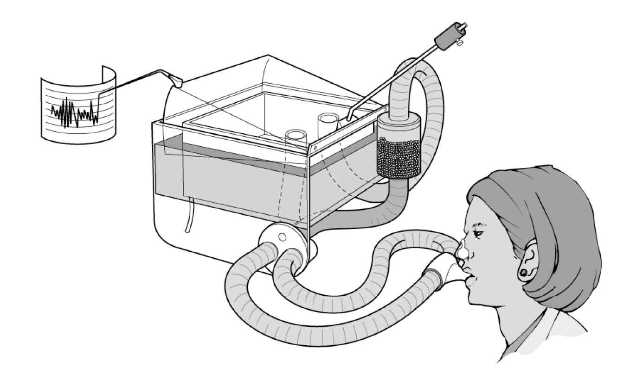
Figure 1 A spirometer.
Q2 Explain the purpose of:
a wearing a nose clip while using the spirometer
b the soda lime canister.
Analysis and interpretation of a spirometer trace
The spirometer chart in Figure 2 shows two traces; one at rest (lower trace) and one after exercise (upper trace).
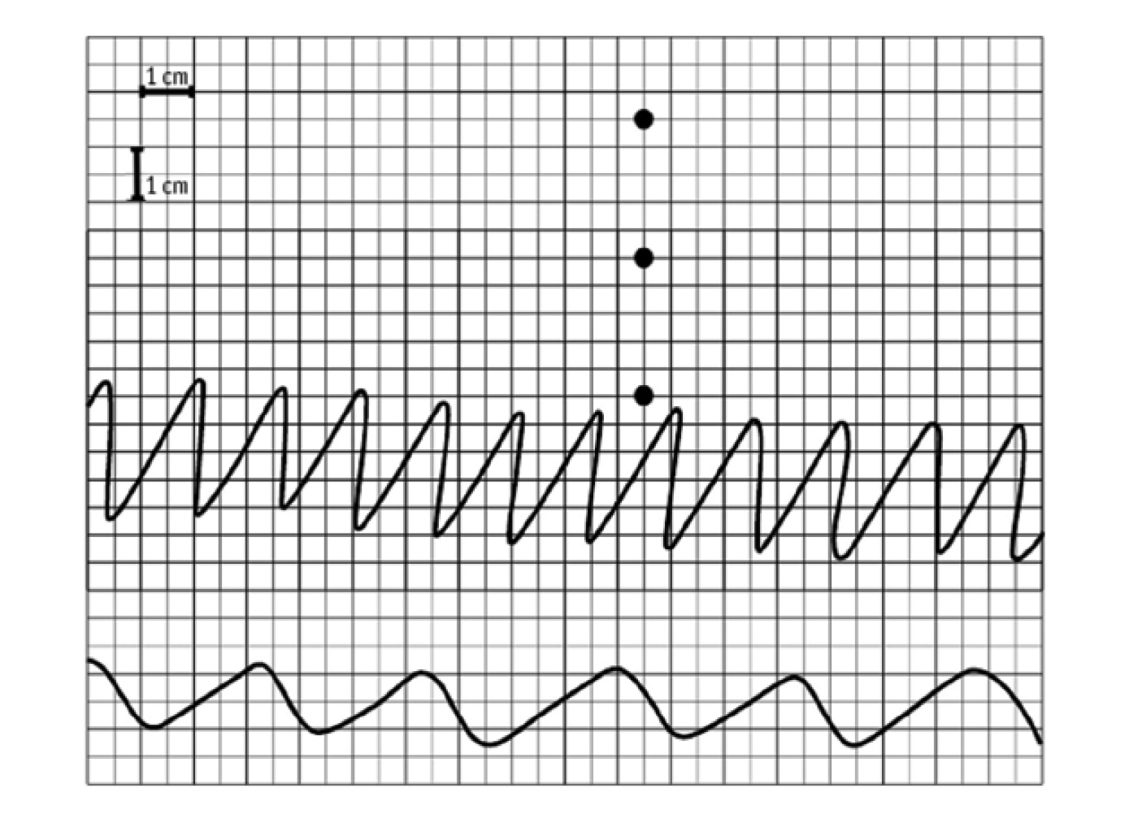
Figure 2 Spirometer chart: top trace = after exercise; bottom trace = before exercise.
The three dots above the upper trace are the calibration dots: the first dot, the lowest of the three, is the baseline level recorded before any oxygen is added, the second dot is after adding 1 dm³ oxygen to the chamber within the spirometer and the third dot is after adding another 1 dm³ oxygen. The chart recorder was set at 0.5 cm s^{–1}. (NB 1 dm³ is the same as 1 litre; 1 dm³ = 1000 cm³.)
Q3 a Use the trace in Figure 2 to find the effect that exercise had on:
i breathing rate
ii tidal volume
iii respiratory minute ventilation
iv oxygen consumption.
b Suggest an explanation for your findings.
c Sketch what the after exercise spirometer trace would look like if the person was asked to take a single deep breath to allow the measurement of vital capacity.
Q4 If you were asked to investigate other changes to the body during exercise, what other factors could you measure easily?
Q5 Spirometers are used to calculate a subject’s basal metabolic rate (BMR) from the volume of oxygen consumed in a given time. Explain why it would be difficult to measure your own BMR in this way during a biology lesson.

Investigating breathing: Sheet B
Purpose
- To investigate tidal volume, vital capacity, rate of breathing, respiratory minute ventilation and oxygen consumption.
- To interpret data from spirometer traces.
Safety

Use eye protection when handling soda lime.

Soda lime is corrosive. Do not handle it directly; use a spatula. See CLEAPSS Student
Safety Sheet 31 for further details.
A spirometer should only be used with teacher supervision. If you have breathing or
circulation (heart) problems or suffer from epilepsy you should not use the spirometer.
Read the manufacturer’s instructions and safety notes before using the equipment.
Stop using the spirometer at once if you experience any unusual breathing problems, or feel dizzy or uncomfortable.
(Asthmatics may use a spirometer if they are otherwise in good health.)
A trained member of staff should use an oxygen cylinder to fill the spirometer.
YOU NEED
- Spirometer  - Kymograph, chart recorder, datalogger or computer | - Soda lime (for the spirometer canister)  - Disinfectant solution
Using a spirometer
The apparatus shown in Figure 1 is a spirometer. Spirometers allow us to study both breathing and respiration. In this activity you will learn how a spirometer works and how to interpret the spirometer trace that is produced.
Figure 1 A spirometer.
The general principle behind a spirometer is simple. It is effectively a tank of water with an air-filled chamber suspended in the water. It is set up so that adding air to the chamber makes the lid of the chamber rise in the water and removing air makes it fall. Movements of the chamber are recorded using a kymograph (pen writing on a rotating drum), a chart recorder, computer or datalogger.
Tubes run from the chamber to a mouthpiece and back again. Breathing in and out through the tubes makes the lid of the chamber fall and rise. The volume of air the person inhales and exhales can be calculated from the distance the lid goes up and down.
The apparatus can be calibrated so that the movement of the lid corresponds to a given volume. A canister containing soda lime is inserted between the mouthpiece and the floating chamber. This absorbs the CO₂ that the subject exhales.
Q1 In what direction will the pen move when the subject inhales?
Carry out practical work safely and ethically
Using students as subjects for an investigation raises ethical issues. It is important that you are well informed about the procedure and that you give your consent to taking part. You should read the information sheet at the end of this activity and read the procedure below carefully.
Procedure
Calibration
In order to interpret the spirometer trace you need to know what both the vertical and the horizontal scales represent.
Finding the vertical scale
The vertical scale measures the volume of air in the chamber. The spirometer’s floating-chamber lid has markings on it showing how much gas it contains.
1 First, empty the chamber completely and make a mark on the kymograph paper, while it is stationary, to show where the pen lies when there is no gas in the tank. Then force a known volume of air into the tank (for example, 500 cm³) and make a second mark on the kymograph trace.
2 Repeat this procedure until the chamber has been completely filled with air. If the range on the kymograph is too large or too small, the length of the arm supporting the pen can be adjusted so that the trace fits onto the paper.
3 Write the values next to your calibrating marks – they will help with interpretation of the trace later. Once the marks have been made on the paper it should be possible to count how many squares on the trace represent 1 dm³. (NB 1 dm³ is the same as 1 litre, 1 dm³ = 1000 cm³).
Finding the horizontal scale
4 On most kymographs there is a switch allowing you to set the speed at which the drum turns. Choose a speed close to 1 mm per second. This is your horizontal scale. Make a note of the speed on your trace, so that the trace can be interpreted once the experiment is complete.
Collecting data on breathing
5 After calibration, the spirometer is filled with medical grade oxygen. A disinfected mouthpiece is attached to the tube, with the tap positioned so that the mouthpiece is connected to the outside air. The subject to be tested puts a nose clip on, places the mouthpiece in their mouth and breathes the outside air until they are comfortable with breathing through the tube.
6 Switch on the kymograph, and at the end of an exhaled breath turn the tap so that the mouthpiece is connected to the spirometer chamber. The trace will move down as the person breathes in. After breathing normally the subject should take as deep a breath as possible and then exhale as much air as possible before returning to normal breathing.
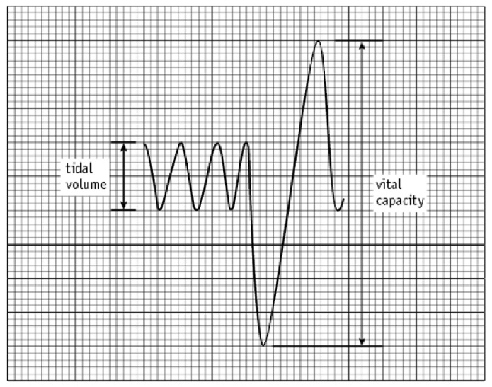
Analysis and interpretation of data
A diagram of a spirometer trace is shown in Figure 2. In this example the subject has breathed in and out normally three times, then taken as deep a breath in as possible, then forced the air from their lungs. Several pieces of information about the subject’s breathing can be read off this kind of trace, or worked out from it.

Figure 2 A sketch of a trace showing normal breathing and one forced breath in and out.
- The tidal volume is the volume of air breathed in and out in one breath at rest. The tidal volume for most adults is only about 0.5 dm³.
- Vital capacity is the maximum volume of air that can be breathed in or out of the lungs in one forced breath.
- Breathing rate is the number of breaths taken per minute.
- Minute ventilation is the volume of air breathed into (and out of) the lungs in one minute. Minute ventilation = tidal volume × rate of breathing (measured in number of breaths per minute).
Some air (about 1 dm³) always remains in the lungs as residual air and cannot be breathed out. Residual air prevents the walls of the bronchioles and alveoli from sticking together. Any air breathed in mixes with this residual air.
Q2 Using the trace produced in class, or one provided by your teacher/lecturer, find the following values:
a tidal volume
b vital capacity
c breathing rate
d minute ventilation.
Ensure you quote figures and their correct units.
Collecting data on rate of respiration
Each time we take a breath, some oxygen is absorbed from the air in the lungs into our blood. An equal volume of carbon dioxide is released back into the lungs from the blood.
When we use the spirometer, each returning breath passes through soda lime, which absorbs the carbon dioxide, so less gas is breathed back into the spirometer chamber than was breathed in.
If we breathe into and out of the spirometer for (say) 1 minute, a steady fall in the spirometer trace can be seen. The gradient of the fall is a measure of the rate of oxygen consumption and so is a measure of the rate of respiration by the body.
Q3 Use the trace produced in class, or one provided by your teacher/lecturer, to work out the rate of oxygen consumption in someone at rest.
Q4 What differences would you expect if the subject had been exercising before a trace was taken?
Q5 Describe how you could use the apparatus to measure changes in breathing and respiration rates due to exercise. State what exercise would be appropriate and any hazards involved.
Q6 Sketch the shape of the trace you would expect before and after exercise.

Investigating Breathing: Using a Spirometer to Investigate Human Lung Function
Information Sheet
The purpose of this practical is to investigate human lung function, to measure tidal and respiratory minute volumes, breathing rate and oxygen consumption. Variation between individuals may also be considered.
You and your classmates will be the humans that we investigate.
SAFETY: If you have any condition that might affect you breathing into a spirometer, please make sure your teacher knows before you start the investigation.
In the investigation you are going to measure and record how much air you breathe in and out. The results will tell us something about the lung capacity of people in your group and you may see how your lung capacity compares with others. When the information is recorded, there will be no record of which trace belongs to which person.
- You are participating in a scientific process of observation and data collection.
- The activity is not a competition.
- The results will not show up any health problems, because we are measuring lung capacity on only one day, in a classroom laboratory.
- If your lung function details are very different from others in your group, don’t worry. There is a lot of variation within the healthy range of lung function.
- If you are worried about anything at the end of the practical, please stay to talk to your teacher about it.
- You do not have to take part in the exercise.
- You can stop at any time.
- You don’t have to put your results into the class set.
- There will be no long-term effects.
This sheet has been modified from a Nuffield Foundation Practical Biology sheet, see weblinks.

STUDENT NOTES:

TOPIC 8

CORE PRACTICAL 18: Investigate habituation to a stimulus.
CPAC criteria focus for the lesson:

(2d) selects appropriate equipment and measurement strategies in order to ensure suitable accurate results.
(3b) Uses appropriate safety equipment and approaches to minimise risks with minimum with minimal prompting.
(5b) sources of information are cited demonstrating that research has taken place, supporting planning and conclusions.

Can snails become habituated to a stimulus?
Purpose
- To investigate habituation of snails to a stimulus.
- To develop practical skills.
Safety
Wash your hands thoroughly after touching the snails and once all the equipment has been
put ready for disinfection. Avoid touching your face after handling the snails.
Take care that the stimulus causes no harm to the snails.
Touching snails
Many people will have touched a snail in the garden and noticed that it immediately withdraws its eye stalks. For such a slow-moving animal this seems a very quick response. This suggests that it is important for protection and survival. A snail only withdraws when it is either inactive or threatened. When touched, it withdraws to avoid danger. Do snails become habituated to the stimulus, ceasing to withdraw with repeated stimulation? In this investigation you will collect data to find out if habituation to a touch stimulus does occur in these organisms.
1 Scientific questions and information research
Before you start the experiment you should:
Research relevant information and state what you are going to investigate. What is the hypothesis you are testing? What do you expect to happen to the response time of the snail as the number of stimuli increases? Why do you expect it to change in this way? Justify your hypothesis using your biological understanding. You may need to carry out additional research in order to do this.
2 Planning and experimental design
Read through the procedure outlined below. Use this to identify the independent and dependent variables, and any other variables that may affect the outcome of this investigation. When using living organisms, it is often difficult to keep all controlled variables the same. Which variables may be difficult to control? What type of error will be introduced to your investigation as a result of this?
What are the ethical issues that arise from the use of live snails in this investigation? How will you account for these issues and ensure the wellbeing of these organisms?
Procedure
YOU NEED
- One giant African land snail (or a garden snail if not available)  - One dampened cotton wool bud | - A suitable clean, firm surface for the snails (e.g. a plastic chopping board)  - A stopwatch
A 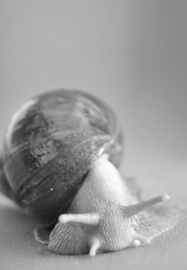 B 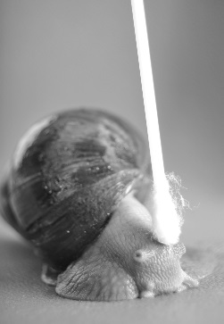
Figure 1 A giant African land snail with eye stalks A extended and B retracted.
1 Collect one giant African land snail and place it on a clean, firm surface. Wait for a few minutes until the snail has fully emerged from its shell (Figure 1A) and is used to its new surroundings.
2 Dampen a cotton wool bud with water.
3 Firmly touch the snail between the eye stalks with the dampened cotton wool bud and immediately start the stopwatch. Measure the length of time between the touch and the snail being fully emerged from its shell once again, with its eye stalks fully extended.
4 Repeat the procedure in step 3 for a total of ten touches, timing how long the snail takes to re-emerge each time.
3 Carrying out practical work safely and ethically
Record your results in a suitable table. Ensure you record results to a suitable degree of precision, and that you include the correct units.
4 Analysis and interpretation of data
Present your results in a suitable graph and identify any trends or patterns in your results.
Using your graph, state whether you think there is a positive, negative or no correlation between the number of stimulations and the time for eye stalk withdrawal.
Explain any patterns or trends in your data, supporting your ideas with evidence from the data and your biological knowledge of habituation. Relate your findings to your hypothesis.
You may see from your data that you appear to have a correlation. However, is your correlation significant? Follow the steps below to complete an appropriate statistical analysis of your data. Refer to Maths and Stats Support Sheet 12 – Spearman’s rank correlation.
Evaluate the procedure used, results obtained and your conclusions.
- Write a null hypothesis that this experiment will test.
- Complete a Spearman’s rank correlation test to determine if there is a statistically significant correlation between the variables. See Maths and Stats Support Sheet 12 – Spearman’s rank correlation – for details on how to calculate the Spearman’s rank correlation coefficient (r_{s}). A table with the headings below will help.
Number of times the snail has been stimulated | Rank stimulation | Time/seconds | Rank time | Difference (D) | D²
- Use a table of critical values to accept or reject your null hypothesis. If your calculated r_{s} is greater than the critical value, then the null hypothesis is rejected. If your calculated value is less than the critical value, then the null hypothesis is accepted.
- Write a statistical conclusion for your experimental data. Make sure you include:
- your calculated value of r_{s}
- the number of pairs of data
- the significance level
- the critical value
- whether the null hypothesis is being accepted or rejected.
Questions
Q1 Suggest a reason why snails may become habituated to a prodding stimulus in the wild.
Q2 This experiment has been shown to be less successful if the snails are handled regularly prior to the experiment. Suggest why handling prior to the experiment could affect the results of the experiment.
Q3 If a baby is shown a new object which they have never seen before, they will stare at the new object. They are fascinated. The length of time they stare at the object without breaking their gaze can be timed and recorded. The object is removed when their gaze is broken. The experiment can be repeated using the same object. With repeated exposure to the same stimulus, the baby changes its response. What would you expect to happen?

STUDENT NOTES:

REVISION NOTES

TOPIC 5

CORE PRACTICAL 10: Carry out a study on the ecology of a habitat, including using quadrats and transects to determine distribution and abundance of organisms, and measuring abiotic factors appropriate to the habitat.

Equipment | What are the independent and dependent variables?
What will you control? (validity) | Method
Risk assessment/Ethical Implications | Results Table/summarise the trends observed
Limitations (sources of error) | Biological explanation (use research to help you to interpret your results)

CORE PRACTICAL 11: Investigate photosynthesis using isolated chloroplasts (the Hill reaction).

Equipment | What are the independent and dependent variables?
What will you control? (validity) | Method
Risk assessment/Ethical Implications | Results Table/summarise the trends observed
Limitations (sources of error) | Biological explanation (use research to help you to interpret your results)

CORE PRACTICAL 12: Investigate the effect of temperature on the initial rate of an enzyme-catalysed reaction, to include Q10.

Equipment | What are the independent and dependent variables?
What will you control? (validity) | Method
Risk assessment/Ethical Implications | Results Table/summarise the trends observed
Limitations (sources of error) | Biological explanation (use research to help you to interpret your results)

CORE PRACTICAL 13: Investigate the effects of temperature on the development of organisms (such as seedling growth rate, brine shrimp hatch rates).

Equipment | What are the independent and dependent variables?
What will you control? (validity) | Method
Risk assessment/Ethical Implications | Results Table/summarise the trends observed
Limitations (sources of error) | Biological explanation (use research to help you to interpret your results)

TOPIC 6:

CORE PRACTICAL 14: Use gel electrophoresis to separate DNA fragments of different length.

Equipment | What are the independent and dependent variables?
What will you control? (validity) | Method
Risk assessment/Ethical Implications | Results Table/summarise the trends observed
Limitations (sources of error) | Biological explanation (use research to help you to interpret your results)

CORE PRACTICAL 15: Investigate the effect of different antibiotics on bacteria.

Equipment | What are the independent and dependent variables?
What will you control? (validity) | Method
Risk assessment/Ethical Implications | Results Table/summarise the trends observed
Limitations (sources of error) | Biological explanation (use research to help you to interpret your results)

TOPIC 7:

CORE PRACTICAL 16: Investigate rate of respiration

Equipment | What are the independent and dependent variables?
What will you control? (validity) | Method
Risk assessment/Ethical Implications | Results Table/summarise the trends observed
Limitations (sources of error) | Biological explanation (use research to help you to interpret your results)

CORE PRACTICAL 17: Investigate the effects of exercise on tidal volume, breathing rate, respiratory minute ventilation and oxygen consumption using data from spirometer traces.

Equipment | What are the independent and dependent variables?
What will you control? (validity) | Method
Risk assessment/Ethical Implications | Results Table/summarise the trends observed
Limitations (sources of error) | Biological explanation (use research to help you to interpret your results)

TOPIC 8:

CORE PRACTICAL 18: Investigate habituation to a stimulus

Equipment | What are the independent and dependent variables?
What will you control? (validity) | Method
Risk assessment/Ethical Implications | Results Table/summarise the trends observed
Limitations (sources of error) | Biological explanation (use research to help you to interpret your results)

